Core Java Concepts Wise Programs
Introduction:
1) Write a java program to print your name.
package Introduction;
import java.util.*;
public class Program1 {
public static void main(String[] args) {
System.out.println("enter your name");
Scanner s=new Scanner(System.in);
String name=s.nextLine();
System.out.println("Hello "+name);
}
}
Output:
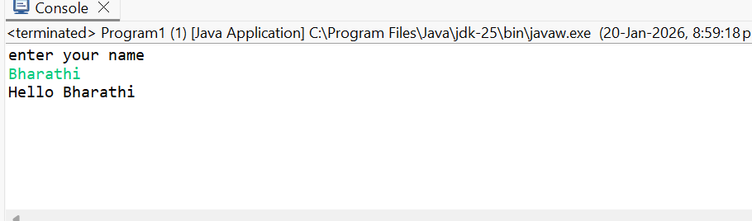
2) Write a program to print the sum of all even numbers from 1 to 100.
// program to print sum of even numbers between 1 to 100
public class Evensum {
public static void main(String[] args) {
int sum=0;
for(int i=1;i<=100;i++){
if(i%2==0){
sum+=i; }
}
System.out.println("sum of even numbers from 1 to 100 is "+sum);
}
}
Output:
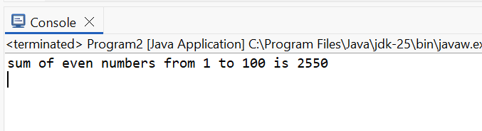
3) Write a program to swap two numbers without using a temporary variable.
import java.util.*;
public class Program3 {
public static void main(String[] args) {
Scanner sc = new Scanner(System.in);
System.out.print("Enter a value: ");
int a = sc.nextInt();
System.out.print("Enter b value: ");
int b = sc.nextInt();
a = a + b;
b = a - b;
a = a - b;
System.out.println("After swapping:");
System.out.println("a = " + a);
System.out.println("b = " + b);
}
}
Output:
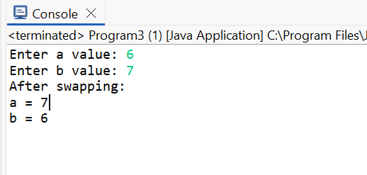

4) Write java program to check given number is prime or not.
import java.util.*;
public class Program4 {
public static void main(String[] args) {
Scanner s=new Scanner(System.in);
System.out.println("enter a number ");
int a=s.nextInt();
int count=0;
for(int i=1;i<=a;i++){
if(a%i==0){
count++; }
if(count>2){ break; }
}
if(count>2){
System.out.print(a+" is not prime number");
}
else{
System.out.println(a+" is prime number");
}
}
}
Output:
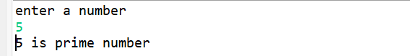
5) write a program to find factorial of a number using recursion.
//program to find factorial of a number
import java.util.*;
public class Program5 {
public static void main(String[] args) {
Scanner s=new Scanner(System.in);
System.out.println("enter a number");
int n=s.nextInt();
System.out.println("factorial of "+n+" is "+ factorial(n));
}
public static int factorial(int n){
if(n<=1){
return 1;
}
else{
return n*factorial(n-1);
}
}
}
Output:
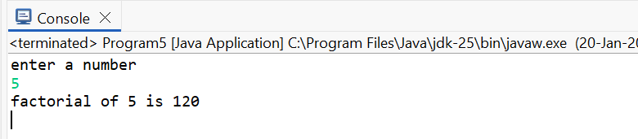
6) Write a program to find the roots of a quadratic equation.
package Introduction;
import java.util.*;
public class Program6 {
public static void main(String[] args) {
Scanner sc = new Scanner(System.in);
System.out.println("Enter coefficients a, b and c:");
double a = sc.nextDouble();
double b = sc.nextDouble();
double c = sc.nextDouble();
double discriminant = b * b - 4 * a * c;
if (discriminant > 0) {
double root1 = (-b + Math.sqrt(discriminant)) / (2 * a);
double root2 = (-b - Math.sqrt(discriminant)) / (2 * a);
System.out.println("Two distinct real roots:");
System.out.println("Root 1 = " + root1);
System.out.println("Root 2 = " + root2);
}
else if (discriminant == 0) {
double root = -b / (2 * a);
System.out.println("Two equal real roots:");
System.out.println("Root = " + root);
}
else {
double realPart = -b / (2 * a);
double imaginaryPart = Math.sqrt(-discriminant) / (2 * a);
System.out.println("Complex roots:");
System.out.println("Root 1 = " + realPart + " + " + imaginaryPart + "i");
System.out.println("Root 2 = " + realPart + " - " + imaginaryPart + "i");
}
}
}
Output:
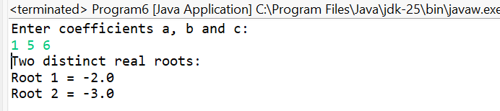
7) Write a program to find area of triangle.
import java.util.*;
public class Program7 {
public static void main(String[] args) {
Scanner s=new Scanner(System.in);
System.out.println("Enter base of the triangle:");
double base = s.nextDouble();
System.out.println("Enter height of the triangle:");
double height = s.nextDouble();
double area = 0.5 * base * height;
System.out.println("Area of the triangle = " + area);
}
}
Output:
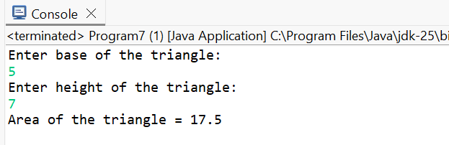
8)Write a program to print fibanacci series up to given number of terms.
import java.util.*;
public class Program8 {
public static void main(String[] args) {
Scanner s=new Scanner(System.in);
System.out.println("Enter a number");
int n=s.nextInt();
int first=0;
int second=1;
System.out.print(first+" "+second+" ");
for(int i=1;i<=n-2;i++){
int next=first+second;
first=second;
second=next;
System.out.print(next+" ");
}
}
}
Output:
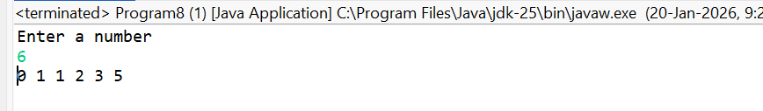
9) Write a program to find second largest element in an array.
// Second largest element
import java.util.*;
public class SecondLargest {
public static void main(String[] args) {
Scanner s=new Scanner(System.in);
System.out.println("Enter array size");
int n=s.nextInt();
int array[]=new int[n];
System.out.println("Enter elemnts");
for (int i= 0; i<n; i++) {
array[i]=s.nextInt();
}
int f=Integer.MIN_VALUE;
int sc=Integer.MIN_VALUE;
for(int i=0;i<n;i++){
if(array[i]>f){
sc=f;
f=array[i];
}
else if(array[i]>sc && array[i]!=f){
sc=array[i];
}
}
System.out.println("Secnd Largest elemnt "+ sc);
} }
Output:
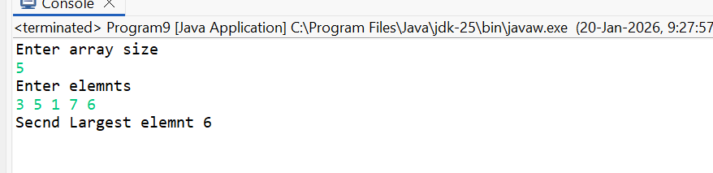
10) Write a program to reverse a string.
//program to reverseing a string
import java.util.*;
public class StringReverse {
public static void main(String[] args) {
Scanner s=new Scanner(System.in);
String str=s.nextLine();
StringBuffer st=new StringBuffer(str);
st.reverse();
String sb=st.toString();
System.out.println("Reversed string "+sb);
}
}
Output:
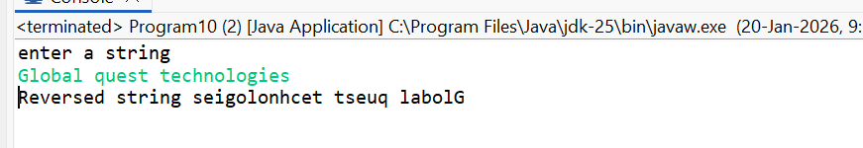
11) write a program to check a string palindrome or not.
//program to check string is pallindrome or not
import java.util.*;
public class Pallindrome {
public static void main(String[] args) {
Scanner s=new Scanner(System.in);
String str=s.nextLine();
String temp=str;
StringBuffer st=new StringBuffer(str);
st.reverse();
String sb=st.toString();
System.out.println("Reversed string "+sb);
if(sb.equals(temp)){
System.out.println("String is palindrome");
}
else{
System.out.println("String is not pallindrome");
}
}
}
Output:
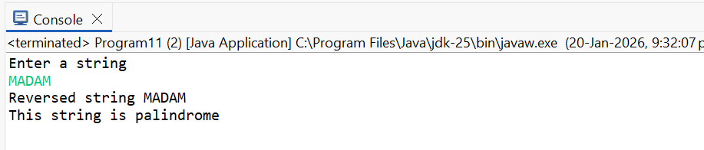
12) Write a program to count the no of occurences of a character in a string.
// Program to count number of occurrences in a string
import java.util.*;
public class Numberofoccurences {
public static void main(String[] args) {
Scanner s = new Scanner(System.in);
System.out.println("Enter a string:");
String str = s.nextLine();
HashMap<Character, Integer> map = new HashMap<>();
for (int i = 0; i < str.length(); i++) {
char ch = str.charAt(i);
if (map.containsKey(ch)) {
map.put(ch, map.get(ch) + 1);
} else {
map.put(ch, 1);
}
}
for (char ch : map.keySet()) {
System.out.println("No of occurrences of " + ch + " is " + map.get(ch));
}
}}
Output:
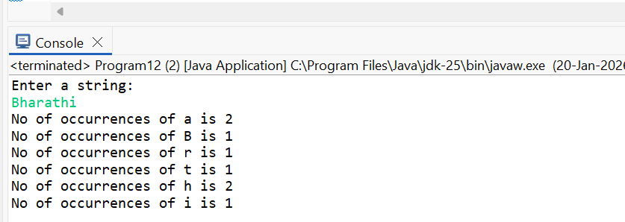
13) Write a program to find the GCD of two numbers.
import java.util.*;
public class Program13 {
public static void main(String[] args) {
Scanner s=new Scanner(System.in);
System.out.println("Enter two numbers");
int n=s.nextInt();
int m=s.nextInt();
while (m!= 0) {
int temp = m;
m = n % m;
n = temp;
}
System.out.println("GCD = " + n);
}}
Output: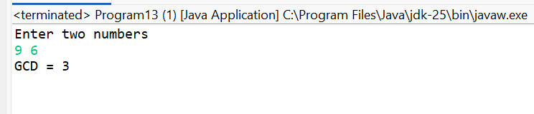
14) Write a program to convert decimal number to binary.
import java.util.*;
public class Program14 {
public static void main(String[] args) {
Scanner sc = new Scanner(System.in);
System.out.println("enter a number ");
int num = sc.nextInt();
String binary = "";
while (num > 0) {
binary = (num % 2) + binary;
num = num / 2;
}
System.out.println("Binary = " + binary);
}
}
Output:
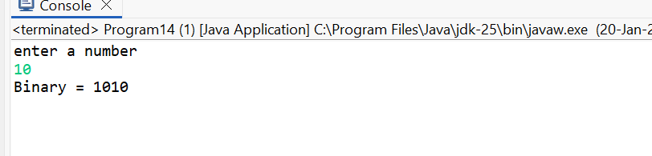
15) Write a program to calculate the sum of digits of a given number.
import java.util.*;
public class Program15 {
public static void main(String[] args) {
Scanner s=new Scanner(System.in);
System.out.println("enter number ");
int n=s.nextInt();
int sum=0;
while(n>0){
sum+=n%10;
n=n/10;
}
System.out.println("sum of the digits is "+sum);
}
Output:
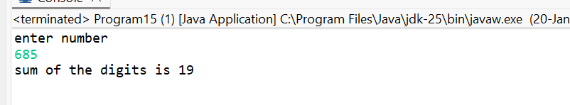
16) Write a program to check given year is leap year or not.
package Introduction;
import java.util.*;
public class Program16 {
public static void main(String[] args) {
Scanner s=new Scanner(System.in);
System.out.println("enter year");
int n=s.nextInt();
if((n%400==0)||(n%4==0&&!(n%100==0))){
System.out.println("Leap Year");
}
else{
System.out.println("Not a leap year");
}
}
}
Output:
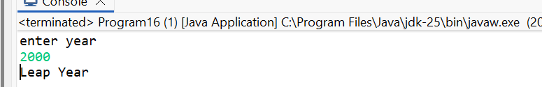
17) Write a program to find the factorial of a number using iteration.
package Introduction;
import java.util.*;
public class Program17 {
public static void main(String[] args) {
Scanner s=new Scanner(System.in);
System.out.println("enter a number");
int n=s.nextInt();
int fact=1;
for(int i=1;i<=n;i++){
fact=fact*i;
}
System.out.println("Factorial of "+n+" is "+fact);
}}
Output:
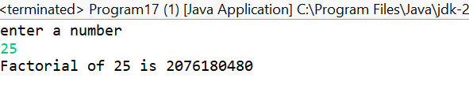
18) Write a program to print the pascal’s triangle.
package Introduction;
import java.util.*;
public class Program18 {
public static void main(String[] args) {
Scanner sc = new Scanner(System.in);
int n = sc.nextInt();
for (int i = 0; i < n; i++) {
int num = 1;
for (int space = 1; space <= n - i; space++) {
System.out.print(" ");
}
for (int j = 0; j <= i; j++) {
System.out.print(num + " ");
num = num * (i - j) / (j + 1);
}
System.out.println();
}
}}
Output:
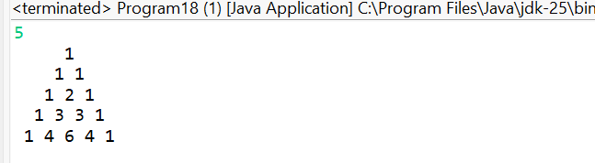
19) Write a program to check if a number is Armstrong or not.
import java.util.*;
public class Program19 {
public static void main(String[] args) {
Scanner sc = new Scanner(System.in);
System.out.println("Enter a number ");
int num = sc.nextInt();
int original = num;
int sum = 0;
int digits = String.valueOf(num).length();
while (num > 0) {
int digit = num % 10;
sum += Math.pow(digit, digits);
num /= 10;
}
if (sum == original) {
System.out.println("Armstrong Number");
} else {
System.out.println("Not an Armstrong Number");
} }}
Output:
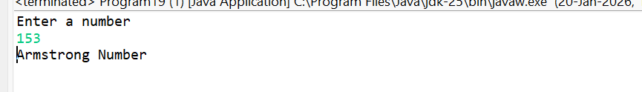

20) Write a program to find the area and perimeter of a circle.
package Introduction;
import java.util.*;
public class Program20 {
public static void main(String[] args) {
Scanner s=new Scanner(System.in);
System.out.println("enter radius");
double r = s.nextDouble();
double pi = 3.14159;
double area = pi * r * r;
double perimeter = 2 * pi * r;
System.out.println("Area of Circle = " + area);
System.out.println("Perimeter of Circle = " + perimeter);
}
}
Output:
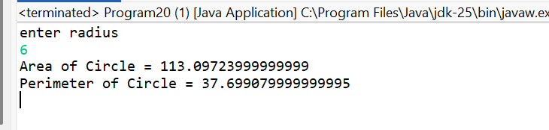
21) Write a program to print the multiplication table of a given number.
import java.util.*;
public class Program21 {
public static void main(String[] args) {
Scanner s=new Scanner(System.in);
System.out.println("enter a number");
int n=s.nextInt();
for(int i=1;i<=10;i++){
System.out.println(n+" * "+i+" = "+(n*i));
}
}}
Output:
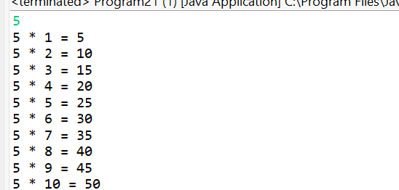
22) Write a program to find the sum of all elements in an array.
package Introduction;
import java.util.*;
public class Program22 {
public static void main(String[] args) {
Scanner sc = new Scanner(System.in);
System.out.println("enter array size");
int n = sc.nextInt();
int[] arr = new int[n];
int sum = 0;
for (int i = 0; i < n; i++) {
arr[i] = sc.nextInt();
sum += arr[i];
}
System.out.println("Sum of array = " + sum); }}
Output:
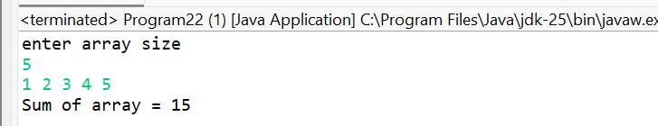
23) Write a program to check if a given number is a perfect number.
package Introduction;
import java.util.*;
public class Program23 {
public static void main(String[] args) {
Scanner sc = new Scanner(System.in);
int num = sc.nextInt();
int sum = 0;
for (int i = 1; i <= num / 2; i++) {
if (num % i == 0) {
sum += i;
}
}
if (sum == num) {
System.out.println("Perfect Number");
} else {
System.out.println("Not a Perfect Number");
}
}
Output:
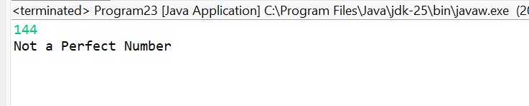
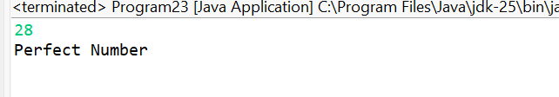
24) Write a program to find the ASCII value of a character.
package Introduction;
import java.util.*;
public class Program24 {
public static void main(String[] args) {
Scanner sc = new Scanner(System.in);
System.out.println("Enter a character");
char ch = sc.next().charAt(0);
int ascii = ch;
System.out.println("ASCII value of " + ch + " = " + ascii);
}
}
Output:
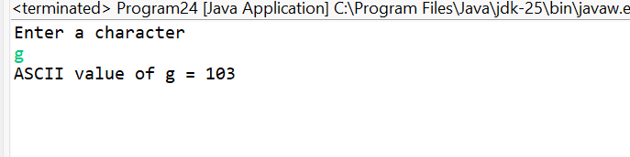
25) Write a program to calculate the power if a number.
package Introduction;
import java.util.*;
public class Program25 {
public static void main(String[] args) {
Scanner sc = new Scanner(System.in);
System.out.println("enter the base ");
int base = sc.nextInt();
System.out.println("enter the exponent");
int exp = sc.nextInt();
long result = 1;
for (int i = 1; i <= exp; i++) {
result *= base;
}
System.out.println("Result = " + result);}}
Output:
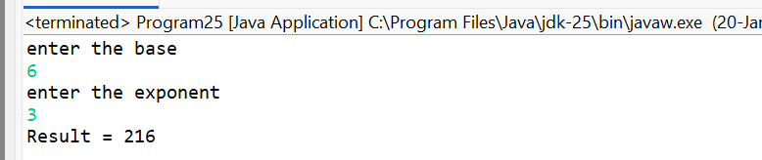
OPERATORS:
- Write a program to perform arithmetic operators on two numbers.
package Operators;
import java.util.*;
public class Program1 {
public static void main(String[] args) {
System.out.println("enter two numbers ");
Scanner s=new Scanner(System.in);
int n=s.nextInt();
int m=s.nextInt();
System.out.println("Addition is "+(n+m));
System.out.println("substraction is "+(n-m));
System.out.println("multiplication is "+(n*m));
System.out.println("division is "+(n/m));
}
}
OUTPUT:
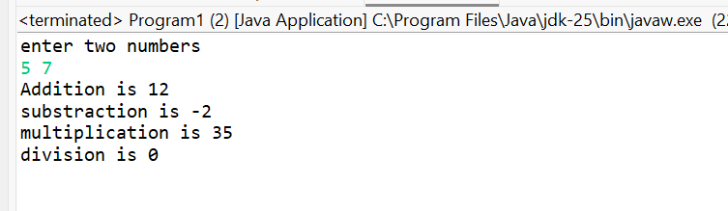
- Write a program to perform bitwise AND, OR, and XOR operations on two integers.
package Operators;
import java.util.*;
public class Program2 {
public static void main(String[] args) {
Scanner sc = new Scanner(System.in);
System.out.println("Enter first integer:");
int a = sc.nextInt();
System.out.println("Enter second integer:");
int b = sc.nextInt();
int andResult = a & b;
int orResult = a | b;
int xorResult = a ^ b;
System.out.println("Bitwise AND (a & b) = " + andResult);
System.out.println("Bitwise OR (a | b) = " + orResult);
System.out.println("Bitwise XOR (a ^ b) = " + xorResult);
}
}
OUTPUT:
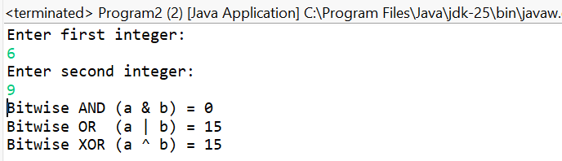

- Write a program to check whether a given number is positive, negative, or zero.
package Operators;
import java.util.*;
public class Program3 {
public static void main(String[] args) {
Scanner s=new Scanner(System.in);
System.out.println("enter a number");
int n=s.nextInt();
if(n>0){
System.out.println("Positive Number");
}
else if(n<0){
System.out.println("Negative Number");
}
else{
System.out.println("Zero");
} }
OUTPUT: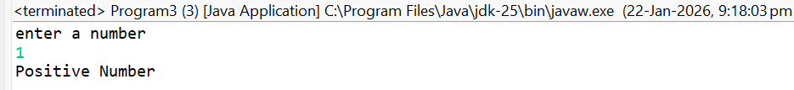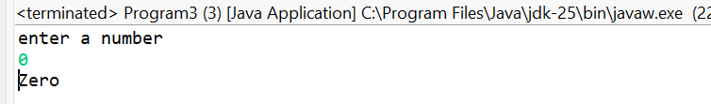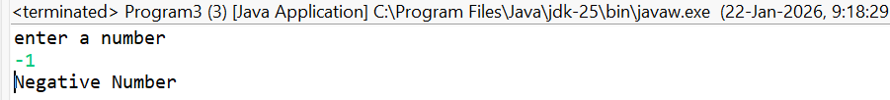
- Write a program to swap two numbers using bitwise XOR operator.
package Operators;
import java.util.*;
public class Program4 {
public static void main(String[] args) {
Scanner s=new Scanner(System.in);
System.out.println("Enter 2 values ");
int n=s.nextInt();
int m=s.nextInt();
System.out.println("Before swap: n = " + n + ", m = " + m);
n=n^m;
m=n^m;
n=n^m;
System.out.println("n = "+n+" m = "+m);
}}
OUTPUT:
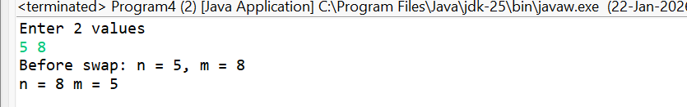
- Write a program to calculate the area of a circle using the radius entered by the user.
package Operators;
import java.util.*;
public class Program5 {
public static void main(String[] args) {
Scanner s=new Scanner(System.in);
System.out.println("enter radius ");
double r = s.nextDouble();
double pi = 3.14159;
double area = pi * r * r;
System.out.println("Area of circle is "+ area);
}
}
OUTPUT:
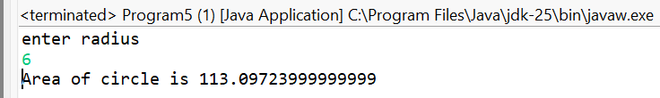
- Write a program to convert temperature from Fahrenheit to Celsius.
package Operators;
import java.util.*;
public class Program6 {
public static void main(String[] args) {
Scanner s=new Scanner(System.in);
System.out.println("enter temperature in fahrenheit ");
double t=s.nextDouble();
double c=(t-32)*(5.0/9.0);
System.out.println("temperature in celcius "+c);
}
}
OUTPUT:
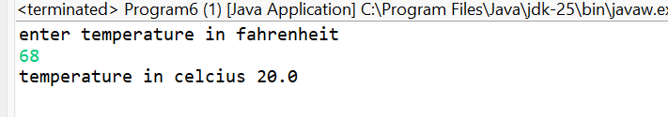
- Write a program to check if a given number is divisible by both 5 and 7.
package Operators;
import java.util.*;
public class Program7 {
public static void main(String[] args) {
Scanner s=new Scanner(System.in);
System.out.println("Enter a number");
int n=s.nextInt();
if((n%5==0) && (n%7==0)){
System.out.println("Yes "+n+" divisible by both 5 and 7");
}
else{
System.out.println("No "+n+" does not divisible by both 5 and 7");
}
}}
OUTPUT:
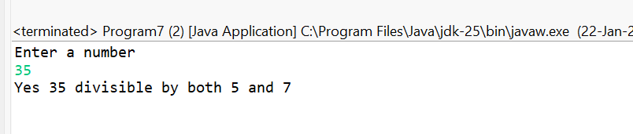
- Write a program to calculate the compound interest.
package Operators;
import java.util.*;
public class Program8 {
public static void main(String[] args) {
Scanner s=new Scanner(System.in);
System.out.println("enter pricipal amount, rate of interest, and time ");
double p=s.nextDouble();
double i=s.nextDouble();
double t=s.nextDouble();
double amount=p*Math.pow((1+(i/100)),t);
double ci=amount-p;
System.out.println("Compound interest "+ci);
}
}
OUTPUT:

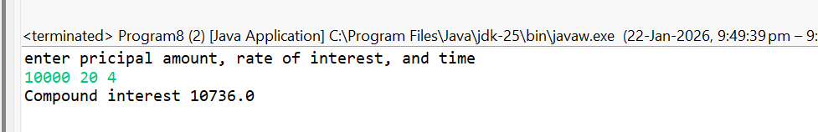
- Write a program to check whether a given character is a vowel or consonant.
package Operators;
import java.util.*;
public class Program9 {
public static void main(String[] args) {
Scanner s=new Scanner(System.in);
char c=s.next().charAt(0);
String vowel="aeiouAEIOU";
if(vowel.contains(String.valueOf(c))){
System.out.println(c+" is a vowel");
}
else{
System.out.println(c+" is a consonant");
}
}
}
OUTPUT:
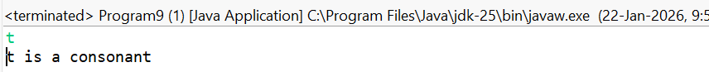
- Write a program to find the maximum of three numbers using conditional operator.
package Operators;
import java.util.*;
public class Program10 {
public static void main(String[] args) {
Scanner s=new Scanner(System.in);
System.out.println("enter three numbers ");
int a=s.nextInt();
int b=s.nextInt();
int c=s.nextInt();
if(a>b){
if(a>c){
System.out.println(a+" is greater ");
}
else{
System.out.println(c+" is greater ");
}
}
else if(b>c){
System.out.println(b+" is greater ");
}
else{
System.out.println(c+" is greater ");
}
}
}
OUTPUT:
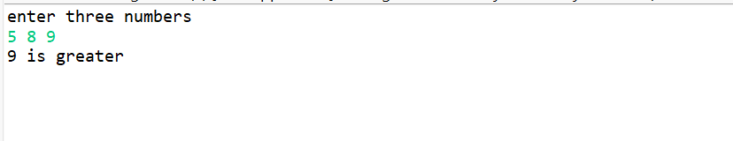
- Write a program to find the sum of digits of a number using while loop.
package Operators;
import java.util.*;
public class Program11 {
public static void main(String[] args) {
Scanner s=new Scanner(System.in);
System.out.println("enter number ");
int n=s.nextInt();
int sum=0;
while(n>0){
sum+=n%10;
n=n/10;
}
System.out.println("sum of the digits is "+sum); }}
OUTPUT:
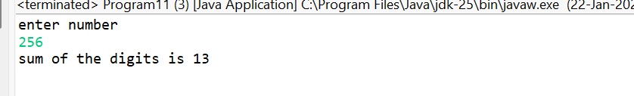
- Write a program to check whether a given number is palindrome or not using recursion.
package Operators;
import java.util.*;
public class Program12 {
public static void main(String[] args) {
Scanner s=new Scanner(System.in);
System.out.println("enter number ");
int n=s.nextInt();
int rev=pallindrome(n,0);
if(rev==n){
System.out.println("Pallindrome");
}
else{
System.out.println("not pallindrome");
}
}
static int pallindrome(int n,int rev){
if (n == 0) return rev;
return pallindrome(n / 10, rev * 10 + (n % 10));
}
}
OUTPUT:
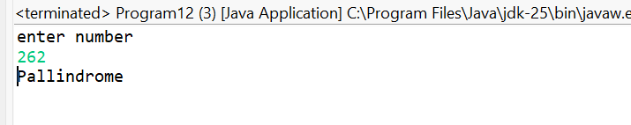
- Write a program to check whether a given number is prime or not using for loop.
package Operators;
import java.util.*;
public class Program13 {
public static void main(String[] args) {
Scanner s=new Scanner(System.in);
System.out.println("Enter a number ");
int n=s.nextInt();
int count=0;
for(int i=1;i<=n;i++){
if(5%i==0){
count++;
}
}
if(count<=2){
System.out.println("It is a Prime number");
}
else{
System.out.println("It is not a prime number");
} }
}
OUTPUT:
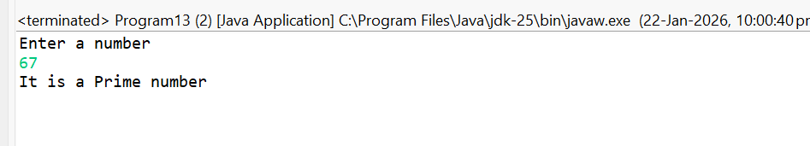
- Write a program to find the factorial of a number using recursion.
package Operators;
import java.util.*;
public class Program14 {
public static void main(String[] args) {
Scanner s=new Scanner(System.in);
System.out.println("Enetr a number ");
int n=s.nextInt();
System.out.println("Factorial of "+n+" :"+Factorial(n));
}
static int Factorial(int n){
if(n<=1){
return 1;
}
else{
return n*Factorial(n-2);
}
}
}OUTPUT:
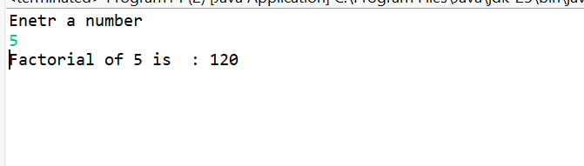
- Write a program to calculate the power of a number using recursion.
package Operators;
import java.util.*;
public class Program15 {
public static void main(String[] args) {
Scanner s=new Scanner(System.in);
System.out.println("Enter a base ");
int n=s.nextInt();
System.out.println("enter exponent");
int m=s.nextInt();
System.out.println("Result "+power(n,m));
}
static int power(int base,int exp){
if(exp==0){
return 1;
}
else{
return base*power(base,exp-1);
}
}
}
OUTPUT:
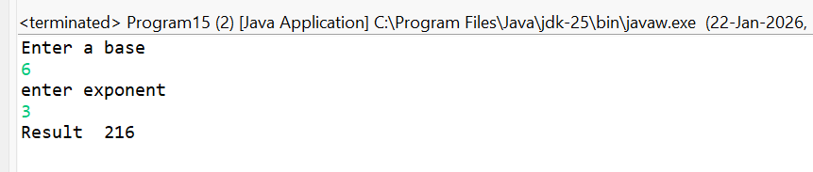

- Write a program to print the Fibonacci series using recursion.
package Operators;
import java.util.*;
public class Program166 {
static int fibonacci(int n) {
if (n == 0)
return 0;
if (n == 1)
return 1;
return fibonacci(n - 1) + fibonacci(n - 2);
}
public static void main(String[] args) {
Scanner sc = new Scanner(System.in);

System.out.println("Enter number of terms:");
int n = sc.nextInt();

System.out.println("Fibonacci Series:");
for (int i = 0; i < n; i++) {
System.out.print(fibonacci(i) + " ");
} }}
OUTPUT:
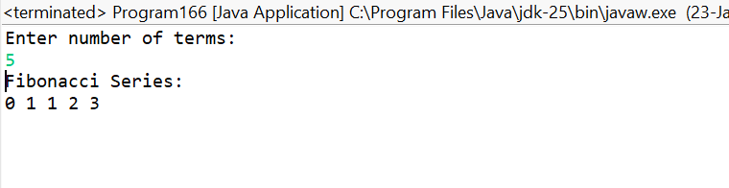
- Write a program to reverse a string using recursion.
package Operators;
import java.util.*;
public class Program17 {
public static void main(String[] args) {
Scanner s=new Scanner(System.in);
System.out.println("enter a string");
String st=s.nextLine();
System.out.println("Reversed string is "+stringReverse(st));
}
static String stringReverse(String str){
if(str.isEmpty()){
return str;
}
else{
return stringReverse(str.substring(1))+str.charAt(0);
}
}
}
OUTPUT:
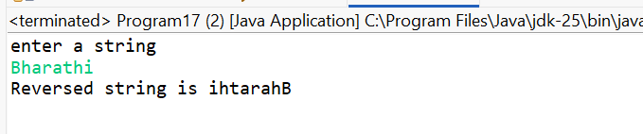
- Write a program to calculate the sum of natural numbers up to a given term.
package Operators;
import java.util.*;
public class Program18 {
public static void main(String args[]){
Scanner s=new Scanner(System.in);
System.out.println("Enter a number");
int n=s.nextInt();
int sum=0;
for(int i=1;i<=n;i++){
sum+=i;
}
System.out.println("Sum of natural numbers is "+sum);
}}
OUTPUT:
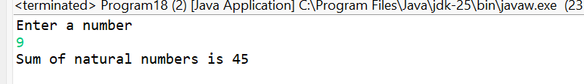
- Write a program to check whether a given year is leap year or not using conditional operator.
package Operators;
import java.util.*;
public class Program19 {
public static void main(String args[]) {
Scanner s=new Scanner(System.in);
System.out.println("Enter a year ");
int n=s.nextInt();
if((n%400==0)||((n%4==0)&&(n%100==0))){
System.out.println("Given year is leap year");
}
else{
System.out.println("Given year not q leap year");
}
}
}
OUTPUT:
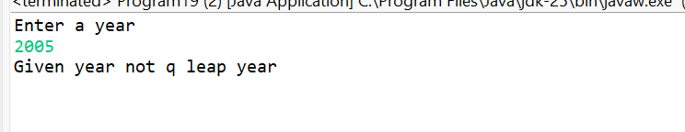
- Write a program to find the LCM (Least Common Multiple) of two numbers.
package Operators;
import java.util.*;
public class Program20 {
public static void main(String[] args) {
Scanner s=new Scanner(System.in);
System.out.println("Enter two numbers ");
int n=s.nextInt();
int m=s.nextInt();
int lcm = (n * m) / gcd(n, m);
System.out.println("LCM = " + lcm);
}
static int gcd(int a, int b) {
if (b == 0)
return a;
return gcd(b, a % b);
}
}
OUTPUT:
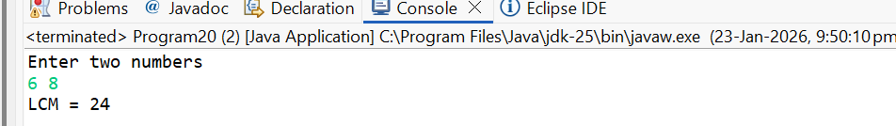
- Write a program to calculate the area of a triangle using Heron's formula.
package Operators;
import java.util.*;
public class Program21 {
public static void main(String[] args) {
Scanner sc=new Scanner(System.in);
System.out.print("Enter side a: ");
double a = sc.nextDouble();
System.out.print("Enter side b: ");
double b = sc.nextDouble();
System.out.print("Enter side c: ");
double c = sc.nextDouble();
double s = (a + b + c) / 2;
double area = Math.sqrt(s * (s - a) * (s - b) * (s - c));
System.out.println("Area of the triangle = " + area);

}
}
OUTPUT:
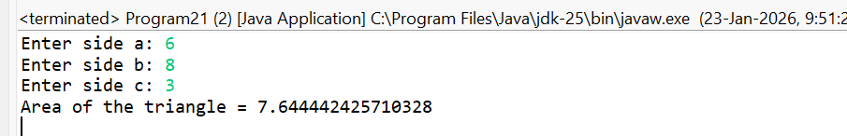
- Write a program to find the sum of all even numbers between 1 to 100 using for loop.
package Operators;
import java.util.*;
public class Program22 {
public static void main(String[] args) {
Scanner s=new Scanner(System.in);
System.out.println("printing numbers from 1 to 100");
for(int i=1;i<=100;i++){
System.out.print(i+" ");
}
}}
OUTPUT:
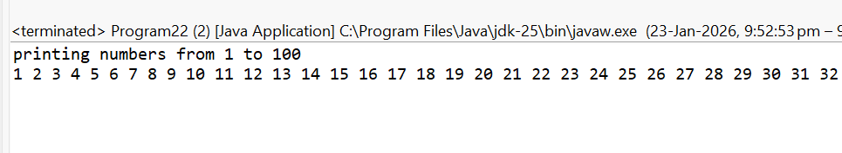
- Write a program to calculate the simple interest.
package Operators;
import java.util.*;
public class Program23 {
public static void main(String[] args) {
Scanner s=new Scanner(System.in);
System.out.println("enter pricipal amount, year and rate");
int a=s.nextInt();
int y=s.nextInt();
int r=s.nextInt();
double SI=(a*y*r)/100;
System.out.println("simple interest "+SI); }
}
OUTPUT:
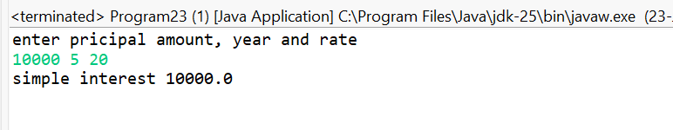
- Write a program to print the multiplication table of a given number using for loop.
package Operators;
import java.util.*;
public class Program24 {
public static void main(String[] args) {
Scanner s=new Scanner(System.in);
System.out.println("Enter a number");
int n=s.nextInt();
for(int i=1;i<=10;i++){
System.out.println(n+" * "+i+" = "+(n*i));
}
}
}
OUTPUT:
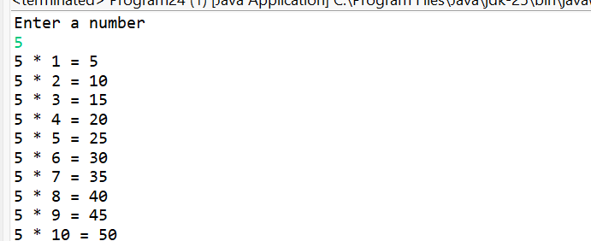
- Write a program to check whether a given number is Armstrong or not using while loop.
package Operators;
import java.util.*;
public class Program25 {
public static void main(String[] args) {
Scanner sc = new Scanner(System.in);
System.out.println("enter a number");
int num = sc.nextInt();
int original = num;
int sum = 0;
int digits = String.valueOf(num).length();
while (num > 0) {
int digit = num % 10;
sum += Math.pow(digit, digits);
num /= 10;
}
if (sum == original) {
System.out.println("Armstrong Number");
}
else {
System.out.println("Not an Armstrong Number");
}
}
}
OUTPUT:
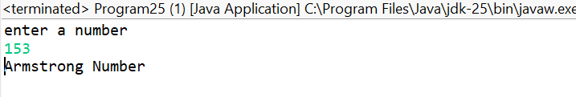
Arrays:
- Write a program to find the sum of all elements in an array.
package Arrays;
import java.util.*;
public class Program1 {
public static void main(String[] args) {
Scanner s = new Scanner(System.in);
System.out.println("Enter array size");
int n = s.nextInt();
int array[] = new int[n];
int sum = 0;
System.out.println("Enter array elements");
for(int i = 0; i < n; i++){
array[i] = s.nextInt();
sum = sum + array[i];
}
System.out.println("Sum = " + sum);
}
}
OUTPUT:
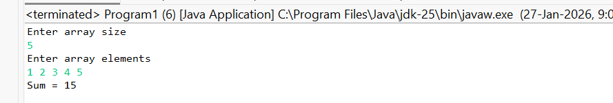
- Write a program to find the largest and smallest elements in an array.
package Arrays;
import java.util.*;
public class Program2 {
public static void main(String[] args) {
Scanner s=new Scanner(System.in);
System.out.println("Enter array size ");
int n=s.nextInt();
int array[] = new int[n];
System.out.println("Enter array elements:");
for (int i = 0; i < n; i++) {
array[i] = s.nextInt();
}
int largest = array[0];
for (int i = 1; i < n; i++) {
if (array[i] > largest) {
largest = array[i];
}
}
System.out.println("Largest: " + largest);
// Smallest element
int smallest = array[0];
for (int i = 1; i < n; i++) {
if (array[i] < smallest) {
smallest = array[i];
}
}
System.out.println("Smallest: " + smallest);
}
}
OUTPUT:
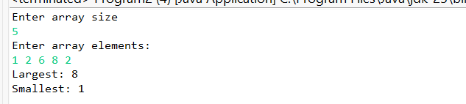
- Write a program to copy elements from one array to another.
package Arrays;
import java.util.Scanner;
public class Program3 {
public static void main(String[] args) {
Scanner s=new Scanner(System.in);
System.out.println("Enter array size ");
int n=s.nextInt();
int array[] = new int[n];
System.out.println("Enter array elements:");
for (int i = 0; i < n; i++) {
array[i] = s.nextInt();
}
int a2[]=new int[n];
for(int i=0;i<n;i++) {
a2[i]=array[i];
}
System.out.println("Array2 elements are");
for(int i=0;i<n;i++) {
System.out.print(a2[i]+" ");
}
}}
OUTPUT:
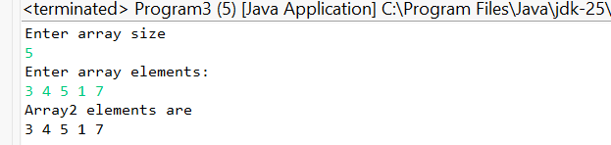
- Write a program to remove duplicate elements from an array.
package Arrays;
import java.util.*;
public class Program4 {
public static void main(String[] args) {
Scanner s = new Scanner(System.in);
System.out.println("Enter array size");
int n = s.nextInt();
int array[] = new int[n];
System.out.println("Enter array elements");
for(int i = 0; i < n; i++){
array[i] = s.nextInt();
}
int u[]=Arrays.stream(array).distinct().toArray();
for(int i=0;i<u.length;i++){
System.out.print(u[i]+" ");
}
}}
OUTPUT:
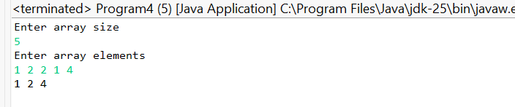
- Write a program to reverse an array.
package Arrays;
import java.util.*;
public class Program5 {
public static void main(String[] args) {
Scanner s=new Scanner(System.in);
System.out.println("Enter array size ");
int n=s.nextInt();
int array[] = new int[n];
System.out.println("Enter array elements");
for(int i = 0; i < n; i++){
array[i] = s.nextInt();
}
for(int i=0;i<n/2;i++){
int t=array[i];
array[i]=array[n-1-i];
array[n-1-i]=t;
}
System.out.println("Array after reversing ");
for(int i = 0; i < n; i++){
System.out.print(array[i]+" ");
}
}
}
OUTPUT:
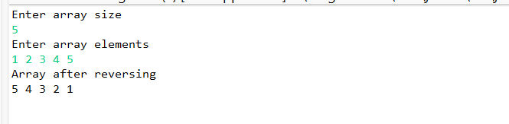
- Write a program to sort an array in ascending and descending order.
package Arrays;
import java.util.*;
public class Program6 {
public static void main(String[] args) {
Scanner s= new Scanner(System.in);
System.out.println("enter array size");
int n=s.nextInt();
int array[]=new int[n];
for (int i = 0; i <n; i++) {
array[i]=s.nextInt();
}
for(int i=1;i<n;i++){
if(array[i]<array[i-1]){
int t=array[i];
array[i]=array[i-1];
array[i-1]=t;
}
}
System.out.println("Sorted array is ");
for(int i=0;i<n;i++) {
System.out.print(array[i]+" ");
}
}
}
OUTPUT:
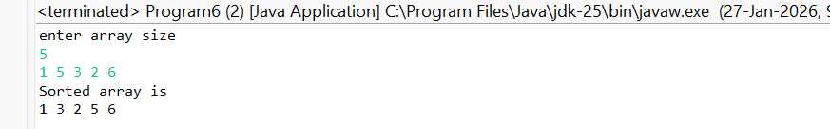
- Write a program to find the frequency of each element in an array.
package Arrays;
import java.util.*;
public class Program7 {
public static void main(String[] args) {
Scanner s=new Scanner(System.in);
System.out.println("enter array size ");
int n=s.nextInt();
int array[]=new int[n];
System.out.println("Enter array elements");
for(int i=0;i<n;i++){
array[i]=s.nextInt();
}
Map <Integer,Integer> map=new HashMap<>();
for(int value: array){
map.put(value,map.getOrDefault(value,0)+1);
}
System.out.println("Frequency of each element is ");
for(Map.Entry<Integer,Integer> entry: map.entrySet()){
System.out.println(entry.getKey()+"->"+entry.getValue());
}
}
}
OUTPUT:
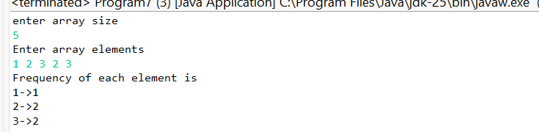
- Write a program to merge two sorted arrays.
package Arrays;
import java.util.*;
public class Program8 {
public static void main(String[] args) {
Scanner s=new Scanner(System.in);
System.out.println("Enter size of 2 arrays");
int n=s.nextInt();
int m=s.nextInt();
int array[]=new int[n];
System.out.println("Enter elements of array1");
for(int i=0;i<n;i++){
array[i]=s.nextInt();
}
int array2[]=new int[m];
System.out.println("Enter elements of array2");
for(int i=0;i<m;i++){
array2[i]=s.nextInt();
}
int newarray[]=new int[n+m];
System.arraycopy(array,0, newarray, 0, n);
System.arraycopy(array2, 0, newarray, n, m);
System.out.println("Resultant array is ");
for(int i=0;i<newarray.length;i++){
System.out.print(newarray[i]+" ");

}
}
}
OUTPUT:
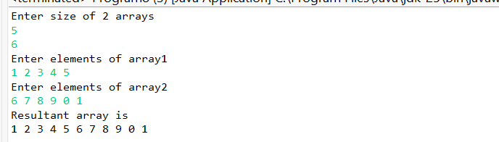
- Write a program to find the intersection of two arrays.
package Arrays;
import java.util.*;
public class Program9 {
public static void main(String[] args) {
Scanner s=new Scanner(System.in);
System.out.println("enter array sizes");
int n=s.nextInt();
int m=s.nextInt();
int array1[]=new int[n];
int array2[]=new int[m];
System.out.println("enter array1 elements ");
for(int i=0;i<n;i++){
array1[i]=s.nextInt();
}
System.out.println("enter array2 elements ");
for(int i=0;i<m;i++){
array2[i]=s.nextInt();
}
Set <Integer> set1=new HashSet<>();
for(int v:array1){
set1.add(v);
}
Set <Integer> intersection=new HashSet<>();
for(int v:array2){
if(set1.contains(v)){
intersection.add(v);
}
}
int array[]=new int[intersection.size()];
int i=0;
for(int v:intersection){
array[i++]=v;
}
System.out.println("Intersection of arrays :"+ Arrays.toString(array));
}
}
OUTPUT:
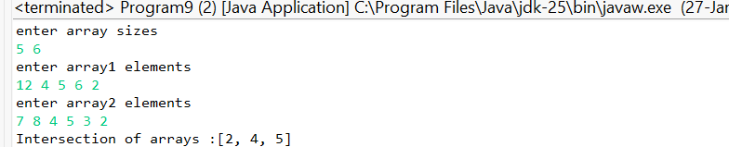
- Write a program to check whether an array is palindrome or not.
package Arrays;
import java.util.Scanner;
public class Program10 {
public static void main(String[] args) {
Scanner sc = new Scanner(System.in);
System.out.println("Enter size of array:");
int n = sc.nextInt();
int[] arr = new int[n];
System.out.println("Enter array elements:");
for (int i = 0; i < n; i++) {
arr[i] = sc.nextInt();
}
boolean isPalindrome = true;
for (int i = 0; i < n / 2; i++) {
if (arr[i] != arr[n - 1 - i]) {
isPalindrome = false;
break;
}
}
if (isPalindrome) {
System.out.println("Array is Palindrome");
} else {
System.out.println("Array is NOT Palindrome");
} }}
OUTPUT:
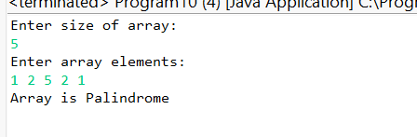
- Write a program to find the sum of all positive numbers in an array.
package Arrays;
import java.util.*;
public class Program11 {
public static void main(String[] args) {
Scanner sc = new Scanner(System.in);
System.out.println("Enter size of array:");
int n = sc.nextInt();
int[] arr = new int[n];
System.out.println("Enter array elements:");
for (int i = 0; i < n; i++) {
arr[i] = sc.nextInt();
}
int sum = 0;
for (int i = 0; i < n; i++) {
if (arr[i] > 0) {
sum = sum + arr[i];
} }
System.out.println("Sum of positive numbers: " + sum);
}
}

OUTPUT:
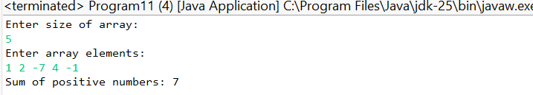
- Write a program to find the sum of all negative numbers in an array.
package Arrays;
import java.util.*;
public class Program12 {
public static void main(String[] args) {
Scanner sc = new Scanner(System.in);
System.out.println("Enter size of array:");
int n = sc.nextInt();
int[] arr = new int[n];
System.out.println("Enter array elements:");
for (int i = 0; i < n; i++) {
arr[i] = sc.nextInt();
}
int sum = 0;
for (int i = 0; i < n; i++) {
if (arr[i] < 0) {
sum = sum + arr[i];
}
}
System.out.println("Sum of negative numbers: " + sum);
}
}
OUTPUT:
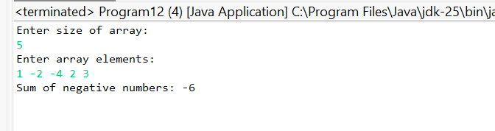
- Write a program to find the product of all elements in an array.
package Arrays;
import java.util.*;
public class Program13 {
public static void main(String[] args) {
Scanner s = new Scanner(System.in);
System.out.println("Enter array size");
int n = s.nextInt();
int array[] = new int[n];
int sum = 1;
System.out.println("Enter array elements");
for(int i = 0; i < n; i++){
array[i] = s.nextInt();
sum = sum * array[i];
}
System.out.println("Product = " + sum);
}}
OUTPUT:
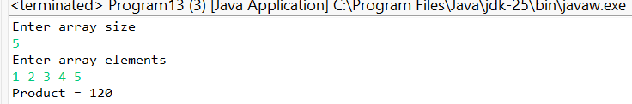
- Write a program to find the second largest and second smallest elements in an array.
package Arrays;
import java.util.*;
public class Program14 {
public static void main(String[] args) {
Scanner s=new Scanner(System.in);
System.out.println("Enter array size");
int n=s.nextInt();
int array[]=new int[n];
System.out.println("Enter elemnts");
for (int i= 0; i<n; i++) {
array[i]=s.nextInt();
}
int f=Integer.MIN_VALUE;
int sc=Integer.MIN_VALUE;
for(int i=0;i<n;i++){
if(array[i]>f){
sc=f;
f=array[i];
}
else if(array[i]>sc && array[i]!=f){
sc=array[i];
}
}
System.out.println("Secnd Largest elemnt "+ sc);
}}
OUTPUT:
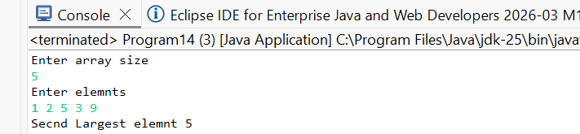
- Write a program to find the index of a given element in an array.
package Arrays;
import java.util.*;
public class Program15 {
public static void main(String[] args) {
Scanner sc = new Scanner(System.in);
System.out.println("Enter size of array:");
int n = sc.nextInt();
int[] arr = new int[n];
System.out.println("Enter array elements:");
for (int i = 0; i < n; i++) {
arr[i] = sc.nextInt();
}
System.out.println("Enter element to search:");
int key = sc.nextInt();
int index = -1;
for (int i = 0; i < n; i++) {
if (arr[i] == key) {
index = i;
break;
} }
if (index != -1) {
System.out.println("Element found at index: " + index);
} else {
System.out.println("Element not found in array");
} }}
OUTPUT:
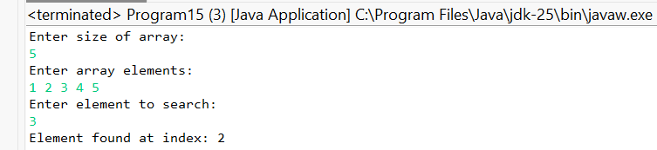
- Write a program to rotate an array to the left or right.
package Arrays;
import java.util.*;
import java.util.Scanner;
public class Program16 {
public static void main(String[] args) {
Scanner sc = new Scanner(System.in);
System.out.println("Enter size of array:");
int n = sc.nextInt();
int[] arr = new int[n];
System.out.println("Enter array elements:");
for (int i = 0; i < n; i++) {
arr[i] = sc.nextInt();
}
System.out.println("Enter number of rotations:");
int r = sc.nextInt();
System.out.println("Enter direction (L for Left, R for Right):");
char dir = sc.next().charAt(0);
r = r % n;
if (dir == 'L' || dir == 'l') {
for (int i = 0; i < r; i++) {
int first = arr[0];
for (int j = 0; j < n - 1; j++) {
arr[j] = arr[j + 1];
}
arr[n - 1] = first;
}
} else if (dir == 'R' || dir == 'r') {
for (int i = 0; i < r; i++) {
int last = arr[n - 1];
for (int j = n - 1; j > 0; j--) {
arr[j] = arr[j - 1];
}
arr[0] = last;
} }
System.out.println("Rotated Array:");
for (int i = 0; i < n; i++) {
System.out.print(arr[i] + " ");
} }}
OUTPUT:
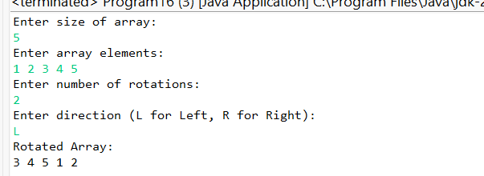
- Write a program to print the elements of a 2D array in spiral order.
package Arrays;
import java.util.Scanner;
public class Program17 {
public static void main(String[] args) {
Scanner sc = new Scanner(System.in);
System.out.println("Enter number of rows:");
int r = sc.nextInt();
System.out.println("Enter number of columns:");
int c = sc.nextInt();
int[][] arr = new int[r][c];
System.out.println("Enter matrix elements:");
for (int i = 0; i < r; i++) {
for (int j = 0; j < c; j++) {
arr[i][j] = sc.nextInt();
}
}
int top = 0, bottom = r - 1;
int left = 0, right = c - 1;
System.out.println("Spiral Order:");
while (top <= bottom && left <= right) {
for (int i = left; i <= right; i++) {
System.out.print(arr[top][i] + " ");
}
top++;
for (int i = top; i <= bottom; i++) {
System.out.print(arr[i][right] + " ");
}
right--;
if (top <= bottom) {
for (int i = right; i >= left; i--) {
System.out.print(arr[bottom][i] + " ");
}
bottom--;
}
if (left <= right) {
for (int i = bottom; i >= top; i--) {
System.out.print(arr[i][left] + " ");
}
left++;
} }
}
}
OUTPUT:
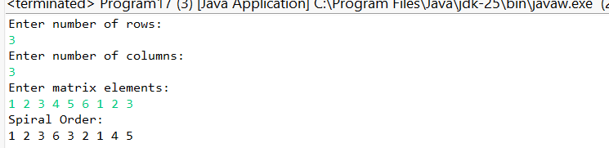
- Write a program to check whether two arrays are equal or not.
package Arrays;
import java.util.Scanner;
public class Program18 {
public static void main(String[] args) {
Scanner sc = new Scanner(System.in);
System.out.println("Enter size of arrays:");
int n = sc.nextInt();
int[] arr1 = new int[n];
int[] arr2 = new int[n];
System.out.println("Enter elements of first array:");
for (int i = 0; i < n; i++) {
arr1[i] = sc.nextInt();
}
System.out.println("Enter elements of second array:");
for (int i = 0; i < n; i++) {
arr2[i] = sc.nextInt();
}
boolean isEqual = true;
for (int i = 0; i < n; i++) {
if (arr1[i] != arr2[i]) {
isEqual = false;
break;
}
}
if (isEqual) {
System.out.println("Arrays are Equal");
} else {
System.out.println("Arrays are NOT Equal");
}
}
}
OUTPUT:
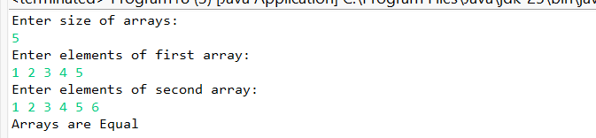
- Write a program to find the sum of elements in the upper triangle of a matrix.
package Arrays;
import java.util.Scanner;
public class Program19 {
public static void main(String[] args) {
Scanner sc = new Scanner(System.in);
System.out.println("Enter order of square matrix:");
int n = sc.nextInt();
int[][] mat = new int[n][n];
System.out.println("Enter matrix elements:");
for (int i = 0; i < n; i++) {
for (int j = 0; j < n; j++) {
mat[i][j] = sc.nextInt();
}
System.out.println();
}
int sum = 0;
for (int i = 0; i < n; i++) {
for (int j = i; j < n; j++) {
sum = sum + mat[i][j];
}
}
System.out.println("Sum of upper triangle elements: " + sum);
}
}
OUTPUT:
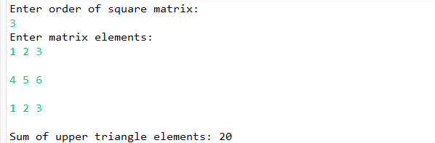
- Write a program to find the sum of elements in the lower triangle of a matrix.
package Arrays;
import java.util.Scanner;
public class Program20 {
public static void main(String[] args) {
Scanner sc = new Scanner(System.in);
System.out.println("Enter order of square matrix:");
int n = sc.nextInt();
int[][] mat = new int[n][n];
System.out.println("Enter matrix elements:");
for (int i = 0; i < n; i++) {
for (int j = 0; j < n; j++) {
mat[i][j] = sc.nextInt();
}
}
int sum = 0;
for (int i = 0; i < n; i++) {
for (int j = 0; j <= i; j++) {
sum = sum + mat[i][j];
}
}
System.out.println("Sum of lower triangle elements: " + sum);
}
}

OUTPUT:
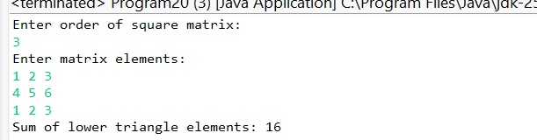
- Write a program to find the sum of elements in each row and column of a matrix.
package Arrays;
import java.util.Scanner;
public class Program21 {
public static void main(String[] args) {
Scanner sc = new Scanner(System.in);
System.out.println("Enter number of rows:");
int r = sc.nextInt();
System.out.println("Enter number of columns:");
int c = sc.nextInt();
int[][] mat = new int[r][c];
System.out.println("Enter matrix elements:");
for (int i = 0; i < r; i++) {
for (int j = 0; j < c; j++) {
mat[i][j] = sc.nextInt();
}
}
for (int i = 0; i < r; i++) {
int rowSum = 0;
for (int j = 0; j < c; j++) {
rowSum += mat[i][j];
}
System.out.println("Sum of row " + (i + 1) + " = " + rowSum);
}
for (int j = 0; j < c; j++) {
int colSum = 0;
for (int i = 0; i < r; i++) {
colSum += mat[i][j];
}
System.out.println("Sum of column " + (j + 1) + " = " + colSum);
} }}
OUTPUT:
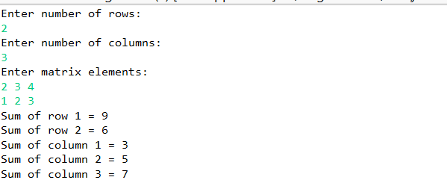
- Write a program to check whether a given matrix is symmetric or not.
package Arrays;
import java.util.Scanner;
public class Program22 {
public static void main(String[] args) {
Scanner sc = new Scanner(System.in);
System.out.println("Enter order of square matrix:");
int n = sc.nextInt();
int[][] mat = new int[n][n];
System.out.println("Enter matrix elements:");
for (int i = 0; i < n; i++) {
for (int j = 0; j < n; j++) {
mat[i][j] = sc.nextInt();
}
}
boolean isSymmetric = true;
for (int i = 0; i < n; i++) {
for (int j = i + 1; j < n; j++) {
if (mat[i][j] != mat[j][i]) {
isSymmetric = false;
break;
}
}
}
if (isSymmetric) {
System.out.println("Matrix is Symmetric");
} else {
System.out.println("Matrix is NOT Symmetric");
}
}
}
OUTPUT:
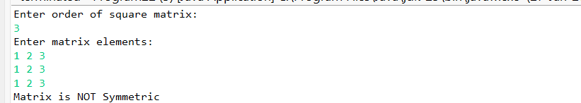

- Write a program to find the saddle point of a matrix.
package Arrays;
import java.util.Scanner;
public class Program23 {
public static void main(String[] args) {
Scanner sc = new Scanner(System.in);
System.out.println("Enter number of rows:");
int r = sc.nextInt();
System.out.println("Enter number of columns:");
int c = sc.nextInt();
int[][] mat = new int[r][c];
System.out.println("Enter matrix elements:");
for (int i = 0; i < r; i++) {
for (int j = 0; j < c; j++) {
mat[i][j] = sc.nextInt();
}
}
boolean found = false;
for (int i = 0; i < r; i++) {
int min = mat[i][0];
int colIndex = 0;
for (int j = 1; j < c; j++) {
if (mat[i][j] < min) {
min = mat[i][j];
colIndex = j;
}
}
int k;
for (k = 0; k < r; k++) {
if (mat[k][colIndex] > min) {
break;
}
}
if (k == r) {
System.out.println("Saddle Point found: " + min);
found = true;
}
}
if (!found) {
System.out.println("No Saddle Point found");
} }}
OUTPUT:
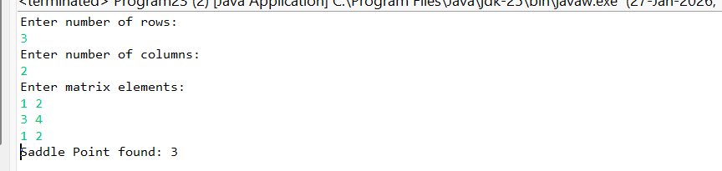
- Write a program to find the kth smallest and kth largest elements in an array.
package Arrays;
import java.util.Scanner;
public class Program24 {
public static void main(String[] args) {
Scanner sc = new Scanner(System.in);
System.out.println("Enter size of array:");
int n = sc.nextInt();
int[] arr = new int[n];
System.out.println("Enter array elements:");
for (int i = 0; i < n; i++) {
arr[i] = sc.nextInt();
}
System.out.println("Enter value of k:");
int k = sc.nextInt();
for (int i = 0; i < n - 1; i++) {
for (int j = 0; j < n - 1 - i; j++) {
if (arr[j] > arr[j + 1]) {
int temp = arr[j];
arr[j] = arr[j + 1];
arr[j + 1] = temp;
}
} }
if (k > 0 && k <= n) {
System.out.println(k + "th Smallest element: " + arr[k - 1]);
System.out.println(k + "th Largest element: " + arr[n - k]);
} else {
System.out.println("Invalid value of k");
}
}
}
OUTPUT:
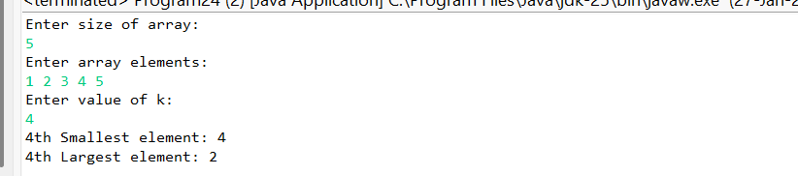

- Write a program to count the number of negative, positive, and zero elements in an array.
package Arrays;
import java.util.Scanner;
public class Program25 {
public static void main(String[] args) {
Scanner sc = new Scanner(System.in);
System.out.println("Enter size of array:");
int n = sc.nextInt();
int[] arr = new int[n];
System.out.println("Enter array elements:");
for (int i = 0; i < n; i++) {
arr[i] = sc.nextInt();
}
int positive = 0, negative = 0, zero = 0;
for (int i = 0; i < n; i++) {
if (arr[i] > 0) {
positive++;
} else if (arr[i] < 0) {
negative++;
} else {
zero++;
} }
System.out.println("Positive numbers count: " + positive);
System.out.println("Negative numbers count: " + negative);
System.out.println("Zero count: " + zero);
}
}
OUTPUT:
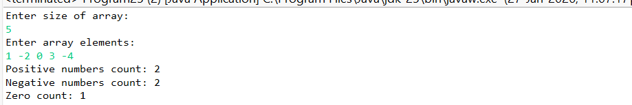
Data Types:
1)Write a program to demonstrate the use of primitive data types in Java.
public class Dt1 {
public static void main(String[] args) {
int a = 10;
float b = 5.5f;
double c = 25.75;
char d = 'A';
boolean e = true;
System.out.println("int: " + a);
System.out.println("float: " + b);
System.out.println("double: " + c);
System.out.println("char: " + d);
System.out.println("boolean: " + e);
}
}
Output:
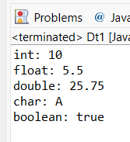
2) Write a program to perform arithmetic operations using float and double data types.
public class Dt2 {
public static void main(String[] args) {
float a = 10.5f;
double b = 4.2;
System.out.println("Addition: " + (a + b));
System.out.println("Subtraction: " + (a - b));
System.out.println("Multiplication: " + (a * b));
System.out.println("Division: " + (a / b));
}
}
Output:
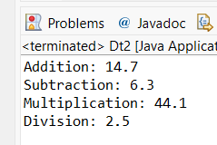
3) Write a program to convert an integer to binary and vice versa.
public class Dt3 {
public static void main(String[] args) {
int num = 10;
String binary = Integer.toBinaryString(num);
int decimal = Integer.parseInt(binary, 2);
System.out.println("Binary: " + binary);
System.out.println("Decimal: " + decimal);
}
}
Output:
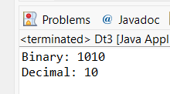
4) Write a program to perform operations on characters such as converting lowercase to uppercase and vice versa.
public class Dt4 {
public static void main(String[] args) {
char ch = 'a';
System.out.println("Uppercase: " + Character.toUpperCase(ch));
System.out.println("Lowercase: " + Character.toLowerCase('B'));
}
}
Output:
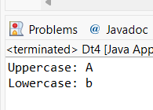
5) Write a program to demonstrate the use of boolean data type
public class Dt5{
public static void main(String[] args) {
int a = 10, b = 20;
boolean result = a < b;
System.out.println("Result: " + result);
}}
Output:
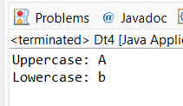
6) Write a program to demonstrate the use of arrays in Java.
public class Dt6 {
public static void main(String[] args) {
int[] arr = {10, 20, 30, 40};
for (int i = 0; i < arr.length; i++)
System.out.print(arr[i] + " ");
}}
Output:
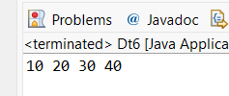
7) Write a program to find the maximum and minimum values in an array of integers.
public class Dt7 {
public static void main(String[] args) {
int[] arr = {10, 5, 25, 3};
int max = arr[0], min = arr[0];
for (int i : arr) {
if (i > max) max = i;
if (i < min) min = i;
}
System.out.println("Maximum: " + max);
System.out.println("Minimum: " + min);
}}
Output:
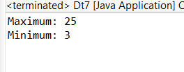
8) Write a program to calculate the average of elements in an array.
public class Dt8 {
public static void main(String[] args) {
int[] arr = {10, 20, 30};
int sum = 0;
for (int i : arr)
sum += i;
System.out.println("Average: " + (sum / arr.length));
}
}
Output:
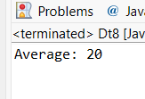
9) Write a program to find the length of a string.
public class Dt9 {
public static void main(String[] args) {
String str = "Java";
System.out.println("Length: " + str.length());
}
}
Output:
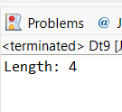
10) Write a program to concatenate two strings.
public class Dt10 {
public static void main(String[] args) {
String a = "Hello";
String b = "World";
System.out.println(a + " " + b);
}}
Output:
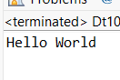
11) Write a program to demonstrate the use of wrapper classes in Java.
public class Dt11 {
public static void main(String[] args) {
int a = 10;
Integer obj = Integer.valueOf(a);
System.out.println("Primitive value: " + a);
System.out.println("Wrapper object value: " + obj);
}}
Output:
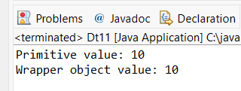
12) Write a program to convert a string to integer and vice versa.
import java.util.Scanner;
public class Dt12 {
public static void main(String[] args) {
Scanner sc = new Scanner(System.in);
System.out.println("Enter a number as string:");
String str = sc.nextLine();
int num = Integer.parseInt(str);
System.out.println("String to Integer: " + num);
System.out.println("Enter an integer:");
int n = sc.nextInt();
String s = Integer.toString(n);
System.out.println("Integer to String: " + s);
}}
Output:
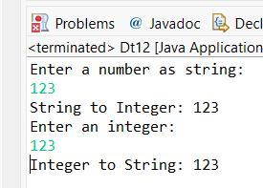
13) Write a program to demonstrate string methods such as substring, indexOf, and equals.
public class Dt13 {
public static void main(String[] args) {
String str = "JavaProgramming";
System.out.println("Substring: " + str.substring(4));
System.out.println("Index of 'P': " + str.indexOf('P'));
System.out.println("Equals check: " + str.equals("JavaProgramming"));
}}
Output:
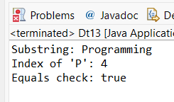
14) Write a program to count the occurrences of a character in a string.
Program.
package com.gqt_java.java_gqt.programs;
import java.util.Scanner;
public class Dt14 {
public static void main(String[] args) {
Scanner sc = new Scanner(System.in);
System.out.println("Enter a string:");
String str = sc.nextLine();
System.out.println("Enter a character:");
char ch = sc.next().charAt(0);
int count = 0;
for (int i = 0; i < str.length(); i++) {
if (str.charAt(i) == ch)
count++;
}
System.out.println("Occurrences: " + count);
}
}
Output:
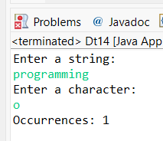
15) Write a program to check whether a given string is palindrome or not.
import java.util.Scanner;
public class Dt15 {
public static void main(String[] args) {
Scanner sc = new Scanner(System.in);
System.out.println("Enter a string:");
String str = sc.next();
String rev = "";
for (int i = str.length() - 1; i >= 0; i--)
rev += str.charAt(i);
if (str.equals(rev))
System.out.println("Palindrome String");
else
System.out.println("Not a Palindrome String");
}}
Output:
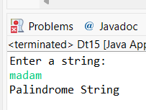
16) Write a program to reverse a string without using any built-in methods.
import java.util.Scanner;
public class Dt16 {
public static void main(String[] args) {
Scanner sc = new Scanner(System.in);
System.out.println("Enter a string:");
String str = sc.next();
char[] arr = str.toCharArray();
for (int i = arr.length - 1; i >= 0; i--)
System.out.print(arr[i]);
}}
Output:
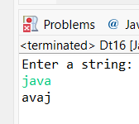
17) Write a program to convert a string to uppercase and vice versa.
import java.util.Scanner;
public class Dt16 {
public static void main(String[] args) {
Scanner sc = new Scanner(System.in);
System.out.println("Enter a string:");
String str = sc.next();
char[] arr = str.toCharArray();
for (int i = arr.length - 1; i >= 0; i--)
System.out.print(arr[i]);
}}
Output:
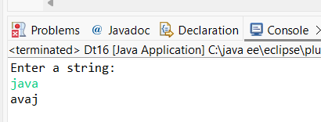
18) Write a program to demonstrate the use of StringBuilder class.
public class Dt18 {
public static void main(String[] args) {
StringBuilder sb = new StringBuilder("Hello");
sb.append(" Java");
System.out.println("StringBuilder Result: " + sb);
}}
Output:
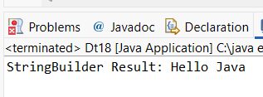
19) Write a program to find the factorial of a number using BigInteger class.
import java.math.BigInteger;
import java.util.Scanner;
public class Dt19 {
public static void main(String[] args) {
Scanner sc = new Scanner(System.in);
System.out.println("Enter a number:");
int n = sc.nextInt();
BigInteger fact = BigInteger.ONE;
for (int i = 1; i <= n; i++)
fact = fact.multiply(BigInteger.valueOf(i));
System.out.println("Factorial: " + fact);
}}
Output:
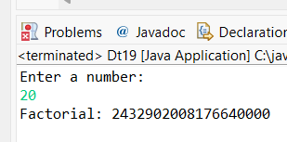
20) Write a program to demonstrate the use of arrays of objects.
class Student {
int id;
String name;
Student(int id, String name) {
this.id = id;
this.name = name;
}}
public class Dt20 {
public static void main(String[] args) {
Student[] s = new Student[2];
s[0] = new Student(1, "Ram");
s[1] = new Student(2, "Sita");
for (Student st : s)
System.out.println(st.id + " " + st.name);
}}
Output:
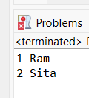
21) Write a program to sort an array of integers in ascending and descending order.
Program.
import java.util.Arrays;
import java.util.Scanner;
public class Dt21 {
public static void main(String[] args) {
Scanner sc = new Scanner(System.in);
System.out.println("Enter number of elements:");
int n = sc.nextInt();
int[] arr = new int[n];
System.out.println("Enter array elements:");
for (int i = 0; i < n; i++)
arr[i] = sc.nextInt();
Arrays.sort(arr);
System.out.println("Ascending order:");
for (int i : arr)
System.out.print(i + " ");
System.out.println("\nDescending order:");
for (int i = n - 1; i >= 0; i--)
System.out.print(arr[i] + " ");
}}
Output:
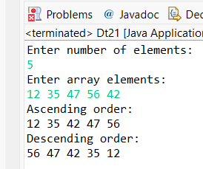
22) Write a program to find the second largest and second smallest elements in an array.
import java.util.Arrays;
import java.util.Scanner;
public class Dt22 {
public static void main(String[] args) {
Scanner sc = new Scanner(System.in);
System.out.println("Enter number of elements:");
int n = sc.nextInt();
int[] arr = new int[n];
System.out.println("Enter array elements:");
for (int i = 0; i < n; i++)
arr[i] = sc.nextInt();
Arrays.sort(arr);
System.out.println("Second Smallest: " + arr[1]);
System.out.println("Second Largest: " + arr[n - 2]);
}}
Output:
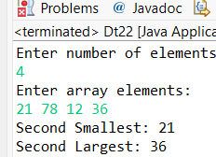
23) Write a program to find the sum of diagonal elements of a matrix.
Program.
import java.util.Scanner;
public class Dt23 {
public static void main(String[] args) {
Scanner sc = new Scanner(System.in);
System.out.println("Enter matrix size:");
int n = sc.nextInt();
int[][] mat = new int[n][n];
System.out.println("Enter matrix elements:");
for (int i = 0; i < n; i++)
for (int j = 0; j < n; j++)
mat[i][j] = sc.nextInt();
int sum = 0;
for (int i = 0; i < n; i++)
sum += mat[i][i];
System.out.println("Sum of diagonal elements: " + sum);
}}
Output:
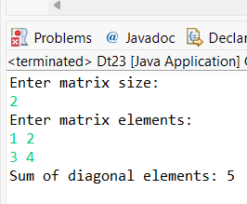
24) Write a program to transpose a matrix.
import java.util.Scanner;
public class Dt24 {
public static void main(String[] args) {
Scanner sc = new Scanner(System.in);
System.out.println("Enter number of rows:");
int r = sc.nextInt();
System.out.println("Enter number of columns:");
int c = sc.nextInt();
int[][] mat = new int[r][c];
System.out.println("Enter matrix elements:");
for (int i = 0; i < r; i++)
for (int j = 0; j < c; j++)
mat[i][j] = sc.nextInt();
System.out.println("Transpose Matrix:");
for (int j = 0; j < c; j++) {
for (int i = 0; i < r; i++)
System.out.print(mat[i][j] + " ");
System.out.println();
}}}

Output:
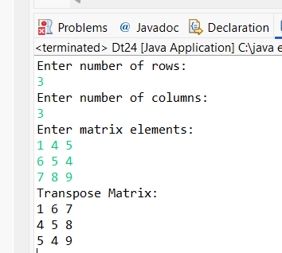
25) Write a program to multiply two matrices.
import java.util.Scanner;
public class Dt25 {
public static void main(String[] args) {
Scanner sc = new Scanner(System.in);
System.out.println("Enter rows and columns of first matrix:");
int r1 = sc.nextInt();
int c1 = sc.nextInt();
System.out.println("Enter rows and columns of second matrix:");
int r2 = sc.nextInt();
int c2 = sc.nextInt();
int[][] a = new int[r1][c1];
int[][] b = new int[r2][c2];
int[][] mul = new int[r1][c2];
System.out.println("Enter first matrix elements:");
for (int i = 0; i < r1; i++)
for (int j = 0; j < c1; j++)
a[i][j] = sc.nextInt();
System.out.println("Enter second matrix elements:");
for (int i = 0; i < r2; i++)
for (int j = 0; j < c2; j++)
b[i][j] = sc.nextInt();
for (int i = 0; i < r1; i++)
for (int j = 0; j < c2; j++)
for (int k = 0; k < c1; k++)
mul[i][j] += a[i][k] * b[k][j];
System.out.println("Resultant Matrix:");
for (int i = 0; i < r1; i++) {
for (int j = 0; j < c2; j++)
System.out.print(mul[i][j] + " ");
System.out.println();
}}}
Output:
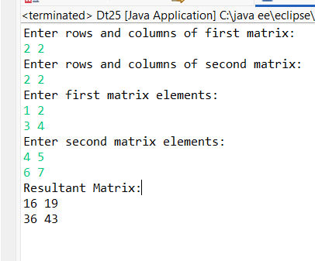
Strings.
1)Write a program to reverse a string.
import java.util.Scanner;
public class St1 {
public static void main(String[] args) {
Scanner sc = new Scanner(System.in);
System.out.println("Enter a string:");
String str = sc.nextLine();
String rev = "";
for (int i = str.length() - 1; i >= 0; i--)
rev += str.charAt(i);
System.out.println("Reversed string: " + rev);
}}
Output:
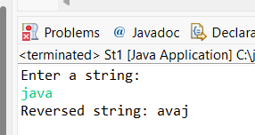
2) Write a program to check whether a given string is palindrome or not.
import java.util.Scanner;
public class St2 {
public static void main(String[] args) {
Scanner sc = new Scanner(System.in);
System.out.println("Enter a string:");
String str = sc.next();
String rev = "";
for (int i = str.length() - 1; i >= 0; i--)
rev += str.charAt(i);
if (str.equals(rev))
System.out.println("Palindrome String");
else
System.out.println("Not a Palindrome String");
}
}
Output:
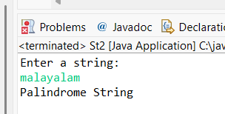
3) Write a program to count the number of vowels and consonants in a string.
Program.
import java.util.Scanner;
public class St3 {
public static void main(String[] args) {
Scanner sc = new Scanner(System.in);
System.out.println("Enter a string:");
String str = sc.nextLine().toLowerCase();
int vowels = 0, consonants = 0;
for (int i = 0; i < str.length(); i++) {
char ch = str.charAt(i);
if (ch >= 'a' && ch <= 'z') {
if (ch == 'a' || ch == 'e' || ch == 'i' || ch == 'o' || ch == 'u')
vowels++;
else
consonants++;
}
}
System.out.println("Vowels: " + vowels);
System.out.println("Consonants: " + consonants);
}
}
Output:
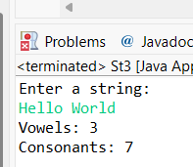
4) Write a program to count the occurrences of a character in a string.
import java.util.Scanner;
public class St4 {
public static void main(String[] args) {
Scanner sc = new Scanner(System.in);
System.out.println("Enter a string:");
String str = sc.nextLine();
System.out.println("Enter a character:");
char ch = sc.next().charAt(0);
int count = 0;
for (int i = 0; i < str.length(); i++) {
if (str.charAt(i) == ch)
count++;
}
System.out.println("Occurrences of '" + ch + "': " + count);
}
}
Output:
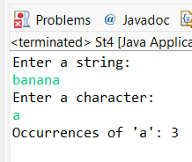
5) Write a program to remove all white spaces from a string.
import java.util.Scanner;
public class St5 {
public static void main(String[] args) {
Scanner sc = new Scanner(System.in);
System.out.println("Enter a string:");
String str = sc.nextLine();
str = str.replaceAll("\\s+", "");
System.out.println("String without spaces: " + str);
}
}
Output:
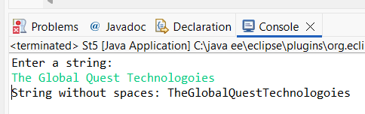
6) Write a program to find the length of a string.
import java.util.Scanner;
public class St6 {
public static void main(String[] args) {
Scanner sc = new Scanner(System.in);
System.out.println("Enter the string:");
String str = sc.nextLine();
System.out.println("Length of the string: " + str.length());
}}
Output:
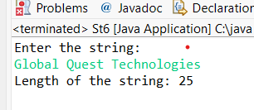
7) Write a program to concatenate two strings.
import java.util.Scanner;
public class St7 {
public static void main(String[] args) {
Scanner sc = new Scanner(System.in);
System.out.println("Enter first string:");
String s1 = sc.nextLine();
System.out.println("Enter second string:");
String s2 = sc.nextLine();
System.out.println("Concatenated string: " + s1 + s2);
}}
Output:
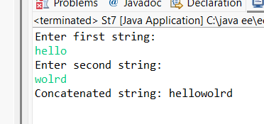
8) Write a program to convert lowercase letters to uppercase and vice versa.
import java.util.Scanner;
public class St8 {
public static void main(String[] args) {
Scanner sc = new Scanner(System.in);
System.out.println("Enter a string:");
String str = sc.nextLine();
String result = "";
for (int i = 0; i < str.length(); i++) {
char ch = str.charAt(i);
if (Character.isUpperCase(ch))
result += Character.toLowerCase(ch);
else if (Character.isLowerCase(ch))
result += Character.toUpperCase(ch);
else
result += ch;
}
System.out.println("Converted string: " + result);
}}
Output:
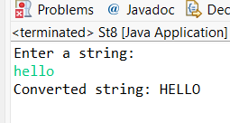
9) Write a program to find the longest word in a string.
import java.util.Scanner;
public class St9 {
public static void main(String[] args) {
Scanner sc = new Scanner(System.in);
System.out.println("Enter a sentence:");
String str = sc.nextLine();
String[] words = str.split(" ");
String longest = words[0];
for (String word : words) {
if (word.length() > longest.length())
longest = word;
}
System.out.println("Longest word: " + longest);
}}
Output:
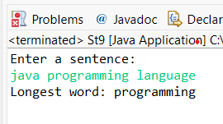
10) Write a program to check whether two strings are anagrams or not.
import java.util.Arrays;
import java.util.Scanner;
public class St10 {
public static void main(String[] args) {
Scanner sc = new Scanner(System.in);
System.out.println("Enter first string:");
String s1 = sc.next().toLowerCase();
System.out.println("Enter second string:");
String s2 = sc.next().toLowerCase();
char[] a = s1.toCharArray();
char[] b = s2.toCharArray();
Arrays.sort(a);
Arrays.sort(b);
if (Arrays.equals(a, b))
System.out.println("Strings are Anagrams");
else
System.out.println("Strings are not Anagrams");
}}
Output:
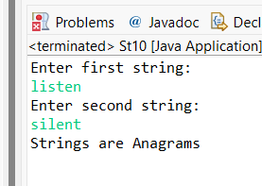
11) Write a program to find the first non-repeated character in a string.
import java.util.Scanner;
public class St11 {
public static void main(String[] args) {
Scanner sc = new Scanner(System.in);
System.out.println("Enter a string:");
String str = sc.nextLine();
for (int i = 0; i < str.length(); i++) {
if (str.indexOf(str.charAt(i)) == str.lastIndexOf(str.charAt(i))) {
System.out.println("First non-repeated character: " + str.charAt(i));
break;
}}}}
Output:
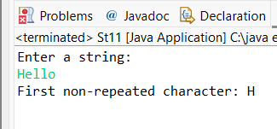

12) Write a program to check whether a string contains only digits or not.
import java.util.Scanner;
public class St12 {
public static void main(String[] args) {
Scanner sc = new Scanner(System.in);
System.out.println("Enter a string:");
String str = sc.nextLine();
boolean isDigit = str.matches("\\d+");
if (isDigit)
System.out.println("String contains only digits");
else
System.out.println("String does not contain only digits");
}}
Output:
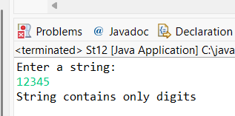
13) Program to find all permutations of a string.
import java.util.Scanner;
public class St13 {
static void permute(String str, String ans) {
if (str.length() == 0) {
System.out.println(ans);
return;
}
for (int i = 0; i < str.length(); i++) {
permute(str.substring(0, i) + str.substring(i + 1), ans + str.charAt(i));
}
}
public static void main(String[] args) {
Scanner sc = new Scanner(System.in);
System.out.println("Enter the string:");
String s = sc.next();
permute(s, "");
}}
Output:
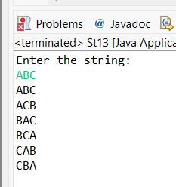
14) Program to find frequency of each character.
import java.util.*;
public class St14 {
public static void main(String[] args) {
Scanner sc = new Scanner(System.in);
System.out.println("Enter a string:");
String s = sc.nextLine();
Map<Character, Integer> map = new HashMap<>();
for (char c : s.toCharArray())
map.put(c, map.getOrDefault(c, 0) + 1);
System.out.println("Character frequencies:");
for (char c : map.keySet())
System.out.println(c + " : " + map.get(c));
}}
Output:
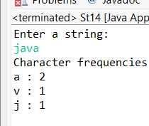
15) Write a program to reverse words in a sentence.
import java.util.Scanner;
public class St15 {
public static void main(String[] args) {
Scanner sc = new Scanner(System.in);
System.out.println("Enter a sentence:");
String[] words = sc.nextLine().split(" ");
for (int i = words.length - 1; i >= 0; i--)
System.out.print(words[i] + " ");
}}
Output:
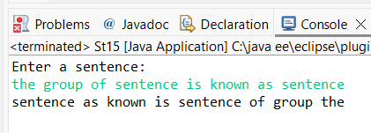
16) Write a program to find the duplicate characters in a string.
import java.util.*;
public class St16 {
public static void main(String[] args) {
Scanner sc = new Scanner(System.in);
System.out.println("Enter the string:");
String s = sc.nextLine();
HashSet<Character> set = new HashSet<>();
System.out.println("Duplicate characters:");
for (char c : s.toCharArray()) {
if (!set.add(c))
System.out.println(c);
}}}
Output:
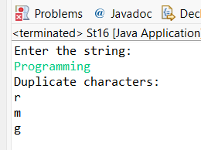
17) Write a program to find the first repeating character in a string.
import java.util.*;
public class St17 {
public static void main(String[] args) {
Scanner sc = new Scanner(System.in);
System.out.println("Enter the string:");
String s = sc.nextLine();
HashSet<Character> set = new HashSet<>();
for (char c : s.toCharArray()) {
if (!set.add(c)) {
System.out.println("First repeating character: " + c);
return;
}}
System.out.println("No repeating characters found");
}
}
Output:
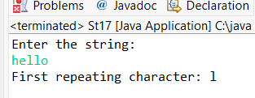
18) Write a program to capitalize the first letter of each word in a sentence.
import java.util.Scanner;
public class St18 {
public static void main(String[] args) {
Scanner sc = new Scanner(System.in);
System.out.println("Enter a sentence:");
String[] words = sc.nextLine().split(" ");
for (String w : words)
System.out.print(w.substring(0,1).toUpperCase() + w.substring(1) + " ");
}
}
Output:
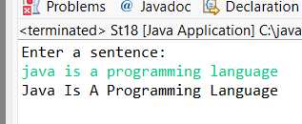
19) Write a program to check whether a string is a rotation of another string.
import java.util.Scanner;
public class St19 {
public static void main(String[] args) {
Scanner sc = new Scanner(System.in);
System.out.println("Enter first string:");
String s1 = sc.next();
System.out.println("Enter second string:");
String s2 = sc.next();
if ((s1 + s1).contains(s2))
System.out.println("String is a rotation");
else
System.out.println("String is not a rotation");
}
}

Output:
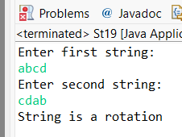
20) Write a program to check whether a string is a substring of another string.
import java.util.Scanner;
public class St20 {
public static void main(String[] args) {
Scanner sc = new Scanner(System.in);
System.out.println("Enter main string:");
String s1 = sc.nextLine();
System.out.println("Enter substring:");
String s2 = sc.nextLine();
if (s1.contains(s2))
System.out.println("Substring found");
else
System.out.println("Substring not found");
}}
Output:
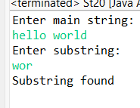
21) Write a program to remove duplicates from a string.
public class St21 {
public static void main(String[] args) {
Scanner sc = new Scanner(System.in);
System.out.println("Enter the string:");
String s = sc.nextLine();
String result = "";
for (char c : s.toCharArray())
if (!result.contains(String.valueOf(c)))
result += c;
System.out.println("String after removing duplicates: " + result);
}}
Output:
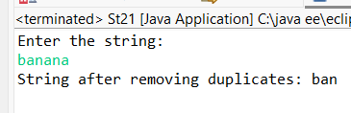
22) Write a program to find the common characters in two given strings.
import java.util.*;
public class St22 {
public static void main(String[] args) {
Scanner sc = new Scanner(System.in);
System.out.println("Enter first string:");
String s1 = sc.next();
System.out.println("Enter second string:");
String s2 = sc.next();
HashSet<Character> set = new HashSet<>();
for (char c : s1.toCharArray())
if (s2.indexOf(c) != -1)
set.add(c);
System.out.println("Common characters: " + set);
}}
Output:
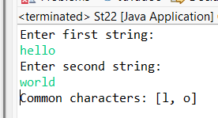
23) Write a program to check whether a given string is a pangram or not.
import java.util.*;
public class St23{
public static void main(String[] args) {
Scanner sc = new Scanner(System.in);
System.out.println("Enter a sentence:");
String s = sc.nextLine().toLowerCase();
HashSet<Character> set = new HashSet<>();
for (char c : s.toCharArray())
if (c >= 'a' && c <= 'z')
set.add(c);
if (set.size() == 26)
System.out.println("Pangram");
else
System.out.println("Not a Pangram");
}}
Output:
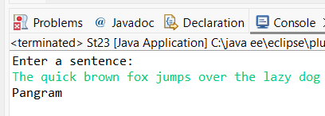
24) Write a program to find the smallest window in a string containing all characters of another string.
import java.util.Scanner;
public class St24 {
public static void main(String[] args) {
Scanner sc = new Scanner(System.in);
System.out.println("Enter main string:");
String s = sc.next();
System.out.println("Enter pattern string:");
String p = sc.next();
int minLen = Integer.MAX_VALUE;
String result = "";
for (int i = 0; i < s.length(); i++) {
for (int j = i + 1; j <= s.length(); j++) {
String sub = s.substring(i, j);
boolean found = true;
for (char c : p.toCharArray())
if (sub.indexOf(c) == -1)
found = false;
if (found && sub.length() < minLen) {
minLen = sub.length();
result = sub;
}}}
System.out.println("Smallest window: " + result);
}
}
Output:
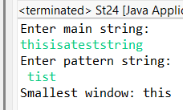
25) Write a program to find the longest common prefix among an array of strings.
import java.util.Scanner;
public class St25 {
public static void main(String[] args) {
Scanner sc = new Scanner(System.in);
System.out.println("Enter number of strings:");
int n = sc.nextInt();
String[] arr = new String[n];
System.out.println("Enter the strings:");
for (int i = 0; i < n; i++)
arr[i] = sc.next();
String prefix = arr[0];
for (int i = 1; i < n; i++)
while (!arr[i].startsWith(prefix))
prefix = prefix.substring(0, prefix.length() - 1);
System.out.println("Longest common prefix: " + prefix);
}}
Output:
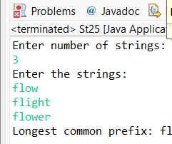

OverLoading
1)Write a program to find the sum of two integers.
class SumInt {
int add(int a, int b) {
return a + b;
}
public static void main(String[] args) {
SumInt s = new SumInt();
System.out.println("Sum = " + s.add(10, 20));
}}
Output:
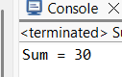
2) Write a program to find the sum of two floats.
class SumFloat {
float add(float a, float b) {
return a + b;
}
public static void main(String[] args) {
SumFloat s = new SumFloat();
System.out.println("Sum = " + s.add(10.5f, 20.5f));
}
}
Output:

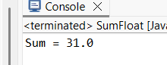
3) Write a program to find the area of a rectangle.
class Rectangle {
int area(int l, int b) {
return l * b;
}
public static void main(String[] args) {
Rectangle r = new Rectangle();
System.out.println("Area = " + r.area(5, 4));
}}
Output:
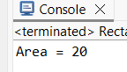
4) Write a program to find the volume of a cylinder.
class Cylinder {
double volume(double r, double h) {
return 3.14 * r * r * h;
}
public static void main(String[] args) {
Cylinder c = new Cylinder();
System.out.println("Volume = " + c.volume(3, 7));
}}
Output:
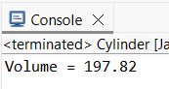
5) Write a program to calculate the factorial of a number.
class Factorial {
int fact(int n) {
int f = 1;
for(int i=1;i<=n;i++) f *= i;
return f;
}
public static void main(String[] args) {
Factorial f = new Factorial();
System.out.println("Factorial = " + f.fact(5));
}}
Output:
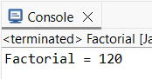
6) Write a program to find the average of three numbers.
class Average {
int avg(int a, int b, int c) {
return (a + b + c) / 3;
}
public static void main(String[] args) {
Average a = new Average();
System.out.println("Average = " + a.avg(10, 20, 30));
}}
Output:
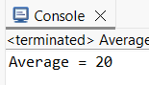
7) Write a program to find the maximum of two numbers.
class Maximum {
int max(int a, int b) {
return a > b ? a : b; }
public static void main(String[] args) {
Maximum m = new Maximum();
System.out.println("Maximum = " + m.max(10, 25));
}}
Output:
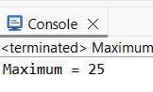
8) Write a program to find the minimum of two numbers.
class Minimum {
int min(int a, int b) {
return a < b ? a : b;
}
public static void main(String[] args) {
Minimum m = new Minimum();
System.out.println("Minimum = " + m.min(10, 25));
}}
Output:
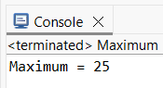
9) Write a program to calculate the power of a number.
class Minimum {
int min(int a, int b) {
return a < b ? a : b;
}
public static void main(String[] args) {
Minimum m = new Minimum();
System.out.println("Minimum = " + m.min(10, 25));
}}
Output:
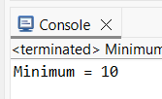
10) Write a program to check whether a number is prime or not.
class Prime {
boolean check(int n) {
if(n<=1) return false;
for(int i=2;i<=n/2;i++)
if(n%i==0) return false;
return true;
}
public static void main(String[] args) {
Prime p = new Prime();
System.out.println(p.check(7));
}}
Output:
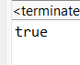
11) Write a program to find the square root of a number.
class SquareRoot {
double root(double n) {
return Math.sqrt(n);
}
public static void main(String[] args) {
SquareRoot s = new SquareRoot();
System.out.println("Square Root = " + s.root(25));
}}
Output:
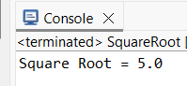
12) Write a program to calculate the perimeter of a rectangle.
class Perimeter {
int peri(int l, int b) {
return 2 * (l + b);
}
public static void main(String[] args) {
Perimeter p = new Perimeter();
System.out.println("Perimeter = " + p.peri(5, 4));
}}
Output:
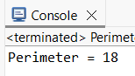
13) Write a program to find the area of a circle.
class Circle {
double area(double r) {
return 3.14 * r * r;
}
public static void main(String[] args) {
Circle c = new Circle();
System.out.println("Area = " + c.area(7));
}}
Output:
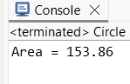
14) Write a program to find the area of a triangle.
class Triangle {
double area(double b, double h) {
return 0.5 * b * h;
}
public static void main(String[] args) {
Triangle t = new Triangle();
System.out.println("Area = " + t.area(10, 5));
}}
Output:
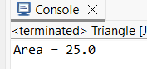
15) Write a program to convert Celsius to Fahrenheit.
class Temp {
double convert(double c) {
return (c * 9/5) + 32;
}
public static void main(String[] args) {
Temp t = new Temp();
System.out.println("Fahrenheit = " + t.convert(25));
}}
Output:
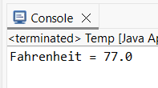
16) Write a program to convert Fahrenheit to Celsius.
class Temp2 {
double convert(double f) {
return (f - 32) * 5/9;
}
public static void main(String[] args) {
Temp2 t = new Temp2();
System.out.println("Celsius = " + t.convert(77));
}}
Output:
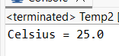
17) Write a program to find the volume of a sphere.
class Sphere {
double volume(double r) {
return (4.0/3) * 3.14 * r * r * r;
}
public static void main(String[] args) {
Sphere s = new Sphere();
System.out.println("Volume = " + s.volume(3));
}}
Output:
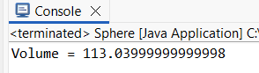
18) Write a program to find the average of an array of integers.
class ArrayAvg {
int avg(int[] a) {
int sum = 0;
for(int i : a) sum += i;
return sum / a.length;
}
public static void main(String[] args) {
ArrayAvg a = new ArrayAvg();
System.out.println("Average = " + a.avg(new int[]{10,20,30}));
}}
Output:
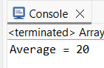
19) Write a program to calculate compound interest.
class Compound {
double ci(double p, double r, double t) {
return p * Math.pow(1 + r/100, t);
}
public static void main(String[] args) {
Compound c = new Compound();
System.out.println("CI = " + c.ci(1000, 10, 2));
}}
Output:
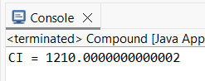
20) Write a program to find the area of a trapezoid.
class Trapezoid {
double area(double a, double b, double h) {
return 0.5 * (a + b) * h;
}
public static void main(String[] args) {
Trapezoid t = new Trapezoid();
System.out.println("Area = " + t.area(5, 7, 4));
}}
Output:
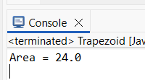
21) Write a program to find the area of a parallelogram.
class Parallelogram {
double area(double b, double h) {
return b * h;
}
public static void main(String[] args) {
Parallelogram p = new Parallelogram();
System.out.println("Area = " + p.area(6, 5));
}}
Output:
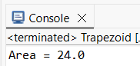

22) Write a program to calculate simple interest.
class SimpleInterest {
double si(double p, double r, double t) {
return (p * r * t) / 100;
}
public static void main(String[] args) {
SimpleInterest s = new SimpleInterest();
System.out.println("SI = " + s.si(1000, 5, 2));
}}
Output:
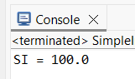
23) Write a program to find the area of a square.
class Square {
int area(int s) {
return s * s;
}
public static void main(String[] args) {
Square s = new Square();
System.out.println("Area = " + s.area(5));
}}
Output:
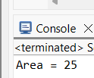
24) Write a program to find the area of a rhombus.
class Rhombus {
double area(double d1, double d2) {
return 0.5 * d1 * d2;
}
public static void main(String[] args) {
Rhombus r = new Rhombus();
System.out.println("Area = " + r.area(10, 8));
}}
Output:
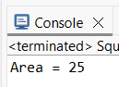
25) Write a program to find the area of a regular polygon.
class Polygon {
double area(double n, double s) {
return (n * s * s) / (4 * Math.tan(Math.PI/n));
}
public static void main(String[] args) {
Polygon p = new Polygon();
System.out.println("Area = " + p.area(6, 4));
}}
Output:
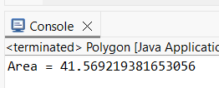
Encapsulation
1) Write a Java program to demonstrate encapsulation by creating a Student class with private data members name, roll number and age. Use public methods to set and display values.
import java.util.Scanner;
class Student1 {
private String name;
private int rollNo;
private int age;
public Student1() {
}
public void setData(String n, int r, int a) {
name = n;
rollNo = r;
age = a;
}
public void display() {
System.out.println("Name: " + name);
System.out.println("Roll No: " + rollNo);
System.out.println("Age: " + age);
}}
public class StudentDetails {
public static void main(String[] args) {
Scanner sc = new Scanner(System.in);
Student1 s = new Student1();
System.out.print("Enter name: ");
String n = sc.nextLine();
System.out.print("Enter roll number: ");
int r = sc.nextInt();
System.out.print("Enter age: ");
int a = sc.nextInt();
s.setData(n, r, a);
s.display();
}}
Output:
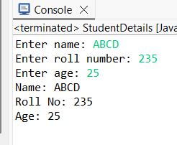
2)Write a program to demonstrate encapsulation by accessing private member variables through public accessor methods.
import java.util.Scanner;
class DemoEncap {
private int value;
public void setValue(int v) {
value = v;
}
public int getValue() {
return value;
}}
public class EncapsulationDemo1 {
public static void main(String[] args) {
Scanner sc = new Scanner(System.in);
DemoEncap d = new DemoEncap();
System.out.print("Enter value: ");
d.setValue(sc.nextInt());
System.out.println("Value: " + d.getValue());
}}
Output:
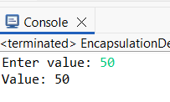
3) Create a class representing a bank account with private member variables (account number, balance) and public methods (deposit, withdraw).
import java.util.Scanner;
class BankEncap {
private int accNo;
private double balance;
public void setAccount(int a) {
accNo = a;
balance = 0;
}
public void deposit(double amt) {
balance += amt;
}
public void withdraw(double amt) {
balance -= amt;
}
public double getBalance() {
return balance;
}}
public class BankEncap1 {
public static void main(String[] args) {
Scanner sc = new Scanner(System.in);
BankEncap b = new BankEncap();
System.out.print("Enter account number: ");
b.setAccount(sc.nextInt());
System.out.print("Enter deposit amount: ");
b.deposit(sc.nextDouble());
System.out.print("Enter withdraw amount: ");
b.withdraw(sc.nextDouble());
System.out.println("Balance: " + b.getBalance());
}}
Output:
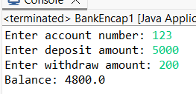
4)Write a program to demonstrate encapsulation by accessing private member variables through public accessor methods.
import java.util.Scanner;
class BankAccount {
private int accountNumber;
private double balance;
public void setAccountNumber(int accNo) {
accountNumber = accNo;
}
public void deposit(double amount) {
balance = balance + amount;
}
public void withdraw(double amount) {
balance = balance - amount;
}
public int getAccountNumber() {
return accountNumber;
}
public double getBalance() {
return balance;
}}
public class BankEncapDemo {
public static void main(String[] args) {
Scanner sc = new Scanner(System.in);
BankAccount b = new BankAccount();
System.out.print("Enter account number: ");
b.setAccountNumber(sc.nextInt());
System.out.print("Enter deposit amount: ");
b.deposit(sc.nextDouble());
System.out.print("Enter withdraw amount: ");
b.withdraw(sc.nextDouble());
System.out.println("Account Number: " + b.getAccountNumber());
System.out.println("Final Balance: " + b.getBalance());
}

}

Output:
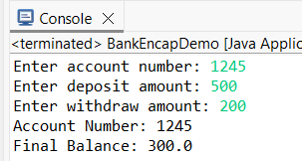
5) Create a class representing a car with private member variables (model, color, price) and public methods (getters and setters).
import java.util.Scanner;
class CarEncap {
private String model, color;
private double price;
public void setCar(String m, String c, double p) {
model = m;
color = c;
price = p;
}
public String getModel() { return model; }
public String getColor() { return color; }
public double getPrice() { return price; }
}
public class CarEncap1 {
public static void main(String[] args) {
Scanner sc = new Scanner(System.in);
CarEncap c = new CarEncap();
System.out.print("Enter model: ");
String m = sc.nextLine();
System.out.print("Enter color: ");
String col = sc.nextLine();
System.out.print("Enter price: ");
double p = sc.nextDouble();
c.setCar(m, col, p);
System.out.println("Model: " + c.getModel());
System.out.println("Color: " + c.getColor());
System.out.println("Price: " + c.getPrice());
}}
Output:
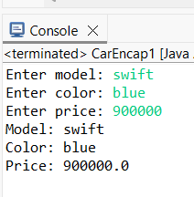
6) Write a program to demonstrate encapsulation by accessing private member variables through public accessor methods.
import java.util.Scanner;
class Car {
private String model;
private String color;
private double price;
public void setModel(String m) {
model = m;
}
public void setColor(String c) {
color = c;
}
public void setPrice(double p) {
price = p;
}
public String getModel() {
return model;
}
public String getColor() {
return color;
}
public double getPrice() {
return price;
}}
public class CarEncapsulationDemo {
public static void main(String[] args) {
Scanner sc = new Scanner(System.in);
Car c = new Car();
System.out.print("Enter model: ");
c.setModel(sc.nextLine());
System.out.print("Enter color: ");
c.setColor(sc.nextLine());
System.out.print("Enter price: ");
c.setPrice(sc.nextDouble());
System.out.println("Model: " + c.getModel());
System.out.println("Color: " + c.getColor());
System.out.println("Price: " + c.getPrice());
}}
Output:
7) Create a class representing a book with private member variables (title, author, price) and public methods (getters and setters).
import java.util.Scanner;
public class Book {
private String title;
private String author;
private double price;
public void setTitle(String t) {
title = t;
}
public void setAuthor(String a) {
author = a;
}
public void setPrice(double p) {
price = p;
}
public String getTitle() {
return title;
}
public String getAuthor() {
return author;
}
public double getPrice() {
return price;
}
public static void main(String[] args) {
Scanner sc = new Scanner(System.in);
Book b = new Book();
System.out.print("Enter title: ");
b.setTitle(sc.nextLine());
System.out.print("Enter author: ");
b.setAuthor(sc.nextLine());
System.out.print("Enter price: ");
b.setPrice(sc.nextDouble());
System.out.println("Title: " + b.getTitle());
System.out.println("Author: " + b.getAuthor());
System.out.println("Price: " + b.getPrice());
}}
Output:
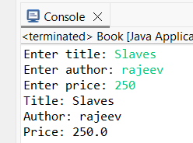
8) Write a program to demonstrate encapsulation by accessing private member variables through public accessor methods.
import java.util.Scanner;
class Book {
private String title;
public void setTitle(String t) {
title = t;
}
public String getTitle() {
return title;
}}
public class BookEncapDemo {
public static void main(String[] args) {
Scanner sc = new Scanner(System.in);
Book b = new Book();
System.out.print("Enter book title: ");
b.setTitle(sc.nextLine());
System.out.println("Book Title: " + b.getTitle());
}}
Output:
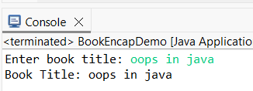
9) Create a class representing a student with private member variables (name, roll number, marks) and public methods (getters and setters).
import java.util.Scanner;
public class StudentMarks {
private String name;
private int rollNumber;
private int marks;
public void setName(String n) {
name = n;
}
public void setRollNumber(int r) {
rollNumber = r;
}
public void setMarks(int m) {
marks = m;
}
public String getName() {
return name;
}
public int getRollNumber() {
return rollNumber;
}
public int getMarks() {
return marks;
}
public static void main(String[] args) {
Scanner sc = new Scanner(System.in);
StudentMarks s = new StudentMarks();
System.out.print("Enter name: ");
s.setName(sc.nextLine());
System.out.print("Enter roll number: ");
s.setRollNumber(sc.nextInt());
System.out.print("Enter marks: ");
s.setMarks(sc.nextInt());
System.out.println("Name: " + s.getName());
System.out.println("Roll No: " + s.getRollNumber());
System.out.println("Marks: " + s.getMarks());
}}
Output:
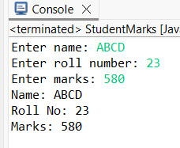
10) Write a program to demonstrate encapsulation by accessing private member variables through public accessor methods.
import java.util.Scanner;
class Student {
private int marks;
public void setMarks(int m) {
marks = m;
}
public int getMarks() {
return marks;
}}
public class StudentMarksDemo {
public static void main(String[] args) {
Scanner sc = new Scanner(System.in);
Student s = new Student();
System.out.print("Enter marks: ");
s.setMarks(sc.nextInt());
System.out.println("Marks: " + s.getMarks());
}}
Output:
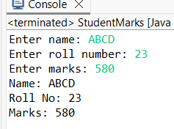
11) Create a class representing a circle with private member variables (radius, area, circumference) and public methods (getters and setters)
import java.util.Scanner;
public class Circle1 {
private double radius;
public void setRadius(double r) {
radius = r;
}
public double getArea() {
return Math.PI * radius * radius;
}
public double getCircumference() {
return 2 * Math.PI * radius;
}
public static void main(String[] args) {
Scanner sc = new Scanner(System.in);
Circle1 c = new Circle1();
System.out.print("Enter radius: ");
c.setRadius(sc.nextDouble());
System.out.println("Area of Circle: " + c.getArea());
System.out.println("Circumference of Circle: " + c.getCircumference());
}}
Output:
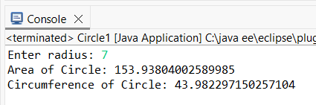
12) Write a program to demonstrate encapsulation by accessing private member variables through public accessor methods.
import java.util.Scanner;
public class CircleDemo {
private double radius;
public void setRadius(double r) {
radius = r;
}
public double getArea() {
return Math.PI * radius * radius;
}
public double getCircumference() {
return 2 * Math.PI * radius;
}
public static void main(String[] args) {
Scanner sc = new Scanner(System.in);
CircleDemo c = new CircleDemo();
System.out.print("Enter radius: ");
c.setRadius(sc.nextDouble());
System.out.println("Area of Circle: " + c.getArea());
System.out.println("Circumference of Circle: " + c.getCircumference());
}}
Output:
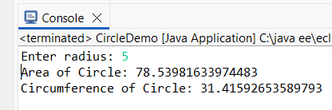
13) Create a class representing a Rectangle with private member variables (length, breadth) and public methods to calculate area and perimeter.
import java.util.Scanner;
public class Rectangle13 {
private double length;
private double breadth;
public void setDimensions(double l, double b) {
length = l;
breadth = b;
}
public double getArea() {
return length * breadth;
}
public double getPerimeter() {
return 2 * (length + breadth);
}
public static void main(String[] args) {
Scanner sc = new Scanner(System.in);
Rectangle13 r = new Rectangle13();
System.out.print("Enter length: ");
double l = sc.nextDouble();
System.out.print("Enter breadth: ");
double b = sc.nextDouble();
r.setDimensions(l, b);
System.out.println("Area: " + r.getArea());
System.out.println("Perimeter: " + r.getPerimeter());
}}
Output:
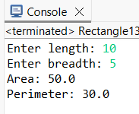
14) Write a program to demonstrate encapsulation by accessing private member variables through public accessor methods (Rectangle).
import java.util.Scanner;
public class RectangleEncap14 {
private double length;
private double breadth;
public void setLength(double l) {
length = l;
}
public void setBreadth(double b) {
breadth = b;
}
public double getArea() {
return length * breadth;
}
public static void main(String[] args) {
Scanner sc = new Scanner(System.in);
RectangleEncap14 r = new RectangleEncap14();
System.out.print("Enter length: ");
r.setLength(sc.nextDouble());
System.out.print("Enter breadth: ");
r.setBreadth(sc.nextDouble());
System.out.println("Area: " + r.getArea());
}}
Output:
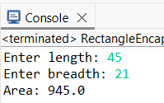
15) Create a class representing an Employee with private member variables (id, salary) and public methods to calculate annual salary.
import java.util.Scanner;
public class Employee15 {
private int id;
private double salary;
public void setDetails(int i, double s) {
id = i;
salary = s;
}
public double getAnnualSalary() {
return salary * 12;
}
public static void main(String[] args) {
Scanner sc = new Scanner(System.in);
Employee15 e = new Employee15();
System.out.print("Enter employee id: ");
int id = sc.nextInt();
System.out.print("Enter monthly salary: ");
double sal = sc.nextDouble();
e.setDetails(id, sal);
System.out.println("Annual Salary: " + e.getAnnualSalary());
}}
Output:
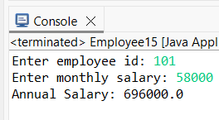
16) Write a program to demonstrate encapsulation by accessing private member variables through public accessor methods (Employee).
import java.util.Scanner;
public class EmployeeEncap16 {
private String name;
private double salary;
public void setName(String n) {
name = n;
}
public void setSalary(double s) {
salary = s;
}
public String getName() {
return name;
}
public double getSalary() {
return salary;
}
public static void main(String[] args) {
Scanner sc = new Scanner(System.in);
EmployeeEncap16 e = new EmployeeEncap16();
System.out.print("Enter employee name: ");
e.setName(sc.nextLine());
System.out.print("Enter salary: ");
e.setSalary(sc.nextDouble());
System.out.println("Name: " + e.getName());
System.out.println("Salary: " + e.getSalary());
}}
Output:
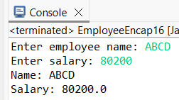
17) Create a class representing a Bank Account with private member variables (account number, balance) and public methods (deposit, withdraw).
import java.util.Scanner;
public class BankAccountMain {
private int accountNumber;
private double balance;
public void setAccountNumber(int accNo) {
accountNumber = accNo;
}
public void deposit(double amount) {
balance += amount;
}
public void withdraw(double amount) {
if (amount <= balance) {
balance -= amount;
} else {
System.out.println("Insufficient Balance");
}}
public double getBalance() {
return balance;
}
public static void main(String[] args) {
Scanner sc = new Scanner(System.in);
BankAccountMain acc = new BankAccountMain();
System.out.print("Enter account number: ");
acc.setAccountNumber(sc.nextInt());
System.out.print("Enter deposit amount: ");
acc.deposit(sc.nextDouble());
System.out.print("Enter withdraw amount: ");
acc.withdraw(sc.nextDouble());
System.out.println("Final Balance: " + acc.getBalance());
}}
Output:
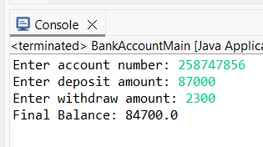
18) Write a program to demonstrate encapsulation by accessing private member variables through public accessor methods.
import java.util.Scanner;
public class BookEncap18 {
private String bookName;
public void setBookName(String n) {
bookName = n;
}
public String getBookName() {
return bookName;
}
public static void main(String[] args) {
Scanner sc = new Scanner(System.in);
BookEncap18 b = new BookEncap18();
System.out.print("Enter book name: ");
b.setBookName(sc.nextLine());
System.out.println("Book Name: " + b.getBookName());
}}
Output:
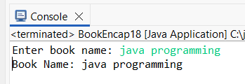
19) Create a class representing a Computer with private member variables (brand, model, price) and public methods (getters and setters).
import java.util.Scanner;
public class ComputerMain {
private String brand;
private String model;
private double price;
public void setBrand(String b) {
brand = b;
}
public void setModel(String m) {
model = m;
}
public void setPrice(double p) {
price = p;
}
public String getBrand() {
return brand;
}
public String getModel() {
return model;
}
public double getPrice() {
return price;
}
public static void main(String[] args) {
Scanner sc = new Scanner(System.in);
ComputerMain c = new ComputerMain();
System.out.print("Enter computer brand: ");
c.setBrand(sc.nextLine());
System.out.print("Enter computer model: ");
c.setModel(sc.nextLine());
System.out.print("Enter computer price: ");
c.setPrice(sc.nextDouble());
System.out.println("\n--- Computer Details ---");
System.out.println("Brand: " + c.getBrand());
System.out.println("Model: " + c.getModel());
System.out.println("Price: " + c.getPrice());
}}
Output:
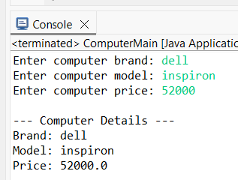
20) Write a program to demonstrate encapsulation by accessing private member variables through public accessor methods (Mobile).
import java.util.Scanner;
public class MobileEncap20 {
private double price;
public void setPrice(double p) {
price = p;
}
public double getPrice() {
return price;
}
public static void main(String[] args) {
Scanner sc = new Scanner(System.in);
MobileEncap20 m = new MobileEncap20();
System.out.print("Enter price: ");
m.setPrice(sc.nextDouble());
System.out.println("Mobile Price: " + m.getPrice());
}
}
Output:
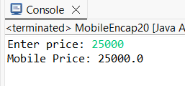
21) Create a class representing a Library Book with private member variables (title, author, price) and public methods (getters and setters).
import java.util.Scanner;
public class LibraryBookMain {
private String title;
private String author;
private double price;
public void setTitle(String t) {
title = t;
}
public void setAuthor(String a) {
author = a;
}
public void setPrice(double p) {
price = p;
}
public String getTitle() {
return title;
}
public String getAuthor() {
return author;
}
public double getPrice() {
return price;
}
public static void main(String[] args) {
Scanner sc = new Scanner(System.in);
LibraryBookMain book = new LibraryBookMain();
System.out.print("Enter book title: ");
book.setTitle(sc.nextLine());
System.out.print("Enter author name: ");
book.setAuthor(sc.nextLine());
System.out.print("Enter price: ");
book.setPrice(sc.nextDouble());
System.out.println("\n--- Library Book Details ---");
System.out.println("Title: " + book.getTitle());
System.out.println("Author: " + book.getAuthor());
System.out.println("Price: " + book.getPrice());
}
}

Output:
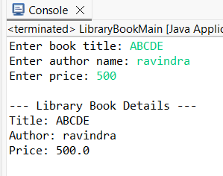
22) Write a program to demonstrate encapsulation by accessing private member variables through public accessor methods.
class Demo {
private int value;
public void setValue(int v) {
value = v;
}
public int getValue() {
return value;
}
}
public class EncapsulationDemo22 {
public static void main(String[] args) {
Demo d = new Demo();
d.setValue(100);
System.out.println("Value: " + d.getValue());
}}
Output:
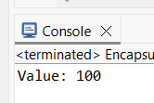
23) Create a class representing a rectangle with private member variables (length, width, area) and public methods (getters and setters).
import java.util.Scanner;
public class Rectangle23 {
private double length, width, area;
public void setLength(double length) {
this.length = length;
}
public void setWidth(double width) {
this.width = width;
}
public void calculateArea() {
area = length * width;
}
public double getArea() {
return area;
}
public static void main(String[] args) {
Scanner sc = new Scanner(System.in);
Rectangle23 r = new Rectangle23();
System.out.print("Enter length: ");
r.setLength(sc.nextDouble());
System.out.print("Enter width: ");
r.setWidth(sc.nextDouble());
r.calculateArea();
System.out.println("Area of Rectangle: " + r.getArea());
}
}
Output:
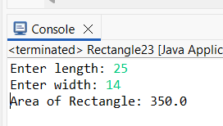
24) Write a program to demonstrate encapsulation by accessing private member variables through public accessor methods.
import java.util.Scanner;
class Test24 {
private String name;
public void setName(String name) {
this.name = name;
}
public String getName() {
return name;
}}
public class EncapsulationDemo24 {
public static void main(String[] args) {
Scanner sc = new Scanner(System.in);
Test24 t = new Test24();
System.out.print("Enter name: ");
t.setName(sc.nextLine());
System.out.println("Name: " + t.getName());
}}
Output:
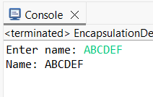
25) Create a class representing a bank account with private member variables (account number, balance) and public methods (deposit, withdraw).
import java.util.Scanner;
public class BankAccount25 {
private int accNo;
private double balance;
public void setAccNo(int accNo) {
this.accNo = accNo;
}
public void deposit(double amount) {
balance += amount;
}
public void withdraw(double amount) {
if (amount <= balance)
balance -= amount;
else
System.out.println("Insufficient Balance");
}
public double getBalance() {
return balance;
}
public static void main(String[] args) {
Scanner sc = new Scanner(System.in);
BankAccount25 b = new BankAccount25();
System.out.print("Enter account number: ");
b.setAccNo(sc.nextInt());
System.out.print("Enter deposit amount: ");
b.deposit(sc.nextDouble());
System.out.print("Enter withdrawal amount: ");
b.withdraw(sc.nextDouble());
System.out.println("Final Balance: " + b.getBalance());
}}
Output:
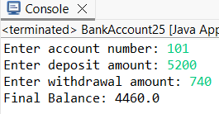
26) Write a program to demonstrate encapsulation by accessing private member variables through public accessor methods.
import java.util.Scanner;
class Sample26 {
private int number;
public void setNumber(int number) {
this.number = number;
}
public int getNumber() {
return number;
}}
public class EncapsulationDemo26 {
public static void main(String[] args) {
Scanner sc = new Scanner(System.in);
Sample26 s = new Sample26();
System.out.print("Enter number: ");
s.setNumber(sc.nextInt());
System.out.println("Number: " + s.getNumber());
}

}
Output:
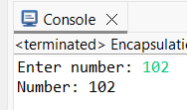
27) Create a class representing a student with private member variables (name, roll number, marks) and public methods (getters and setters).
import java.util.Scanner;
public class Student27 {
private String name;
private int roll;
private double marks;
public void setName(String name) {
this.name = name;}
public void setRoll(int roll) {
this.roll = roll;
}
public void setMarks(double marks) {
this.marks = marks;
}
public String getName() {
return name;
}
public int getRoll() {
return roll;
}
public double getMarks() {
return marks;
}
public static void main(String[] args) {
Scanner sc = new Scanner(System.in);
Student27 s = new Student27();
System.out.print("Enter name: ");
s.setName(sc.nextLine());
System.out.print("Enter roll number: ");
s.setRoll(sc.nextInt());
System.out.print("Enter marks: ");
s.setMarks(sc.nextDouble());
System.out.println("Name: " + s.getName());
System.out.println("Roll No: " + s.getRoll());
System.out.println("Marks: " + s.getMarks());
}}
Output:
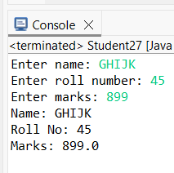
28) Write a program to demonstrate encapsulation by accessing private member variables through public accessor methods.
import java.util.Scanner;
class Encap28 {
private String message;
public void setMessage(String message) {
this.message = message;
}
public String getMessage() {
return message;
}}
public class EncapsulationDemo28 {
public static void main(String[] args) {
Scanner sc = new Scanner(System.in);
Encap28 e = new Encap28();
System.out.print("Enter message: ");
e.setMessage(sc.nextLine());
System.out.println("Message: " + e.getMessage());
}}
Output:
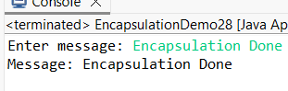
Static
1)Write a Java program to count the number of objects created for a class using a static variable.
import java.util.Scanner;
class ObjectCount {
static int count = 0;
ObjectCount() {
count++;
}
public static void main(String[] args) {
Scanner sc = new Scanner(System.in);
System.out.print("Enter number of objects to create: ");
int n = sc.nextInt();
for (int i = 0; i < n; i++) {
new ObjectCount();
}
System.out.println("Number of objects created = " + count);
}}
Output:
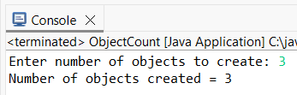
2) Implement a static method to find the factorial of a number.
import java.util.Scanner;
class Factorial1 {
static int factorial(int n) {
int fact = 1;
for (int i = 1; i <= n; i++)
fact *= i;
return fact;
}
public static void main(String[] args) {
Scanner sc = new Scanner(System.in);
System.out.print("Enter a number: ");
int n = sc.nextInt();
System.out.println("Factorial of " + n + " = " + factorial(n));
}}
Output:
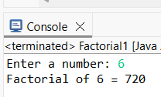
3) Write a Java program to calculate the area of a circle using a static method.
import java.util.Scanner;
class CircleArea {
static double area(double r) {
return 3.14 * r * r;
}
public static void main(String[] args) {
Scanner sc = new Scanner(System.in);
System.out.print("Enter radius: ");
double r = sc.nextDouble();
System.out.println("Area of Circle = " + area(r));
}}
Output:
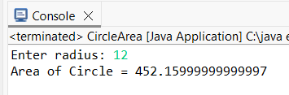
4) Write a Java program to find the sum of elements in an array using a static method.
import java.util.Scanner;
class ArraySum {
static int sum(int[] a) {
int s = 0;
for (int i : a)
s += i;
return s;
}
public static void main(String[] args) {
Scanner sc = new Scanner(System.in);
System.out.print("Enter array size: ");
int n = sc.nextInt();
int[] a = new int[n];
System.out.println("Enter array elements:");
for (int i = 0; i < n; i++)
a[i] = sc.nextInt();
System.out.println("Sum of elements = " + sum(a));
}}
Output:
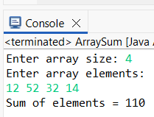
5) Write a Java program to find the maximum of two numbers using a static method.
import java.util.Scanner;
class Max {
static int max(int a, int b) {
return (a > b) ? a : b;
}
public static void main(String[] args) {
Scanner sc = new Scanner(System.in);
System.out.print("Enter two numbers: ");
int a = sc.nextInt();
int b = sc.nextInt();
System.out.println("Maximum number = " + max(a, b));
}}
Output:
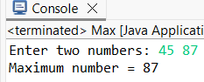
6) Write a Java program to find the minimum of two numbers using a static method.
import java.util.Scanner;
class Min {
static int min(int a, int b) {
return (a < b) ? a : b;
}
public static void main(String[] args) {
Scanner sc = new Scanner(System.in);
System.out.print("Enter two numbers: ");
int a = sc.nextInt();
int b = sc.nextInt();
System.out.println("Minimum number = " + min(a, b));
}}
Output:
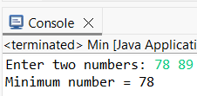
7) Write a Java program to find the power of a number using a static method.
import java.util.Scanner;
class Power1 {
static int power(int a, int b) {
return (int) Math.pow(a, b);
}
public static void main(String[] args) {
Scanner sc = new Scanner(System.in);
System.out.print("Enter base and exponent: ");
int a = sc.nextInt();
int b = sc.nextInt();
System.out.println("Result = " + power(a, b));
}}
Output:
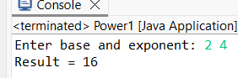
8) Write a Java program to calculate the square root of a number using a static method.
import java.util.Scanner;
class Power1 {
static int power(int a, int b) {
return (int) Math.pow(a, b);
}
public static void main(String[] args) {
Scanner sc = new Scanner(System.in);
System.out.print("Enter base and exponent: ");
int a = sc.nextInt();
int b = sc.nextInt();
System.out.println("Result = " + power(a, b));
}}
Output:
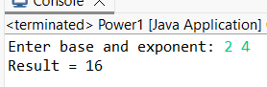
9) Write a Java program to find the area of a triangle using a static method.
import java.util.Scanner;
class TriangleArea {
static double area(double b, double h) {
return 0.5 * b * h;
}
public static void main(String[] args) {
Scanner sc = new Scanner(System.in);
System.out.print("Enter base and height: ");
double b = sc.nextDouble();
double h = sc.nextDouble();
System.out.println("Area of Triangle = " + area(b, h));
}}
Output:
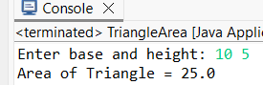
10) Write a Java program to calculate simple interest using a static method.
import java.util.Scanner;
class SimpleInterest1 {
static double calculateSI(double p, double r, double t) {
return (p * r * t) / 100;
}
public static void main(String[] args) {
Scanner sc = new Scanner(System.in);
System.out.print("Enter principal, rate and time: ");
double p = sc.nextDouble();
double r = sc.nextDouble();
double t = sc.nextDouble();
System.out.println("Simple Interest = " + calculateSI(p, r, t));
}}
Output:
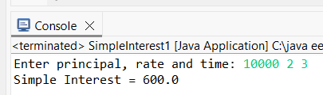
11) Write a Java program to find the volume of a cylinder using a static method.
import java.util.Scanner;
class CylinderVolume {
static double volume(double r, double h) {
return 3.14 * r * r * h;
}
public static void main(String[] args) {
Scanner sc = new Scanner(System.in);
System.out.print("Enter radius and height: ");
double r = sc.nextDouble();
double h = sc.nextDouble();
System.out.println("Volume of Cylinder = " + volume(r, h));
}}
Output:
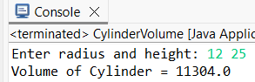
12) Write a Java program to calculate compound interest using a static method.
import java.util.Scanner;
class CompoundInterest {
static double ci(double p, double r, double t) {
return p * Math.pow((1 + r / 100), t) - p;
}
public static void main(String[] args) {
Scanner sc = new Scanner(System.in);
System.out.print("Enter principal, rate and time: ");
double p = sc.nextDouble();
double r = sc.nextDouble();
double t = sc.nextDouble();
System.out.println("Compound Interest = " + ci(p, r, t));
}}
Output:
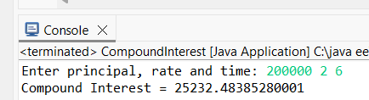

13) Write a Java program to find the area of a rectangle using a static method.
import java.util.Scanner;
class RectangleArea {
static double area(double l, double b) {
return l * b;
}
public static void main(String[] args) {
Scanner sc = new Scanner(System.in);
System.out.print("Enter length and breadth: ");
double l = sc.nextDouble();
double b = sc.nextDouble();
System.out.println("Area of Rectangle = " + area(l, b));
}}
Output:
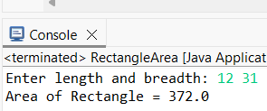
14) Write a Java program to find the area of a square using a static method.
import java.util.Scanner;
class SquareArea {
static double area(double s) {
return s * s;
}
public static void main(String[] args) {
Scanner sc = new Scanner(System.in);
System.out.print("Enter side: ");
double s = sc.nextDouble();
System.out.println("Area of Square = " + area(s));
}}
Output:
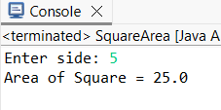
15) Write a Java program to find the area of a rhombus using a static method.
import java.util.Scanner;
class RhombusArea {
static double area(double d1, double d2) {
return 0.5 * d1 * d2;
}
public static void main(String[] args) {
Scanner sc = new Scanner(System.in);
System.out.print("Enter diagonals: ");
double d1 = sc.nextDouble();
double d2 = sc.nextDouble();
System.out.println("Area of Rhombus = " + area(d1, d2));
}
}

Output:
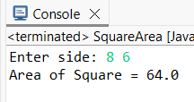
16) Write a Java program to find the area of a parallelogram using a static method.
import java.util.Scanner;
class ParallelogramArea {
static double area(double b, double h) {
return b * h;
}
public static void main(String[] args) {
Scanner sc = new Scanner(System.in);
System.out.print("Enter base and height: ");
double b = sc.nextDouble();
double h = sc.nextDouble();
System.out.println("Area of Parallelogram = " + area(b, h));
}}
Output:
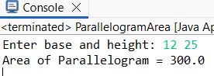
17) Write a Java program to find the area of a trapezoid using a static method.
import java.util.Scanner;
class TrapezoidArea {
static double area(double a, double b, double h) {
return 0.5 * (a + b) * h;
}
public static void main(String[] args) {
Scanner sc = new Scanner(System.in);
System.out.print("Enter parallel sides and height: ");
double a = sc.nextDouble();
double b = sc.nextDouble();
double h = sc.nextDouble();
System.out.println("Area of Trapezoid = " + area(a, b, h));
}}
Output:
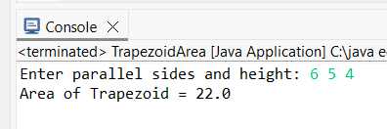
18) Write a Java program to find the area of a regular polygon using a static method.
import java.util.Scanner;
class RegularPolygonArea {
static double area(int n, double s) {
return (n * s * s) / (4 * Math.tan(Math.PI / n));
}
public static void main(String[] args) {
Scanner sc = new Scanner(System.in);
System.out.print("Enter number of sides and side length: ");
int n = sc.nextInt();
double s = sc.nextDouble();
System.out.println("Area of Regular Polygon = " + area(n, s));
}}
Output:
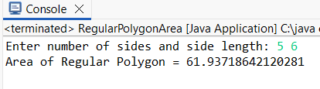
19) Write a Java program to convert temperature from Celsius to Fahrenheit using a static method.
import java.util.Scanner;
class CelsiusToFahrenheit {
static double convert(double c) {
return (c * 9 / 5) + 32;
}
public static void main(String[] args) {
Scanner sc = new Scanner(System.in);
System.out.print("Enter temperature in Celsius: ");
double c = sc.nextDouble();
System.out.println("Temperature in Fahrenheit = " + convert(c));
}}
Output:
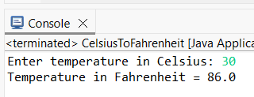
20) Write a Java program to convert temperature from Fahrenheit to Celsius using a static method.
import java.util.Scanner;
class FahrenheitToCelsius {
static double convert(double f) {
return (f - 32) * 5 / 9;
}
public static void main(String[] args) {
Scanner sc = new Scanner(System.in);
System.out.print("Enter temperature in Fahrenheit: ");
double f = sc.nextDouble();
System.out.println("Temperature in Celsius = " + convert(f));
}}
Output:
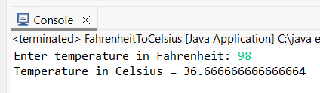
21) Write a Java program to find the factorial of a given number using recursion.
import java.util.Scanner;
class RecFact {
static int factorial(int n) {
if (n == 1)
return 1;
return n * factorial(n - 1);
}
public static void main(String[] args) {
Scanner sc = new Scanner(System.in);
System.out.print("Enter a number: ");
int n = sc.nextInt();
System.out.println("Factorial of " + n + " = " + factorial(n));
}}
Output:
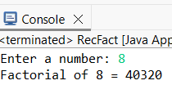
22) Write a Java program to find the sum of digits of a given number using recursion.
import java.util.Scanner;
class SumDigits {
static int sum(int n) {
if (n == 0)
return 0;
return (n % 10) + sum(n / 10);
}
public static void main(String[] args) {
Scanner sc = new Scanner(System.in);
System.out.print("Enter a number: ");
int n = sc.nextInt();
System.out.println("Sum of digits = " + sum(n));
}}
Output:
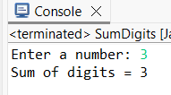
23) Write a Java program to calculate the power of a number using recursion.
import java.util.Scanner;
class RecPower {
static int power(int a, int b) {
if (b == 0)
return 1;
return a * power(a, b - 1);
}
public static void main(String[] args) {
Scanner sc = new Scanner(System.in);
System.out.print("Enter base and exponent: ");
int a = sc.nextInt();
int b = sc.nextInt();
System.out.println("Result = " + power(a, b));
}}

Output:
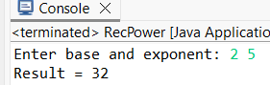
24) Write a Java program to generate the Fibonacci series using recursion.
import java.util.Scanner;
class Fibonacci {
static int fib(int n) {
if (n <= 1)
return n;
return fib(n - 1) + fib(n - 2);
}
public static void main(String[] args) {
Scanner sc = new Scanner(System.in);
System.out.print("Enter the number of terms: ");
int n = sc.nextInt();
System.out.println("Fibonacci Series:");
for (int i = 0; i < n; i++) {
System.out.print(fib(i) + " ");
}
}
}
Output:
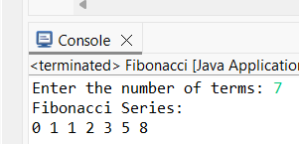
25) Write a Java program to reverse a given string using recursion.
import java.util.Scanner;
class ReverseString {
static String reverse(String s) {
if (s.isEmpty())
return s;
return reverse(s.substring(1)) + s.charAt(0);
}
public static void main(String[] args) {
Scanner sc = new Scanner(System.in);
System.out.print("Enter a string: ");
String s = sc.nextLine();
System.out.println("Reversed string = " + reverse(s));
}}
Output:
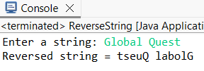

Abstraction:
- Write an abstract class "Shape" with abstract methods "calculateArea" and "calculatePerimeter". Implement it in subclasses "Circle" and "Rectangle".
package Abstraction;
abstract class Shape {
abstract void calculateArea();
abstract void calculatePerimeter();
}
class Circle extends Shape {
double r = 5;
void calculateArea() {
System.out.println("Circle Area: " + (3.14 * r * r));
}
void calculatePerimeter() {
System.out.println("Circle Perimeter: " + (2 * 3.14 * r));
}
}
class Rectangle extends Shape {
int l = 4, b = 6;
void calculateArea() {
System.out.println("Rectangle Area: " + (l * b));
}
void calculatePerimeter() {
System.out.println("Rectangle Perimeter: " + (2 * (l + b)));
}
}
public class Program1 {
public static void main(String[] args) {
Shape s1 = new Circle();
s1.calculateArea();
s1.calculatePerimeter();
Shape s2 = new Rectangle();
s2.calculateArea();
s2.calculatePerimeter();
}
}
OUTPUT:
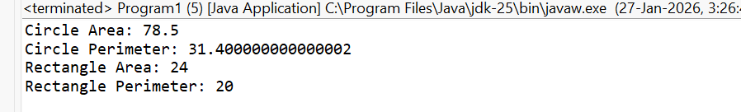
- Write a program to demonstrate abstraction by creating objects of subclasses and invoking abstract methods.
package Abstraction;
abstract class Animal {
abstract void eat();
abstract void sleep();
}
class Dog extends Animal {
void eat() {
System.out.println("Dog eats bones");
}
void sleep() {
System.out.println("Dog sleeps at night");
}
}
class Cat extends Animal {
void eat() {
System.out.println("Cat eats fish");
}
void sleep() {
System.out.println("Cat sleeps during the day");
}
}
public class Program2 {
public static void main(String[] args) {
Animal a1 = new Dog();
a1.eat();
a1.sleep();
Animal a2 = new Cat();
a2.eat();
a2.sleep();
}
}
OUTPUT:
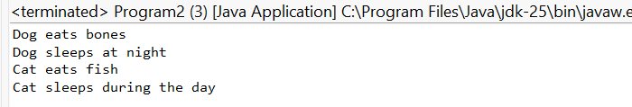
- Write an abstract class "Animal" with abstract methods "eat" and "sleep". Implement it in subclasses "Dog" and "Cat".
package Abstraction;
abstract class Animal {
abstract void eat();
abstract void sleep();
}
class Dog extends Animal {
void eat() {
System.out.println("Dog eats bones");
}
void sleep() {
System.out.println("Dog sleeps at night");
}
}
class Cat extends Animal {
void eat() {
System.out.println("Cat eats fish");
}
void sleep() {
System.out.println("Cat sleeps during the day");
}
}
public class Program2 {
public static void main(String[] args) {
Animal a1 = new Dog();
a1.eat();
a1.sleep();
Animal a2 = new Cat();
a2.eat();
a2.sleep();
}
}
OUTPUT:
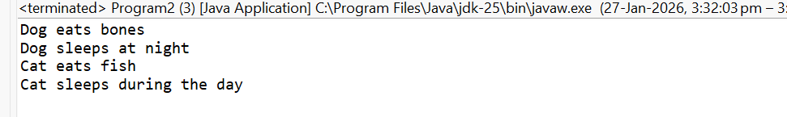
- Write a program to demonstrate abstraction by creating objects of subclasses and invoking abstract methods.
package Abstraction;
abstract class Animal {
abstract void eat();
abstract void sleep();
}
class Dog extends Animal {
void eat() {
System.out.println("Dog eats bones");
}
void sleep() {
System.out.println("Dog sleeps at night");
}
}
class Cat extends Animal {
void eat() {
System.out.println("Cat eats fish");
}
void sleep() {
System.out.println("Cat sleeps during the day");
}
}
public class Program2 {
public static void main(String[] args) {
Animal a1 = new Dog();
a1.eat();
a1.sleep();

Animal a2 = new Cat();
a2.eat();
a2.sleep();
}
}
OUTPUT:
- Write an abstract class "Employee" with abstract methods "calculateSalary" and "calculateBonus". Implement it in subclasses "Manager" and "Clerk".
package Abstraction;
abstract class Employee {
abstract void calculateSalary();
abstract void calculateBonus();
}
class Manager extends Employee {
void calculateSalary() {
System.out.println("Manager Salary: 50000");
}
void calculateBonus() {
System.out.println("Manager Bonus: 10000");
}
}
class Clerk extends Employee {
void calculateSalary() {
System.out.println("Clerk Salary: 20000");
}
void calculateBonus() {
System.out.println("Clerk Bonus: 3000");
}}
public class Program3{
public static void main(String[] args) {
Employee e1 = new Manager();
e1.calculateSalary();
e1.calculateBonus();
Employee e2 = new Clerk();
e2.calculateSalary();
e2.calculateBonus();
}
}

OUTPUT:
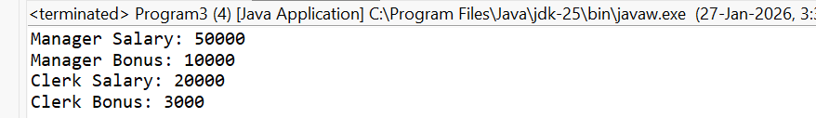
- Write a program to demonstrate abstraction by creating objects of subclasses and invoking abstract methods.
package Abstraction;
abstract class Animal {
abstract void eat();
abstract void sleep();
}
class Dog extends Animal {
void eat() {
System.out.println("Dog eats bones");
}
void sleep() {
System.out.println("Dog sleeps at night");
}
}
class Cat extends Animal {
void eat() {
System.out.println("Cat eats fish");
}
void sleep() {
System.out.println("Cat sleeps during the day");
}}
public class Program2 {
public static void main(String[] args) {
Animal a1 = new Dog();
a1.eat();
a1.sleep();
Animal a2 = new Cat();
a2.eat();
a2.sleep();
}
}
OUTPUT:

- Write an abstract class "BankAccount" with abstract methods "deposit" and "withdraw". Implement it in subclasses "SavingsAccount" and "CurrentAccount".
package Abstraction;
abstract class BankAccount {
abstract void deposit();
abstract void withdraw();
}
class SavingsAccount extends BankAccount {
void deposit() {
System.out.println("Deposited in Savings Account");
}
void withdraw() {
System.out.println("Withdrawn from Savings Account");
}
}
class CurrentAccount extends BankAccount {
void deposit() {
System.out.println("Deposited in Current Account");
}
void withdraw() {
System.out.println("Withdrawn from Current Account");
}
}
public class Program7 {
public static void main(String[] args) {
BankAccount b1 = new SavingsAccount();
b1.deposit();
b1.withdraw();
BankAccount b2 = new CurrentAccount();
b2.deposit();
b2.withdraw();
}
}
OUTPUT:
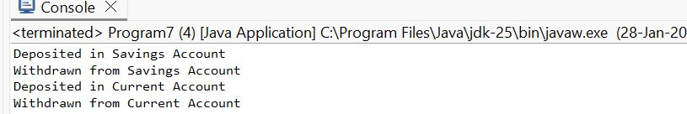
- Write a program to demonstrate abstraction by creating objects of subclasses and invoking abstract methods.
package Abstraction;
abstract class Animal4{
abstract void eat();
abstract void sleep();
}
class Dog4 extends Animal4 {
void eat() {
System.out.println("Dog eats bones");
}
void sleep() {
System.out.println("Dog sleeps at night");
}
}
class Cat4 extends Animal4 {
void eat() {
System.out.println("Cat eats fish");
}
void sleep() {
System.out.println("Cat sleeps during the day");
}
}
public class Program8 {
public static void main(String[] args) {
Animal4 a1 = new Dog4();
a1.eat();
a1.sleep();
Animal4 a2 = new Cat4();
a2.eat();
a2.sleep();
}
}
OUTPUT:
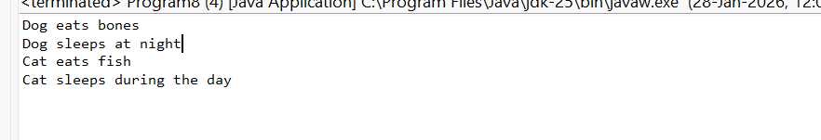
- Write an abstract class "Vehicle" with abstract methods "start" and "stop". Implement it in subclasses "Car" and "Motorcycle".
abstract class Vehicle {
abstract void start();
abstract void stop();
}
class Car extends Vehicle {
void start() {
System.out.println("Car started");
}
void stop() {
System.out.println("Car stopped");
}
}
class Motorcycle extends Vehicle {
void start() {
System.out.println("Motorcycle started");
}
void stop() {
System.out.println("Motorcycle stopped");
}
}
public class VehicleDemo {
public static void main(String[] args) {
Vehicle v1 = new Car();
v1.start();
v1.stop();
Vehicle v2 = new Motorcycle();
v2.start();
v2.stop();
}
}
OUTPUT:
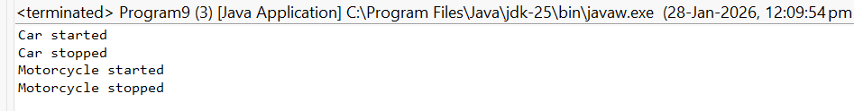
- Write a program to demonstrate abstraction by creating objects of subclasses and invoking abstract methods.
package Abstraction;
abstract class Animal4{
abstract void eat();
abstract void sleep();
}
class Dog4 extends Animal4 {
void eat() {
System.out.println("Dog eats bones");
}
void sleep() {
System.out.println("Dog sleeps at night");
}
}
class Cat4 extends Animal4 {
void eat() {
System.out.println("Cat eats fish");
}
void sleep() {
System.out.println("Cat sleeps during the day");
}
}
public class Program8 {
public static void main(String[] args) {
Animal4 a1 = new Dog4();
a1.eat();
a1.sleep();
Animal4 a2 = new Cat4();
a2.eat();
a2.sleep();
}
}
OUTPUT:
- Write an abstract class "Shape" with abstract methods "calculateArea" and "calculatePerimeter". Implement it in subclasses "Triangle" and "Circle".
package Abstraction;
abstract class Shape1 {
abstract void calculateArea();
abstract void calculatePerimeter();
}
class Triangle extends Shape1 {
int b = 5, h = 4;
void calculateArea() {
System.out.println("Triangle Area: " + (0.5 * b * h));
}
void calculatePerimeter() {
System.out.println("Triangle Perimeter: 12");
}
}
class Circle1 extends Shape1 {
int r = 3;
void calculateArea() {
System.out.println("Circle Area: " + (3.14 * r * r));
}
void calculatePerimeter() {
System.out.println("Circle Perimeter: " + (2 * 3.14 * r));
}
}
public class Program10 {
public static void main(String[] args) {
Shape1 s1 = new Triangle();
s1.calculateArea();
s1.calculatePerimeter();
Shape1 s2 = new Circle1();
s2.calculateArea();
s2.calculatePerimeter();
}
}
OUTPUT:
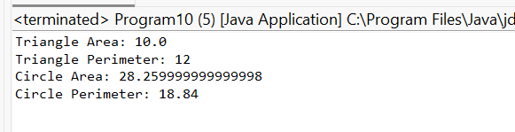
- Write a program to demonstrate abstraction by creating objects of subclasses and invoking abstract methods.
package Abstraction;
abstract class Animal4{
abstract void eat();
abstract void sleep();
}
class Dog4 extends Animal4 {
void eat() {
System.out.println("Dog eats bones");
}
void sleep() {
System.out.println("Dog sleeps at night");
}
}
class Cat4 extends Animal4 {
void eat() {
System.out.println("Cat eats fish");
}
void sleep() {
System.out.println("Cat sleeps during the day");
}
}
public class Program12 {
public static void main(String[] args) {
Animal4 a1 = new Dog4();
a1.eat();
a1.sleep();
Animal4 a2 = new Cat4();
a2.eat();
a2.sleep();
}
}
OUTPUT:
- Write an abstract class "Bank" with abstract methods "openAccount" and "closeAccount". Implement it in subclasses "SavingsBank" and "CurrentBank".
package Abstraction;
abstract class Bank {
abstract void openAccount();
abstract void closeAccount();
}
class SavingsBank extends Bank {
void openAccount() {
System.out.println("Savings Account opened");
}
void closeAccount() {
System.out.println("Savings Account closed");
}}
class CurrentBank extends Bank {
void openAccount() {
System.out.println("Current Account opened");
}
void closeAccount() {
System.out.println("Current Account closed");
}}
public class Program13 {
public static void main(String[] args) {
Bank b1 = new SavingsBank();
b1.openAccount();
b1.closeAccount();
Bank b2 = new CurrentBank();
b2.openAccount();
b2.closeAccount();
}}
OUTPUT:
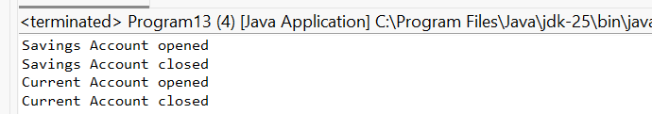
- Write a program to demonstrate abstraction by creating objects of subclasses and invoking abstract methods.
package Abstraction;
abstract class Animal4{
abstract void eat();
abstract void sleep();
}
class Dog4 extends Animal4 {
void eat() {
System.out.println("Dog eats bones");
}
void sleep() {
System.out.println("Dog sleeps at night");
}}
class Cat4 extends Animal4 {
void eat() {
System.out.println("Cat eats fish");
}
void sleep() {
System.out.println("Cat sleeps during the day");
}}
public class Program12 {
public static void main(String[] args) {
Animal4 a1 = new Dog4();
a1.eat();
a1.sleep();
Animal4 a2 = new Cat4();
a2.eat();
a2.sleep();
}
}
OUTPUT:
- Write an abstract class "Figure" with abstract methods "draw" and "erase". Implement it in subclasses "Rectangle" and "Circle".
package Abstraction;
abstract class Figure {
abstract void draw();
abstract void erase();
}
class Rectangle2 extends Figure {
void draw() {
System.out.println("Rectangle drawn");
}
void erase() {
System.out.println("Rectangle erased");
}
}
class Circle2 extends Figure {
void draw() {
System.out.println("Circle drawn");
}
void erase() {
System.out.println("Circle erased");
}
}
public class Program14 {
public static void main(String[] args) {
Figure f1 = new Rectangle2();
f1.draw();
f1.erase();
Figure f2 = new Circle2();
f2.draw();
f2.erase();
}
}
OUTPUT:
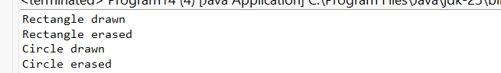
- Write a program to demonstrate abstraction by creating objects of subclasses and invoking abstract methods.
package Abstraction;
abstract class Animal4{
abstract void eat();
abstract void sleep();
}
class Dog4 extends Animal4 {
void eat() {
System.out.println("Dog eats bones");
}
void sleep() {
System.out.println("Dog sleeps at night");
}
}
class Cat4 extends Animal4 {
void eat() {
System.out.println("Cat eats fish");
}
void sleep() {
System.out.println("Cat sleeps during the day");
}
}
public class Program12 {
public static void main(String[] args) {
Animal4 a1 = new Dog4();
a1.eat();
a1.sleep();
Animal4 a2 = new Cat4();
a2.eat();
a2.sleep();
}
}
OUTPUT:
- Write an abstract class "Vehicle" with abstract methods "drive" and "stop". Implement it in subclasses "Car" and "Truck".
package Abstraction;
abstract class Vehicle1 {
abstract void drive();
abstract void stop();
}
class Car1 extends Vehicle1 {
void drive() {
System.out.println("Car is driving");
}
void stop() {
System.out.println("Car stopped");
}}
class Truck1 extends Vehicle1 {
void drive() {
System.out.println("Truck is driving");
}
void stop() {
System.out.println("Truck stopped");
}}
public class Program17 {
public static void main(String[] args) {
Vehicle1 v1 = new Car1();
v1.drive();
v1.stop();
Vehicle1 v2 = new Truck1();
v2.drive();
v2.stop();
}}
OUTPUT:
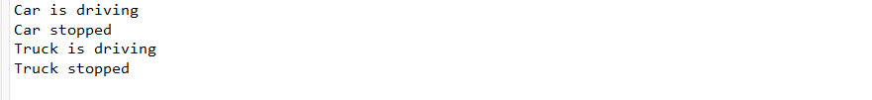
- Write a program to demonstrate abstraction by creating objects of subclasses and invoking abstract methods.
package Abstraction;
abstract class Animal4{
abstract void eat();
abstract void sleep();
}
class Dog4 extends Animal4 {
void eat() {
System.out.println("Dog eats bones");
}
void sleep() {
System.out.println("Dog sleeps at night");
}}
class Cat4 extends Animal4 {
void eat() {
System.out.println("Cat eats fish");
}
void sleep() {
System.out.println("Cat sleeps during the day");
}}
public class Program12 {
public static void main(String[] args) {
Animal4 a1 = new Dog4();
a1.eat();
a1.sleep();
Animal4 a2 = new Cat4();
a2.eat();
a2.sleep();
}
}
OUTPUT:
- Write an abstract class "BankAccount" with abstract methods "deposit" and "withdraw". Implement it in subclasses "SavingsAccount" and "CurrentAccount".
package Abstraction;
abstract class BankAccount {
abstract void deposit();
abstract void withdraw();
}
class SavingsAccount extends BankAccount {
void deposit() {
System.out.println("Amount deposited in Savings Account");
}
void withdraw() {
System.out.println("Amount withdrawn from Savings Account");
}
}
class CurrentAccount extends BankAccount {
void deposit() {
System.out.println("Amount deposited in Current Account");
}
void withdraw() {
System.out.println("Amount withdrawn from Current Account");
}
}
public class Program19 {
public static void main(String[] args) {
BankAccount b1 = new SavingsAccount();
b1.deposit();
b1.withdraw();
BankAccount b2 = new CurrentAccount();
b2.deposit();
b2.withdraw();
}
}
OUTPUT:
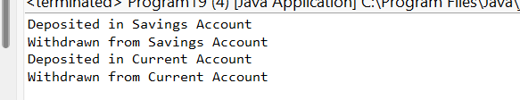
- Write a program to demonstrate abstraction by creating objects of subclasses and invoking abstract methods.
package Abstraction;
abstract class Animal4{
abstract void eat();
abstract void sleep();
}
class Dog4 extends Animal4 {
void eat() {
System.out.println("Dog eats bones");
}
void sleep() {
System.out.println("Dog sleeps at night");
}
}
class Cat4 extends Animal4 {
void eat() {
System.out.println("Cat eats fish");
}
void sleep() {
System.out.println("Cat sleeps during the day");
}
}
public class Program12 {
public static void main(String[] args) {
Animal4 a1 = new Dog4();
a1.eat();
a1.sleep();
Animal4 a2 = new Cat4();
a2.eat();
a2.sleep();
}
}
OUTPUT:
- Write an abstract class "Animal" with abstract methods "eat" and "sleep". Implement it in subclasses "Dog" and "Cat".
package Abstraction;
abstract class Animal {
abstract void eat();
abstract void sleep();
}
class Dog extends Animal {
void eat() {
System.out.println("Dog eats bones");
}
void sleep() {
System.out.println("Dog sleeps at night");
}
}
class Cat extends Animal {
void eat() {
System.out.println("Cat eats fish");
}
void sleep() {
System.out.println("Cat sleeps during the day");
}}
public class Program2 {
public static void main(String[] args) {
Animal a1 = new Dog();
a1.eat();
a1.sleep();
Animal a2 = new Cat();
a2.eat();
a2.sleep();
}}
OUTPUT:
- Write a program to demonstrate abstraction by creating objects of subclasses and invoking abstract methods.
package Abstraction;
abstract class Animal4{
abstract void eat();
abstract void sleep();
}
class Dog4 extends Animal4 {
void eat() {
System.out.println("Dog eats bones");
}
void sleep() {
System.out.println("Dog sleeps at night");
}}
class Cat4 extends Animal4 {
void eat() {
System.out.println("Cat eats fish");
}
void sleep() {
System.out.println("Cat sleeps during the day");
}}
public class Program12 {
public static void main(String[] args) {
Animal4 a1 = new Dog4();
a1.eat();
a1.sleep();
Animal4 a2 = new Cat4();
a2.eat();
a2.sleep();
}}
OUTPUT:
- Write an abstract class "Shape" with abstract methods "calculateArea" and "calculatePerimeter". Implement it in subclasses "Rectangle" and "Square".
package Abstraction;
abstract class Shape2 {
abstract void calculateArea();
abstract void calculatePerimeter();
}
class Rectangle1 extends Shape2 {
int length = 5;
int breadth = 4;
void calculateArea() {
System.out.println("Area of Rectangle: " + (length * breadth));
}
void calculatePerimeter() {
System.out.println("Perimeter of Rectangle: " + (2 * (length + breadth)));
}
}
class Square extends Shape2{
int side = 4;
void calculateArea() {
System.out.println("Area of Square: " + (side * side));
}
void calculatePerimeter() {
System.out.println("Perimeter of Square: " + (4 * side));
}
public class Program23 {
public static void main(String[] args) {
Shape2 s1 = new Rectangle1();
s1.calculateArea();
s1.calculatePerimeter();
Shape2 s2 = new Square();
s2.calculateArea();
s2.calculatePerimeter();
}
}
OUTPUT:
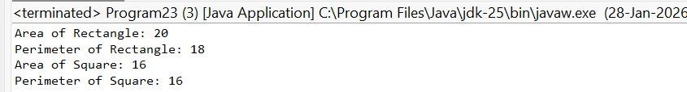
- Write a program to demonstrate abstraction by creating objects of subclasses and invoking abstract methods.
package Abstraction;
abstract class Animal4{
abstract void eat();
abstract void sleep();
}
class Dog4 extends Animal4 {
void eat() {
System.out.println("Dog eats bones");
}
void sleep() {
System.out.println("Dog sleeps at night");
}
}
class Cat4 extends Animal4 {
void eat() {
System.out.println("Cat eats fish");
}
void sleep() {
System.out.println("Cat sleeps during the day");
}
}
public class Program12 {
public static void main(String[] args) {
Animal4 a1 = new Dog4();
a1.eat();
a1.sleep();
Animal4 a2 = new Cat4();
a2.eat();
a2.sleep();
}}
OUTPUT:
- Write an abstract class "Bank" with abstract methods "openAccount" and "closeAccount". Implement it in subclasses "SavingsBank" and "CurrentBank".
package Abstraction;
abstract class Bank {
abstract void openAccount();
abstract void closeAccount();
}
class SavingsBank extends Bank {
void openAccount() {
System.out.println("Savings Account opened");
}
void closeAccount() {
System.out.println("Savings Account closed");
}}
class CurrentBank extends Bank {
void openAccount() {
System.out.println("Current Account opened");
}
void closeAccount() {
System.out.println("Current Account closed");
}}
public class Program13 {
public static void main(String[] args) {
Bank b1 = new SavingsBank();
b1.openAccount();
b1.closeAccount();
Bank b2 = new CurrentBank();
b2.openAccount();
b2.closeAccount();
}}
OUTPUT:
- Write a program to demonstrate abstraction by creating objects of subclasses and invoking abstract methods.
package Abstraction;
abstract class Animal4{
abstract void eat();
abstract void sleep();
}
class Dog4 extends Animal4 {
void eat() {
System.out.println("Dog eats bones");
}
void sleep() {
System.out.println("Dog sleeps at night");
}}
class Cat4 extends Animal4 {
void eat() {
System.out.println("Cat eats fish");
}
void sleep() {
System.out.println("Cat sleeps during the day");
}}
public class Program12 {
public static void main(String[] args) {
Animal4 a1 = new Dog4();
a1.eat();
a1.sleep();
Animal4 a2 = new Cat4();
a2.eat();
a2.sleep();
}}
OUTPUT:
- Write an abstract class "Vehicle" with abstract methods "start" and "stop". Implement it in subclasses "Car" and "Motorcycle".
abstract class Vehicle {
abstract void start();
abstract void stop();
}
class Car extends Vehicle {
void start() {
System.out.println("Car started");
}
void stop() {
System.out.println("Car stopped");
}
}
class Motorcycle extends Vehicle {
void start() {
System.out.println("Motorcycle started");
}
void stop() {
System.out.println("Motorcycle stopped");
}
}
public class VehicleDemo {
public static void main(String[] args) {
Vehicle v1 = new Car();
v1.start();
v1.stop();
Vehicle v2 = new Motorcycle();
v2.start();
v2.stop();
}
}
OUTPUT:
- Write a program to demonstrate abstraction by creating objects of subclasses and invoking abstract methods.
package Abstraction;
abstract class Animal4{
abstract void eat();
abstract void sleep();
}
class Dog4 extends Animal4 {
void eat() {
System.out.println("Dog eats bones");
}
void sleep() {
System.out.println("Dog sleeps at night");
}
}
class Cat4 extends Animal4 {
void eat() {
System.out.println("Cat eats fish");
}
void sleep() {
System.out.println("Cat sleeps during the day");
}
}
public class Program12 {
public static void main(String[] args) {
Animal4 a1 = new Dog4();
a1.eat();
a1.sleep();
Animal4 a2 = new Cat4();
a2.eat();
a2.sleep();
}
}
OUTPUT:
- Write an abstract class "Shape" with abstract methods "calculateArea" and "calculatePerimeter". Implement it in subclasses "Triangle" and "Circle".
package Abstraction;
abstract class Shape1 {
abstract void calculateArea();
abstract void calculatePerimeter();
}
class Triangle extends Shape1 {
int b = 5, h = 4;
void calculateArea() {
System.out.println("Triangle Area: " + (0.5 * b * h));
}
void calculatePerimeter() {
System.out.println("Triangle Perimeter: 12");
}}
class Circle1 extends Shape1 {
int r = 3;
void calculateArea() {
System.out.println("Circle Area: " + (3.14 * r * r));
}
void calculatePerimeter() {
System.out.println("Circle Perimeter: " + (2 * 3.14 * r));
}}
public class Program10 {
public static void main(String[] args) {
Shape1 s1 = new Triangle();
s1.calculateArea();
s1.calculatePerimeter();
Shape1 s2 = new Circle1();
s2.calculateArea();
s2.calculatePerimeter();
}}
OUTPUT:
- Write a program to demonstrate abstraction by creating objects of subclasses and invoking abstract methods.
package Abstraction;
abstract class Animal4{
abstract void eat();
abstract void sleep();
}
class Dog4 extends Animal4 {
void eat() {
System.out.println("Dog eats bones");
}
void sleep() {
System.out.println("Dog sleeps at night");
}}
class Cat4 extends Animal4 {
void eat() {
System.out.println("Cat eats fish");
}
void sleep() {
System.out.println("Cat sleeps during the day");
}}
public class Program12 {
public static void main(String[] args) {
Animal4 a1 = new Dog4();
a1.eat();
a1.sleep();
Animal4 a2 = new Cat4();
a2.eat();
a2.sleep();
}}
OUTPUT:
- Write an abstract class "BankAccount" with abstract methods "deposit" and "withdraw". Implement it in subclasses "SavingsAccount" and "CurrentAccount".
package Abstraction;
abstract class Bank {
abstract void openAccount();
abstract void closeAccount();
}
class SavingsBank extends Bank {
void openAccount() {
System.out.println("Savings Account opened");
}
void closeAccount() {
System.out.println("Savings Account closed");
}
}
class CurrentBank extends Bank {
void openAccount() {
System.out.println("Current Account opened");
}
void closeAccount() {
System.out.println("Current Account closed");
}
}
public class Program13 {
public static void main(String[] args) {
Bank b1 = new SavingsBank();
b1.openAccount();
b1.closeAccount();
Bank b2 = new CurrentBank();
b2.openAccount();
b2.closeAccount();
}
}
OUTPUT:
- Write a program to demonstrate abstraction by creating objects of subclasses and invoking abstract methods.
package Abstraction;
abstract class Animal4{
abstract void eat();
abstract void sleep();
}
class Dog4 extends Animal4 {
void eat() {
System.out.println("Dog eats bones");
}
void sleep() {
System.out.println("Dog sleeps at night");
}
}
class Cat4 extends Animal4 {
void eat() {
System.out.println("Cat eats fish");
}
void sleep() {
System.out.println("Cat sleeps during the day");
}}
public class Program12 {
public static void main(String[] args) {
Animal4 a1 = new Dog4();
a1.eat();
a1.sleep();
Animal4 a2 = new Cat4();
a2.eat();
a2.sleep();
}}
OUTPUT:
- Write an abstract class "Animal" with abstract methods "eat" and "sleep". Implement it in subclasses "Dog" and "Cat".
package Abstraction;
abstract class Animal {
abstract void eat();
abstract void sleep();
}
class Dog extends Animal {
void eat() {
System.out.println("Dog eats bones");
}
void sleep() {
System.out.println("Dog sleeps at night");
}}
class Cat extends Animal {
void eat() {
System.out.println("Cat eats fish");
}
void sleep() {
System.out.println("Cat sleeps during the day");
}}
public class Program2 {
public static void main(String[] args) {
Animal a1 = new Dog();
a1.eat();
a1.sleep();
Animal a2 = new Cat();
a2.eat();
a2.sleep();
}}
OUTPUT:
- Write a program to demonstrate abstraction by creating objects of subclasses and invoking abstract methods.
package Abstraction;
abstract class Animal4{
abstract void eat();
abstract void sleep();
}
class Dog4 extends Animal4 {
void eat() {
System.out.println("Dog eats bones");
}
void sleep() {
System.out.println("Dog sleeps at night");
}
}
class Cat4 extends Animal4 {
void eat() {
System.out.println("Cat eats fish");
}
void sleep() {
System.out.println("Cat sleeps during the day");
}
}
public class Program12 {
public static void main(String[] args) {
Animal4 a1 = new Dog4();
a1.eat();
a1.sleep();
Animal4 a2 = new Cat4();
a2.eat();
a2.sleep();
}
}
OUTPUT:
Inheritance:
- Create a base class "Vehicle" with properties (make, model, year) and a subclass "Car" with additional properties (color, mileage).
class Vehicle {
String make;
String model;
int year;
Vehicle(String make, String model, int year) {
this.make = make;
this.model = model;
this.year = year;
}
void displayVehicle() {
System.out.println("Make : " + make);
System.out.println("Model : " + model);
System.out.println("Year : " + year);
}}
class Car extends Vehicle {
String color;
int mileage;
Car(String make, String model, int year, String color, int mileage) {
super(make, model, year);
this.color = color;
this.mileage = mileage;
}
void displayCar() {
displayVehicle();
System.out.println("Color : " + color);
System.out.println("Mileage : " + mileage + " km");
}}
public class Main {
public static void main(String[] args) {
Vehicle v = new Vehicle("Honda", "Activa", 2020);
System.out.println("Vehicle Details:");
v.displayVehicle();

System.out.println("\nCar Details:");
Car c = new Car("Toyota", "Innova", 2022, "White", 15000);
c.displayCar();
}}
OUTPUT:
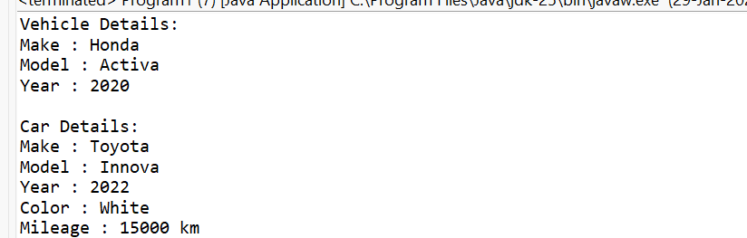
- Write a program to demonstrate inheritance by creating objects of both classes and accessing properties.
package Inheritance;
class Person {
String name;
int age;
}
class Student extends Person {
int rollNo;
String course;
}
public class Program3
{
public static void main(String[] args) {
Person p = new Person();
p.name = "Ravi";
p.age = 40;
System.out.println("Person Details:");
System.out.println("Name: " + p.name);
System.out.println("Age: " + p.age);
System.out.println();
Student s = new Student();
s.name = "Bharathi";
s.age = 21;
s.rollNo = 101;
s.course = "Java";
System.out.println("Student Details:");
System.out.println("Name: " + s.name);
System.out.println("Age: " + s.age);
System.out.println("Roll No: " + s.rollNo);
System.out.println("Course: " + s.course);
}}
OUTPUT:
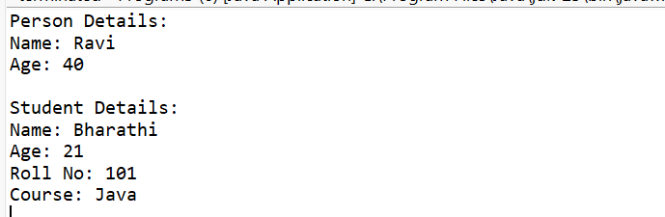

- Create a base class "Shape" with methods to calculate area and perimeter. Derive classes "Circle" and "Rectangle" from it and override the methods.
abstract class Shape {
abstract void calculateArea();
abstract void calculatePerimeter();
}
class Circle extends Shape {
double radius;
Circle(double radius) {
this.radius = radius;
}
void calculateArea() {
System.out.println("Circle Area : " + (Math.PI * radius * radius));
}
void calculatePerimeter() {
System.out.println("Circle Perimeter : " + (2 * Math.PI * radius));
}
}
class Rectangle extends Shape {
double length, width;
Rectangle(double length, double width) {
this.length = length;
this.width = width;
}
void calculateArea() {
System.out.println("Rectangle Area : " + (length * width));
}
void calculatePerimeter() {
System.out.println("Rectangle Perimeter : " + (2 * (length + width)));
}
}
public class Main {
public static void main(String[] args) {
Shape s1 = new Circle(5);
s1.calculateArea();
s1.calculatePerimeter();

Shape s2 = new Rectangle(10, 5);
s2.calculateArea();
s2.calculatePerimeter();
}}
OUTPUT: 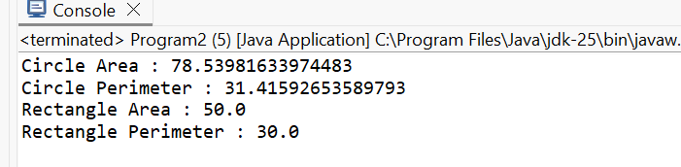
- Write a program to demonstrate inheritance by creating objects of derived classes and invoking base class methods.
package Inheritance;
class Employee {
String company;
Employee() {
company = "Infosys";
}
void displayCompany() {
System.out.println("Company: " + company);
}
}
class Developer extends Employee {
String role = "Software Developer";
void displayDeveloper() {
displayCompany();
System.out.println("Role: " + role);
}
}
class Tester extends Employee {
String role = "Software Tester";
void displayTester() {
displayCompany();
System.out.println("Role: " + role);
}}
public class Program4 {
public static void main(String[] args) {
Developer d = new Developer();
System.out.println("Developer Details:");
d.displayDeveloper();
System.out.println();
Tester t = new Tester();
System.out.pri ntln("Tester Details:");
t.displayTester();
}}
OUTPUT:
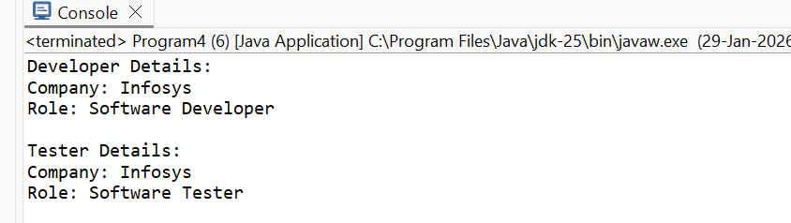
- Create a base class "Animal" with properties (name, age) and subclasses "Dog" and "Cat" with additional properties (breed, color).
package Inheritance;
class Animal {
String name;
int age;
Animal(String name, int age) {
this.name = name;
this.age = age;
}
void displayAnimal() {
System.out.println("Name : " + name);
System.out.println("Age : " + age);
}
}
class Dog extends Animal {
String breed;
Dog(String name, int age, String breed) {
super(name, age);
this.breed = breed;
}
void displayDog() {
displayAnimal();
System.out.println("Breed : " + breed);
}
}
class Cat extends Animal {
String color;
Cat(String name, int age, String color) {
super(name, age);
this.color = color;
}
void displayCat() {
displayAnimal();
System.out.println("Color : " + color);
}
}
public class Program5 {
public static void main(String[] args) {
Dog d = new Dog("Bruno", 3, "German Shepherd");
System.out.println("Dog Details:");
d.displayDog();
System.out.println();
Cat c = new Cat("Kitty", 2, "White");
System.out.println("Cat Details:");
c.displayCat();
}}
OUTPUT: 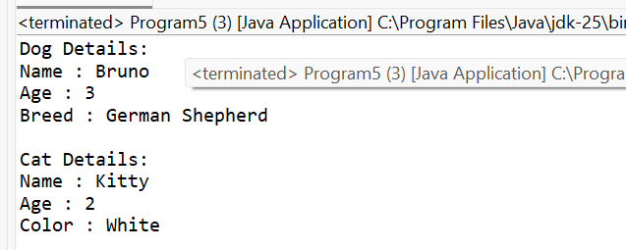
- Write a program to demonstrate inheritance by creating objects of derived classes and accessing properties.
package Inheritance;
class Fruit {
String name;
String color;
}
class Apple extends Fruit {
String taste;
}
class Banana extends Fruit {
String size;
}
public class Program6 {
public static void main(String[] args) {
Apple a = new Apple();
a.name = "Apple";
a.color = "Red";
a.taste = "Sweet";
Banana b = new Banana();
b.name = "Banana";
b.color = "Yellow";
b.size = "Large";
System.out.println("Apple Details:");
System.out.println(a.name + " " + a.color + " " + a.taste);
System.out.println();
System.out.println("Banana Details:");
System.out.println(b.name + " " + b.color + " " + b.size);
}
}
OUTPUT:
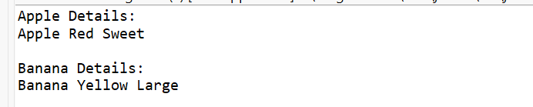
- Create a base class Employee with properties (name, id, salary) and a subclass Manager with additional properties (department, designation).
package Inheritance;
class Employee1 {
String name;
int id;
double salary;
}
class Manager extends Employee1{
String department;
String designation;
}
class Program6 {
public static void main(String[] args) {
Employee1 e = new Employee1();
e.name = "Ravi";
e.id = 101;
e.salary = 30000;
System.out.println("Employee Details:");
System.out.println(e.name + " " + e.id + " " + e.salary);
Manager m = new Manager();
m.name = "Bharathi";
m.id = 102;
m.salary = 60000;
m.department = "IT";
m.designation = "Manager";
System.out.println("Manager Details:");
System.out.println(m.name + " " + m.id + " " + m.salary);
System.out.println(m.department + " " + m.designation);
}
}
OUTPUT:
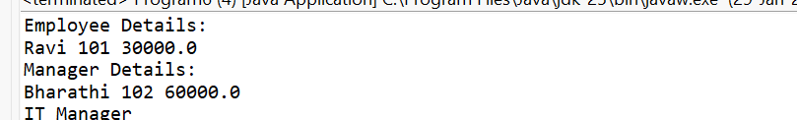
- Write a program to demonstrate inheritance by creating objects of both classes and accessing properties.
package Inheritance;
class Fruit {
String name;
String color;
}
class Apple extends Fruit {
String taste;
}
class Banana extends Fruit {
String size;
}
public class Program6 {
public static void main(String[] args) {
Apple a = new Apple();
a.name = "Apple";
a.color = "Red";
a.taste = "Sweet";
Banana b = new Banana();
b.name = "Banana";
b.color = "Yellow";
b.size = "Large";
System.out.println("Apple Details:");
System.out.println(a.name + " " + a.color + " " + a.taste);
System.out.println();
System.out.println("Banana Details:");
System.out.println(b.name + " " + b.color + " " + b.size);
}
}
OUTPUT:
- Create a base class Person with properties (name, age) and subclasses Student and Teacher with additional properties (roll number, subject).
package Inheritance;
class Person3 {
String name;
int age;
}
class Student3 extends Person3 {
int rollNo;
}
class Teacher extends Person3 {
String subject;
}
class Program9 {
public static void main(String[] args) {
Student s = new Student();
s.name = "Anu";
s.age = 20;
s.rollNo = 101;
Teacher t = new Teacher();
t.name = "Mr. Rao";
t.age = 45;
t.subject = "Java";
System.out.println(s.name + " " + s.age + " " + s.rollNo);
System.out.println(t.name + " " + t.age + " " + t.subject);
}
}
OUTPUT:
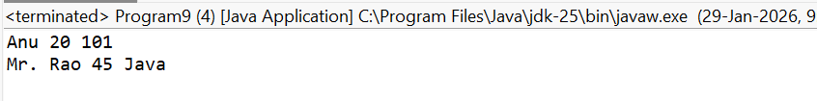
- Write a program to demonstrate inheritance by creating objects of derived classes and accessing properties.
package Inheritance;
class Fruit {
String name;
String color;
}
class Apple extends Fruit {
String taste;
}
class Banana extends Fruit {
String size;
}
public class Program6 {
public static void main(String[] args) {
Apple a = new Apple();
a.name = "Apple";
a.color = "Red";
a.taste = "Sweet";
Banana b = new Banana();
b.name = "Banana";
b.color = "Yellow";
b.size = "Large";
System.out.println("Apple Details:");
System.out.println(a.name + " " + a.color + " " + a.taste);
System.out.println();
System.out.println("Banana Details:");
System.out.println(b.name + " " + b.color + " " + b.size);
}
}
OUTPUT:
- Create a base class BankAccount with properties (account number, balance) and subclasses SavingsAccount and CurrentAccount.
package Inheritance;
class BankAccount {
int accountNumber;
double balance;
}
class SavingsAccount extends BankAccount {
double interestRate;
}
class CurrentAccount extends BankAccount {
double overdraftLimit;
}
class Program11 {
public static void main(String[] args) {
SavingsAccount s = new SavingsAccount();
s.accountNumber = 111;
s.balance = 5000;
s.interestRate = 4.5;
CurrentAccount c = new CurrentAccount();
c.accountNumber = 222;
c.balance = 10000;
c.overdraftLimit = 2000;
System.out.println(s.accountNumber + " " + s.balance + " " + s.interestRate);
System.out.println(c.accountNumber + " " + c.balance + " " + c.overdraftLimit);
}
}

OUTPUT:
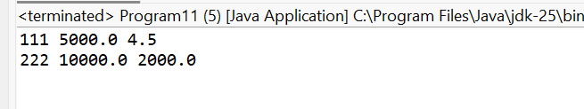
- Write a program to demonstrate inheritance by creating objects of derived classes and accessing properties.
package Inheritance;
class Fruit {
String name;
String color;
}
class Apple extends Fruit {
String taste;
}
class Banana extends Fruit {
String size;
}
public class Program6 {
public static void main(String[] args) {
Apple a = new Apple();
a.name = "Apple";
a.color = "Red";
a.taste = "Sweet";
Banana b = new Banana();
b.name = "Banana";
b.color = "Yellow";
b.size = "Large";
System.out.println("Apple Details:");
System.out.println(a.name + " " + a.color + " " + a.taste);
System.out.println();
System.out.println("Banana Details:");
System.out.println(b.name + " " + b.color + " " + b.size);
}
}
OUTPUT:
- Create a base class Shape with properties (type, color) and a subclass Triangle with additional properties (base, height).
package Inheritance;
class Shape1 {
String type;
String color;
}
class Triangle extends Shape1 {
double base;
double height;
}
class Program13 {
public static void main(String[] args) {
Shape1 s = new Shape1();
s.type = "Generic Shape";
s.color = "Red";
Triangle t = new Triangle();
t.type = "Triangle";
t.color = "Blue";
t.base = 10;
t.height = 5;
System.out.println(s.type + " " + s.color);
System.out.println(t.type + " " + t.color + " " + t.base + " " + t.height);
}
}
OUTPUT:
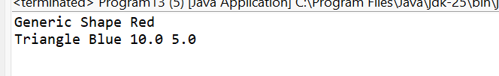
- Write a program to demonstrate inheritance by creating objects of both classes and accessing properties.
package Inheritance;
class Fruit {
String name;
String color;
}
class Apple extends Fruit {
String taste;
}
class Banana extends Fruit {
String size;
}
public class Program6 {
public static void main(String[] args) {
Apple a = new Apple();
a.name = "Apple";
a.color = "Red";
a.taste = "Sweet";
Banana b = new Banana();
b.name = "Banana";
b.color = "Yellow";
b.size = "Large";
System.out.println("Apple Details:");
System.out.println(a.name + " " + a.color + " " + a.taste);
System.out.println();
System.out.println("Banana Details:");
System.out.println(b.name + " " + b.color + " " + b.size);
}
}
OUTPUT:
- Create a base class Vehicle with properties (make, model, year) and a subclass Truck with additional properties (capacity, mileage).
package Inheritance;
class Vehicle1 {
String make;
String model;
int year;
}
class Truck extends Vehicle1{
int capacity;
int mileage;
}
class Program15 {
public static void main(String[] args) {
Vehicle1 v = new Vehicle1();
v.make = "Tata";
v.model = "Ace";
v.year = 2020;
Truck t = new Truck();
t.make = "Ashok Leyland";
t.model = "Dost";
t.year = 2022;
t.capacity = 2000;
t.mileage = 15;
System.out.println(v.make + " " + v.model + " " + v.year);
System.out.println(t.make + " " + t.model + " " + t.year + " " + t.capacity + " " + t.mileage);
}
}
OUTPUT:
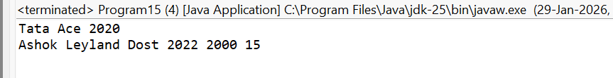
- Write a program to demonstrate inheritance by creating objects of both classes and accessing properties.
package Inheritance;
class Fruit {
String name;
String color;
}
class Apple extends Fruit {
String taste;
}
class Banana extends Fruit {
String size;
}
public class Program6 {
public static void main(String[] args) {
Apple a = new Apple();
a.name = "Apple";
a.color = "Red";
a.taste = "Sweet";
Banana b = new Banana();
b.name = "Banana";
b.color = "Yellow";
b.size = "Large";
System.out.println("Apple Details:");
System.out.println(a.name + " " + a.color + " " + a.taste);
System.out.println();
System.out.println("Banana Details:");
System.out.println(b.name + " " + b.color + " " + b.size);
}
}
OUTPUT:
- Create a base class Fruit with properties (name, color) and subclasses Apple and Banana with additional properties (taste, size).
package Inheritance;
class Fruit {
String name;
String color;
}
class Apple extends Fruit {
String taste;
}
class Banana extends Fruit {
String size;
}
public class Program6 {
public static void main(String[] args) {
Apple a = new Apple();
a.name = "Apple";
a.color = "Red";
a.taste = "Sweet";
Banana b = new Banana();
b.name = "Banana";
b.color = "Yellow";
b.size = "Large";
System.out.println("Apple Details:");
System.out.println(a.name + " " + a.color + " " + a.taste);
System.out.println();
System.out.println("Banana Details:");
System.out.println(b.name + " " + b.color + " " + b.size);
}
}
OUTPUT:

- Write a program to demonstrate inheritance by creating objects of derived classes and accessing properties.
package Inheritance;
class Fruit {
String name;
String color;
}
class Apple extends Fruit {
String taste;
}
class Banana extends Fruit {
String size;
}
public class Program6 {
public static void main(String[] args) {
Apple a = new Apple();
a.name = "Apple";
a.color = "Red";
a.taste = "Sweet";
Banana b = new Banana();
b.name = "Banana";
b.color = "Yellow";
b.size = "Large";
System.out.println("Apple Details:");
System.out.println(a.name + " " + a.color + " " + a.taste);
System.out.println();
System.out.println("Banana Details:");
System.out.println(b.name + " " + b.color + " " + b.size);
}
}
OUTPUT:
- Create a base class Animal with properties (name, type) and subclasses Dog and Cat with additional properties (breed, color).
package Inheritance;
class Animal1 {
String name;
String type;
}
class Dog1 extends Animal1 {
String breed;
}

class Cat1 extends Animal1 {
String color;
}
class Program19 {
public static void main(String[] args) {
Dog1 d = new Dog1();
d.name = "Bruno";
d.type = "Pet";
d.breed = "German Shepherd";
Cat1 c = new Cat1();
c.name = "Kitty";
c.type = "Pet";
c.color = "White";
System.out.println(d.name + " " + d.type + " " + d.breed);
System.out.println(c.name + " " + c.type + " " + c.color);
}
}
OUTPUT:
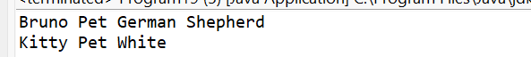
- Write a program to demonstrate inheritance by creating objects of both classes and accessing properties.
package Inheritance;
class Fruit {
String name;
String color;
}
class Apple extends Fruit {
String taste;
}
class Banana extends Fruit {
String size;
}
public class Program6 {
public static void main(String[] args) {
Apple a = new Apple();
a.name = "Apple";
a.color = "Red";
a.taste = "Sweet";
Banana b = new Banana();
b.name = "Banana";
b.color = "Yellow";
b.size = "Large";
System.out.println("Apple Details:");
System.out.println(a.name + " " + a.color + " " + a.taste);
System.out.println();
System.out.println("Banana Details:");
System.out.println(b.name + " " + b.color + " " + b.size);
}
}
OUTPUT:
- Create a base class Person with properties (name, age) and a subclass Employee with additional properties (id, salary).
class Person1 {
String name;
int age;
}
class Employee2 extends Person1 {
int id;
double salary;
}
class Program9 {
public static void main(String[] args) {
Person p = new Person();
p.name = "Ravi";
p.age = 35;
Employee2 e = new Employee2();
e.name = "Bharathi";
e.age = 22;
e.id = 101;
e.salary = 25000;
System.out.println(p.name + " " + p.age);
System.out.println(e.name + " " + e.age + " " + e.id + " " + e.salary);
}
}
OUTPUT:
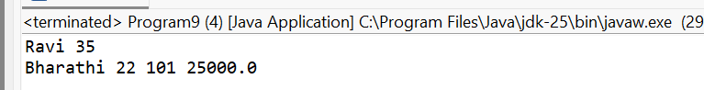
- Write a program to demonstrate inheritance by creating objects of both classes and accessing properties.
package Inheritance;
class Fruit {
String name;
String color;
}
class Apple extends Fruit {
String taste;
}
class Banana extends Fruit {
String size;
}
public class Program6 {
public static void main(String[] args) {
Apple a = new Apple();
a.name = "Apple";
a.color = "Red";
a.taste = "Sweet";
Banana b = new Banana();
b.name = "Banana";
b.color = "Yellow";
b.size = "Large";
System.out.println("Apple Details:");
System.out.println(a.name + " " + a.color + " " + a.taste);
System.out.println();
System.out.println("Banana Details:");
System.out.println(b.name + " " + b.color + " " + b.size);
}
}
OUTPUT:
- Create a base class Shape with properties (type, color) and a subclass Rectangle with additional properties (length, width).
package Inheritance;
class Shape2 {
String type;
String color;
}
class Rectangle1 extends Shape2 {
int length;
int width;
}
class Program23 {
public static void main(String[] args) {
Shape2 s = new Shape2();
s.type = "Shape";
s.color = "Green";

Rectangle1 r = new Rectangle1();
r.type = "Rectangle";
r.color = "Blue";
r.length = 10;
r.width = 5;
System.out.println(s.type + " " + s.color);
System.out.println(r.type + " " + r.color + " " + r.length + " " + r.width);
}
}
OUTPUT:
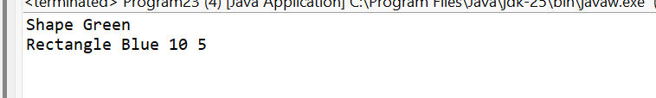
- Write a program to demonstrate inheritance by creating objects of both classes and accessing properties.
package Inheritance;
class Fruit {
String name;
String color;
}
class Apple extends Fruit {
String taste;
}
class Banana extends Fruit {
String size;
}
public class Program6 {
public static void main(String[] args) {
Apple a = new Apple();
a.name = "Apple";
a.color = "Red";
a.taste = "Sweet";
Banana b = new Banana();
b.name = "Banana";
b.color = "Yellow";
b.size = "Large";
System.out.println("Apple Details:");
System.out.println(a.name + " " + a.color + " " + a.taste);
System.out.println();
System.out.println("Banana Details:");
System.out.println(b.name + " " + b.color + " " + b.size);
}
}
OUTPUT:
- Create a base class Vehicle with properties (make, model, year) and a subclass Car with additional properties (color, mileage).
package Inheritance;
class Vehicle1 {
String make;
String model;
int year;
}
class Car extends Vehicle {
String color;
int mileage;
}
class Program25 {
public static void main(String[] args) {
Vehicle v = new Vehicle();
v.make = "Honda";
v.model = "City";
v.year = 2021;
Car c = new Car();
c.make = "Toyota";
c.model = "Innova";
c.year = 2023;
c.color = "White";
c.mileage = 18;
System.out.println(v.make + " " + v.model + " " + v.year);
System.out.println(c.make + " " + c.model + " " + c.year + " " + c.color + " " + c.mileage);
}
}
OUTPUT:
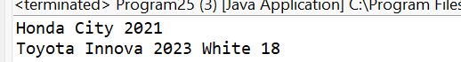

- Write a program to demonstrate inheritance by creating objects of both classes and accessing properties.
package Inheritance;
class Fruit {
String name;
String color;
}
class Apple extends Fruit {
String taste;
}
class Banana extends Fruit {
String size;
}
public class Program6 {
public static void main(String[] args) {
Apple a = new Apple();
a.name = "Apple";
a.color = "Red";
a.taste = "Sweet";
Banana b = new Banana();
b.name = "Banana";
b.color = "Yellow";
b.size = "Large";
System.out.println("Apple Details:");
System.out.println(a.name + " " + a.color + " " + a.taste);
System.out.println();
System.out.println("Banana Details:");
System.out.println(b.name + " " + b.color + " " + b.size);
}
}
OUTPUT:
- Create a base class Animal with properties (name, type) and a subclass Bird with additional properties (color, wingspan).
package Inheritance;
class Animal2{
String name;
String type;
}
class Bird extends Animal2 {
String color;
double wingspan;
}
class Program27 {
public static void main(String[] args) {
Animal2 a = new Animal2();
a.name = "Generic";
a.type = "Animal";
Bird b = new Bird();
b.name = "Parrot";
b.type = "Bird";
b.color = "Green";
b.wingspan = 0.5;
System.out.println(a.name + " " + a.type);
System.out.println(b.name + " " + b.type + " " + b.color + " " + b.wingspan);
}
}
OUTPUT:
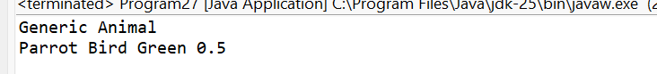
- Write a program to demonstrate inheritance by creating objects of both classes and accessing properties.
package Inheritance;
class Fruit {
String name;
String color;
}
class Apple extends Fruit {
String taste;
}
class Banana extends Fruit {
String size;
}
public class Program6 {
public static void main(String[] args) {
Apple a = new Apple();
a.name = "Apple";
a.color = "Red";
a.taste = "Sweet";
Banana b = new Banana();
b.name = "Banana";
b.color = "Yellow";
b.size = "Large";
System.out.println("Apple Details:");
System.out.println(a.name + " " + a.color + " " + a.taste);
System.out.println();
System.out.println("Banana Details:");
System.out.println(b.name + " " + b.color + " " + b.size);
}}
OUTPUT:
- Create a base class Shape with properties (type, color) and a subclass Circle with additional properties (radius, area).
package Inheritance;
class Shape3 {
String type;
String color;
}
class Circle1 extends Shape3 {
double radius;
double area;}
public class Program29 {
public static void main(String[] args) {
Shape3 s = new Shape3();
s.type = "Shape";
s.color = "Blue";
Circle1 c = new Circle1();
c.type = "Circle";
c.color = "Red";
c.radius = 5;
c.area = 3.14 * c.radius * c.radius;
System.out.println("Shape Details:");
System.out.println(s.type + " " + s.color);
System.out.println("\nCircle Details:");
System.out.println(c.type + " " + c.color + " " + c.radius + " " + c.area);
}}
OUTPUT: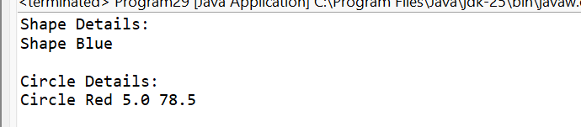
- Write a program to demonstrate inheritance by creating objects of both classes and accessing properties.
package Inheritance;
class Fruit {
String name;
String color;
}
class Apple extends Fruit {
String taste;
}
class Banana extends Fruit {
String size;
}
public class Program6 {
public static void main(String[] args) {
Apple a = new Apple();
a.name = "Apple";
a.color = "Red";
a.taste = "Sweet";
Banana b = new Banana();
b.name = "Banana";
b.color = "Yellow";
b.size = "Large";
System.out.println("Apple Details:");
System.out.println(a.name + " " + a.color + " " + a.taste);
System.out.println();
System.out.println("Banana Details:");
System.out.println(b.name + " " + b.color + " " + b.size);
}
}
OUTPUT:

- Create a base class Employee with properties (name, id, salary) and a subclass Manager with additional properties (department, designation).
package Inheritance;
class Employee3 {
String name;
int id;
double salary;
}
class Manager1 extends Employee3{
String department;
String designation;
}
public class Program31 {
public static void main(String[] args) {
Employee3 e = new Employee3();
e.name = "Ravi";
e.id = 101;
e.salary = 30000;
Manager m = new Manager();
m.name = "Bharathi";
m.id = 102;
m.salary = 60000;
m.department = "IT";
m.designation = "Manager";
System.out.println("Employee Details:");
System.out.println(e.name + " " + e.id + " " + e.salary);
System.out.println("\nManager Details:");
System.out.println(m.name + " " + m.id + " " + m.salary);
System.out.println(m.department + " " + m.designation);
}
}

OUTPUT:
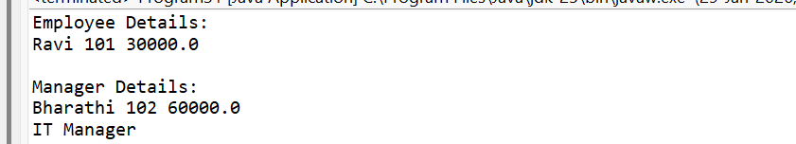

- Write a program to demonstrate inheritance by creating objects of both classes and accessing properties
package Inheritance;
class Fruit {
String name;
String color;
}
class Apple extends Fruit {
String taste;
}
class Banana extends Fruit {
String size;
}
public class Program6 {
public static void main(String[] args) {
Apple a = new Apple();
a.name = "Apple";
a.color = "Red";
a.taste = "Sweet";
Banana b = new Banana();
b.name = "Banana";
b.color = "Yellow";
b.size = "Large";
System.out.println("Apple Details:");
System.out.println(a.name + " " + a.color + " " + a.taste);
System.out.println();
System.out.println("Banana Details:");
System.out.println(b.name + " " + b.color + " " + b.size);
}
}
OUTPUT:
Exception Handling
- Write a program to handle ArrayIndexOutOfBoundsException.
package Exceptions;
class Program1 {
public static void main(String[] args) {
try {
int[] a = {1, 2, 3};
System.out.println(a[5]);
} catch (ArrayIndexOutOfBoundsException e) {
System.out.println("Array index out of bounds");
}
}
}
OUTPUT:
- Implement a program to handle ArithmeticException such as division by zero.
package Exceptions;
class Program2 {
public static void main(String[] args) {
try {
int a = 10 / 0;
} catch (ArithmeticException e) {
System.out.println("Cannot divide by zero");
}
}
}
OUTPUT:
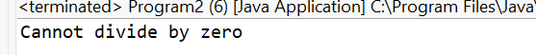
- Write a program to handle NullPointerException.
package Exceptions;
class Program3 {
public static void main(String[] args) {
try {
String s = null;
System.out.println(s.length());
} catch (NullPointerException e) {
System.out.println("Null reference accessed");
}
}
}
OUTPUT:
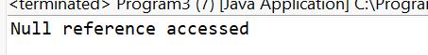
- Implement a program to handle FileNotFoundException.
package Exceptions;
import java.io.*;
class Program4 {
public static void main(String[] args) {
try {
FileReader fr = new FileReader("abc.txt");
} catch (FileNotFoundException e) {
System.out.println("File not found");
}
}
}
OUTPUT:
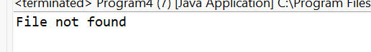
- Write a program to handle NumberFormatException.
package Exceptions;
class Program5 {
public static void main(String[] args) {
try {
int n = Integer.parseInt("abc");
} catch (NumberFormatException e) {
System.out.println("Invalid number format");
} }
}
OUTPUT:
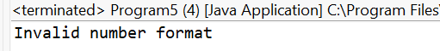
- Implement a program to handle IOException.
package Exceptions;
import java.io.*;
class Program6 {
public static void main(String[] args) {
try {
throw new IOException();
} catch (IOException e) {
System.out.println("IO Exception handled");
}
}
}
OUTPUT:
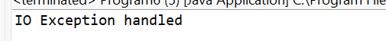
- Write a program to handle ClassNotFoundException.
package Exceptions;
class Program7 {
public static void main(String[] args) {
try {
Class.forName("Test");
} catch (ClassNotFoundException e) {
System.out.println("Class not found");
} }
}
OUTPUT:
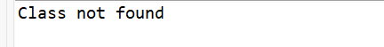
- Implement a program to handle StackOverflowError.
package Exceptions;
class Program8 {
static void display() {
display();
}
public static void main(String[] args) {
try {
display();
} catch (StackOverflowError e) {
System.out.println("Stack overflow error");
} }}
OUTPUT:
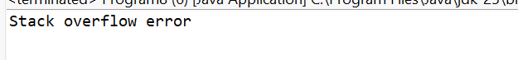
- Write a program to handle NegativeArraySizeException.
package Exceptions;
class Program9 {
public static void main(String[] args) {
try {
int[] a = new int[-5];
} catch (NegativeArraySizeException e) {
System.out.println("Negative array size");
}
}
}
OUTPUT:
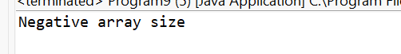

- Implement a program to handle InterruptedException.
package Exceptions;
class Program10 {
public static void main(String[] args) {
try {
Thread.sleep(100);
System.out.println("Thread woke up after 1 second");

} catch (InterruptedException e) {
System.out.println("Thread interrupted");
}
}
}
OUTPUT:
- Write a program to handle ArrayStoreException.
package Exceptions;
class Program11 {
public static void main(String[] args) {
try {
Object[] arr = new Integer[5];
arr[0] = "Hello";
} catch (ArrayStoreException e) {
System.out.println("Invalid array store");
} }}
OUTPUT:
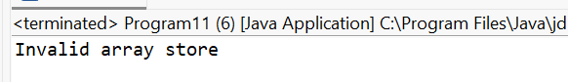
- Implement a program to handle IllegalStateException.
package Exceptions;
import java.util.*;
class Program12 {
public static void main(String[] args) {
try {
Iterator<Integer> it = new ArrayList<Integer>().iterator();
it.remove();
} catch (IllegalStateException e) {
System.out.println("Illegal state");
} }}
OUTPUT:
- Write a program to handle NoSuchElementException.
package Exceptions;
import java.util.*;
class Program13 {
public static void main(String[] args) {
try {
Iterator<Integer> it = new ArrayList<Integer>().iterator();
it.next();
} catch (NoSuchElementException e) {
System.out.println("No element found");
}
}
}
OUTPUT:
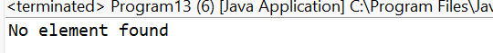
- Implement a program to handle UnsupportedOperationException.
package Exceptions;
import java.util.*;
class Program14 {
public static void main(String[] args) {
try {
List<Integer> list = List.of(1,2,3);
list.add(4);
} catch (UnsupportedOperationException e) {
System.out.println("Operation not supported");
}
}
}
OUTPUT:
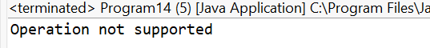
- Write a program to handle UnsupportedOperationException.
package Exceptions;
import java.util.*;
class Program14 {
public static void main(String[] args) {
try {
List<Integer> list = List.of(1,2,3);
list.add(4);
} catch (UnsupportedOperationException e) {
System.out.println("Operation not supported");
}
}
}
OUTPUT:
- Implement a program to handle ConcurrentModificationException.
package Exceptions;
import java.util.*;
class Program15 {
public static void main(String[] args) {
try {
ArrayList<Integer> list = new ArrayList<>();
list.add(1);
for(Integer i : list) {
list.add(2);
}
} catch (ConcurrentModificationException e) {
System.out.println("Concurrent modification");
} }}
OUTPUT:
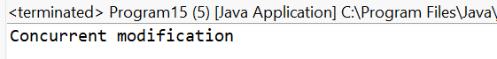
- Write a program to handle IllegalArgumentException.
package Exceptions;
class Program16 {
static void check(int age) {
if(age < 18)
throw new IllegalArgumentException();
}
public static void main(String[] args) {
try {
check(15);
} catch (IllegalArgumentException e) {
System.out.println("Invalid argument");
} }
}
OUTPUT:
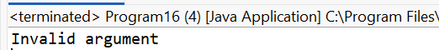
- Implement a program to handle SecurityException.
package Exceptions;
class Program17 {
public static void main(String[] args) {
try {
throw new SecurityException();
} catch (SecurityException e) {
System.out.println("Security exception");
}
}
}
OUTPUT:
- Write a program to handle DateTimeParseException
package Exceptions;
import java.time.*;
import java.time.format.*;
class Program18 {
public static void main(String[] args) {
try {
LocalDate.parse("abc");
} catch (DateTimeParseException e) {
System.out.println("Invalid date format");
}
}
}
OUTPUT:
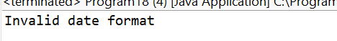
- Implement a program to handle PatternSyntaxException.
package Exceptions;
import java.util.regex.*;
class Program19 {
public static void main(String[] args) {
try {
Pattern.compile("[");
} catch (PatternSyntaxException e) {
System.out.println("Pattern syntax error");
}
}
}
OUTPUT:
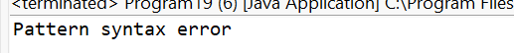
- Write a program to handle MissingResourceException.
package Exceptions;
import java.util.*;
class Program20 {
public static void main(String[] args) {
try {
ResourceBundle.getBundle("test");
} catch (MissingResourceException e) {
System.out.println("Resource missing");
}
}}
OUTPUT:
- Implement a program to handle FormatterClosedException.
package Exceptions;
import java.util.*;
class Program21 {
public static void main(String[] args) {
try {
Formatter f = new Formatter();
f.close();
f.format("Hello");
} catch (FormatterClosedException e) {
System.out.println("Formatter closed");
} }}
OUTPUT:
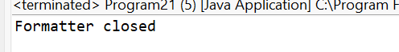
- Write a program to handle BufferOverflowException.
package Exceptions;
import java.nio.*;

class Program22 {
public static void main(String[] args) {
try {
ByteBuffer buffer = ByteBuffer.allocate(2);
buffer.put((byte)1);
buffer.put((byte)2);
buffer.put((byte)3);
} catch (BufferOverflowException e) {
System.out.println("Buffer overflow");
}
}
}
OUTPUT:
- Implement a program to handle BufferUnderflowException.
package Exceptions;
import java.nio.*;
class Program23 {
public static void main(String[] args) {
try {
ByteBuffer buffer = ByteBuffer.allocate(6);
buffer.get();
} catch (BufferUnderflowException e) {
System.out.println("Buffer underflow");
}
}
}
OUTPUT:
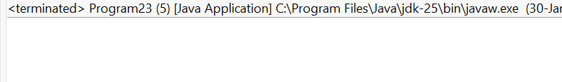
- Write a program to handle DateTimeException.
package Exceptions;
import java.time.*;

class Program24 {
public static void main(String[] args) {
try {
LocalDate.of(2025, 13, 10);
} catch (DateTimeException e) {
System.out.println("Invalid date time");
}
}
}

OUTPUT:
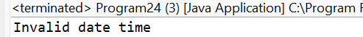
Interface:
- Create interfaces Drawable and Resizable with methods draw and resize. Implement them in a class representing a shape.
package Interfaces;
interface Drawable {
void draw();
}
interface Resizable {
void resize();
}
class Program1 implements Drawable, Resizable {
public void draw() {
System.out.println("Drawing shape");
}
public void resize() {
System.out.println("Resizing shape");
}
public static void main(String[] args) {
Program1 s = new Program1();
s.draw();
s.resize();
}
}
OUTPUT:
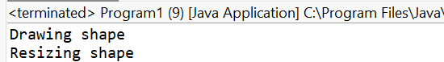
- Write a program to demonstrate interface implementation by creating objects of the shape class and invoking interface methods.
package Interfaces;
interface Drawable {
void draw();
}
interface Resizable {
void resize();
}
class Program1 implements Drawable, Resizable {
public void draw() {
System.out.println("Drawing shape");
}
public void resize() {
System.out.println("Resizing shape");
}
public static void main(String[] args) {
Program1 s = new Program1();
s.draw();
s.resize();
}
}
OUTPUT:
- Create interfaces Flyable and Swimmable with methods fly and swim. Implement them in classes representing a bird and a fish.
package Interfaces;
interface Flyable {
void fly();
}
interface Swimmable {
void swim();
}
class Bird implements Flyable {
public void fly() {
System.out.println("Bird is flying");
}
}
class Program2 implements Swimmable {
public void swim() {
System.out.println("Fish is swimming");
}
public static void main(String[] args) {
Bird b = new Bird();
Program2 f = new Program2();
b.fly();
f.swim();
}
}
OUTPUT:
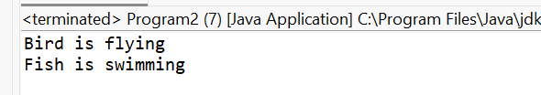
- Write a program to demonstrate interface implementation by creating objects of the bird and fish classes and invoking interface methods.
package Interfaces;
interface Drawable {
void draw();
}
interface Resizable {
void resize();
}
class Program1 implements Drawable, Resizable {
public void draw() {
System.out.println("Drawing shape");
}
public void resize() {
System.out.println("Resizing shape");
}
public static void main(String[] args) {
Program1 s = new Program1();
s.draw();
s.resize();
}
}
OUTPUT:
- Create interfaces Comparable and Cloneable with methods compareTo and clone. Implement them in classes representing a number and a person
package Interfaces;
interface MyComparable {
int compareTo(int x);
}
interface MyCloneable {
Object clone();
}
class MyNumber implements MyComparable, MyCloneable {
int n;
MyNumber(int n) {
this.n = n;
}
public int compareTo(int x) {
return n - x;
}
public Object clone() {
return new MyNumber(n);
}
}
class Person implements MyComparable, MyCloneable {
int age;
Person(int age) {
this.age = age;
}
public int compareTo(int x) {
return age - x;
}
public Object clone() {
return new Person(age);
}
}
public class Program5 {
public static void main(String[] args) {
MyNumber num = new MyNumber(10);
Person p = new Person(25);
System.out.println(num.compareTo(5));
System.out.println(p.compareTo(30));
MyNumber n2 = (MyNumber) num.clone();
Person p2 = (Person) p.clone();
System.out.println("Cloned objects created");
}
}
OUTPUT:
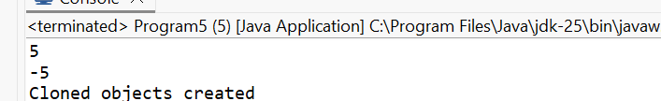
- Write a program to demonstrate interface implementation by creating objects of the number and person classes and invoking interface methods.
package Interfaces;
interface Drawable {
void draw();
}
interface Resizable {
void resize();
}
class Program1 implements Drawable, Resizable {
public void draw() {
System.out.println("Drawing shape");
}
public void resize() {
System.out.println("Resizing shape");
}
public static void main(String[] args) {
Program1 s = new Program1();
s.draw();
s.resize();
}
}
OUTPUT:
- Create interfaces List and Set with methods add, remove, and contains. Implement them in classes representing an array list and a hash set.
package Interfaces;
interface MyList {
void add(int x);
void remove(int x);
boolean contains(int x);
}
interface MySet {
void add(int x);
void remove(int x);
boolean contains(int x);
}
class MyArrayList implements MyList {
int[] arr = new int[5];
int size = 0;
public void add(int x) {
arr[size++] = x;
}
public void remove(int x) {
size--;
}
public boolean contains(int x) {
for(int i=0;i<size;i++)
if(arr[i]==x) return true;
return false;
}
}
class MyHashSet implements MySet {
int[] arr = new int[5];
int size = 0;
public void add(int x) {
arr[size++] = x;
}
public void remove(int x) {
size--;
}
public boolean contains(int x) {
for(int i=0;i<size;i++)
if(arr[i]==x) return true;
return false;
}
}
public class Program7 {
public static void main(String[] args) {
MyArrayList list = new MyArrayList();
MyHashSet set = new MyHashSet();
list.add(10);
set.add(20);
System.out.println(list.contains(10));
System.out.println(set.contains(20));
}
}OUTPUT:
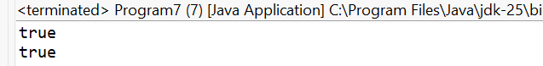
- Write a program to demonstrate interface implementation by creating objects of the array list and hash set classes and invoking interface methods.
package Interfaces;
interface Drawable {
void draw();
}
interface Resizable {
void resize();
}
class Program1 implements Drawable, Resizable {
public void draw() {
System.out.println("Drawing shape");
}
public void resize() {
System.out.println("Resizing shape");
}
public static void main(String[] args) {
Program1 s = new Program1();
s.draw();
s.resize();
}
}
OUTPUT:
- Create interfaces Printable and Scannable with methods print and scan. Implement them in classes representing a printer and a scanner.
package Interfaces;
interface Printable {
void print();
}
interface Scannable {
void scan();
}
class Printer implements Printable {
public void print() {
System.out.println("Printing document");
}
}
class ScannerMachine implements Scannable {
public void scan() {
System.out.println("Scanning document");
}
}
public class Program9 {
public static void main(String[] args) {
Printer p = new Printer();
ScannerMachine s = new ScannerMachine();
p.print();
s.scan();
}
}
OUTPUT
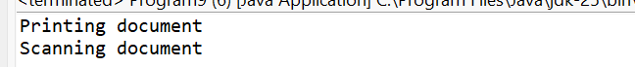
- Write a program to demonstrate interface implementation by creating objects of the printer and scanner classes and invoking interface methods.
package Interfaces;
interface Drawable {
void draw();
}
interface Resizable {
void resize();
}
class Program1 implements Drawable, Resizable {
public void draw() {
System.out.println("Drawing shape");
}
public void resize() {
System.out.println("Resizing shape");
}
public static void main(String[] args) {
Program1 s = new Program1();
s.draw();
s.resize();
}
}
OUTPUT:
- Create interfaces Sortable and Searchable with methods sort and search. Implement them in classes representing a list and a dictionary.
package Interfaces;
interface Sortable {
void sort();
}
interface Searchable {
void search();
}
class MyListData implements Sortable {
public void sort() {
System.out.println("List sorted");
}
}
class Dictionary implements Searchable {
public void search() {
System.out.println("Word searched in dictionary");
}
}
public class Program11 {
public static void main(String[] args) {
MyListData l = new MyListData();
Dictionary d = new Dictionary();
l.sort();
d.search();
}
}
OUTPUT:
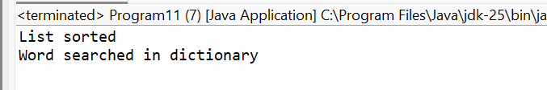
- Write a program to demonstrate interface implementation by creating objects of the list and dictionary classes and invoking interface methods.
package Interfaces;
interface Drawable {
void draw();
}
interface Resizable {
void resize();
}
class Program1 implements Drawable, Resizable {
public void draw() {
System.out.println("Drawing shape");
}
public void resize() {
System.out.println("Resizing shape");
}
public static void main(String[] args) {
Program1 s = new Program1();
s.draw();
s.resize();
}}
OUTPUT:
- Create interfaces Serializable and Deserializable with methods serialize and deserialize. Implement them in classes representing a file and a database.
package Interfaces;
interface Serializable {
void serialize();
}
interface Deserializable {
void deserialize();
}
class FileData implements Serializable {
public void serialize() {
System.out.println("File serialized");
}
}
class DatabaseData implements Deserializable {
public void deserialize() {
System.out.println("Database deserialized");
}
}
public class Program13 {
public static void main(String[] args) {
FileData f = new FileData();
DatabaseData d = new DatabaseData();
f.serialize();
d.deserialize();
}
}
OUTPUT:
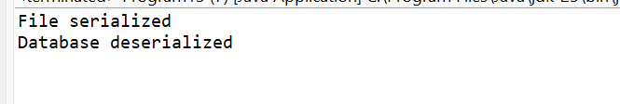
- Write a program to demonstrate interface implementation by creating objects of the file and database classes and invoking interface methods.
package Interfaces;
interface Drawable {
void draw();
}
interface Resizable {
void resize();
}
class Program1 implements Drawable, Resizable {
public void draw() {
System.out.println("Drawing shape");
}
public void resize() {
System.out.println("Resizing shape");
}
public static void main(String[] args) {
Program1 s = new Program1();
s.draw();
s.resize();
}
}
OUTPUT:
- Create interfaces Encryptable and Decryptable with methods encrypt and decrypt. Implement them in classes representing an encoder and a decoder.
package Interfaces;
interface Encryptable {
void encrypt();
}
interface Decryptable {
void decrypt();
}
class Encoder implements Encryptable {
public void encrypt() {
System.out.println("Data encrypted");
}
}
class Decoder implements Decryptable {
public void decrypt() {
System.out.println("Data decrypted");
}
}
public class Program15 {
public static void main(String[] args) {
Encoder e = new Encoder();
Decoder d = new Decoder();

e.encrypt();
d.decrypt();
}
}
OUTPUT:
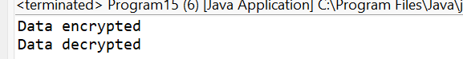
- Write a program to demonstrate interface implementation by creating objects of the encoder and decoder classes and invoking interface methods.
package Interfaces;
interface Drawable {
void draw();
}
interface Resizable {
void resize();
}
class Program1 implements Drawable, Resizable {
public void draw() {
System.out.println("Drawing shape");
}
public void resize() {
System.out.println("Resizing shape");
}
public static void main(String[] args) {
Program1 s = new Program1();
s.draw();
s.resize();
}
}
OUTPUT:
- Create interfaces Runnable and Walkable with methods run and walk. Implement them in classes representing a cheetah and a tortoise.
package Interfaces;
interface Runnable {
void run();
}
interface Walkable {
void walk();
}
class Cheetah implements Runnable {
public void run() {
System.out.println("Cheetah is running fast");
}
}
class Tortoise implements Walkable {
public void walk() {
System.out.println("Tortoise is walking slowly");
}
}
public class Program17 {
public static void main(String[] args) {
Cheetah c = new Cheetah();
Tortoise t = new Tortoise();
c.run();
t.walk();
}
}
OUTPUT:
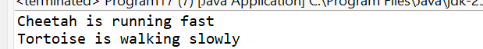
- Write a program to demonstrate interface implementation by creating objects of the cheetah and tortoise classes and invoking interface methods.
package Interfaces;
interface Drawable {
void draw();
}
interface Resizable {
void resize();
}

class Program1 implements Drawable, Resizable {
public void draw() {
System.out.println("Drawing shape");
}
public void resize() {
System.out.println("Resizing shape");
}
public static void main(String[] args) {
Program1 s = new Program1();
s.draw();
s.resize();
}
}
OUTPUT:
- Create interfaces Playable and Recordable with methods play and record. Implement them in classes representing a music player and a recorder.
package Interfaces;
interface Playable {
void play();
}
interface Recordable {
void record();
}
class MusicPlayer implements Playable {
public void play() {
System.out.println("Playing music");
}
}
class Recorder implements Recordable {
public void record() {
System.out.println("Recording audio");
}
}
public class Program19 {
public static void main(String[] args) {
MusicPlayer m = new MusicPlayer();
Recorder r = new Recorder();
m.play();
r.record();
}
}
OUTPUT:
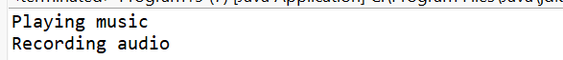
- Write a program to demonstrate interface implementation by creating objects of the music player and recorder classes and invoking interface methods.
package Interfaces;
interface Drawable {
void draw();
}
interface Resizable {
void resize();
}
class Program1 implements Drawable, Resizable {
public void draw() {
System.out.println("Drawing shape");
}
public void resize() {
System.out.println("Resizing shape");
}
public static void main(String[] args) {
Program1 s = new Program1();
s.draw();
s.resize();
}}
OUTPUT:
- Create interfaces Drawable and Erasable with methods draw and erase. Implement them in classes representing a whiteboard and a chalkboard.
package Interfaces;
interface Drawable {
void draw();
}
interface Erasable {
void erase();
}
class WhiteBoard implements Drawable {
public void draw() {
System.out.println("Drawing on whiteboard");
}
}
class ChalkBoard implements Erasable {
public void erase() {
System.out.println("Erasing chalkboard");
}
}
public class Program21 {
public static void main(String[] args) {
WhiteBoard w = new WhiteBoard();
ChalkBoard c = new ChalkBoard();
w.draw();
c.erase();
}
}
OUTPUT:
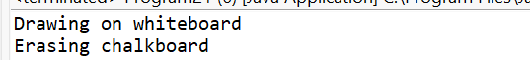
- Write a program to demonstrate interface implementation by creating objects of the whiteboard and chalkboard classes and invoking interface methods.
package Interfaces;
interface Drawable {
void draw();
}
interface Resizable {
void resize();
}
class Program1 implements Drawable, Resizable {
public void draw() {
System.out.println("Drawing shape");
}
public void resize() {
System.out.println("Resizing shape");
}
public static void main(String[] args) {
Program1 s = new Program1();
s.draw();
s.resize();
}
}
OUTPUT:
- Create interfaces Sendable and Receivable with methods send and receive. Implement them in classes representing a transmitter and a receiver.
package Interfaces;
interface Sendable {
void send();
}
interface Receivable {
void receive();
}
class Transmitter implements Sendable {
public void send() {
System.out.println("Sending signal");
}
}class Receiver implements Receivable {
public void receive() {
System.out.println("Receiving signal");
}
}
public class Program23 {
public static void main(String[] args) {
Transmitter t = new Transmitter();
Receiver r = new Receiver();
t.send();
r.receive();
}
}
OUTPUT:
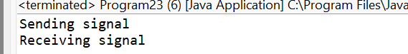
- Write a program to demonstrate interface implementation by creating objects of the transmitter and receiver classes and invoking interface methods.
package Interfaces;
interface Drawable {
void draw();
}
interface Resizable {
void resize();
}
class Program1 implements Drawable, Resizable {
public void draw() {
System.out.println("Drawing shape");
}
public void resize() {
System.out.println("Resizing shape");
}
public static void main(String[] args) {
Program1 s = new Program1();
s.draw();
s.resize();
}}
OUTPUT:
- Create interfaces Encryptable and Decryptable with methods encrypt and decrypt. Implement them in classes representing an encryption algorithm and a decryption algorithm.
package Interfaces;
class EncryptionAlgorithm implements Encryptable {
public void encrypt() {
System.out.println("Algorithm encrypting data");
}
}
class DecryptionAlgorithm implements Decryptable {
public void decrypt() {
System.out.println("Algorithm decrypting data");
}
}
public class Program25 {
public static void main(String[] args) {
EncryptionAlgorithm e = new EncryptionAlgorithm();
DecryptionAlgorithm d = new DecryptionAlgorithm();
e.encrypt();
d.decrypt();
}
}
OUTPUT:
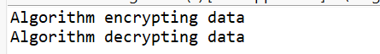
- Write a program to demonstrate interface implementation by creating objects of the encryption and decryption classes and invoking interface methods.
package Interfaces;
interface Drawable {
void draw();
}
interface Resizable {
void resize();
}
class Program1 implements Drawable, Resizable {
public void draw() {
System.out.println("Drawing shape");
}
public void resize() {
System.out.println("Resizing shape");
}
public static void main(String[] args) {
Program1 s = new Program1();
s.draw();
s.resize();
}
}
OUTPUT:
- Create interfaces Writable and Readable with methods write and read. Implement them in classes representing a text file and a database table.
package Interfaces;
interface Writable {
void write();
}
interface Readable {
void read();
}
class TextFile implements Writable {
public void write() {
System.out.println("Writing to text file");
}
}
class DatabaseTable implements Readable {
public void read() {
System.out.println("Reading from database table");
}
}
public class Program27 {
public static void main(String[] args) {
TextFile t = new TextFile();
DatabaseTable d = new DatabaseTable();
t.write();
d.read();
}}
OUTPUT:
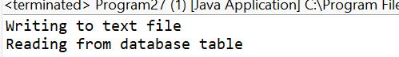
- Write a program to demonstrate interface implementation by creating objects of the text file and database table classes and invoking interface methods.
package Interfaces;
interface Drawable {
void draw();
}
interface Resizable {
void resize();
}
class Program1 implements Drawable, Resizable {
public void draw() {
System.out.println("Drawing shape");
}
public void resize() {
System.out.println("Resizing shape");
}
public static void main(String[] args) {
Program1 s = new Program1();
s.draw();
s.resize();
}
}
OUTPUT:
- Create interfaces Drawable and Printable with methods draw and print. Implement them in classes representing a canvas and a printer.
package Interfaces;
class Canvas implements Drawable {
public void draw() {
System.out.println("Drawing on canvas");
}
}
class OfficePrinter implements Printable {
public void print() {
System.out.println("Printing from printer");
}
}
public class Program29 {
public static void main(String[] args) {
Canvas c = new Canvas();
OfficePrinter p = new OfficePrinter();
c.draw();
p.print();
}
}
OUTPUT:
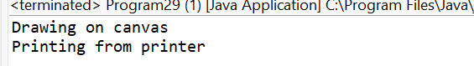
- Write a program to demonstrate interface implementation by creating objects of the canvas and printer classes and invoking interface methods.
package Interfaces;
interface Drawable {
void draw();
}
interface Resizable {
void resize();
}

class Program1 implements Drawable, Resizable {
public void draw() {
System.out.println("Drawing shape");
}
public void resize() {
System.out.println("Resizing shape");
}
public static void main(String[] args) {
Program1 s = new Program1();
s.draw();
s.resize();
}
}
OUTPUT:
- Create interfaces Runnable and Callable with methods run and call. Implement them in classes representing a thread and a task.
package Interfaces;
interface MyRunnable {
void run();
}
interface MyCallable {
void call();
}
class MyThread implements MyRunnable {
public void run() {
System.out.println("Thread running");
}
class MyTask implements MyCallable {
public void call() {
System.out.println("Task executing");
}}
public class Program31 {
public static void main(String[] args) {
MyThread t = new MyThread();
MyTask task = new MyTask();
t.run();
task.call();
}
}
OUTPUT:
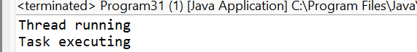
- Write a program to demonstrate interface implementation by creating objects of the thread and task classes and invoking interface methods.
package Interfaces;
interface Drawable {
void draw();
}
interface Resizable {
void resize();
}
class Program1 implements Drawable, Resizable {
public void draw() {
System.out.println("Drawing shape");
}
public void resize() {
System.out.println("Resizing shape");
}
public static void main(String[] args) {
Program1 s = new Program1();
s.draw();
s.resize();
}}
OUTPUT:
Collection
- Write a program to demonstrate ArrayList by adding, removing, and iterating over elements.
package Collections;
import java.util.*;
class ArrayListDemo {
public static void main(String[] args) {
ArrayList<String> list = new ArrayList<>();
list.add("A");
list.add("B");
list.add("C");
list.remove("B");
for(String s : list) {
System.out.println(s);
}
}
}

OUTPUT:
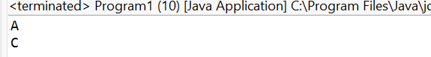
- Implement a program to demonstrate LinkedList by adding, removing, and iterating over elements.
package Collections;
import java.util.*;
class Program1 {
public static void main(String[] args) {
LinkedList<Integer> list = new LinkedList<>();
list.add(10);
list.add(20);
list.add(30);
list.remove(Integer.valueOf(20));
for(int i : list) {
System.out.println(i);
}
}
}
OUTPUT:
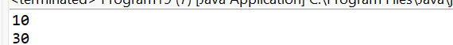
- Write a program to demonstrate HashSet by adding, removing, and iterating over elements.
package Collections;
import java.util.*;
class Program3 {
public static void main(String[] args) {
HashSet<Integer> set = new HashSet<>();
set.add(1);
set.add(2);
set.add(3);
set.remove(2);
for(int i : set) {
System.out.println(i);
}
}
}
OUTPUT:
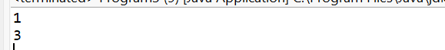
- Implement a program to demonstrate TreeSet by adding, removing, and iterating over elements.
package Collections;
import java.util.*;
class Program4 {
public static void main(String[] args) {
TreeSet<Integer> set = new TreeSet<>();
set.add(30);
set.add(10);
set.add(20);
set.remove(10);
for(int i : set) {
System.out.println(i);
}
}
}
OUTPUT:
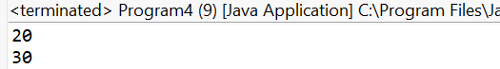
- Write a program to demonstrate HashMap by adding and retrieving key value pairs.
package Collections;
import java.util.*;
class Program5 {
public static void main(String[] args) {
HashMap<Integer, String> map = new HashMap<>();
map.put(1, "Java");
map.put(2, "Python");
System.out.println(map.get(1));
System.out.println(map.get(2));
}
}
OUTPUT:
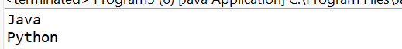
- Implement a program to demonstrate TreeMap by adding and retrieving key value pairs.
package Collections;
import java.util.*;
class Program6 {
public static void main(String[] args) {
TreeMap<Integer, String> map = new TreeMap<>();
map.put(3, "C");
map.put(1, "Java");
map.put(2, "Python");
for(Map.Entry<Integer,String> e : map.entrySet()) {
System.out.println(e.getKey() + " " + e.getValue());
}
}
}
OUTPUT:
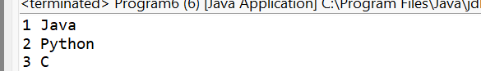
- Write a program to demonstrate LinkedHashMap by adding and retrieving key value pairs.
package Collections;
import java.util.*;
class Program7 {
public static void main(String[] args) {
LinkedHashMap<Integer, String> map = new LinkedHashMap<>();
map.put(1, "One");
map.put(2, "Two");
for(Map.Entry<Integer,String> e : map.entrySet()) {
System.out.println(e.getKey() + " " + e.getValue());
}
}
}

OUTPUT:
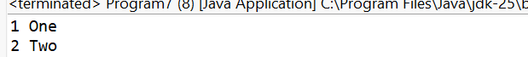
- Implement a program to demonstrate Queue by adding, removing, and iterating over elements.
package Collections;
import java.util.*;
class Program8 {
public static void main(String[] args) {
Queue<Integer> q = new LinkedList<>();
q.add(10);
q.add(20);
q.remove();
for(int i : q) {
System.out.println(i);
}
}}
OUTPUT:
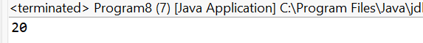
- Write a program to demonstrate PriorityQueue by adding, removing, and iterating over elements.
package Collections;
import java.util.*;
class Program9 {
public static void main(String[] args) {
PriorityQueue<Integer> pq = new PriorityQueue<>();
pq.add(30);
pq.add(10);
pq.add(20);
pq.poll();
for(int i : pq) {
System.out.println(i);
} }}
OUTPUT:
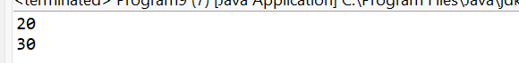
- Implement a program to demonstrate Stack by adding, removing, and iterating over elements.
package Collections;
import java.util.*;
class Program10 {
public static void main(String[] args) {
Stack<Integer> stack = new Stack<>();
stack.push(1);
stack.push(2);
stack.pop();
for(int i : stack) {
System.out.println(i);
}
}
}
OUTPUT:
- Write a program to demonstrate ArrayDeque by adding, removing, and iterating over elements.
package Collections;
import java.util.*;
class Program11 {
public static void main(String[] args) {
ArrayDeque<Integer> dq = new ArrayDeque<>();
dq.add(10);
dq.add(20);
dq.remove();
for(int i : dq) {
System.out.println(i);
}
}}
OUTPUT:
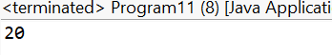
- Implement a program to demonstrate EnumSet by adding, removing, and iterating over elements.
package Collections;
import java.util.*;
enum Day { MON, TUE, WED }
class Program12 {
public static void main(String[] args) {
EnumSet<Day> set = EnumSet.allOf(Day.class);
set.remove(Day.TUE);
for(Day d : set) {
System.out.println(d);
}
}}
OUTPUT:
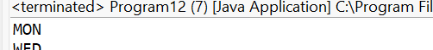

- Write a program to demonstrate BitSet by adding, removing, and iterating over elements.
package Collections;
import java.util.*;
class Program13 {
public static void main(String[] args) {
BitSet bs = new BitSet();
bs.set(1);
bs.set(3);
bs.clear(1);
System.out.println(bs);
}}
OUTPUT:
- Implement a program to demonstrate Hashtable by adding and retrieving key value pairs.
package Collections;
import java.util.*;
class Program14 {
public static void main(String[] args) {
Hashtable<Integer, String> ht = new Hashtable<>();
ht.put(1, "One");
ht.put(2, "Two");
System.out.println(ht.get(1));
}}
OUTPUT:
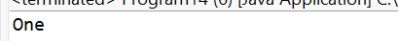
- Write a program to demonstrate Properties by adding and retrieving key value pairs.
package Collections;
import java.util.*;
class Program15 {
public static void main(String[] args) {
Properties p = new Properties();
p.setProperty("username", "admin");
p.setProperty("password", "123");
System.out.println(p.getProperty("username"));
}}
OUTPUT:
- Implement a program to demonstrate Vector by adding, removing, and iterating over elements.
package Collections;
import java.util.*;
class Program16 {
public static void main(String[] args) {
Vector<String> v = new Vector<>();
v.add("A");
v.add("B");
v.remove("A");
for(String s : v) {
System.out.println(s);
}
}
}
OUTPUT:
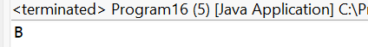
- Write a program to demonstrate Enumeration by iterating over elements of a collection.
package Collections;
import java.util.*;
class Program17 {
public static void main(String[] args) {
Vector<Integer> v = new Vector<>();
v.add(1);
v.add(2);
Enumeration<Integer> e = v.elements();
while(e.hasMoreElements()) {
System.out.println(e.nextElement());
}
}
}
OUTPUT:
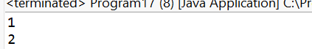
- Implement a program to demonstrate ListIterator by iterating over elements of a list.
package Collections;
import java.util.*;
class Program18 {
public static void main(String[] args) {
ArrayList<String> list = new ArrayList<>();
list.add("X");
list.add("Y");
ListIterator<String> it = list.listIterator();
while(it.hasNext()) {
System.out.println(it.next());
}
}
}

OUTPUT:
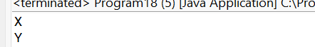
- Write a program to demonstrate Iterator by iterating over elements of a collection.
package Collections;
import java.util.*;
class Program19 {
public static void main(String[] args) {
ArrayList<Integer> list = new ArrayList<>();
list.add(10);
list.add(20);
Iterator<Integer> it = list.iterator();
while(it.hasNext()) {
System.out.println(it.next());
}
}
}
OUTPUT:
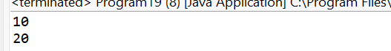
- Implement a program to demonstrate ArrayBlockingQueue by adding, removing, and iterating over elements.
package Collections;
import java.util.concurrent.*;
class Program20 {
public static void main(String[] args) {
ArrayBlockingQueue<Integer> q = new ArrayBlockingQueue<>(3);
q.add(1);
q.add(2);
q.remove();
for(int i : q) {
System.out.println(i);
}
}
}
OUTPUT:
- Write a program to demonstrate LinkedBlockingQueue by adding, removing, and iterating over elements.
package Collections;
import java.util.concurrent.*;
class Program21 {
public static void main(String[] args) {
LinkedBlockingQueue<Integer> q = new LinkedBlockingQueue<>();
q.add(10);
q.add(20);
q.remove();
for(int i : q) {
System.out.println(i);
}
}
}
OUTPUT:
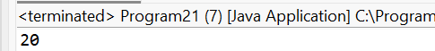
- Implement a program to demonstrate PriorityBlockingQueue by adding, removing, and iterating over elements.
package Collections;
import java.util.concurrent.*;
class Program22 {
public static void main(String[] args) {
PriorityBlockingQueue<Integer> q = new PriorityBlockingQueue<>();
q.add(30);
q.add(10);
q.add(20);
q.poll();
for(int i : q) {
System.out.println(i);
}
}
}
OUTPUT:
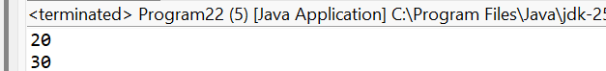
- Write a program to demonstrate SynchronousQueue by adding and removing elements.
package Collections;
import java.util.concurrent.*;
class Program23 {
public static void main(String[] args) throws Exception {
SynchronousQueue<Integer> q = new SynchronousQueue<>();
new Thread(() -> {
try {
q.put(10);
} catch (Exception e) {}
}).start();
System.out.println(q.take());
}
}
OUTPUT:
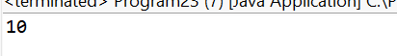
- Implement a program to demonstrate DelayQueue by adding and retrieving elements.
package Collections;
import java.util.concurrent.*;
import java.util.*;
class MyDelay implements Delayed {
long time;
MyDelay(long delay) {
time = System.currentTimeMillis() + delay;
}
public long getDelay(TimeUnit unit) {
return unit.convert(time - System.currentTimeMillis(), TimeUnit.MILLISECONDS);
}
public int compareTo(Delayed d) {
return Long.compare(this.time, ((MyDelay)d).time);
}
}
class Program24 {
public static void main(String[] args) throws Exception {
DelayQueue<MyDelay> dq = new DelayQueue<>();
dq.add(new MyDelay(1000));
System.out.println("Element retrieved: " + dq.take());
}
}
OUTPUT:
- Write a program to demonstrate ConcurrentLinkedQueue by adding, removing, and iterating over elements.
package Collections;
import java.util.concurrent.*;
class Program25 {
public static void main(String[] args) {
ConcurrentLinkedQueue<Integer> q = new ConcurrentLinkedQueue<>();
q.add(1);
q.add(2);
q.remove();
for(int i : q) {
System.out.println(i);
}
}}
OUTPUT:
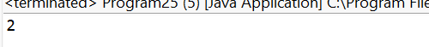
Multi Threading
- Write a Java program to create multiple threads and display their names.
package Multithreding;
class MyThread extends Thread {
public void run() {
System.out.println("Thread name: " + Thread.currentThread().getName());
}
}
public class Program1 {
public static void main(String[] args) {
new MyThread().start();
new MyThread().start();
new MyThread().start();
}
}
OUTPUT:
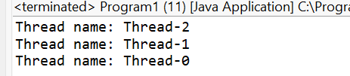
- Implement a program to demonstrate thread synchronization using synchronized blocks.
package Multithreding;
class Counter {
int count = 0;
void increment() {
synchronized (this) {
count++;
}
}
}
public class Program2 {
public static void main(String[] args) throws Exception {
Counter c = new Counter();
Thread t1 = new Thread(() -> { for(int i=0;i<1000;i++) c.increment(); });
Thread t2 = new Thread(() -> { for(int i=0;i<1000;i++) c.increment(); });
t1.start(); t2.start();
t1.join(); t2.join();
System.out.println("Count: " + c.count);
}
}
OUTPUT:
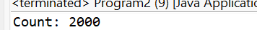
- Write a Java program to create multiple threads and display their priorities.
package Multithreding;
class Program3 extends Thread {
public void run() {
System.out.println(getName() + " Priority: " + getPriority());
}
public static void main(String[] args) {
Program3 t1 = new Program3();
Program3 t2 = new Program3();
t1.setPriority(1);
t2.setPriority(10);
t1.start();
t2.start();
}
}
OUTPUT:
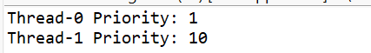
- Implement a program to create a thread pool and execute multiple tasks using Executor Service.
package Multithreding;
import java.util.concurrent.*;
public class Program4 {
public static void main(String[] args) {
ExecutorService es = Executors.newFixedThreadPool(3);
for(int i=1;i<=5;i++) {
es.execute(() -> System.out.println("Task by " + Thread.currentThread().getName()));
}
es.shutdown();
}
}
OUTPUT:
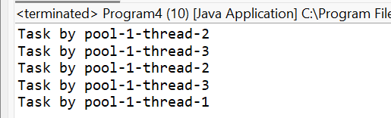
- Write a Java program to create multiple threads and join them.
package Multithreding;
class Program5 extends Thread {
public void run() {
System.out.println(getName() + " running");
}
public static void main(String[] args) throws Exception {
Program5 t1 = new Program5();
Program5 t2 = new Program5();
t1.start();
t1.join();
t2.start();
}}
OUTPUT:
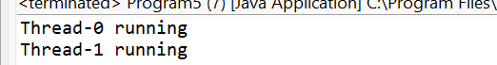
- Implement a program to demonstrate deadlock condition in multithreading.
package Multithreding;
class Program6 {
static final Object A = new Object();
static final Object B = new Object();
public static void main(String[] args) {
Thread t1 = new Thread(() -> {
synchronized(A) {
synchronized(B) {}
}
});
Thread t2 = new Thread(() -> {
synchronized(B) {
synchronized(A) {}
}
});
t1.start();
t2.start();
}
}
OUTPUT:
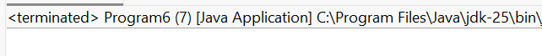
- Write a Java program to create multiple threads and interrupt them.
package Multithreding;
class Program7 extends Thread {
public void run() {
try {
Thread.sleep(5000);
} catch (InterruptedException e) {
System.out.println("Thread interrupted");
}
}
public static void main(String[] args) {
Program7 t = new Program7();
t.start();
t.interrupt();
}
}
OUTPUT:
- Implement a program to demonstrate thread local variables.
package Multithreding;
class Program8 {
static ThreadLocal<Integer> tl = ThreadLocal.withInitial(() -> 0);
public static void main(String[] args) {
Runnable r = () -> {
tl.set((int)(Math.random()*100));
System.out.println(Thread.currentThread().getName() + " value: " + tl.get());
};
new Thread(r).start();
new Thread(r).start();
}
}
OUTPUT:
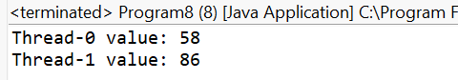
- Write a Java program to create multiple threads and wait for them to complete using Count Down Latch.
package Multithreding;
import java.util.concurrent.*;
public class Program9 {
public static void main(String[] args) throws Exception {
CountDownLatch latch = new CountDownLatch(3);
for(int i=1;i<=3;i++) {
new Thread(() -> {
System.out.println("Task done");
latch.countDown();
}).start();
}
latch.await();
System.out.println("All threads completed");
}
}
OUTPUT:
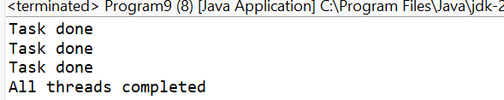
- Implement a program to demonstrate thread priorities in Java.
package Multithreding;
public class Program10 {
public static void main(String[] args) {
Thread t = new Thread();
t.setPriority(Thread.MAX_PRIORITY);
System.out.println(t.getPriority());
}
}
OUTPUT:
- Write a Java program to create multiple threads and use thread group.
package Multithreding;
public class Program11 {
public static void main(String[] args) {
ThreadGroup g = new ThreadGroup("MyGroup");
new Thread(g, () -> System.out.println("Thread in group")).start();
System.out.println("Group name: " + g.getName());
}
}
OUTPUT:
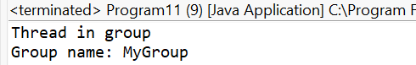
- Implement a program to demonstrate thread communication using wait and notify methods.
package Multithreding;
class Shared {
synchronized void waitMethod() throws Exception {
wait();
System.out.println("Resumed");
}
synchronized void notifyMethod() {
notify();
}
}
public class Program12 {
public static void main(String[] args) {
Shared s = new Shared();

new Thread(() -> {
try { s.waitMethod(); } catch(Exception e){}
}).start();

new Thread(() -> {
try { Thread.sleep(1000); s.notifyMethod(); } catch(Exception e){}
}).start();
}}
OUTPUT:
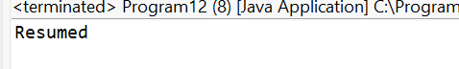
- Write a Java program to create multiple threads and use thread local variables.
package Multithreding;
class Program13 {
static ThreadLocal<String> tl = new ThreadLocal<>();
public static void main(String[] args) {
new Thread(() -> {
tl.set("A");
System.out.println(tl.get());
}).start();
}}
OUTPUT:
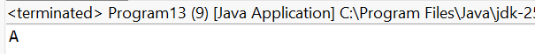
- Implement a program to demonstrate thread communication using volatile keyword.
package Multithreding;
class Program14 {
volatile boolean flag = true;
public static void main(String[] args) throws Exception {
Program14 v = new Program14();
new Thread(() -> {
while(v.flag){}
System.out.println("Stopped");
}).start();
Thread.sleep(1000);
v.flag = false;
}
}
OUTPUT:
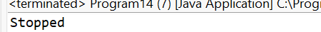
- Write a Java program to create multiple threads and use Executors framework.
package Multithreding;
import java.util.concurrent.*;
public class Program15 {
public static void main(String[] args) {
ExecutorService es = Executors.newSingleThreadExecutor();
es.submit(() -> System.out.println("Executor task"));
es.shutdown();
}
}
OUTPUT:
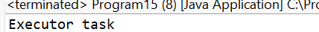
- Implement a program to demonstrate thread interruption in Java.
package Multithreding;
public class Program16 {
public static void main(String[] args) {
Thread t = new Thread(() -> {
while(!Thread.currentThread().isInterrupted()) {}
System.out.println("Interrupted");
});
t.start();
t.interrupt();
}
}
OUTPUT:
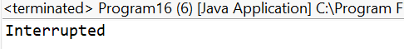

- Write a Java program to create multiple threads and use Callable and Future.
package Multithreding;
import java.util.concurrent.*;
public class Program17 {
public static void main(String[] args) throws Exception {
ExecutorService es = Executors.newSingleThreadExecutor();
Future<Integer> f = es.submit(() -> 10 + 20);
System.out.println(f.get());
es.shutdown();
}
}
OUTPUT:
- Implement a program to demonstrate thread communication using BlockingQueue.
package Multithreding;
import java.util.concurrent.*;
public class Program18 {
public static void main(String[] args) throws Exception {
BlockingQueue<Integer> q = new ArrayBlockingQueue<>(1);
new Thread(() -> {
try { q.put(10); } catch(Exception e){}
}).start();
System.out.println(q.take());
}
}
OUTPUT:
- Write a Java program to create multiple threads and use Phaser.
package Multithreding;
import java.util.concurrent.*;
public class Program19 {
public static void main(String[] args) {
Phaser p = new Phaser(2);
new Thread(() -> {
System.out.println("Thread 1");
p.arrive();
}).start();
new Thread(() -> {
System.out.println("Thread 2");
p.arrive();
}).start();
}
}
OUTPUT:
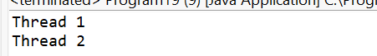
- Implement a program to demonstrate thread communication using CyclicBarrier.
package Multithreding;
import java.util.concurrent.*;
public class Program20 {
public static void main(String[] args) {
CyclicBarrier cb = new CyclicBarrier(2, () -> System.out.println("Barrier reached"));
new Thread(() -> { try { cb.await(); } catch(Exception e){} }).start();
new Thread(() -> { try { cb.await(); } catch(Exception e){} }).start();
}
}
OUTPUT:
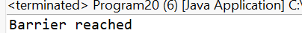
- Write a Java program to create multiple threads and use Semaphore.
package Multithreding;
import java.util.concurrent.*;
public class Program21 {
public static void main(String[] args) {
Semaphore s = new Semaphore(1);
new Thread(() -> {
try {
s.acquire();
System.out.println("Accessed");
s.release();
} catch(Exception e){}
}).start();
}
}
OUTPUT:
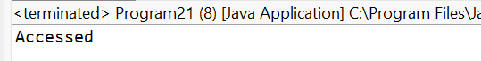
- Implement a program to demonstrate thread communication using Exchanger.
package Multithreding;
import java.util.concurrent.*;
public class Program22 {
public static void main(String[] args) {
Exchanger<String> ex = new Exchanger<>();
new Thread(() -> {
try {
System.out.println(ex.exchange("Hello"));
} catch(Exception e){}
}).start();
new Thread(() -> {
try {
System.out.println(ex.exchange("World"));
} catch(Exception e){}
}).start();
}
}
OUTPUT:
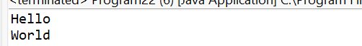
- Write a Java program to create multiple threads and use CompletionService.
package Multithreding;
import java.util.concurrent.*;
public class Program23 {
public static void main(String[] args) throws Exception {
ExecutorService es = Executors.newFixedThreadPool(2);
CompletionService<Integer> cs = new ExecutorCompletionService<>(es);
cs.submit(() -> 5);
cs.submit(() -> 10);
System.out.println(cs.take().get());
System.out.println(cs.take().get());
es.shutdown();
}
}
OUTPUT:
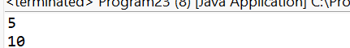
- Implement a program to demonstrate thread communication using TransferQueue.
package Multithreding;
import java.util.concurrent.*;
public class Program24 {
public static void main(String[] args) throws Exception {
TransferQueue<Integer> tq = new LinkedTransferQueue<>();
new Thread(() -> {
try { tq.transfer(100); } catch(Exception e){}
}).start();
System.out.println(tq.take());
}
}
OUTPUT:
- Write a Java program to create multiple threads and use ScheduledExecutorService.
package Multithreding;
import java.util.concurrent.*;
public class Program25 {
public static void main(String[] args) {
ScheduledExecutorService ses = Executors.newScheduledThreadPool(1);

ses.schedule(() -> System.out.println("Scheduled task"), 2, TimeUnit.SECONDS);
ses.shutdown();
}
}
OUTPUT:
- Implement a program to demonstrate thread communication using Lock and Condition.
package Multithreding;

import java.util.concurrent.locks.*;
public class Program26 {
static Lock lock = new ReentrantLock();
static Condition cond = lock.newCondition();
public static void main(String[] args) {
new Thread(() -> {
lock.lock();
try {
cond.await();
System.out.println("Resumed");
} catch(Exception e){}
finally { lock.unlock(); }
}).start();

new Thread(() -> {
lock.lock();
try {
cond.signal();
} finally { lock.unlock(); }
}).start();
}
}
OUTPUT:

