DATA SCIENCE INTERNSHIP – WEEK 4 REPORT
Machine Learning Model Development and Evaluation
Dataset: Titanic Passenger Dataset
Algorithm: Logistic Regression
Task: Binary Classification – Passenger Survival Prediction

1. Introduction
This week focused on applying machine learning techniques to a real-world dataset and evaluating a predictive model. The Titanic passenger dataset was used for a binary classification problem in which the model predicts whether a passenger survived the disaster. Python and Scikit-learn were used for data preparation, feature selection, model training, prediction, evaluation, visualization, error analysis, and model comparison. Logistic Regression was selected because the target variable, Survived, has two possible outcomes: 0 for did not survive and 1 for survived. Accuracy, precision, recall, F1-score, and AUC were used to evaluate performance from multiple perspectives. A confusion matrix was created to identify correct and incorrect classifications, while an ROC curve examined the model's ability to distinguish between the two classes. An improved model was also developed by adding the Embarked feature. The two models were compared to determine whether the additional feature produced a meaningful improvement. The results showed that the original six-feature model was preferable overall.

2. Objective
The objective was to develop a simple machine learning model capable of predicting Titanic passenger survival and to evaluate it using appropriate classification metrics and visualizations. The task also aimed to identify sources of prediction errors and discuss possible improvements.

3. Dataset Description
The Titanic dataset contains passenger-level information such as passenger class, sex, age, number of siblings or spouses aboard, number of parents or children aboard, ticket fare, embarkation port, and survival status. Survived was selected as the target variable. The original model used Pclass, Sex, Age, SibSp, Parch, and Fare. The improved model additionally included Embarked.
- Pclass – Passenger class.
- Sex – Passenger gender.
- Age – Passenger age.
- SibSp – Siblings/spouses aboard.
- Parch – Parents/children aboard.
- Fare – Ticket fare.
- Embarked – Port where the passenger boarded.
- Survived – 0 = did not survive, 1 = survived.

4. Data Preparation
The dataset was loaded using Pandas. Missing Age values were replaced with the median Age because the median is less affected by extreme values than the mean. Sex was converted from text into numerical values, with male represented by 0 and female by 1. For the improved model, missing Embarked values were filled using the mode and its categories were numerically encoded. These steps ensured that the selected features could be supplied to Logistic Regression.

5. Feature Selection
The original model used Pclass, Sex, Age, SibSp, Parch, and Fare. These variables represent passenger characteristics, socioeconomic status, family relationships, and travel conditions that may be associated with survival. An improved feature set was later created by adding Embarked.

6. Train/Test Split
The dataset was divided into training and testing subsets using an 80:20 split. The training data was used to learn model parameters, while the testing data evaluated performance on unseen observations. random_state=42 made the split reproducible, and stratify=y preserved the approximate survival-class proportions. The test set contained 179 passengers.

7. Model Selection and Training
Logistic Regression was selected because this is a binary classification problem. The model estimates the probability of belonging to the positive class and then produces a class prediction. The max_iter parameter was set to 1000 to provide sufficient iterations for convergence.

8. Model Evaluation Metrics
The original model achieved 80.45% accuracy, 76.56% precision, 71.01% recall, and 73.68% F1-score. Accuracy represents the proportion of all test predictions that were correct. Precision measures how reliable positive survival predictions were. Recall measures how many actual survivors were correctly identified. F1-score balances precision and recall. These metrics provide a more complete assessment than accuracy alone.
Metric | Original Model | Improved Model
Accuracy | 80.45% | 80.45%
Precision | 76.56% | 79.31%
Recall | 71.01% | 66.67%
F1 Score | 73.68% | 72.44%
AUC | 0.850 | 0.843
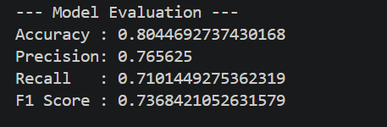

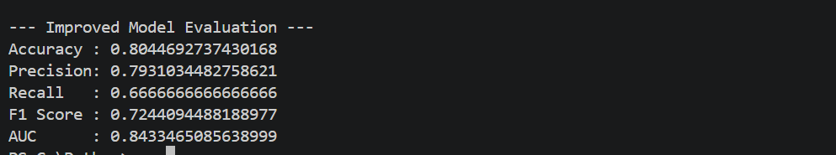
Screenshot 1: Model performance output / metric results

9. Confusion Matrix Analysis
The confusion matrix showed that the model correctly predicted 95 passengers who did not survive and 49 passengers who survived. It incorrectly predicted survival for 15 passengers who did not survive (false positives) and incorrectly predicted non-survival for 20 passengers who actually survived (false negatives). Thus, 144 of 179 test observations were classified correctly and 35 were misclassified.
Actual / Predicted | Did Not Survive (0) | Survived (1)
Did Not Survive (0) | 95 (TN) | 15 (FP)
Survived (1) | 20 (FN) | 49 (TP)
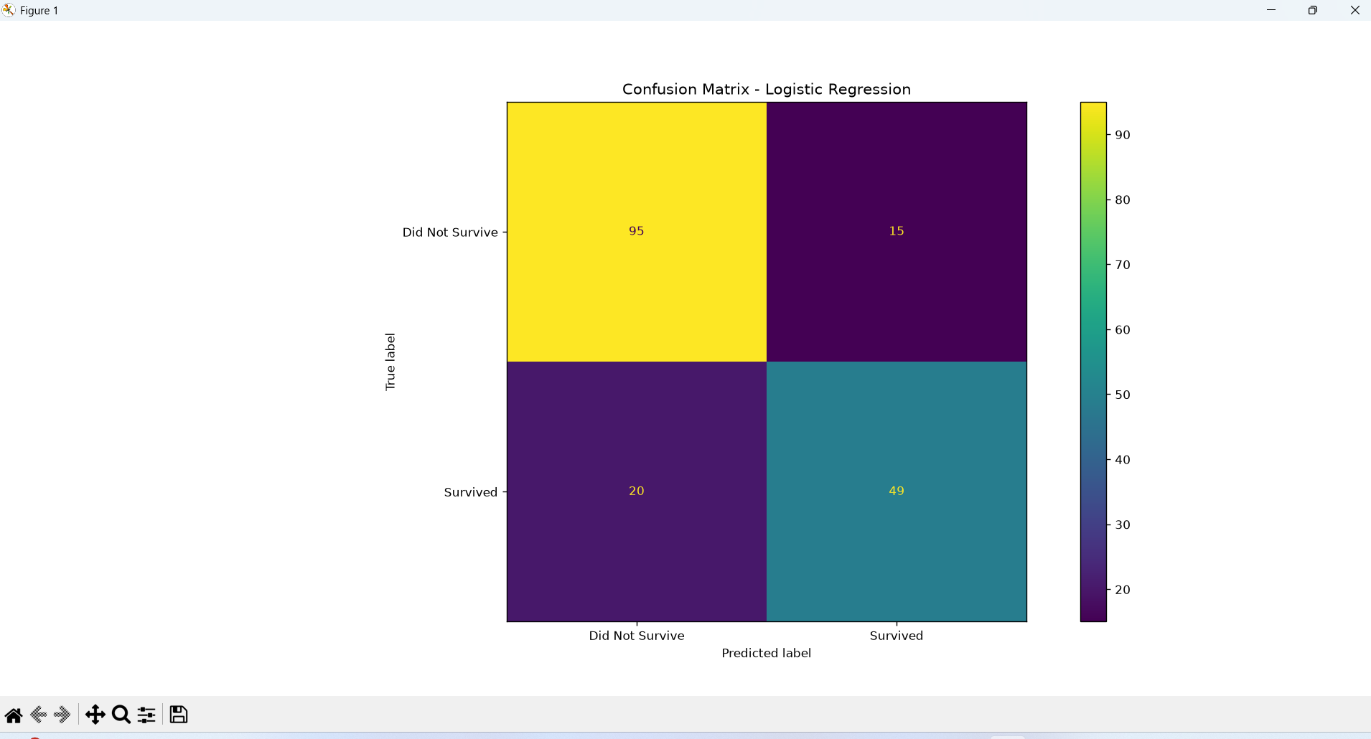
Screenshot 2: Confusion Matrix

10. ROC Curve and AUC Analysis
The ROC curve was generated using predicted survival probabilities. The original model achieved an AUC of 0.85, indicating good ability to distinguish survivors from non-survivors across different classification thresholds. An AUC near 0.50 represents random discrimination, while a value closer to 1.00 indicates stronger discrimination.
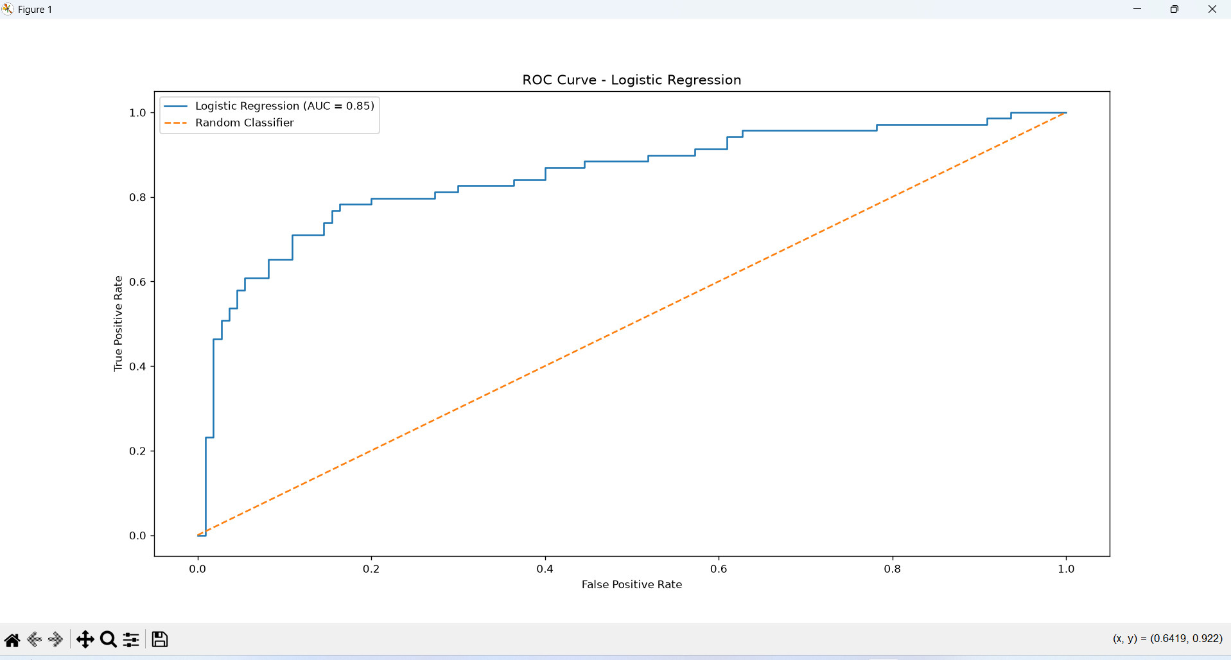
Screenshot 3: ROC Curve with AUC = 0.85

11. Error Analysis
The model made 35 incorrect predictions out of 179 test observations: 15 false positives and 20 false negatives. The higher number of false negatives indicates that the model missed more passengers who actually survived than it incorrectly classified as survivors. Possible sources of error include incomplete or noisy age information, complex family effects, and the inability of the selected variables to fully explain individual survival outcomes. Logistic Regression also represents a relatively simple decision boundary and may not capture nonlinear interactions between passenger characteristics.

12. Model Improvement
An improved Logistic Regression model was created by adding Embarked to the original six features. Accuracy remained 80.45%, while precision increased from 76.56% to 79.31%. However, recall decreased from 71.01% to 66.67%, F1-score decreased from 73.68% to 72.44%, and AUC decreased slightly from 0.850 to 0.843. Therefore, adding Embarked did not improve overall performance, so the original model was retained as the preferred baseline.
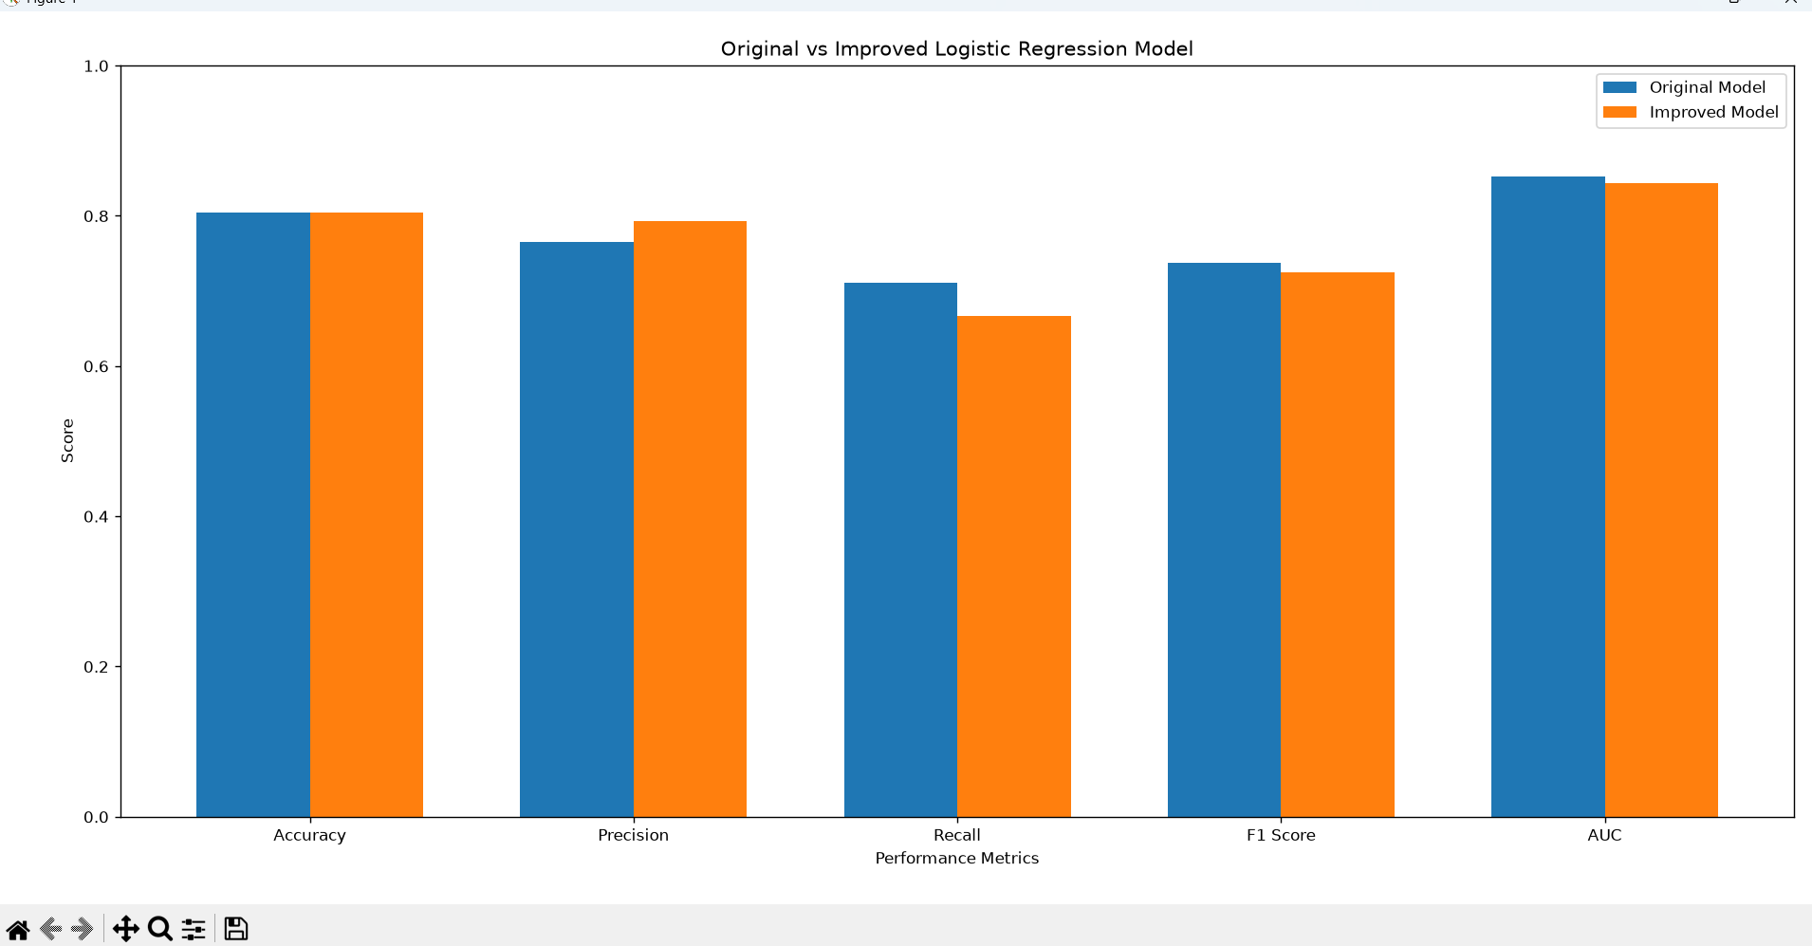
Screenshot 4: Original vs Improved Model Comparison Chart

13. Critical Discussion and Potential Improvements
The model provides a useful baseline, but performance could potentially be improved. Additional meaningful features could be engineered, such as family size, whether a passenger was traveling alone, or title information extracted from names. Categorical variables can be handled using one-hot encoding instead of assigning arbitrary numerical order. Alternative algorithms such as Decision Trees, Random Forest, Gradient Boosting, or Support Vector Machines could also be tested. Hyperparameter tuning with cross-validation could improve generalization. More systematic feature selection and class-specific error analysis would further strengthen the study.

14. Business and Scientific Implications
Although the Titanic dataset is historical, the workflow demonstrates a general approach used in predictive analytics. Similar methods can be applied to customer churn, loan default, fraud detection, or risk classification. The project also demonstrates why multiple metrics matter: a model with good accuracy may still miss important positive cases. Model selection should therefore consider the consequences of different error types rather than accuracy alone.

15. Conclusion
A complete machine learning pipeline was developed using the Titanic dataset and Logistic Regression. The workflow included data preparation, feature selection, missing-value handling, categorical encoding, train/test splitting, model training, prediction, evaluation, visualization, error analysis, and model comparison. The original model achieved 80.45% accuracy, 76.56% precision, 71.01% recall, 73.68% F1-score, and an AUC of 0.85. Adding Embarked did not improve the overall performance. Consequently, the original model was selected as the preferred baseline. The project demonstrates that effective machine learning requires not only training a model but also interpreting errors, comparing alternatives, and communicating results clearly.

