Patient Tumor Analysis 23 June 2026
All reference controls: Run 17 June 2026
Cell Lines (fixed from previous experiment)
- U251 blank
- Non Transduced T cells, PBMC
- CHLA+/- CD1d
- HEK blank methanol

Patient Tissues

- PT 160 LN3 R4 B6 #55 24hr HIB pediatric AT/RT
- PT169 Pediatric pilocytic astrocytoma LN3 R3 B6 #57-78
- PT 170 metastatic melanoma (brain met) adult LN3 R3 B6 #51-54
- PT171 breast to brain metastatic carcinoma adult LN3 R3 B4 #55-70
- PT172 GBM/HGG Astrocytoma adult LN3 R3 B4 #8-35

Reagents
Reagent | Catalog # | location
TruStain FcX | ThermoFisher NC9067567 | 4C TCH
UltraComp beads | BD 550566 | 4C TCH
TruStain monocyte blocker | Biolegend 426101 | 4C TCH
FlowX FoxP3/Transcription Factor Fixation & Perm Buffer Kit | R&D Systems FC012-100 | TCH 4C
Brilliant stain buffer | BD 563794 | 4C TCH
PBS 1x
DPBS 10 x (- Calcium Chloride - Magnesium chloride | Gibco 14200-075 | Morrent Lab bench
HBSS (+ Calcium Chloride + Magnesium chloride) | Gibco 14025-092
Percoll | Santa Cruz sc-500790A | Morrent lab bench (RT)
Tumor dissociation kit (human) | Miltenyi 130-095-929 | TCH -20C
FBS
Electron Microscopy Grade PFA | Electron microscopy sciences 15710 | Fume hood
1mL syringe
Falcon® 5 mL Round Bottom Polystyrene Test Tube, with Snap Cap | Corning 352058 | Morrent lab bench
100 um cell strainers | CELLTREAT 229485 | TC1 drawer

Antibodies
Name | Catalog # | supplier | Ex/Em
LIVE/DEAD™ Fixable Near IR (876) Viability Kit | #L34980 | Invitrogen/Fisher Scientific | 849/876  R8/YG10
Helix NP™ Blue | #425305 | Biolegend | 430/470  V4
Anti- human CD45 PE-Cy7 | 560915 | BD | 565/778  YG9
Anti-human CD3 BV421 | 300434 | Biolegend | 408/422  V1/V3
Mouse Anti-Human CD276 (B7H3) RB705 | 756996 | BD | 498/707  B9
APC-H7 Mouse Anti-Human CD8 | #561423 | BD | 651/785  R7
RY655 Mouse Anti-Human CD25 (IL-2 Receptor α) | #572336 | BD | 561/654  YG4
BB515 Mouse Anti-Human CD279 (PD-1) | #565936 | BD | 490/515  B1
FOXP3 Monoclonal Antibody (PCH101), PE, eBioscience™ | 12-4776-41 | Fisher Scientific | 565/578  YG1
CD4 BV615 (RPA-T4) | 366-0049-41 | eBioscience/Fisher | 355/616  UV10
CD274 (PD-L1) APC (29E.2A3) | 568316 | BD biosciences | 650/660  R1
FoxP3 AF660 (PCH101) | 606-4776-41 | eBioscience/Fisher | 663/690  R3
Anti-Ki67 BUV 395 | 564071 | BD | 348/395  UV2
BD OptiBuild™ RY703 Mouse Anti-Human CD206 (Mannose Receptor) | 770722 | BD | 557/703  YG7
BD OptiBuild™ RB613 Mouse Anti-Human CD80 (B7-1) | 758353 | BD | 492/613  YG3
BD OptiBuild™ RB780 Mouse Anti-Human CD86 (B7-2) | 755466 | BD | 488/780  B14
CD56 BV711 | 318335 | Biolegend | 405/711  V13
BD Horizon™ BUV805 Rat Anti-CD11b | 568345 | BD | 349/804  UV16
Anti-GFAP AF488 | 53-9892-82 | fisher | 488/496  B2
Anti-human DR5 PE | 50-112-75 | Fisher Scientific | 561/570  YG2
BD OptiBuild™ RY703 Mouse Anti-Human CD1d | BDB770936 | BD | 557/703  YG7
Brilliant Violet 421™ anti-SOX2 | 14A6A34 | Biolegend | 408/422  V1/V3
Day 1: Tumor digestion and Fixation
Human Tumor Digestion with TDK
- Prepare new PBS+0.5% BSA according to protocol
- Pre-weigh one 15mL conical tube per tumor sample, add 4 mL of PBS+ 0.5% BSA to each tube after weighing
- Obtain tumor sample from liquid nitrogen and note on inventory which vials were taken. Transport vial on dry ice if bringing to the 4th floor.
- Thaw vials by gentle agitation in 37C water bath, transfer to 15 mL conical tubes using cut off pipette tips or a transfer pipette
- Centrifuge at 1500RPM for 5 minutes to pellet tissue
- While spinning, thaw dissociation reagents from the Miltenyi tumor dissociation kit from the -20C
- Remove supernatant and weigh each tube with tumor
Tissue | Tube weight (g) | Tube+ tissue (g) | Tissue (g) | # vials used | Cell count
PT160 hib
PT169
PT170
PT171
PT172
- For 0.05-0.2g of tumor, add 100 uL enzyme H, 50 uL enzyme R, 12.5 uL enzyme A, 150 uL serum free media
- For 0.2-1.0g of tumor, add 200 uL enzyme H, 100 uL enzyme R, 25 uL enzyme A, 300 uL serum free media (DMEM)
- Vortex/flick to mix, Incubate tumors for 30 minutes on the rotator in the heated shaker at 37C. Seal tubes with parafilm before placing on rotator as tubes will be upside down. Monitor the tubes to make sure the chunks are getting digested.
- Brief spin to get liquid out of the cap before opening (1000 RPM for 1 minute)
- Add 5 mL of PBS+ 0.5% BSA to dilute out and neutralize the enzyme
- Place 100 um filter on 50 mL conical tube, pre wet 100 um filter with PBS
- Pass through 100 um filter to remove debris, wash the filter with another 25 mL of PBS (bring total volume in tube up to 30 mL)
  - Option to take sample for counting from 30 mL
- Spin down at 1500 RPM for 5 minutes
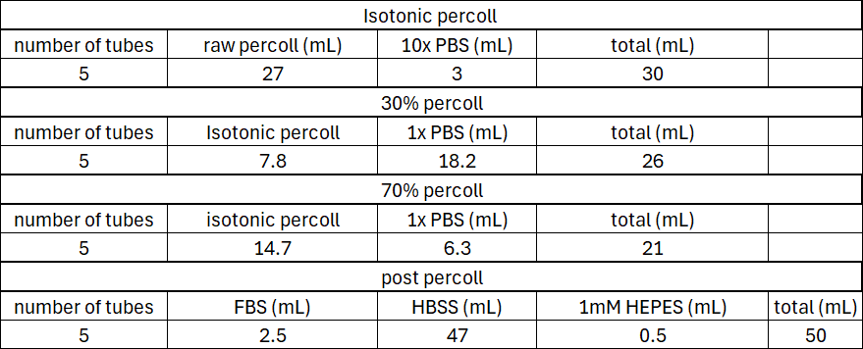
- Aspirate supernatant leaving up to 5 mL liquid left, then switch to manual removal of remaining supernatant to avoid aspirating the pellet

- Remove Myelin via Percoll Gradient
  - Warm all components of percoll gradient to 20-25C before mixing
  - Resuspend the myelin removal tube in 1 mL of 30% percoll solution,
    - Count cells using hemocytometer (1:20 dilution)
  - then add 4 mL of 30% percoll on top of this
  - Place a Pasteur pipette in the 15 mL tube covering the top while placing the tip on the bottom
  - Underlay 4mL of 70% percoll by pipetting in 1 mL increments into the Pasteur pipet
    - Lift tube slightly off the bottom to release any last fluid, then cover top of pipet with finger, avoid disturbing layers and remove the pipet from the 15 mL tube
    - If liquid gets stuck, move Pasteur pipette up and down to dislodge any bubbles
  - Centrifuge 20 minutes at 340xg 23C and no brake
    - Put tubes on the outside of the adaptor and not on the french side (will get stuck)
  - Aspirate out the top debris layer from the gradient (myelin layer) up to 1 mL
  - Centrifuge again if debris layer is disturbed
  - Pipette out the cells in the interphase in 1 mL increments (up to 4 mL total)
  - Transfer cells into a new 15 mL tube containing 10 mL post percoll solution per tube
  - Centrifuge at 300xg for 10 minutes 4C
  - Aspirate the supernatant and resuspend in PBS+0.5% BSA for staining
    - There might be a secondary percoll gradient forming in the bottom of the tube a few mm above the pellet. If so, do not aspirate this part and retain these cells for following steps
Preparation of Reference Controls (use from previous experiment)
- Lift U251 using trypsin, neutralize with complete media
- Wash off media and resuspend in protein free PBS
- Set aside cells for full stained sample, stain with Live Dead NIR 876 1:500 concentration in protein free PBS (100-500 uL staining volume), incubate for 15 minutes.
- Quench viability dye by adding 0.5% BSA in PBS to reach a final volume of 800 uL in each tube, wash off and resuspend in 400 uL PBS for fixation (7b)
- Use PBMCs, NT Tcells and HEK previously thawed and fixed from 7May26 optimization experiment
- Fix U251 *ALL PFA STEPS TO BE PERFORMED IN THE FUME HOOD
  - Dilute the 16% electron microscopy grade PFA to 2% PFA
    - Make fresh PFA for every experiment!
  - Resuspend cells in 400 uL PBS after wash
  - Add 400 uL 2% PFA to cells for a final concentration of 1% PFA in 1mL volume total
  - Vortex tubes to mix
  - Incubate cells at 4C for 15 minutes
  - Wash off PFA (3x) and remove supernatant manually, discard into appropriate waste container in fume hood. Use program 5 for centrifugation
Preparation of Cell lines for Reference controls
- Lift U251 blank cells using trypsin, resuspend in PBS+0.5% BSA
- Thaw human PBMCs in RPMI growth media, resuspend in PBS+0.5%BSA
- Thaw a tube of HEK blank methanol from -80C, wash 3x to remove methanol and dispose in appropriate waste container
Sample name | Live cell count | Viability | uL per tube
PBMC
U251 blank
HEK blank | 5e6 | ------------
Raji blank

Fixation and viability dye
- Transfer cells into flow tubes according to the list of tubes on the last page. Calculate how much volume of each is needed for ~1-5e6 cells per tube for reference controls and note the volume and how many cells were put in each.
- Split patient tissues into 2 tubes- unstained and full stained. Add about 70% of the sample to the full stained tube and about 30% to the unstained tube. Use all patient tissue no matter of cell count.
- Bring all tubes up to a total volume of 700 uL with PBS and centrifuge
  - 1500RPM for 5 minutes= program 5 on floor 2 centrifuge. Make sure caps snap. Aspirate supernatant with vacuum setup on bench, leaving 30-50uL of volume left to maximize sample recovery
  - For tubes that don’t need viability dye, resuspend in 400 uL clean PBS for fixation later (step 9 below)
- Identify tubes that will need viability dye (full stained samples and reference control) and wash these 2x with clean PBS containing no protein to ensure a protein free environment for staining
  - 1500RPM for 5 minutes= program 5 on floor 2 centrifuge. Make sure caps snap. Aspirate supernatant with vacuum setup on bench, leaving 30-50uL of volume left to maximize sample recovery
- Stain appropriate tubes with Live Dead NIR 876 viability dye
  - After washing, resuspend tubes in 100 uL of viability dye diluted 1:500 in clean PBS
  - Incubate with dye for 15 minutes protected from light
  - Add 600 uL PBS+0.5% BSA at the end of incubation to inactivate dye
  - Wash tubes 1x (centrifuge 1500 RPM for 5 minutes)

- Fix tubes ALL PFA STEPS TO BE PERFORMED IN THE FUME HOOD
  - Dilute the 16% electron microscopy grade PFA to 2% PFA
    - Make fresh PFA for every experiment!
  - Resuspend cells in 400 uL PBS after wash (or already done in 6b above)
  - Add 400 uL 2% PFA to cells for a final concentration of 1% PFA in 1mL volume total
  - Vortex tubes to mix
  - Incubate cells at 4C for 15 minutes
  - Wash off PFA (3x) and remove supernatant manually, discard into appropriate waste container in fume hood. Use program 5 for centrifugation
Store cells in PBS with 0.5% BSA for longer term storage

Day 2: Antibody staining
Stain tubes
- Identify tubes that will require staining. Leave unstained tubes in 4C fridge protected from light.
- Spin down tubes (program 5) and aspirate supernatant using bench top vacuum setup
- Resuspend tubes in blocking mix according to the table on the next page
  - human FC block and monocyte blocker to avoid nonspecific binding of APCs
  - Add brilliant buffer to all primary human samples (PBMC, tumor) due to anti-PEG antibodies possibly being present. Also add to any samples containing two or more brilliant dyes (contain PEG)
- Allow to incubate for 5 minutes while preparing antibody master mix
- Stain with surface marker antibodies in a final staining volume of 100uL, incubate for 30 minutes at 4C
- Wash tubes 3x (program 5) and aspirate supernatant using bench top vacuum setup
  - First wash, just 0.5% BSA in PBS
  - Wash 2 and 3, use permeabilization buffer (below)
Permeabilization
- Prepare permeabilization buffer: dilute 10x permeabilization and wash buffer in diH20 ( 3mL of concentrate+27 mL diH2O)
  - Dilute fresh permeabilization buffer for every experiment!
- Wash cells 2x with 600 uL of cold wash/perm buffer
- Prepare master mix for intracellular staining according to table on the last page (in perm buffer) for a final staining volume of 100uL
- incubate over night at 4C protected from light
- In the morning, wash 3x with perm/wash buffer
- Resuspend in 300 uL PBS for analysis
Helix Dye (nuclear counterstain)
- Dilute helix NP blue 1:10,000 in PBS
- Add 20 uL to each tube requiring helix dye (full stained samples)
- Do not wash after, cells are ready for analysis
- Bring dye to flow core in case cells are not separated enough. If that is the case, add another 20 uL of dye while at the machine (stains almost instantaneously)

Day 3: Analysis on Cytek Aurora

Reference Controls to run 17 June 2026
- Unstained beads
- Unstained PBMC
- Unstained NT Tcells
- unstained U251
- unstained CHLA
- unstained Raji
- Unstained HEK methanol
- HEK methanol live dead NIR 876 (1:500)
- HEK methanol Helix NP Blue
- PBMC CD45 PE-Cy7
- PBMC CD3 BV421
- PBMC CD11b BUV805
- PBMC CD4 BV615
- PBMC CD8a APC-H7
- PBMC CD56 BV711
- PBMC CD25 RY655
- PBMC PD-1 BB515
- Raji CD86 RB780
- Raji CD80 RB613
- NT Tcells FoxP3 PE
- CHLA+/- CD1d RY703
- U251 GFAP AF488
- U251 Ki-67 BUV395
- U251 B7H3 RB705
- U251 PD-L1 APC
- U251 CD262 DR5 PE
- Beads CD206 RY703

Patient Samples 23 June 2026:
- PT160 unstained
- PT169 unstained
- PT170 unstained
- PT171 unstained
- PT172 unstained
- U251, PBMC Tumor Panel
- U251, PBMC, NT Tcell Imune Panel
- PT 160 Tumor Panel
- PT 160 Immune Panel
- PT 169 Tumor Panel
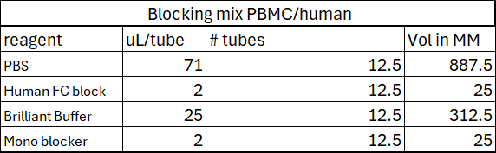
- PT169 Immune Panel
- PT170 tumor panel
- PT170 immune panel
- PT171 tumor panel
- PT171 immune panel
- PT172 tumor panel
- PT172 immune panel

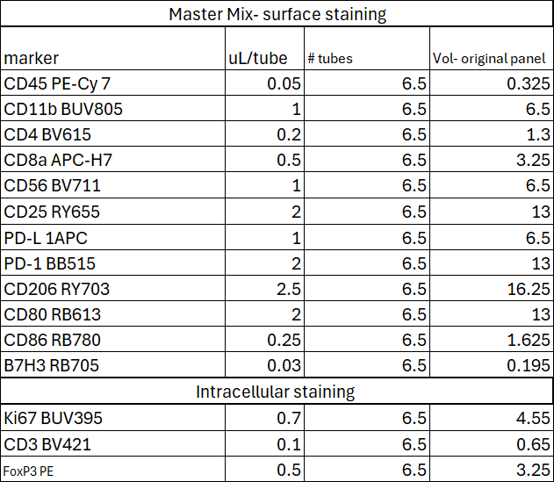
Tumor Panel Immune Panel
