**HYDRAULICS AND PNEUMATICS**



**PNEUMATIC ANTI-LOCK BRAKING SYSTEM**

# SUBMITTED TO:

# SIR AMIR SHARIF

**SUBMITTED BY:**

AROOBA IJAZ (2022-MC-29)

LAIBA OMER (2022-MC-25)

AHSAN ABDULLAH(2022-MC-61)

BILAL SHAHID (2022-MC-04)

ANAS GULZAR(2022-MC-07)

_____________________________________

**Mechatronics and Control Engineering Department**

University of Engineering and Technology, Lahore

## INTRODUCTION:

Anti-lock braking systems (ABS) are critical for vehicle safety, especially in emergency braking situations. The pneumatic ABS leverages pneumatic actuators and electronic controls to dynamically adjust braking force, ensuring wheels maintain traction with the road surface. This report focuses on a compact and efficient design suitable for automotive applications, incorporating sensors and microcontrollers for real-time monitoring and control.

**OBJECTIVES:**

* **Enhance Vehicle Safety**: Develop an anti-lock braking system (ABS) to prevent wheel lockup during braking and improve control.
* **Optimize Braking Efficiency**: Ensure maximum braking force while maintaining traction with the road surface.
* **Low-Cost Implementation**: Use cost-effective components like ESP8266, solenoid valves, and ultrasonic sensors.
* **IoT Integration**: Enable wireless monitoring and control through the ESP8266 microcontroller.

**METHODOLOGY:**

1. **System Design:**

* **Use an ultrasonic** sensor to measure the speed of wheel rotation or proximity of moving parts during braking.
* **Employ an ESP8266** microcontroller to process the sensor data and detect wheel lockup based on sudden deceleration patterns.
* **Control air supply** to the double-acting pneumatic cylinder using a 5/2 solenoid valve to regulate brake pressure.

1. **Component Integration**

* Connect the ultrasonic sensor to the ESP8266 to continuously monitor wheel speed.
* Interface the relay with the ESP8266 to control the 5/2 solenoid valve for braking adjustments.

1. **Braking Control**

* During braking, monitor wheel speed in real-time.
* If wheel lockup is detected, the ESP8266 reduces brake pressure by actuating the solenoid valve, retracting the double-acting cylinder.
* Once the wheel regains traction, the cylinder re-applies braking pressure.

1. **IoT Implementation**

* Use ESP8266's Wi-Fi capability for live monitoring of braking performance.
* Transmit data to a mobile app or dashboard for analysis.

1. **Testing and Optimization**

* Perform tests on various surfaces and conditions to fine-tune braking thresholds and system responsiveness.

# COMPONENTS:

The following components were used :

**12V DC MOTOR**

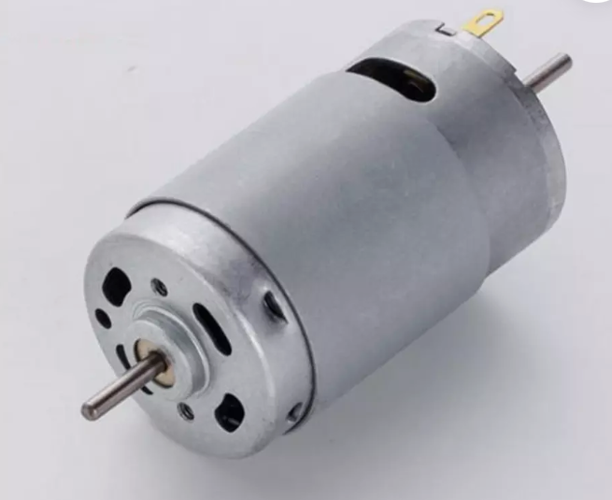

* **Function**: Drives the wheel assembly for simulation and testing.
* **Specifications:** Operates on 12V DC, providing consistent rotational speed for the test setup.

**WHEEL ASSEMBLY**

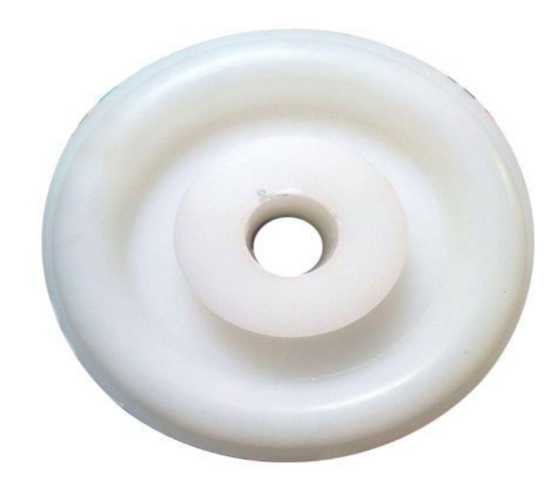

* **Function**: Represents the vehicle’s wheel, allowing observation of braking dynamics.
* **Material**: Durable material to withstand repeated braking simulations.(plastic)

**DOUBLE-ACTING CYLINDER**

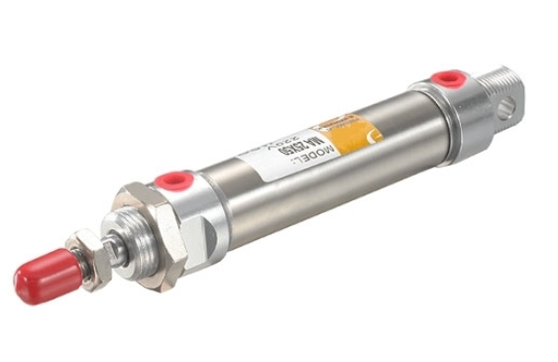

* **Function**: Provides the pneumatic actuation required to apply and release braking force.
* **Specifications**:
  + - Bore diameter: 50 mm
    - Stroke length: 100 mm

**SOLENOID VAVLE (5/2)**

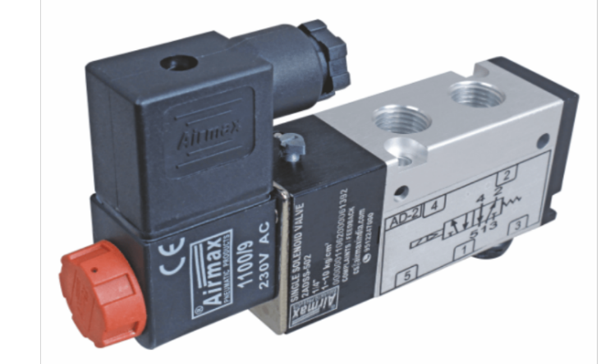

* **Function**: Controls airflow to the double-acting cylinder, enabling precise actuation.
* **Type:** 5/2-way valve for directional control.

**SINGLE-CHANNEL RELAY(220V)**

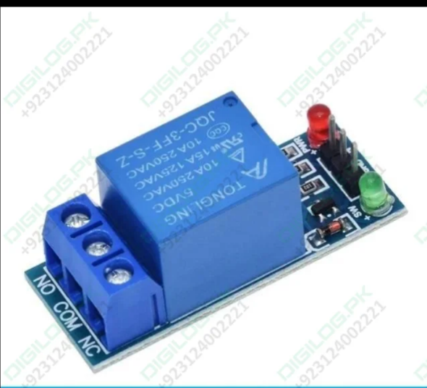

* **Function**: Interfaces with the ESP8266 to control high-power components such as the solenoid valve.
* **Specifications:** Rated for 220V operation.

**ESP8266 MICROCONTROLLER**

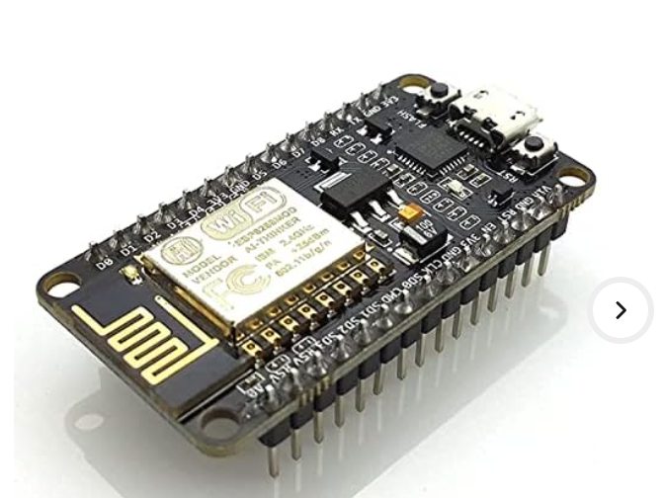

* **Function:** Serves as the control unit, processing input from the ultrasonic sensor and controlling the relay.
* **Features:** Wi-Fi-enabled for remote monitoring and control.

**ULTRASONIC SENSOR**

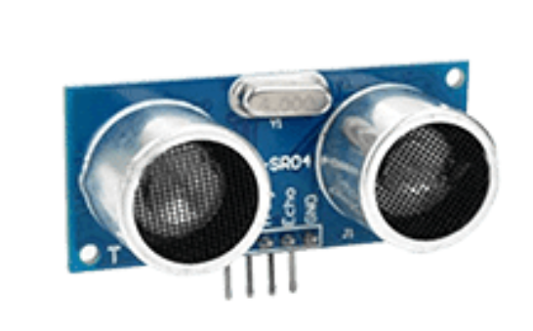

* **Function:** Measures wheel speed and detects impending lockup by monitoring rotational dynamics.
* **Specifications:** Accurate within a range of 2 cm to 400 cm.

**WORKING PRINCIPLE:**

The pneumatic ABS operates as follows:

1. **Wheel Speed Monitoring:** The ultrasonic sensor measures the rotational speed of the wheel in real-time.
2. **Lockup Detection:** The ESP8266 processes sensor data to identify if a wheel is about to lock up during braking.
3. **Brake Actuation:** If lockup is detected, the ESP8266 activates the solenoid valve via the relay, adjusting the airflow to the double-acting cylinder.
4. **Brake Release:** The cylinder modulates braking force to prevent lockup while maintaining effective braking.
5. **Feedback Loop:** The system continuously monitors wheel speed and adjusts braking force dynamically for optimal performance.

# CONNECTION CONFIGURATION:

The following are the configuration of pinouts of all the components used:

|  |  |  |
| --- | --- | --- |
| **Sr No.** | **COMPONENT** | **ESP8266 PIN CONFIGURATION** |
|  | Ultrasonic sensor  (input pin) | ECHO_PIN (D1 / GPIO4) |
|  | Ultrasonic sensor  (output pin) | TRIG_PIN (D2 / GPIO5) |
| 3. | Relay  (output pin) | RELAY_PIN (D5 / GPIO0) |

**FLOWCHART :**

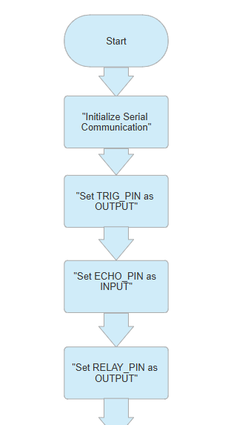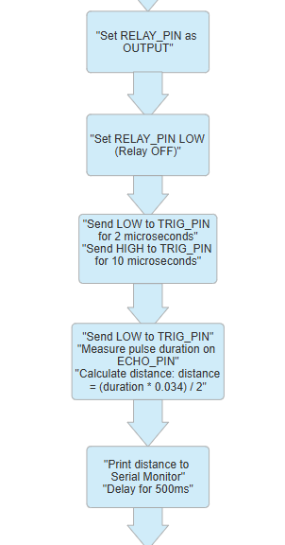

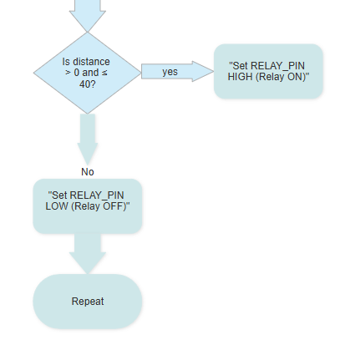

## PROJECT HARDWARE:

The following below is the HARDWARE of the whole setup:

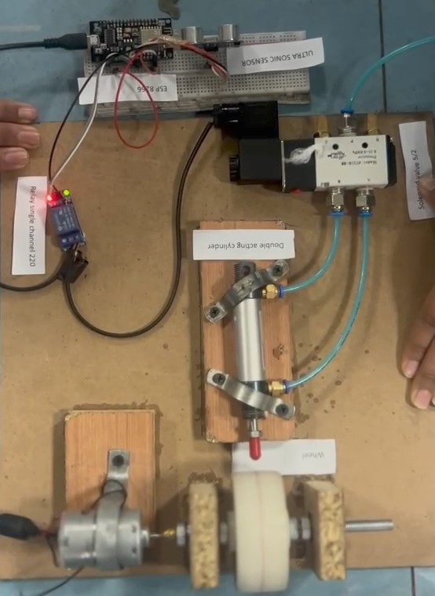 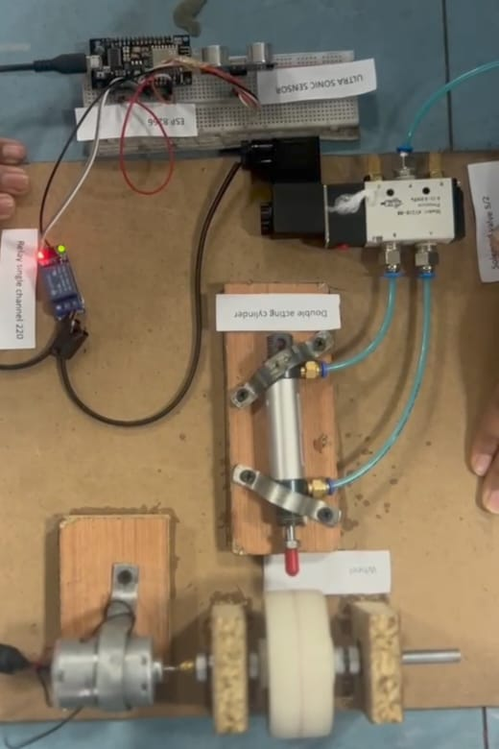

# BILL OF MATERIAL:

|  |  |  |  |  |  |  |  |
| --- | --- | --- | --- | --- | --- | --- | --- |
| **Sr No.** | **COMPONENT** | **DESCRIPTION** | **UNIT PRICE** | **QUANTITY** | **TOTAL PRICE** | **VENDOR** | **STATUS** |
| 1 | DC MOTOR | 12 V | 250 | 1 | 250 | Brunth road  0317 4546128 | Active |
| 2 | WHEEL | FOR ASSEMBLY | 200 | 1 | 200 | Brunth road | Active |
| 3 | AXEL + NUTS(4) | FOR ASSEMBLY | 290 | 1 | 290 | Brunth road | Active |
| 4 | WOOD | FOR SUPPORT | 150 | 1 | 150 | Baghbanpura near bilal masjid | Active |
| 5 | BEARINGS | FOR SUPPORT | 50 | 2 | 100 | store near baghbanpura station | Active |
| 6 | WELDING | TO SECURELY HOLD THE MOTOR | 150 | 1 | 150 | Baghbanpura near bilal masjid | Active |
| 7 | GLUE | FOR WOOD ASSEMBLY | 30 | 3 | 90 | store near baghbanpura station | Active |
| 8 | LABOUR | - | 250 | 1 | 250 | store near baghbanpura station | Active |
| 9 | 5/2 SOLENOID VALVE | Pneumatic valve with 5 ports and 2 positions, used to control double-acting cylinders. | 850 | 1 | 850 | Brunth road  0317 4546128 | Active |
| 10 | DOUBLE ACTING CYLINDER | Pneumatic actuator providing force in both extension and retraction using air pressure. | 1250 | 1 | 1250 | Brunth road  0317 4546128 | Active |
| 11 | RELAY SINGLE CHANNEL | Electrically operated switch to control high-power devices using low-power signals. | 220 | 1 | 220 | Brunth road  0317 4546128 | Active |
| 12 | ESP 8266 | Wi-Fi-enabled microcontroller for IoT applications with GPIO pins for peripheral interfacing. | 800 | 1 | 800 | Brunth road  0317 4546128 | Active |
| 13 | ULTRASONIC SENSOR | Distance measurement sensor using sound waves, (HC-SR04). | 200 | 1 | 200 | Brunth road  0317 4546128 | Active |
| 14 | PIPE | FOR AIR SUPPLY | 100 | 2 | 200 | Brunth road  0317 4546128 | Active |
| 15 | POWER SUPPLY | 12V ,5AMPS | 700 | 1 | 700 | Brunth road  0317 4546128 | Active |