جامعة عمان الأهلية |  | Al-Ahliyya Amman University
Faculty of Information Technology

Project Report

Group Number: 8 | Date: / 6 / 2026

Department: Data Science & Artificial Intelligence | Faculty: Information Technology
Semester: 2 | Academic Year: 2025 / 2026
Course No.: A0374502 | Course Name: Pattern Recognition
Project Report — Random Forest: Credit Card Fraud Detection
No. of Pages: ~8 Pages | Duration: —
Coordinator: Dr. Ayman Mohamed | Instructor: Dr. Ayman Mohamed

Awarded Mark | CLO5 (10) | CLO4 (5) | CLO3 (5) | Student Name | Student No.
 | /10 | /5 | /5 | Abdelrahman Fayyad Lehlouh | 202210838
 | /10 | /5 | /5 | Mohamad Zahe Al-Sarawr | 202120502
 | /10 | /5 | /5 | Mohamad Amen Al-Hmod | 202120606
 | /10 | /5 | /5
Total: /20

1. Problem Definition
Credit card fraud is one of the most serious problems in the banking and financial industry. Every year, billions of dollars are lost due to fraudulent transactions. The goal of this project is to build a machine learning model that can automatically detect whether a credit card transaction is fraudulent (Class = 1) or normal (Class = 0).
We use the Random Forest algorithm, which works by building many decision trees and combining their answers. This makes it very powerful and accurate for classification problems like this one.
Real-world importance:
- Banks can automatically block fraudulent transactions in real time.
- Customers are protected from unauthorized charges.
- Reduces manual review work for bank employees.
- Saves millions of dollars in financial losses every year.

2. Dataset Description
- Source: Provided by Dr. Ayman Mohamed (pr4_CreditcardDataset.csv)
- Total samples: 100 transactions
- Number of features: 30 (Time, V1–V28, Amount, Class)
- Number of classes: 2 → Class 0 = Normal (40 samples), Class 1 = Fraud (60 samples)
- Missing values: None (clean dataset)

The features V1 to V28 are the result of a PCA transformation (to protect privacy). Only 'Time' and 'Amount' are the original features.

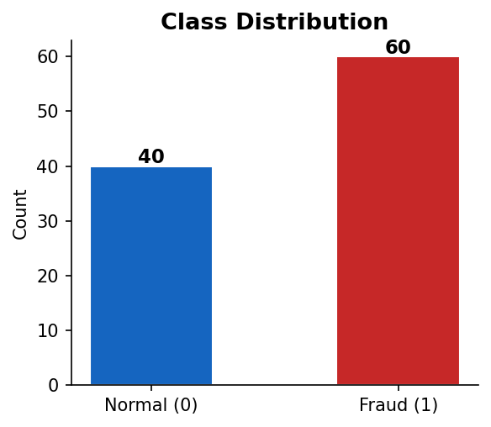
Figure 1: Class Distribution in the Dataset

3. Data Preprocessing
Before training the model, we performed the following preprocessing steps:

Step | Description
Cleaning | Checked for null/missing values — none found. Dataset was already clean.
Normalization | Applied StandardScaler to all features (mean = 0, standard deviation = 1). This ensures no single feature dominates the model.
Split | Train/Test split: 80% training (80 samples) / 20% testing (20 samples). Stratified to preserve class ratio.
Augmentation | Not applied — tabular data, no augmentation needed.

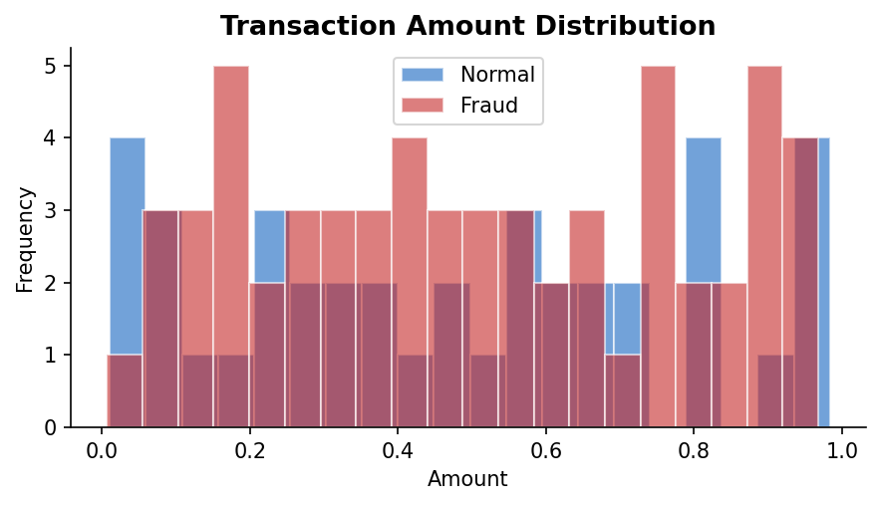
Figure 2: Transaction Amount Distribution by Class

4. Model Architecture — Random Forest
Random Forest is an ensemble learning method. Instead of building one decision tree, it builds many trees (a 'forest') and combines their predictions. Each tree is trained on a random subset of the data and a random subset of features. The final prediction is decided by majority vote.

How it works (simple steps):
- Step 1: Take many random samples from the training data (called 'bootstrap samples').
- Step 2: Build a decision tree on each sample, using random features at each split.
- Step 3: To predict, pass the data through all trees.
- Step 4: Each tree votes for a class. The majority vote wins.

Model hyperparameters used:
Parameter | Value Used | Meaning
n_estimators | 100 | Number of trees in the forest
max_depth | 5 | Maximum depth of each tree
random_state | 42 | Seed for reproducibility
criterion | gini (default) | Splits based on Gini impurity

5. Training Details
- Training samples: 80 | Testing samples: 20
- Algorithm: Random Forest Classifier (sklearn)
- Optimizer: Not applicable (tree-based model — no gradient descent)
- Loss function: Gini Impurity (used internally for tree splits)
- No epochs needed — tree-based models train in a single pass
- Library: scikit-learn (Python)

Note about the dataset size:
The dataset provided contains 100 samples, which is a small dataset for machine learning. In a real-world scenario, credit card fraud datasets contain hundreds of thousands of records (e.g., Kaggle's 284,807 transactions). The model's performance is limited by the dataset size, which is expected for a course project.

6. Results
6.1 Performance Metrics

Metric | Normal (Class 0) | Fraud (Class 1) | Overall
Precision | 28.57% | 53.85% | —
Recall | 25% | 58.33% | —
F1-Score | 26.67% | 56% | —
Accuracy | — | — | 45%

6.2 Confusion Matrix
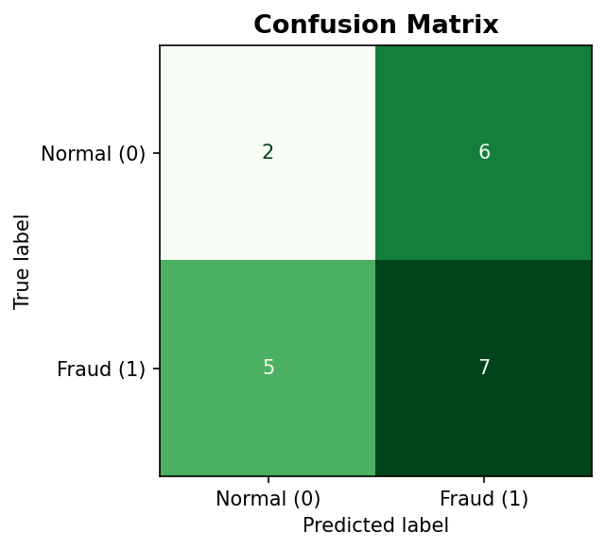
Figure 3: Confusion Matrix — Rows = Actual, Columns = Predicted

6.3 Feature Importance
The top 5 most important features were: V17, V9, V23, V20, Amount. These features had the highest influence on the model's decisions.

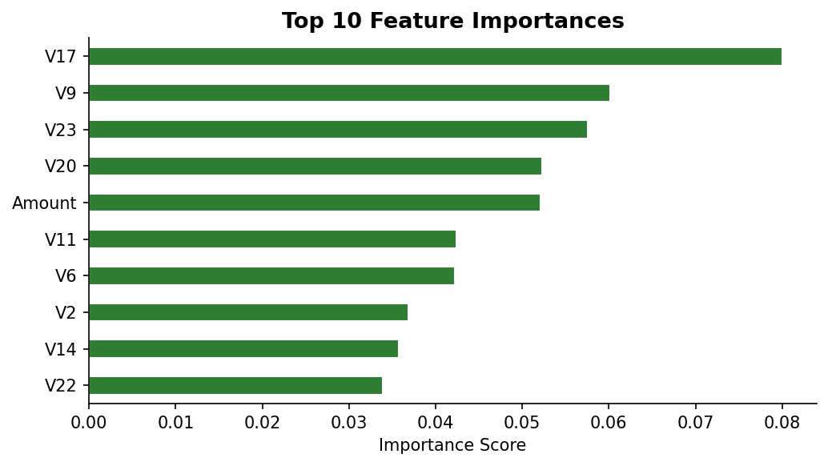
Figure 4: Top 10 Feature Importances

References
- Breiman, L. (2001). Random Forests. Machine Learning, 45(1), 5–32.
- Scikit-learn Documentation: https://scikit-learn.org/stable/modules/ensemble.html#random-forests
- Dataset: Provided by Dr. Ayman Mohamed — Pattern Recognition Course (A0374502), Al-Ahliyya Amman University.
- Pandas Documentation: https://pandas.pydata.org/docs/
- Matplotlib Documentation: https://matplotlib.org/stable/

