1.

2.     create view  Customer_addresses_v as SELECT Customer.cName AS "Name", 'Individual' AS "Type", Customer.cAddress AS "Address" FROM Customer NATURAL JOIN Corporate UNION SELECT Corporate.organization AS "Name", 'Corporation' AS "Type", Corporate.corpAddress AS "Address" FROM Corporate;

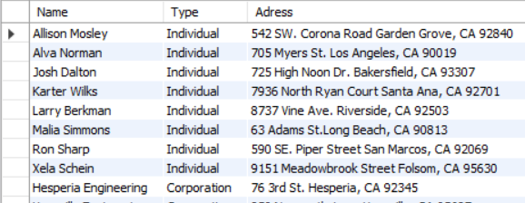

3.      Create VIEW Sous_mentor_v AS

    SELECT

        E.eName AS eName,

        M.idNumMentor AS idNumMentor,

        M.idNumMentee AS idNumMentee,

        M.itemName AS itemName,

        M.startDate AS startDate

    FROM

        (Mentorship M

        JOIN Employee E);

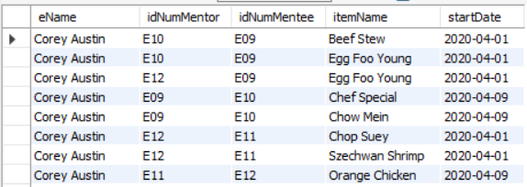

4.      create view Customer_Sales_v as

SELECT c.cName AS 'Name', SUM(oi.price*oi.quantity) AS 'Total', year(s.shiftDate) AS 'Year'

FROM Customer c

INNER JOIN KnownCustomer kc ON kc.email = c.email

INNER JOIN Orders o ON kc.orderID = o.orderID

INNER JOIN OrderedItems oi ON oi.orderID = oi.orderID

INNER JOIN Shift s on s.shiftID = o.shiftID

GROUP BY cName

ORDER BY year(s.shiftDate) DESC;

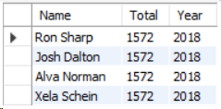

5.      create view Customer_Value_v as

SELECT c.cName AS 'Name', SUM(oi.price*oi.quantity) AS 'Total'

FROM Customer c

INNER JOIN KnownCustomer kc ON kc.email = c.email

INNER JOIN Orders o ON kc.orderID = o.orderID

INNER JOIN OrderedItems oi ON oi.orderID = oi.orderID

INNER JOIN Shift s on s.shiftID = o.shiftID

WHERE shiftDate BETWEEN '2019-05-06' AND '2020-05-06'

GROUP BY cName

ORDER BY SUM(oi.price*oi.quantity) DESC;

