1.       SELECT Customer.cName AS "Name", 'Customer' AS "Category", Customer.email AS "Contact" FROM Customer NATURAL JOIN Corporate UNION SELECT Corporate.organization AS "Name", 'Corporation' AS "Category", Corporate.corporation AS "Contact" FROM Corporate;

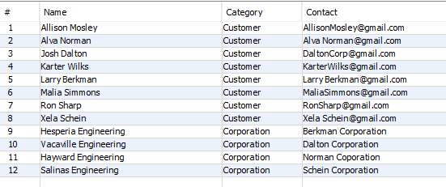

2.      SELECT c.cName AS 'Name', SUM(oi.price*oi.quantity) AS 'Total'

FROM Customer c

INNER JOIN KnownCustomer kc ON kc.email = c.email

INNER JOIN Orders o ON kc.orderID = o.orderID

INNER JOIN OrderedItems oi ON oi.orderID = oi.orderID

INNER JOIN Shift s on s.shiftID = o.shiftID

WHERE shiftDate BETWEEN '2018-05-06' AND '2020-05-06'

GROUP BY cName

ORDER BY SUM(oi.price*oi.quantity) DESC

LIMIT 3;

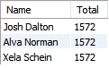

3.     SELECT eName, COUNT(*) AS 'Items Learned', GROUP_CONCAT(itemName) FROM Expertise NATURAL JOIN Employee GROUP BY eName HAVING COUNT(*) >= 3;

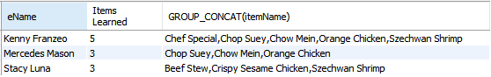

4. SELECT  eName, COUNT(itemName), GROUP_CONCAT(itemName) from SousChef

NATURAL JOIN Employee

Natural Join Mentorship

GROUP BY eName HAVING COUNT(itemName) >= 3;

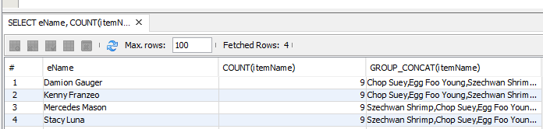

5.     SELECT itemName AS 'Item Name',quantity AS 'Quantity Ordered' FROM OrderedItems

        INNER JOIN MenuItem USING(itemName)

        WHERE menuType = 'Childrens'

        ORDER BY quantity DESC

        LIMIT 3;

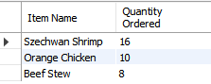

6.     Select eName, WEEK(shiftDate)*8 as 'hours' from Shift

Natural Join Employee;

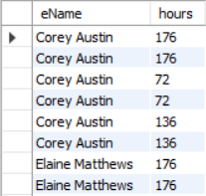

7.

Select mimiStoredMoney, cName from Customer

order by mimiStoredMoney DESC;

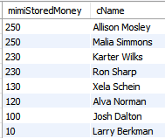

8.

SELECT c.cName AS 'Name', sum(o.billtotal) AS 'Total Spent'

FROM Customer c

INNER JOIN KnownCustomer kc ON kc.email = c.email

INNER JOIN Orders o ON kc.orderID = o.orderID

GROUP BY c.Cname

ORDER BY sum(o.billtotal) desc;

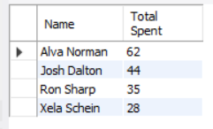

9.     SELECT c.cName AS 'Name', s.shiftDate AS 'Date', COUNT(c.cName) AS "Times Frequented"

FROM Customer c

INNER JOIN KnownCustomer kc ON kc.email = c.email

INNER JOIN Orders o ON kc.orderID = o.orderID

INNER JOIN Shift s on s.shiftID = o.shiftID

GROUP BY cName

ORDER BY count(c.cName) DESC;

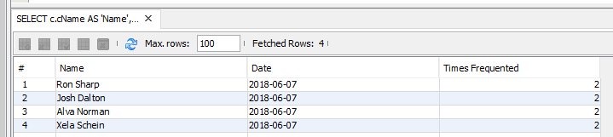

10.  SELECT c.cName AS 'Name', SUM(oi.price*oi.quantity) AS 'Total', year(s.shiftDate) AS 'Year'

FROM Customer c

INNER JOIN KnownCustomer kc ON kc.email = c.email

INNER JOIN Orders o ON kc.orderID = o.orderID

INNER JOIN OrderedItems oi ON oi.orderID = oi.orderID

INNER JOIN Shift s on s.shiftID = o.shiftID

WHERE shiftDate BETWEEN '2019-05-06' AND '2020-05-06'

GROUP BY cName

ORDER BY year(s.shiftDate) DESC

LIMIT 3;

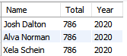

11.SELECT oi.itemName AS 'Name', SUM(oi.price*oi.quantity) AS 'Total'

FROM OrderedItems oi

INNER JOIN Orders o ON oi.orderID = o.orderID

INNER JOIN Shift s on s.shiftID = o.shiftID

WHERE shiftDate BETWEEN '2019-05-06' AND '2020-05-06'

GROUP BY itemName

ORDER BY Total DESC

LIMIT 5;

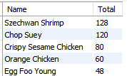

12. SELECT eName AS "Mentor", count(idNumMentee) AS "Mentee Count", group_concat(idNumMentee)

FROM Mentorship

INNER JOIN Employee

ON Mentorship.idNumMentor = Employee.idNum

GROUP BY idNumMentor

ORDER BY count(idNumMentee) desc

LIMIT 1;



13.

SELECT itemName AS 'Item Name', count(idNum) AS 'Number of Chefs who mastered it'

FROM Expertise

GROUP BY itemName

ORDER BY count(idNum) desc

LIMIT 3;

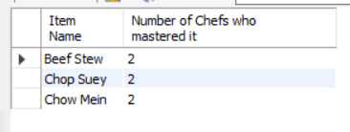

14.

SELECT cu.cName AS "Name"

FROM Customer cu

INNER JOIN Corporate co

ON cu.email = co.corpEmail;



15.  SELECT itemName, price, category, portionSize, menuType, spiciness FROM MenuItem ORDER BY itemName ASC;

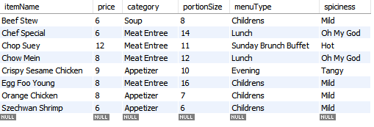

16.

Show all customers who succeeded the spicy challenge and unique email printing for the permanent 5% discount (Rules 1 and 2)

SELECT c.cName AS 'Hall of Fame', c.email AS 'Customer Identification'

FROM Customer c

WHERE c.spicyChallenge = TRUE;

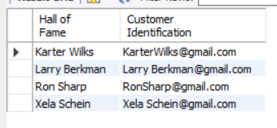

Show all tables who must pay gratuity and show maximum table size (Rule 3 and 4)

SELECT po.size AS 'Table Size (Cannot exceed 30', po.tableNumber AS 'Table Number',

      po.seatNumber AS 'Seat Number', po.orderID 'Order ID (Add 10% tip)'

FROM PartyOrder po

WHERE po.size > 5;

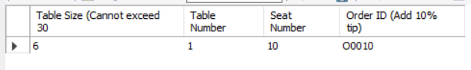

SELECT mi.itemName AS 'Ordered Dish', mi.price AS 'Price', mi.menuType AS 'Menu Type',

       mi.portionSize AS 'Ounces', mi.category AS 'Category', mi.spiciness AS 'Spiciness'

FROM MenuItem mi;

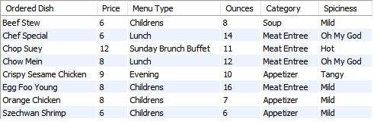

           SELECT mi.itemName AS 'Ordered Dish', mi.menuType AS 'Menu Type', mi.portionSize AS 'Ounces'

                 FROM MenuItem mi;

