姓名：吴阳高 | 专业： 物联网工程 | 班级：20181191 | 学号：2018119105
科目：嵌入式系统概论 |  | 实验日期：2021/1/3
实验题目：GPIO输出控制实验-Led闪烁、流水灯
【实验目的】
PC --- UART实验
【实验内容】
1.实验设备
◆ 硬件：小熊派
◆ 软件：win10 系统，STM32CubeMX，Keil 5。
- 实验相关原理图

串口原理图

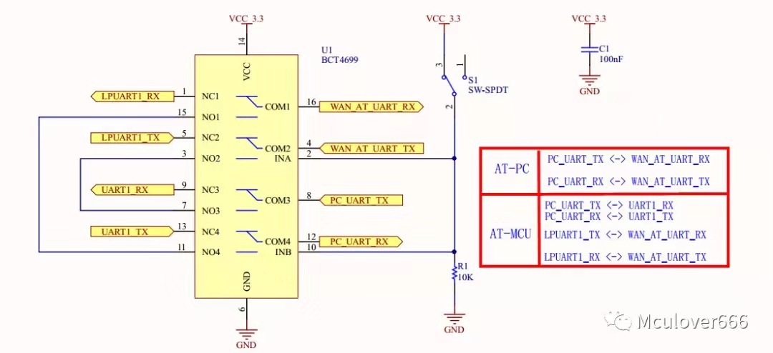

3.实验效果
打开串口调试器调试串口，可以通过串口发送数据和接收数据
【实验结果】
1.构思
步骤1：配置时钟源，使用外部高速时钟（HSE）
步骤2：配置串口，是PC的串口与USART1之间连接
步骤3：配置时钟树，配置PLL
步骤4：在main.c中编写代码，编写接收数据和输出数据的代码。

2.实现
/* USER CODE BEGIN Header */
/**
******************************************************************************
* @file : main.c
* @brief : Main program body
******************************************************************************
* @attention
*
* <h2><center>&copy; Copyright (c) 2021 STMicroelectronics.
* All rights reserved.</center></h2>
*
* This software component is licensed by ST under BSD 3-Clause license,
* the "License"; You may not use this file except in compliance with the
* License. You may obtain a copy of the License at:
* opensource.org/licenses/BSD-3-Clause
*
******************************************************************************
*/
/* USER CODE END Header */

/* Includes ------------------------------------------------------------------*/
#include "main.h"
#include "usart.h"
#include "gpio.h"

/* Private includes ----------------------------------------------------------*/
/* USER CODE BEGIN Includes */

/* USER CODE END Includes */

/* Private typedef -----------------------------------------------------------*/
/* USER CODE BEGIN PTD */

/* USER CODE END PTD */

/* Private define ------------------------------------------------------------*/
/* USER CODE BEGIN PD */

/* USER CODE END PD */

/* Private macro -------------------------------------------------------------*/
/* USER CODE BEGIN PM */

/* USER CODE END PM */

/* Private variables ---------------------------------------------------------*/

/* USER CODE BEGIN PV */

/* USER CODE END PV */
void SystemClock_Config(void);
/* Private function prototypes -----------------------------------------------*/

/* USER CODE BEGIN PFP */

/* USER CODE END PFP */

/* Private user code ---------------------------------------------------------*/
/* USER CODE BEGIN 0 */

/* USER CODE END 0 */

/**
* @brief The application entry point.
* @retval int
*/
//create main
int main(void)
{
/* USER CODE BEGIN 1 */
char str[12] = "Hello World\n";
char recv_buf[12] = {0};
/* USER CODE END 1 */

/* MCU Configuration--------------------------------------------------------*/

/* Reset of all peripherals, Initializes the Flash interface and the Systick. */
HAL_Init();

/* USER CODE BEGIN Init */

/* USER CODE END Init */

/* Configure the system clock */
SystemClock_Config();

/* USER CODE BEGIN SysInit */

/* USER CODE END SysInit */

/* Initialize all configured peripherals */
MX_GPIO_Init();
MX_USART1_UART_Init();
/* USER CODE BEGIN 2 */
HAL_UART_Transmit(&huart1, (uint8_t*)str, 12, 0xFFFF);
/* USER CODE END 2 */

/* Infinite loop */
/* USER CODE BEGIN WHILE */
while (1)
{
/* USER CODE END WHILE */

/* USER CODE BEGIN 3 */
if(HAL_OK == HAL_UART_Receive(&huart1, (uint8_t*)recv_buf, 12, 0xFFFF))
{

HAL_UART_Transmit(&huart1, (uint8_t*)recv_buf, 12, 0xFFFF);
}
}
/* USER CODE END 3 */
}

/**
* @brief System Clock Configuration
* @retval None
*/
void SystemClock_Config(void)
{
RCC_OscInitTypeDef RCC_OscInitStruct = {0};
RCC_ClkInitTypeDef RCC_ClkInitStruct = {0};
RCC_PeriphCLKInitTypeDef PeriphClkInit = {0};

/** Initializes the CPU, AHB and APB busses clocks
*/
RCC_OscInitStruct.OscillatorType = RCC_OSCILLATORTYPE_HSE;
RCC_OscInitStruct.HSEState = RCC_HSE_ON;
RCC_OscInitStruct.PLL.PLLState = RCC_PLL_ON;
RCC_OscInitStruct.PLL.PLLSource = RCC_PLLSOURCE_HSE;
RCC_OscInitStruct.PLL.PLLM = 1;
RCC_OscInitStruct.PLL.PLLN = 8;
RCC_OscInitStruct.PLL.PLLP = RCC_PLLP_DIV7;
RCC_OscInitStruct.PLL.PLLQ = RCC_PLLQ_DIV2;
RCC_OscInitStruct.PLL.PLLR = RCC_PLLR_DIV2;
if (HAL_RCC_OscConfig(&RCC_OscInitStruct) != HAL_OK)
{
Error_Handler();
}
/** Initializes the CPU, AHB and APB busses clocks
*/
RCC_ClkInitStruct.ClockType = RCC_CLOCKTYPE_HCLK|RCC_CLOCKTYPE_SYSCLK
|RCC_CLOCKTYPE_PCLK1|RCC_CLOCKTYPE_PCLK2;
RCC_ClkInitStruct.SYSCLKSource = RCC_SYSCLKSOURCE_PLLCLK;
RCC_ClkInitStruct.AHBCLKDivider = RCC_SYSCLK_DIV1;
RCC_ClkInitStruct.APB1CLKDivider = RCC_HCLK_DIV1;
RCC_ClkInitStruct.APB2CLKDivider = RCC_HCLK_DIV1;

if (HAL_RCC_ClockConfig(&RCC_ClkInitStruct, FLASH_LATENCY_1) != HAL_OK)
{
Error_Handler();
}
PeriphClkInit.PeriphClockSelection = RCC_PERIPHCLK_USART1;
PeriphClkInit.Usart1ClockSelection = RCC_USART1CLKSOURCE_PCLK2;
if (HAL_RCCEx_PeriphCLKConfig(&PeriphClkInit) != HAL_OK)
{
Error_Handler();
}
/** Configure the main internal regulator output voltage
*/
if (HAL_PWREx_ControlVoltageScaling(PWR_REGULATOR_VOLTAGE_SCALE1) != HAL_OK)
{
Error_Handler();
}
}

/* USER CODE BEGIN 4 */

/* USER CODE END 4 */

/**
* @brief This function is executed in case of error occurrence.
* @retval None
*/
void Error_Handler(void)
{
/* USER CODE BEGIN Error_Handler_Debug */
/* User can add his own implementation to report the HAL error return state */

/* USER CODE END Error_Handler_Debug */
}

#ifdef USE_FULL_ASSERT

}
#endif /* USE_FULL_ASSERT */

/************************ (C) COPYRIGHT STMicroelectronics *****END OF FILE****/
3.运行结果如下：
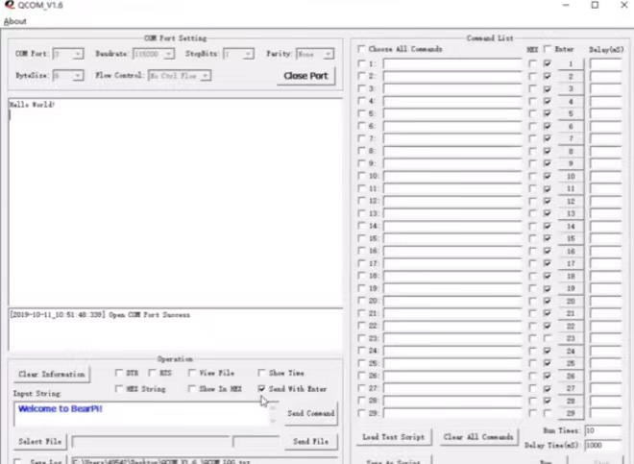
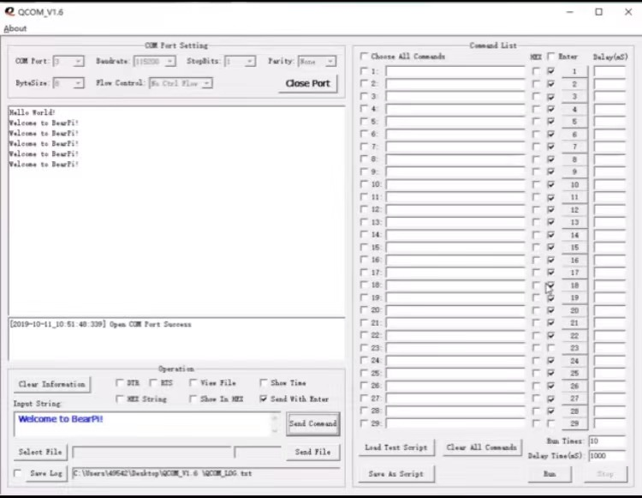

【实验结论】（写结论，心得，和收获）

心得体会：通过这次的实验，学到了串口和pc之间的通信，并且可以通过串口监视器可以接收和发送数据给开发板。

【教师评语和成绩】

成绩： 指导教师： 日期：

