LINUX SERVER ATTACK RESIDUE & FORENSIC RESPONSE SYSTEM

USE-CASE DOCUMENTATION

A report submitted in partial fulfillment of the requirements
for the degree of Bachelor of Technology in
Computer Science & Engineering / Cyber Security

Submitted by
Aman Sharma — 2400320100161

Under the guidance of
Sarath G
Cybersecurity Trainer & Consultant

Department of Computer Science & Engineering
ABES Engineering College, Ghaziabad

Dr. A.P.J. Abdul Kalam Technical University, Lucknow — Session 2026-27

1. Use-Case Diagram
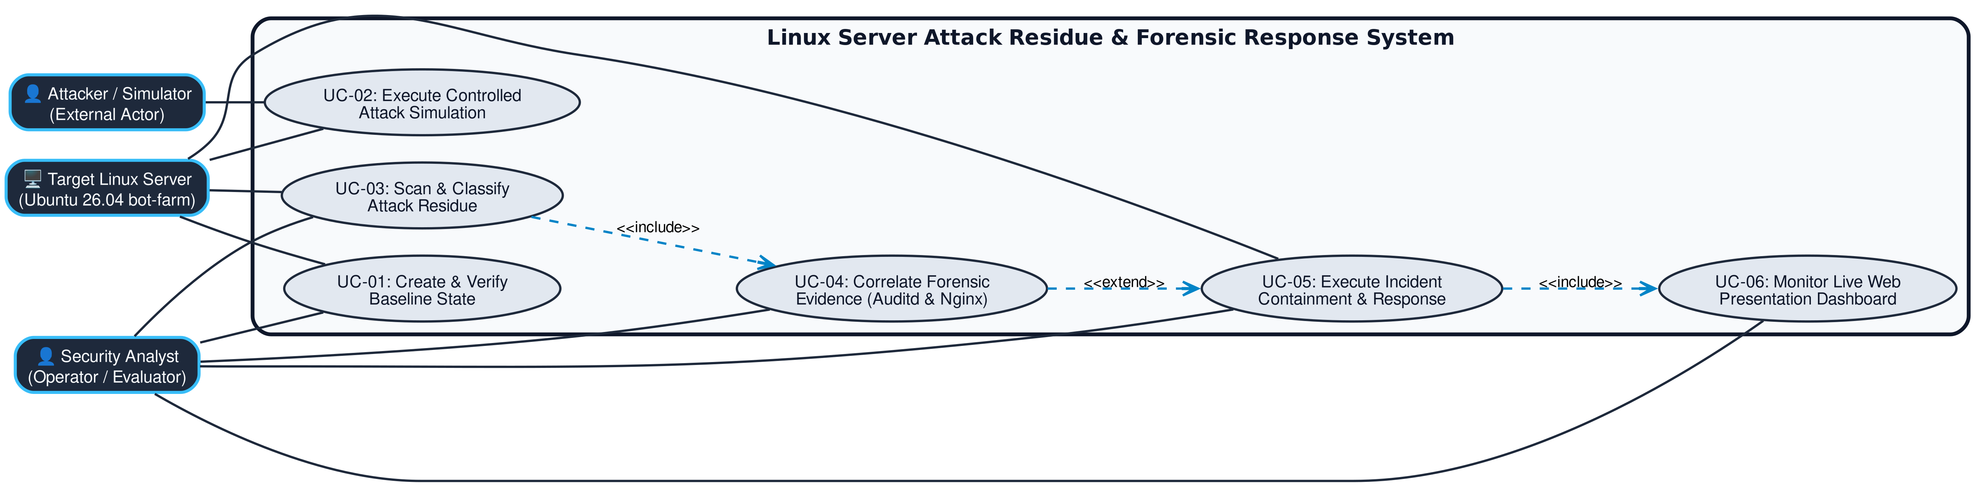

2. Use-Case Descriptions

2.1 Example (filled) — Run Detection
Use Case ID | UC-01
Use Case Name | Record & Verify Baseline State
Actor(s) | Security Analyst (primary); Target Linux Server (secondary)
Description | Analyst records cryptographic SHA256 baseline state of monitored files, unit files, listening ports, users, and SSH keys.
Preconditions | Target host accessible; systemd and python 3.14 standard library operational.
Trigger | Analyst runs 'residue-system baseline create --name local' command.
Main Flow | 1. Analyst initiates baseline recording. 2. System collects host state. 3. System computes SHA256 hashes. 4. Manifest stored at /var/lib/residue-system/artifacts/.
Alternate Flow | 3a. Baseline already exists -> system verifies manifest cryptographic integrity.
Exception Flow | 2a. System file unreadable due to permission -> logs warning and continues scan.
Postconditions | Trusted baseline JSON manifest saved and locked with 0600 permissions.
Priority | High

2.2 Blank table — copy one per use case
Use Case ID | UC-02
Use Case Name | Execute Controlled Compromise Simulation
Actor(s) | Attacker / Simulator (external); Target Linux Server (secondary)
Description | Simulator executes multi-stage attack (plants web shell, unauthorized update-service.service, and /opt/.cache/update binary).
Preconditions | Trusted baseline state recorded on target host.
Trigger | Analyst executes 'python3 attack/compromise_sim.py' command.
Main Flow | 1. Simulator issues HTTP request to target. 2. Planted web shell drops executable. 3. Unit file registered. 4. Simulated backdoor active.
Alternate Flow | 2a. Unit file already present -> overwrites unit file and updates state timestamp.
Exception Flow | 1a. Target web server down -> simulation aborts with connection refused error.
Postconditions | Attack residues planted on target system.
Priority | High

