Alex van der Meer  
Student number: 10400958

Questions 5

1. *Ware argues that human perception involves 2.5 dimensions. Given this assertion, when might a 3D visualization be useful and why?*

This did not became clear to me from reading chapters 5 or 6 but I believe this is useful when something has an unusual shape that is not easily recognised when shown in multiple 2D images but is, when shown in 3D.

1. *In Chapter 6, Ware presents some implications of pattern recognition and visual working memory on design. Provide an example that harnesses some of these principles (perhaps an advertisement, visualization, or interface) and discuss how the design takes these principles into account. Please include a screenshot, photo, or website URL.*

When I think of highly effective advertising I think of the Nazi’s so I found this poster (figure 1.)  
<http://www.ushmm.org/wlc/en/media_ph.php?MediaId=7408>  
  
It was used to make the P0lish people disgusted by Jews. Ware talks about using visual que’s that trigger a mentally stored concept.  
The background here is black witch is normally associated with the night and evil things. The largest and most easily to spot object, is a huge lice. A lice is assiociated with uncomftrable itching, with pain and with unhygienic people. The face of the jewish man is coloured greyish white witch could be associated with a corpse. The men is missing an eye linking further to a corpse. Also the cheaks are sunken in, like that of a skull. Also there are some teeth missing which further associates to the concept of no hygiene. The color of the lice is given the same color as the mens face and the face and the lice overlap so that the two objects are visually and mentally linked.   
Ware also talks of creating a conflict in the sense of putting an object in a scenery were it is not expected to be. This poster imidiatly catches attension in this way because a lice is a very small animal and it when it is shown just as large as a face this creates a conflict.

  
*Figure 1. A poster used to make the Polish population afraid of Jews and give them negative associations. The caption reads “Jews are lice, they cause Typhus”.*

1. *According to Bostock et. al., what are the primary advantages of D3? Based on your reading of the article, please provide an example of a type of visualization that would be easier and better implemented in D3 as opposed to HTML5, JSON, and Javascript. Please list the pros and cons of choosing D3 over pure HTML5, JSON and Javascript.*

D3 is efficient, the article talks of it being faster than other visualization toolkits. With this library it is possible to modify a visualization after the developer is done with it. A change in data can add or remove components of the visualization, this saves the developer time.

As an example I choose the following: <http://mbostock.github.io/d3/talk/20111018/collision.html>  
This visualization is not about data but an example of d3. The visualization consists of a collections of circles that are “afraid” of the mouse. The circles move away from the mouse and collide with eachother and find a new position on the screen. To implement this system of dependence from circle to circle and the force they experience relative to the mouse would require massive amount of work to write in javascript. To write the code to let HTML5 visualize these movements would also be cumbersome. D3 handles this nicely with a small amount of statements.   
Now I will list the pro’s and the con’s of using D3 compared to pure CSS, HTML5 and Javascript.  
**Pro’s**  
- Less work because a large amount of functionality has been written for you  
- D3 creators have already thought about optimaztion so in many cases you do not have to.   
- Learning how to make a certain type of visualization in D3 takes much less time than learning how to make that same visualization with the pure languages because then there are no abstractions made.

**Con’s**  
- Using the pure languages gives one more flexibility and possibilities than D3.   
- Something can almost be optimized a little more, so using pure languages and doing something clever you can make faster rendering visualizations than D3  
- Every browser is compatible.

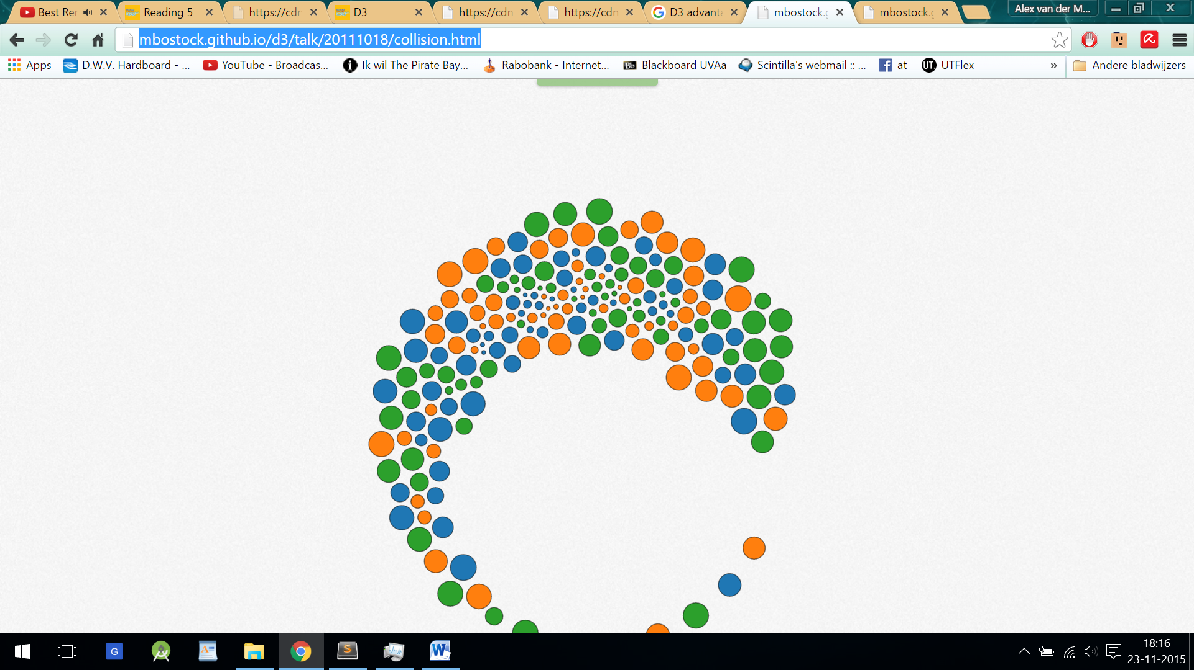  
*Figure 2. Screenshot of the example visualization*

1. *Of the visualization figures presented in Heer et. al., which do you find the most difficult to comprehend? Does the complexity of the figure interfere with the goal of visualization as described in the article? Include a screenshot of the figure you have chosen in your response and use principles that you have learned so far (i.e., from design, perception, and cognition) to justify your choice.*

I chose figure 2b from the article as displayed here in figure 3

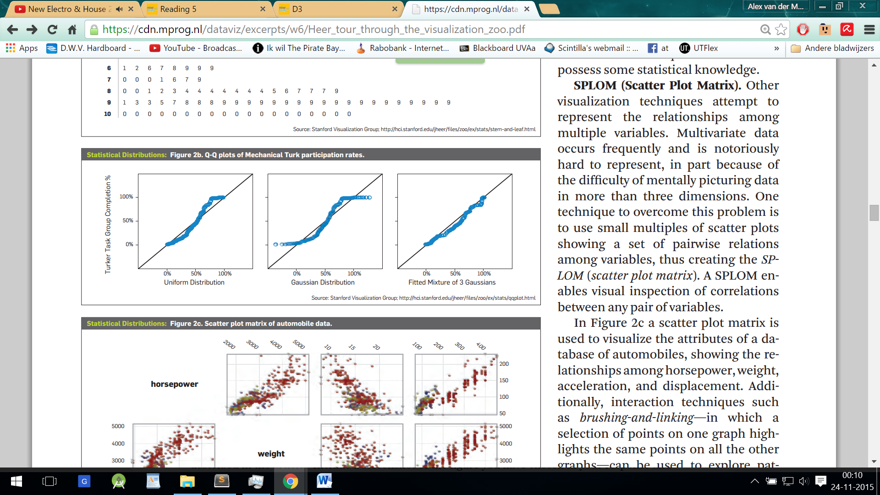  
*Figure 3. Screenshot of the visualization chosen to be most difficult*

I personally do not understand what is happening in this visualization. It should display how well a statistic distribution fits the distribution of the data but what is on the x and y axis or what the line means are unclear. In all graphs the labels are the same, but the data points change in position somehow.   
A design principle that was violated would be having clear axis labels. For the rest it is okay I believe.

1. *Play around with the interactive graphs included in the Heer article. You need to open this page in a browser that runs Java. Focus on Figure 1A. To what extent do interactivity and transitions, elements that D3 optimizes, add to the clarity and message of the visualization? With the element of interactivity in mind, redesign and sketch the contents of figure 1A with one of the other visualization types described in the Heer article. Include a picture of a sketch of your idea, and describe how it supports comprehension and data exploration.*

Since with this problem it is of interest how values relate to a bias value (wich is shown as 0% in the current visualization) a horizon graph comes to mind. However plotting mulitiple sets of data in one horizon graph window would not be clear. Also, seeing clearly what happened per individual company is a clear goal of this visualization.

Considering all these points I suggest to combine the small multiples method with the horizon graph method. I suggest using the horizon method where values are just mirrored in the horizon but depending on space requirements this could be altered.   
  
Now the y axis scales automatically to contain the full range of data on one screen. The maximum in the full range is 3000% so a value of 20% is unreadable while an increase of 20% can be a huge deal for an investor. This could be changed in a scaling where the top of the range can be lowered to a certain value, for example 50% (the same for every graph to allow comparasons). This would clip all the data above 50% but would show changes below that value very clearly.  
 I suppose having two radio buttons; “Auto scaling” to adjust the bounds of the y axis to the maximum value for that company, and “Cumstom scaling” to set the maximum y value with a slider. Figure 4. shows the resulting sketch

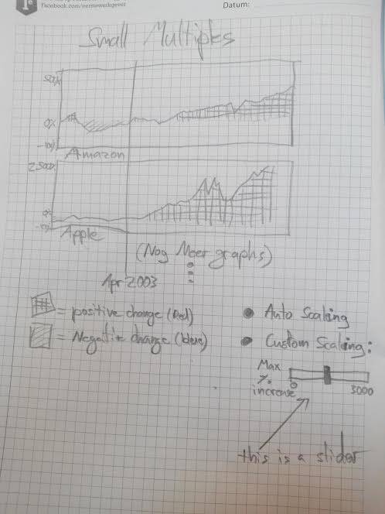

Figure 4. The sketch of the new visualization