

**ITA_First Step Guide**

*－*Version 1.5*－*

Copyright © NEC Corporation 2019. All rights reserved.

Disclaimer

All the contents of this document are protected by copyright owned by NEC Corporation.

Unauthorized reproduction or copying of all or part of the contents of this document is prohibited.

The contents of this document are subject to change without prior notice in the future.

NEC Corporation is not responsible for any technical or editorial errors or omissions in this document.

NEC Corporation do not guarantee accuracy, usability, certainty of the content in this document.

Trademark

* Linux is registered trademark or trademark of Linus Torvalds, registered in the United States and other countries.
* Red Hat is registered trademark or trademark of Red Hat, Inc., registered in the United States and other countries.
* Apache、Apache Tomcat、Tomcat are registered trademarks or trademarks of Apache Software Foundation.
* Ansible is registered trademark or trademark of Red Hat, Inc.

The names of other systems, company name and products mentioned in this document are registered trademarks or trademarks of their respective companies.

The ® mark and TM mark is not specified in this document.

「Exastro IT Automation」is written as「ITA」in this document.

# Table of contents

Table of contents 2

Introduction 4

1 Overview of ITA 5

1.1 What is ITA 5

1.2 Functions of ITA 5

1.2.1 Configuration management function 5

1.2.2 Association execution function 6

1.2.3 User, permission management 6

1.3 Customize function 6

2 Menu and screen configuration of ITA 7

2.1 Connect to main menu 7

2.2 Basic screen configuration 9

3 Operation procedure of ITA 11

3.1 Concept of workflow in ITA 11

3.2 Procedure of environment construction using ITA 13

3.2.1 Register construction target server 15

3.2.2 Register Movement (work pattern) 16

3.2.3 Configure and execute workflow (Symphony) 18

3.2.4 Configure and execute workflow (Conductor) 19

3.3 Operation execution on the second or later device / from the second time 20

# Introduction

**Target reader and Purpose**

This document describes the functions, features, and basic usage of ITA for the first time users.

**Reference**

For operation manual of Cobbler and Cobbler Web, please refer to Cobbler Project.

Cobbler Project ： http://cobbler.github.io/

Please refer to the Redhat Installation Guide for kickstart file references.

Redhat ： https://access.redhat.com/documentation/ja-jp/red_hat_enterprise_linux/

# Overview of ITA

## What is ITA

ITA is a management and automation tool for constructing environment and setting up configuration for devices such as server, storage, and network.

ITA provides a "Configuration management" function which enables users to manage device information, configuration, and execution history, etc. and an "Association execution" function that manages and executes construction and operation configurations of each device as a workflow.

ITA also provides drivers to associate with platform construction tool such as Ansible, etc. where device construction and operation configuration performed on.  
ITA also provides a UI to operate functions via browser and functions that are required for operating and maintaining the system such as user management and permission management.

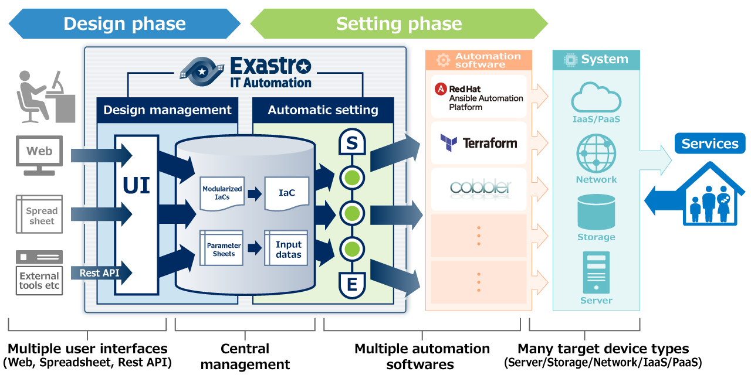

Figure 1.1-1 Overview of ITA

## Functions of ITA

### Configuration management function

* ITA manages construction/management target device information, network configuration, OS information and various information on configuration management database.
* Registered information can be searched and perform history management from the screen. Information list can be output in excel or original csv format and can be registered in the same format in summary.

### Association execution function

* ITA can associate with various platform construction tools. ITA provides drivers to associate with various tools and a workflow function to control the executions.
* ITA 1.0 supports association with tools as below.

**Table 1.2-1 Description of associated driver①**

|  |  |  |
| --- | --- | --- |
| Tool name | Function | Description |
| Ansible | System construction | OSS platform construction tool provided by Red Hat,inc. Used to apply software installation, various configuration, file transfer, and patching to devices connected to the network based on a construction code called Playbook. |
| Cobbler | Operation system construction | OSS installation automation tool.  Users can install operation system to devices that connects to internet based on pre-created template. |
| OpenStack | Virtual system construction | OSS cloud environment construction tool.  Used to construct virtual machine, storage, network, etc. for cloud environment. |
| Terraform | System construction | Terraform is an orchestration tool provided by HashiCorp, Inc. that improves the efficiency of infrastructure process.  The construction is executed after the execution plan is generated based on the infrastructure configuration coded in HCL　(HashiCorp Configuration Language).  Furthermore, with Policy as Code, it's also possible manage access policy in code. |

### User, permission management

Manage ITA users and their permission.

It is possible to set the menu and screens that users can access and control operation (view, update) according to their permission.

　　　Please refer to user instruction manual (ITA management console) for the details.

## Customize function

Users can add functions to ITA according to project requirement.

By using the menu creating tool in ITA, users can create their own configuration management screen of project and add it to ITA menu.

Please refer to the user instruction manual (ITA management console) for detailed information.

Table 1.3-1 Customize function

|  |  |  |
| --- | --- | --- |
| Function name | Function | Description |
| Menu creation tool, menu management function | Add custom configuration management screen | Users can create custom configuration management screen and add it to ITA menu. |

# Menu and screen configuration of ITA

## Connect to main menu

The following is the procedure to connect to the main menu of ITA.

Preparation work

Set the IP address and host name of the ITA implementation server in the hosts file of operation terminal(Windows)  
  
For Windows7, the hosts file is as below.

|  |
| --- |
| C:\Windows\System32\drivers\etc\hosts |

Please add the setting to the hosts file.

|  |
| --- |
| “IP address of the server ITA installed in”　 exastro-it-automation  Example:  127.0.0.1 exastro-it-automation |

1. Login screen of ITA

　　 Connect to the URL of ITA. When the login screen is displayed, enter the following login ID and initial password, then click the "Login" button.

　　　　URL ： https://exastro-it-automation

　　Login ID ： administrator

Initial password ： password

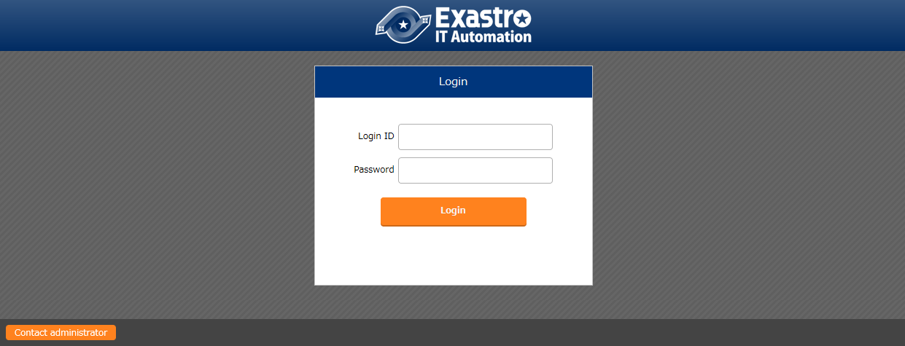

**Figure 2.1-1　Login screen**

When logging in for the first time after installation, the screen will be redirected to the "Password changing screen". Please change the initial password at the "Password changing screen".

1. Main menu screen

The main menu screen after log into ITA.

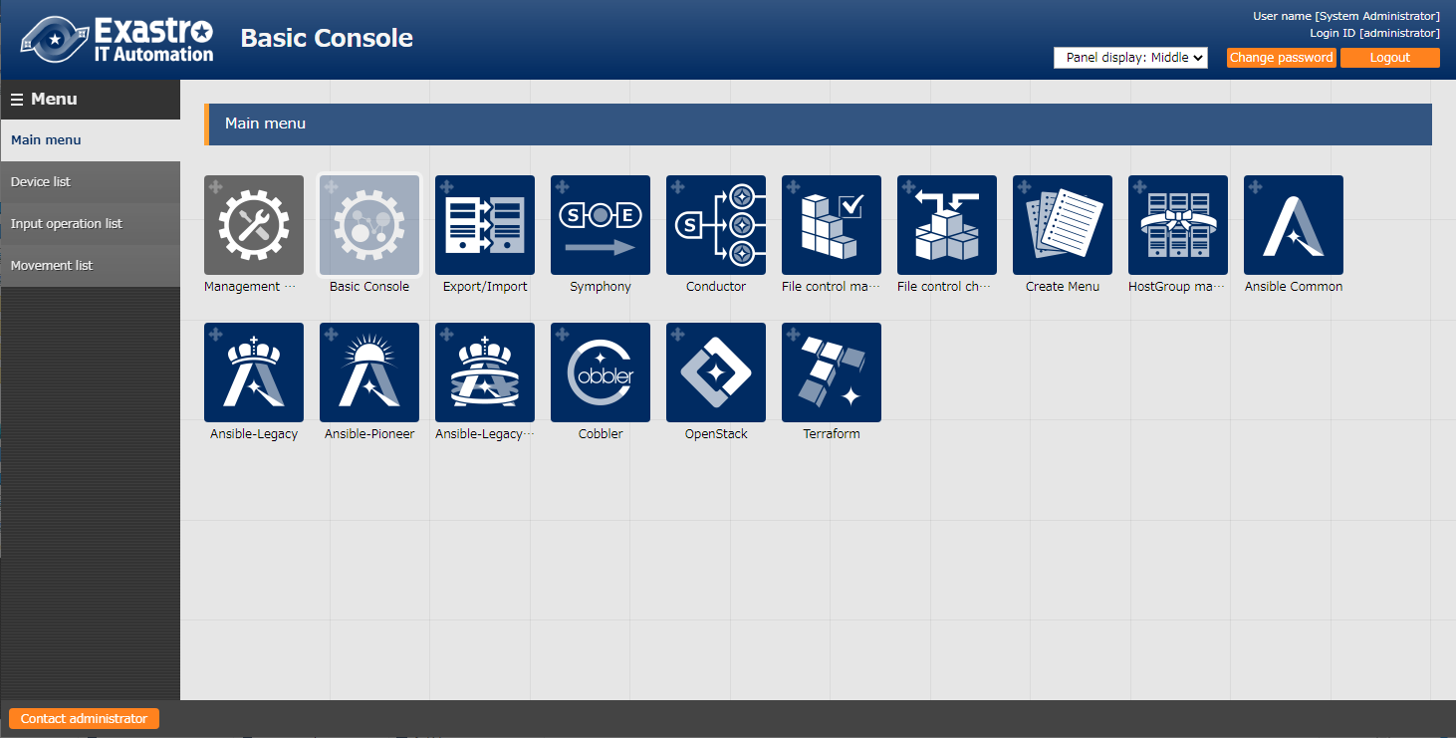

Main menu

Return to main menu

Submenu

**Figure 2.1-2　Main menu screen**

The main menu is displayed on the right of screen and submenu is displayed on the left side of the screen.

After selecting console menu from the main menu, submenu according to the selected console will display.

To return to the main menu, click “Main Menu” at the top of the submenu.

**Table 2.1-1　List of Console in main menu**

|  |  |
| --- | --- |
| Console name | Description |
| Management console | A function that manages ITA system.  User management, permission management and various ITA system setting is perform in this console. |
| Basic console | Common function used in ITA system.  Registration of device information, creation and execution of workflow if performed in this console. |
| Ansible common console | Common configuration information of Ansible driver.  Users can manage installation configuration of Ansible driver and Ansible in this console. |
| Ansible-Legacy console | A function to use Ansible from ITA.  Legacy console is used when using a single YAML file as construction code. |
| Ansible-LegacyRole console | A function to use Ansible from ITA.  Legacy role console is used when using Role package provided from product division, etc. as construction code. |
|  | |
| Console name | Description |
| Ansible-Pioneer console | A function to use Ansible from ITA.  Pioneer console is used to execute the operation while directly interacting with target machine in situations such as when not connected via SSH. |
| Cobbler console | A function to use Cobbler from ITA.  Used when installing operating system to target device. |

Please refer to the respective usage manual of each console menu for details.

## Basic screen configuration

Each menu screen provided by ITA is basically in the same layout.

Name of console menu screen

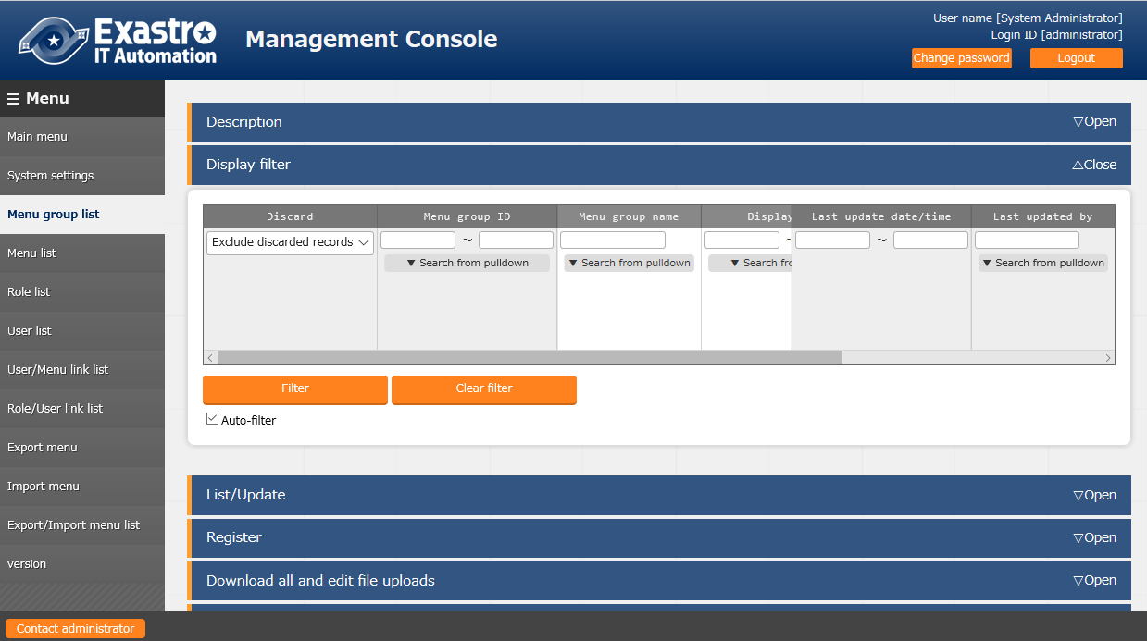

**Figure 2.2-1　Submenu screen**

Menu operation section

Submenu

The screen to perform configuration and registration is called "Menu operation section". The configuration of operation section is as below.

Please refer to "User Instruction Manual - Basic Console" for detailed operation of items in each screen.

**Table 2.2-1　Description of menu operation section**

|  |  |  |
| --- | --- | --- |
| **No** | **Screen item** | **Description** |
| 1 | Description | Description of each menu |
| 2 | Display filter | Assigning searching filter of items registered in each menu.  ※Nothing is displayed when entering the menu screen.  All items will be displayed when clicking "filter" with blank search criteria.  Please assign the search criteria to narrow down the search result. |
| 3 | List /update | Listing the items that meet the search criteria specified in the filter.  Users can update or discard displayed item. |
| 4 | Register | Register new item to each menu.  The content of registration is different for each menu, so please refer to each manual. |
| 5 | Download all and edit file uploads [some screens only] | Information registered in each menu screen can be downloaded in excel format and can register multiple information with the same format in one file at once. |
| 6 | Trace history | It is possible to display the modification history of registered item in each menu screen. |

# Operation procedure of ITA

## Concept of workflow in ITA

Execution of work in ITA is linked with operation name called "Operation" and a workflow called "Symphony" and performed in the unit of "Operation".  
Work pattern called "Movement" is created according to the construction and configuration work for devices. Then workflow instructs the execution in combination of the work patterns.

**Operation**

　　　　　　　・Work execution unit in ITA. Users can schedule Operation execution and manage execution history.

**Symphony**

・Unit of a series of work in ITA. Execute by associating with Operation.  
・Create workflow by combining work patterns called "Movement" and perform a series of works such as construction and configuration to multiple devices.

・Execute work pattern one by one (in the order of registered Movements)

**Conductor**

・Unit of a series of work in ITA. Execute by associating with Operation.  
・Create workflow by combining work patterns called "Node" and perform a series of works such as construction and configuration to multiple devices.

・It is possible to create workflow that is more complicated than Symphony such as execute Movement parallelly, call other workflow, condition branching according to the execution result of Movement.

**Movement**

・Unit of work such as construction and configuration to each devices using construction tools.

・Movements are created in the console of each driver. The way to create Movement differs from each driver so please refer to the manual of each driver.

・Movements are recommended to be created in function unit in order to reuse them in other operations.

Workflow

**Ｍｏｖｅｍｅｎｔ ①**

**Ｍｏｖｅｍｅｎｔ ②**

**Ｍｏｖｅｍｅｎｔ ③**

Symphony

Operation

**Construction**

**Target　Device ①**

Playbook １

Playbook n

Scenario 1

Role 1

**Construct**

**Configure/collect**

**Construction**

**Target　Device ②**

**Figure 3.1-1　Workflow**

(Workflow：Conductor)

**Construction**

**Target　Device①**

Operation name

Conductor

**Construction**

**Target　Device②**

**Construct**

**Ｍｏｖｅｍｅｎｔ ①**

**End**

**Start**

**Ｍｏｖｅｍｅｎｔ ②**

**Configure/collect**

**Role １**

Playbook １

Playbook **ｎ**

**Scenario１**

**Figure 3.1-2　Workflow (Conductor)**

## Procedure of environment construction using ITA

The standard procedure of environment construction using ITA is as below.

The procedure from registering target server, configuring workflow, to execution is introduced here.

The purpose here is to let readers understand the overall procedure of operations.

Please refer to the user instruction manual of each console for the details of each procedure.

**Figure 3.2-1　Procedure of environment construction work(Symphony)**

Driver consoles

**Register construction data**

**Register Movement**

**Register Operation target host**

**Manage substitution value list**

Basic Console

**Register device information**

**Register input operation**

Symphony

**Edit Symphony class**

**Execute Symphony**

**Check Symphony execution**

**3.2.3 Configure workflow and execute**

**3.2.1 Register construction target server**

**3.2.2. Register work pattern (Movement)**

Conductor

Driver consoles

**Register construction data**

**Register Movement**

**Register Operation target host**

**Manage substitution value list**

Basic Console

**Register device information**

**Register input Operation**

**Edit Conductor class**

**Execute Conductor**

**Check Conductor execution**

**3.2.4 Configure workflow and execute**

**3.2.1 Register construction target server**

**3.2.2. Register work pattern (Movement)**

**Figure 3.2-2　Procedure of environment construction work(Conductor)**

### Register construction target server

Register the information of the target device to be constructed and managed from basic console menu and also register the operation name when executing workflow (Symphony).

1. Register device information

Register the information (host name, IP address) of the target device to be constructed and managed and the account information for connection from the "Device list" menu. Also configure the usage information of platform construction tool according to each device.  
  
Please refer to "User Instruction Manual - Basic Console - 4.1.2 Device list" for details.

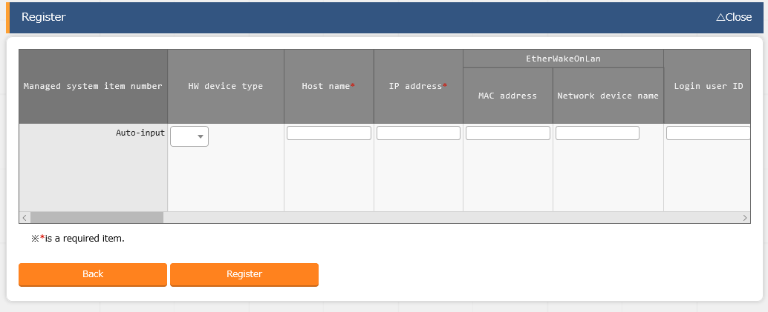

**Figure 3.2-3　Registration screen (Device list)**

1. Register input operation

Register the name of operation to execute as workflow and the scheduled execution date from the "Input operation list" menu.  
  
Please refer to "User Instruction Manual - Basic Console - Input operation list" for details.

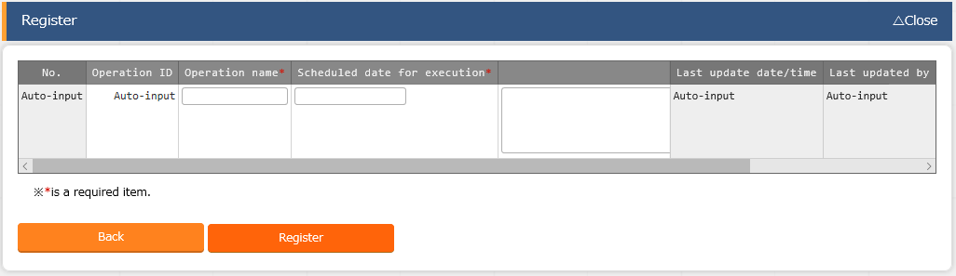

**Figure 3.2-4 Registration screen (Input operation list)**

### Register Movement (work pattern)

Create construction and configuration to each devices as Movements (work pattern) from the console of each driver.  
The method to create Movement (work pattern) varies depending on each driver and console menu. Please refer to workflow in the manual of each driver.

Take the way to create the Movement (work pattern) for platform construction by using Ansible Legacy driver for an example here. Please refer to the user instruction manual (Ansible driver) for detailed procedure.

1. Register construction file

Register the construction code of Ansible – Playbook (YAML file) from the "Playbook files" menu.

1. Register Movement

Register the Movement name in "Movement list" menu and associate the Movement with the Playbook file that is going to be executed, in the "Movement details" menu.

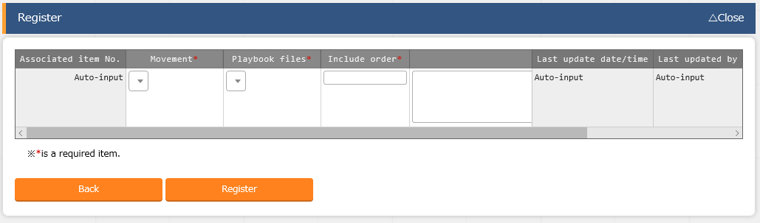

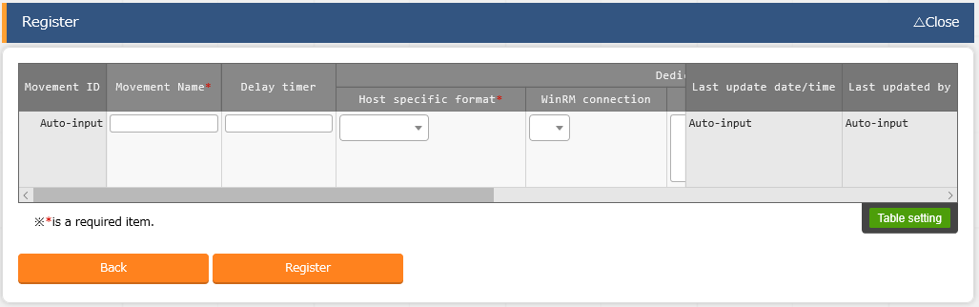

**Figure 3.2-5　Registration screen （Movement list）**

1. Register operation target host

Set the execution target host from the "Target host" menu.

1. Manage substitution value

Users can assign value of variables defined in Playbook from ITA screen.

※ Variables have to follow the original naming rule of ITA.

Configuration that varies for each devices can be configured and managed in ITA without modifying Playbook.

Set variable values in the “Substitute Value list” menu if necessary.

1. Execute operation

Standalone execution of Movement (work pattern) is possible.

There is also a dry run function that only checks the content of Playbook without affecting the target host.

### Configure and execute workflow (Symphony)

Combine the Movements (work pattern) created in section 3.2.2 and register them into workflow (Symphony) then assign the execution to target device in the Symphony menu.

1. Edit Symphony class

Combine the created Movements (work pattern) and create workflow (Symphony) in the "Symphony class editor" of basic console menu.

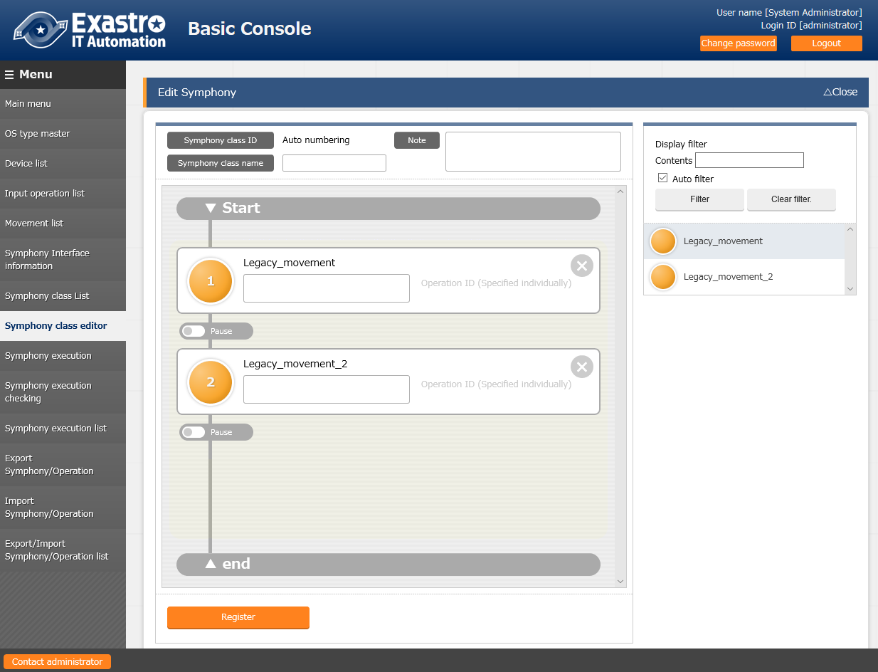   
**Figure 3.2-6　Symphony class editor screen**

**Drag and drop the circle**

1. Execute symphony

Using the "Symphony execution" submenu in the basic console to select the Symphony and Operation to be executed then indicate execution to platform construction tools such as Ansible.

1. Check execution of Symphony

Using the "Symphony execution checking" submenu in the basic console to check the result of execution.

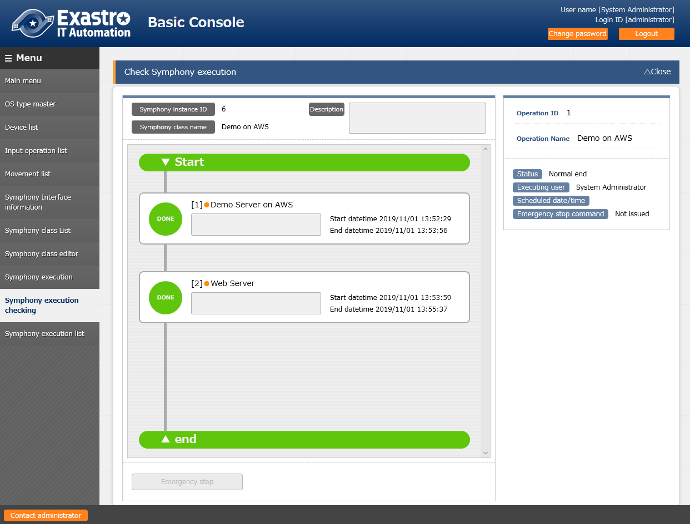

**Figure 3.2-7　Symphony execution checking screen**

3. 2. 4. Configure and execute workflow (Conductor)

Combine the Movements (work pattern) created in section 3.2.2 and register them into workflow (Conductor) then assign the execution to target device in the Conductor menu.

1. Edit Conductor class

Combine the created Movements (work pattern) and create workflow (Conductor) in the "Conductor class editor" of Conductor menu.

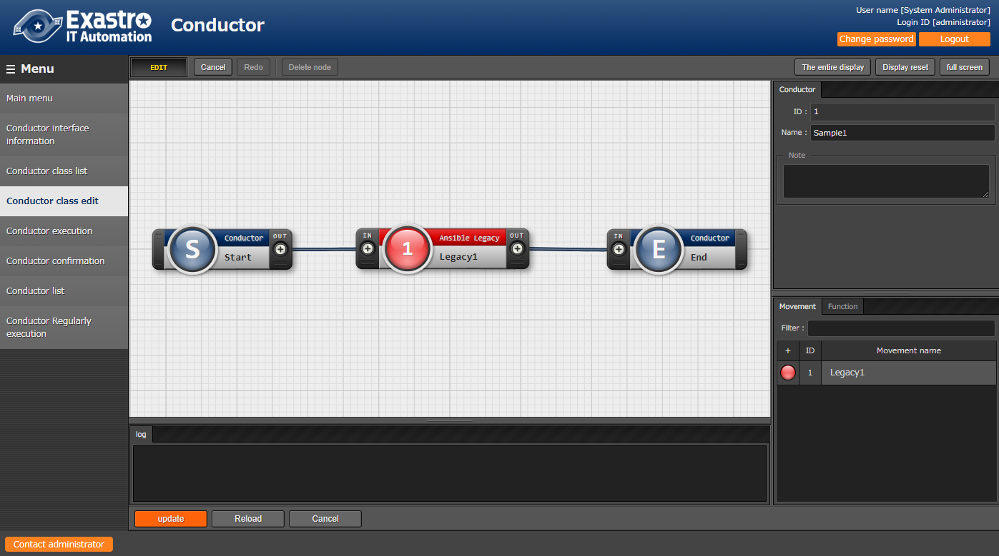

**Drag & Drop**

1. Execute Conductor

Using the "Conductor execution" submenu in Conductor menu to select the Conductor and Operation to be executed then indicate execution to platform construction tools such as Ansible.

1. Check Conductor execution

Using the "Conductor confirmation" submenu in Conductor menu to check the result of execution.

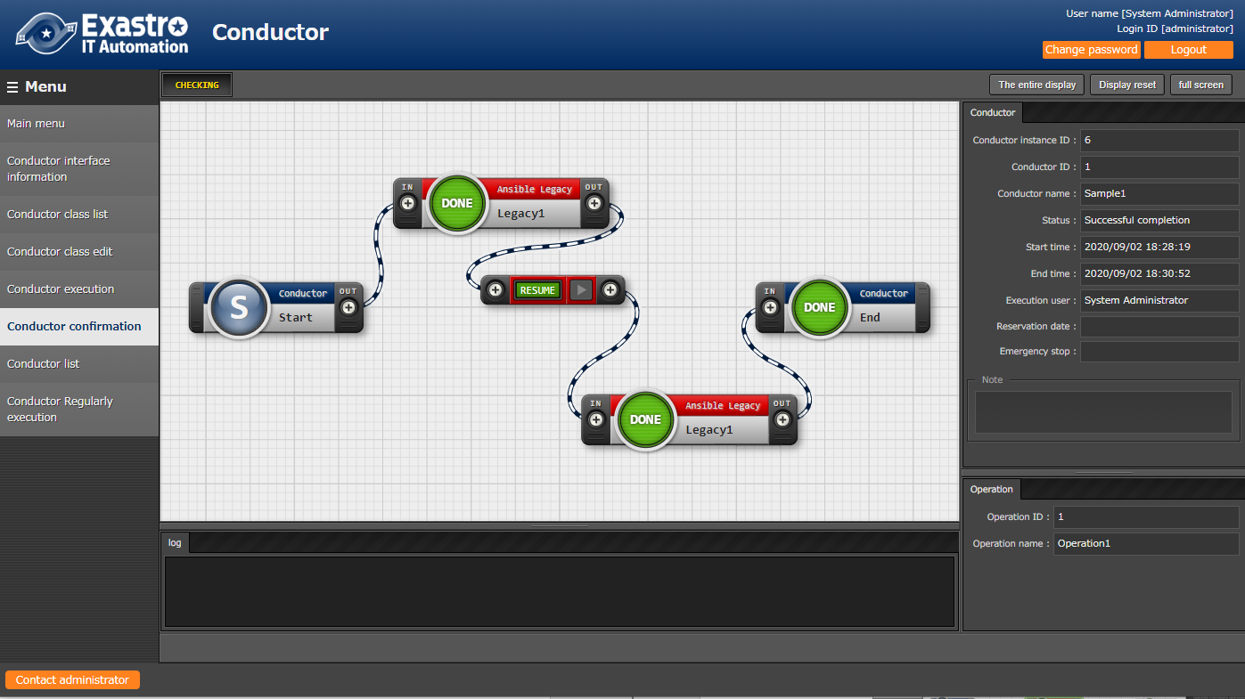

**Figure 3.2-9　 Conductor confirmation screen**

## Operation execution on the second or later device / from the second time

For constructing similar environment, it is possible to reuse created Movement (work pattern) and workflow for operation execution on second or later device/from the second time.

The procedure introduced in section "3.2 Procedure of environment construction using ITA" is required to be perform on the first construction. However the workflow of operation on the second or later device/from the second time is as below (Server construction on the second or later device). Constructing the environment of the second and later device / from the second time is possible by only modifying "Register device information", "Register input operation", "Register operation target host", and "Manage substitution value" that are surrounded by green frame according to the construction specification and indicating execution to workflow (Symphony/Conductor).

Driver consoles

**Register construction file**

**Register movement**

**Register operation target**

**Manage substitution value**

Basic console

**Register device infomation**

**Register input Operation**

Symphony

**Edit Symphony class**

**Edit Symphony**

**Check Symphony execution**

Driver consoles

**Register construction file**

**Register movement**

**Register operation target**

**Manage substitution value**

Basic console

**Register device infomation**

**Register input Operation**

Symphony

**Edit Symphony class**

**Edit Symphony**

**Check Symphony execution**

**【First Server Construction】　  
・Perform all procedure**

**【Second and later server construction】**

**・Perform procedures in green frame.**

**Figure 3.3-1 Workflow from the second time in similar environments**