

ITA_ System Configuration/

Environment Construction Guide

Ansible-driver

*－*　Version 1.4*－*

Copyright © NEC Corporation 2019. All rights reserved.

Disclaimer

All the contents of this document are protected by copyright owned by NEC Corporation.

Unauthorized reproduction or copying of all or part of the contents of this document is prohibited.

The contents of this document are subject to change without prior notice in the future.

NEC Corporation is not responsible for any technical or editorial errors or omissions in this document.

NEC Corporation do not guarantee accuracy, usability, certainty of the content in this document.

Trademark

* Linux is registered trademark or trademark of Linus Torvalds, registered in the U.S. and other countries.
* Red Hat is registered trademark or trademark of Red Hat, Inc., registered in the U.S. and other countries.
* Apache、Apache Tomcat、Tomcat are registered trademarks or trademarks of Apache Software Foundation.
* Oracle and MySQL are registered trademarks of Oracle Corporation and its subsidiaries and affiliates in the United States and other countries.
* MariaDB is a registered trademark or trademark of the MariaDB Foundation.
* Ansible is a registered trademark or trademark of Red Hat,Inc.
* AnsibleTower is a registered trademark or trademark of Red Hat,Inc.

The names of other systems, company name and products mentioned in this document are registered trademarks or trademarks of their respective companies.

The ® mark and TM mark is not specified in this document.

※「Exastro IT Automation」is written as「ITA」in this document.

Table of contents

Introduction 3

1 Function 4

2 System configuration 5

3 System requirements 6

4 Prepare shared directory 7

4.1 Ansible driver － Ansible RestAPI 7

4.2 Ansible driver － Ansible Tower server 7

4.3 Ansible Tower SCM management directory 7

5 AnsibleTower initial settings 8

5.1 Settings 8

5.2 Package confirmation 9

5.3 Required resource preparation 10

5.3.1 [Project] Operation before creating new project 10

5.3.2 [Project] Operation after deleting project 11

5.3.3 [Inventory] Local access 11

5.3.4 [Credential] Local access 12

5.3.5 Application 12

5.3.6 [User] Token 12

# Introduction

This document explains the system configuration and environment construction for operating Ansible optional function (referred to as Ansible driver hereafter) in ITA.

To use the ITA Ansible driver, it is assumed that the basic ITA functions have been built. Please refer to "System Configuration/Environment Construction Guide - Basics" for constructing ITA basic function.

# Function

Ansible driver provides the following functions.

Table 1 Function name

|  |  |  |  |  |
| --- | --- | --- | --- | --- |
| No | Function name | Use | WEB  Content | BackYard  Content |
| 1 | Ansible driver | Manage construction of server, storage, network devices from ITA through Ansible or AnsibleTower. | ○ | ○ |
| 2 | Ansible RestAPI | Contents providing RestAPI for operating Ansible from external. | ○ | － |

# System configuration

The system configuration of Ansible driver is same as the ITA system.

Ansible RestAPI is considered to be configured in a dedicated Ansible server seperated from the Ansible driver.

Also, preparing a designated server for Ansible Tower is required. (Consolidating the construction into one server is also possible.)

This figure shows a configuration in which an Ansible RESTAPI server is added to the balanced HA type, the recommended configuration for the ITA system.

※The figure here is a omitted version. Please refer to "System Configuration/Environment Construction Guide - Basics" for details.

Ansible RestAPI

ITA system/Ansible driver

AP/DB server [SBY]

BackYard

function

AP/DB server [ACT]

DB

Session management

Uploaded file

DB connection

information

DBMS

Web server [ACT]

Web server [ACT]

Web

function

Web server [ACT]

DB connection information

**Ansible**

**driver**

Load balancer

Ansible server

Configuration

target device

Network

device

Server

Storage

**AnsibleAPI**

**function**

Ansible

AnsibleTower server

**Ansible**

**driver**

SCM management

External installed data

In the case that AnsibleTower is in cluster configuration.

# System requirements

Since Ansible driver is based on system requirements of ITA system, please refer to "System Configuration/Environment Construction Guide - Basics". This section describes the requirements for BackYard, Ansible RestAPI, and Ansible Tower.

●BackYard

Table 3-1. Linux commands required for Ansible BackYard

|  |  |
| --- | --- |
| **Command** | **Note** |
| zip |  |

Table 3-2. External modules required for Ansible BackYard

|  |  |  |
| --- | --- | --- |
| **External module** | **Version** | **Note** |
| Spyc.php | 0.6.2 |  |

●Ansible RestAPI

Table 3-3 Ansible RestAPI system requirements

|  |  |  |
| --- | --- | --- |
| **Package** | **Version** | **Note** |
| Ansible | 2.5 or higher |  |
| Python | 3.0 or higher |  |
| pywinrm |  | Python module. If installation fails when using yum, please use pip to install. |
| Pexpect |  | Python module. |
| telnet | － | Required for telnet connection to the configuration target. |
| Apache | 2.2 series / 2.4 series | Required when operating the function on the server different from the ITA system.  The package and version should match the ITA system servers |

Table 3-4 Linux command required for Ansible Driver

|  |  |
| --- | --- |
| **Command** | **Note** |
| expect |  |

●Ansible Tower

Table 3-5 Ansible Tower system requirements

|  |  |  |
| --- | --- | --- |
| **Package** | **Version** | **Note** |
| Ansible Tower | 3.5.0 or higher | The user/password authentication method under version 3.5.0 is not supported |

# Prepare shared directory

## Ansible driver － Ansible RestAPI

Please prepare a shared directory which both Ansible driver and Ansible RestAPI can refer.

After installing Ansible driver and Ansible RestAPI, it is required to register the shared directory to ITA system. Please refer to "Interface information" in "User instruction manual - Ansible-driver" and perform registration.

## Ansible driver － Ansible Tower server

Please prepare a shared directory which both Ansible driver and AnsibleTower server can reference.

After installing Ansible driver and constructing AnsibleTower server, registering the shared directory to ITA system is required.

Please refer to "Interface information" in "User instruction manual - Ansible-driver" and perform registration.

## Ansible Tower SCM management directory

SCM type is set to manual when creating an AnsibleTower project from ITA.

When constructing AnsibleTower in cluster configuration, please prepare a shared directory for the project base path (/var/lib/awx/projects) and share all instances with it.

# AnsibleTower initial settings

Perform settings required for AnsibleTower after installing AnsibleTower.

## Settings

Login AnsibleTower from browser, set “/var/lib/awx/.ssh” in “SETTINGS” → “JOBS” → “PATHS TO EXPOSE ISOLATED JOBS”.

According to this setting, ssh connection that does not require the user and password of the target node with key exchange is enabled.

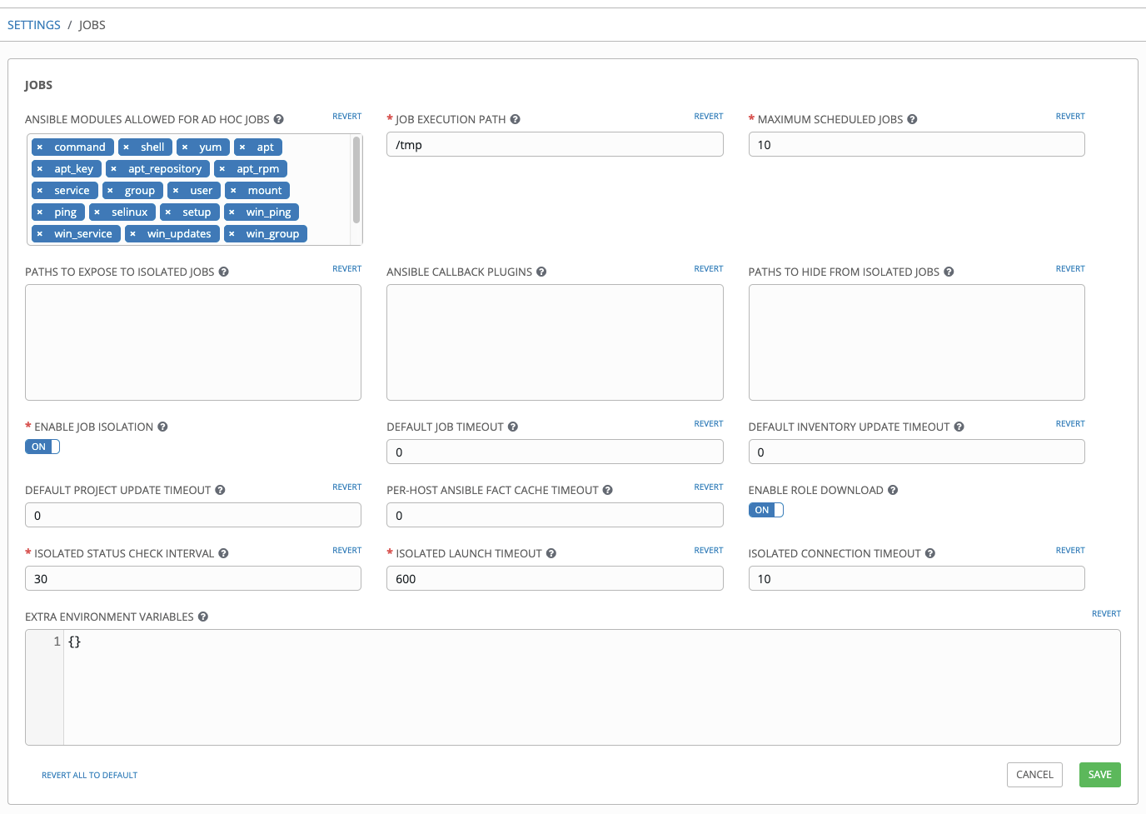

/var/lib/awx/.ssh

## Package confirmation

Confirm packages that are required for Ansible-driver are installed.

If not installed, it’s required to install the packages.

* Required package

pexpect

* Method to confirm

su - awx

source /var/lib/awx/venv/ansible/bin/activate

pip list

deactivate

* Method to install

su - awx

source /var/lib/awx/venv/ansible/bin/activate

umask 0022

pip install --upgrade pexpect

deactivate

## Required resource preparation

It is required to register projects, inventory, credentials, and application with Ansible Tower in advance.

Table 5-1 AnsibleTower required resource

|  |  |  |  |
| --- | --- | --- | --- |
| **Type** | **Use** | **Name** | **Description** |
| Project | Operation before creating new project | ita_executions_prepare_build | Copy the role structure directory received from shared directory to the project base path of AnsibleTower |
| Project | Operation after deleting project | ita_executions_cleanup | Delete the directory created in the above "Operation before creating new project". |
| Inventory | Local access | ita_executions_local | Inventory information for executing the operation of above project in AnsibleTower locally. |
| Credential | Local access | ita_executions_local | Credential for executing the operation of project above in AnsibleTower locally. |
| Application | Authentication application | o_auth2_access_token | Application information for authentication when connecting from ITA to AnsibleTower with RestAPI |
| User | Token | - | Connection token used to connect from ITA to AnsibleTower with RestAPI |

1. [Project] Operation before creating new project

* Create directory in AnsibleTower server

Project root (Default：/var/lib/awx/projects/)

　　┗ ita_executions_prepare_build/

　　　　　┣ site.yml

　　　　　┗ roles/

　　　　　　　　┗ copy_materials_role/

　　　　　　　　　　　┗ tasks/

　　　　　　　　　　　　　　┗ main.yml

* Content of site.yml

---

- name: copy matetials from data_relay_storage to projects

gather_facts: no

hosts: all

roles:

- copy_materials_role

* Content of main.yml

---

- name: copy_materials

copy:

src: "{{ if_info_data_relay_storage }}/{{ driver_type }}/{{ driver_id }}/{{ execution_no_with_padding }}/in/"

dest: "/var/lib/awx/projects/ita_{{ driver_name }}_executions_{{ execution_no_with_padding }}"

* AnsibleTower settings
* Name ：　ita_executions_prepare_build
* Organization ：　Default
* SCM type ：　Manual (Machine)
* PLAYBOOK directory ：　ita_executions_prepare_build

1. [Project] Operation after deleting project

* Directory configuration in AnsibleTower server

Project root (Default：/var/lib/awx/projects/)

　　┗ ita_executions_cleanup/

　　　　　┣ site.yml

　　　　　┗ roles/

　　　　　　　　┗ rmdir_role/

　　　　　　　　　　　┗ tasks/

　　　　　　　　　　　　　　┗ main.yml

* Content of site.yml

---

- name: remove local directory

hosts: all

gather_facts: no

roles:

- rmdir_role

* Content of main.yml

- name: rmdir_local

file:

path: "/var/lib/awx/projects/ita_{{ driver_name }}_executions_{{ execution_no_with_padding }}"

state: absent

* AnsibleTower settings
* Name ：　ita_executions_cleanup
* Organization ：　Default
* SCM type ：　Manual (Machine)
* PLAYBOOK directory ：　ita_executions_cleanup

1. [Inventory] Local access

* AnsibleTower settings (inventory)
* Name ：　ita_executions_local
* Organization ：　Default
* AnsibleTower settings(in inventory - host)
* Host name ：　localhost
* Variable ：

ansible_ssh_host: localhost

1. [Credential] Local access

* AnsibleTower settings
* Name ：　ita_executions_local
* CREDENTIAL TYPE ：　Machine
* User name ：　Linux user
* Password ： password

The user/password to execute Project：ita_executions_cleanup /ita_executions_prepare_build.

Please use the user that owns read/write permission of project base path(/var/lib/awx/projects). Creating a dedicated Linux user is recommended.

When constructing AnsibleTower in cluster configuration, creating Linux users / passwords that is same with each Ansible Tower server in advance is required.

1. Application

* AnsibleTower settings
* Name ：　o_auth2_access_token
* Organization ：　Default
* Authorization Grant Type ：　Password base of resource owner
* Client type ： Secret

1. [User] Token

* AnsibleTower settings
* APPLICATION ：　o_auth2_access_token
* SCOPE ：　write

Login with the user used to login AnsibleTower beforehand is required.

The generated token must be set as the connection token in the interface information of the AnsibleTower console.