

ITA_System Configuration / Environment Construction Guide

Terraform-CLI-driver

*－*Version 1.11*－*

Copyright © NEC Corporation 2023. All rights reserved.

Disclaimer

All the contents of this document are protected by copyright owned by NEC Corporation

Unauthorized reproduction or copying of all or part of the contents of this document is prohibited

The contents of this document are subject to change without prior notice in the future.

NEC Corporation is not responsible for any technical or editorial errors or omissions in this document.

NEC Corporation do not guarantee accuracy, usability, certainty of the content in this document.

Trademark

* Linux is registered trademark or trademark of Linux Torvalds, registered in the U.S. and other countries.
* Red Hat is registered trademark or trademark of Red Hat, Inc., registered in the U.S. and other countries.
* Apache、Apache Tomcat and Tomcat are registered trademarks or trademarks of the Apache Software Foundation.
* Oracle and MySQL are registered trademarks of Oracle Corporation and its subsidiaries and affiliates in the U.S. and other countries.
* MariaDB is a registered trademark or trademark of the MariaDB Foundation.
* Terraform is a registered trademark or trademark of HarshCorp, Inc..

The names of other systems, company name and products mentioned in this document are registered trademarks or trademarks of their respective companies.

The ® mark and TM mark are not specified in this document.

※”Exastro IT Automation” is written as ”ITA” in this document.

Table of Contents

Introduction 3

1 Function 4

2 System configuration 5

2.1 System configuration 5

2.2　System connection requirements 6

3 System requirements 7

# Introduction

This document describes the system configuration and environment construction required in order to operate the Terraform option function (hereinafter written as Terraform CLI driver) in ITA.

To use the ITA Terraform CLI driver, the basic ITA functions must have been built. Please refer to "System Configuration/Environment Construction Guide - Basics" for constructing ITA basic function.

# Function

The Terraform CLI driver provides the following function.

Table 1. Function name

|  |  |  |  |  |
| --- | --- | --- | --- | --- |
| No | Function | Application | WEB/AP | BackYard |
| 1 | Terraform CLI driver | Uses Terraform via ITA to generate execution plans and executes the construction based on the coded infrastructure configuration. | ◎ | ◎ |

# System configuration

## System configuration

The system configuration for the Terraform CLI Driver is the same as the ITA System.

※The following diagram illustrates a Terraform configuration. The ITA system is not included in the diagram.

For more information, see "Exastro-ITA_System_Configuration_Environment_Construction_Guide_Basic"

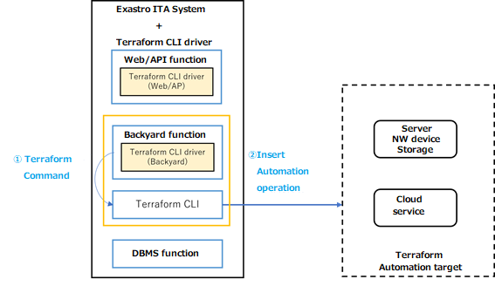

## 2.2　System connection requirements

The table below contains the connection requirements for the different services in this system configuration

For more information regarding the connection requirements for the ITA System, please see   
“Exastro-ITA_System_Configuration_Environment_Construction_Guide_Basic”.

Table 2.2 Connection requirements list

|  |  |  |  |  |
| --- | --- | --- | --- | --- |
| **Connection No.※1** | **FROM** | **TO** | **Protocol**  **[Port number ※2]** | **Main application** |
| ① | ITA server  (Backyard function) | Terraform CLI | https  [443/tcp] | Runs Terraform commands from the Backyard function |
| ② | Terraform | Target device | Any  (Differs depending on the Terraform provider） | Runs commands and inputs API commands to the Target device/Cloud service from Terraform. |

※1 Describe the connection numbers linked to the numbers in the diagram in" 2.1 System configuration".

# System requirements

Since Terraform driver (ITA side) is based on system requirements of ITA system, please refer to "System Configuration/Environment Construction Guide - Basics". This section describes the requirements for using BackYard.

●BackYard

**Table 3-1. Linux commands required for Terraform backyard**

|  |  |  |
| --- | --- | --- |
| **Command** | **Version** | **Remarks** |
| Terraform | v1.3.7 or later |  |
| zip |  |  |

Python Library

Table 3‑2. Terraform driver system requirements

|  |  |  |
| --- | --- | --- |
| **Name** | **Requirements** | **Remarks** |
| python-hcl2 | Python3.6 or later | Both WebAP Server and BackYard server is required. |