

ITA_System Configuration / Environment Construction Guide

Basic

－Version 1.10－

Copyright © NEC Corpo**r**ation 2020. All rights reserved.

Disclaimer

All the contents of this document are protected by copyright owned by NEC Corporation

Unauthorized reproduction or copying of all or part of the contents of this document is prohibited

The contents of this document are subject to change without prior notice in the future.

NEC Corporation is not responsible for any technical or editorial errors or omissions in this document.

NEC Corporation do not guarantee accuracy, usability, certainty of the content in this document.

Trademark

* Linux is registered trademark or trademark of Linux Torvalds, registered in the U.S. and other countries.
* Red Hat is registered trademark or trademark of Red Hat, Inc., registered in the U.S. and other countries.
* Apache、Apache Tomcat and Tomcat are registered trademarks or trademarks of the Apache Software Foundation.
* Oracle and MySQL are registered trademarks of Oracle Corporation and its subsidiaries and affiliates in the U.S. and other countries.
* MariaDB is a registered trademark or trademark of the MariaDB Foundation.

The names of other systems, company name and products mentioned in this document are registered trademarks or trademarks of their respective companies.

The® mark and TM mark are not specified in this document.

※”Exastro IT Automation” is written as ”ITA” in this document.

Table of contents

Introduction 3

1. System requirements 4

1.1 Server requirements 4

1.2 Client requirements 6

2. System configuration 7

2.1 System configuration pattern 7

2.2 System communication requirements 9

2.3 Server scalability affecting points 9

# Introduction

This document explains the system configuration and environment construction for ITA system operation.

# System requirements



## Server requirements

The system operates on a Linux server and is accessed from a client PC via browser.

When installing the system, please prepare a server that meets the following requirements.

■1.1.1　Server configuration

Table 1.1.1 Server configuration list

|  |  |  |  |
| --- | --- | --- | --- |
| **Category** | **Required/ Select** | **Product name** | **Version** |
| OS | Either of | RHEL ※1 | 7.x 8.x |
| CentOS | 7.x ※8.x reached EOL 2021/12/31 and is not supported. |
| CentOS Stream | 8.x |
| Web server | Required | Apache | 2.4 series |
| DataBase | Required | MariaDB | 10.3 or later |
| Language | Required | PHP | ITAv1.9.1 or earlier: 7.2 ITAv1.10.0 or later: 7.2 or 7.4 |
| PHP library | Required | PhpSpreadsheet | 1.10.1 or later |
| php-yaml | 2.1.0 or later |
| Pear library | Required | HTML_AJAX | 0.5.7 or later |

※1 Red Hat Enterprise Linux

■1.1.2　 Server minimum specifications

Table 1.1.2 List of minimum server specifications

|  |  |  |
| --- | --- | --- |
| **Category** | **Minimum specification** | **Remarks** |
| CPU | 2Core |  |
| Memory | 4GB |  |
| Disk space | 1GB | Capacity of ITA system. Excluding OS and log storage capacity. |

■1.1.3　 Sizing

The following is the recommended spec for server.

1. Number of records in 1 menu

The number of records (columns) inside a single menu which is created in menu creation function.

Table 1.1.3-1 Number of items in 1 menu and server spec

|  |  |  |
| --- | --- | --- |
| Number of menu items | CPU | Memory |
| ～ 10,000 | 2Core | 4GB |
| 1,000 ～ 20,000 | 4Core | 8GB |

1. Number of parallel execution of Ansible operations

Maximum number of parallel execution can be set in “Ansible Common” > “Interface information” > “Number of parallel executions”.

Table 1.1.3-2 Number of parallel execution of Ansible operations and server spec

|  |  |  |
| --- | --- | --- |
| Number of parallel executions | CPU | Memory |
| ～ 50 | 2Core | 4GB |
| 50 ～ 100 | 4Core | 8GB |

1. Number of simultaneous login and operation

The number of the users that logged in to the system at the same time, and perform operations such as screen moving, filter searching or registration in login stat.

Table 1.1.3-3 Number of simultaneous login and operation and server spec

|  |  |  |
| --- | --- | --- |
| Number of simultaneous  login and operation | CPU | Memory |
| ～ 200 | 2Core | 4GB |
| 200 ～ 300 | 4Core | 8GB |

The setting of ITA after installation is set to the minimum spec (CPU: 2 core / Memory: 4GB) for ITA to operate on ITA system server.

Please change the setting value to improve the performance for the system to work above minimum spec.

Please refer to the “[Reference] Configuration settings during installation” manual for details of setting value.

※1 ITA system server … A basic ITA configuration that server of associated driver such as Ansible server is constructed in individual server .

## Client requirements

While using the functions of this system, the following requirements are recommended for client PCs.

Table 1.2.1 Requirements of client PC

|  |  |  |
| --- | --- | --- |
| **Category** | **Product name** | **Version** |
| Software | Excel（※） | MS Office 2010 or later |
| Browser | Google Chrome | 72 or later |
| FireFox | 41 or later |
| Edge | 20 or later |

※Required when downloading Excel files (because the format of download file is Excel).

# System configuration

## System configuration pattern

The Web / AP function, BackYard function, database and data storage of this software can be operated with following server configurations.

Table 2.1 System configuration patterns

|  |  |  |  |
| --- | --- | --- | --- |
| No | Configuration | Description | Remarks |
| 1 | All-in-one configuration | A configuration pattern that assembles the system on a single server. | Association driver that is possible to be configured in All-in-one configuration with ITA-BASE function.  ・Ansible-driver  ・Cobbler-driver |
| 2 | HA configuration | A configuration pattern in which all systems are separated into individual servers to create a redundant configuration, and data files and DataBase files are stored in external storage. | Web/AP server (Act/Act configuration)  DBMS server (Act/Sby configuration)  Backyard server (Act/Sby configuration) |

The following is a representative example image of a system using the Ansible driver

■ All-in-one configuration

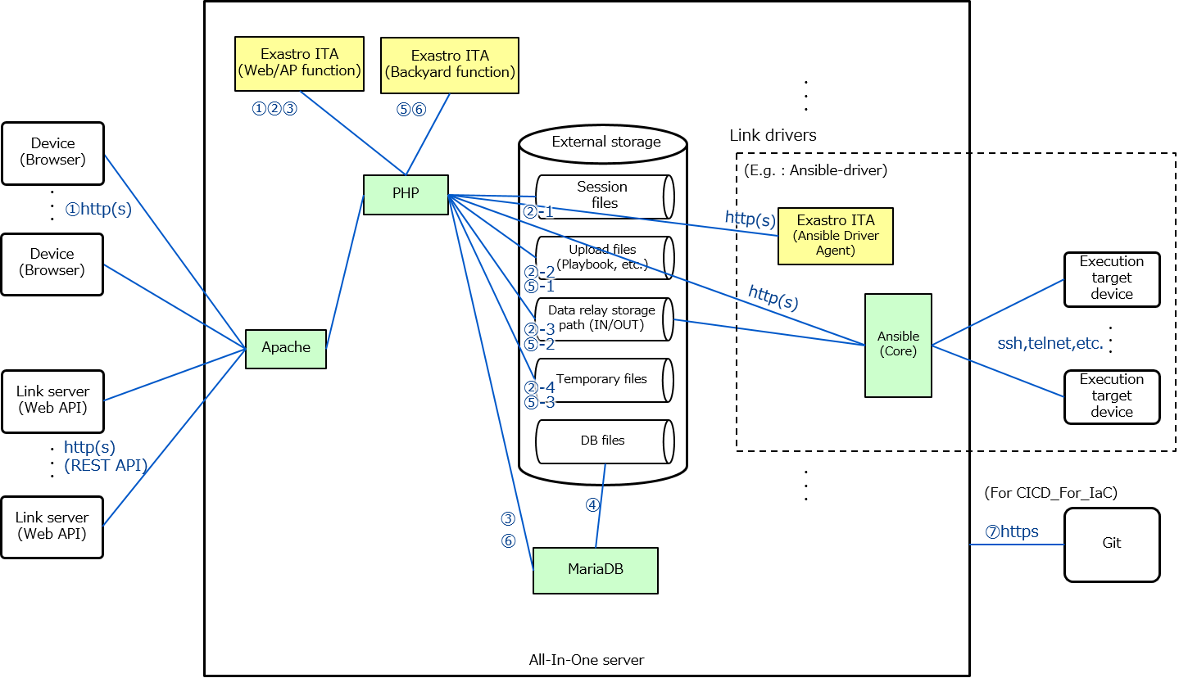

(Engine)

■　HA configuration

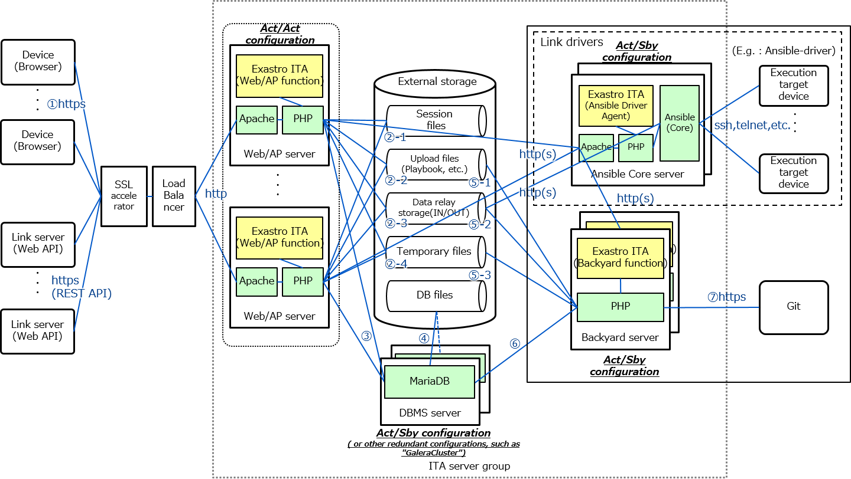

## System communication requirements

In this system configuration, the communication requirements between each service are as follows.

For information regarding connection requirements for Ansible Driver and Terraform Driver, please refer to the following documents:   
“Exastro-ITA_System_Configuration_Environment_Construction_Guide_Ansible-Driver”

“Exastro-ITA_System_Configuration_Environment_Construction_Guide_Terraform-Driver”

Table 2.2 List of communication requirements

|  |  |  |  |  |
| --- | --- | --- | --- | --- |
| **Communication number ※1** | **FROM** | **TO** | **Protocol [port number ※2]** | **Main Applications** |
| ① | Device | Web/AP server | http(s)  [80(443)/tcp] | Access to Exastro ITA Web content |
| ②-1 | Web/AP  server | Storage device (session file) | File access (tcp or storage I / O) | Store / view web session files |
| ②-2 | Storage device (uploaded file) | Store / view uploaded files (Playbook,etc) |
| ②-3 | Storage device (data relay storage) | Store execution information (Playbook, host_vars, etc.) in Symphony execution. |
| ②-4 | Storage device (temporary file) | Store/ view temporary files (upload files, etc.) |
| ③ | DBMS server | tcp (DB access) [3306 / tcp] | Access to DB server (Data processing according to view/ registration / update /discard / restore on ITA screen) |
| ④ | DBMS server | Storage device (DB file) | File access (tcp or storage I / O) | Write DB file |
| ⑤-1 | Backyard  server | Storage device (uploaded file) | File access (tcp or storage I / O) | Refer to uploaded file (Playbook, etc.) |
| ⑤-2 | Storage device (data relay storage) | Store information and logs during Symphony execution |
| ⑤-3 | Storage device (temporary file) | Store / view temporary files (upload files, etc.) |
| ⑥ | DBMS　server | tcp (DB access) [3306 / tcp] | Access to DB server (View/update/discard) |
| ⑦ | Backyard server | git | http(s)  [80(443)/tcp] | Uses CI/CD for IaC to connect to the Git repository and gathers file information. |

※1 Describe the communication number associated with the above number in the configuration image of "2.1 System Configuration Pattern".

※2 The port number is the standard port number

## Server scalability affecting points

In this system configuration, the points that affect server scalability and the configuration are as follows.

The numbers in the table below indicates the following:

1. What component is most affected (Memory, Disc or CPU)
2. What effect it has when running out of resources
3. How to solve

Table 2.3 Affecting points of server scalability

|  |  |  |  |  |  |
| --- | --- | --- | --- | --- | --- |
|  | Web/AP  server | DBMS  server | Backyard  server | External  storage | Ansible  server |
| ACT/ACT | ACT/SBY | ACT/SBY | - | ACT/SBY |
| Increase in the number of web accesses (combining various requirements) | ①Memory  ②Exhausts memory and returns system error when searching, registering or updating takes too much time or when processing a large amount of data  ③Scale up or Scale out | ①CPU/Memory(Depends on MariaDB specs)  ②Searching/Registering/Updating takes more time(Depends on MariaDB specs)  ③Scale up | No effect | ①Disc  ②Registering/Updating the database and writing to files returns an error.  ③Scale up or Scale out | No effect |
| Increasing number of Symphony/Conductor to be executed simultaneously | No effect | ①CPU/Memory(Depends on MariaDB specs) ②Searching/Registering/Updating takes more time(Depends on MariaDB specs) ③Scale up | ①CPU ②Sets the processing Symphony/Condoctur to “Finished (Error) when processing large amounts of data or when the process is taking too much time to finish. ③Scale up | ①Disc ②Registering/Updating the database and writing to files returns an error. ③Scale up or scale out | ①CPU/Memory(Depends on Ansible specs) ②(Depends on Ansible specs) ③Scale up or implement Tower |
| Increase in work pattern (Movement, Playbook, parameter sheet, etc.) | No effect | ①Memory  ②Exhausts memory and returns system error when searching, registering or updating takes too much time or when processing a large amount of data  ③Scale up | ①CPU/Memory ②Outputs an error to the log when processing large amounts of data or when the process is taking too much time to finish. ③Scale up | ①Disc ②Registering/Updating the database and writing to files returns an error. ③Scale up or Scale out | No effect |
| Increase in the number of target devices. | No effect | No effect | No effect | No effect | ①CPU/Memory(Depends on Ansible specs) ②(Depends on Ansible specs) ③Scale up or implement Tower |