

ITA_ User instruction manual

Ansible-driver

*－* Version 1.3*－*

Copyright © NEC Corporation 2019. All rights reserved.

Disclaimer

All the contents of this document are protected by copyright owned by NEC Corporation.

Unauthorized reproduction or copying of all or part of the contents of this document is prohibited.

The contents of this document are subject to change without prior notice in the future.

NEC Corporation is not responsible for any technical or editorial errors or omissions in this document.

NEC Corporation do not guarantee accuracy, usability, certainty of the content in this document.

Trademark

* Linux is registered trademark or trademark of Linus Torvalds, registered in the U.S. and other countries.
* Red Hat is registered trademark or trademark of Red Hat, Inc., registered in the U.S. and other countries.
* Apache、Apache Tomcat、Tomcat are registered trademarks or trademarks of Apache Software Foundation.
* Ansible is a registered trademark or trademark of Red Hat, Inc.
* AnsibleTower is a registered trademark or trademark of Red Hat, Inc.

The names of other systems, company name and products mentioned in this document are registered trademarks or trademarks of their respective companies.

The ® mark and TM mark is not specified in this document.

※「Exastro IT Automation」is written as「ITA」in this document.

Table of contents

Table of contents 2

Introduction 4

1 Overview of Ansible driver 5

1.1 About Ansible 5

1.2 About AnsibleTower 5

1.3 About Ansible driver 6

2 Variable handling in Ansible driver 7

2.1 Variable type 7

2.2 Extract variables and register specific values 9

2.3 Variable handling according to substitution value registration 10

3 Ansible driver console menu configuration 11

3.1 Menu/screen list 11

4 Ansible driver operation procedure 13

4.1 Workflow 13

4.1.1 Workflow of Ansible-Legacy 13

4.1.2 Workflow of Ansible-Legacy Role 16

4.1.3 Workflow of Ansible-Pioneer 19

5 Ansible driver　function・operation method explanation 22

5.1 Basic console 22

5.1.1 Device list 22

5.1.2 Input operation list 26

5.2 Ansible common console 27

5.2.1 Interface information 27

5.2.2 Global variable list 31

5.2.3 Template list 33

5.2.4 Contents list 37

5.3 Ansibel-Legacy／Legacy Role／Pioneer console 40

5.3.1 Movement list 40

5.3.2 Playbook file list (Ansible-Legacy only) 43

5.3.3 Role package list (Ansible-Legacy Role only) 45

5.3.4 Dialog type list (Ansible-Pioneer only) 47

5.3.5 Dialog files (Ansible-Pioneer only) 48

5.3.6 Movement details 50

5.3.7 Nested variable maximum iteration count list (Ansible-Legacy Role only) 52

5.3.8 Substitution value auto-registration setting 54

5.3.9 Target host 57

5.3.10 Substitution value list 58

5.3.11 Check operation status 64

5.3.12 Execution list 66

5.3.13 Execution 67

6 How to write construction code 68

6.1 Describe Playbook (Ansible-Legacy) 68

6.2 Describe Dialog file(Ansible-Pioneer) 69

6.3 Describe role package (Ansible-Legacy Role) 81

6.4 Describe ITA readme(Ansible-Legacy Role only) 84

6.5 Describe substitution table(Ansible-Legacy Role only) 86

6.6 BackYard contents 88

6.7 Ansible usage guideline ITA additional rules 90

7 Application operation 91

7.1 Maintenance 91

7.2 About the maintenance method 92

8 Troubleshooting 93

9 Appendix 94

9.1 The linkage between the input data used during Ansible execution and ITA menu 94

9.1.1 Ansible-Legacy input data 95

9.1.2 Ansible-Pioneer input data 97

9.1.3 Ansible-LegacyRole input data 99

Introduction

This document explains the function and the operation method of ITA.

# Overview of Ansible driver

This chapter explains Ansible, AnsibleTower, and Ansible driver.

## About Ansible

Ansible is a platform construction automation tool that makes deploying applications / systems to many construction management targets easy.

Ansible can implement various operations by describing YAML textfiles called Playbook which record routine operations and executing them.

Tasks are linked to processing programs called modules, and can control various devices.

For the detailed information of Ansible, please refer to the product manual of Ansible.

The version of Ansible is 2.2.1.0. Please note that the notation according to the newest Ansible may not be used.

## About AnsibleTower

AnsibleTower is a management platform that extends the function of Ansible, a platform construction automation tool such as "access control", "job scheduling", "task visualization", etc.

Ansible can combine "project", "inventory", "credentials" to create "job template" and execute with Ansible.

By combining multiple "Job Templates" to create a "Workflow Job Template", a more diverse workflow can be expressed.

For the detailed information of AnsibleTower, please refer to the product manual of AnsibleTower.

For the ITA compatible AnsibleTower version, please refer to "System Configuration/Environment Construction Guide-Ansible-driver".

Please note that the notation according to the newest version may not be used.

## About Ansible driver

Ansible driver operates as options of ITA system. Ansible driver selects using Ansible or AnsibleTower and perfom actual operation configuration automatically according to each construction target server, storage, network device registered on ITA system.

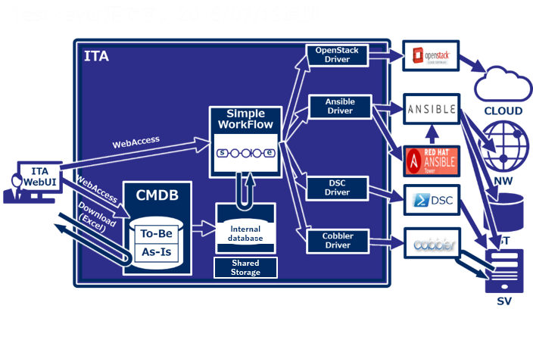

The following 3 modes are available in Ansible driver according to the usage.

1. **Legacy mode**  
   Configure settings to various hosts using the standard function of Ansible.

Register the construction code in a single YAML file and construct the operation pattern with that combination.

This mode is assumed to be used in works such as environment configuration of operation system and network

1. **Legacy Role mode**  
   Same with the Legacy mode, configure settings to various hosts using the standard function of Ansible.

Register construction code as package and construct work pattern with the combination of Role.

It is assumed that this mode will be used when using the Role package provided by the product department to install product or construct environment, etc.

* + 1. **Pioneer mode**It is possible to add individual module to Ansible and input setting in interactive mode.

Supports all devices that can login using Telnet or SSH, regardless of server, storage, or

network device.

Since interacting with target device directly is required, appropriate IT skills are required.

In addition, Ansible driver can configure the variables in Playbook from screen. For details please refer to "2　Variable handling in Ansible driver" in this manual.

# Variable handling in Ansible driver

## Variable type

Ansible driver can set the specific value of Playbook variable in the setting screen in ITA.

**※For the detail of setting method, please refer to "5.3.10 Substitution value list" in this manual**

The six types of Playbook variable that can be handled as ITA variable are as below.

|  |  |  |  |  |
| --- | --- | --- | --- | --- |
| Type | Content | Legacy | Pioneer | Legacy  Role |
| Normal variable | A variable that can define one specific value to the variable name.  Please describe the variable in Playbook as {{△VAR_xxx△}}.  △:half-width space xxx: half-width alphanumeric character and underscore ( _ )   |  | | --- | | e.g.)  VAR_users: root | | ○ | ○ | ○ |
| Multiple specific value variable | A variable that can define multiple specific value for a variable name.  Please describe the variable in Playbook as {{△VAR_xxx△}}.  △:half-width space xxx: half-width alphanumeric character and underscore( _ )   |  | | --- | | e.g.)  VAR_users:  - root  - mysql | | ○ | ○ | ○ |
| Nested variable | Hierarchical variables.  Please describe the variable in Playbook as {{△VAR_xxx△}}.  △:half-width space xxx: half-width alphanumeric character and underscore( _ )   |  | | --- | | e.g.)  VAR_users:  - name: alice  authorized: | | × | × | ○ |
| Global variable | Variable registered from the "Global variable" menu. | ○ | ○ | ○ |

|  |  |  |  |  |  |
| --- | --- | --- | --- | --- | --- |
| Type | Content | Legacy | Pioneer | | Legacy  Role |
| ITA original variable | Original variable defined by ITA.  The following items in the basic console device list can be handled as variables.   |  |  | | --- | --- | | Item name | variable name | | host name | __loginhostname__ | | protocol | __loginprotocol__ | | login user ID | __loginuser__ | | login password | __loginpassword__ |   **The 「__」 surrounding the variable name is a pair of 2 half-width underscore.**  For “device list”, please refer to "User instruct manual_basic console"  The directory path during operation execution can be handled as following variable.   |  |  | | --- | --- | | Item name | Variable name | | Operation directory path | __workflowdir__ |   By creating a file under the operation directory path in Playbook, users can download the result data file of "operation execution" menu.  The directory path shared by each movement when executing Symphony is handled as the following variables.   |  |  | | --- | --- | | Item name | Variable name | | Symphony  Operation directory path | __symphony_workflowdir__ |   By creating files under the Symphony operation directory path in Playbook, files can be shared between Movements. Also, during operation execution, the same path as __workflowdir__ is set. | ○ | | ○ | ○ |
| Substitution variable | Variable "LCA_XXX" that used to handle variables in Defaults variable definition file or ITA readme other than "VAR_XXX" type in ITA.  Please refer to " 6.5 Describe substitution table(Ansible-Legacy Role only)" for details. | × | | × | ○ |

## Extract variables and register specific values

In each mode, variables are extracted from files uploaded to ITA such as Playbook.

The method to extract variable is as below.

1. **Ansible-Legacy**  
   Extract the varaiable definitions in the following format from the Playbook uploaded in "Playbook file list (5.3.2 Playbook file list (Ansible-Legacy only) in this manual)".

{{△VAR_xxx△}}

※ △:half-width space xxx: half-width alphanumeric character and underscore ( _ )

Ansible-Legacy determines whether to register specific values as normal variables or multiple specific value variables. Please refer to "5.3.10 Substitution value list" for details.

1. **Ansible-Pioneer**  
   Extract the same variable definition as Ansible-Legacy from the dialog file uploaded in "Dialog files(5.3.5 Dialog files (Ansible-Pioneer only) in this manual)"
2. **Ansible-Legacy Role**  
   Extract the same variable as Ansible-Legacy from the Playbook in role package uploaded in "Role package list(5.3.3 Role package list (Ansible-Legacy Role only)in this manual)"

Please refer to "Role package list (5.3.3 Role package list (Ansible-Legacy Role only)in this manual)" for details.

Also, by creating substitution table, ITA can handle the variables other than "VAR_xxx" defined in defaults varaiable definition file and ITA readme. Please refer to " 6.5 Describe substitution table(Ansible-Legacy Role only)" for details.

It is possible to extract variables from the files uploaded to ITA such as Playbook and register their specific value.

The specific value of the extracted variables are registered in "5.3.8 Substitution value auto-registration setting" and "5.3.10 Substitution value list".

The registered variable and specific value will be output in host variable file during work execution.

## Variable handling according to substitution value registration

By using substitution value registration function, it is possible to overwrite the value of variable defined in Playbook.

The relationship between Playbook variable and the variable value registered in substitution value management function is shown as the following figure.

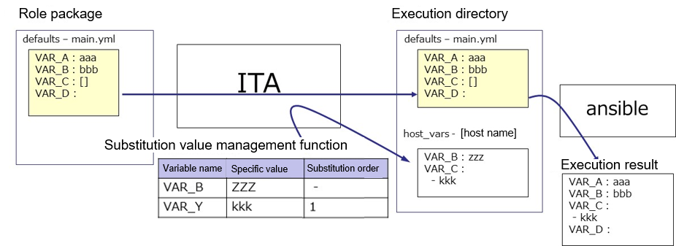

The value of the variable registered in the substitution value management function is output to the variable definition file (host_vars) for each host, and executed on each host by using the original Playbook and variable definition file as input in Ansible.  
  
The priority of variable values in the result is as below.

1. Value registered in substitution value management function
2. Value specified in Playbook variable  
   Please refer to "5.3.10 Substitution value list" for details.

# Ansible driver console menu configuration

This chapter explains the configuration of ITA console menu.

For the method to log in Web console and the components / basic operations of the menu screen, please refer to the "First Step Guide".

## Menu/screen list

1. ITA basic console menu

The menu list of ITA basic console used in Ansible driver is as below.

Table 3.1-1 Basic console menu/screen list

|  |  |  |  |
| --- | --- | --- | --- |
| No | Menu group | Menu・Screen | Descritption |
| 1 | ITA baic console | Device list | Maintain (View/Register/Update/Discard) operation target system list. |
| 2 | Associated menu | Manage the configuration management database associated with Substitution value auto-registration setting menu. |
| 3 | Input operation list | Maintain(View/Register/Update/Discard) input operation list |

1. **Ansible common console menu**

Ansible common console menu list is as below.

Table 3.1-2 Common console menu/screen list

|  |  |  |  |
| --- | --- | --- | --- |
| No | Menu group | Menu・Screen | Description |
| 1 | Ansible common console | Interface information | Select whether to use Ansible or Ansible Tower server as the execution engine for the construction operation.  Manage the path of directory shared by ITA system, Ansible driver server, and execution engine server and the connection interface information to the execution engine server. |
| 2 | Global variable list | Manage the variable commonly used in Playbook or dialog file, etc. (referred to as global variable hereafter) and their specific values. |
| 3 | Template list | Manage template files and embedded variables used in the template modules, etc. in Playbook. |
| 4 | Contents list | Manage the files and embedded variable used in each module in Playbook. |

1. **Ansible console menu**

The menu list according to each Ansible console is as below.

Table 3.1-3 Ansible driver console menu/screen list

| No | menu group | | | Menu・Screen | Description |
| --- | --- | --- | --- | --- | --- |
| **Ansible console** | | |
| Legacy | Legacy Role | Pioneer |
| 1 | **○** | **○** | **○** | Movement list | Manage the list of Movements registered in Symphony. |
| 2 | **○** |  |  | Playbook files | Manage Playbook file. |
| 3 |  | **○** |  | Role package list | Manage role package. |
| 4 |  |  | **○** | Dialog type list | Manages the type of grouping dialog files of the same purpose as dialog type. |
| 5 |  |  | **○** | Dialog files | Manage the OS type associated with the dialog type and the ITA system original format work procedure file (referred to as dialog file in the following). |
| 6 | **○** | **○** | **○** | Movement details | Manage the association between Movement and Playbook file. |
| 7 |  | **○** |  | Nested variable maximum iteration count list | Manage the maximum iteration array count if nested variable is configured as iterative array. |
| 8 | **○** | **○** | **○** | Substitution value auto-registration setting | Manage Movement and variable associated to every item value of operation and host registered in the configuration management database menu. |
| 9 | **○** | **○** | **○** | Target host | Manage the host used in Movement. |
| 10 | **○** | **○** | **○** | Substitution value list | Manage the substitution value of variable. |
| 11 | **○** | **○** | **○** | Execution | Select the Movement and Operation for work execution and indicate the execution. |
| 12 | **○** | **○** | **○** | Check operation status | Displays the operation execution status. |
| 13 | **○** | **○** | **○** | Execution list | Manage the operation execution history. |

※ Since user operations such as configuration are not perfomed in Ansible RestAPI, the description is omitted here.

# Ansible driver operation procedure

This chapter explains the operation procedure for using each Ansible console.

## Workflow

The standard workflow of each Ansible console is as follow.

The details of each operation is described in the next section.

Please refer to "User instruction manual_Basic console" for how to use the ITA basic console.

### Workflow of Ansible-Legacy

The workflow of executing operation using Ansible-Legacy is as follows.

1. **Set Ansible usage information in device list**

**④ Register work pattern(Movement)**

**⑤ Register playbook**

**⑨ Specify operation target gost ※**

**⑩ Set variable value**

**⑪ Operation execution**

**⑫ Check execution status**

**⑦ Register content file**

**⑥ Register template file**

**⑬ Check operation history**

**※Once Movement is configured, it is possible to start the operation from the following procedure from the next time.**

**Required task**

**Optional task**

**【Legend】**

**⑧　Specify Playbook file to Movement**

**②　Register input operation name**

**③** **Set interface information**

* **Workflow details and references**

1. **Set Ansible usage information in device list**

Set the Ansible usage information to each devices in the device list screen of ITA basic console.  
Please refer to “5.1.1 Device list” for details.

1. **Register input operation name**

Register the input operation name for work from the input operation list screen of ITA basic console.

Please refer to “5.1.2 Input operation list” for details.

1. **Set interface information**

Select using whether Ansible or AnsibleTower server as the execution engine and register the connection information of the execution engine server from the interface information screen of Ansible common console.

Please refer to “5.2.1 Interface information” for details.

1. **Register work pattern (Movement)**Register the Movement for operation from the Movement list screen of Ansible-Legacy console.

Please refer to “5.3.1 Movement list” for details.

1. **Register playbook**Register the Playbook used in operation from the Playbook files screen of Ansible-Legacy console.  
   Please refer to “5.3.2 Playbook file list (Ansible-Legacy only)” for details.
2. **Register template file (execute if necessary)**

Register/Update/Discard the template file (src) and the template embedded variable used in the template module, etc. of Playbook from the template list screen of Ansible common console.

Please refer to “5.2.3 Template list” for details.

1. **Register content file (execute if necessary)**Register the file used to configure the operation target server from the contents list screen of Ansible common console.

Please refer to “5.2.4 Contents list” for details.

1. **Specify Playbook file to Movement**Specify Playbook file to the registered Movement from movement details screen of Ansible-Legacy console.

Please refer to “5.3.6 Movement details” for details.

1. **Specify operation target host**Specify the operation target host from the target host screen of Ansible-Legacy console.  
   Please refer to “5.3.9 Target host” for details.
2. **Set variable value (execute if necessary)**Set the value of the variable in the Playbook which has been registered to Movement from the substitution value list screen in Ansible-Legacy console. If variable is not used, then configuration is not required.

Please refer to “5.3.10 Substitution value list” for details.

1. **Operation execution**Select and set execution date, input operation and indicate operation execution from the execution screen of Ansible-Legacy console.

Please refer to “5.3.13 Execution” for details.

1. **Check operation status**The status of executed operation is displayed in real time in the "Check operation status" screen of Ansible-Legacy console. In addition, users can perform emergency stop on operation and monitor the execution log and error log.  
   Please refer to “5.3.11 Check operation status” for details.
2. **Check operation history**The list of executed operation is displayed in the execution list screen of Ansible-Legacy console and users can check the execution history.

Please refer to “5.3.12 Execution list” for details.

### Workflow of Ansible-Legacy Role

The workflow of executing operation using Ansible-Legacy Role is as follows.

1. **Set Ansible usage information in device list**

**④ Register work pattern(Movement)**

**⑤ Register role package**

**⑩ Specify operation target gost**

**⑫ Operation execution**

**⑬ Check execution status**

**⑧ Specify role package to Movement**

**⑭ Check operation history**

**Required task**

**Optional task**

**【Legend】**

**※ Once Movement is configured, it is possible to start the operation from the following procedure from the next time.**

**⑪ Set variable value**

**⑨ Specify the maximum iteration count 　of nested variable※**

**②　Register input operation name**

**⑦ Register content file**

**③ Set interface information**

**⑥ Register template file**

* **Workflow details and references**

1. **Set Ansible usage information in device list**Set the Ansible usage infromation according to each devices in the device list screen of ITA basic console.  
   Please refer to “5.1.1 Device list” for details.
2. **Register input operation name**

Register the input operation name from the input operation list screen of ITA basic console.

Please refer to “5.1.2 Input operation list” for details.

1. **Set interface information**

Select using whether Ansible or AnsibleTower server as the execution engine and register the connection information of the execution engine server from the interface information screen of Ansible common console.

Please refer to “5.2.1 Interface information” for details.

1. **Register work pattern (Movement)**Register the Movement for operation from the Movement list screen of Ansible-Legacy Role console.  
   Please refer to “5.3.1 Movement list” for details.
2. **Register role package**Register the role package used in operation from the role package list screen of Ansible-Legacy Role console.  
   Please refer to “5.3.3 Role package list (Ansible-Legacy Role only)” for details.
3. **Register template file (execute if needed)**

Register/Update/Discard the template file (src) and the template embedded variable used in the template module, etc. of Playbook from the template list screen of Ansible common console.

Please refer to “5.2.3 Template list” for details.

1. **Register content file (execute if needed)**

Register the file used to configure the operation target server from the contents list screen of Ansible common console.

Please refer to “5.2.4 Contents list” for details.

1. **Specify role package to Movement**

Specify the Playbook file to the registered Movement from Movement details screen of Ansible-Legacy Role console.

Please refer to “5.3.6 Movement details” for details.

1. **Specify the maximum iteration count of nested variable**Specify the maximum iteration count of the array of member variables defined in nested variables from nested variable maximum iteration count list screen of the Ansible-Legacy Role console.

Please refer to “5.3.7 Nested variable maximum iteration count list (Ansible-Legacy Role only)” for details.

1. **Specify operation target host**Specify the operation target host from the target host screen of Ansible-Legacy Role console.  
   Please refer to “5.3.9 Target host” for details.
2. **Set variable value (execute if needed)**Set the value of the variable in the Playbook which has benn registered to Movement from the substitution value list screen in Ansible-Legacy Role console. If variable is not used, then configuration is not required.

Please refer to “5.3.10 Substitution value list” for details.

1. **Operation execution**Select and set execution date, input operation and instruct operation execution from the execution screen of Ansible-Legacy Role console.

Please refer to “5.3.13 Execution” for details.

1. **Check operation status**The status of executed operation is displayed in real-time in the "Check operation status" screen of Ansible-Legacy console. In addition, users can perform emergency stop on operation and monitor the execution log and error log.  
   Please refer to “5.3.11 Check operation status” for details.
2. **Check operation history**The list of executed operation is displayed in the execution list screen of Ansible-Legacy Role console and users can check the execution history.

Please refer to “5.3.12 Execution list” for details.

### Workflow of Ansible-Pioneer

The workflow to execute the operation in Ansible-Pioneer is as follows.

**①Set Ansible usage information in device list**

**④ Register work pattern(Movement)**

**⑥ Register dialog file**

**⑩ Specify operation target host ※**

**⑪ Set variable value**

**⑫ Operation execution**

**⑬ Check execution status**

**⑧ Register content file**

**⑦ Register template file**

**⑭ Check operation history**

**※Once Movement is configured, it is possible to start the operation from the following procedure from the next time.**

**Required task**

**Optional task**

**【Legend】**

**⑨　Specify dialog file to Movement**

**②　Register the input operation name**

**⑤ Register dialog type**

**③ Set the interface information**

* **Workflow details and references**

1. **Set Ansible usage information in device list**Set the Ansible usage information for each device from the device list screen of the ITA basic console.  
   Please refer to “5.1.1 Device list” for details.
2. **Register the input operation name**

Register the input operation name from the input operation list screen of ITA basic console.

Please refer to “5.1.2 Input operation list” for details.

1. **Register the interface information**

Select using whether Ansible or AnsibleTower server as the execution engine and register the connection information of the execution engine server from the interface information screen of Ansible common console.

Please refer to “5.2.1 Interface information” for details.

1. **Register work pattern (Movement)**Register the Movement for operation from the Movement list screen of Ansible-Pioneer console.  
   Please refer to “5.3.1 Movement list” for details.
2. **Register dialog type**

Register dialog type from the dialog type list screen of Ansible-Pioneer console.

Ansible-Pioneer defines the differences for each OS type in each dialog file, and combines the same purpose dialog file as dialog type to absorb (abstract) the device difference.

Please refer to “5.3.4 Dialog type list (Ansible-Pioneer only)” for details.

1. **Register dialog file**

Register dialog file according to the combination of dialog type and OS type from the dialog files screen of Ansible-Pioneer console.

Please refer to “5.3.5 Dialog files (Ansible-Pioneer only)” for details.

1. **Register template file (execute if needed)**

Register/Update/Discard the template file (src) and the template embedded variable used in the template module, etc. of Playbook from the template list screen of Ansible common console.

Please refer to “5.2.3 Template list” for details.

1. **Register content file (execute if needed)**

Register the file used to configure the operation target server from the contents list screen of Ansible common console.

Please refer to “5.2.4 Contents list” for details.

1. **Specify dialog file to Movement**Specify dialog file to the registered Movement from movement details screen of Ansible-Legacy Role console.

Please refer to “5.3.6 Movement details” for details.

1. **Specify operation target host**Specify the operation target host from the target host screen of Ansible-Pioneer console.  
   Please refer to “5.3.9 Target host” for details.
2. **Set variable value (execute if needed)**Set the value of the variable in the Playbook which has been registered to Movement from the substitution value list screen in Ansible-Pioneer console. If variable is not used, then configuration is not required.  
   Please refer to “5.3.10 Substitution value list” for details.
3. **Operation execution**Select and set execution date, input operation and indicate operation execution from the execution screen of Ansible-Pioneer console.

Please refer to “5.3.13 Execution” for details.

1. **Check operation status**The status of executed operation is displayed in real time in the Check operation status screen of Ansible-Pioneer console. In addition, users can perform emergency stop on operation or monitor the execution log and error log.  
   Please refer to “5.3.11 Check operation status” for details.
2. **Check operation history**The list of executed operation is displayed in the execution list screen of Ansible-Pioneer console and users can check the execution history.

Please refer to “5.3.12 Execution list” for details.

**■Legend of Registration screen item list**

The content of the Registration screen item list are described in the next section.

**②②**

|  |  |  |  |  |
| --- | --- | --- | --- | --- |
|  | **②** | **③** | **④** | **⑤** |
| **Item** | **Description** | **Input**  **required** | **Input type** | **Restrictions** |
|  |  |  |  |  |

1. **Item**

　・The item name in the submenu.

1. **Description**

　・The description for the item.

1. **Input required**

　・○： Items that entering contents are required for them.

　・‐ ： Items that entering contents are optional for them.

1. **Input type**

　・Manual： Items that require manual input.

　・Auto：Items whose content are entered automatically.

　・Checkbox: Check box format item.

　・Button: Radio button format item.

　・List: List box format item.

1. **Restrictions**

　・The restrictions for the item(Limitation on number of characters, etc.)

# Ansible driver　function・operation method explanation

This chapter explains each console function used in Ansible driver.

## Basic console

This section describes the operation of ITA basic console.

Please refer to the ITA basic console manual for this operation and perform the operation in the ITA basic console screen.

### Device list

1. Register/Update/Discard information of operation target host is performed in the "Device list" menu.  
   This document explains the items (red frame) in the device list required for Ansible driver operations.  
   Please refer to "User instruction manual_Basic console" for the description of other items.

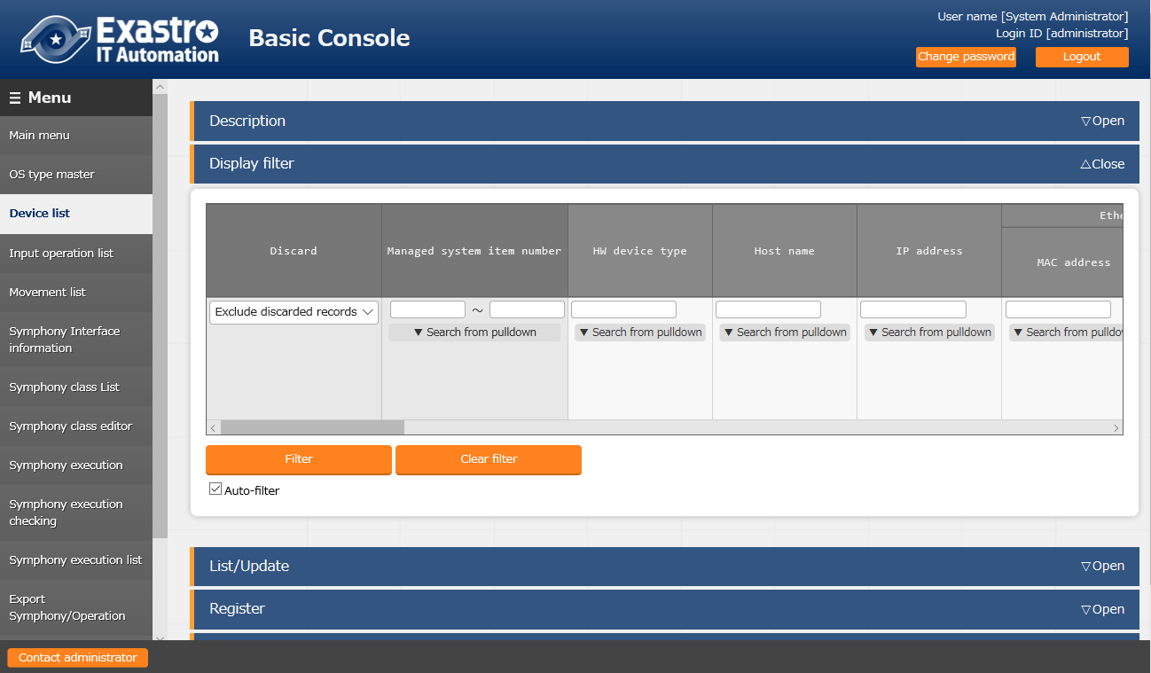

Figure 5.1-1 Submenu screen (Device list)

1. Click the "Register" - "Start Registration" button to register the device information.

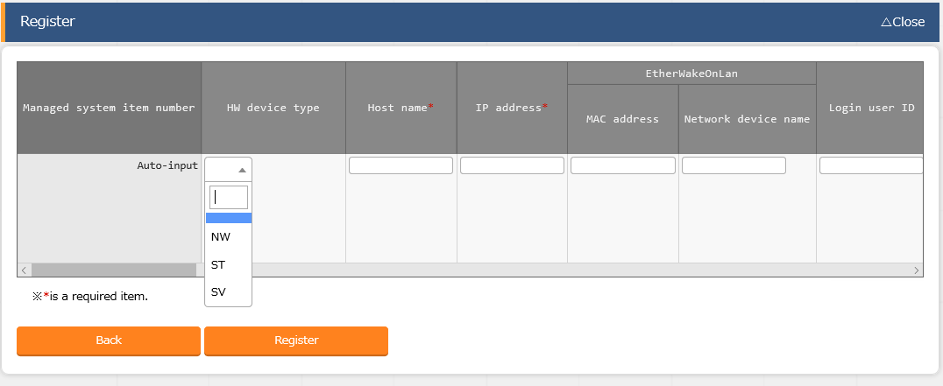

Figure 5.1-2 Registration screen(Device list-common item)

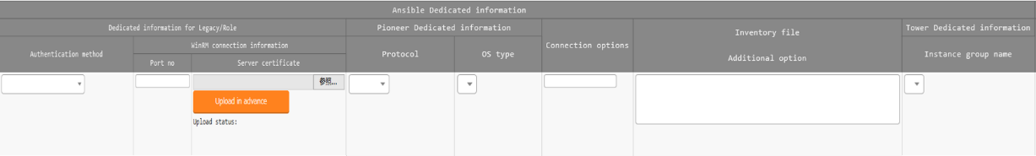

Figure 5.1-3 Registration screen(Device list-Ansible usage information)

1. The list of common item in registration screen is as follows.  
   Input of the columns with a red asterisk (*) after their column name in the web screen is required. In the case of using Ansible driver, please enter the usage information of Ansible.

If operation is executed while required column is not entered, unexpected errors may occur.

**Table 5.1-1 Registration screen item list (Device list)**

| Item | | | | **Description** | **Input required** | **Input type** | **Restrictions** |
| --- | --- | --- | --- | --- | --- | --- | --- |
| Managed system item number | | | | A unique ID that identifies the registration information is entered automatically. | - | Auto | - |
| host name | | | | Enter host name. | ○ | Manual | Maximum length 128 bytes |
| IP address | | | | Enter IP address in xxx.xxx.xxx.xxx format. | ○ | Manual | Maximum length 15 bytes |
| EtherWake  OnLan | | MAC address | | Enter MAC address. | - | Manual | Maximum length 17 bytes |
| Network device name | | Enter network device name. | - | Manual | Maximum length 256 bytes |
| Login user ID | | | | Enter network device name. | ○ | Manual | Maximum length 30 bytes |
| Login password | | Management | | Select "●" when using ITA to manage password. | ○ | List | - |
| Login password | | Specify password. | ○ | Manual | Maximum length 30 bytes |
| ssh authentication key file | | | | Specify the ssh authentication key file and enter the file when using key authentication.  Required when specifying the ssh authentication key file if authentication method is the key authentication | - | File | Maximum size 10K bytes |
| Ansible dedicated information | Dedicated information for Legacy/Role | Authentication method | | Select the authentication method when connecting the host from Ansible.  ・In the case of using password authentication, ”●” is required to be selected in the "Management" column of Login password.  ・In the case of using key authentication, exchanging public key in advance is required.  Also, it is required to set sudo privilege for login user in /etc/sudoers in advance.  Exp)  Demo_user ALL=(ALL) NOPASSWD:ALL | ○ | List | As described in the description column. |
| WinRM connection information | Port no. | Enter the port number when connecting to WindowsServer with WinRm.  If the column is left not entered, Ansible will connect to the default (5985) WinRM. | - | Manual | As described in the description column |
| Server certificate | Enter the server certificatie when https port number is specified as the WinRM connection port  To omit server certificate authentication, add the following to the inventory file additional option. ansible_winrm_server_cert_validation=ignore | - | File | Maximum size 10K bytes |
| Pioneer dedicated information | Protocol | | Select the protocol (ssh/telnet) when logging into target device. | ○ | List | - |
| OS type | | Select the OS of target device.  The OS types registered in the OS type master are displayed in list. | ○ | List | - |
| Connection options | | | 1. (In the case of connecting via ssh)   If users want to set options other than the ssh options set in /etc/ansible.cfg/ssh_args , please enter the desired option.  (In the case of connecting via telnet)  If users want to set options when connecting via telnet, please enter the desired option. | - | Manual | Maximum length 512 bytes |
| Connection options | | | Enter this column if users want to add the inventory file option that is not set in ITA.  e.g. )  In the case of not verifying https server certificate with Python version is 2.7 or higher.  ansible_winrm_server_cert_validation=ignore | - | Manual | Maximum length 512 bytes |
| Tower dedicated information | Instance group name | | If AnsibleTower is in cluster configuration, select which instance group that the AnsibleTower belongs to(※1)  The settings here are specified to the inventory of Tower(※2)   1. The column will be default("Tower") of Ansible tower if not selected   If AnsibleTower is not in cluster configuration, the column can be left unselected. | - | List | - |
| Remarks | | | | Free description field. | - | Manual | Maximum length 4000 bytes |

※1 Although the column is an input item in basic console, it is selected among the data obtain by the Ansible driver backyard function "Tower server data association"

※2 The instance group is specified in the Tower inventory object.

### Input operation list

1. In the "Input operation list" screen, the operations for the target host to be executed by the orchestrator are managed. Operations are selected from the menu in ITA basic console

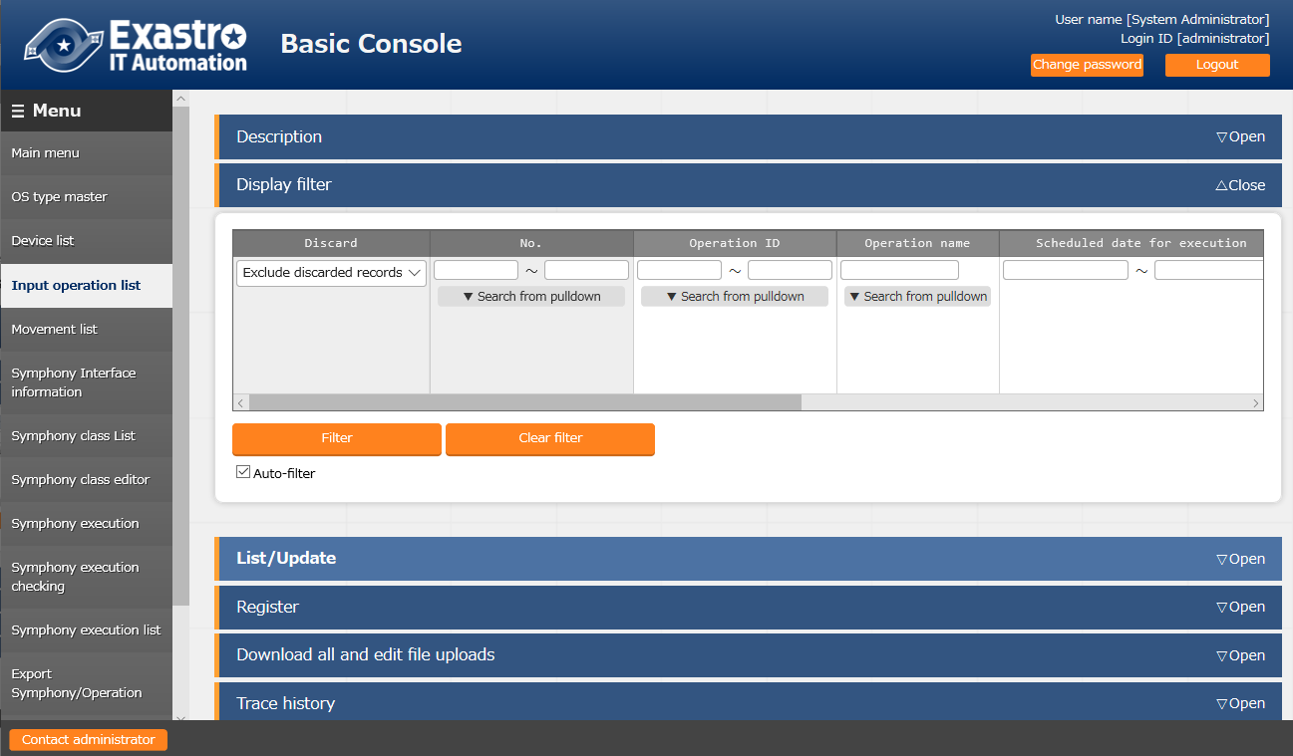

**Figure 5.1-4 Submenu screen (Input operation list)**

Please refer to the related manual "User instruction manual_Basic console" for the details of registration method.

## Ansible common console

This section describes the operation of　Ansible common console.

### Interface information

1. In the ”interface information" menu, select using whether Ansible or AnsibleTower server as the execution engine and register/update/discard the shared directory path between ITA system, Ansible driver server, and execution engine server , and the connection interface information of the execution engine server.

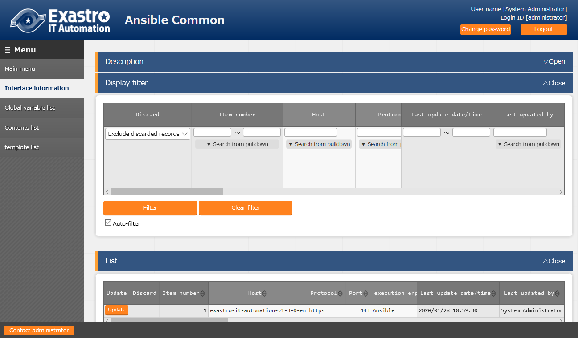

**Figure 5.2-1 Submenu screen (interface information)**

1. Click the "List" - "Update" button to register the interface information.

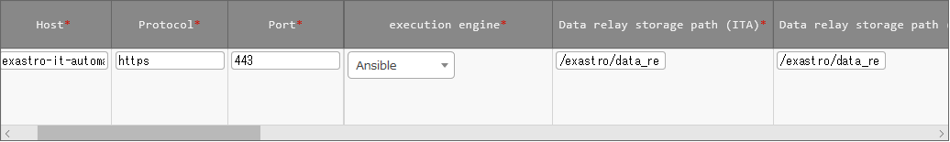

Figure 5.2-2 Registration screen (Interface information)

1. The item list of interface information screen is as follows.  
   If operation is executed while interface information not registered or multiple information is registered, unexpected errors may occur.

**Table 5.2-3 Registration screen item list (Interface information)**

| Item | | **Description** | **Input required** | **Input type** | **Restrictions** |
| --- | --- | --- | --- | --- | --- |
| Host | | Enter the host name (or IP address) of the execution engine (Ansible, AnsibleTower server).  It is recommended to enter host name when using HTTPS communication.  In addition, if AnsibleTower is constructed in cluster configuration, please enter the hostname (or IP address) where AnsibleTower is installed. | ○ | Manual | Maximum length 128 bytes |
| Protocol | | Enter either http/https as the protocol with Ansible, AnsibleTower server. | ○ | Manual | - |
| Port | | Enter the connection port (80/443) of Ansible, AnsibleTower. The port is usually HTTPS (443). | ○ | Manual | - |
| Execution engine | | Select the execution engine between Ansible and AnsibleTower. | ○ | List |  |
| Data relay storage path (ITA) ※1 | | Enter the directory viewed from the ITA system / Ansible driver server. | ○ | Manual | Maximum length 128 bytes |
| Data relay storage path (Ansible/Ansible Tower) | | Enter the directory viewed from the Ansible RestAPI and AnsibleTower servers. | ○ | Manual | Maximum length 128 bytes |
| Symphony instance data relay storage path  (Ansible/Ansible Tower) | | Enter the directory which shares the shared directory between each movement when executing Symphony with Ansible RestAPI, AnsibleTower server.  The path viewed from the ITA system is set from the Symphony interface information menu.  Please refer to the "User instruction manual_ITA basic console" for the Symphony interface information. | ○ | Manual | Maximum length 128 bytes |
| Optional parameter | | Enter the Movement-common optional parameter of Ansible-Playbook command.  Movement-specific optional parameters are entered in the Movement list menu.  In the case that the execution engine is Ansible:  Enter the optional parameter of Ansible-Playbook command.  　The -i option is set by ITA.  In the case that the execution engine is AnsibleTower:  　The following option parameters can be set:  　　-verbosity  　　-f FORKS,--forks=FORKS  　　-l SUBSET,--limit=SUBSET  　　-e EXTRA_VARS,--extra-vars=EXTRA_VARS  EXTRA_VARS: Variable name=specific value Variable name=specific value.....  　　-t TAGS,--tags=TAGS  　　-b,--become  　　-D,--diff  　　--skip-tags=SKIP_TAGS  　　--start-at-task=START_AT_TASK  　The original optional parameters of AnsibleTower are as follows.  　　-ufc,--use_fact_cache　 use fact cache  　　-as,--allow_simultaneous enable simultaneous job execution  　　-jsc,--job_slice_count=　　job slice count  For the original optional parameters of AnsibleTower, please refer to the description of job template in the Ansible Tower user guide. | - | Manual | Maximum length 512 bytes  Exastro1.2 does not support job slice count "-jsc, -job_slice_count=" |
| **Ansible information** | Execution user | Enter the execution user when executing AnsiblePlaybook command with sudo command  Enter the column if the execution engine is Ansible. | - | Manual | Maximum length 64 bytes |
| ACCESS_KEY_ID | Enter the access key used for authentication when connecting to the Ansible server.  Enter the column if the execution engine is Ansible. | - | Manual | Maximum length 64 bytes |
| SECRET_ACCESS_KEY | Enter the secret access key used for authentication when connecting to the Ansible server.  Enter the column if the execution engine is Ansible. | - | Manual | Maximum length 64 bytes |
| **Ansible Tower information** | Organization name | Enter the organization name registered in AnsibleTower.  Enter the column if the execution engine is AnsibleTower. | - | List |  |
| Authentication token | Enter the user authentication token when connecting AnsibleTower server from ITA.  Enter the column if the execution engine is AnsibleTower. | - | Manual | Maximum length 256 bytes |
| Status monitoring cycle(milliseconds) | | Enter the refresh interval of the log displayed in "5.3.11 Check operation status".  Usually the value around 3000 milliseconds is recommended. | ○ | Manual | Minimum value 1000 milliseconds |
| Number of rows to display progress status | | Enter the maximum display line count of the execution log, errorlog in "5.3.11 Check operation status".  Usually the value around 1000 lines is recommended. | ○ | Manual | - |
| NULL link | | Set whether to register NULL (blank) value to substitution value list menu if the specific value in parameter sheet is NULL(blank) in the substitution value auto-registration setting menu.  This value will be applied when “NULL link” in the substitution value auto-registration setting menu is blank.  ・If the "Valid" is set, any value in the parameter sheet will be registered in the substitution value list menu. (NULL value will be registered)  ・If the "Invalid" is set, only specific value in the parameter sheet will be registered in the substitution value list menu(NULL value will not be registered) | ○ | List | - |
| Remarks | | Free description field | - | Manual | Maximum length 4000 bytes |

※1 Data relay storage paths are managed separately because directory path name may be different when operated on different servers.

Please refer to "System Configuration/Environment Construction Guide-Ansible-driver" for details.

### Global variable list

1. In the "Global variable list" menu, register/update/discard the global variable name used in Playbook, dialog files, etc.

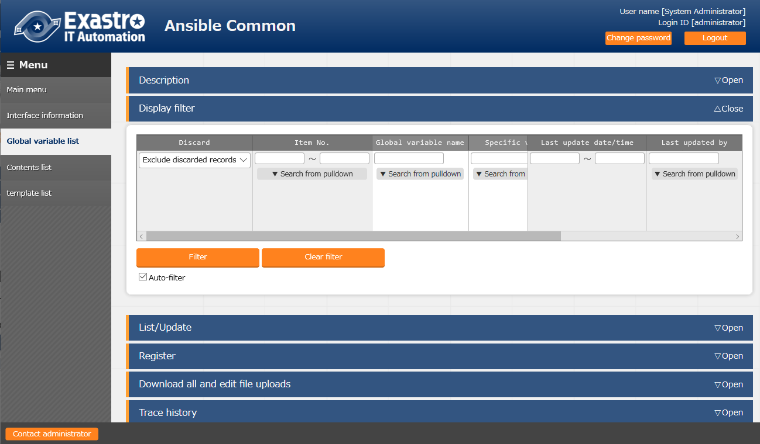

**Figure 5.2-3 Submenu screen (Global variable list)**

1. Click the "Register" - "Start Registration" button to register the operation information.

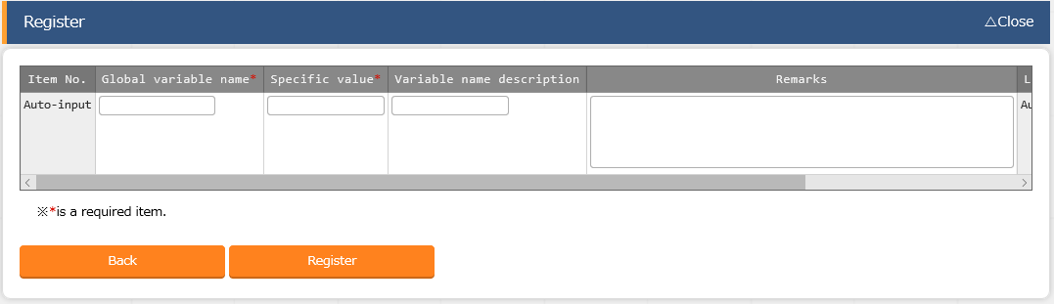

**Figure 5.2-4 Registration screen (Global variable list)**

1. The item list of global variable list screen is as follows.

**Table 5.2-4 Registration screen item list (Global variable list)**

|  |  |  |  |  |
| --- | --- | --- | --- | --- |
| Item | **Description** | **Input required** | **Input type** | **Restrictions** |
| Global variable name | Enter the variable name.  Enter the variable name in the "GBL_****" format.  Half-width alphanumeric character and underscore (_) can be used.  (Minimum length: 1 byte, maximum length: 128 bytes) | ○ | Manual | As described in the description column. |
| specific value | Enter the specific value  File embedded variable "CPF_" and template embedded variable "TPF_" can be entered in the specific value column.  When describing the variables, enclose the variable names with {{}} as describing the variables in the Playbook.  e.g. )  Entering TPF_sample for specific value  '{{△TPF_sample△}}' △: half-width space  ‘: recommended | ○ | Manual | Maximum length 1024 bytes |
| Variable name discription | Enter the description or comment of the variable. | - | Manual | Maximum length 256 bytes |
| Remarks | free description field | - | Manual | Maximum length 4000 bytes |

### Template list

1. In the "template list" menu, register/update/discard the Jinja2 template file and the template embedded variable used in the parameter of template module and ios_config module, etc. defined in the Playbook.

If template module is registered in the template list, the template file used in the template module etc. defined in the playbook can be specified by template embedded variable.

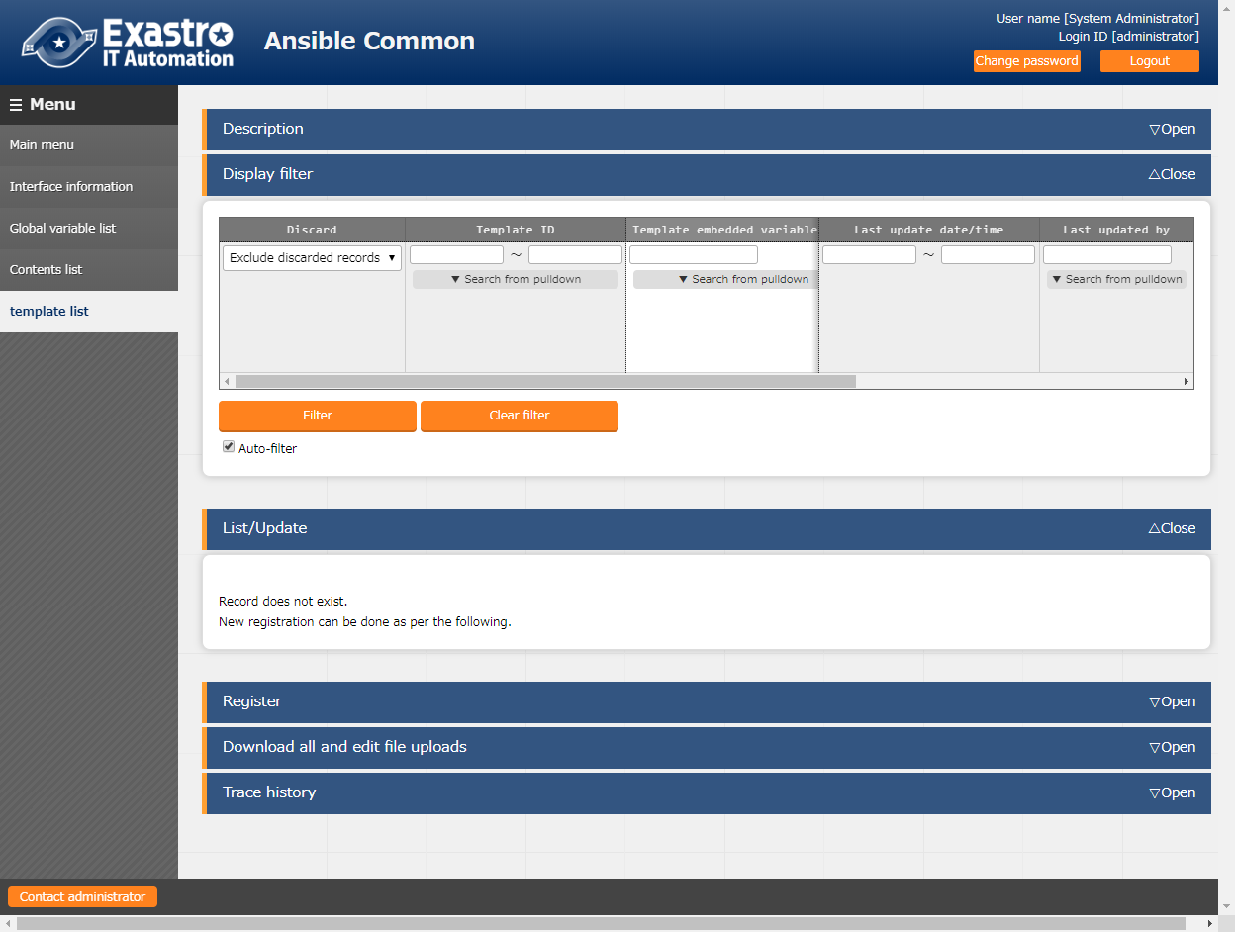

**Figure 5.2-4 Submenu screen(Template list)**

**(2)** Click the "Register" - "Start Registration" button to register the file management information.

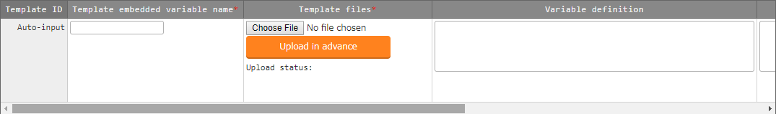

Figure 5.2-5 Registration screen (Template list)

**(3)** The items of registration screen are as follows.

Table 5.2-5 Registration screen item list (template list)

| **Item** | **Description** | **Input required** | **Input type** | **Restrictions** |
| --- | --- | --- | --- | --- |
| Template embedded variable name | Enter the variable name embedded in parameters such as template module or ios_config module, etc.  Enter the variable name in the "TPF_****" format.  Half-width alphanumeric character and underscore (_) can be used.(Minimum length: 1 byte, maximum length: 128 bytes) | ○ | Manual | As described in the description column. |
| Template files | Upload the Jinja2 template file used as the parameter of module. | ○ | File | Text format |
| Variable definition | Define the variable used in the template file.  If the template is used only in Ansible-Role and the variable is defined in the default variable definition file, then the variable definition column can be omitted.  If the template is used only in Ansible-Role and the variable is defined in the default variable definition file, then the variable definition column can be omitted.  If the variable with same name is used in multiple template, the variable definitions have to match. Error will occur during registration if the variable definitions do not match.  Although the variable definition is based on the specification of Ansible, there is own specification of ITA.The notes of variable definition is described in 5.2-5-1. | - | Manual | Maximum length 4000 bytes |
| Remarks | free description field. | - | Manual | Maximum length 4000 bytes |

Please "Upload in advance (①)" the "template files" before "register".

Please click the "Register" button after checking the Playbook file name displayed in the "Upload status".

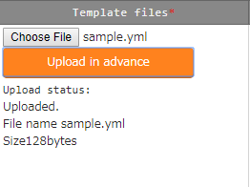

Table 5.2-5-1 Notes of variable definition

|  |  |
| --- | --- |
| Type | Notes |
| Normal variable | Specfic value is optional.  e.g.)  VAR_sample_1: none  VAR_sample_2: |
| Multiple specific value variable | Specfic value is optional.  e.g.)  VAR_sample_1:  △- none  VAR_sample_2: []  Please enter 1 or more half-width space(△) before - when defining specific value. The variable definition maybe misinterpreted. |
| Nested variable | Specific value is required for the first variable of the nested structure.  If the specific value is not defined, the variable definition maybe misinterpreted.  Also, please enter 1 or more half-width space(△) before - when defining specific value. The variable definition maybe misinterpreted  e.g.)  VAR_sample_1:  △- item1: none　**#** **The definition of specific value is required** since it’s the starting variable of the nested structure  △ item2: **#** **The definition of specific value is optional**  VAR_sample_2:  △- array:  △- item1: none　　　**#** **The definition of specific value is required** since it’s the starting variable of the nested structure  △ item2: **#** **The definition of specific value is optional**  The template with nested variable defined can only be used in Ansible-Role  When used in Ansible-Role, if the variable with same name is defined in default variable definition file, etc., the definition of the variables have to match.  If the definition of the variables do not match, an error will occur during registration. |
| Global variable | The definition of specific value is optional  e.g.)  GBL_sample_1: none  GBL_sample_2: |
| ITA original variable | The definition of variable is not required. |
| substitution variable | The 3 kinds of variable that can be defined are as follows.  ・Normal variable  ・Multiple specific value variable  ・Nested variable  The note of each variable definition are the same.  e.g.)  LCA_sample_1:  LCA_sample_2: []  LCA_sample_3:  △- item1: none　　　 **#** **The definition of specific value is required** since it’s the starting variable of the nested structure  △ item2: **#** **The definition of specific value is optional**  The template with substitution variable defined can only be used in Ansible-Role |

For details, Please refer to the attachment "User Instruction Manual - Ansible-driver attachment- Ansible usage guideline with additional rules"

1. Describe Playbook

When describing the template registered in template list menu in Playbook, describe the appropriate parameter in the template embedded variable name.

If the template embedded variable name is not used, describe the variable registered in the substitution list and the path of the file.

|  |  |  |  |  |
| --- | --- | --- | --- | --- |
| e.g. )  **Describe Playbook Registration content**   |  |  | | --- | --- | | **Template embedded variable name** | **Template file** | | TPF_hosts | /etc/hosts |   - template: src='{{△TPF_hosts△}}' dest=/etc/hosts  △: half-width space  **Please describe the file name in _dest. If the file name is not specified, the work will be executed with the registered template file whose file name is added with the ITA management number in the front of the file name.**  **For example, in the case of dest=/etc/, the file name will be /etc/10-digit-number_hosts** |

1. Describe dialog file

In the case of describing the dialog file, describe the template embedded variable name.

|  |  |  |  |  |
| --- | --- | --- | --- | --- |
| e.g. )  **Describe dialog file**  - expect: '{{△__loginuser__△}}@{{△__loginhostname__△}}'  exec: 'scp △ITA user@ITA host name:{{△TPF_hosts△}}△forwarding destination'  - expect: 'password:'　　　　　　　　　　　　　　　　　　　　　　　　**Registration content**   |  |  | | --- | --- | | **Template embedded variable name** | **Template file** | | TPF_hosts | /etc/hosts |   exec: 'ITAuser password'  △: half-width space  Please describe the file name in the forwarding destination.  If the file name is not specified, the work will be executed with the registered template file whose file name is added with the ITA management number in the front of the file name.  For example, in the case of forwarding destination=/etc/, the file name will be /etc/10-digit-number_hosts  {{△TPF_hosts△}} will be replaced by the absolute path during execution. |

By reading the variable definition of template with internal process, it is possible to register specific value in menu "5.3.8 Substitution value auto-registration setting" and menu "5.3.10 Substitution value list".

Since the timing of file reading is not in real time, it may take some time※1 until the variables can be handled in menu "5.3.8 Substitution value auto-registration setting" and menu "5.3.10 Substitution value list".

**※1 The timing of file reading is described in " 7.2 About the maintenance method", so please refer to it.**

### Contents list

1. In the "contents list" menu, register/update/discard the file and file embedded variable used in each module defined in the Playbook.

If the files are registered in the contents list, the file used in each module defined in the Playbook can be specified by file embedded variable.

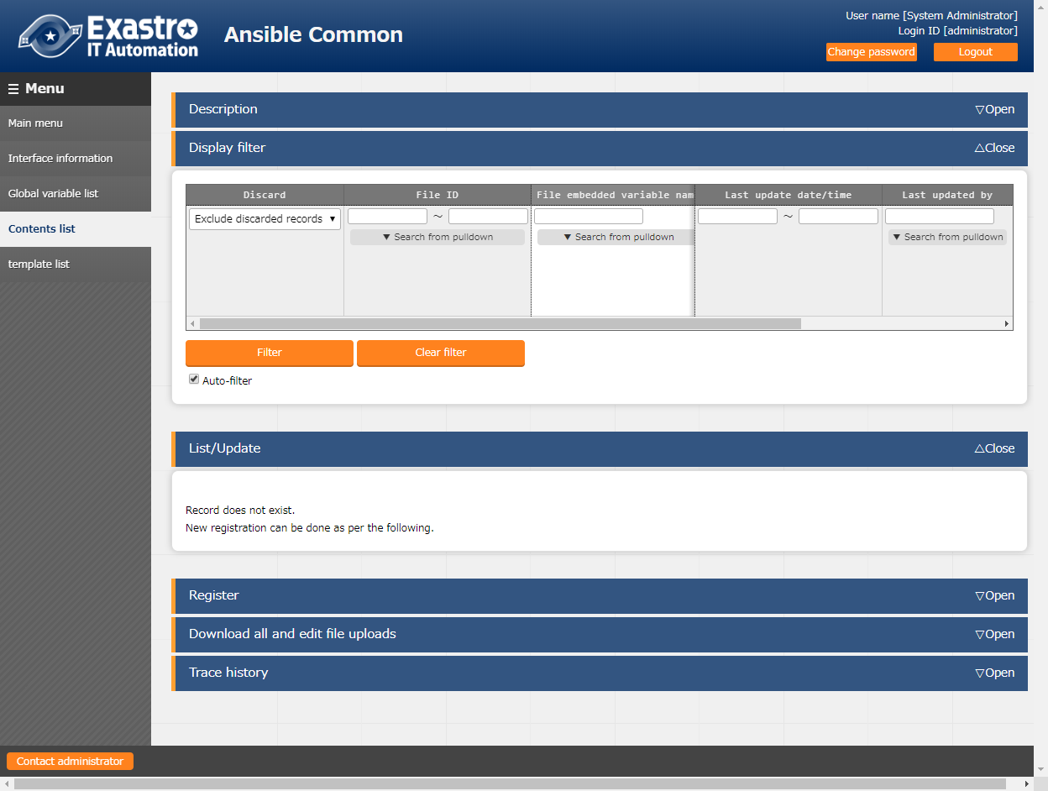

**Figure 5.2-5 submenu screen (Contents list)**

1. Click the "Register" - "Start Registration" button to register the file management information.

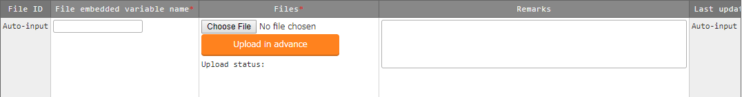

Figure 5.2-6 Registration screen (Contents list)

**(3)** The items of registration screen are as follows.

**Table 5.2-6 Registration screen item list (contents list)**

|  |  |  |  |  |
| --- | --- | --- | --- | --- |
| **Item** | **Description** | **Input required** | **Input type** | **Restrictions** |
| File embedded variable name | Enter the variable names to be embedded in the parameter of each module. Enter the variable name in the "CPF_****" format.  Half-width alphanumeric character and underscore(_) can be used.(Minimum length: 1 byte, maximum length: 128 bytes) | ○ | Manual | As described in the description column |
| Files | Upload the file used in each module. | ○ | File | Maximum size 20M bytes |
| Remarks | Free description field. | - | Manual | Maximum length 4000 bytes |

Please "Upload in advance (①)" the "template files" before "register".

Please click the "Register" button after checking the Playbook file name displayed in the "Upload status".



1. Describe Playbook

When describing each modules in the Playbook, describe the file embedded variable name.

|  |  |  |  |  |  |  |  |  |
| --- | --- | --- | --- | --- | --- | --- | --- | --- |
| e.g)  **Describe Playbook**  Registration content   |  |  | | --- | --- | | File embedded variable name | Files | | CPF_hosts | hosts |   -copy: src='{{△CPF_hosts△}}' dest=/etc/hosts  △: half-width space  Please describe the file name for dest. If the file name is not specified, the work will be executed with the registered file whose file name is added with the ITA management number in the front of the file name.  For example, in the case of dest=/etc/, the file name will be /etc/10-digit-number_hosts  -unarchive src={{△CPF_tool_tgz△}} dest=/usr/local/bin   |  |  | | --- | --- | | File embedded variable name | Files | | CPF_tool_tgz | tool.tgz |   △: half-width space |

1. Describe dialog file

In the case of describing the dialog file, describe the file embedded variable name.

|  |  |  |  |  |
| --- | --- | --- | --- | --- |
| e.g)  **Describe dialog file**  Registration content  - expect: '{{△__loginuser__△}}@{{△__loginhostname__△}}'  exec: 'scp △ITA user@ITA host name:{{△CPF_hosts△}}△forwarding destination'  - expect: 'password:'  exec: 'exec: ITAuser password'   |  |  | | --- | --- | | File embedded variable name | Files | | CPF_hosts | hosts |   △:half-width space  Please describe the file name in the forwarding destination.  If the file name is not specified, the work will be executed with the registered file whose file name is added with the ITA management number in the front of the file name.  For example, in the case of forwarding destination=/etc/, the file name will be /etc/10-digit-number_hosts  {{△CPF_hosts△}} will be replaced by the absolute path of forwarding origin during execution. |

## Ansibel-Legacy／Legacy Role／Pioneer console

The operation of Ansibel-Legacy／Legacy Role／Pioneer console.

### Movement list

1. Register/Update/Discard Movement name in "Movement list"

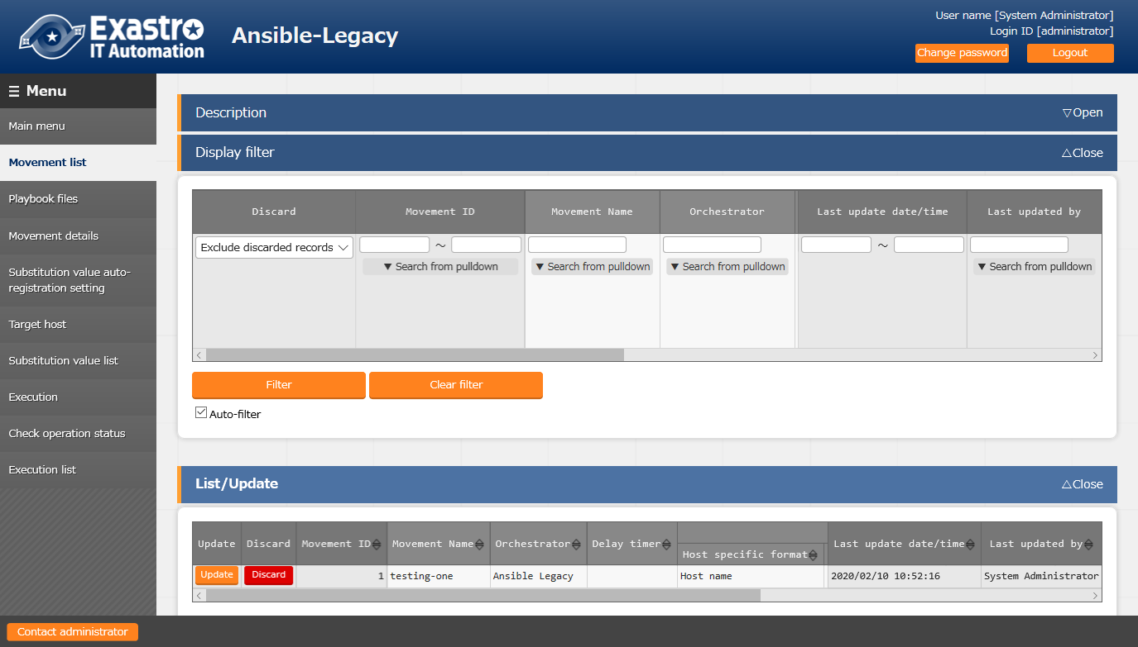

**Figure 5.3-1 submenu screen (Movement list)**

1. Click the "Register" - "Start Registration" button to register the Movement information.

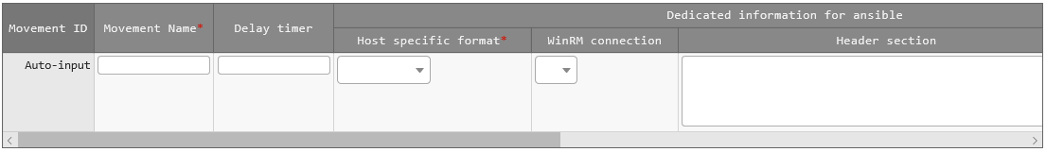

**Figure 5.3-2 Registration screen (Movement list)**

1. The list of registration screen items are as follows.

Table 5.3-7 Registration screen item list (Movement list)

| Item | Description | **Input required** | **Input type** | **Restrictions** |
| --- | --- | --- | --- | --- |
| Movement name | Enter the name of Movement | ○ | Manual | Maximum length 256 bytes |
| Delay timer | Enter the specified period (1~) if you want the warning of delay status to display when the scheduled time of Movement has delayed. (Unit:minute)  The warning will not display if the column is not entered. | - | Manual | - |
| Host specific format | Select "Host name" if the user wants to specify the host that is not represented by an IP address. Normally IP is recommended | ○ | List | - |
| Number of parallel executions  ※Only displayed in the Movement list of Pioneer. | Enter the number of target hosts that Ansible can execute simultaneously.  If there exists more target hosts than the configured value, after executing the amount of target hosts as the configured value, the remaining target hosts will be executed randomly.  ■About the behavior when the column is not entered  ・In the case of Ansible driver, the content of configuration file(/etc/ansible.conf) in the server will be the default values.  ・In the case of AnsibleTower driver, the default value of AnsibleTower will be used. | - | Manual | NULL or Integer |
| WinRM connection *1 | Select "●" if the target host if WindowsServer. | - | List | - |
| Header section  ※ Not displayed in the Movement list of Pioneer | Edit the parent Playbook automatically generated by ITA from the beginning to the tasks or roles section.  The following will be applied if the column is not entered.  Ansible:  - hosts: all  remote_user: \"{{ __loginuser__ }}\"  gather_facts: no  become: yes  Ansible Tower:  - hosts: all  　　　gather_facts: no  become: yes  ※In case of connecting with winrm, become:yes can't be applied. | - | Manual | Maximum length 512 bytes |
| Optional parameter | Enter the Movement-specific optional parameter of Ansible-Playbook command.  In the case that the execution engine is Ansible:  Enter the optional parameter of Ansible-Playbook command.  The -i option is set by ITA  In the case that the execution engine is Ansible Tower:  　 The following option operator can be set  　　-verbosity  　　-f FORKS,--forks=FORKS  　　-l SUBSET,--limit=SUBSET  　　-e EXTRA_VARS,--extra-vars=EXTRA_VARS  EXTRA_VARS: Variable name=specific value Variable name=specific value .....  　　-t TAGS,--tags=TAGS  　　-b,--become  　　-D,--diff  　　--skip-tags=SKIP_TAGS  　　--start-at-task=START_AT_TASK  　 The original optional parameters of AnsibleTower are as follows.  　　-ufc,--use_fact_cache　 use fact cache  　　-as,--allow_simultaneous enable simultaneous job execution  　　-jsc,--job_slice_count=　　　 job slice count  For the original optional parameters of AnsibleTower, please refer to the description of job template in the Ansible Tower user guide. | - | Manual | Maximum length 256 bytes |
| **Virtualenv**  **※**Displayed when the execution engine is AnsibleTower | Select the Ansible execution environment where virtualenv is constructed.  The Ansible execution environment used when installing Tower will be used if this column is not selected. | - | List |  |
| Remarks | free description field | - | Manual | Maximum length 4000 bytes |

*1 In the case other than WindowsServer, please be sure to select blank from the list. Also, Ansible-Pioneer is always operating with gather_facts=false parameter.

**【Notes】**

**In the case of selecting "●" in the WinRM connection column, all connection hosts will be considered as WindowsServer.**

### Playbook file list (Ansible-Legacy only)

1. Register/update/discard the Playbooks created by users in the "Playbook files" menu.  
   ※This menu only exists in the Ansible-Legacy console.

Please refer to " 6.1 Describe Playbook (Ansible-Legacy)" about describing Playbook.

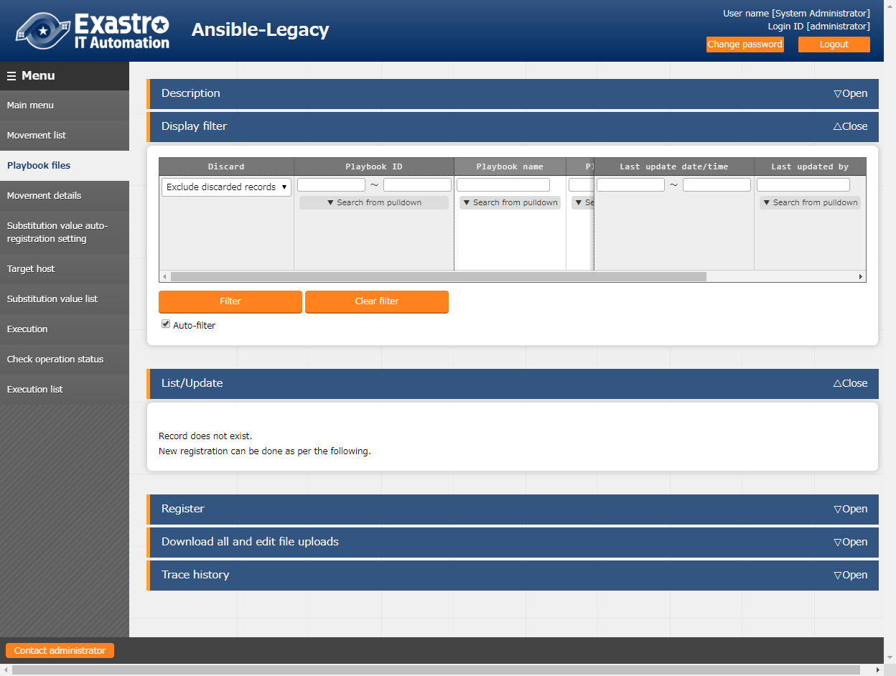

**Figure 5.3-3 Submenu screen (Playbook files)**

Click the "Register" - "Start Registration" button to register the Playbook.

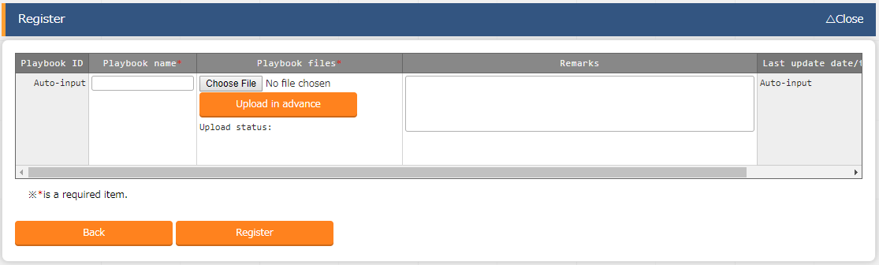

Figure 5.3-4 Registration screen (Playbook files)

1. The list of registration screen items are as follows.

**Table 5.3-8 Registration screen item list (Playbook files)**

|  |  |  |  |  |
| --- | --- | --- | --- | --- |
| Item | Description | **Input required** | **Input type** | Restrictions |
| Playbook name | Enter the Playbook name to be managed in ITA. | ○ | Manual | Maximum length 256 bytes |
| Playbook files | Upload the created Playbook file. | ○ | File | Maximum size 20M bytes |
| Remarks | Free description field. | - | Manual | Maximum length 4000 bytes |

Please "Upload in advance (①)" the "Playbook files" before "register". Please click the "Register" button after checking the Playbook file name displayed in the "Upload status"

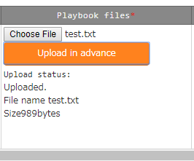

The internal process will extract the variables defined in Playbook files.Users can register specific value of the extracted variables in menu "5.3.8 Substitution value auto-registration setting" and menu "5.3.10 Substitution value list".

Since the timing of extraction is not in real time, it may take some time※1 until the variables can be handled in menu "5.3.8 Substitution value auto-registration setting" and menu "5.3.10 Substitution value list".

※1 The timing of extraction is described in " 7.2 About the maintenance method", so please refer to it.

### Role package list (Ansible-Legacy Role only)

**(1)** Register/upload/discard the role package file created by the users.

※This menu only exists in Ansible-Legacy Role console.

Please compress the directory of the hiearchy level which contains "roles" into zip file and register role package file with the zip file.

Please refer to " 6.3 Describe role package (Ansible-Legacy Role)" for the structure of role package directory.

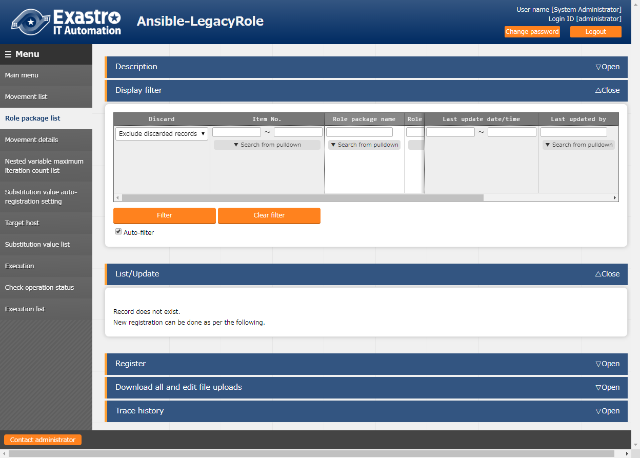

**Figure 5.3-5 Submenu screen (Role package list)**

**(2)** Click the "Register" - "Start Registration" button to register the Playbook.

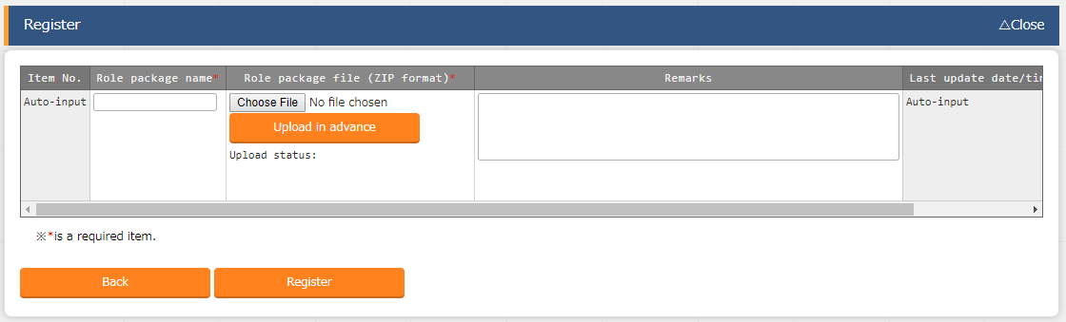

**Figure 5.3-6 Registration screen (Role package list)**

**(3)** The list of registration screen items are as follows.

**Table 5.3-9 Registration screen item list (Role package list)**

|  |  |  |  |  |
| --- | --- | --- | --- | --- |
| Item | Description | **Input required** | **Input type** | **Restrictions** |
| Role package name | Enter the role package name to be managed in ITA. | ○ | Manual | Maximum length 256 bytes |
| Role package file | Upload the created role package file(zip format). | ○ | File | Maximum size 20M bytes |
| Remarks | Free description field. | - | Manual | Maximum length 4000 bytes |

Please "Upload in advance (①)" the "Role package file" before "register".

Please click the "Register" button after checking the role package file name displayed in the "Upload status".

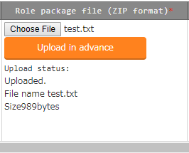

The internal process will extract the variables defined in Role package files.Users can register specific value of the extracted variables in menu "5.3.8 Substitution value auto-registration setting" and menu "5.3.10 Substitution value list".

Since the timing of extraction is not in real time, it may take some time※1 until the variables can be handled in menu "5.3.8 Substitution value auto-registration setting" and menu "5.3.10 Substitution value list".

※1 The timing of extraction is described in " 7.2 About the maintenance method", so please refer to it.

### Dialog type list (Ansible-Pioneer only)

1. Register/update/discard dialog type in the "dialog type list" menu

This menu only exists in the Ansible-Pioneer console

Ansible-Pioneer defines the differences for each OS type in each dialog file, and combines the same purpose dialog file as dialog type to remove (abstract) the device difference.

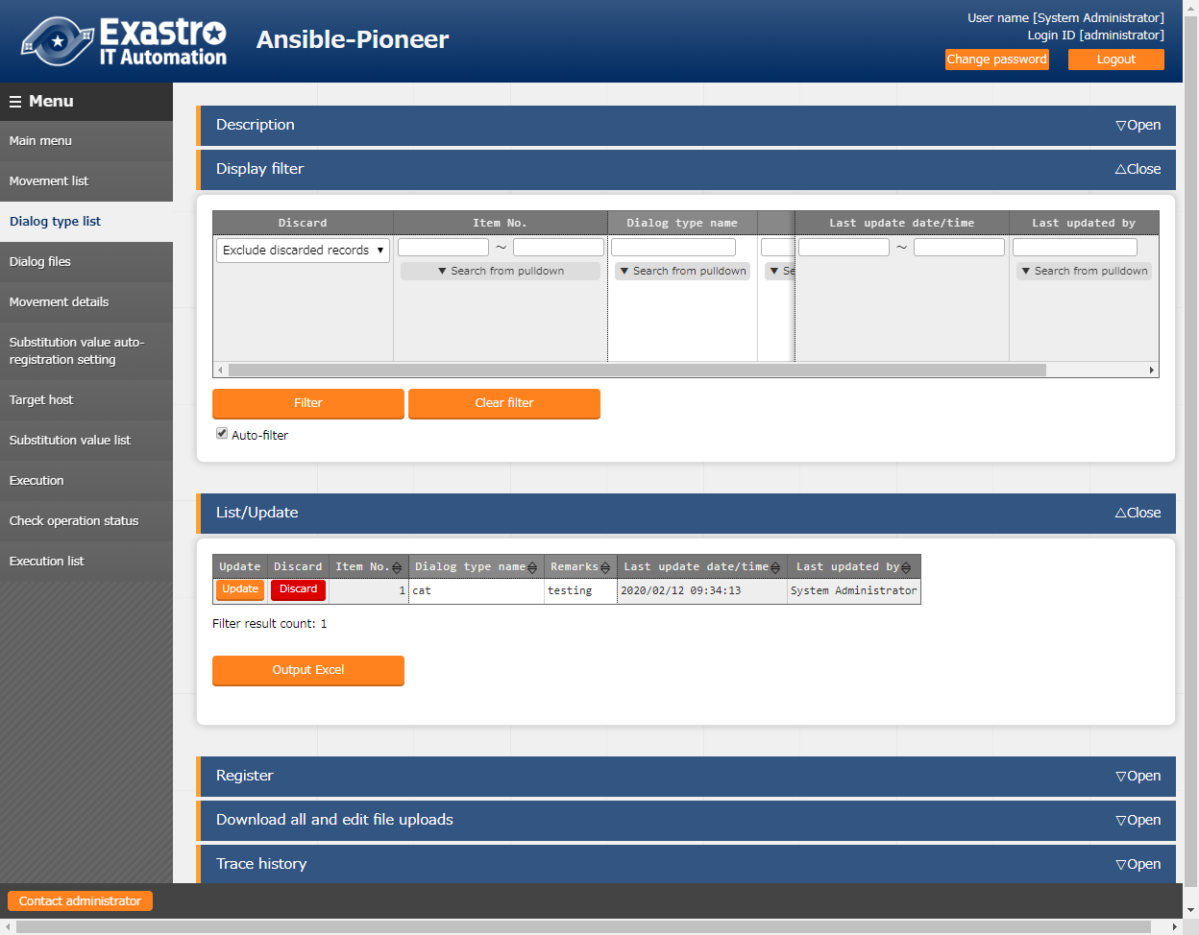

**Figure 5.3-7 Submenu screen (dialog type list)**

1. Click the "Register" - "Start Registration" button to register the operation information.

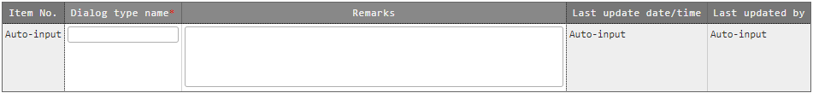

Figure 5.3-8 Registration screen (Dialog type list)

1. The list of registration screen items are as follows.

**Table 5.3-10 Registration screen item list (Dialog type list)**

|  |  |  |  |  |
| --- | --- | --- | --- | --- |
| Item | Description | Input required | Input type | Restrictions |
| Dialog type name | Enter the name of dialog type | ○ | Manual | Maximum length 256 bytes |
| Remarks | Free description field | - | Manual | Maximum length 4000 bytes |

### Dialog files (Ansible-Pioneer only)

1. Register/update/discard the dialog file created by users in "dialog files" menu.

※This menu only exists in Ansible-Pioneer console.

1. Please refer to " 6.2 Describe Dialog file(Ansible-Pioneer)" for describing the dialog file, etc.

Register dialog files for each combination of dialog type and OS type.

Please register dialog file of each "OS type" with the same "dialog type" in the case of supporting multiple OS types with one "dialog type".

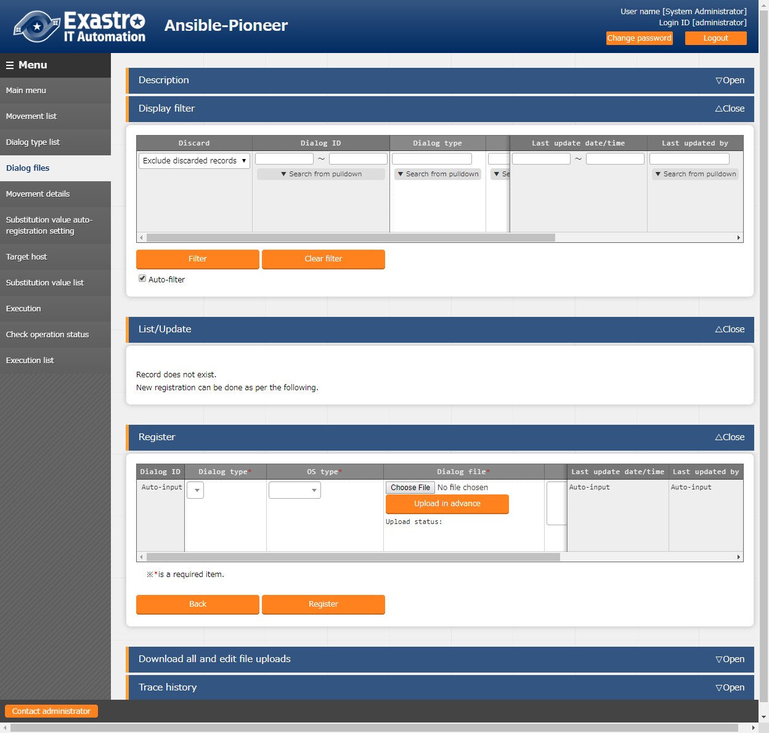

**Figure 5.3-9 Submenu screen (dialog files)**

1. Click the "Register" - "Start Registration" button to register the dialog files.

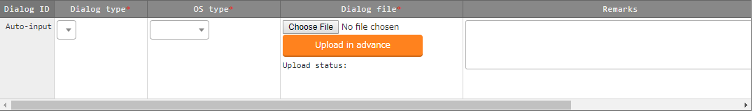

Figure 5.3-10 Registration screen (dialog files)

1. The list of registration screen items are as follows.

**Table 5.3-11 Registration screen item list (Dialog files)**

|  |  |  |  |  |
| --- | --- | --- | --- | --- |
| Item | **Description** | **Input**  **required** | **Input type** | **Restrictions** |
| Dialog type | The dialog type registered in the dialog type list menu will be displayed. Select the dialog type of dialog file to be registered. | ○ | List | - |
| OS type | The OS type registered in the OS type master menu will be displayed. Select the OS type of dialog file to be registered. | ○ | List | - |
| Dialog file | Upload the dialog file according to the dialog type and OS type. | ○ | File | Maximum size 20M bytes |
| Remarks | Free description field. | - | Manual | Maximum length 4000 bytes |

Please "Upload in advance (①)" the "dialog file" before "register".

Please click the "Register" button after checking the dialog file name displayed in the "Upload status".

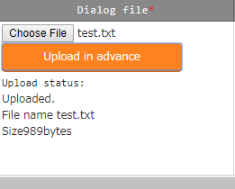

The internal process will extract the variables defined in dialog files.Users can register specific value of the extracted variables in menu "5.3.8 Substitution value auto-registration setting" and menu "5.3.10 Substitution value list".

Since the timing of extraction is not in real time, it may take some time※1 until the variables can be handled in menu "5.3.8 Substitution value auto-registration setting" and menu "5.3.10 Substitution value list".

※1 The timing of extraction is described in " 7.2 About the maintenance method", so please refer to it.

### Movement details

1. Register/update/discard the files executed in the Movement in "Movement details" menu.

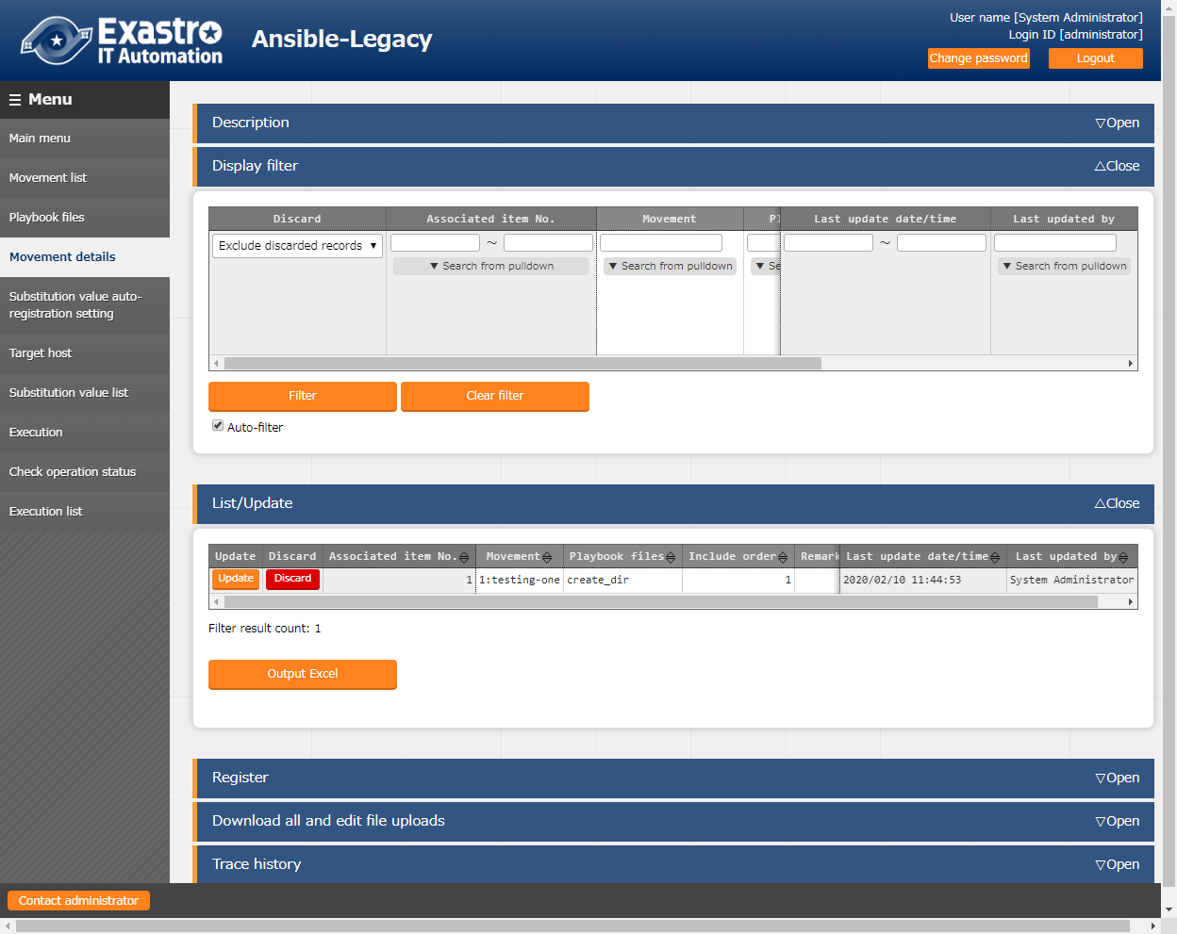

**Figure 5.3-11 Submenu screen (Movement details)**※The screen is from Ansible Legacy.

1. Click the "Register" - "Start Registration" button to register the details of Movement.

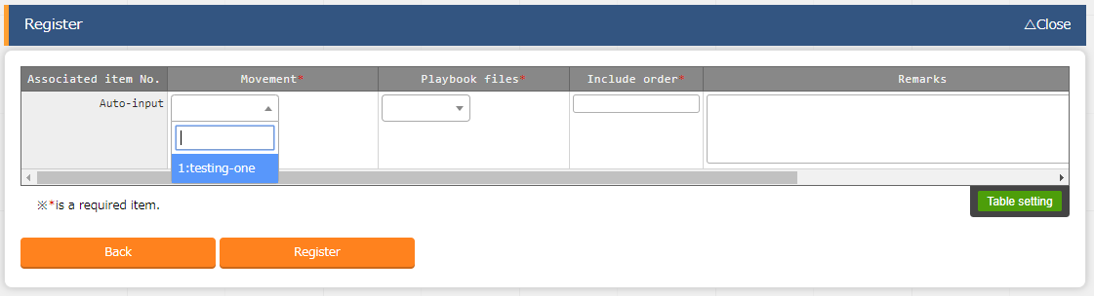

Figure 5.3-12 Registration screen (Movement details)

1. The list of registration screen items are as follows.

* **In Ansible-Legacy console**

**Table 5.3-12 Registration screen item list (Movement details in Ansible-Legacy console)**

|  |  |  |  |  |
| --- | --- | --- | --- | --- |
| Item | Description | Input required | Input type | Restrictions |
| Movement | The Movement registered in the Movement list will be displayed. Select the Movement. | ○ | List | - |
| Playbook file | The Playbook file registered in "5.3.2 Playbook file list (Ansible-Legacy only)" will be displayed. Select the Playbook file. | ○ | List | - |
| Include order | Enter the execution order of playbook files (unique value starts from 1). Playbook files will be executed as the enetered include order (ascending). | ○ | Manual | Half-width integer |
| Remarks | Free description field. | - | Manual | Maximum length 4000 bytes |

* **In Ansible-Legacy Role console**

**Table 5.3-13 Registration screen item list (Movement details in Ansible-Legacy Role console)**

**【Notes】**

**Please do not register one Movement to multiple role packages.**

**If Movement is executed with multiple role packages registered, unexpected error will occur.**

|  |  |  |  |  |
| --- | --- | --- | --- | --- |
| Item | Description | Input required | Input type | Restrictions |
| Movement | Same as Ansible-Legacy | ○ | List | - |
| Role package name | The role package registered in the role package list menu will be displayed.Select the role package to be executed. | ○ | List | - |
| Role name | The role names included in role package selected in role package name are displayed.Select the role in the role package to be executed. | ○ |  | - |
| Include order | Same as Ansible-Legacy | ○ | Manual | Half-width integer |
| Remarks | Free description field. | - | Manual | Maximum length 4000 bytes |

* **In Ansible-Pioneer console**

**Table 5.3-14 Registration screen item list (Movement details in Ansible-Pioneer console)**

|  |  |  |  |  |
| --- | --- | --- | --- | --- |
| Item | Description | Input required | Input type | Restrictions |
| Movement | Same as Ansible-Legacy. | ○ | List | - |
| Dialog type | The dialog type registered in "5.3.4 dialog type list" will be displayed. Select the dialog type of dialog file to be executed.  The dialog file associated with the OS type and dialog type of every host are execution target. | ○ | List | - |
| Include order | Same as Ansible-Legacy | ○ | Manual | Half-width integer |
| Remarks | Free description field. | - | Manual | Maximum length 4000 bytes |

### Nested variable maximum iteration count list (Ansible-Legacy Role only)

**(1)** In the "Nested variable maximum iteration count list" menu, update the maximum iteration count of member variable array defined as nested array in the nested variable which is defined in the role package registered in "5.3.3 Role package list (Ansible-Legacy Role only)". Click the update button of the member variable that the user want to change and update the maximum iteration count.

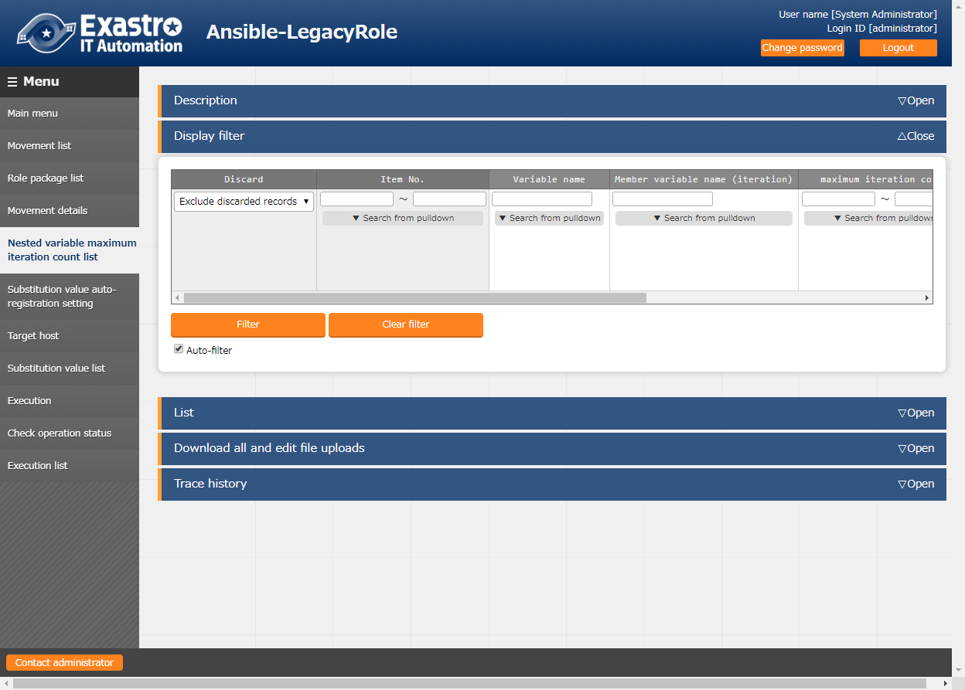

**Figure 5.3-13 Submenu screen (Nested variable maximum iteration count list)**

**(2)** Click the "List" - "Update" button to update the maximum iteration count.]

**（※Not the registration button）**

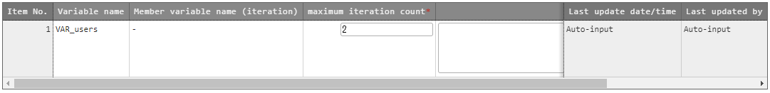

**Figure 5.3-14 Registration screen (Nested variable maximum iteration count list)**

**(3)** The list of registration screen items are as follows.

**Table 5.3-15 Registration screen item list (Nested variable maximum iteration count list)**

|  |  |  |  |  |
| --- | --- | --- | --- | --- |
| Item | Description | Input required | Input type | Restrictions |
| maximum iteration count | Enter the maximum iteration count of the array in the range of 1~99,999,999. | ○ | Manual | Value 1～99,999,999 |
| Remarks | Free description field. | - | Manual | Maximum length 4000 bytes |

The display of member variable names are the variables of each heriarchy level scoped with ".".

Also, if the first level is nested array, the member variable name will be displayed as "-".

e.g.)

|  |  |
| --- | --- |
| **Variable definition**  VAR_users:  - name: alice  authorized:  - /tmp/alice/onekey.pub  - create_users:  　　　Name: root  password: xxxxxxxxx  - create_users:  　　　Name: mysql  password: xxxxxxxxx | **Display of member variable**  **default value of the**  **maximum iteration count**   * + 1   create_users　　　　　　　　 2 |

The internal process initially registers the iteration count of member variable defined in the nested variable which is defined in the role package. After the initial registration, the iteration count can be updated in the "Nested variable maximum iteration count list" menu.

Also, since initial registration and update of iteration count is not in real time, it may take some time※1 until the variables can be handled in menu "5.3.8 Substitution value auto-registration setting" and menu "5.3.10 Substitution value list".

※1 The timing of extraction is described in " 7.2 About the maintenance method", so please refer to it.

### Substitution value auto-registration setting

1. Link the parameter sheet created in menu creation function with the variables in the Movement. The registered information will reflected to "substitution value list" menu and "target host" menu by internal process.

The reflection rule is described in “6.6 BackYard contents 6.6(2) Substitution value auto-registration setting”.

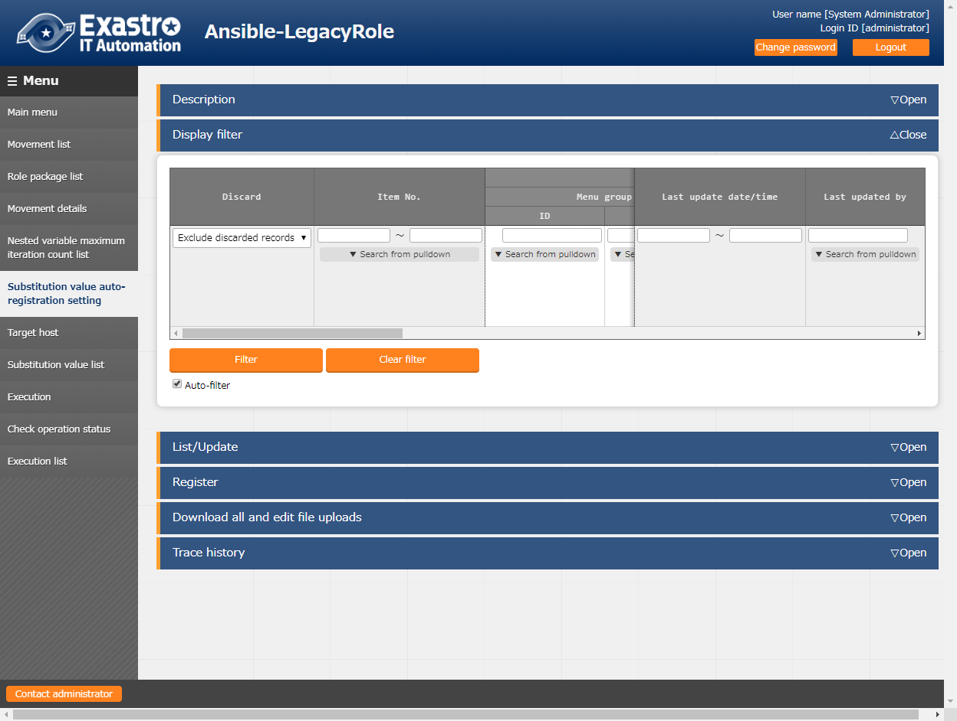

**Figure 5.3-15 Submenu screen (Substitution value auto-registration setting)**

※The screen is from Ansible-Legacy Role

**(2)** Click the "Register" - "Start Registration" button to set the substitution value auto-registration.

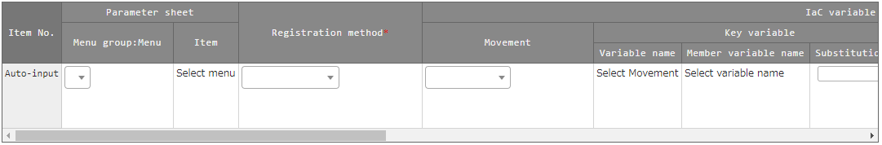

**Figure 5.3-16 Registration screen (Substitution value auto-registration setting)**

**Table 5.3-16 corresponding column list (Substitution value auto-registration setting)**

|  |  |  |  |  |
| --- | --- | --- | --- | --- |
| Column | | Legacy | Legacy Role | Pioneer |
| Menugroup:Menu | | ○ | ○ | ○ |
| Item | | ○ | ○ | ○ |
| Registration method | | ○ | ○ | ○ |
| Movement | | ○ | ○ | ○ |
| Key  variable | Variable name | ○ | ○ | ○ |
| Member variable name | － | ▲ | － |
| Substitution name | △ | △ | △ |
| Value  variable | Variable name | ○ | ○ | ○ |
| Member variable name | － | ▲ | － |
| Substitution name | △ | △ | △ |
| NULL link | | ● | ● | ● |

○: Required

●: Optional  
△: Required only if multiple specific value can be set to the selected variable.  
▲: Required only if the selected variable is nested variable  
－: Not displayed

**(3)** The list of registration screen items is as follows.

**Table 5.3-17 Registration screen item list (Substitution value auto-registration setting)**

| Column | Description | Input required | Input type | Restrictions |
| --- | --- | --- | --- | --- |
| Menugroup:Menu | The menu of parameter list is displayed.  Select the menu of association target. | ○ | List | - |
| item | The item of selected parameter list menu is displayed.  Select the item of association target. | ○ | List | - |
| Registration method | Value type： Select to set the setting value of item as the specific value of the associated variable.  Key type： Select to set the name of item as the specific value of the associated variable.  If the setting value of the item is blank, it cannot be linked.  Key-Value type： Select to set the name(Key) and setting value(Value) of item as the specific value of the associated variable. | ○ | List | - |
| Movement | The Movement registered in the Movement list will be displayed.  Select the Movement. | ○ | List | - |

| Column | | Description | Input required | Input type | Restrictions |
| --- | --- | --- | --- | --- | --- |
| Key  variable | Variable name | The variables used in the file registered in Movement details menu are displayed.  Select the variable to associate with its specific value in key type. | ○  or  ／ | List | Required if the registration method is key type of key-value type. |
| Member variable name | If nested variable is selected in the variable name column, the member variable of nested variable will be displayed.  Select the member variable. | ○  or  ／ | List |  |
| Substitution name | Required only if multiple specific value can be set to the selected variable  Enter the substitution order (1~) of specific value.  Value will be substituted in ascending order following the entered value.  Please enter the substitution order (from 1) even if there are no more specific value. | ○  or  ／ | Manual | Blank or positive integer. |
| Value  variable | Variable name | The variables used in the file registered in Movement details menu are displayed.  Select the variable to associate with its specific value in value type. | ○  or  ／ | Manual | Required if the registration method is key type of key-value type. |
| Member variable name | If nested variable is selected in the variable name column, the member variable of nested variable will be displayed.  Select the member variable. | ○  or  ／ | List | - |
| Substitution name | Required only if multiple specific value can be set to the selected variable  Enter the substitution order (1~) of specific value.  Value will be substituted in ascending order following the entered value.  Please enter the substitution order (from 1) even if there are no more specific value. | ○  or  ／ | Manual | Blank or positive integer. |
| NULL link | | Set whether to register NULL (blank) value to substitution value list menu if the specific value in parameter sheet is NULL (blank).  ・If the "Valid" is set, any value in the parameter sheet will be registered in the substitution value list menu. (NULL value will be registered)  ・If the "Invalid" is set, only specific value in the parameter sheet will be registered in the substitution value list menu (NULL value will not be registered)  ・If the column is blank, the "NULL link" value in Ansible interface information menu will be applied. | - | List | - |
| Remarks | | Free description field. | - | Manual | Maximum length 4000 bytes. |

**※ Please refer to “5.3.10 Substitution value list” for the description of member variable name.**

### Target host

1. Register/update/discard the Movement and host associated with Operation in the "Target host" menu.

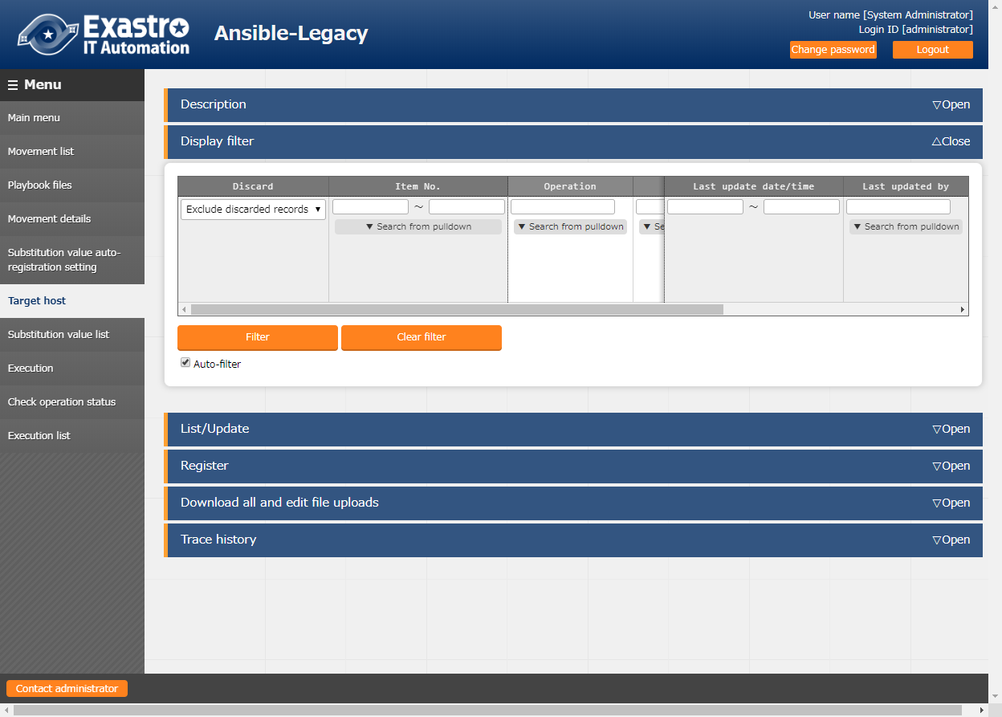

**Figure 5.3-17 Submenu screen (Target host)**

**(2)** Click the "Register" - "Start Registration" button to register the operation target host.

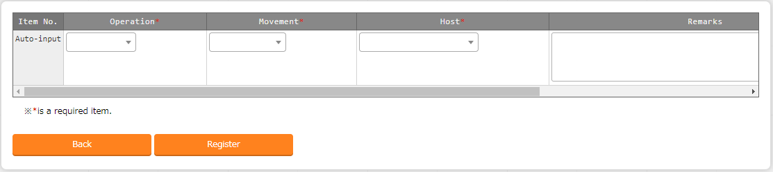

**Figure 5.3-18 Registraton screen (Target host)**

**(3)** The list of registration screen items are as follows.

**Table 5.3-18 Registration screen item list (Target host)**

|  |  |  |  |  |
| --- | --- | --- | --- | --- |
| Item | **Description** | **Input require** | **Input type** | **Restrictions** |
| operation | The Operation registered in the input operation list is displayed.Select the Operation. | ○ | List | - |
| Movement | The Movement registered in the Movement list is displayed. Select the Movement to associate with Operation. | ○ | List | - |
| Host | The host name registered in the device list will be displayed. Select the host to be associated with the Operation. | ○ | List | - |
| Remarks | Free description field. | - | Manual | Maximum length 4000 bytes |

### Substitution value list

1. Register/update/discard the substitution value of variable.

Users can perform maintenance (view/register/update/discard) of the specific values that are substituted with variable “VAR_” of Playbook and template file to be used in target Movement for each operation.

Users can also maintain the specific values that are substituted with variable “LCA_” other than "VAR_" according to the definition of substitution table. Please refer to" 6.5 Describe substitution table(Ansible-Legacy Role only)" for details.

The registered variable information will be output into host variable file (under host_vars/) during operation execution.

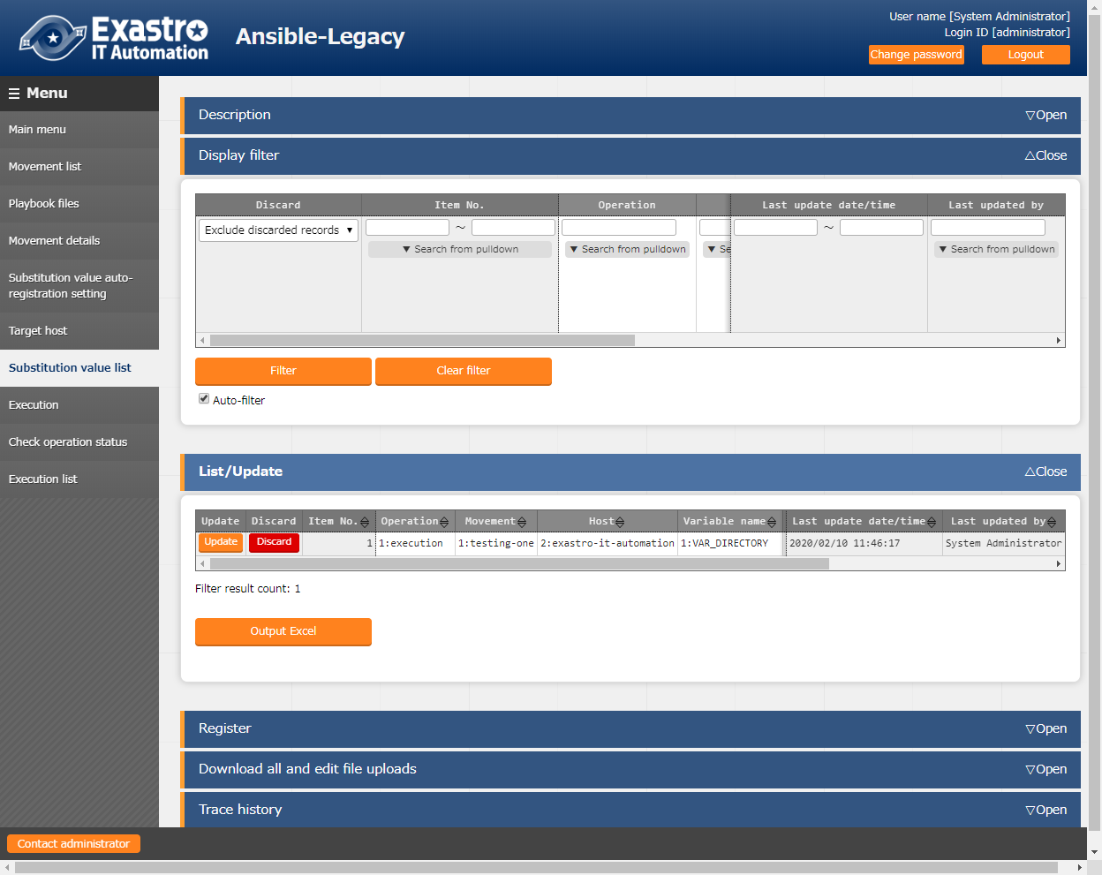

**Figure5.3-19 Submenu screen (Substitution value list)**

※The screen is from Ansible-Legacy Role.

**(2)** Click the "Register" - "Start Registration" button to manage the substitution value.

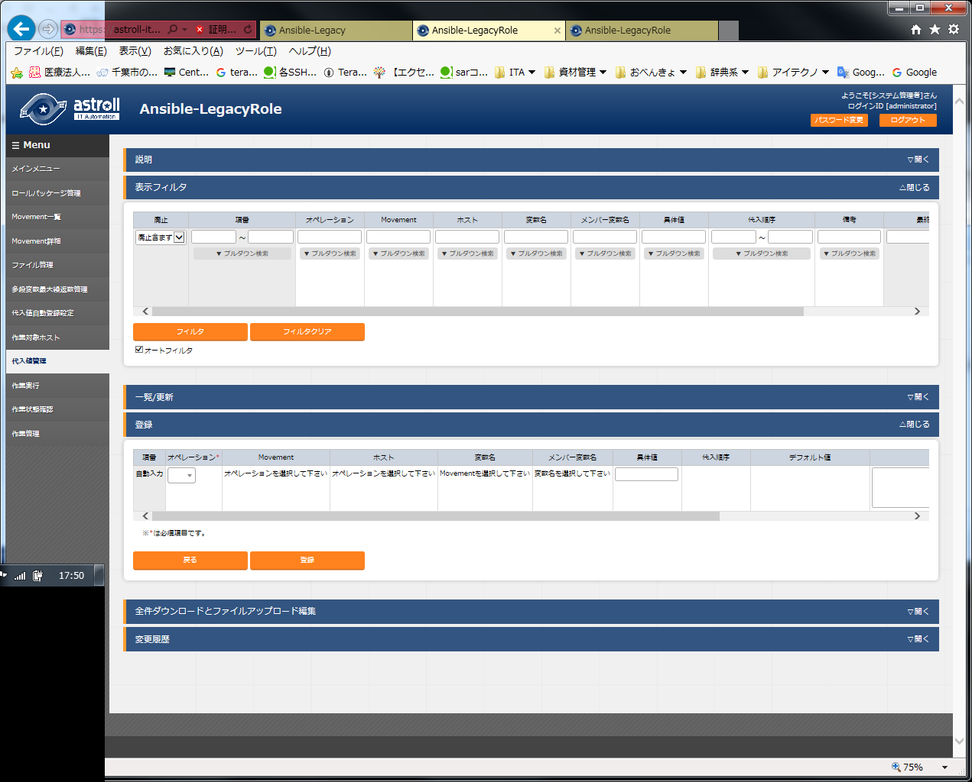

**Figure 5.3-20 Registration screen (Substitution value list)**

The variable name in substitution value list menu is reflected from the uploaded Playbook and the information registered in the substitution value auto-registration setting menu.

※ The timing of extraction is described in " 7.2 About the maintenance method", so please refer to it.

**(3)** The list of registration screen items are as follows.

**Table 5.3-19 corresponding column list (Substitution value list)**

|  |  |  |  |
| --- | --- | --- | --- |
| column | Legacy | Legacy Role | Pioneer |
| Operation | ○ | ○ | ○ |
| Movement | ○ | ○ | ○ |
| host | ○ | ○ | ○ |
| variable name | ○ | ○ | ○ |
| Member variable name | － | ▲ | － |
| Substitution order | △ | △ | △ |
| Default value(display only) | － | ○ | － |

○: Required

△: Required only if multiple specific value can be set to the selected variable

▲: Required only if the selected variable is nested variable

－: Not displayed

**Table 5.3-20 Registration screen item list (Substitution value list)**

| Item | **Description** | **Input required** | **Input type** | **Restrictions** |
| --- | --- | --- | --- | --- |
| Operation | The Operation registered in the operation target host is displayed. Select the Operation. | ○ | List | - |
| Movement | The Movement associated with the Operation selected from the data registered in the target host menu is displayed. Select the Movement. | ○ | List | - |
| Host | The host associated with the Operation and Movement selected from the data registered in the target host menu is displayed. Select the host. | ○ | List | - |
| Variable name | The variable name attached with the Movement selected from the data registered in the Movement details menu is displayed. Select the variable. | ○ | List | - |
| Member variable name | If nested variable is selected in the variable name column, the member variable of nested variable will be displayed. Select the member variable. | ○  or  ／ | List | - |
| Specific value | Enter the specific value used in Operation / Movement / Host.  File embedded variable "CPF_" and template embedded varaible "TPF_" can be entered in the specific value column.  When describing the variable, enclose the variable name in {{}} as describing them in the Playbook.  e.g. )  Entering TPF_sample as specific value.  '{{△TPF_sample△}}' △: Half-width space  ‘: recommended | ○ | Manual | Maximum length 1024 bytes |
| Substitution order | Required only if multiple specific value can be set to the selected variable.  Enter the substitution order (1~) of specific value.  Value will be substituted in ascending order following the entered value.  Please enter the substitution order (1~) even if there are no multiple specific value. | ○  or  ／ | Manual | Blank or positive integer |
| Default value | The specific value of variable selected in the variable name or member variable name column set in the default variable definition file(defaults->main.yml) is displayed  Please refer to " 6.4 Describe ITA readme(Ansible-Legacy Role only)" for details .  True is displayed when the specific value is "Yes","Y", or "y".  False is displayed when the specific value is "No","N", or "n". | - | Display  only | - |
| Remarks | Free description field. | - | Manual | Maximum length 4000 bytes |

【The display content of member variable name】

Selecting member variable is required only if the variable is nested variable.

Only the variable that requires specific value is displayed in the member variables.

The display of variable names of each heriarchy level is scoped with "." .

If the variable is in nested array, the variables are scoped with "[]" at the iteration position (0~).

The iteration array count is set in "5.3.7 Nested variable maximum iteration count list (Ansible-Legacy Role only)".

e.g.)

|  |  |
| --- | --- |
| Variable definition  VAR_users:  - name: alice  authorized:  - /tmp/alice/onekey.pub  mysql:  password: mysql-password  hosts:  - "127.0.0.1"  - "localhost"  - name: bob  authorized:  - /tmp/alice/onekey.pub  mysql:  password: mysql-password  hosts:  - "127.0.0.1"  - "localhost" | Display of member variable  [0].name  [0].authorized  [0].mysql.password  [0].mysql.hosts  [1].name  [1].authorized  [1].mysql.password  [1].mysql.hosts  ※mysql is the variable which indicates the hierarchy directory, so is not displayed in member variable. |

The information registered in "substitution value auto registration setting" menu is reflected to "substitution value list" menu and "target host" menu by internal process.

※ The timing of extraction is described in " 7.2 About the maintenance method", so please refer to it.

1. **Entering the substitution order**

In Ansible-Legacy, if the substitution order is not enetered, the variable will be treated as normal variable.

If the substitution order is entered, the variable will be handled as multiple specific value variable.

Please enter the substitution order although multiple specific value is not required (one specific value is sufficient) if the variable is multiple specific value variable.

In Ansible-Legacy Role, by selecting variable name or member variable name, it is possible to enter substitution order only for multiple specific value variables.

Please enter if the variable is multiple specific value variables.

In Ansible-Pioneer, if the substitution order is not enetered, the variable will be handled as normal variable.

If the substitution order is entered, the variable will be handled as multiple specific value variable

Please enter the substitution order although multiple specific value is not required (one specific value is sufficient) if the variable is multiple specific value variable.

In each mode, it is no problem although the substitution order is not consecutive for specific multiple concrete value variables.

e.g.)

|  |  |  |  |  |  |
| --- | --- | --- | --- | --- | --- |
| **Registration in substitution**  **value list menu** | | | |  | **The content output to the host variable file of HOST_A** |
| Host | Variable | Specific  Value | Substitution  order |  | VAR_std: value1 VAR_list_a:  - value2 VAR_list_b:  - value3  - value4 |
| HOST_A | VAR_std | value1 |  |  |
| HOST_A | VAR_list_a | value2 | 10 |  |
| HOST_A | VAR_list_b | value3 | 100 |  |
| HOST_A | VAR_list_b | value4 | 200 |  |
|  |  |  |  |  |

1. **Output to the host variable file**

The specific value of variable registered in substitution value list menu will be output to host variable file.

In Ansible-Legacy and Ansible-Pioneer, if the specific value of variable used in Playbook or dialog file is not registered in substitution value list menu during operation execution, unexpected error will occur.

In Ansible-Legacy Role, only the variable registered in substitution value list menu the will be output to host variable file during operation execution.

It is same for nested variables that only the member variable registered specific value will be output.

e.g.)

|  |  |  |  |  |  |
| --- | --- | --- | --- | --- | --- |
| **Variable definition**  VAR_users:  - name: alice  authorized:  - /tmp/alice/onekey.pub  mysql:  password: mysql-password  hosts:  - "127.0.0.1"  - "localhost"  - name: bob  omitted | **Registration in substitution value list menu** | | | | |
| Host | Variable | Member variable | Specific value | Subsitution order |
| HOST_A | VAR_users: | [0].name | value1 |  |
| HOST_A | VAR_users | [1].authorized | value2 |  |
| **The content ouput to the host variable file of HOST_A**  VAR_users:  - name :value1  - .authorized: value2 | | | | |

1. **Default value check option**

In the "System settings" of "ITA Management console", users can set the parameter to display warning message and not register the specific value when registering the specific value of the variable whose default value does not match between multiple roles.

This parameter is not registered by default. Please register if necessary.

The content to register in system settings is as follows.

Also, please refer to "User instruction manual_Ansible-Management console" for system settings.

**Table 5.3-23 Registration content in system settings**

| Item | **Input value** | **Input required** |
| --- | --- | --- |
| ID | ANSIBLE_DEF_VAL_CHK | ○ |
| Item name | Any desired string | - |
| Setting value | 1： Parameter enabled  Contents other than 1 or record not registered: Parameter disabled. | ○ |
| Remarks | Any desired string |  |

### Check operation status

1. Monitor the status of operation execution.

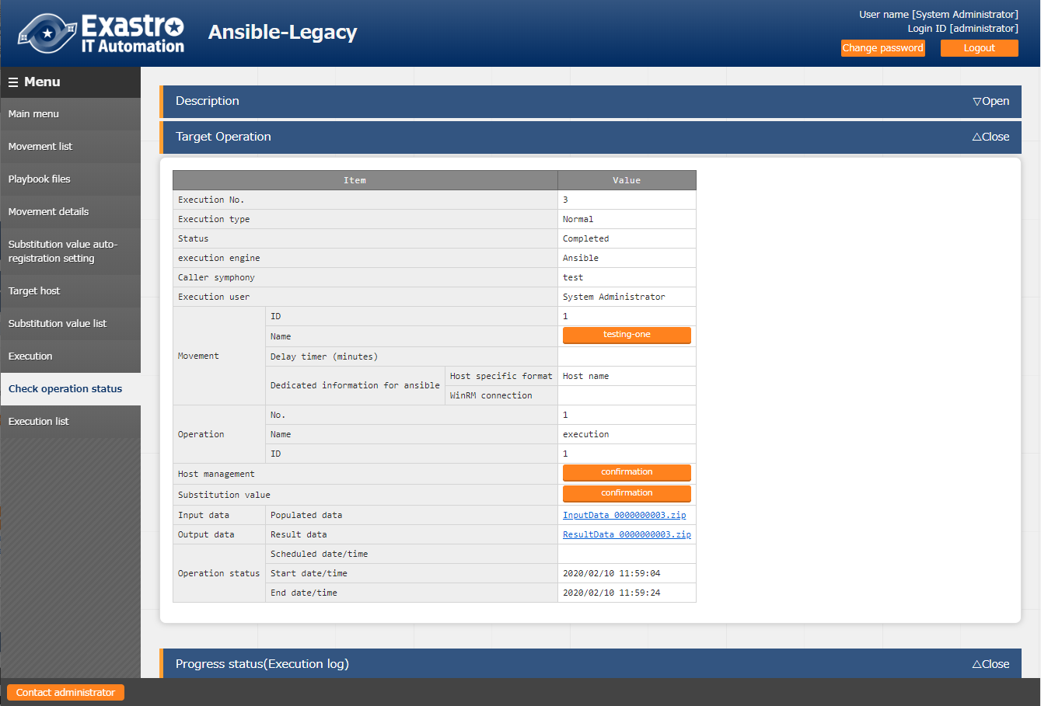

**Figure 5.3-21 Submenu screen (Check operation status)**

1. **Display of execution status**"Status" is displayed according to the execution status.

Also, the details of the execution status is displayed in execution log and error log

In the "execution type", "Dry run" is displayed when performing dry run, "Normal" will be displayed for other cases

If the status ends with an unexpected error, the cause is incomplete registration of web contents, message will be displayed in error log.

In addition, in the case that communication with Ansible RestAPI fails due to incomplete registration in "5.2.1 Interface information", message will not be displayed in error log.

In this case, error information will be record in application log. Please check the application log if necessary.

The symphony which the operation is executed from is displayed in "Caller symphony"

The column will be blank if the operation is executed directly from Ansible-Legacy, Pioneer, LegacyRole driver.

The login user when clicking the "execute" or "dry run" button in the "exeuction" menu will be displayed in "Execution User".

1. **Host management**

By clicking the "confirmation" button, "5.3.9 Target host" will display and the host filtered by the operation and Movement of operation target will be displayed.

1. **Substitution value confirmation**

By clicking the "confirmation" button, "5.3.10 Substitution value list" will display and the substitution value filtered by the operation and Movement of operation target will be displayed.

1. **Emergnecy stop/ Schedule cancellation**

It is possible to stop the construction operation by clicking the "Emergency stop" button

In addition, for the "scheduled execution" operation before execution, the "schedule cancellation" button will display. Cancel the scheduled execution by clicking the "schedule cancellation" button.

1. **Log filter**

Execution log and error log can be filtered. By entering the string that the user wants to search in the filter box of each log and checking the "Display only corresponding lines" checkbox, only the corresponding line will be displayed.  
The display refresh cycle and the maximum display line count of exeuction and error log can be set in "Status monitoring cycle (milliseconds)" and "Number of rows to display progress status" of "5.2.1 Interface information" menu.

1. **Input data**

Users can download files such as the executed Playbook.

Please refer to “ 9.1 The linkage between the input data used during Ansible execution and ITA menu” for the configuration of input data.

1. **Result data**

Users can download files such as execution log and error log.

### Execution list

1. The history of operation can be viewed here.

The operation list table and graph will display by specifying criteria and clicking the "filter" button.

By hovering the mouse cursor over each graph, the downlod button of each graph will be displayed on the top-right of the graph.

Users can download the graph by clicking the download button of each displayed graph.

By clicking the "Check execution status" button, the screen will transit to "5.3.11 Check operation status" and the details of execution status can be viewed.

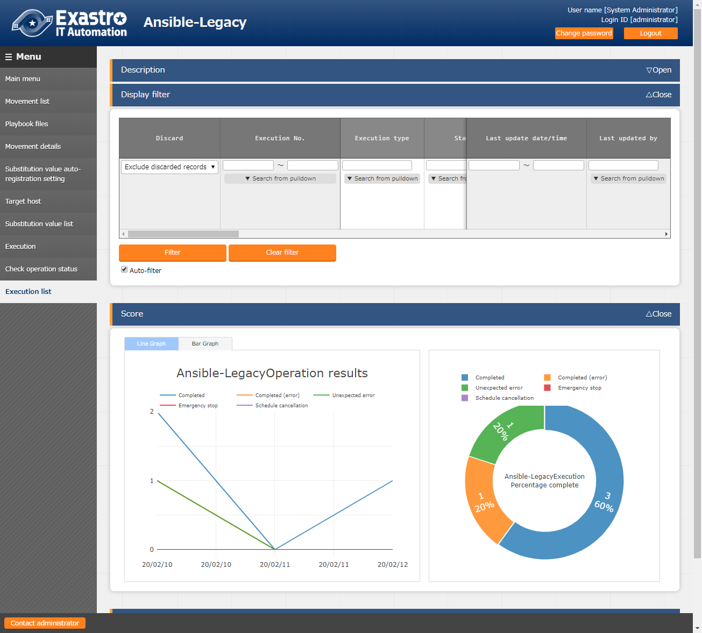

**Figure 5.3-22 Submenu screen (Execution list)**

### Execution

1. Indicate Operation execution. Select the radio button from the Movement list and operation list and click the execution button, the screen will transit to "5.3.11 Check operation status" and the operation will be executed.

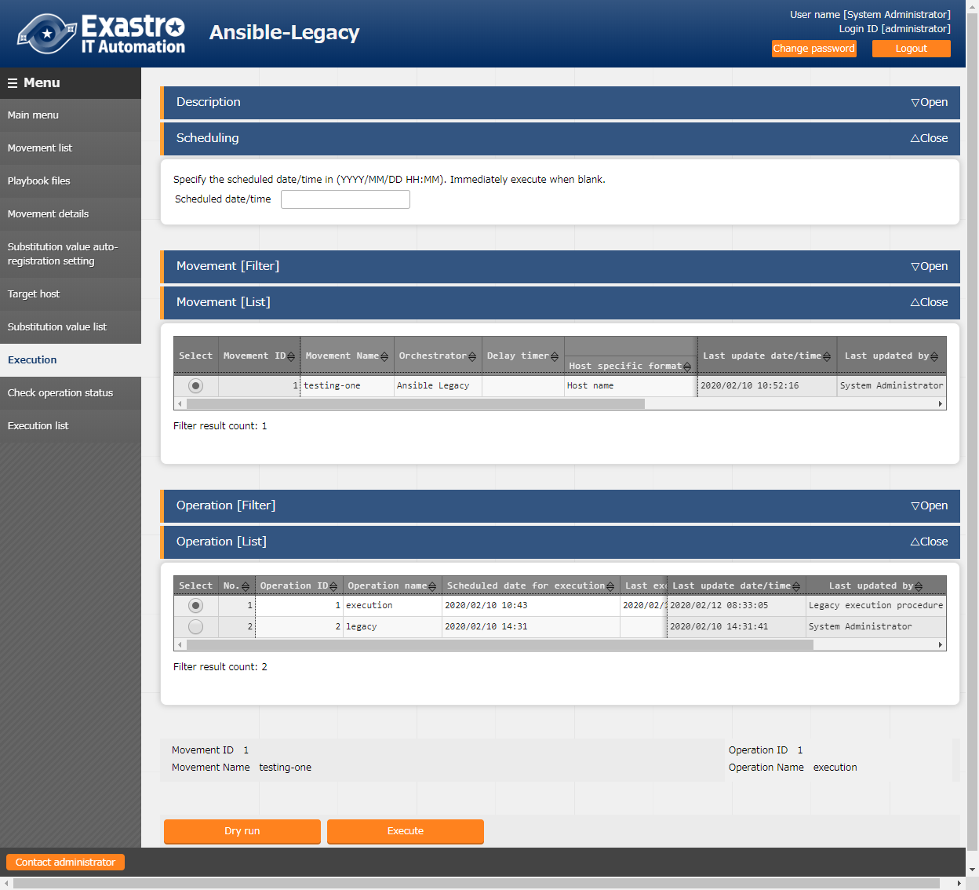

**Figure 5.3-23 Submenu screen (Execution)**

※The screen is from Ansible Legacy

1. **Dry run**

By clicking the "Dry run" button, dry run can be executed without actually constructing the target device. In the case of dry run, the operation of each mode is as follows.

|  |  |
| --- | --- |
| Driver | Action |
| Ansible-Legacy | Execute the playbook by specifying the -check parameter to the Ansible-Playbook command. |
| Ansible-Legacy Role | Execute the role by specifying the - check parameter to the Ansible-Playbook command. |
| Ansible-Pioneer | Only perform the connection check to target device |

1. **Specify scheduled date/time**

Execution can be scheduled by entering “Scheduled date/time” column.

Only future date/time can be registered for "Scheduled date/time"

# How to write construction code

## Describe Playbook (Ansible-Legacy)

Please refer to the official manual for the basic Playbook format.

Please use UTF-8 for the character encoding

Please adjust the indent in the Playbook to multlple of 2

e.g.)

-△name: Service script setting

△△template:

△△△△src: "{{ item.src }}"

△△△△dest: "{{ item.dest }}"

△△△△owner: "{{ item.owner is none |ternary('root', item.owner) }}"

△△△△group: "{{ item.group is none |ternary('bacula', item.group) }}"

△△△△mode: "{{ item.mode is none |ternary('0654', item.mode) }}"

～omitted～

△: Half-width space

## Describe Dialog file(Ansible-Pioneer)

The dialog file in Ansible-Pioneer incorporates an ITA-specific module into Ansible.

The dialog file is in ITA-specific format.

Please use UTF-8 for the character encoding.

**(1)** Structure of dialog file

The dialog file is constructed with 2 types of section.

|  |  |
| --- | --- |
| Section name | Usage |
| Conf | Specify the timeout value according to timeout parameter.  timeout value: 1~3600(unit:second) |
| exec_list | Construct the target host with 4 kinds of dialog command. |

Describe the timeout parameter in the beginning of dialog file then describe the dialog comment in the later part.

Comments can be described in the same format with Ansible basic format.

e.g.)

# Comment

conf:

△△timeout: 10

exec_list:

**※△: Half-width space**

**Please enter 2 half-width space before “timeout:”**

**(2)** Dialog command

There are 4 kinds of dialog commands as follows.

|  |  |
| --- | --- |
| Module | Use |
| exec | Input command to the target host |
| expect | Waiting for the output of expected string (prompt) from the contents that the target host outputs to the standard output. |
| state | Input the command to target host. The contents of the standard output until the prompt is output to the standard output are analyzed by external shell, and the result is determined. |
| command | Loops and conditional branching can be performed before and after inputting commands to the target host. |

1. expect module

Waiting for the output of expected string (prompt) from the contents that the target host outputs to the standard output.

Describe the expected string in regular expression.

When the expected string is received, proceed to the next. In addition, if the string is not received within the time specified by the time out parameter, the dialog file will terminate abnormally.

e.g.)　　Waiting for the prompt of password entry via telnet connection

△△-△expect:△’Password’

**※△:** **half-width space**

**Please enter 2 half-width space before “- expect:”**

**It is recommended to enclose the waiting string with quotation.**

1. exec module

Input command to the target host.

exec module and expect module are used in pairs.

e.g.) Wait for the password entry prompt via telnet connection and input password.

△△-△expect:△’Password’

△△△△exec:△itapassword

**※△: Half-width space**

**Please enter 4 half-width space before the description of “exec:”**

**It is recommended to enclose the waiting string with quotation if necessary.**

1. state module

Input the command to target host. The contents of the standard output until the prompt is output to the standard output are analyzed by external shell, and the result is determined.

**The format of state module**

| Parameter | Required/ Optional | Description |
| --- | --- | --- |
| △△－△state:△xxx | Required | Specify the input command. |
| △△△△prompt:△xxx | Required | Specify the waiting prompt. The prompt can be described in regular expression. |
| △△△△shell:△xxx | Optional | Specify the shell file name to check the result with the created shell.  If the exit code of the created shell is 0, the result is determined as normal, and the others are abnormal.  This parameter is not required when checking the result with default shell.  The default shell will grep the contents of standard output with the string specified by parameter (-).  If there is at least one matching row, the result is determined normal, and if there is no matching row, the result is determined to be abnormal.  In addition, if the parameter is not specified, the result will be determined as abnormal. In the case of using the parameter to save the command result (standard output) to the file specified by stdout_file, please specifiy yes for ignore_errors. |
| △△△△parameter:  △△△△△△-△xxx  △△△△△△-△xxx | Optional | Specify the string to search for the result (standard output) of the input command. If the shell is specified, the strings will become the parameters during shell execution. Enumerate the criteria strings if there are multiple of them. |
| △△△△stdout_file:△xxx | Optional | The file to save the result (standard output) of the input command. |
| △△△△success_exit:△ xxx | Optional | Please set this file to the shell parameter if the shell parameter if specified.  Specify "yes" to exit the dialog normally if the search result is normal and specify no to proceed to the next. "no" is set on default. |
| △△△△ignore_errors:△ xxx  ※△:Half-width space | Optional | Specify "yes" to proceed to the next even if the search result is abnormal.  "no" is set on default. |

Exp3)

cat the hosts file and grep the displayed results with parameter value.If there is line containing 139.0.0.1 or lalhost, the result is determined as normal and proceed to the next.If there is no such line, the result is determined as abnormal and proceed to the next according to the ignore_errors:yes setting.

exec_list:

- state: cat /etc/hosts

prompt: root@{{ __loginhostname__ }}

parameter:

- 139.0.0.1

- lalhost

ignore_errors: yes

Exp2)

cat the hosts file and grep the displayed results with parameter value.If there is line containing 139.0.0.1 or lalhost, the result is determined as normal and terminate normally according to the success_exit:yes setting. If there is no such line, the result is determined as abnormal and the dialog file is terminated abnormally

exec_list:

- state: cat /etc/hosts

prompt: root@{{ __loginhostname__ }}

parameter:

- 139.0.0.1

- lalhost

success_exit: yes

Exp1)

cat the hosts file and grep the displayed results with parameter value. If there is line containing 139.0.0.1 or lalhost, the result is determined as normal and proceed to the next. If there is no such line, the result is determined as abnormal and the dialog file is terminated abnormally.

exec_list:

- state: cat /etc/hosts

prompt: root@{{ __loginhostname__ }}

parameter:

- 139.0.0.1

- lalhost

Exp5)

cat the hosts file and save the displayed result to the file specified by stdout_file then proceed to the next. If the “no” parameter is set to the default shell, the result will be determined as abnormal.

Set ignore_errors:yes to proceed to the next. exec_list:

- state: cat /etc/hosts

prompt: root@{{ __loginhostname__ }}

stdout_file: {{ __symphony_workflowdir__ }}/hosts

ignore_errors: yes

Exp4)

cat the hosts file and use the user created shell to grep the displayed results with parameter value. If there is line containing 139.0.0.1 or lalhost, the result is determined as normal and proceed to the next. If there is no such line, the result is determined as abnormal and the dialog file is terminated abnormally

exec_list:

- state: cat /etc/hosts

prompt: root@{{ __loginhostname__ }}

shell: /tmp/grep.sh

stdout_file: /tmp/stdout.txt

parameter:

- 139.0.0.1

- lalhost

User created shell(/tmp/grep.sh)

#!/bin/bash

STDOUT=/tmp/STDOUT.tmp

STDERR=/tmp/STDERR.tmp

cat /tmp/stdout.txt|grep $1|grep $2 | wc -l >${STDOUT} 2>${STDERR}

RET=$?

if [ $RET -ne 0 ]; then

EXIT_CODE=$RET

else

if [ -s ${STDERR} ]; then

EXIT_CODE=1

else

CNT=`cat ${STDOUT}`

if [ ${CNT} -eq 0 ]; then

EXIT_CODE=1

else

EXIT_CODE=0

fi

fi

fi

/bin/rm -rf ${STDOUT} ${STDERR} >/dev/null 2&>1

exit ${EXIT_CODE}

1. command module

Loops and conditional branching can be performed before and after inputting commands to the target host.

The format of command module

| Parameter | Required/  Optional | Description |
| --- | --- | --- |
| △△－△command:△xxx | Required | Specify the input command. |
| △△△△prompt:△xxx | Required | Specify the waiting prompt. It can be described in regular expression. |
| △△△△timeout:△xxx | Optional | Specify the timer to wait for the prompt after the command is sent.  If the parameter is omitted, then conf->timeout is used. |
| △△△△register:△xxx | Optional | Save the information of the standard output to any string specified after sending the command.  When using with_items to loop, the information of the standard output after the last command input is saved. This variable can be used in condition judgment (can only be used in condition judgment). However, saving the information of standard output for every variable name is not possible. Previous information will be overwritten. |
| △△△△with_items:  △△△△△△-△xxx  △△△△△△-△xxx | Optional | The variable set in with_items are multiple speific value variable.  The number of specific value of the variables set in with_items does not have to be the same.  If the numbers are not the same, the process will loop with the maximum number of the specific value of each variable.  The specific value of the variables whose specific value is not enough is handled as null value.  However, the above does not apply to prompt or timeout.  If the specific value is insufficient in prompt or timeout, error will occur.  The scope of each variable is item.X(X is from 0 to 99).  The application range of variable (item.X) is other than register/when.  Please set the variable as the follows when using with_items in prompt and timeout.  prompt： {{△VAR_prompt_XXX△}}  timeout： {{△VAR_timeout_XXX△}}  (△ is half-width space. XXX is made up of any desired half-width alphanumeric character or underscore) |
| △△△△when:  △△△△△△-△xxx  △△△△△△-△xxx | Optional | The condition judgement before command executes.  Execute command if the condition matches.  Move to the next “command” line if the condition doesn't match.  Conditional expression  Judging variable definition  VAR_xx is define Variable defined true  VAR_xx is undefined Variable undefined true  ※define/undefine can be specified only for ITA variable(VAR_xx)  Judging variable specific value  VAR_xx/register variable relational_operator string  VAR_xx/register variable relational_operator VAR_xx  VAR_xx/register variable match(Regular expression string /VAR_xx)  VAR_xx/register variable no match(Regular expression string /VAR_xx)  ※Relational operators are 「==」、「!=」、「>」、「>=」、「<」、「<=」  ※The 「>」、「>=」、「<」、「<=」 relational operators are assumed to be used for numerical values.  ※It is not required to enclose string and regular expression string with single or double quotations.  VAR_status match(active)　　 VAR_status == active  Compound condition with and / or  When processing with or condition, add OR between judge conditions   * + VAR_status == 1　OR VAR_status == 2   When processing with and condition, describe the statement in multiple lines.   * + VAR_status == 1　OR VAR_status == 2   + VAR_sub_status == 1 |
| △△△△exec_when:  △△△△△△-△xxx  △△△△△△-△xxx | Optional | Judge condition for every loop (continue condition)  Perform condition judgement if with_items is described.  If the condition matches, execute command of the corresponding loop.  If the condition doesn't match, move on to the next loop.  Conditional expression  Judging variable definition  VAR_xx is define Variable defined true  VAR_xx is undefined Variable undefined true  ※define/undefine can be specified only for ITA variable(VAR_xx)  Judging variable specific value  VAR_xx/register variable relational_operator string  VAR_xx/register variable relational_operator VAR_xx  VAR_xx/register variable match(Regular expression string /VAR_xx)  VAR_xx/register variable no match(Regular expression string /VAR_xx)  ※Relational operators are 「==」、「!=」、「>」、「>=」、「<」、「<=」  ※The 「>」、「>=」、「<」、「<=」 relational operators are assumed to be used for numerical values.  ※It is not required to enclose string and regular expression string with single or double quotations.  VAR_status match(active)　　 VAR_status == active  Compound condition with and / or  Perform the same description format as “when:” |
| △△△△failed_when:  △△△△△△-△xxx  △△△△△△-△xxx  ※△: half-width space | Optional | Condition judgment for the stdout content after command execution(for every loop)  Perform condition judgment even if with_items is not described  If the condition matches, the result is normal  If the condition doesn't match, the result is abnormal and the dialog file is terminated abnormally  Conditional expression  Judging variable specific value  stdout relational_operator string  stdout relational_operator VAR_xx  stdout match(regular expression string/VAR_xx)  stdout no match(regular expression string/VAR_xx)  ※Relational operators are 「==」、「!=」、「>」、「>=」、「<」、「<=」  ※The 「>」、「>=」、「<」、「<=」 relational operators are assumed to be used for numerical values.  ※It is not required to enclose string and regular expression string with single or double quotations.  VAR_status match(active)　　 VAR_status == active  Compound condition with and / or  Perform the same description format as “when:” |

Exp1)

conf:

timeout: 30

exec_list:

# If waiting for strings other than prompt is required, use the combination of expect/exec.

# In the case that the password is required.

- expect: 'password:'

exec: '{{ __loginpassword__ }}'

# If the ITA variable, VAR_hosts_make, is described in host variable file, cat the host file.

# If the variable is not described, skip the command.

- command: cat /etc/hosts

prompt: root@{{ __loginhostname__ }}

when:

- VAR_hosts_make is define

Exp2)

conf:

timeout: 30

exec_list:

# If waiting for strings other than prompt is required, use the combination of expect/exec.

# In the case that the password is required.

- expect: 'password:'

exec: '{{ __loginpassword__ }}'

# If the ITA variable, VAR_hosts_make, is described in host variable file, cat the host file.

# If the variable is not described, skip the command."

# Use cat to save the contents of the standard output hosts file to result_stdout.

- command: cat /etc/hosts

prompt: root@{{ __loginhostname__ }}

register: result_stdout

when:

- VAR_hosts_make is define

# If the ITA variable, VAR_hosts_make, is described in host variable file, cat the host file.

# If the variable is not described, skip the command.

# Execute the command for the numbers of the specific values of the multiple specific value

# variable set in the with_items.

# From the result of condition judgment for each loop, if "ip address host name" does not

# correspond to the hosts file, execute command.

# Add "IP_address host_name" to the last line of hosts file by using echo.

- command: 'echo {{ item.0 }} {{ item.1 }} >> /etc/hosts'

prompt: 'root@{{ __loginhostname__ }}'

when:

- VAR_hosts_make is define

with_items:

- '{{ VAR_hosts_ip }}' # item.0

- '{{ VAR_hosts_name }}' # item.1

exec_when:

- result_stdout no match({{ item.0 }} *{{ item.1 }})

Exp3)

conf:

timeout: 30

exec_list:

# If waiting for strings other than prompt is required, use the combination of expect/exec.

# In the case that the password is required.

- expect: 'password:'

exec: '{{ __loginpassword__ }}'

# Execute the command for the numbers of the specific values of the multiple specific value

# variable set in the with_items

# Execute auto startup configuration.

- command: 'systemctl enable {{ item.0 }}'

prompt: 'root@{{ __loginhostname__ }}'

with_items:

- '{{ VAR_service_name_list }}' # item.0

# Execute the command for the numbers of the specific values of the multiple specific value

# variable set in the with_items

# Execute service startup

- command: 'systemctl start {{ item.0 }}'

prompt: 'root@{{ __loginhostname__ }}'

with_items:

- '{{ VAR_service_name_list }}' # item.0

Execute the command for the numbers of the specific values of the multiple specific value variable set in the with_items.

Output the service status to standard output.

If the content of result output to standard output contains the regular expression of item.1, the result is right.

For example, in the case that the specific value of VAR_service_status_list is set to running and the service is running, "running" in "Active: active(running)" matches so the result is right. (Move on to the next loop)

In the case that condition doesn't match, the result is determined as abnormal and the dialog file terminates abnormally.

- command: 'systemctl status {{ item.0 }}'

prompt: 'root@{{ __loginhostname__ }}'

with_items:

- '{{ VAR_service_name_list }}' # item.0

- '{{ VAR_service_status_list }}' # item.1

failed_when:

- stdout match({{ item.1 }})

|  |  |
| --- | --- |
| Variable name | Specific value |
| VAR_command_list | systemctl status {{ item.1 }} |
| VAR_service_name_list | ky_pioneer_execute-workflow.service |

Exp5)

conf:

timeout: 30

exec_list:

# If waiting for strings other than prompt is required, use the combination of expect/exec.

# In the case that the password is required.

- expect: 'password:'

exec: '{{ __loginpassword__ }}'

# Execute the command for the numbers of the specific values of the multiple specific value

# variable set in the with_items.

# Setting the specific value of substitution value list to {{item.X}} is possible. In that case, please

# make the numerical value described in the specific value of item.X which is described in the

# dialog file grows.

# The command executed in this example is "systemctl status ky_pioneer_execute-workflow.service".

- command: "{{ item.0 }}"

prompt: 'root@{{ __loginhostname__ }}'

with_items:

- '{{ VAR_command_list }}' # item.0

- '{{ VAR_service_name_list }}' # item.1

Exp4)

conf:

timeout: 30

exec_list:

# If waiting for strings other than prompt is required, use the combination of expect/exec.

# In the case that the password is required.

- expect: 'password:'

exec: '{{ __loginpassword__ }}'

# Execute the command for the numbers of the specific values of the multiple specific value

# variable set in the with_items.

# When describing the command with "{{item.0}}" only, enclose it with double-quotation.

# Please note the numbers of specific value when using with_items in prompt or timeout.

# prompt→command→prompt→command→prompt…(loops thereafter), it is required to plus 1 # to the command count. (Same for timeout)

- command: "{{ item.0 }}"

prompt: '{{ item.1 }}'

timeout: '{{ item.2 }}'

with_items:

- '{{ VAR_command_list }}' # item.0

- '{{ VAR_prompt_list }}' # item.1

- '{{ VAR_timeout_list }}' # item.2

and条件

and condition

Exp6)

conf:

timeout: 30

exec_list:

# If waiting for strings other than prompt is required, use the combination of expect/exec.

# In the case that the password is required.

- expect: 'password:'

exec: '{{ __loginpassword__ }}'

# Example of compound condition using and / or.

# When processing with or condition, describe the if statement horizontally.

# When processing with and condition, describing the statement in multiple lines.

# "when" is used as the example here but the same applies to exec_when and failed_when.

- command: echo aaa

prompt: 'root@{{ __loginhostname__ }}'

when:

- 10 == 9 OR 10 != 9 OR 10 >= 9

- 10 > 9 OR 10 <= 9 OR 10 < 9

**(3)** Regular expression

The strings described in the following command and parameter are evaluated in regular expression.

・expect module

・The prompt parameter of state module

・The prompt parameter of command module

When the string is described in regular expression contains metacharacter "(){}.", etc., inserting escape character "\" before metacharacters is required.

Exp1)

When waiting for the following command, the red characters are metacharacters.

XAMPP Developer Files **[**Y**/**n] exec_list:

　Inserting escape character "\" before metacharacters is required.

　　XAMPP Developer Files \**[**Y\**/**n\] exec_list:

State module and command module extracts the result (standard ouput) of the executed command. The notes of the extraction are as follows.

* 1. The delimitation between the result (standard ouput) of the executed command and the prompt.

The delimitation between the result (standard ouput) of the executed command and the prompt is performed by the string specified in the prompt parameter. When judging the result of the executed command (standard output) or saving it to a file, please do not describe a preceding match with .* in regular expression. The result (standard ouput) of the executed command can not be extracted.

　.* Example of preceding match with .* in regular expression.

　　　‘**.\***[\#\$\%] $’

* 1. Support of escape sequence

Depending on the target device, an Operating System Command sequence may be added immediately before the prompt sent from the target device.

Escape sequences immediately before the string specified by the prompt parameter are excluded.

**(4)** Notes when using multiple specific value variable

The only parameter in the dialog file that can use multiple specific value variable is the with_items parameter of command module. If multiple specific value variable is used in other cases, the operation execution will turn out to be error.

## Describe role package (Ansible-Legacy Role)

Please refer to the Ansible best practices official manual for the basic format.

Please use UTF-8 for the character encoding.

This section describes the directory that is required to be in the zip file of role package file uploaded in "5.3.3 Role package list (Ansible-Legacy Role only)" and the process in ITA.

**(Parent directory)**

**│**

**├─site.yml site.yml(master Playbook) is created in ITA.**

**│ The file will be overwritten if exists.**

**│**

**├─hosts hosts file is created in ITA.**

**│ The file will be overwritten if exists.**

**│**

**├─group_vars host group variables are not handled.**

**│ The group_vars directory will be removed if exists.**

**│**

**├─host_vars Host variables are created in ITA.**

**│ This directory will be overwritten if it exists.**

**│**

**├─ITA readme ITA readme is defined for every role. Error doesn't occur even if the file deosn't exist**

**│ The naming rule of ITA readme file name:**

**│ ita_readme_[role_name].yml**

**│ e.g.)**

**│ Role name: mysql File name: ita_readme_mysql.yml**

**│ Role name: mysql/install File name: ita_readme_mysql%install.yml**

**│ ※If role is in a deep directory hierarchy,**

**│ replacing “/” in the role name with “%” is required.**

**│**

**├─substitution table Substitution table is defined for every role. Error doesn'st occur even if the file deosn't exist**

**│ The naming rule of substitution table file name**

**│ ita_translation-table_[role_name].txt**

**│ e.g.)**

**│ Role name: mysql File name: ita_translation-table_mysql.txt**

**│ Role name: mysql/install File name: ita_translation-table_mysql%install.txt**

**│ ※If role is in a deep directory hierarchy,**

**│ replacing “/” in the role name with “%” is required.**

**│**

**│ ITA does not concern if other directory or file exists other the directory or file above.**

**│**

**└─roles** **Error occur during upload if the roles directory does not exist.**

**│**

**├─[role name①] Error occur during upload if the role name directory does not exist.**

**│ │ Handle the directory containing tasks directory as a role.**

**│ │ Errors doesn't occur even if the directory hierarchy is deep.**

**│ │**

**│ ├─readme.mc ITA does not concern with the file.**

**│ ├─tasks The tasks directory is required.**

**│ │ ├ main.yml Error occur during upload if main.yml does not exist.**

**│ │ └ user_files** **Files other than main.yml can be placed here.**

**│ │ └ user.yml Files other than main.yml can be placed in subdirectory.**

**│ │**

**│ ├─handlers Doesn't concern if handlers directory exists or not.**

**│ │ ├ main.yml** **Doesn't concern if main.yml exists or not**

**│ │ └ user_files** **Files other than main.yml can be placed here.**

**│ │ └ user.yml Files other than main.yml can be placed in subdirectory.**

**│ │**

**│ ├─templates** **Doesn't concern if templates directory exists or not.**

**│ │ ├ hosts.j2** **Files can be placed in subdirectory.**

**│ │ └ user_files**

**│ │ └ user.j2**

**│ │**

**│ ├─files** **Doesn't concern if files directory exists or not.**

**│ │ sudoers Doesn't concern if file and subdirectory exists or not.**

**│ │ The file content is not concerned.**

**│ │**

**│ ├─vars** **Doesn't concern if vars directory exists or not.**

**│ │ main.yml Doesn't concern if file and subdirectory exists or not.**

**│ │ The file content is not concerned.**

**│ │**

**│ ├─defaults** **Doesn't concern if defaults directory exists or not.**

**│ │ ├ main.yml** **Doesn't concern if main.yml exists or not.**

**│ │ └ user_files** **Files other than main.yml can be placed here.**

**│ │ └ user.yml** **Files other than main.yml can be placed in subdirectory.**

**│ │**

**│ ├─meta Doesn't concern if meta directory exists or not.**

**│ │ main.yml** **Doesn't concern if file and subdirectory exists or not.**

**│ │ The file content is not concerned.**

**│ │**

**│ ITA does not concern if other directory or file exists other the directory or file above.**

**│**

**└─[role name②]** **There is no specific limit on the number of roles.**

1. Unique management of variable name

The variable information registered in the substitution value list of ITA is handled as host variable.

Variable names in all role packages of each drivers are uniquely managed.

When using same the variable name between roles with different variable structure, error will occur during upload

For example, in the case that the normal variable and nested variable or the nested structure is different between nested variables, etc.

1. ITA original specification of default variable definition file (defaults-> main.yml)

There is ITA original specification of the description (variable definition) of default variable definition.

Please refer to the attachment file "User Instruction Manual - Ansible-driver attachment Ansible usage guideline with additional rules" for details.

1. Notes on subdirectories of a predetermined directory in Ansible Role Directory Structure

If a subdirectory that has the same name of the predetermined directory is created under the predetermined directory in Ansible Role Directory structure (For example, a "files" directory under the "files" directory, etc.), error will occur during operation execution.

## Describe ITA readme(Ansible-Legacy Role only)

The substitution value management function interpretes the variable type defined in defaults variable definition file and sets the variable value of each variable and its' member variable.

In the cases such as not wanting to define variable directly in the Playbook, etc. if variable is not defined in defaults variable definition file, variable value can be specified in the substitution value management function by setting the variable definition in ITA readme file.

The relation between ITA readme file and substitution value management function is as the following figure.

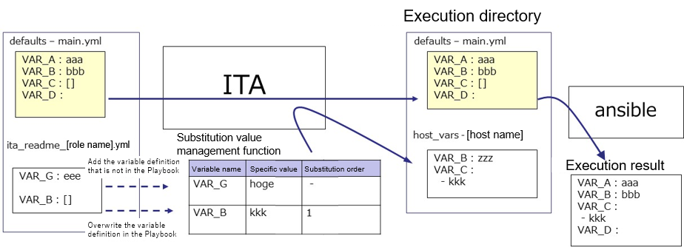

If the variable that is not in Playbook is defined in ITA readme file, the value of defined variable can be set in the substitution value management function.

Furthermore, if a type different from the variable in the Playbook is defined in the ITA readme file, the value can be registered in the substitution value management function with the overwritten variable type.

The value set in the substitution value management function is output to the variable definition file (host_vars) of each host, and is executed on each host by using the original Playbook and variable definition file as input in Ansible.

ITA readme file is only used to provide variable definition to substitution value management function, the variable and variable value defined in ITA readme don't affect the excecution of Ansible.

It is optional to create ITA readme. If the variable definition in ITA readme and defaults variable definition file overlaps, the following rules will be used to handle the situation.

**Table 6.4-1 variable adoption rule**

|  |  |  |
| --- | --- | --- |
| defaults variable definition file | ITA readme | Adoption source of variable definition |
| defined | undefined | defaults variable definition file |
| undefined | defined | ITA readme |
| defined | defined | ITA readme |

In addition, the default value displayed in "5.3.10 Substitution value list" is processed following the rule below.

**Table 6.4-2 default value display rule**

|  |  |  |
| --- | --- | --- |
| defaults variable definition file | ITA readme | The method to handle the default value |
| defined | undefined | Adopt the defaults variable definition file. |
| undefined | defined | Handle as no default value. |
| defined | defined | Adopt the defaults variable definition file. However, the rule is applied only when the definition variable matches. If the variable definition doesn't match, the variable is handled as no default value. |

ITA readme is seperated from role package during work execution.

The variable and specific value registered in ITA readme can't be applied.

## Describe substitution table(Ansible-Legacy Role only)

The substitution table is a file set for making setting the specific value of variable other than "VAR_xxx" defined in defaults varaiable definiton file or ITA readme in "5.3.10 Substitution value list" possible.

Define the link between the “arbitrary variable” defined in the default variable definition file or ITA readme with the “substitution variable” handled in substitution management function.

**(1)** The format of substitution table

The format is as follows in text format.

The combination of substitution variable and arbitrary variable has to be unique within single role.

Substitution variable($s*):($s+)arbitrary variable

substitution variable：LCA_***

***：half-width alphanumeric character and underscore(_) can be used.

(Minimum length: 1byte, Maximum length: 256 bytes)

Arbitrary variable: (Minimum length: 1byte, Maximum length: 256 bytes)

($s*)： More than 0 half-width space

($s+)： More than 1 half-width space

e.g.)

LCA_var1: var1

# The line starts with # is comment line

LCA_var2: var2

The relationship of substitution value management function is as the following figure.

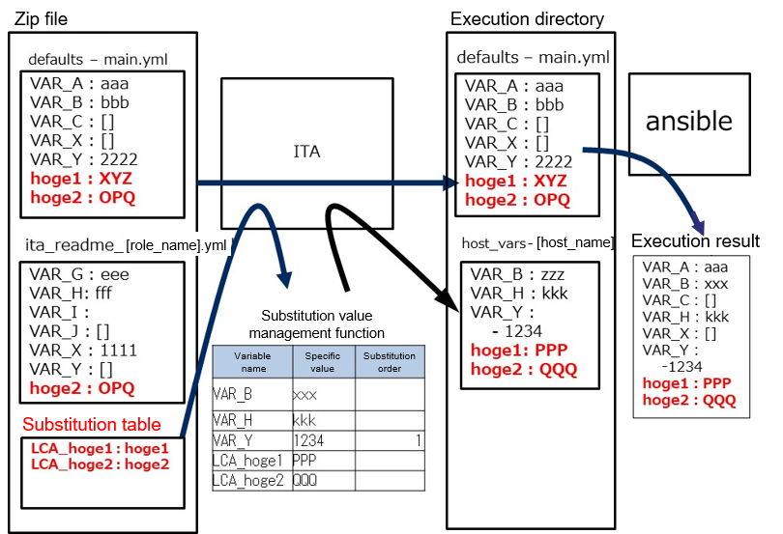

**(2)** Notes

Listing the notes when creating substitution table.

|  |  |  |
| --- | --- | --- |
| Case | The behavior of ITA | Remarks |
| The substitution table exists but defaults variable definition file and ITA readme doesn't exist. (For every role) | Translation table can’t be read. |  |
| The variable begins with VAR_ is defined as arbitrary variable | Error occurs when uploading role package. |  |
| Uses any variables not defined in the defaults variable definition file and ITA readme | Error occurs when uploading role package. |  |
| Definition of substitution variables are duplicated in the role | Error occurs when uploading role package. | Package A->Role A  LCA_A: user_A/LCA_A: user_B |
| Definition of arbitrary variables are duplicated in the role | Error occurs when uploading role package. | Package A->Role B  LCA_A: user_A/LCA_B: user_A |
| The structure of arbitrary variable differs between roles | Error occurs when uploading role package. | Package A->Role A/B　　LCA_C: user_C |
| The combination of substitution variable and arbitrary variable is not unique in role package | Error occurs when uploading role package. | Package A  Role A　　LCA_D: user_D Role B　　LCA_D: user_E |
| The structure of arbitrary variable differs between role packages | Error doesn't occurs when uploading role package, but the substiution variable is not displayed in substitution value list. | Package A->Role A  LCA_F: user_F Package B->Role A  LCA_F: user_F |
| Nested arbitrary variable is defined between role packages | The nested structure is the same so error does not occur but the setting of nested iteration count is common setting for each package. | Package A->Role B  LCA_H: user_H Package B->Role A  LCA_H: user_H |

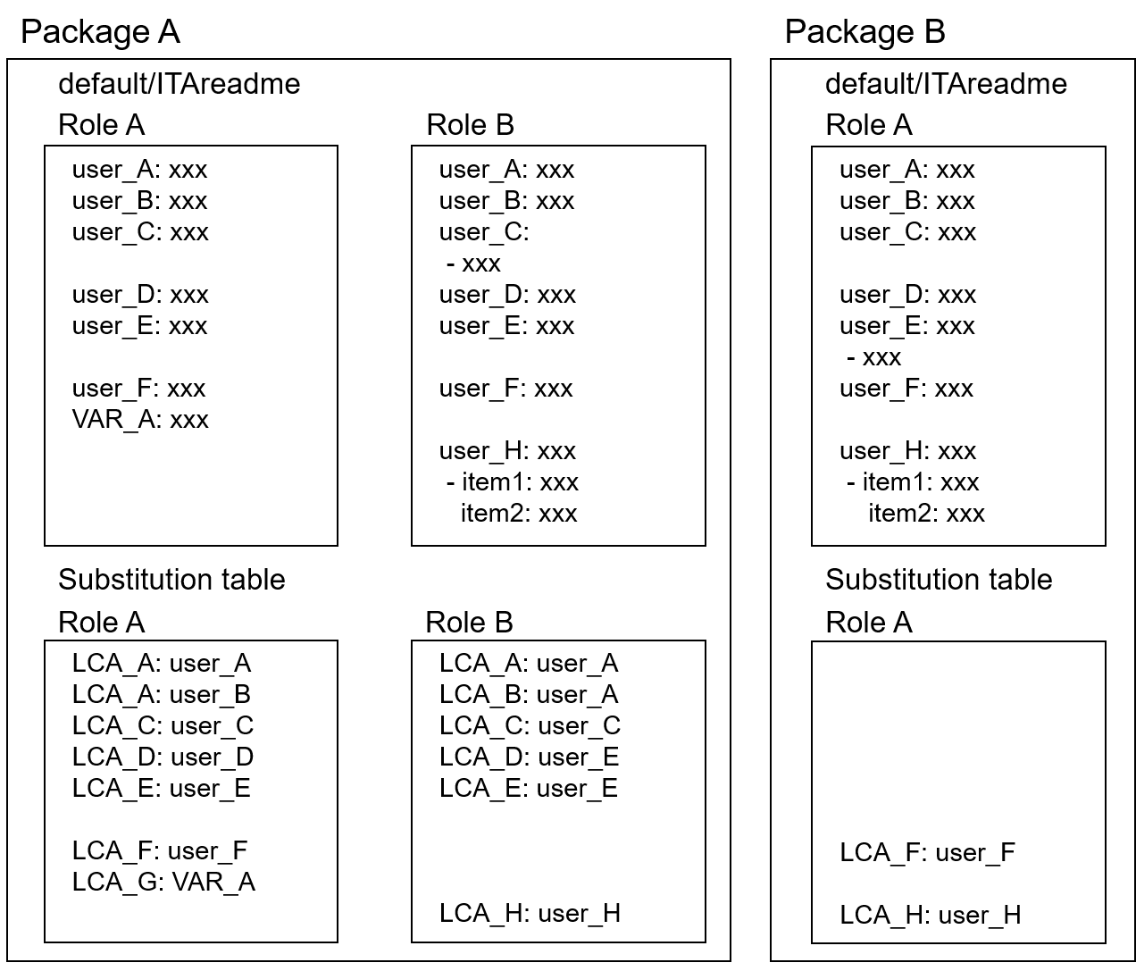

## BackYard contents

1. **Variable auto registration**

When the variable analysis target file is uploaded, extract variable from the uploaded file.

Table 6.6-1 Variable handling of the file uploaded in each mode

|  |  |  |  |
| --- | --- | --- | --- |
| Menu | Legacy | Legacy Role | Pioneer |
| Playbook files | ○ | × | × |
| Role package list | × | ○ | × |
| Dialog files | × | × | ○ |

The extract timing depends on the startup cycle of the automatic process.

※Unique management of variable name

The extracted variable names in all role packages of each mode are uniquely managed.

Since the variable structure is defined in the default variable definition file, the notes when the variable stucture is different in each file are as follows

●Single role package

When using same the variable name between roles with different variable structure.

※In the case that the normal variable and nested variable or the nested structure is different between nested variables, etc.

**=>** Error occurs during file upload.

●All role package

When using same the variable name between role packages with different variable structure.

**=>** Error occurs during file upload.

1. **Substitution value auto-registration setting**

The Operation of parameter sheet and Movement linked with the item setting value of every host and the variable information are reflected to Target host menu and Substitution value list menu as the association target.

The reflection timing also depends on the startup cycle of the automatic process as described above.

Target host and substitution value list menu is updated by multiple operators. Reflection will not be performed if the last updater is other operator (not Backyard).

When user wants to reflect the data in substitution value auto-registration setting menu, please perform operations such as discard the applicable record in substitution value list value or disable the applicable record in other BackYard process.

The reflection rules to Target host menu and Substitution value list menu are as follows.

1. When reflecting the information registered in substitution value auto-registration setting to substitution value list.

|  |  |  |  |  |  |
| --- | --- | --- | --- | --- | --- |
| **The status of substitution value list** | **Doesn't exist applicable record** | **Exist applicable record** | | | **Applicable record is being discarded** |
| **=** **Specific value** | **≠** **Specific value** | |
| **Last updated by** | |
| **BackYard process** | **Other operators** |
| **Reflection in substitution value list** | Add new record | - | Update the specific value of the applicable record | - | Restore the  discarded record |

※Applicable record: The record that has same Operation+host+Movement+variable name + (member variable)+(include order)

1. When reflecting the information that is not registered in "substitution value auto-registration setting" menu (registered only in "substitution value" menu) to substitution value list

|  |  |  |
| --- | --- | --- |
| **The status of substitution value list** | **Exist applicable record** | |
| **Last updated by** | |
| **BackYard process** | **Other operators** |
| **Reflection in substitution value list** | Discard the applicable record | - |

1. When reflecting the information registered in substitution value auto-registration setting to target host menu

|  |  |  |  |
| --- | --- | --- | --- |
| **The status of operation target host** | **Doesn't exist applicable record** | **Exist applicable record** | **Applicable record is being discarded** |
| **Reflection in operation target host** | Add new record | － | Restore the discarded record |

※ Applicable record: The record that has same Operation+host+Movement

1. When reflecting the information that is not registered in substitution value auto-registration setting(only registered in target host menu) to target host menu

|  |  |  |
| --- | --- | --- |
| **The status of substitution value list** | **Exist applicable record** | |
| **Last updated by** | |
| **BackYard process** | **Other operators** |
| **Reflection in substitution value list** | Discard the applicable record | - |

1. When link to multiple items is registered to for the same Movemeny, variable, and substitution order.

When multiple parameter sheets are linked with same operation and host, one item is selected randomly and reflected to substitution value list.

|  |  |  |  |  |  |  |  |  |
| --- | --- | --- | --- | --- | --- | --- | --- | --- |
| **Parameter sheet: sheetA** | | |  |  |  | **Substitutuion value**  **auto-registration setting** | | |
| **No** | **Operation** | **host** | **Item 1** |  |  | **Parameter sheet** | | **Movement** | **Registration method** | **IaC variable** | |
| **1** | **Op1** | **Host01** | **Value1** |  |  | **Menu** | **Item** | **Value variable** | **Substitution order** |
| **2** | **Op1** | **Host02** | **Value2** |  |  | **sheetA** | **Item 1** | **setting** | **Value** | **VAR_val** |  |
|  |  |  |  |  |  | **sheetB** | **Item 1** | **setting** | **Value** | **VAR_val** |  |
| Since Operation: Op1 amd host: Host01 is linked with multiple parameter sheet, the setting value of the item in the random selected parameter sheet: sheetA is reflected to substitution value list. | | | |  |  |  |  |  |  |  |  |
|  | | | |  |  |  |  |  |  |  |  |
|  | | | |  |  |  |  |  |  |  |  |
|  | | | |  |  |  |  |  |  |  |  |
|  | | | |  |  |  |  |  |  |  |  |
| **Parameter sheet: sheetB** | | |  |  |  | **Substitutuion value list** | | |  |  |  |
| **No** | **Operation** | **host** | **Item 1** |  |  | **Operation** | **host** | **Movement** | **Variable name** | **Substitution order** | |
| **1** | **Op1** | **Host01** | **Value4** |  |  | **Op1** | **Host01** | **setting** | **VAR_val** | **Value1** | |
| **2** | **Op1** | **Host03** | **Value3** |  |  | **Op1** | **Host02** | **setting** | **VAR_val** | **Value2** | |
|  |  |  |  |  |  | **Op1** | **Host03** | **setting** | **VAR_val** | **Value3** | |

## Ansible usage guideline ITA additional rules

A Playbook creation guideline for using ITA to execute on Ansible.

Please refer to the attachment "User Instruction Manual - Ansible-driver attachment- Ansible usage guideline with additional rules" for details.

# Application operation

The operation to utilize ITA system contains not only inputs by user from the browser screen of client PC but also operations according to system operation and maintenance. The available operation and maintenance are as follows.

## Maintenance

The required file to start/stop/restart Ansible driver independent processes are as follows.

|  |  |
| --- | --- |
| **Description** | **Target file name** |
| legacy execution monitor  Execute the unexecuted Operation. | ky_legacy_execute-workflow.service |
| legacy execution monitor  Monitor the execution status of Operation. | ky_legacy_checkcondition-workflow.service |
| legacy variable automatic registration  Extract variable from the uploaded file. | ky_legacy_varsautolistup-workflow.service |
| legacy automatic registration setting  Reflect the information set in auto-registration setting to substitution value list and operation target host menu. | ky_legacy_valautostup-workflow.service |
| pioneer execution monitor  Execute the unexecuted Operation. | ky_pioneer_execute-workflow.service |
| pioneer execution monitor  Monitor the execution status of Operation. | ky_ pioneer_checkcondition-workflow.service |
| pioneer variable automatic registration  Extract variable from the uploaded file. | ky_ pioneer_varsautolistup-workflow.service |
| pioneer automatic registration setting  Reflect the information set in auto-registration setting to substitution value list and operation target host menu. | ky_ pioneer_valautostup-workflow.service |
| legacyRole execution monitor  Execute the unexecuted Operation. | ky_legacy_role_execute-workflow.service |
| legacyRole execution monitor  Monitor the execution status of Operation. | ky_legacy_role_checkcondition-workflow.service |
| legacyRole variable automatic registration  Extract variable from the uploaded file. | ky_legacy_role_varsautolistup-workflow.service |
| legacyRole automatic registration setting  Reflect the information set in auto-registration setting to substitution value list and operation target host menu. | ky_legacy_role_valautostup-workflow.service |
| AnsibleTower data synchronization  Obtain setting information from Ansible-tower. | ky_ansible_towermasterSync-workflow.service |

The target files are stored in “/usr/lib/system/system”.

The method to start/stop/restart process are as follows.

Please execute the command with root privilege.

1. Start process

# systemctl start ky_legacy_execute-workflow.service

1. Stop process

# systemctl stop ky_legacy_execute-workflow.service

1. Restart process

# systemctl restart ky_legacy_execute-workflow.service

Please substitute each target file name to start / stop / restart the process.

## About the maintenance method

1. Change to NORMAL level

Rewrite the 8th line of the following file from “DEBUG” to “NORMAL”.  
Log level setting file： <insallation direcotory>/ita-root/confs/backyardconfs/ita_env

1. Change to DEBUG level  
   Rewrite the 8th line of the following file from “NORMAL” to “DEBUG”.  
   Log level setting file： <installation direcotory>/ita-root/confs/backyardconfs/ita_env
2. Change the startup cycle

Change the 5th parameter of ExecStart in each target file. (Unit: second)

Please use the default value of startup cycle excluding exceptions.

ExecStart=/exastro/ita-root/backyards/common/ky_loopcall-php-procedure.sh /usr/local/bin/php /usr/local/bin/php /exastro/ita-root/backyards/ansible_driver/ky_pioneer_varsautolistup-workflow.php /exastro/ita-root/logs/backyardlogs **10** NORMAL > /dev/null 2>&1

After rewriting the file, **the change takes effect after restarting the process.**

Log file output destinaton： <installation directory>/ita-root/logs/backyardlogs

# Troubleshooting

|  |  |
| --- | --- |
| No | Contents |
| Q-1 | When executing legacy operation on a host with the user set in device list menu other than root user, error occurs when executing Ansible command. |
| A-1 | When executing Ansible command with ITA, the sudo parameter is set to yes on default. Please give sudo privilege to the user on the operation target host side.  Please add sudo parameter to Playbook if sudo privilege can't be given to the user |
| Q-2 | When executing pioneer operation to the host whose protocol is set to telnet in device list menu, error occurs when connecting to operation target host. |
| A-2 | Please check if the password and password prompt described in the dialog file are correct. |
| Q-3 | When executing orchestrator operation on host whose authentication method in device list is set to public key authentication, error occur when connecting to target host. |
| A-3 | Please check if the public key on the target host side is registered in .ssh/known_hosts of Ansible server and AnsibleTower server. The public key is registered when loggin in the target host with target host name or IP address from the servers mentioned above using ssh command. |
| Q-4 | When executing orchestrator operation to host whose authentication method in device list is set to password authentication, error occur when connecting to target host. |
| A-4 | Please check if password authentication in the ssh setting is allowed on the target host side. |
| Q-5 | When executing each orchestrator operation with host specification type specified in the Movement list menu, error occur when connecting to the target host. |
| A-5 | Please check the registration of /etc/hosts, etc. to see if the address of the target host can be resolved or not. When connecting via ssh, please check if the public key on the target host side is registered in the known_hosts of Ansible server and AnsibleTower server with the target host name. |
| Q-6 | Creating file in /tmp using Playbook, but file is not created in /tmp. |
| A-6 | PrivateTmp function has been added from RHEL7. The PrivateTmp option in Apache installed by ITA is enabled. The execution of Playbook from ITA is via Apache so /tmp is binded by other directory. ITA recommends that users refrain from accessing files in /tmp from Playbook. |
| Q-7 | Can't connect Windows server from Ansible. |
| A-7 | Please start Powershell in Windows server as administrator and execute the following command.  C:\User\User> Enable-PSRemoting -Force  ↓  C:\User\User> Set-NetConnectionProfile -InterfaceAlias (Get-NetConnectionProfile -IPv4Connectivity Internet).InterfaceAlias -NetworkCategory Private  ↓  C:\User\User> winrm set winrm/config/service/auth '@{Basic="true"}'  ↓  C:\User\User> winrm set winrm/config/service '@{AllowUnencrypted="true"}' |

# Appendix

## The linkage between the input data used during Ansible execution and ITA menu

Extract information from each ITA menu and create the "input data" that is required for Ansible execution.At that time, the password in device list menu is encrypted. Ansible-Legacy and Ansible-LegacyRole encrypts with ansible-vault, while pioneer encryptes with the original method of ITA.

The "Input data" can be downloaded from "5.3.11 Check operation status" in ZIP format. Executing the following command in Ansible directly is also possible.

Ansible-Legacy

ansible-playbook (option) –i hosts --vault-password-file password_file playbook.yml

Ansible-Pioneer

ansible-playbook (option) –i hosts playbook.yml

Ansible-LegacyRole

ansible-playbook (option) –i hosts --vault-password-file password_file site.yml

The password file name is at user’s desire. Please set the password to the password file with the value of the content in “ITA installation target directory/ita-root/confs/commonconfs/ansible_vault_accesskey.txt”, decoded in the order of rot13, base64.

The relationship between various data and the ITA menu is as follows.

### Ansible-Legacy input data

【Parent directory】

|  |  |  |  |  |
| --- | --- | --- | --- | --- |
|  |  |  |  |  |
| **―** | child_playbooks | The directory containing user created Playbooks. | | |
|  |  |  | | |
|  |  | Ansible-Legacy | Playbook files | Playbook file |
|  |  | Ansible-Legacy | Movement details | Include order |
|  |  |  |  |  |
| ― | template_files | The directory containing the template file used in Playbook that is going to be executed. | | |
|  |  |  | | |
|  |  | Ansible-Legacy | Template list | Template file |
|  |  | Ansible-Legacy | Movement details | Include order |
|  |  |  |  |  |
| ― | copy_files | The directory containing the file that is going to be deployed on operation target server. | | |
|  |  |  | | |
|  |  | Ansible-Legacy | Contents list | Files |
|  |  | Ansible-Legacy | Movement details | Include order |
|  |  |  |  |  |
| ― | host_vars | The directory containing the host information of the operation target host and the definition file of various variable. | | |
|  |  |  | | |
|  |  | Ansible common | Global variable list | Variable name/specific value |
|  |  | Ansible-Legacy | Substitution value list | Variable name/specific value |
|  |  | Ansible-Legacy | Template list | Template file |
|  |  | Ansible-Legacy | Contents list | File variable name |
|  |  | Ansible-Legacy | Movement details | Include order |
|  |  | Ansible-Legacy | Interface information | Data relay storage path(ITA) |
|  |  | Ansible-Legacy | Interface information | Symphony instance data relay storage path(Ansible) |
|  |  | Basic console | Device list | Protocol |
|  |  | Basic console | Device list | Login user ID |
|  |  | Basic console | Device list | Login password  ※Encrypted with ansible-vault |
|  |  | Basic console | Device list | Host name |

|  |  |  |  |  |  |  |
| --- | --- | --- | --- | --- | --- | --- |
|  |  |  |  | | |  |
| ― | ssh_key_files | The directory in which the specified ssh authentication key file is stored when using key authentication as the authentication method. | | | | |
|  |  |  | | | | |
|  |  | Basic console | Device list | | | ssh authentication key file |
|  |  |  |  | | |  |
| ― | winrm_ca_files | The directory in which the file that defines the connection information when connecting to WinRM is stored. | | | | |
|  |  |  | | | | |
|  |  | Basic console | Device list | | WinRM connection information | |
|  |  |  |  | | |  |
|  | AnsibleExecOption.txt | Parameter for AnsiblePlaybook execution | | | | |
|  |  |  | | | | |
|  |  | Ansible common | Interface information | | | Option parameter |
|  |  | Ansible-Legacy | Movement list | | | Number of parallel executions |
|  |  |  |  | | |  |
|  | hosts | The file describing the operation execution target host | | | | |
|  |  |  | | | | |
|  |  | Basic console | Device list | | | host name |
|  |  | Basic console | Device list | | | IP address |
|  |  | Basic console | Device list | | | Login user ID |
|  |  | Basic console | Device list | | | Login password  ※Encrypted with ansible-vault |
|  |  | Basic console | Device list | | | Connection options |
|  |  |  |  | ※The parameter of ansible_ssh_extra_args | | |
|  |  | Basic console | Device list | | | ssh authentication key file |
|  |  | Basic console | Device list | | | Server certificate |
|  |  | Basic console | Device list | | | Inventory file additional option |
|  |  |  |  | | |  |
|  | playbook.yml | The file calls the whole information of playbook and host information and executes Ansible. | | | | |
|  |  |  | | | | |
|  |  | Ansible-Legacy | Playbook files | | | Playbook file |
|  |  | Ansible-Legacy | Movement details | | | Include order |
|  |  | Ansible-Legacy | Movement details | | | gather_facts |
|  |  |  |  | | |  |

### Ansible-Pioneer input data

【Parent directory】

|  |  |  |  |  |  |  |
| --- | --- | --- | --- | --- | --- | --- |
|  |  |  |  | | |  |
| ― | template_files | The directory containing the template file used in Playbook that is going to be executed. | | | | |
|  |  |  | | | | |
|  |  | Ansible-Pioneer | Template list | | | Template file |
|  |  | Ansible-Pioneer | Movement details | | | Include order |
|  |  |  |  | | |  |
| ― | copy_files | The directory containing the file that is going to be deployed on operation target server. | | | | |
|  |  |  | | | | |
|  |  | Ansible-Pioneer | Contents list | | | Files |
|  |  | Ansible-Pioneer | Movement details | | | Include order |
|  |  |  |  | | |  |
| ― | ssh_key_files | The directory in which the specified ssh authentication key file is stored when using key authentication as the authentication method. | | | | |
|  |  |  | | | | |
|  |  | Basic console | Device list | | | ssh authentication key file |
|  |  |  |  | | |  |
| ― | winrm_ca_files | The directory in which the file that defines the connection information is stored when connecting to WinRM. | | | | |
|  |  |  | | | | |
|  |  | Basic console | Device list | | WinRM connection information | |
|  |  |  |  | | |  |
| ― | host_vars | The directory in which the host information of the operation target host and the definition file of various variable is stored. | | | | |
|  |  |  | | | | |
|  |  | Ansible common | Interface information | | | Data relay storage path(ITA) |
|  |  | Ansible common | Interface information | | | Symphony instance data relay storage path(Ansible) |
|  |  | Ansible common | Global variable list | | | Variable name/specific value |
|  |  | Ansible-Pioneer | Substitution value list | | | Variable name/specific value |
|  |  | Ansible-Pioneer | Template list | | | Template file |
|  |  | Ansible-Pioneer | Movement details | | | Include order |
|  |  | Ansible-Pioneer | Contents list | | | File variable name |
|  |  | Ansible-Pioneer | Movement details | | | Include order |
|  |  | Basic console | Device list | | | Login password |
|  |  |  |  | ※Encrypted with ITA original method | | |
|  |  | Basic console | Device list | | | Host name |
|  |  | Basic console | Device list | | | Connenction options |
|  |  | Basic console | Device list | | | Protocol |
|  |  | Basic console | Device list | | | Login user ID |
|  |  |  |  | | |  |
|  |  |  | | | | |
| ― | dialog_files | The directory in which user created dialog files is stored. | | | | |
|  |  |  | | | | |
|  |  | Ansible-Pioneer | Dialog files | | | Dialog file |
|  |  | Ansible-Pioneer | Movement details | | | Include order |
|  |  |  | | | | |
|  | AnsibleExecOption.txt | Parameter for AnsiblePlaybook execution. | | | | |
|  |  |  |  | | |  |
|  |  | Ansible common | Interface information | | | Option parameter |
|  |  |  |  | | |  |
|  | hosts | The file describing the operation execution target host | | | | |
|  |  |  | | | | |
|  |  | Basic console | Device list | | | Host name |
|  |  | Basic console | Device list | | | IP address |
|  |  | Basic console | Device list | | | Login user ID |
|  |  | Basic console | Device list | | | Login password |
|  |  |  |  | ※Encrypted with ITA original method | | |
|  |  | Basic console | Device list | | | ssh authentication key file |
|  |  | Basic console | Device list | | | Inventory file additional option |
|  |  |  |  | | |  |
|  | playbook.yml | The file calls the whole information of playbook and host information and executes Ansible. | | | | |
|  |  |  | | | | |
|  |  | Ansible-Pioneer | Interface information | | | Data relay storage path(ITA) |

### Ansible-LegacyRole input data

【Parent directory 】

|  |  |  |  |  |  |
| --- | --- | --- | --- | --- | --- |
| ― | copy_files | The directory in which the file that is going to be deployed on operation target server is stored. | | | |
|  |  |  | | | |
|  |  | Ansible-LegacyRole | Contents list | | Files |
|  |  | Ansible-LegacyRole | Movement details | | Include order |
|  |  |  |  | |  |
| ― | roles | The directory containing the user created role. | | | |
|  |  |  | | | |
|  |  | Ansible-LegacyRole | Role package list | | Role package file (ZIP format) |
|  |  |  |  | |  |
| ― | ssh_key_files | The directory in which the specified ssh authentication key file is stored when using key authentication as the authentication method. | | | |
|  |  |  | | | |
|  |  | Basic console | Device list | | ssh authentication key file |
|  |  |  |  | |  |
| ― | winrm_ca_files | The directory in which the file that defines the connection information when connecting to WinRM is stored. | | | |
|  |  |  | | | |
|  |  | Basic console | Device list | WinRM connection information | |
|  |  |  |  | |  |
| ― | host_vars | The directory containing the host information of the operation target host and the definition file of various variable. | | | |
|  |  |  | | | |
|  |  | Ansible common | Interface information | | Data relay storage path(ITA) |
|  |  | Ansible common | Interface information | | Symphony instance data relay storage path(Ansible) |
|  |  | Ansible common | Global variable list | | Variable name/specific value |
|  |  | Ansible-LegacyRole | Substitution value list | | Variable name/specific value |
|  |  | Ansible-LegacyRole | Template list | | Template file |
|  |  | Ansible-LegacyRole | Movement details | | Include order |
|  |  | Ansible-LegacyRole | Contents list | | File variable name |
|  |  | Ansible-LegacyRole | Movement details | | Include order |
|  |  | Basic console | Device list | | Protocol |
|  |  | Basic console | Device list | | Login user ID |
|  |  | Basic console | Device list | | Login password  ※Encrypted with ansible-vault |
|  |  | Basic console | Device list | | Host name |

|  |  |  |  |  |  |
| --- | --- | --- | --- | --- | --- |
|  |  |  |  | |  |
|  | AnsibleExecOption.txt | Parameter for AnsiblePlaybook execution. | | | |
|  |  |  | | | |
|  |  | Ansible common | Interface information | | Option parameter |
|  |  | Ansible-LegacyRole | Movement list | | Number of parallel executions |
|  |  |  |  | |  |
|  | hosts | The file describing the operation execution target host. | | | |
|  |  |  | | | |
|  |  | Basic console | Device list | | host name |
|  |  | Basic console | Device list | | IP address |
|  |  | Basic console | Device list | | Login user ID |
|  |  | Basic console | Device list | | Login password  ※Encrypted with ansible-vault |
|  |  | Basic console | Device list | | Connection options |
|  |  |  |  | ※The parameter of ansible_ssh_extra_args | |
|  |  | Basic console | Device list | | ssh authentication key file |
|  |  | Basic console | Device list | | Server certificate |
|  |  | Basic console | Device list | | Inventory file additional option |
|  |  |  |  | |  |
|  | site.yml | The file calls the whole information of playbook and host information and executes Ansible. | | | |
|  |  |  | | | |
|  |  | Ansible-Legacy | Playbook files | | Playbook file |
|  |  | Ansible-Legacy | Movement details | | Include order |
|  |  | Ansible-Legacy | Movement details | | gather_facts |
|  |  |  |  | |  |