

ITA_User instruction Manual

Basic Console

*－*Version 1.3*－*

Copyright © NEC Corporation 2019. All rights reserved.

Disclaimer

All the contents of this document are protected by copyright owned by NEC Corporation.

Unauthorized reproduction or copying of all or part of the contents of this document is prohibited.

The contents of this document are subject to change without prior notice in the future.

NEC Corporation is not responsible for any technical or editorial errors or omissions in this document.

NEC Corporation do not guarantee accuracy, usability, certainty of the content in this document.

Trademark

* Linux is registered trademark or trademark of Linux Torvalds, registered in the U.S. and other countries.
* Red Hat is registered trademark or trademark of Red Hat,Inc. Registered in the U.S. and other countries.
* Apache, Apache Tomcat, and Tomcat are registered trademarks or trademarks of the Apache Software Foundation.
* Ansible is registered trademark or trademark of Red Hat,Inc.
* AnsibleTower is registered trademark or trademark of Red Hat,Inc.

The names of other systems, company name and products mentioned in this document are registered trademarks or trademarks of their respective companies.

The® mark and TM mark are not specified in this document.

※ 「Exastro IT Automation」 is written as 「ITA」 in this document.

**Table of contents**

Introduction 3

1 Overview of ITA basic console 4

2 ITA basic console menu screen configuration 5

2.1 ITA basic console menu list 5

3 ITA basic console user instruction procedure 6

3.1 Work flow 6

4 Function and operation method description 7

4.1 ITA basic console 7

4.1.1 OS type master 7

4.1.2 Device list 9

4.1.3 Associated menu 11

4.1.4 Input operation list 12

4.1.5 Movement list 13

4.1.6 Symphony interface information. 14

4.1.7 Symphony class list 15

4.1.8 Symphony class editor 16

4.1.9 Symphony execution 18

4.1.10 Symphony execution checking 21

4.1.11 Symphony execution list 23

4.1.12 Export Symphony/ Operation 24

4.1.13 Import Symphony/Operation 25

4.1.14 Export / Import Symphony/Operation list 27

5 Operation notes 28

5.1 Routine deletion of operation work history. 28

6 Remarks 29

6.1 About the data that can be retrieved by Export Symphony /Operation 29

6.1.1 Symphony Export 29

6.1.2 Export operation 33

Introduction

This document explains the functions and operation methods of the ITA basic console.

# Overview of ITA basic console

This chapter explains the functions and operation methods of the basic console menu.  
The basic console provides the following functions that are commonly required to perform work using ITA.

・ Registration and management of device information

・ Create, manage and execute workflows

Refer to the 「First Step Guide」 for the position of the basic console in the ITA operation procedure.

# ITA basic console menu screen configuration

This chapter explains the menu and screen configuration of the ITA basic console.



## ITA basic console menu list

The ITA common / basic console menu is shown below.

**Table 2.1-1 ITA screen list**

|  |  |  |  |
| --- | --- | --- | --- |
| **No** | **Menu**  **Group** | **Menu / Screen** | **Description** |
| 1 | ITA basic  console | OS type master | OS type can be maintained (view/ register / update / discard). |
| 2 | Device list | Users can maintain the list of managed systems (view / register / update / discard). |
| 3 | Input operation list | Users can maintain the operation list (view / register / update / discard). |
| 4 | Movement list | Users can view the list of registered movements. |
| 5 | Symphony interface information | During Symphony work, Users can maintain the shared directory path by Movement (view / register / update / discard). |
| 6 | Symphony class list | Symphony class can be maintained (view/discard) by clicking "Details" and redirecting to the Symphony class Edit menu. |
| 7 | Symphony class editor | Symphony class can be edited. |
| 8 | Symphony execution. | Symphony class can be executed. |
| 9 | Symphony execution checking | Users can check the execution result of Symphony work |
| 10 | Symphony execution list | Users can view the Symphony Work list(execution history)  Click on “details” to go to the Symphony execution checking |
| 11 | Export Symphony/Operation | Users can export the data associated with symphony or operations. |
| 12 | Import Symphony/Operation | Users can Import the data which is exported from Export Symphony/Operation menu. |
| 13 | Export/Import Symphony/Operation list | This menu manages the status of export performed with the [Export Symphony/Operation] menu and import performed with the [Import Symphony /Operation] menu. |

# ITA basic console user instruction procedure

## Work flow

The standard workflow in the ITA basic console is as follows.

Details of each operation are described in next section.

Please refer to the details on how to register a Movement in the user instruction manual of each driver.

1. **Confirm / Check OS type**

**② Confirm/ Check device information**

**③ Confirm / Check operation**

**⑦ Register Symphony**

**⑧ Check Symphony**

**⑨ Execute Symphony**

**⑩ Check the execution result of Symphony**

**⑪ Check the execution history of Symphony.**

**⑤ Check Movement**

**④ Registering Movement from each driver in ITA**

**⑥ Register Symphony interface information**

**Figure 3.1-1 Work flow**

# Function and operation method description

## ITA basic console

OS type master

The [OS Type Master] screen manages the OS type of the ITA operation target device.

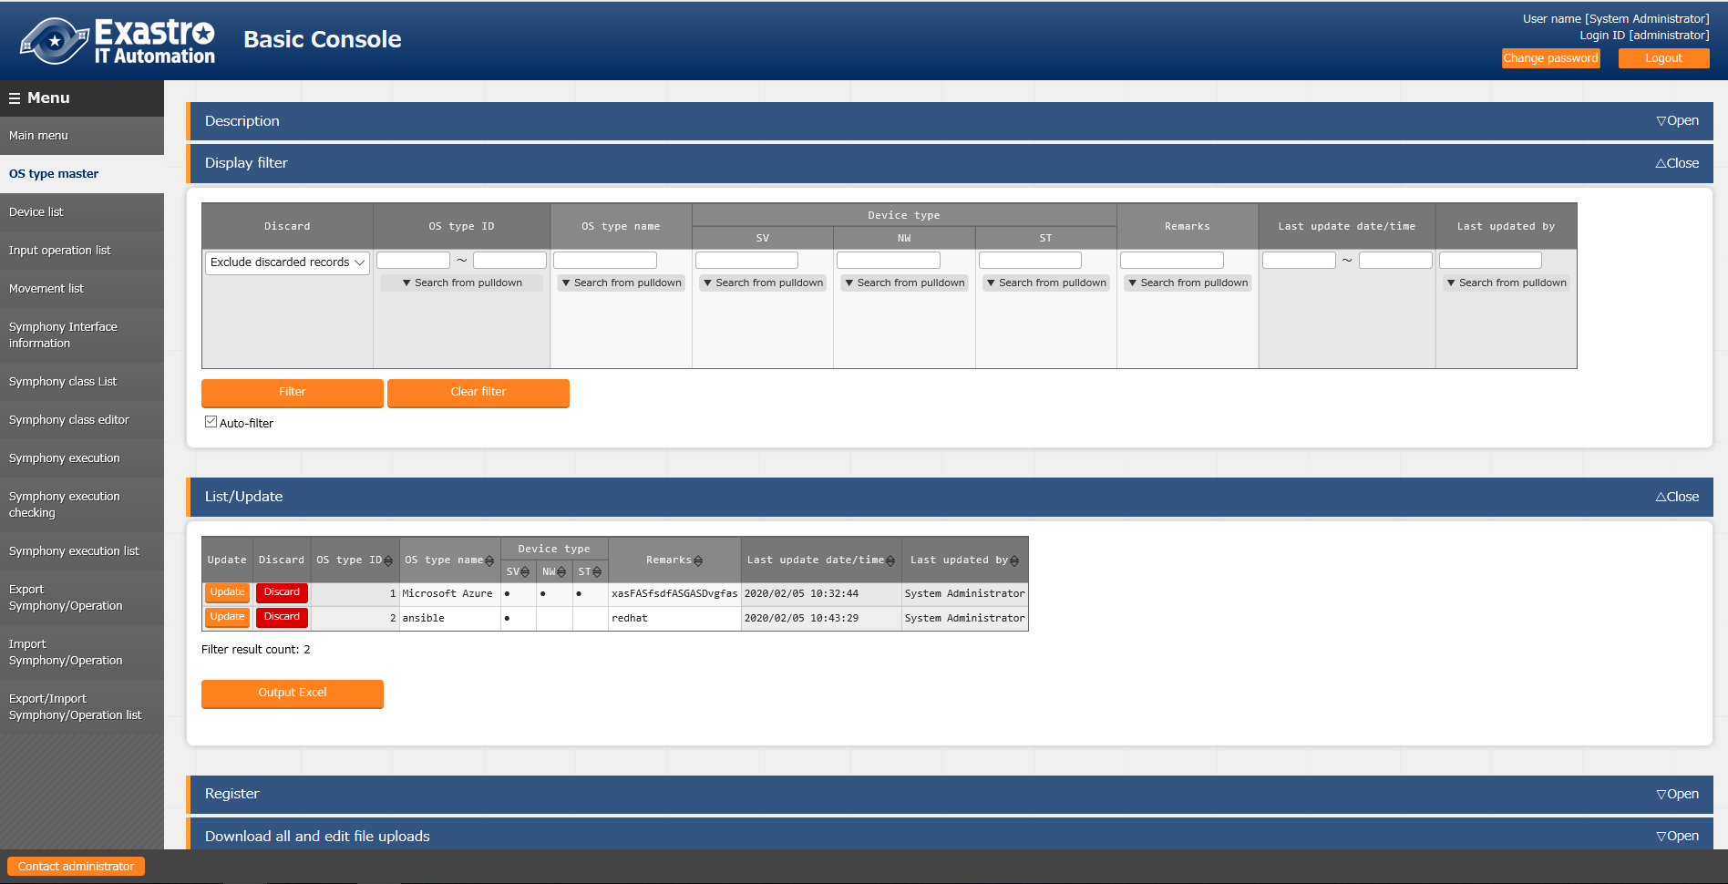

Figure 4.1-1 Submenu screen (OS type master)

Click [Registration]-[Start Registration] button to register OS information.



Figure 4.1-2 Registration screen (OS type master)

The list of items on the registration screen is as follows. Please make sure to register the OS type name.

Table 4.2-1 List of registration screen items (OS type master)

|  |  |  |  |  |  |
| --- | --- | --- | --- | --- | --- |
| **Item** | | **Description** | **Input**  **Required** | **Input type** | **Restrictions** |
| OS type ID | | A unique ID that identifies the registration information is automatically entered. | ○ | Autofill | - |
| OS type name | | Enter the name of the desired device. | ○ | Manual input | Maximum length 256 bytes |
| Device type | SV | Select [●] ,if the device type is a server | - | List selection | - |
| NW | Select [●], if the device type is a network device | - | List selection | - |
| ST | Select [●] ,if the device type is a storage device | - | List selection | - |
| Remarks | | Free description field | - | Manual input | - |

Device list

1. On the [Device List] screen, information on the target host is managed. Please register the required information according to the server type before running each orchestrator. Also, if the server information has been changed when re-executing, change the server information in advance.

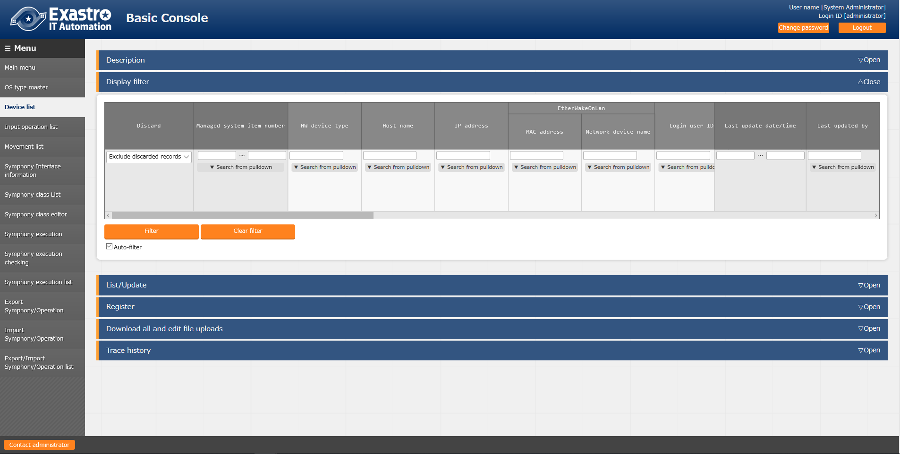

Figure 4.1-3 Submenu screen (device list)

1. Click [Registration]-[Start Registration] button to register device information.

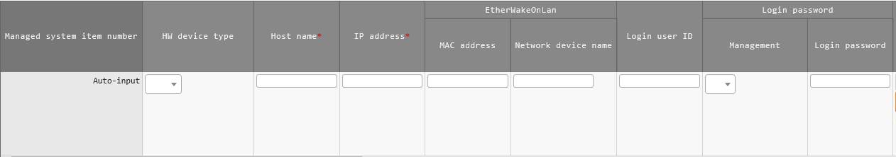

Figure 4.1-4 Registration screen (device list-common items)

1. The list of common items on the registration screen is as follows.

Please make sure to enter the target [Host name] and [IP address].

※Registration is required if “Login password” is "●" for “Management”.

**Table 4.2-2 List of Registration Screen Items (Device List-Common Items)**

|  |  |  |  |  |  |
| --- | --- | --- | --- | --- | --- |
| **Item** | | **Description** | **Input**  **Required** | **Input** **type** | **Restrictions** |
| Managed system item number | | A unique ID that identifies the registration information is automatically entered. | - | Autofill | - |
| HW device type | | Select the type of HW device | - | Manual input | Maximum length 128 bytes |
| Host name | | Enter the host name | ○ | Manual input | - |
| IP address | | Enter the IP address (xxx.xxx.xxx.xxx format). | ○ | Manual input | Maximum length 15 bytes |
| EtherWakeOnLan | MAC  address | Enter MAC address | - | Manual input | Maximum length 17 bytes |
| Network device name | Enter the network device name | - | Manual input | Maximum length 256 bytes |
| Login user ID | | Enter the user ID to log in. | - | Manual input | Maximum length 30 bytes |
| Login password | Management | Select 「●」to manage the password in ITA | - | List selection | - |
| Login passwords | Specify a password | ※ | Manual input | Maximum length 30 bytes |
| ssh authentication key file | | Enter the key file when performing key authentication by specifying the ssh authentication key file. Provide a key file that can be authenticated by the root user. | - | File selection | Maximum size 10K bytes |
| Remarks | | Free description field | - | Manual input | - |

1. In addition to the common items, information is registered when using each Driver/orchestrator. For details on each Driver, Please refer to the usage instruction for each driver.
2. Ansible Dedicated information

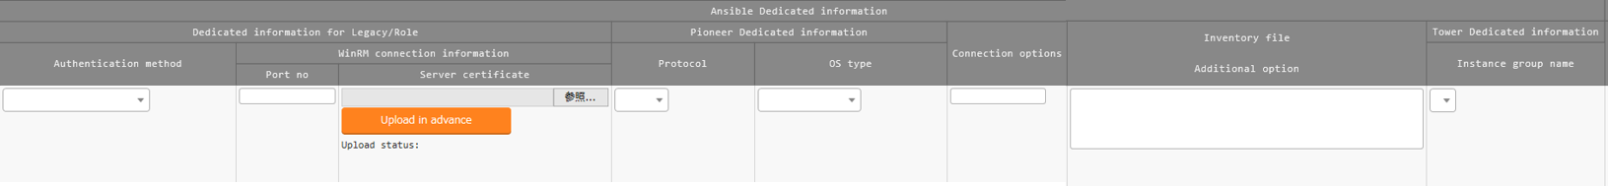

Figure 4.1-5 Registration Screen (Device List-Ansible)

* Ansible Dedicated information is a required parameter for Ansible driver.
* For more details, Please refer to “Usage Instruction_Manual_Ansible-driver”.

### Associated menu

1. Register/Update/Discard the menu of CMDB that is associated by the substitution value auto registration setting in associated menu.  
   ※This is an optional function that can be associate when the CMDB is customized。This function can’t be used on default.

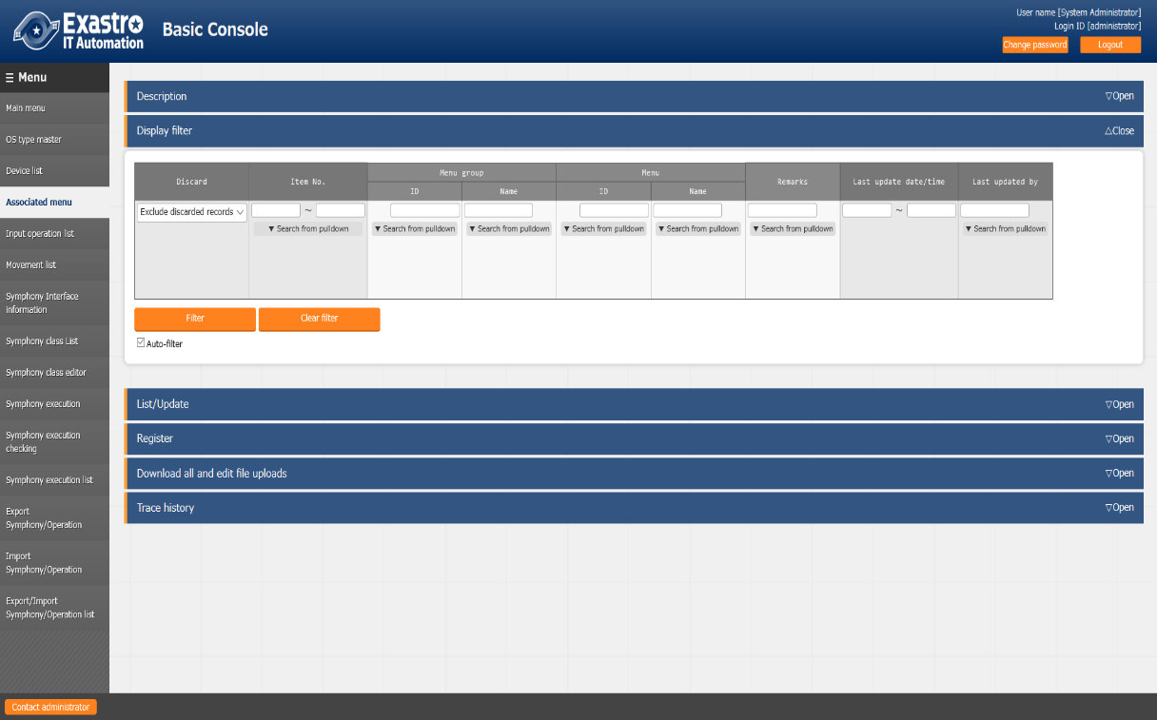

**Figure 4.1-6 Submenu screen (Associated menu)**

1. Click [Registration]-[Registration start] button to link/associate the menu.

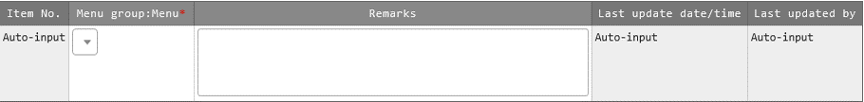

Figure 4.1-7 Registration screen (linking/Associated menu)

1. The list of items on the registration screen is as follows.

**Table 4.2-3 List of registration screen items (associated menu)**

|  |  |  |  |  |
| --- | --- | --- | --- | --- |
| **item** | **Description** | **Input**  **Required** | **Input Type** | **Restrictions** |
| Menu group:Menu※2 | The CMDB menu is displayed. Select the menu of CMDB to be associate with the substitution value automatic registration setting. | ○ | List selection | - |
| Remarks | Free description field | - | Manual input | Maximum length 4000 bytes |

※2 Registration of CMDB menu group and menu is required

Please refer to [User Instruction Manual_Management Console] for the registration of menu group and menu of CMDB.

Input operation list

1. In the [Input operation list] screen, the operations for the target host to be executed by the orchestrator are managed.

(Example) [Service additional construction work] etc.

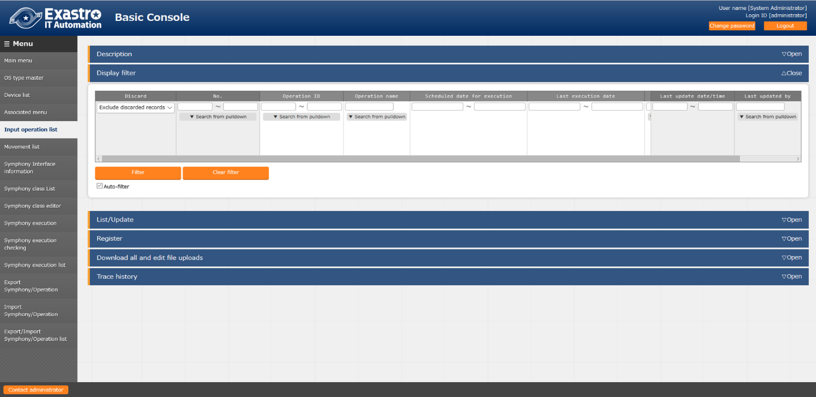

**Figure 4.1-8 Submenu screen (list of input operations)**

1. Click [Registration]-[Registration start] button to register the operation information.



Figure 4.1-9 Registration Screen (List of Input Operations)

1. The list of items on the registration screen is as follows.

**Table 4.2-4 List of registration screen items (input operation list)**

|  |  |  |  |  |
| --- | --- | --- | --- | --- |
| **item** | **Description** | **Input**  **required** | **Input type** | **Restrictions** |
| Operation name | Register desired operation name | ○ | Manual input | Maximum length 256 bytes |
| Scheduled date for executions | Enter the scheduled date and time of the operation.  ※The process is not actually executed on the date specified here.  ※The work history associated with the operation for which the scheduled execution date and time is set is automatically deleted after the specified reservation period. | ○ | Manual input | - |
| Operation ID | The system automatically inputs a unique ID that identifies the operation. | - | Autofill | - |
| Last execution date | Displays the actual date and time when the operation is selected for Symphony execution or each driver's work execution. | - | Display item | Blank is displayed for unexecuted operations. |
| Remarks | Free description field | - | Manual input | - |

Movement list

1. In the [Movement list] screen, you can see the association of the Movement with the orchestrator when using the orchestrator (for reference only).

For the actual registration of Movement, please refer to the instruction manual of each Driver and go to the console menu of the ITA driver of each orchestrator.

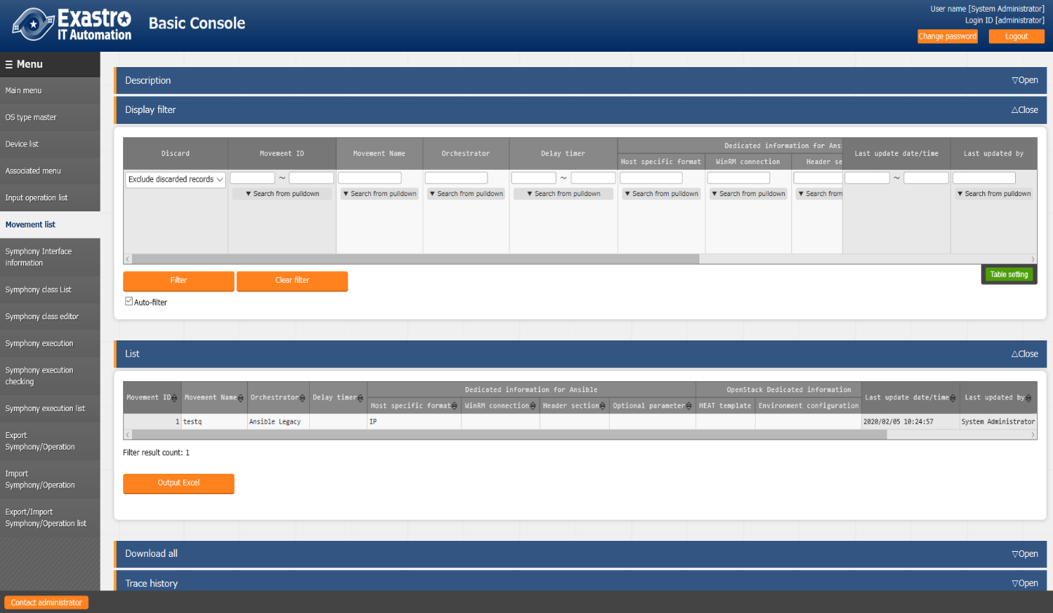

**Figure 4.1-10 Submenu screen (Movement list)**

Symphony interface information.

1. In the [Symphony Interface Information] screen, set the directory path shared by each Movement executed from Symphony and the refresh interval of the [Symphony execution check] screen

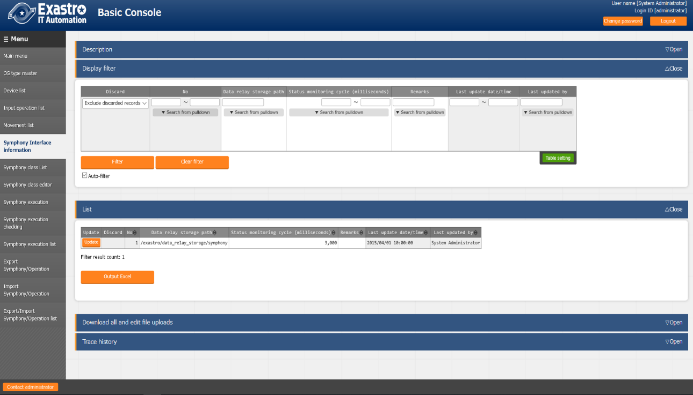

**Figure 4.1-11 Submenu screen (Symphony interface information)**

1. The list of items on the screen is as follows.

**Table 4.2-5 List of registration screen items (input operation list)**

|  |  |  |  |  |
| --- | --- | --- | --- | --- |
| **item** | **Description** | **Input**  **Required** | **Input Type** | **Restrictions** |
| Data relay storage path | When executing Symphony, enter the directory shared by each Movement with the directory path viewed from the ITA server. For the path viewed from each driver, Refer to the interface information in the instruction manual for each driver. Drivers that can share the directory are as follows.  ・Ansible  ・Ansible-Tower  ・DSC | ○ | Manual input | Maximum length 128 bytes |
| Status monitoring cycle (unit: millisecond) | Enter the interval for refreshing the display of [4.3.9 Symphony execution]. Generally, about 3000 milliseconds is the recommended value. | ○ | Manual input | Minimum value 1000ms |
|  | Free description field | - | Manual input | - |

Symphony class list

1. In the [Symphony Class List] screen, registered Symphony classes can be referred (Browse) or discarded.

Clicking the “Details” button in the list will redirect you to the edit screen [4.1.8 Edit Symphony class] of that Symphony class.

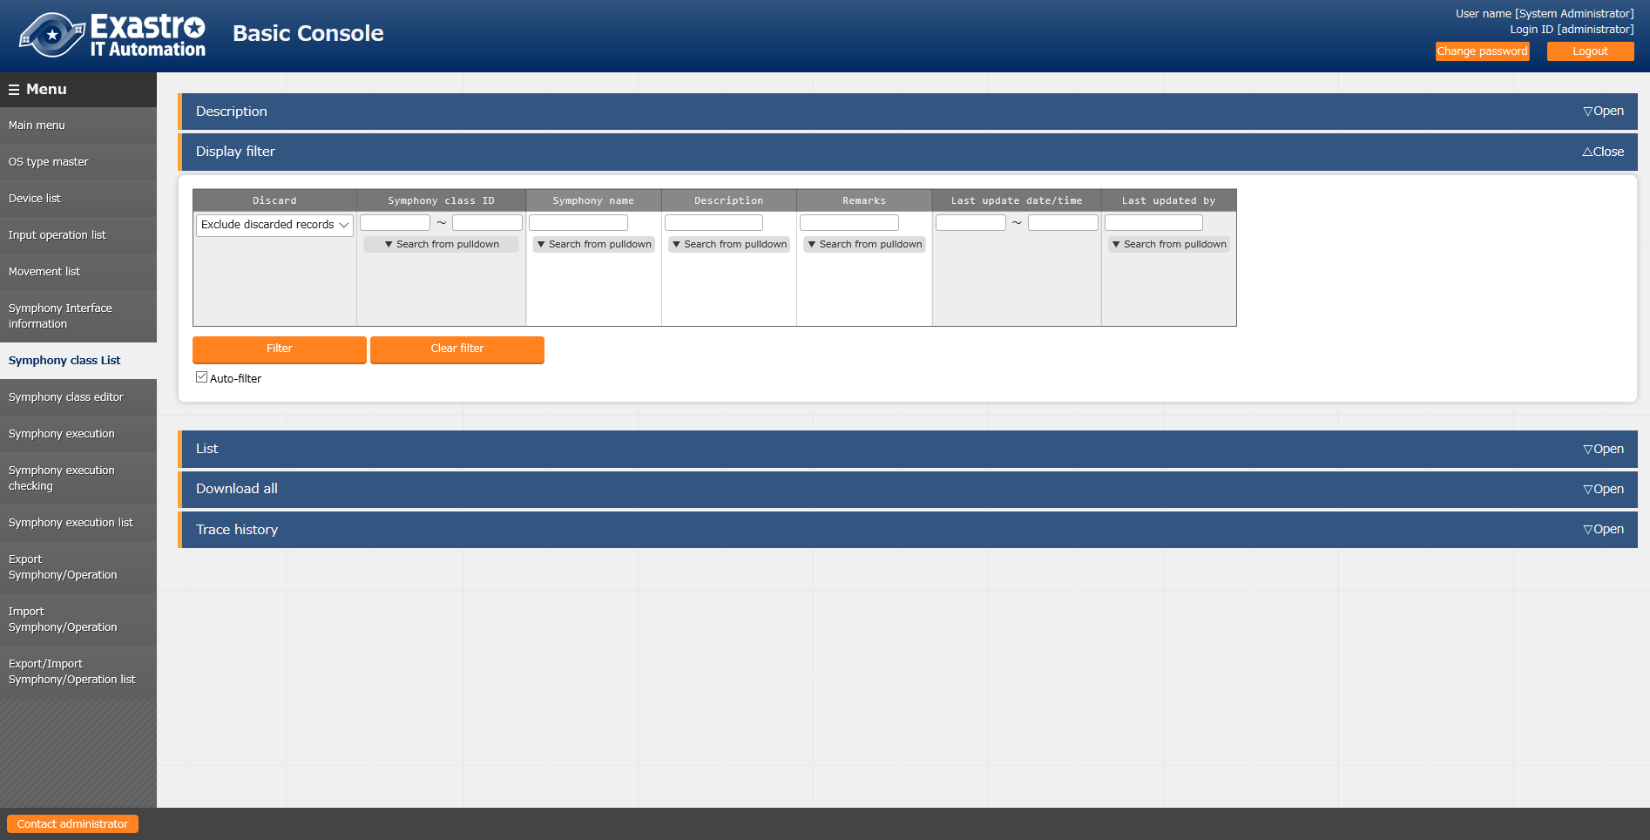

admin@nec.amc.jp

~

~

~

~

:set bin noeol

**Figure 4.1-12 Submenu screen (Symphony class list)**

Symphony class editor

1. In the [Symphony class editor] screen, register the Symphony class name and the Movement of the workflow.

admin@nec.amc.jp

~

~

~

~

:set bin noeol

* Registered Movement are displayed in the display filter area on the right side of the screen.
* Movement can be set by drag and drop from the display filter area on the right side of the screen.
* In the Movement flow editing area, you can swap the Movement by dragging and dropping.
* Paus can be set by the check box under the set Movement.
* In the “Description” column and the entry column under the name of the dropped Movement, users can note the processing description and comments. This information is a memo field that has no effect on the execution of the process and can be referenced only on the WEB.
* After setting the Movement flow, click the “Register” button to register the Symphony class.

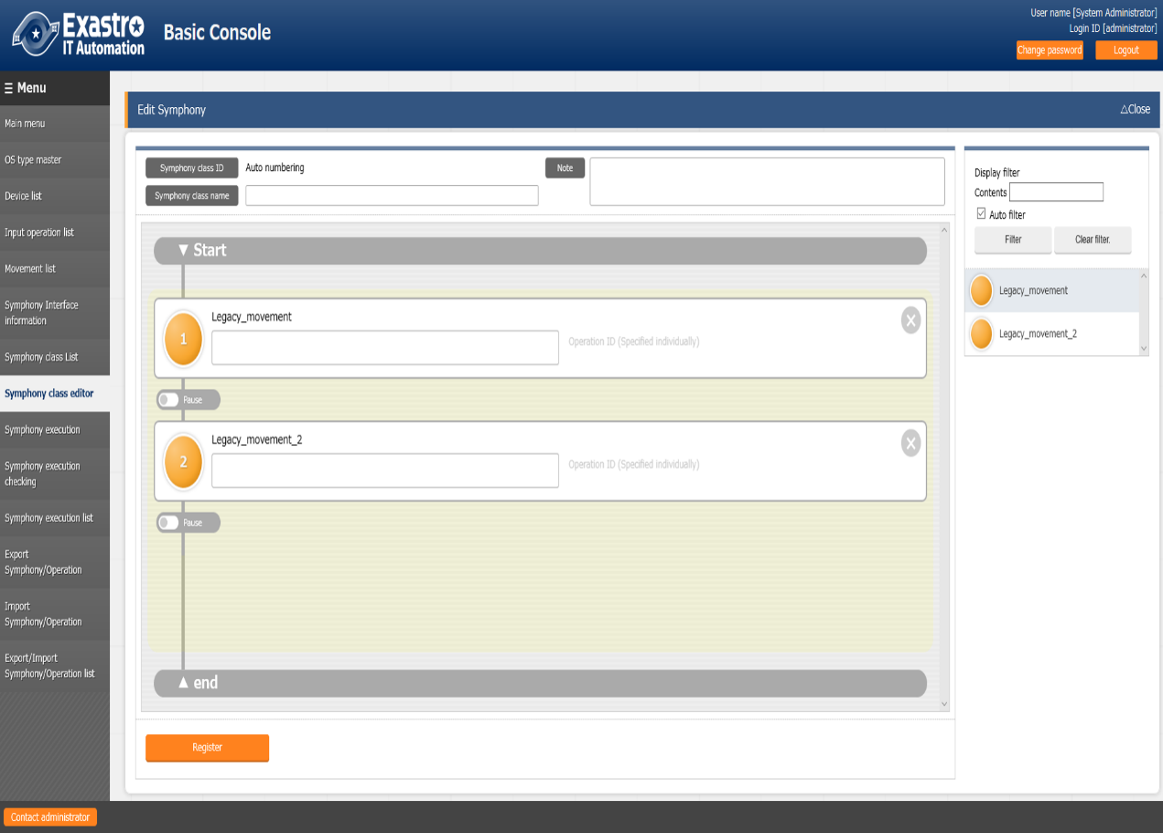

**Display filter area**

**Drag and drop the circle**

**Pause**

**Movement area**

**Figure 4.1-13 Submenu screen (Symphony class editor)**

The list of items on the Symphony class edit screen is as follows.

**Table 4.2-6 list of registration screen items(Symphony class editor）**

|  |  |  |  |  |
| --- | --- | --- | --- | --- |
| **item** | **Description** | **Input**  **Required** | **Input type** | **Restrictions** |
| Symphony class ID | A unique ID for Symphony is automatically assigned. | - | Autofill | - |
| Symphony class name | Enter desired Symphony class name | ○ | Manual input | - |
| Description | Enter a description or comment for the Symphony class | - | Manual input | - |
| Movement　Description field | Enter a description or comment for the Movement | - | Manual input | - |
| Operation ID (specified individually) | Enter the ID of the operation you want to specify individually. For details, refer to「4.1.9 Symphony execution」for specifying the operation ID individually. | - | Manual input | - |
| Pause | Check if users want to pause after executing the Movement | - | Checkbox | - |
| Delete | Delete Movement | - | button | - |

1. When registration is completed, the following screen will change to [Symphony class list] screen.

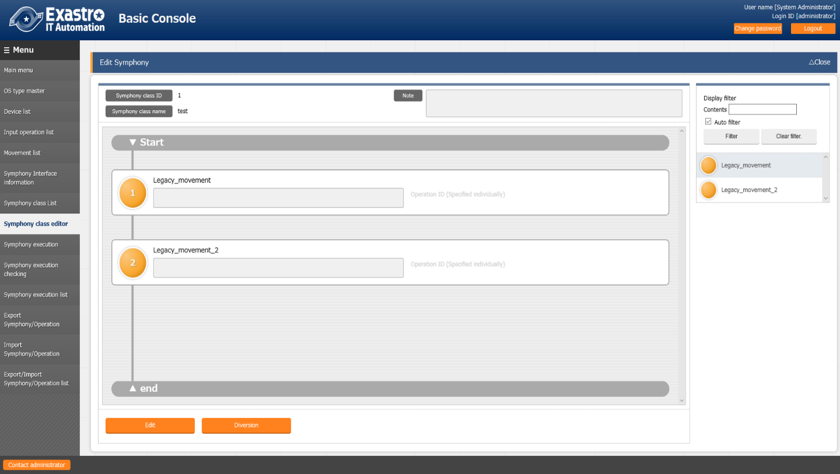

admin@nec.amc.jp

~

~

~

~

:set bin noeol

* Registered Symphony can be edited with the “Edit” button.

・　With the “Diversion” button, you can copy the registered Symphony and create a new one.]

1. If you click the “Edit” button, the following screen is displayed.

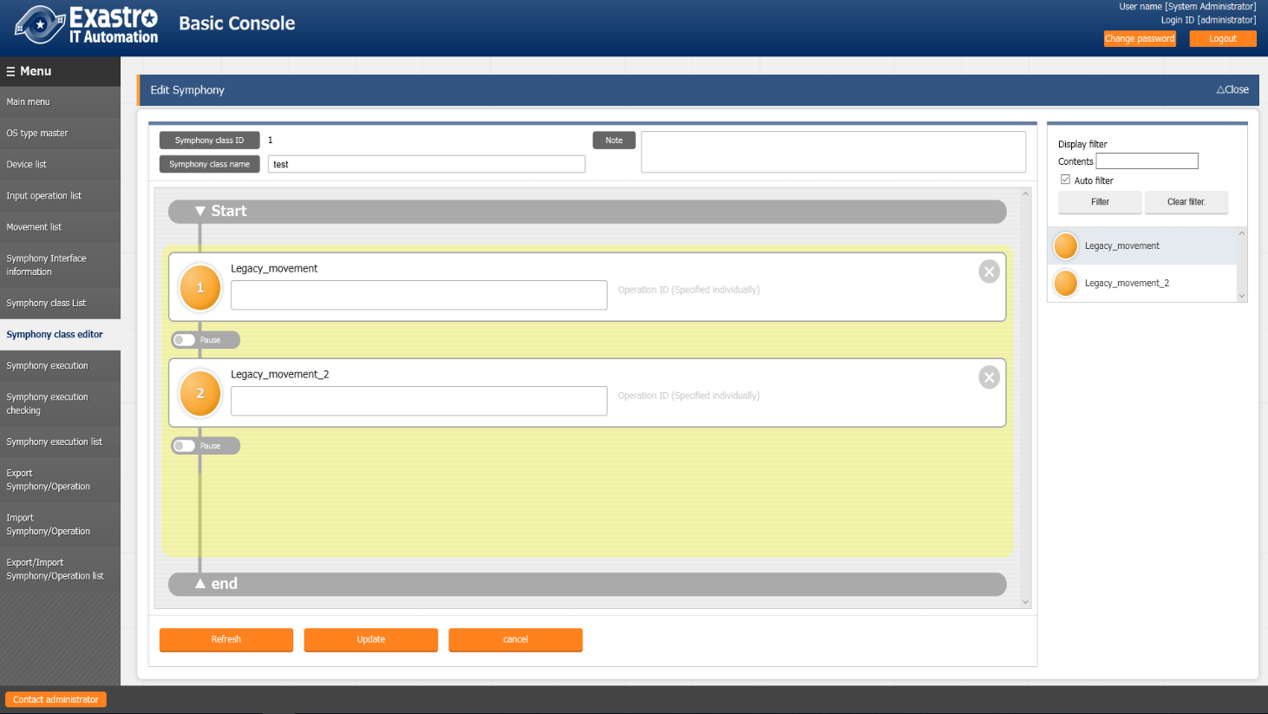

admin@nec.amc.jp

~

~

~

~

:set bin noeol

* Click the “Refresh” button to discard the edited contents and return to registered contents.

・　Click the “Update” button to save the edited content.

* Click the “Cancel” button to return to the state before pressing the “Edit” button.

Symphony execution

1. Instruct Symphony execution in the “Symphony execution” screen.

* In “Symphony [ list]”, the Symphony registered in 「4.1.7 Symphony List」 is displayed.
* In “Operation [list]” ,The Operations registered in 「4.14 List of input operations」 is displayed.
* Select from the radio buttons of “Symphony[list]” and “Operation[list]”, and press the “Execute button” to transit to 「4.1.10 Symphony execution check 」 and start tracing the execution.
* When you enter the scheduled date and time and press the “Execute” button, the work schedule is made. Users can check this in the 「4.1.11 Symphony list」。※The date and time earlier than the current time cannot be entered.
* If you check “□Skip” next to the Movement symbol the Movement will be skipped during execution.

**Figure 4.1-14 Submenu screen (Symphony execution checking)**

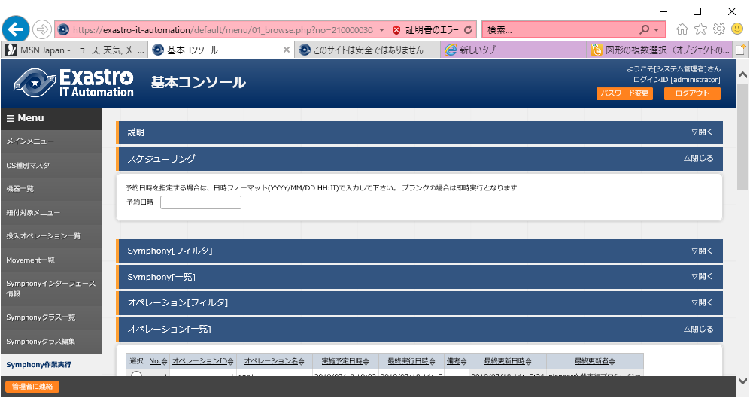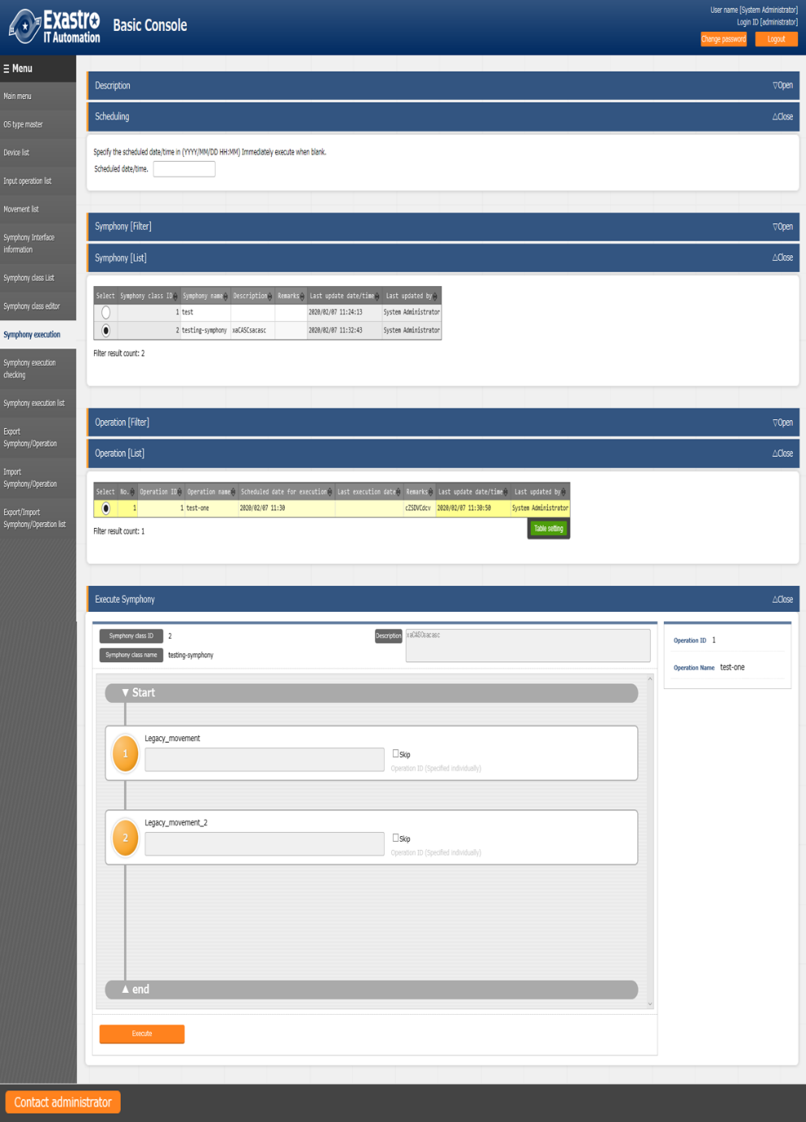

The list of common items on the Symphony execution screen is as follows.

**Table 4.2-7 List of registration screen items (Symphony execution)**

|  |  |  |  |  |
| --- | --- | --- | --- | --- |
| **item** | **Description** | **Input**  **Required** | **Input type** | **Restrictions** |
| Scheduled date and time | Specify the scheduled date and time of Symphony execution | - | Manual input | Date and time before the current time cannot be entered |
| Symphony[list] | The Symphony registered in 「4.1.7 Symphony class list」 will be displayed. | ○ | Radio buttons |  |
| Operation [List] | The operations registered in [4.1.4 List of input operations] will be displayed | ○ | Radio buttons |  |
| Skip | Check to skip the target operation | - | Checkbox |  |
| Operation ID（specified individually） | ※Refer to “Specifying the operation ID individually” below. | - | Manual input |  |
| Execute | Execute the registered Symphony | ○ | Button |  |

※About individual specification of operation ID

When you click on the operation ID (individual specification) in light character to display a text box.In this text box, you can enter an operation ID different from the operation ID of the operation specified by the radio button on the screen.

This allows users to assign “specific value” That is registered in another operation ID in the “substitution value management” menu of the orchestrator to which the Movement belongs (for example, in the “substitution value management” menu of the ITA Ansible-Legacy console).

The operation ID specified individually in the Symphony class edit screen can be saved by the Symphony register/update button

In addition, users can perform individual assignment in Symphony execution screen before execution, and also make further changes to the operation ID that has already been registered with the individual specification registration in the Symphony class editor menu then execute Symphony.

However, the operation ID specified individually on the Symphony execution screen is reflected only at the time of execution, and the setting is not saved.

Please use it when you want to divert the same Movement and operate another server.

Symphony execution checking

1. On the [Symphony execution check] screen, the execution status of Symphony is displayed.

Click the “Details” button in [4.1.11 Symphony execution list] to monitor the processing status of the selected Symphony execution. Depending on the situation, “unhold” and “emergency stop” can be executed.

In addition, users can move to each execution status checking screen by clicking the circle of the Movement flow.

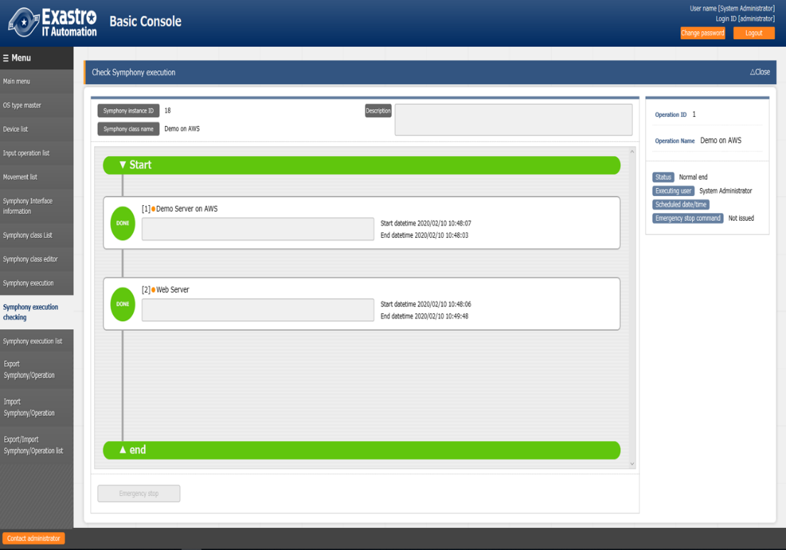

**Figure 4.1-15 Submenu screen (Symphony execution check)**

In addition, if the selected Symphony operation has a scheduled date and time, but has not yet been executed, the schedule cancellation button is displayed. If you click the schedule cancellation button, the status that can be confirmed in 「4.1.11 Symphony Work List 」 will becomes “Schedule cancellation” and it will not be executed.

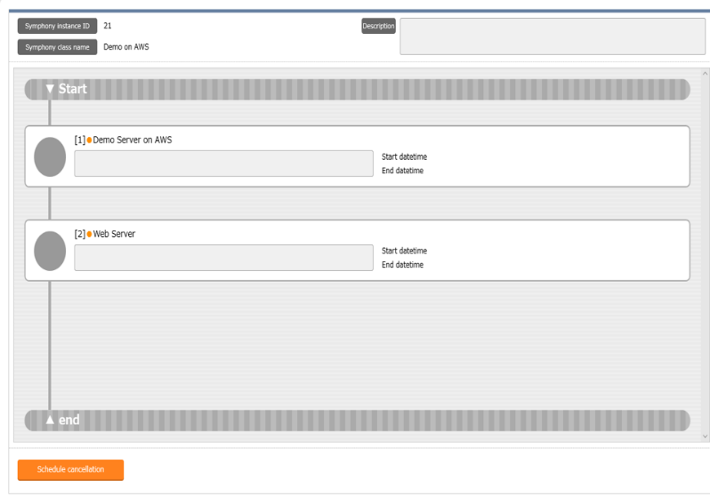

**Figure 4.1-16 Submenu screen (Symphony execution check-Schedule cancellation)**

The list of common items for Symphony work confirmation is as follows.

**Table 4.2-8 List of registration screen items (Symphony execution check)**

|  |  |  |  |  |
| --- | --- | --- | --- | --- |
| **item** | **Description** | **Input Required** | **Input Type** | **Restrictions** |
| Unhold | Unhold target Movement | - | button | - |
| Emergency stop | Stop Symphony execution | - | button | - |
| Schedule cancellation | Cancel Symphony execution schedule | - | button | Displayed when the reservation date and time has been set and not been executed |

Symphony execution list

1. In the [Symphony execution list] screen, the executed Symphony is managed. When user specify criteria and click the “Filter” button, the operation list table and graph are displayed.

When you move the mouse cursor over each graph, the download button of the graph is displayed in the upper right corner. It is possible to download the graph by clicking the download button of displayed graph.

When the “Details” button in the execution display column is clicked, the screen will move to 「4.1.10 Symphony」 screen.

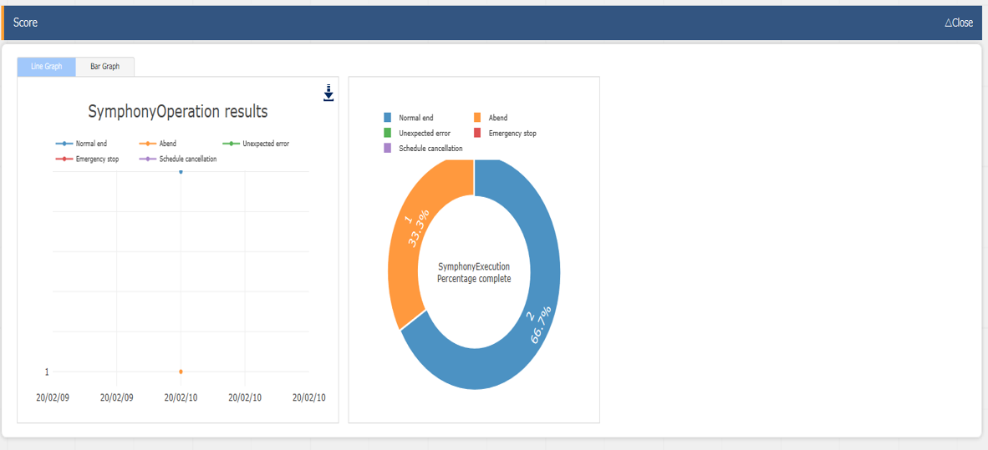

**Figure 4.1-17 Submenu screen (Symphony execution list)**

Export Symphony/ Operation

Specify Symphony or operation and export the data associated with it.

For information about the associated data, please refer “6.1” about the data that can be retrieved by “「Export Symphony/Operation」”.

This function is assumed to be used for exporting data from one ITA environment and then importing the data into another ITA environment.

While [Management Console] - [Export menu] exports the data of the whole menu, this function exports the associated data unit.

1. Select the Symphony and operation user’s wants to export and click the “Export” button.

**Figure 4.1-18 Submenu-screen (Export Symphony/Operation①)**

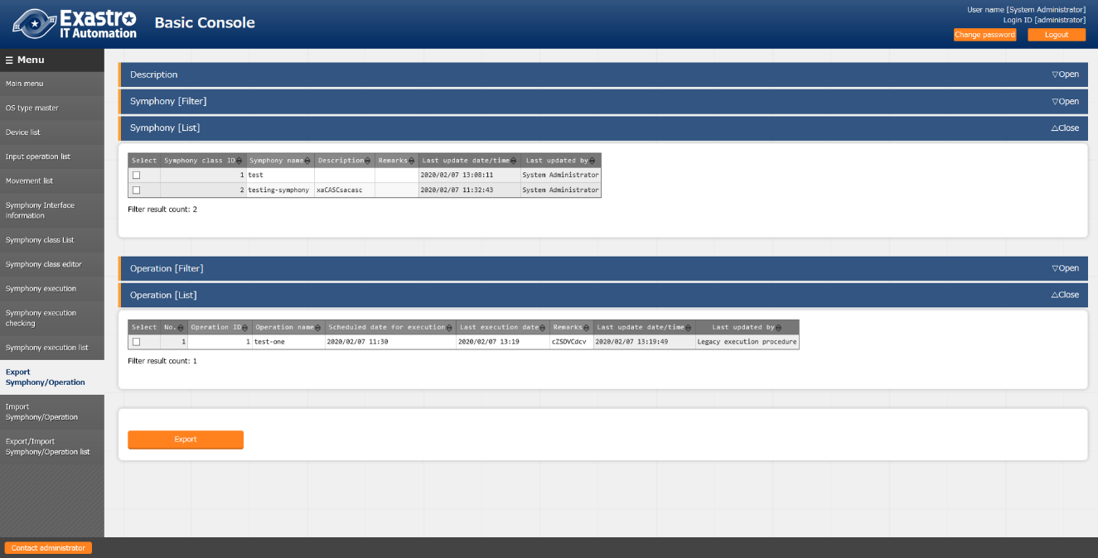

1. Transit to the reception completion screen. Click the 「Export/Import Symphony/Operation list」 button, then the screen moves to the 「Export/Import Symphony/Operation list」 menu. For export status, Users can check and get export data.

**Figure 4.1-19 Submenu screen (Export Symphony/Operation②)**

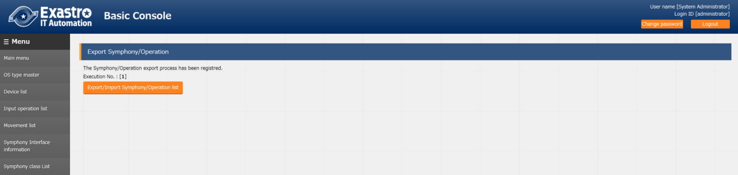

Import Symphony/Operation

Import the data which is exported from [Export Symphony / Operation] menu.

※The data to be imported is imported using the unique item of the data as a key (the numerical value at the left end of the table).If data of the same unique item already exists, data will be overwritten.

※The last modified person of the data after the import will be the user who executed the import.

※For example, in this function it is assumed that data registered in the A environment is exported, and imported into the B environment to execute work. If users edit the data after importing into the B environment, each function may not work properly.

1. Select the file you want to import and press the “Upload” button.

**Figure 4.1-20 Submenu screen (Import Symphony/Operation ①)**

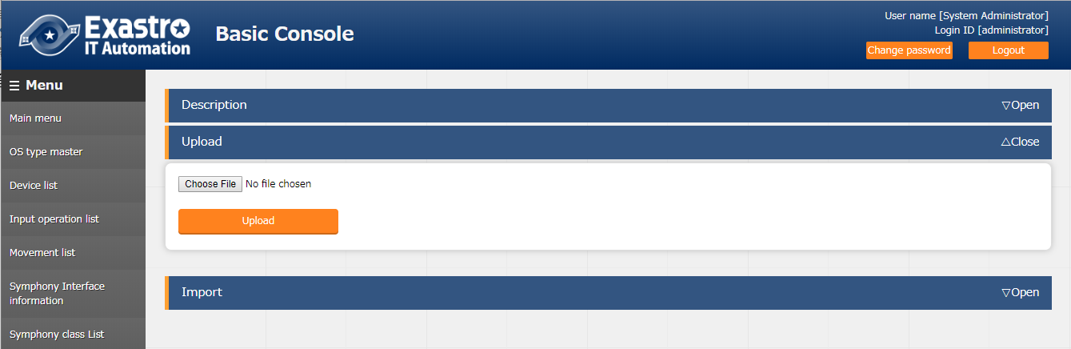

1. Displays a list of Symphony and operations in the imported file. Select the Symphony and operations you want to import and press the “Import” button.

**Figure 4.1-21 Submenu Screen (Import Symphony/Operation ②)**

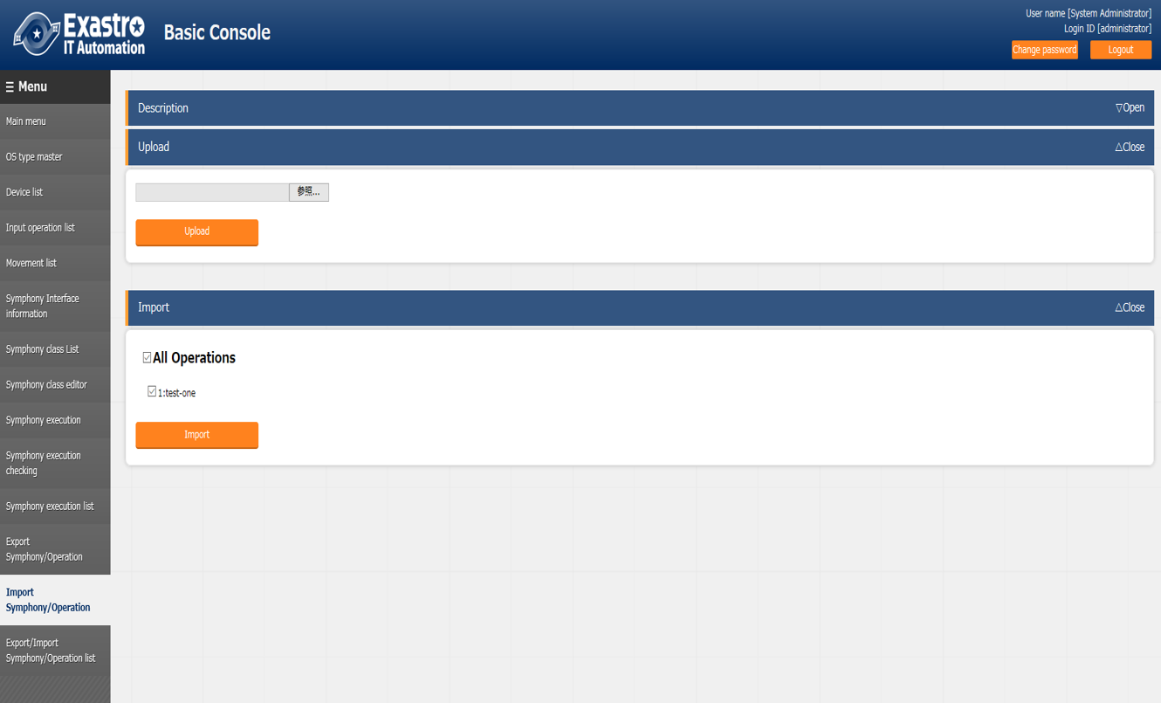

1. Transit to the reception completion screen. Click the 「Export/Import Symphony/Operation list」 button will take you to the 「Export / Import Symphony/Operation list」 menu, where status of import can be checked.

**Figure 4.1-22 Submenu Screen (Import Symphony /Operation③)**

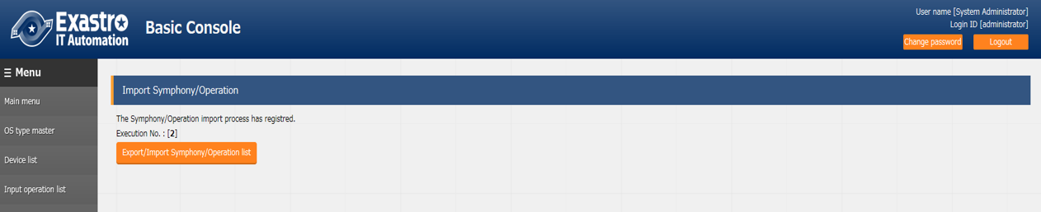

Export / Import Symphony/Operation list

Manages the status of exports performed with the [Export Symphony /Operation] menu and the status of imports performed with the [Import Symphony /Operation] menu.

The status changes in the order of “Unexecuted”, “Executing” and “Completed”.The processing type displays 「Export」or 「Import」.In the case of Export , the Export data will be displayed when the file name is 「Completed」, please download and use it. In the case of import, the imported data is displayed.

Remarks displays the ID of selected Symphony and operation.

**Figure 4.1-23 Submenu screen (Export / Import Symphony /Operation list)**

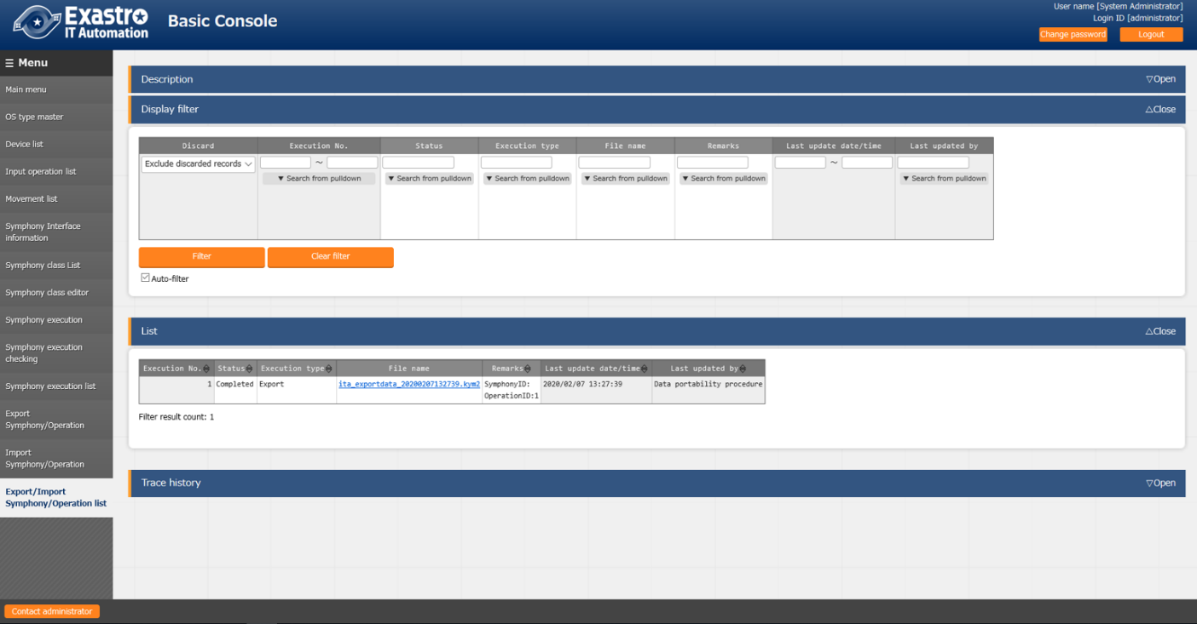

The list of items on the screen is as follows.

**Table 4.2-9 List screen item list (Export / Import Symphony /Operation list)**

|  |  |
| --- | --- |
| **item** | **Description** |
| Execution No. | A unique ID is automatically assigned. |
| Status | Changes in the order of “Unexecuted”, “Executing” and “Completed”. If an error occurs, the column will be “Completed” (abnormal). |
| Execution type | Export ・・・Export Symphony / Operation  Import ・・・ Import Symphony / Operation |
| File name | In the case of Export, the export data will be displayed when “Completed”, so please download and use it. In the case of import, the imported data is displayed, the remarks. |
| Remarks | Displays the selected Symphony and operation ID |

# Operation notes



## Routine deletion of operation work history.

The function to delete the data associated with the scheduled date and time of the operation that is registered in the 「input operation list」 menu is available.

Please refer to 「User Instruction Manual_Management Console」 for details.

# Remarks

## About the data that can be retrieved by Export Symphony /Operation

The data acquired by Export Symphony /operation is retrieved by following the linked menu .The link of each menu is as follows.

### Symphony Export

|  |
| --- |
| **Movement details** |
| (PK)Associated item No. |
| Movement |
| Playbook file |
| ・・・ |

|  |
| --- |
| **Template list** |
| (PK) file ID |
| Template embedded variable name |
| ・・・ |

|  |
| --- |
| **Template list** |
| (PK) file ID |
| Template embedded variable name |
| ・・・ |

|  |
| --- |
| **File list** |
| (PK) file ID |
| File embedded variable name |
| ・・・ |

**Ａｎｓｉｂｌｅ-Legacy**

**The specified SymphonyID**

Hidden menu

|  |
| --- |
| **Movement variable association list** |
| (PK)Associated item No. |
| Movement |
| Variable name |
| ・・・ |

Hidden menu

|  |
| --- |
| **variable name list** |
| (PK) number |
| ・・・ |

１:playbook

|  |
| --- |
| **Symphony class list** |
| Symphony class ID |
| ・・・ |

|  |
| --- |
| **Movement list** |
| (PK)MovementID |
| ・・・ |
|  |
|  |
|  |
|  |
|  |

|  |
| --- |
| **Playbook file** |
| (PK) file ID |
| Playbook file |
| ・・・ |

Hidden menu

|  |
| --- |
| **List of common variables usage** |
| (PK)No |
| File Type |
| Primary key |
| Variable name |
| ・・・ |

|  |
| --- |
| **Global variable list** |
| (PK) number |
| Global variable name |
| ・・・ |

|  |
| --- |
| **File list** |
| (PK) file ID |
| File embedded variable name |
| ・・・ |

**Ａｎｓｉｂｌｅ-Pioneer**

**Ａｎｓｉｂｌｅ-LegacyRole**

**DSC**

**OpenStack**

Hidden menu

|  |
| --- |
| **Movement associated with Symphony list** |
| (PK)Movement Class ID |
| Symphony Class No |
| Movement ID |
| ・・・ |

**Ａｎｓｉｂｌｅ-Pioneer**

|  |
| --- |
| **Movement details** |
| (PK)Associated item No. |
| Movement |
| Dialogue type |
| ・・・ |

|  |
| --- |
| **Dialog files** |
| (PK)file ID |
| Dialogue type |
| OS type |
| ・・・ |

|  |
| --- |
| **Dialogue type list** |
| (PK) Item No. |
| Dialogue type |
| ・・・ |

Hidden menu

|  |
| --- |
| **Movement variable association list** |
| (PK) associate item number |
| Movement |
| Variable name |
| ・・・ |
| 変数名 |
| ・・・ |

1: Dialogue file

Hidden menu

|  |
| --- |
| **Variable name list** |
| (PK) Item No. |
| ・・・ |

Hidden menu

|  |
| --- |
| **List of common variables usage** |
| (PK)No |
| File Type |
| Primary key |
| Variable name |
| ・・・ |

|  |
| --- |
| **OS type master** |
| (PK)OS type ID |
| ・・・ |

|  |
| --- |
| **Global variable list** |
| (PK) Item No. |
| Global variable name |
| ・・・ |

|  |
| --- |
| **Template list** |
| (PK) file ID |
| Template embedded variable name |
| ・・・ |

|  |
| --- |
| **File list** |
| (PK) file ID |
| File embedded variable name |
| ・・・ |

|  |
| --- |
| **Template list** |
| (PK) file ID |
| Template embedded variable name |
| ・・・ |

|  |
| --- |
| **File list** |
| (PK) file ID |
| File embedded variable name |
| ・・・ |

|  |
| --- |
| **Movement list** |
| (PK)Movement ID |
| ・・・ |

**Ａｎｓｉｂｌｅ-LegacyRole**

|  |
| --- |
| **Movement details** |
| (PK)Associated item No. |
| Movement |
| Role package name |
| ・・・ |

|  |
| --- |
| **Role package management** |
| (PK) Item No. |
| ・・・ |

Hidden menu

|  |
| --- |
| **Role name management** |
| (PK) Item No |
| Role package name |
| ・・・ |

Hidden menu

|  |
| --- |
| **List of common variables usage** |
| (PK)No |
|  |
| File Type |
| Primary key |
| Variable name |
| ・・・ |

|  |
| --- |
| **Global variable list** |
| (PK) Item No |
| Global variable name |
| ・・・ |

|  |
| --- |
| **Template list** |
| (PK) Template ID |
| Template embedded variable name |
| ・・・ |

|  |
| --- |
| **File list** |
| (PK) Template ID |
| File embedded variable name |
| ・・・ |

|  |
| --- |
| **Template management** |
| (PK) file ID |
| Template embedded variable name |
| ・・・ |

|  |
| --- |
| **File management** |
| (PK) file ID |
| File embedded variable name |
| ・・・ |

Hidden menu

|  |
| --- |
| **Role variable name list** |
| (PK) Item No |
| Role package name |
| ・・・ |

Hidden menu

|  |
| --- |
| **Movement variable association list** |
| (PK) associate item number |
| Movement |
| variable name |
| ・・・ |

Hidden menu

|  |
| --- |
| **Variable specific value list** |
| (PK) Item No |
| Roll package |
| ・・・ |

Hidden menu

|  |
| --- |
| **Variable name list** |
| (PK) Item No |
| ・・・ |

Hidden menu

|  |
| --- |
| **List of substitution variables** |
| (PK) Item No |
| Role package |
| ・・・ |

Hidden menu

|  |
| --- |
| **Member variable list** |
| (PK) Item No |
| Array variable name |
| ・・・ |

|  |
| --- |
| **Nested variable maximum iteration count list** |
| (PK) Item No |
| Member variable name (iteration ) |
| ・・・ |

Hidden menu

|  |
| --- |
| **Nested variable array combination list** |
| (PK) Item No |
| variable name |
| ・・・ |

Hidden menu

|  |
| --- |
| **Nested variable member list** |
| (PK) Item No |
| variable name |
| ・・・ |

3:Roll pack

|  |
| --- |
| **Movement list** |
| (PK)Movement ID |
| ・・・ |

|  |
| --- |
| **Movement details** |
| (PK) Associated item No. |
| Movement |
| Config file |
| Ｐｏｗｅｒｓｈｅｌｌ file |
| Ｐaram file |
| Import file |
| Config data file |
| Compile option file |
| ・・・ |

|  |
| --- |
| **Config files** |
| (PK) file ID |
| Config file |
| ・・・ |

|  |
| --- |
| **Material information management** |
| (PK) Credential ID |
| Credential embedded variables |
| ・・・ |

Hidden menu

|  |
| --- |
| **PowerShell files** |
| (PK) file ID |
| ・・・ |

Hidden menu

|  |
| --- |
| **Param files** |
| (PK) file ID |
| ・・・ |

**DSC**

Hidden menu

|  |
| --- |
| **Import files** |
| (PK) file ID |
| ・・・ |

Hidden menu

|  |
| --- |
| **Config data file** |
| (PK) file ID |
| ・・・ |

Hidden menu

|  |
| --- |
| **Compile option files** |
| (PK) file ID |
| ・・・ |

Hidden menu

|  |
| --- |
| **Movement** **variable association list** |
| (PK) associated item number |
| Movement |
| Variable name |
| ・・・ |

Hidden menu

|  |
| --- |
| **Variable name list** |
| (PK) item number |
| ・・・ |

無し

|  |
| --- |
| **Movement list** |
| (PK)Movement ID |
| ・・・ |

|  |
| --- |
| **Movement list** |
| (PK)Movement ID |
| ・・・ |

**OpenStack**

### Export operation

**The specified Operation ID**

|  |
| --- |
| **Input operation list** |
| (PK)No |
| ・・・ |

|  |
| --- |
| **Target host** |
| (PK) Item no |
| オペレーション |
| ホスト |
| ・・・ |

|  |
| --- |
| **Substitution value list** |
| (PK) Item no |
| Operation |
| Specific value |
| ・・・ |

|  |
| --- |
| **Device list** |
| (PK) Managed system item number |
| ・・・ |

|  |
| --- |
| **Template management** |
| (PK) file ID |
| Template embedded variable name・ |
| ・・・ |

|  |
| --- |
| **File management** |
| (PK) file ID |
| File embedded variable name・ |
| ・・・ |

**Ansible-Legacy**

**Ansible-Pioneer**

|  |
| --- |
| **Target host** |
| (PK) Item no |
| Operation |
| Host |
| ・・・ |

|  |
| --- |
| **Substitution value list** |
| (PK) Item no |
| Operation |
| Specific value |
| ・・・ |

|  |
| --- |
| **Device list** |
| (PK) Managed system item number |
| OS type |
| ・・・ |

|  |
| --- |
| **Template management** |
| (PK) file ID |
| Template embedded variable name |
| ・・・ |

|  |
| --- |
| **File management** |
| (PK) file ID |
| File embedded variable name・ |
| ・・・ |

|  |
| --- |
| **OS type master** |
| (PK) OS type ID |
| ・・・ |

**Ａｎｓｉｂｌｅ-LegacyRole**

**DSC**

**OpenStack**

**Ａｎｓｉｂｌｅ-LegacyRole**

|  |
| --- |
| **Substitution value list** |
| (PK) item No. |
| Operation |
| Specific value |
| ・・・ |

|  |
| --- |
| **Target host** |
| (PK) item No |
| Operation |
| Host |
| ・・・ |

|  |
| --- |
| **Device list** |
| (PK) Management system for item number |
| ・・・ |

|  |
| --- |
| **Template list** |
| (PK) file ID |
| Template embedded variable name |
| ・・・ |

|  |
| --- |
| **File list** |
| (PK) file ID |
| File embedded variable name |
| ・・・ |

**DSC**

|  |
| --- |
| **Target host** |
| (PK) item No. |
| Operation |
| Host |
| ・・・ |

|  |
| --- |
| **Substitution value list** |
| (PK) item No |
| Operation |
| ・・・ |

|  |
| --- |
| **Device list** |
| (PK) Management system for item number号 |
| ・・・ |

**OpenStack**

|  |
| --- |
| **Substitution value list** |
| (PK) item No. |
| Operation |
| Project |
| ・・・ |