

ITA_User Instruction Manual

Cobbler-driver

*－*Version 1.3*－*

Copyright © NEC Corporation 2019. All rights reserved.

Disclaimer

All the contents of this document are protected by copyright owned by NEC Corporation.

Unauthorized reproduction or copying of all or part of the contents of this document is prohibited.

The contents of this document are subject to change without prior notice in the future.

NEC Corporation is not responsible for any technical or editorial errors or omissions in this document.

NEC Corporation do not guarantee accuracy, usability, certainty of the content in this document.

Trademark

* Linux is registered trademark or trademark of Linus Torvalds, registered in the U.S. and other countries.
* Red Hat is registered trademark or trademark of Red Hat, Inc., registered in the U.S. and other countries.
* Apache, Apache Tomcat, Tomcat are registered trademarks or trademarks of Apache Software Foundation.
* Ansible is a registered trademark or trademark of the Red Hat, Inc.

The names of other systems, company name and products mentioned in this document are registered trademarks or trademarks of their respective companies.

The ® mark and TM mark is not specified in this document.

※「Exastro IT Automation」is written as 「ITA」 in this document.

# Table of Contents

Table of Contents 2

Introduction 3

1 Overview of Cobbler driver 4

1.1 About Cobbler 4

1.2 About Cobbler driver 5

2 Cobbler driver console menu configuration 6

2.1 Menu/Screen list 6

3 Cobbler operation procedure 7

3.1 WorkFlow 7

3.1.1 The installation workflow using Cobbler 7

4 Cobbler driver function・operation method explanation 10

4.1 Basic console 10

4.1.1 Device list 10

4.2 Cobbler Driver console 12

4.2.2 Interface information 12

4.2.3 Profile list 14

5 Execute installation 15

5.1 Mechanism of installation 15

5.2 Start installation 15

6 Notes of applicational operation 17

6.1 The data relay storage path file on Cobbler server side 17

6.2 Change log level 17

6.3 About the maintenance method 18

6.3.1 Start/Stop/Restart Cobbler driver Back yard process 18

6.4 Download bootloader file 18

7 Troubleshooting 19

Introduction

This document explains the function and the operation method of ITA system.

# Overview of Cobbler driver

This chapter explains Cobbler and Cobbler Driver.

## About Cobbler

Cobbler is a tool that automates OS installation  
By registering installation media and the kickstart file that describes the configuration information during installation on the Cobbler server and distributing the files to devices that connected with network, performing network installation is possible. Installation of operation system becomes more effeciently by utilizing Cobbler.

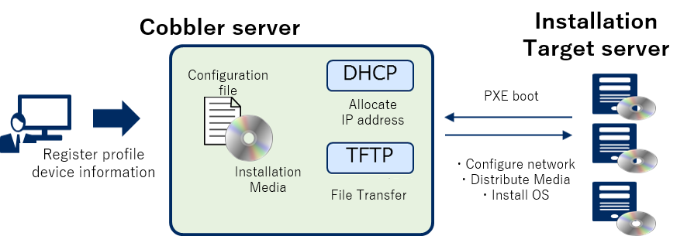

**Figure 1.1-1 Overview of Cobbler system**

Please refer to the information of Cobbler project from the Cobbler developer for the details of Cobbler and Cobbler driver

## About Cobbler driver

Cobbler driver works as the optional function of ITA system and uses Cobbler to perform OS installation via network to the construction target server device registered in ITA system.

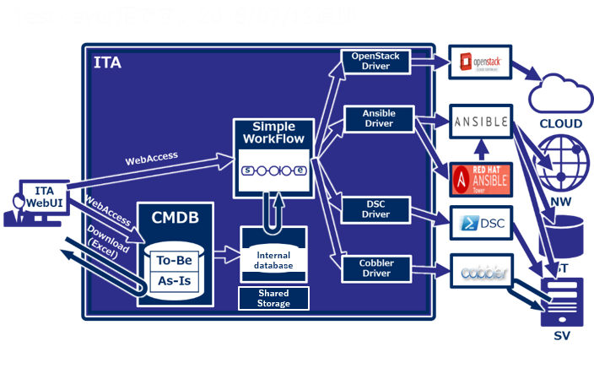

Figure 1.2-1 Overview of ITA system

* Image of utilizing Cobbler, ITA Cobbler Driver

The profile containing the OS installation media and the kickstart file of the installation settings is registered in Cobbler.

Users can view the profile information registered in the Cobbler and can associate the construction target device with profile information in the ITA Cobbler Driver.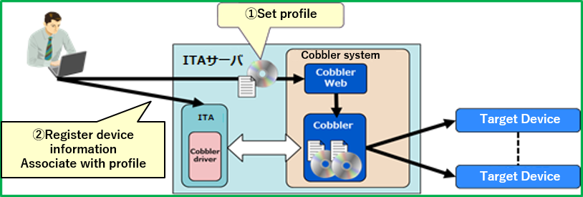

Figure 1.2‑2 Image of utilizing Cobbler, ITACobbler Driver

# Cobbler driver console menu configuration

This chapter explains the configuration of ITA console menu.

For the method to log in Web console and the configuration or basic operations of the menu screen, please refer to the "User instruction manual_Basic console".。

## Menu/Screen list

1. **Menu of ITA basic console**

The menu list of ITA basic console used in Cobbler driver is as below

Table 2.1-1 basic console menu/screen list

|  |  |  |  |
| --- | --- | --- | --- |
| No | Menu group | Menu・Screen | Description |
| 1 | ITA basic console | Device list | Register the parameter required for Cobbler dedicated information with HW device type set to SV |
| 2 | ITACobbler console | Interface information | Set the directory of shared file for information association |
| 3 | Profile list | Display the list of profile registered in Cobbler |

# Cobbler operation procedure

This chapter explains the operation procedure from setting Cobbler to perform installation to installation target server

## WorkFlow

The standard workflow of each Ansible console is as follows.

The details of each operation is described in the next section.

Please refer to "User instruction manual_Basic console" for how to use the ITA basic console.

### The installation workflow using Cobbler

The following is the workflow until the installation operation using Cobbler in ITA environment is executed

**【Legend】**

1. **Import distribution**

**※If profile is already set to Cobbler and can be reused, it is possible to start the operation from this procedure from next time**

**Required Task**

**Optional task**

1. **Create kickstart file**
2. **Create profile**
3. **Reflect configuration**

**⑧ Start installation**

**⑦ Reflect ITA device list to Cobbler**

1. **Confirm the MAC address of installation target server**
2. **Register "dedicated information for Cobbler" in device list**

**Cobbler operation**

**ITA basic console**

**Cobbler operation**

**Figure 3.1-1 installation workflow image**

* **Workflow details and references**

1. **Import distribution**Import the operation system installation media into Cobbler.
2. **Create kickstart file**

Create the kickstart file which defines the basic information to be set for installation operation in Cobbler.

1. **Create profile**Set the profile that associates with distribution and kickstart file.
2. **Reflect configuration**Enable installation with the setting configured in Cobbler then feedback to ITA.
3. **Confirm the MAC address of installation target server**

Confirm the MAC address of installation target server which is required for ITA device list registration.

1. **Register "dedicated information for Cobbler" in device list**

Register the dedicated information for Cobbler to ITA device list.

Please refer to "4.1.1 device list" in this document for details.

1. **Reflect ITA device list to Cobbler**Synchronize ITA device list to Cobbler so that installation can be performed with the configuration information registered in ITA device list
2. **Start installation**Perform installation and configuration of operation system to the installation target server

**■ Legend of register screen item list**

Describing the content of the register screen item list in the following section.

**②②**

|  |  |  |  |  |
| --- | --- | --- | --- | --- |
|  |  |  |  |  |
| **Item** | **Description** | **Input**  **required** | **Input type** | **Restrictions** |
|  |  |  |  |  |

1. **Item**

　・The item name in the submenu.

1. **Description**

　・The description for the item.

1. **Input required**

　・○： Items that entering contents are required for them.

　・‐ ： Items that entering contents are optional for them.

1. **Input type**

　・Manual： Items that require manual input.

　・Auto：Items whose content are entered automatically.

　・Checkbox: Check box format item.

　・Button: Radio button format item.

　・List: List box format item.

1. **Restrictions**

　・The restrictions for the item(Limitation on number of characters, etc.)

# Cobbler driver function・operation method explanation

This chapter explains each console function used in Cobbler driver.

## Basic console

This section describes the operation in ITA basic console.

Please refer to the ITA basic console manual for this operation and perform the operation in the ITA basic console screen.

### Device list

1. Register/Update/Discard information of operation target host is performed in the "Device list" menu.  
   This document describes the items (red frame) in the device list that are required for the operation of Cobbler driver.

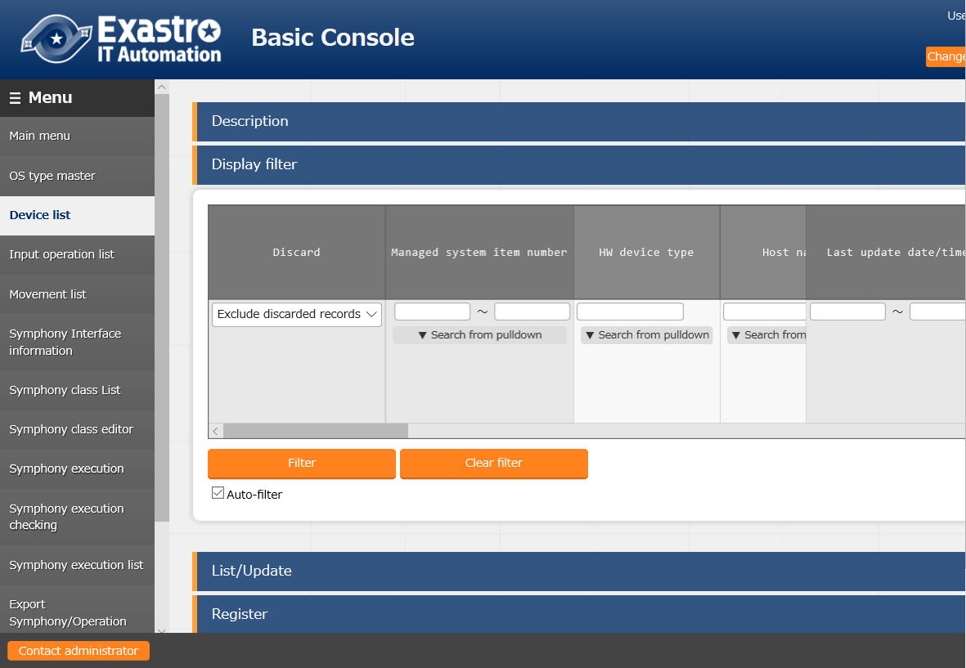

Figure 4.1-1 Submenu screen (Device list)

1. Click the "Register" - "Start Registration" button to register device information.

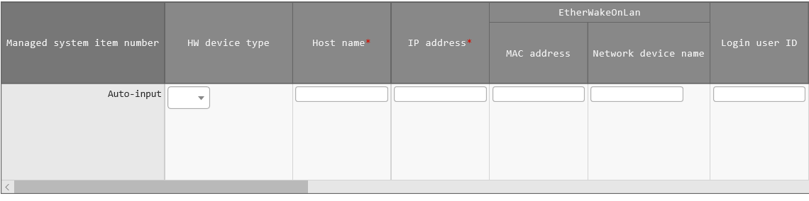

**Figure 4.1-2 Registration screen(Device list-common item**

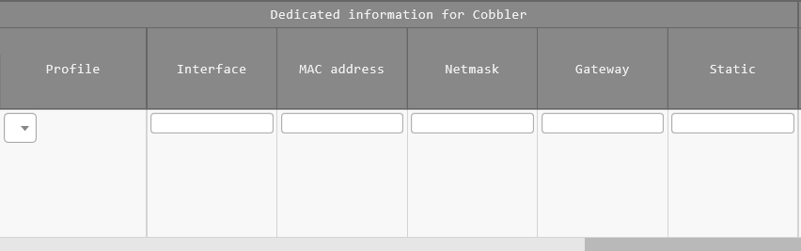

Figure 4.1-3 Registration screen(Device list-Dedicated information for Cobbler)

1. The list of common item in registration screen is as follows  
   Input of the columns with a red asterisk (*) after their column name in the web screen is required. In the case of using Cobbler driver, please enter the "Dedicated information for Cobbler"  
   If operation is executed while required columns not entered, unexpected errors may occur.

**Table 4.1-1 Registration screen item list (Device list)**

| **Item** | | **Description** | **Input required** | **Input**  **type** | **Restrictions** |
| --- | --- | --- | --- | --- | --- |
| Managed system item number | | A unique ID that identifies the registration information is entered automatically | - | Auto | - |
| host name | | Enter host name | ○ | Manual | Maximum length 128 bytes |
| IP address | | Enter IP address in xxx.xxx.xxx.xxx format | ○ | Manual |  |
| Dedicated information for Cobbler | Profile | Select the profile used for installation | ○ | List | Register in Cobbler in advance |
| INTERFACE | Enter the network interface name of the installation target server | ○ | Manual | - |
| MAC Address | Enter the MAC address of the installation target server in xx:xx:xx:xx:xx:xx format | ○ | Manual | - |
| NETMASK | Enter the subnet of the network which installation is performed in xxx.xxx.xxx.xxx format | ○ | Manual | - |
| GATEWAY | Enter the default gateway of the network which installation is performed in xxx.xxx.xxx.xxx format | ○ | Manual | - |
| STATIC | Specify the IP address type of the installation target server  ０：DHCP allocated IP address（※）  １：Static IP address | ○ | Manual | - |

※When specifying "DHCP allocated IP address", please register a temporary value that is not duplicated with other IP address for the IP address column in this screen first then update the IP address again after DHCP allocation.

## Cobbler Driver console

This section describes the operation of Cobbler Driver console.

Select the Cobbler console from the ITA basic console menu.

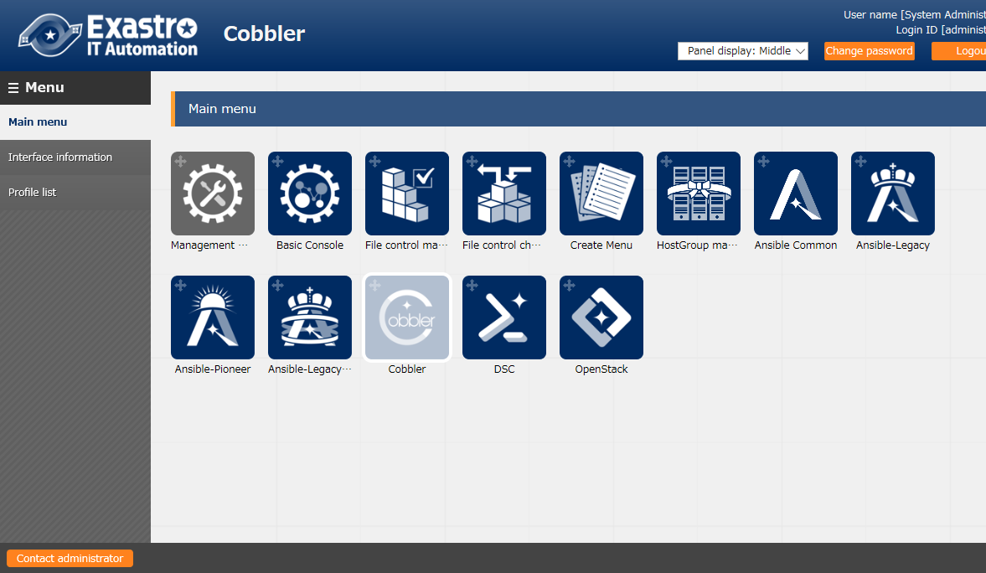

Figure 4.2-1 CobblerDriver menu screen

### Interface information

1. Register/Update/Discard the path of the shared directory between ITA system, Cobbler driver server and Cobbler Server and the information to connect to Cobbler server.

Please refer to "System Configuration/Environment Construction Guide - Cobbler-driver" for detailed explanation.  
※Since required value are set during installation, basically there is no need to perform any configuration.  
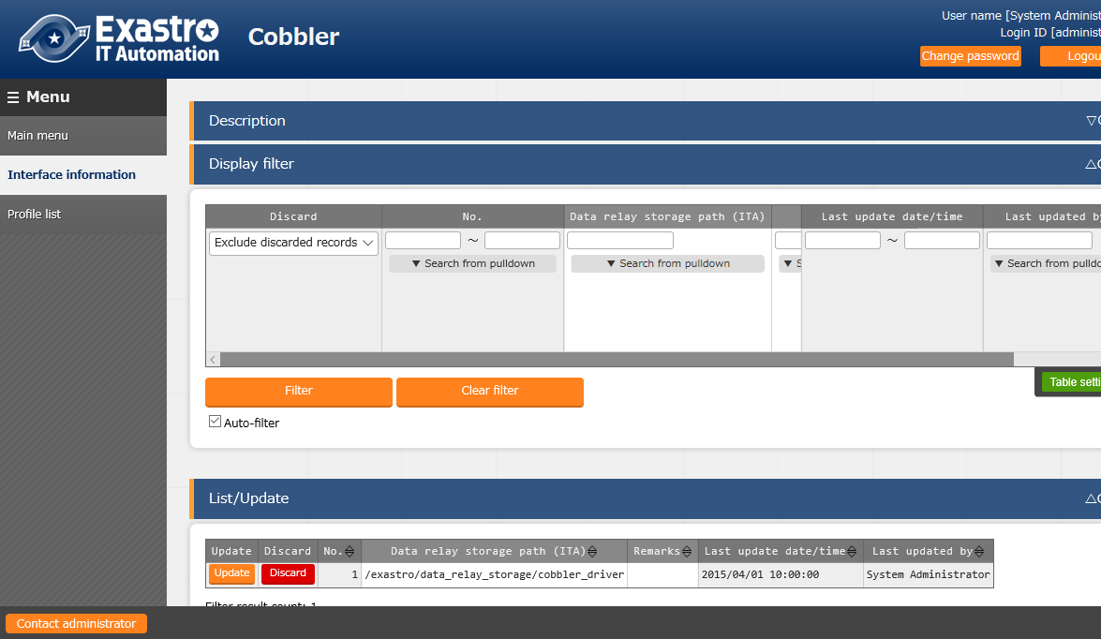

Figure 4.2-2 Cobbler Driver interface information screen

1. Click the "Register" - "Start Registration" button to register the data storage path.

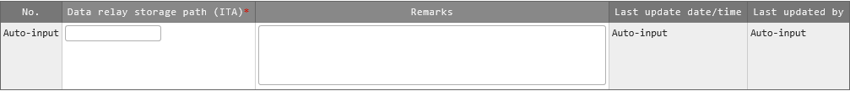

Figure 4.2-3 Registration screen (Interface information)

1. The item list of interface information screen is as follows.  
   If operation is executed while interface information not registered or multiple information is registered, unexpected errors may occur during operation execution.

**Table 4.2-1 Registration screen item list (Interface information)**

| **Item** | **Description** | **Input**  **Required** | **Input**  **type** | **Restriction** |
| --- | --- | --- | --- | --- |
| Data relay storage path (ITA) ※1 | Enter the directory viewed from the ITA system / Cobbler driver server. | ○ | Manual | maximum length 128 bytes |
| Remarks | Free description field. | － | Manual | maximum length 4000 bytes |

※1 Data relay storage paths are managed separately because directory path name may be different when operated on different servers. Please refer to "System Configuration/Environment Construction Guide-Cobbler-driver" for details.

### Profile list

1. Users can check the list of the profile created in Cobbler server in "Profile list" menu.

※ Since this is screen is for displaying the information imported from Cobbler, there is no configuration in this screen.

Figure 4.2-4 Registration screen (Profile list)

The item list of profile list screen is as follows. 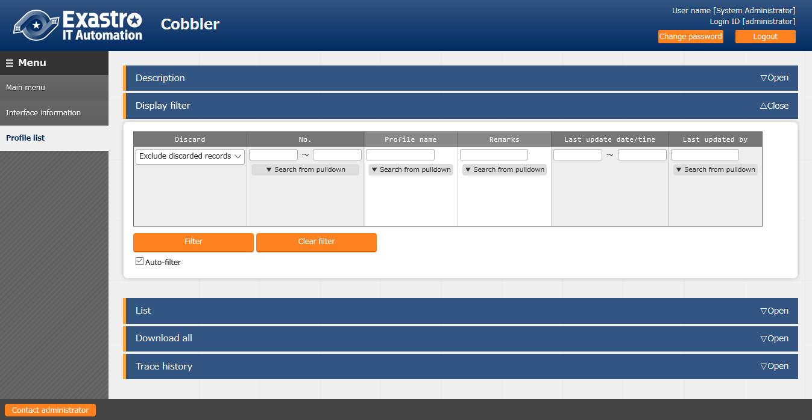

**Table 4.2-2 Display screen item list (Profile list)**

| **Item** | **説明** | **Input required** | **Input type** | **Restrictions** |
| --- | --- | --- | --- | --- |
| Profile name | The profile name created in Cobbler is displayed.  * Since the timing of reflection from Cobbler is not in real-time, it may take some time until items are displayed. | － | － | - |
| Remarks | Unused. | － | － | - |
| Last update date/time | The last update date/time of target profile is displayed. | － | － | - |
| Last updated by | The last updater of target profile is displayed. | － | － | - |

# Execute installation

This chapter explains the workflow of using Cobbler to install operation system to installation target server.

## Mechanism of installation

The installation uses PXE boot and automatically installs operation system with the communication between installation target server and Cobbler server through network.

Cobbler

Installation target



DHCP

PXE boot

①

②

③

④

Configuration

information

OS media

1. Request for IP address once the power is on.
2. Send the IP address and the startup operation system.
3. Request for operation system for installation and configuration information.
4. Operation system for installation and configuration information is sent and starts to install the operation system.

Figure 5.1-1 Overview image of Cobbler installation

## Start installation

The installation of operation system starts automatically when the power of installation target server is on. At that time, the configuration described in the kickstart file is performed.

1. Power on the installation target server

The DHCP server of Cobbler allocates IP address and the network booting starts.

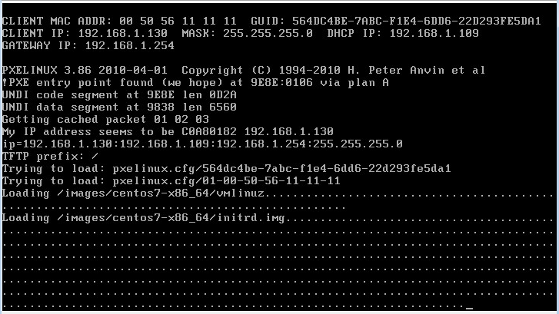

Figure 5.1-1 Cobbler automatic installation (Network booting)

1. The distribution and the configuration file to be installed is sent from Cobbler, then the installation is performed. After installation, the configuration described in the kickstart file will automatically perform.

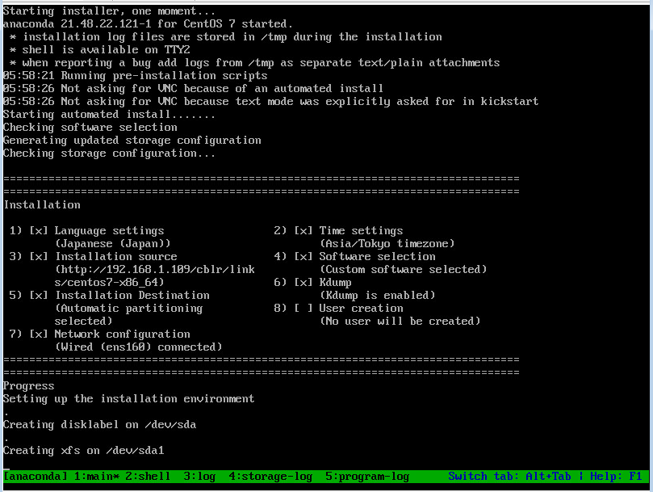

Figure 5.2-2 Cobbler automatic installation (executing installation)

1. The screen will display login prompt after installation. Confirm that the host name is the name set in the ITA device list menu.

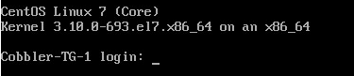

Figure 5.2-3 Display when installation is finished

# Notes of applicational operation

The operation to utilizing ITA system contains not only inputs by user from the browser screen of client PC but also operations according to system operation and maintenance.

The available operation and maintenance are as follows.

* The data relay storage path file on Cobbler side
* Change log level
* Maintenance

## The data relay storage path file on Cobbler server side

The file records the directory which used to transfer data with ITA system in Cobbler server is placed in the following directory

~/ita-root/confs/backyardconfs/cobbler_driver/path_DATA_RELAY_STRAGE_side_Cobbler

　　　　　Please rewrite the file when changing the data relay storage path.

　　　　　At the same time, please change the path referenced on the ITA server side in the Interface information menu of ITA Cobbler console so that the path points to same directory.

## Change log level

The method to change the log level of ITA system independent process is as follows.

1. Change to NORMAL level

Rewrite the 8th line of the following file from “DEBUG” to “NORMAL”.  
Log level setting file： <insallation direcotory>/ita-root/confs/backyardconfs/ita_env

1. Change to DEBUG level  
   Rewrite the 8th line of the following file from “NORMAL” to “DEBUG”.  
   Log level setting file： <installation direcotory>/ita-root/confs/backyardconfs/ita_env

After rewriting the file, the change takes effect after restarting the process.

Please refer to next section "6.3 About the maintenance method" for restart.

Log file output destinaton： <installation directory>/ita-root/logs/backyardlogs

## About the maintenance method

### Start/Stop/Restart Cobbler driver Back yard process

Taking the function to synchronize the profile list in ITA system for example.

* + Start process

＄/usr/bin/systemctl start ky_cobbler_profileSync_side_ITA 

* + Stop process

＄/usr/bin/systemctl stop ky_cobbler_profileSync_side_ITA 

* + Restart process

＄/usr/bin/systemctl restart ky_cobbler_profileSync_side_ITA 

## Download bootloader file

The bootloader file that is required for Cobbler to work is not downloaded when Cobbler is installed during online installation or offline installation of ITA.

Downloading the bootloader file with the following command is required.

＄cobbler get-loaders



# Troubleshooting

|  |  |
| --- | --- |
| No | Contents |
| Q-1 | Unexpected error displayed when registering data in the device list menu. |
| A-1 | Accessing data relay storage path from ITA server failed. |
| Q-2 | The profile in Cobbler is not displayed in the ITA device list menu. |
| A-2 | Please execute Cobbler Sync in Cobbler server. |
| Q-3 | An unexpected IP address allocated to the MAC address registered in the ITA device list. |
| A-3 | The following reasons are possible.   1. The MAC address registered in device list is wrong. 2. Connecting device with multiple LAN port via the LAN port that is different from the registered MAC address. 3. There are multiple DHCP servers in the connected network. |
| Q-4 | The device information registered in ITA device list is not displayed in “Systems” of Cobbler |
| A-4 | Please execute Cobbler Sync in Cobbler server. |
| Q-5 | PXE boot started but stuck with a green band displayed at the buttom of the screen. |
| A-5 | The description of the kickstart file may be incorrect. |