

ITA_User Instruction Manual

Compare function

*－*Ver 1.8*－*

Copyright © NEC Corporation 2021. All rights reserved.

Disclaimer

All the contents of this document are protected by copyright owned by NEC Corporation.

Unauthorized reproduction or copying of all or part of the contents of this document is prohibited.

The contents of this document are subject to change without prior notice in the future.

NEC Corporation is not responsible for any technical or editorial errors or omissions in this document.

NEC Corporation do not guarantee accuracy, usability, certainty of the content in this document.

Trademark

* Linux is registered trademark or trademark of　Linus Torvalds, registered in the U.S. and other countries.
* Red Hat is registered trademark or trademark of Red Hat, Inc. registered in the U.S. and other countries.
* Apache, Apache Tomcat, and Tomcat are registered trademarks or trademarks of the Apache Software Foundation.
* Ansible is registered trademark or trademark of Red Hat, Inc.

The names of other systems, company name and products mentioned in this document are registered trademarks or trademarks of their respective companies.

The ® mark and TM mark are not specified in this document.

※「Exastro IT Automation」 is written as 「ITA」 in this document.

Table of contents

Table of contents 2

Introduction 3

1 Compare function overview 4

1.1 Compare function 4

1.1.1 Compare function overview figure. 4

1.1.2 Compare function process overview 5

1.1.3 Compare list overview 6

1.2 Comparing Parameter sheets 8

1.2.1 Compare function requirements 8

1.2.2 Compare parameters 8

2 Comparing items 9

2.1 Comparing items 9

2.1.1 Items that can be compared. 9

2.1.2 Item combinations that can be compared. 9

3 Compare menu configuration 10

3.1 Menu/Screen list 10

4 Using the Compare function 11

4.1 Operation flow 11

4.1.1 Compare function operation flow. 11

5 Compare function operation 13

5.1 Compare 13

5.1.1 Compare list 13

5.1.2 Compare details. 14

5.1.3 Compare execution 15

6 Appendix 18

6.1 References 18

6.1.1 Example comparing parameter sheets with pulldown selections. 18

Introduction

This document explains ITA’s Functions and how to operate them.

# Compare function overview

This chapter explains the Compare function

## Compare function

The Compare function can be used to compare Parameter sheets created with the ITA Menu create function and output the differences.

This function only supports Parameter sheets (with host/operation).

For more details regarding Parameter sheets, please refer to  
“Exastro-ITA_User_Instruction_Manual_Menu_creation_function.”

For more information regarding Access rights/ Access permission roles, please refer to  
“Exastro-ITA_User_Instruction_Manual_Role-based_access_control_for_data_records”

### Compare function overview figure.

The following figure illustrates the workflow of using the Compare function,。

ITA

3.Symphony

実行

※Link settings for the menu getting compared.

Run Compare

Define Compare

Define Compare details

Parameters when compared

Compare definition

Compare details

Outputs Compare results

※Outputs as Web or File（Excel,Csv）

Parameter sheet

(With host/operation)

Create menu

Register data

※Link settings for every item in the Menu.

### Compare function process overview

The following figure illustrate the process of the Compare function.

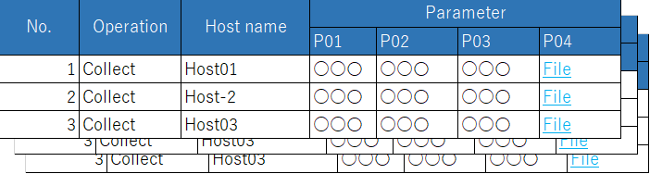

3.Symphony

実行

Define Compare

Define Compare details

Parameter sheet 1



Parameter sheet 2

Execute Compare

Parameter sheet

※Outputs Compare results according to the definition and the detailed definition, as well as the parameters compared.

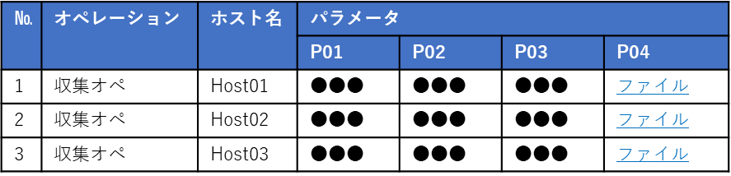

Run Compare

Compare list

Base date 1/2

Target host

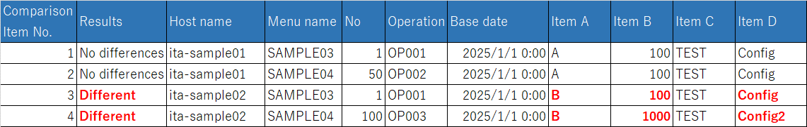

### Compare list overview

The following figure illustrates the link between the parameter sheets as well as the Compare results. For information regarding the Compare list, compare details definition and the different configurations, please refer to Chapter 5, Compare function operation.

・Parameter sheet link(When the items of the parameter sheets are identical to each other)

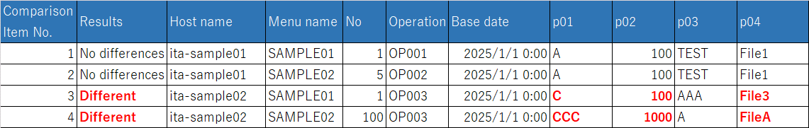

Start comparison

・

**※Link the parameter sheets in the Compare list.**



**Paraneter sheet 1**

**Parameter sheet 2**

**Compare result**

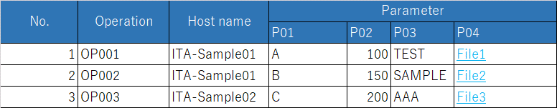

・Parameter sheet link (When the items of the parameter sheets dont match each other).



Run Compare

・

**Link the parameter sheet in the Compare list. Link the items in the detailed Compare list.**

Parameter sheet 1

Parameter sheet 2

**Compare  
results**

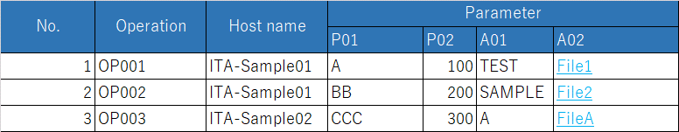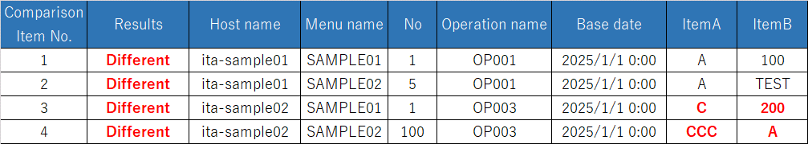

## Comparing Parameter sheets

The Compare function allows users to do Comparisons between parameter sheets linked in the Compare list and the Compare details.

### Compare function requirements

Make sure that the ITA Settings fulfill the following requirements.

* ITA is installed with “createparam” selected in the ITA installer.
* Parameter sheets (with host/operation) is created using the Menu create function.
* A link is created between the parameter sheets you want to compare in the Compare list.
* A link is created between the parameter sheet’s items in the Compare details menu (unnecessary depending on the Compare list settings).

### Compare parameters

Configure the following parameters in order to run the compare function.

For more information regarding Compare list, please see 5.1.1 later in this document.

**Table 1.2‑1　Compare parameters**

| **Parameter** | **Description** | **Input necessary** | **Input format** | **Restrictions** |
| --- | --- | --- | --- | --- |
| Compare list | Select Compare list. | 〇 | List selection |  |
| Base date 1 | Input the base date of Menu 1 in the Compare list. |  | Manual input |  |
| Base date 2 | Input the base date of Menu 2 in the Compare list. |  | Manual input |  |
| Target host | Select the target host.  Default: No host(Shows the whole comparison). |  | List selection |  |

# Comparing items

## Comparing items

### Items that can be compared.

The parameter sheet items that can be compared with the Compare function are as following.。

**Table 2.1‑1　Comparable parameter sheet items**

| **Item type** | **Restrictions** |
| --- | --- |
| String |  |
| Multi string |  |
| Integer |  |
| Decimal number |  |
| Pulldown selection | The ID of the selected list will be compared.  If you dont have access permission, ID Conversion failure(X) will be displayed. |
| File upload | If both items are file upload type items, the file name and the file contents will be compared. |
| Link |  |

※For more information regarding access rights, please refer to   
“Exastro-ITA_User_Instruction_Manual_Role-based_access_control_for_data_records”

### Item combinations that can be compared.

The different combinations of parameter sheet items that can be used with the Compare function are as following.

Table 2-1 Comparable Parameter sheet item combinations

|  |  |  |  |  |  |  |  |
| --- | --- | --- | --- | --- | --- | --- | --- |
|  | **String** | **Multi string** | **Integer** | **Decimal number** | **Pulldown selection** | **File upload** | **Link** |
| **String** | 〇 | 〇 | 〇 | 〇 | 〇※1 | 〇※2 | 〇 |
| **Multi string** | 〇 | 〇 | 〇 | 〇 | 〇※1 | 〇※2 | 〇 |
| **Integer** | 〇 | 〇 | 〇 | 〇 | 〇※1 | 〇※2 | 〇 |
| **Decimal number** | 〇 | 〇 | 〇 | 〇 | 〇※1 | 〇※2 | 〇 |
| **Pulldown selection** | 〇※1 | 〇※1 | 〇※1 | 〇※1 | 〇※1 | 〇※1※2 | 〇※1 |
| **File upload** | 〇※2 | 〇※2 | 〇※2 | 〇※2 | 〇※1※2 | 〇※3 | 〇※2 |
| **Link** | 〇 | 〇 | 〇 | 〇 | 〇※1 | 〇※2 | 〇 |

※1 The pulldown menu will have it's selected list's ID compared.

Please see the Compare example in Chapter 6.1.1 Example comparing parameter sheets with pulldown selections.

※2 The target value and file name will be compared.

※3If either the name or contents of the file are different, they will be displayed as "Different".。

# Compare menu configuration

This chapter explains the menu configuration of the Compare function.

For information regarding loggin into the Web console or the ITA screen configuration and its operations, please refer to the First step guide.

## Menu/Screen list

The Compare function's menu list is as following.

Table 3-1 Compare screen list

|  |  |  |  |
| --- | --- | --- | --- |
| No | Menu group | Menu/Screen | Description |
| 1 | Compare | Compare list | Create Compare definition name and link parameter sheets. |
| 2 | Compare details | Link Parameter sheet items. |
| 3 | Compare execution | Run the Compare using the settings configured in the Compare list and Compare details. |

# Using the Compare function

This chapter explains how to use the Compare function.

## Operation flow

The standard Compare function operation flow is as following.

### Compare function operation flow.

The following figure illustrates a standard Compare function operation flow.

1. **Create Parameter sheet**
2. **Create Compare definition**

**Required**

**Legend**

1. **Register data to Parameter sheet**
2. **Configure detailed settings for Compare Def.**
3. **Run Compare**

**※If the Compare list contains items that don’t completely match up with each other, you will need to configure Detailed Compare list.**

* **Detailed workflow and references.**

1. **Create Parameter sheet**Create a Parameter sheet in the "Create/Define menu" menu in the "Menu create" menu group.

For more information, please refer to   
“Exastro-ITA_User_Instruction_Manual_Menu_creation_function”

1. **Register data data to Parameter sheet**

Register data to the Parameter sheet creted in the previous step.

For more information, please refer to   
“Exastro-ITA_User_Instruction_Manual_Menu_creation_function”

1. **Create Compare list**

Use the "Compare definition" menu to define/create a Compare

For more information, please refer to Chapter 5.1.1 Compare list.

1. **Configure Detailed Compare list**

[Use the "Compare details" menu to configure details for the previously created Compare.

For more information, please refer to Chapter 5.1.2 Compare details

1. **Run Compare**

Use the Compare execution menu to run compare the set parameter sheets.

For more information, please refer to Chapter 5.1.3 Compare execution.

# Compare function operation

This chapter describes the different menus in the Compare function.

## Compare

### Compare list

1. 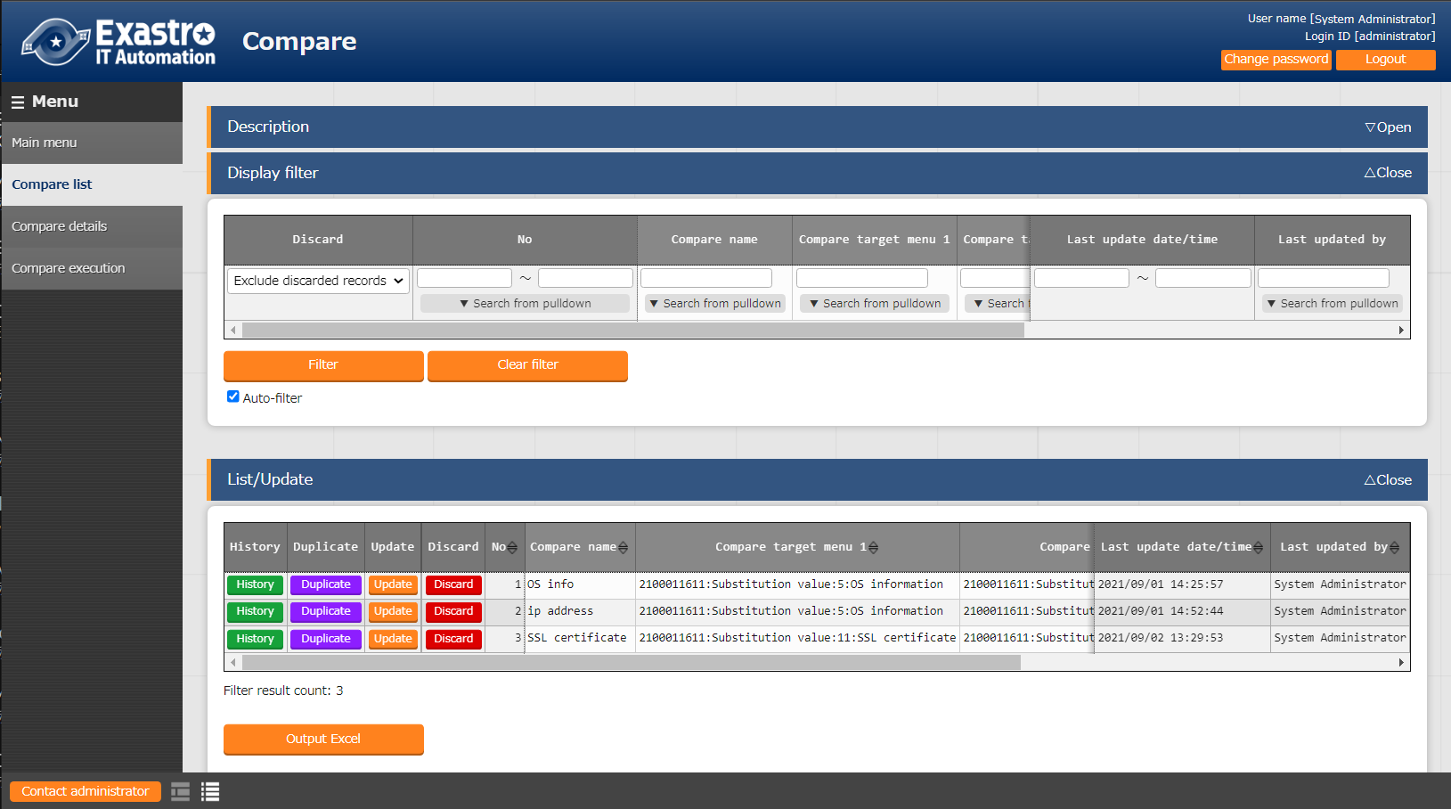In the "Compare list", users can register and update/change Compare lists (Links between parameter sheets)。

**Figure 5.1‑1 Submenu screen（Compare list）**

1. Users can register Compare lists by clicking the “List/Update” button and then the “Start registering” button.

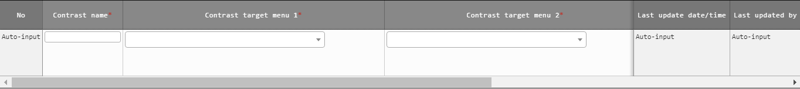

Figure 5.1‑2 Register screen（Compare list）

1. The item list found in the Compare list menu is as following.

**Table 5.1‑1　Registration screen items （Compare list）**

| **Item** | **Description** | **Input required** | **Input format** | **Constraints** |
| --- | --- | --- | --- | --- |
| Compare name | Input name of the Compare | 〇 | Manual input |  |
| Compare target menu 1 | Select target menu | 〇 | List selection |  |
| Compare target menu 2 | Select target menu | 〇 | List selection |  |
| Match all cases | Select if Menu 1 and Menu 2’s item match up. | - | Select | ※1 |
| Remarks | Free description field | - | Manual input |  |

※1 The user does not need to configure Compare details if “Match all cases” is selected.

In order to select this, all items of the selected parameter sheets needs to match up.

### Compare details.

1. 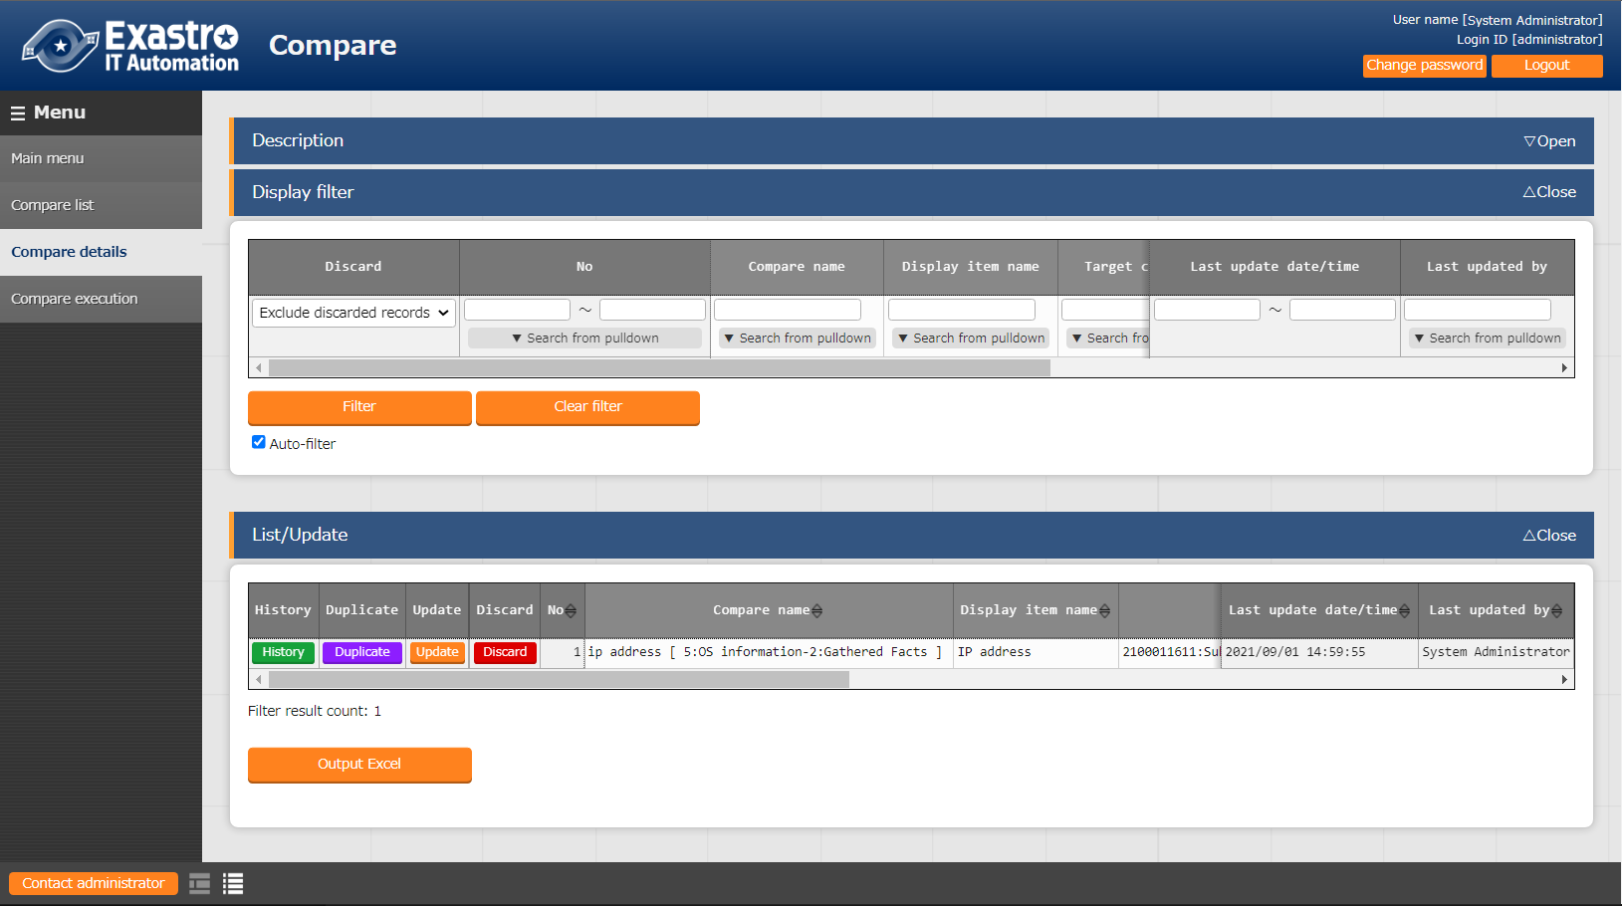In the “Compare details” menu, users can link the different items of the parameter sheets linked in the “Compare list” menu.

**Figure 5.1‑3 Submenu screen（Compare details）**

1. 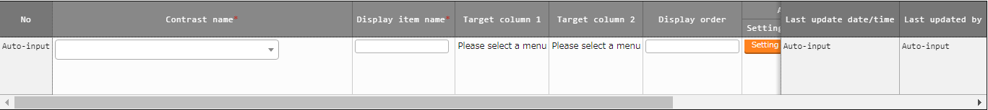Press the “List” and then “Start registration” to register link between items.

Figure 5.1‑4 Registration screen（Compare details）

1. The following table lists the items in the Compare item value list screen.

**Table 5.1‑1　Registration screen item list（Compare details）**

| **Item** | **Description** | **Input required** | **Input method** | **Restrictions** |
| --- | --- | --- | --- | --- |
| Compare name | Select a Compare | 〇 | List selection | ※1 |
| Display item name | Input the name of the display items.  This is the item name that will be used in the output Compare results. | 〇 | Manual input |  |
| Target column 1 | Select Target column | 〇 | List selection | ※2 |
| Target column 2 | Select Target column | 〇 | List selection | ※3 |
| Display order | Select display order | - |  | ※4 |
| Remarks | Free description field | - |  |  |

※1 Only items for parameter sheets that has “Match all cases” unchecked in the “Compare list” menu.

※2 Items that are registered in Target Menu 1 in the Compare list can be selected.

※3 Items that are registered in Target Menu 2 in the Compare list can be selected.

※4 If nothing is input, the Compare results will be output in the order of Compare details ID, left to right.

### Compare execution

1. The “Compare execution” compares parameter sheets based on the information set in the Compare list and Compare details menu.

* 「The list of Compare list registered in “5.1.1 Compare list” is displayed.
* 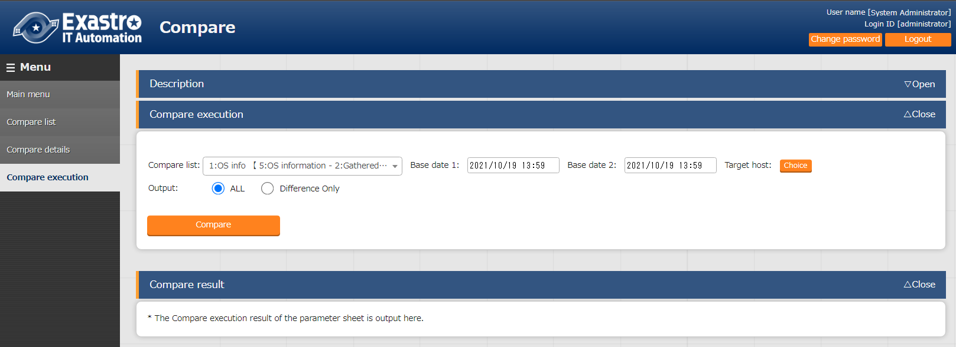Clicking the “Compare” button executes the Compare and compares the target menus and items based on the input parameters.

**Figure 5.1‑5 Compare execution screen（Input Parameter）**

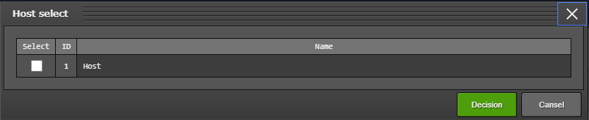

**Figure 5.1‑6 Host list menu（Compare execution：Target host）**

**Table 5.1‑1　Compare execution item list**

| **Item** | **Description** | **Input required** | **Input method** | **Constraints** |
| --- | --- | --- | --- | --- |
| Compare list | Select Compare list. | 〇 | List selection |  |
| Base date 1 | Specify the base date for Menu 1 | - | Manual input | ※1 |
| Base date 2 | Specify the base date for Menu 2 | - | Manual input | ※1 |
| Host | Pressing the “Host” button will open up a list of target hosts. Please select a host and press the “Decision” button. | - | Select | ※2 |
| Compare | Press this button to run the Compare between the selected parameters and outputs the results. | - | - | - |

※1 If a base date is input, the data compared will be the latest version at the time of the input date.

If nothing is input, the latest version will be used,  
※2 No host is selected by default.

Will output the Compare for all host linked to the menu.

* After pressing the “Compare” button, a file output button (excel, CSV) button will be displayed.
* The results will be displayed in the order of Menu 1 and Menu 2 for each host.

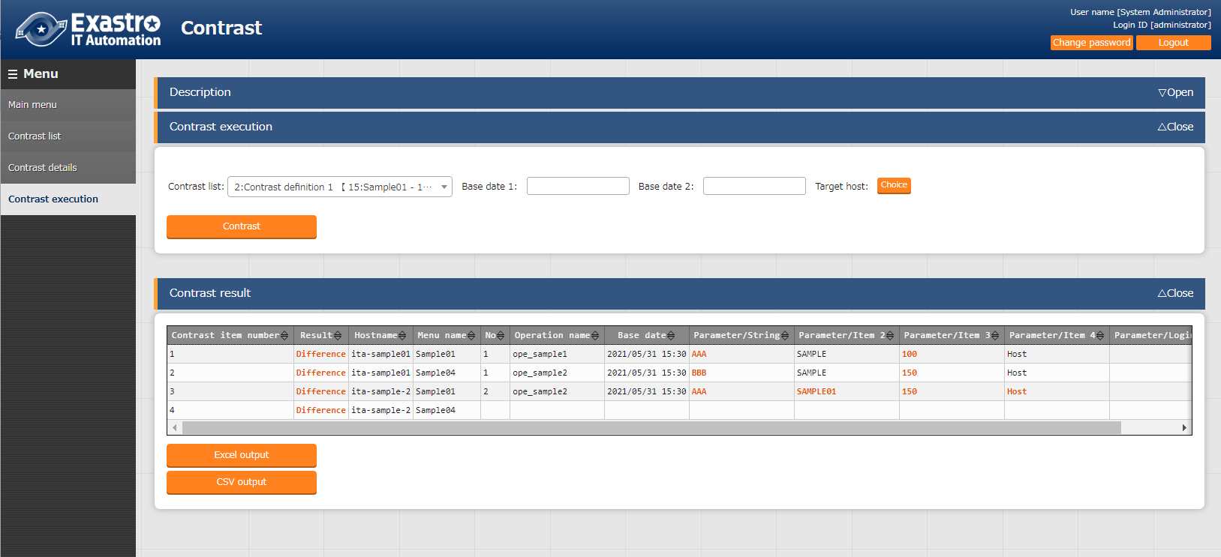

**Figure 5.1‑7 Compare execution screen (Compare results)**

**Table 5.1‑1　Compare execution output list**

| **Item** | **Description** | **Constraints** |
| --- | --- | --- |
| Compare item number | Number of the items output from the Compare results. |  |
| Result | Displays the Compare results.  Either with “Difference” or “no difference”. | ※1 |
| Host name | Displays the target host name |  |
| Menu name | Displays the target menu name |  |
| No | Displays the compared menu number. |  |
| Operation name | Displays the operation name |  |
| Base date | Displays the Base date |  |
| Compare item | Displays the target item. | ※1 |
| Excel output | Outputs the results in excel format. |  |
| CSV output | Outputs the results in CSV format. |  |

※1 If there were any differences, it will be highlighted in red text.

# Appendix

## References

### Example comparing parameter sheets with pulldown selections.

The following illustrates an example using the Compare function to compare parameter sheets with pulldown selection items.

* 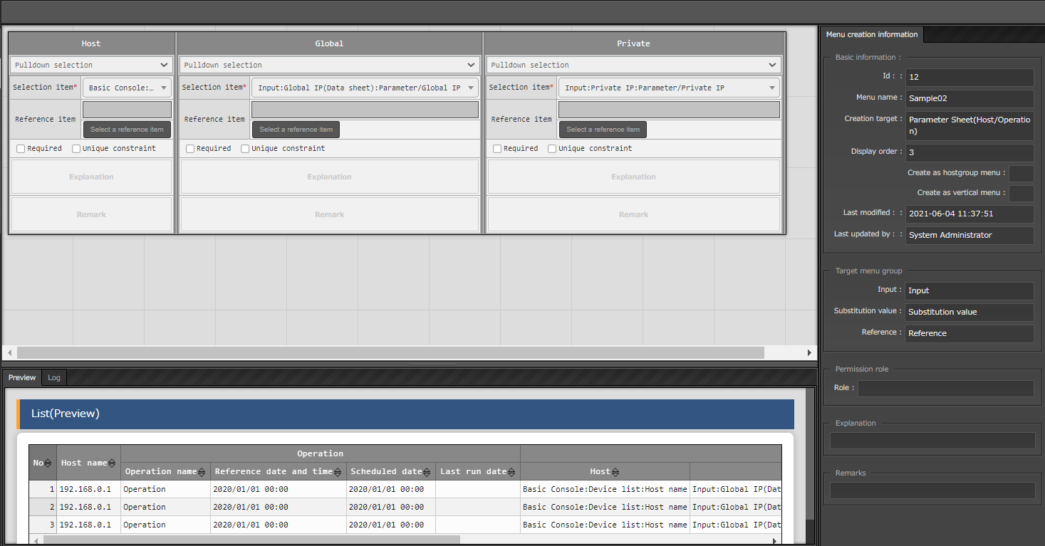Comparing Pulldown selection items in Parameter sheets and their configurations.

**Figure 6.1‑1 Parameter sheet（Create/Define menu）**

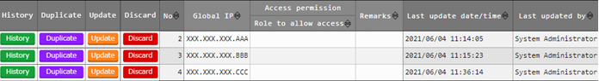

**Figure 6.1‑2 Pulldown reference definition [Data sheet:Global IP]**

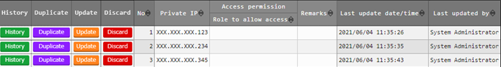

**Figure 6.1‑3 Pulldown reference destination [Data sheet :Private IP]**

* Compares and Compare lists

In the following illustration, the items marked with red-blue are going to be compared.

Gllobal：References Global IP (Datasheet)

Private：References Private IP (Datasheet)

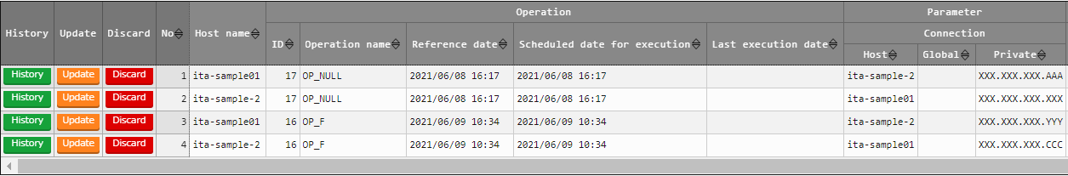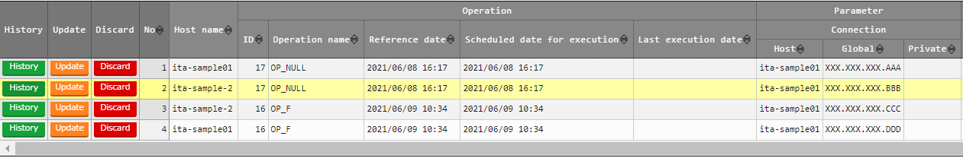

SAMPLE07

SAMPLE08

**Figure 6.1‑4 Comparable parameter sheets**



**Figure 6.1‑5 Compare list setting example**



**Figure 6.1‑6 Compare details setting example**

* Compare execution

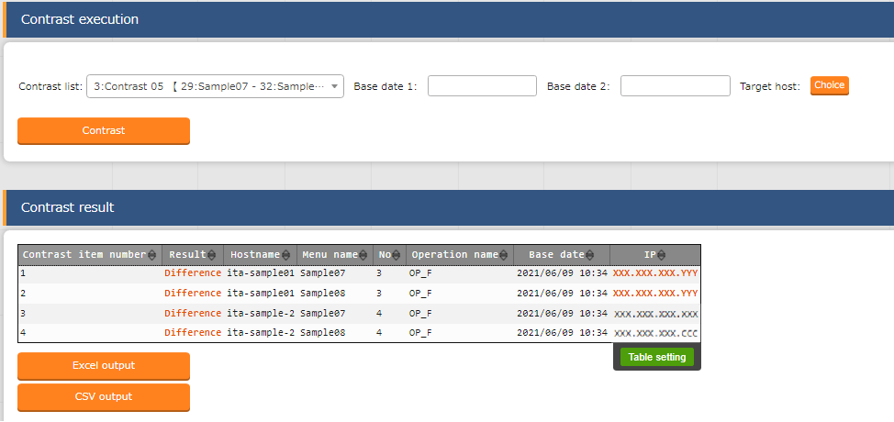

※1

※2

**Figure 6.1‑7　Compare execution results**

Since the pulldown reference destination is different from each other, patterns like ※1 and ※2 might occur.

※1 If the displayed contents are the same, but the reference destinaton’s no. is the same, it will be considered as being different.

※2 If the reference destination’s no. is different, but the contents are the same, it will not be considered as being different.