

ITA_User instruction manual

DSC-driver

*－* Version 1.4*－*

Copyright © NEC Corporation 2019. All rights reserved.

Disclaimer

All the contents of this document are protected by copyright owned by NEC Corporation.

Unauthorized reproduction or copying of all or part of the contents of this document is prohibited.

The contents of this document are subject to change without prior notice in the future.

NEC Corporation is not responsible for any technical or editorial errors or omissions in this document.

NEC Corporation do not guarantee accuracy, usability, certainty of the content in this document.

Trademark

* Linux is registered trademark or trademark of Linus Torvalds, registered in the U.S. and other countries.
* Red Hat is registered trademark or trademark of Red Hat, Inc., registered in the U.S. and other countries.
* Apache, Apache Tomcat, Tomcat are registered trademarks or trademarks of Apache Software Foundation.
* Oracle and MySQL are registered trademarks of Oracle Corporation and its subsidiaries and affiliates in the United States and other countries.
* MariaDB is a registered trademark or trademark of the MariaDB Foundation
* DSC is a registered trademark or trademark of the Microsoft Corporation.

The names of other systems, company name and products mentioned in this document are registered trademarks or trademarks of their respective companies.

The ® mark and TM mark is not specified in this document.

※「Exastro IT Automation」is written as 「ITA」 in this document.

**Table of contents**

**Introduction 4**

**1 Overview of DSC driver 5**

**2 Feature of DSC driver 5**

**3 Configuration definition in DSC driver 6**

**3.1 Automation of DSC utilization. 6**

**3.2 Definition of configuration 7**

**3.3 Definition of resource block 9**

**(1) Description of config file 9**

**(2) Definition of variable name 10**

**(3) Definition of credential variable name 11**

**3.3.1 Definition of import block 12**

**(1) Description of Import file 12**

**(2) Definition of variable name 12**

**3.3.2 Definition of config data block 13**

**(1) Description of config data file 13**

**(2) Definition of variable name 13**

**3.4 Variable type 14**

**3.5 Extract variables and register specific values 15**

**3.6 Variable handling according to substitution value registration 15**

**4 DSC driver operation procedure 16**

**4.1 Workflow 16**

**5 Function explanation 19**

**5.1 Menu screen list 19**

**5.2 Basic console 20**

**5.2.1 Device list 20**

**5.2.2 Associated menu 22**

**5.2.3 Input operation list 23**

**5.3 DSC driver console 24**

**5.3.1 Interface information 24**

**5.3.2 Movement list 26**

**5.3.3 Config files 27**

**5.3.4 Import files 29**

**5.3.5 Config data files 30**

**5.3.6 Credential information 31**

**5.3.7 Movement details 32**

**5.3.8 Substitution value auto-registration setting 33**

**5.3.9 Target host 35**

**5.3.10 Substitution value list 36**

**5.3.11 Execution 37**

**5.3.12 Check operation status 38**

**5.3.13 Execution list 40**

**5.4 Description of configuration (DSC) 41**

**5.5 BackYard contents 41**

**(1) Automatic variable registration setting 41**

**(2) Substitute value auto-registration setting 41**

**(3) Delete operation instance history 42**

**5.6 How to Use Public Key File Output Script 43**

**5.7 Application operation 44**

**5.8 Installation related 44**

**5.9 Change log level 44**

**5.10 Change startup cycle 45**

**5.11 About maintenance methods 46**

**5.11.1 Start/Stop/Restart DSC driver independent process 46**

**5.12 Troubleshooting 47**

# **Introduction**

This document explains the function and the operation method of ITA DSC driver (referred to as DSC driver hereafter) system.

In addition, please note that the screen examples described in this document may be different from the actual screens.

Please note that the contents of this document are subject to change without prior notice in the future.

# **Overview of DSC driver**

DSC driver is a platform construction automation tool that works as the optional function of ITA system, configures Windows server itself into desired state in Windows infrastructure environment.

DSC driver creates configuration file from the resources that describes the desired state according to the user and executes the created configuration file to bring the Windows server into desired state.

* System configuration

DSC driver is divided into DSC ITA function and DSC RestAPI. The DSC ITA function works on the same server with ITA system. DSC RestAPI works on the Windows server with Windows PowerShell 5.1 as the core.

Please refer to "System Configuration/Environment Construction Guide -DSC-driver" for the operating environment of this system.

# **Feature of DSC driver**

The main functions of DSC driver are classified into the following categories.

1. Web

Web contents. The ITA system DSC driver screen provided on the browser.

1. BackYard

W Resident processes that runs on a server which is independent of the web content.

1. DSC RestAPI

Intermediate program that relays between the ITA system and DSC.

* Please refer to "System Configuration/Environment Construction Guide -DSC-driver" for the operating conditions of DSC driver.

# **Configuration definition in DSC driver**

## Automation of DSC utilization.

DSC driver uses the function called "Resource" described in PowerShell and make adding construction target easy by introducing "Resource" according to the usage.

PowerShell generates and executes MOF (Management Object Format) that handles the mechanism of “Resource” in DSC.

The following resources are available as standard PowerShell DSC resources.

Table 3.1-1 Windows PowerShell 5.1 embedded resource

|  |  |  |
| --- | --- | --- |
| Number | Resource name | Function overview |
| １ | Acthive Resource | Extract compressed (.zip) file to specified path |
| ２ | Environment Resource | Manage environment variables |
| ３ | File Resource | Manage files and directories |
| ４ | Group Resource | Manage local groups |
|  | GroupSet Resouce | Manage local groups |
| ５ | Log Resource | Log of configuration messages |
| ６ | Pakege Resource | Manage packages such as Windows installer and Setup.exe, etc. |
| ７ | ProcessSet Resource | Manage Windows processes |
| ８ | Registry Resource | Manage registry keys and values |
| ９ | Script Resource | Execute Window PowerShell script |
| １０ | Service Resource | Manage services |
| １１ | ServiceSet Resource | Manage services |
| １２ | User Resource | Manage local users |
| １３ | WaitForAll Resource | Manage the dependency on the configuration of other nodes |
| １４ | WaitForAny Resource | Manage the dependency on the configuration of other nodes |
| １５ | WaitForSome Resource | Manage the dependency on the configuration of other nodes |
| １６ | WindowsFeature Resource | Manage Windows functions and roles |
| １７ | WindowsFeatureSet Resource | Manage Windows functions and roles |
| １８ | WindowsOptionalFeature | Manage optional functions |
| １９ | WindowsOptionalFeatureSet | Manage optional functions |
| ２０ | WindowsPackageCab | Manage Windows cabinet packages (.cab) |
| ２１ | WindowsProcess Resource | Manage Windows processes |

When using the custom resource that is not mentioned above, installing custom resources to DSC RestAPI (DSC server) and configuration target server in advance is required.

## Definition of configuration

The configuration used in ITA (DSC) is generated and executed in the format specified in Figure 3.2-1 Configuration definition format.

・Configuration block: The block that becomes the input of DSC (PowersShell)

・Import block: The block defined when using the custom resource other than the PowerShell DSC standard resources

・Node block: The block for one node

・Resource block: The block for one resource

・Config data block: The block defined when using config data

Configuration ConfigTest01

{

Import-DscResource -ModuleName PSDesiredStateConfiguration

Import-DscResource -ModuleName xActiveDirectory

Node $AllNodes.Where { $_.NodeName –eq "20.0.0.11" }.NodeName

{

WindowsFeature IIS

{

Name = "{{ VAR_Name1 }}"

Ensure = "{{ VAR_Ensure1 }}"

}

｝

｝

$ITAConfigData =

@{

AllNodes =

@(

@{

NodeName = "20.0.0.11"

RetryCount = 10

}

)

}

Configuration name

**Configuration block**

**Import block**

**Node block**

**Resource block**

**Config data block**

Import resource name

Node name

Resource name

Property

Config data name

Config data parameter

Variable value

Figure 3.2-1 Configuration definition format

The resource block, Import block, and config data block(partial) above are defined (file uploaded) by the users of DSC driver, generated and executed in the format of configuration by DSC driver.

Table 3.2-1 Content of configuration

|  |  |  |
| --- | --- | --- |
| Name | Content | Setting screen |
| Configuration name | The name to be executed by DSC(PowerShell) | Output the config name registered in Config files screen |
| Import resource name | The DSC resource to be imported | Output the Import file registered in Import files screen |
| Node name | The IP information of target host | Output the IP address registered in Device list screen |
| Property | The resource name of the config to be executed | Output the config name of the resource file registered in Config files screen(Output the config name of the resource block created by user) |
| Variable value | Properties specified in the resource | Output the resource file registered in Config files screen(Output the config of the resource block created by user) |
| Config data name | The variable value created by user | Output the config date name registered in Config data files screen |
| Config data parameter | Config data name | Output the config date file registered in Config data files screen(Output the config data created by user) |
| Name | Define the data that can be set to target node | Setting screen |

## Definition of resource block

Create a config file to define the resource block of Configuration.

The created file is uploaded in menu "5.3.3 Config files" and registered to ITA (DSC).

The method to describe the config file is described as below.

#### Description of config file

Please refer to the official contents for the basic format.

Please use UTF-8 for the character encoding.

Please adjust indent into multiple of 2.

Please use UTF-8 for the character encoding.

・Example of Config file (Register user and group)

e.g.)

User△itaSampleUserExample

{

△△UserName△=△"itaSampleUser"

△△Ensure△=△"Present"

△△Disabled△=△$false

△△PasswordNeverExpires△=△$true

}

Group△itaSampleGroupExample

{

△△GroupName△=△"itaSampleGroup"

△△Ensure△=△"Present"

△△MembersToInclude△=△"itaSampleUser"

△△DependsOn△=△"[User] itaSampleUserExample"

}

△: Half-width space

※Describing multiple resources in one file is possible.

【Description of Config file】

resource_name△name ---🡪 **Resource name: The name of resource that can be used in DSC**

**Name: Any desired name (Unique name in the file)**

{　 ---🡪**The start symbol of resource setting information**

△△property name△=△XXX ---🡪 **Property name: The property name defined in the resource**

**XXX: specific value of the property**

**If the property is string type, enclosing it with "" is required.**

} ---🡪 **The end symbol of resource setting information**

**△:** **Half-width space**

#### Definition of variable name

With DSC driver, the variable described in config file can be specified in ITA setting screen.

Substitute the specific value in "5.3.11 Execution" with the substitution value entered in "5.3.10 Substitution value list".

Describe the variable name to be replaced with substitution value in the config file with the following format.

・Example of Config file

e.g. )

User△itaSampleUserExample

{

△△UserName△=△"{{△VAR_UserName△}}"

△△Ensure△=△"{{△VAR_Ensure△}}"

△△Disabled△=△{{△VAR_Disabled△}}

△△PasswordNeverExpires△=△{{△VAR_PasswordNeverExpires△}}

}

△: Half-width space

【Description of Config file】

resource_name△name ---🡪 **Resource name: The resource name that can be used in DSC**

**Name: Any desired name (Unique name in the file)**

{　 ---🡪　 **The start symbol of resource setting information**

△△property name△=△{{△VAR_XXX△}} ---🡪 **Property name: The property name defined in the resource**

**{{： Property name: The property name defined in the resource**

**VAR_XXX：Variable name （Any desired variable name behind VAR_）**

**}}： The end symbol of varaible name**

} ---🡪 **The end symbol of resource setting information**

**△:** **Half-width space**

**【Notes】**

**If the property is string type, the variable name descried in the config file is enclosed with "" like ”{{△VAR_XXX△}}”.**

**If the variable name described in config file is not enclosed with "", then the specific value is required to by enclosed with "".**

#### Definition of credential variable name

When using credential in resources, describe the credential embedded variable name to be substituted in config file with the following format.

DSC driver substitutes specific value in "5.3.11 Execution" with the credential entered in "5.3.6 Credential information".

・Example of Config file

e.g. )

User△itaSampleUserExample

{

△△UserName△=△"itaSampleUser"

△△Ensure△=△"Present"

△△Disabled△=△$false

△△PasswordNeverExpires△=△$true

△△Password△=△{{△CDT_Password△}}

}

△:Half-width space

【Description of Config file】

resource_name△name --🡪 **Resource name: The resource name that can be used in DSC**

**Name: Any desired name (Unique name in the file)**

{　 ---🡪　 **The start symbol of resource setting information**

△△property name△=△{{△CDT_XXX△}} ---🡪 **Property name: The property name defined in the resource**

**{{： The start symbol of variable name**

**CDT_XXX: Credential embedded variable name**

**(Credential embedded variable name registered in credential menu)**

**}}： The end symbol of variable name**

} ---🡪 **The end symbol of resource setting information**

**△:** **Half-width space**

### **Definition of import block**

Create an Import file to define the Import block of Configuration.

The created file is uploaded in menu "5.3.4 Import files" and registered to ITA (DSC).

The method to describe the config file is described as below.

#### Description of Import file

Please use UTF-8 for the character encoding.

Please use ".ps1" for the file extension.

・Import file example (In the case of using xActiveDirectory and xDNSServer resources)

e.g. )

Import-DscResource△–ModuleName△xActiveDirectory

Import-DscResource△-ModuleName△xDNSServer

△: Half-width space

After registration, custom resources other than the standard resources in PowerShell DSC can be used in configuration.

The "Import-DscResource -ModuleName PSDesiredStateConfiguration" description will be output by DSC driver so it is not required.

#### Definition of variable name

Same as the config file, variables described in the Import file can be specified in the ITA setting screen.

Substitute the specific value in "5.3.11 Execution" with the substitution value entered in "5.3.10 Substitution value list".

Please refer to "3.3 (2) Definition of variable name" for variable description.

### **Definition of config data block**

Create a config data file to define the config data block of Configuration.

#### Description of config data file

Please use UTF-8 for the character encoding.

Please use ".ps1" for the file extension.

・Example of config data file (In the case of rebooting the application target server after configuration is applied).

Exp)

RebootNodeIfNeeded△=△$true

△: Half-width space

The "INodeName, PSDscAllowPlainTextPassword, CertificateFile, Thumbprint" description will be output by DSC driver so it is not required.

#### Definition of variable name

Same as the config file, variables described in the Import file can be specified in the ITA setting screen.

Substitute the specific value in "5.3.11 Execution" with the substitution value entered in "5.3.10 Substitution value list".

Please refer to "3.3 (2) Definition of variable name" for variable description.

## Variable type

DSC driver can used to set the specific value of the variable in Configuration (config file, import file, config data file) in the setting screen of ITA.

※For the detail of setting method, please refer to "5.3.6 Credential information" and "5.3.10 Substitution value list".

The three types of the variable in configuration that can be handled as ITA variable are as below.

|  |  |  |
| --- | --- | --- |
| Type | Content | Files can specify with |
| Normal variable | A variable that can define one specific value for a variable name.  Please describe the variable in Configuration (config file, Import file, config data file) in {{△VAR_xxx△}} format.  △:half-width space xxx: half-width alphanumeric character and underscore（ _ ）.  **※If the specific is string type, the variable name descried in the conffig file is enclosed with "" like ”{{△VAR_XXX△}}”.** | Config file  Import fiie  Config data file |
| credential embedded variable | A variable that can define one specific value for a variable name.  Please describe the variable in configuration in {{△CDT_xxx△}} format.  △:half-width space xxx: half-width alphanumeric character and underscore（ _ ）. | Config file |
| ITA original variable | Original variable defined by ITA.  The following items in the basic console device list can be handled as variables.   |  |  | | --- | --- | | **Item name** | Variable name | | host name | __loginhostname__ | | login user ID | __loginuser__ | | login password | __loginpassword__ |   For the device list, please refer to "User instruction manual_basic console".  The directory path during operation execution can be handled as the following variable.   |  |  | | --- | --- | | Item name | Variable name | | Operation directory path | __workflowdir__ |   By creating a file under the operation directory path, users can download the result data file of "operation execution".  The directory path shared by each movement when executing Symphony can be handled as the following variables.   |  |  | | --- | --- | | Item name | Variable name | | Symphony Operation directory path | __symphony_workflowdir__ |   By creating files under the Symphony operation directory path, files can be shared between Movements. Also, during operation execution, the same path as __workflowdir__ is set.  **※Please refer to "User instruction manual_Basic console" for Symphony execution.** | Config file  Import fiie  Config data file |

## Extract variables and register specific values

The variables extracted from the config file, Import file, config data file that are uploaded to ITA.

Register the specific value of the extracted variables in "5.3.8 Substitution value auto-registration setting" and "5.3.10 Substitution value list".

The registered variable and specific value are output to Configuration file.

The method to extract variables is as below.

Extract the variable definitions in the following format from the files uploaded in the "Config files", "Import files" and "Config Data files" menu.

{{△VAR_xxx△}}

※ △: half-width space xxx: half-width alphanumeric character and underscore（ _ ）

## Variable handling according to substitution value registration

The variable values defined in Configuration can be overwritten by the substitute value registration function.

The relationship between the variable in Configuration and the variable value registered in substitution value management function is shown as the following figure.

|  |  |
| --- | --- |
| Variable name | Specific value |
| VAR_A | ZZZ |
| VAR_C | XXX |

Config file

Execution directory

ITA

Resouce.ps1

Resource.ps1

XX1 = VAR_A

XX2 = VAR_B

XX3 = VAR_C

DSC

XX1 = ZZZ

XX2 = VAR_B

XX3 = XXX

YYY = VAR_A

VAR_B = KKK

Config data file

Execution result

Substitution value management function

ConfigData.ps1

XX1 = ZZZ

XX2 = KKK

XX3 = XXX

YYY = ZZZ

YYY = VAR_A

VAR_B = KKK

The values registered in substitution value management function are executed by each hosts using the configuration file and configuration data file of the original configuration and the variable definition file as input.  
  
The priority of variable values in the result is as below.

1. Value registered in substitution value management function
2. Value specified for the variable in Configuration

Please refer to "5.3.10 Substitution value list" for details.

# **DSC driver operation procedure**

This chapter describes how to use the DSC console.

## Workflow

The standard workflow in DSC console is as follows:

Please refer to "User instruction manual_Basic console" for how to use the ITA basic console.

The workflow of operation execution in DSC is as follows.

1. **Set DSC usage information in device list**

**④ Register work pattern (Movement)**

**⑤ Register config file**

**⑩ Specify operation target host ※**

**⑪ Set variable value**

**⑫ Operation execution**

**⑬ Check operation status**

**⑦ Register config data file**

**⑥ Register Import file**

**⑭ Manage operation**

**※Once Movement is configured, it is possible to start the operation from the following procedure from the next execution**

**Required task**

**Optional task**

**【Legend】**

**⑨　Specify config file for Movement**

**③　Set interface information**

**⑧ Register credential**

1. **Register the input operation name**

* **Workflow details and references**

1. **Set DSC usage information in device list**

Set the DSC usage information to each devices in the device list screen of ITA basic console.  
Please refer to "5.2.1 **Device list**" for details.

1. **Register input operation name**

Register the input operation name for work from the input operation list screen of ITA basic console.

Please refer to "5.2.3 **Input operation list**" for details.

1. **Set the interface information**

Register interface information from the "Interface information" screen of DSC console.  
Please refer to "5.3.1 **Interface information**" for details.

1. **Register work pattern (Movement)**Register the Movement for Operation form the Movement list screen of DSC console.  
   Please refer to "5.3.2 **Movement list**" for details.
2. **Register config file**Register the config file used for operation from the “config files” screen of DSC console.  
   Please refer to "5.3.3 **Config files**".
3. **Register Import file (execute if necessary)**

Register the Import file used for operation from the "Import files" screen of DSC the console.

Please refer to "5.3.4 **Import files**".

1. **Register config data file (execute if necessary)**Register the config data file used for operation from the “config data file” screen of DSC console.

Please refer to "5.3.5 **Config data files**".

1. **Register credential (execute if necessary)**

Register credential used for operation from the "credential" screen of DSC console.

Please refer to "5.3.6 **Credential information**".

1. **Specify config file to Movement**

Specify config file to the registered Movement from movement details screen of DSC console.

Please refer to "5.3.7 **Movement details**".

1. **Specify operation target host**

Specify the operation target host from the target host screen of DSC console

Please refer to "5.3.9 **Target host**".

1. **Set variable value (execute if necessary)**

Set the value of the variable in the config file which has been registered to Movement from the substitution value list screen in DSC console.

If variable is not used, then configuration is not required.  
Please refer to "5.3.10 **Substitution value list**".

1. **Operation execution**

Select and set execution date and time, input operation and indicate operation execution from the execution screen of DSC console.

Please refer to "5.3.11 **Execution**".

1. **Check operation status**

The status of executed operation is displayed in real time in the Check operation status screen of DSC console. In addition, users can perform emergency stop on operation or monitor the execution log and error log.

Please refer to "5.3.12 **Check operation status**".

1. **Manage operation**

The list of executed operation is displayed in the execution list screen of DSC console and users can check the execution history.

Please refer to "5.3.13 **Execution list**".

**■Legend of Registration screen item list**

The content of the Registration screen item list are described in the next section.

**②②**

|  |  |  |  |  |
| --- | --- | --- | --- | --- |
|  | **②** | **③** | **④** | **⑤** |
| **Item** | **Description** | **Input**  **required** | **Input type** | **Restrictions** |
|  |  |  |  |  |

1. **Item**

　・The item name in the submenu.

1. **Description**

　・The description for the item.

1. **Input required**

　・○： Items that entering contents are required for them.

　・‐ ： Items that entering contents are optional for them.

1. **Input type**

　・Manual： Items that require manual input.

　・Auto：Items whose content are entered automatically.

　・Checkbox: Check box format item.

　・Button: Radio button format item.

　・List: List box format item.

1. **Restrictions**

　・The restrictions for the item(Limitation on number of characters, etc.)

# **Function explanation**

Explaining the function (Web) provided by DSC driver

The menu screen provided by the Web includes not only Web functions but also screens related to authentication such as login.

## Menu screen list

The list of Web menu is as below.

Table 5.1-1 DSC driver menu/screen list

|  |  |  |
| --- | --- | --- |
| **No** | **Menu・Screen** | Management target |
| 1 | Device list | Maintain(View/Register/Update/Discard) Management target system list |
| 2 | Associated menu | Manage the configuration management database associated with Substitution value auto-registration setting |
| 3 | Input operation list | Maintain(View/Register/Update/Discard) input operation list |
| 4 | Interface information | Manages the path of the directory shared between ITA system, DSC driver server and DSC server and the connection interface information to DSC server |
| 5 | Movement list | Manage the list of Movements registered in Symphony |
| 6 | Config files | Manage config files |
| 7 | Import files | Manage Import files |
| 8 | Config data files | Manage config data files |
| 9 | Credential Information | Manage the credential and credential embedded variable used in config files |
| 10 | Movement details | Manage the association between Movement and config file, Import file, and config data file |
| 11 | Substitution value auto-registration setting | Manage the Movement and variable associated with every item value of operation and host registered in the configuration management database menu |
| 12 | Target host | Manage the host used in Movement |
| 13 | Substitution value list | Manage the substitution value of variable |
| 14 | Execution | Select the Movement and Operation for work execution and indicate the exeuction |
| 15 | Check operation status | Displays the operation execution status |
| 16 | Execution list | Manage the operation execution history |

※ Since user operation such as configuration is not performed in DSC RestAPI, the explanation here is omitted.

## Basic console

This section describes the operation of ITA basic console

Please refer to the ITA basic console manual for this operation and perform the operation in the ITA basic console screen.

### **Device list**

Register/Update/Discard information of configuration target host.

This document explains the items (red frame) in the device list required for the operations of DSC driver.

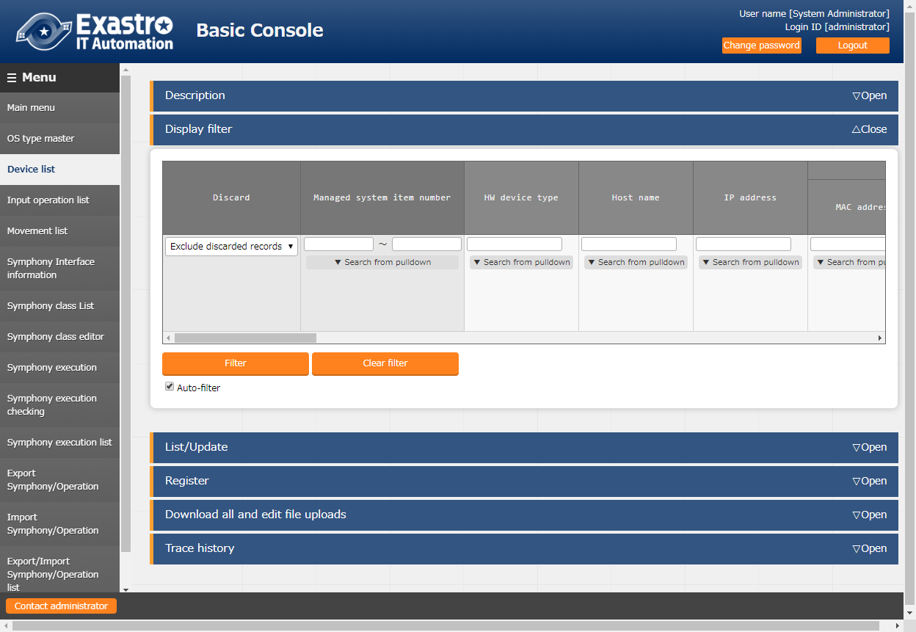

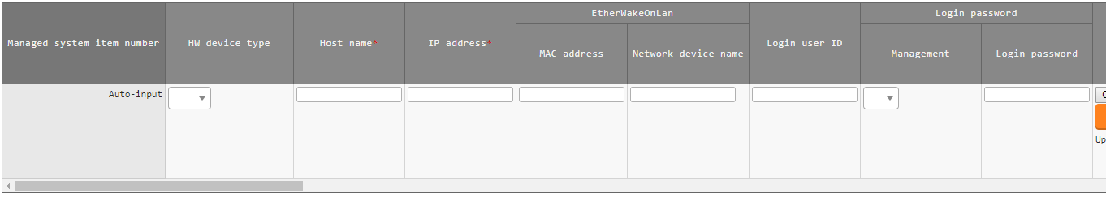

Figure 5.2-1 Device list screen - 1

Table 5.2-1 Device list item description - 1

|  |  |  |  |  |  |
| --- | --- | --- | --- | --- | --- |
| Item | | Description | Input required | Input type | Restrictions |
| HW device type | | Select SV | ○ | List | - |
| Host name | | Enter host name | ○ | Manual | Maximum length 128 bytes |
| IP address | | Enter IP address | ○ | Manual | Maximum length 15 bytes |
| Login user ID | | Enter login user ID | ○ | Manual | Maximum length 30 bytes |
| Login password | Management | Select "●" if password is required when connecting to target host from DSC. | ○ | List | - |
| Login password | Enter the password of Login user ID if "●" is selected for Management column. | ○ | Manual | Maximum length 30 bytes |

**【Notes】**

**Input of the columns with a red asterisk (*) after their column name in the web screen is required. In the case of using DSC driver, entering the items of device list above (red frame) is also required. If operation is executed while required column is not entered, unexpected errors may occur.**

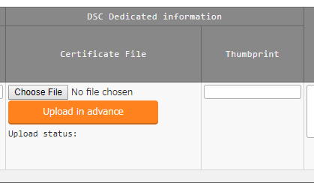

Figure 5.2-2 Device list screen - 2

Table 5.2-2 Device list item description - 2

|  |  |  |  |  |  |
| --- | --- | --- | --- | --- | --- |
| Item | | Description | Input required | Input type | Restrictions |
| DSC Dedicated information | Certificate file | In the case of encrypting credential(password) when creating MOF file, enter the public key file output by public key file output script.  Credential will not be encrypted if the column is not entered.  Refer to “5.6 How to Use Public Key File Output Script” for how to use the public key file output script. | － | File |  |
| Thumbprint | In the case of encrypting credential(password) when creating MOF file, enter the thumbprint output by public key file output script.  Credential will not be encrypted if the column is not entered  Refer to “5.6 How to Use Public Key File Output Script” for how to use the public key file output script. | － | Manual | 40byte alphanumeric character |

### **Associated menu**

Register/Update/Discard the menu of configuration management database that is associated with substitution value auto-registration setting menu.

※This is an optional function the can be associated when configuration management database is customized. This function can't be used on default.

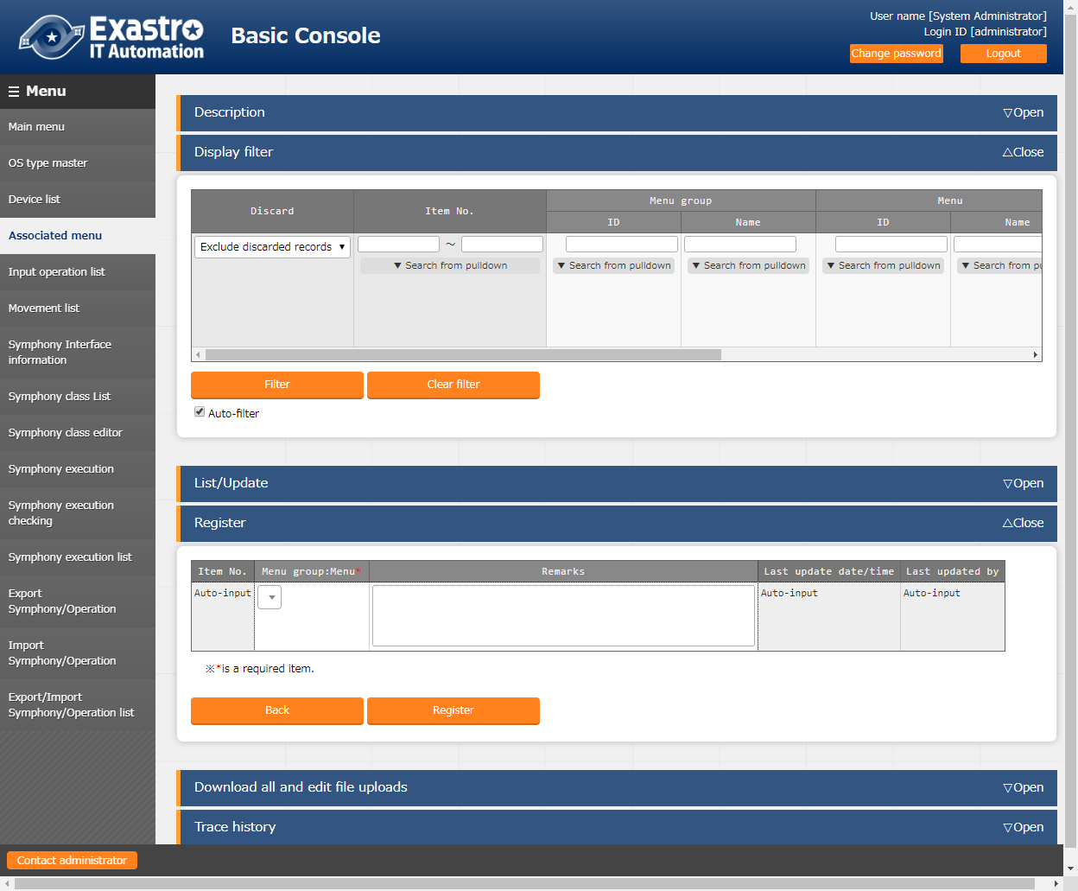

Figure 5.2-3 Associated menu screen

Table 5.2-3 Associated menu item description

|  |  |  |  |  |
| --- | --- | --- | --- | --- |
| Item | Description | Input required | Input type | Restrictions |
| Menu group: Menu※2 | The menu of configuration management database is displayed.  Select the menu of configuration management database to be associate with the substitution value auto-registration setting menu. | ○ | List | － |
| Remarks | Free description field | － | Manual | Maximum length 4000 bytes |

※2 Registration of the menu group and menu of configuration management database is required.

Please refer to "User instruction manual_Basic console" for the details of registration method.

### **Input operation list**

Register/Update/Discard the information of the operations for the construction management target host that are to be executed by the orchestrator.

This document explains the items (red frame) required for the operations of DSC driver.

Please refer to "User instruction manual_Basic console" for the description of the other items.

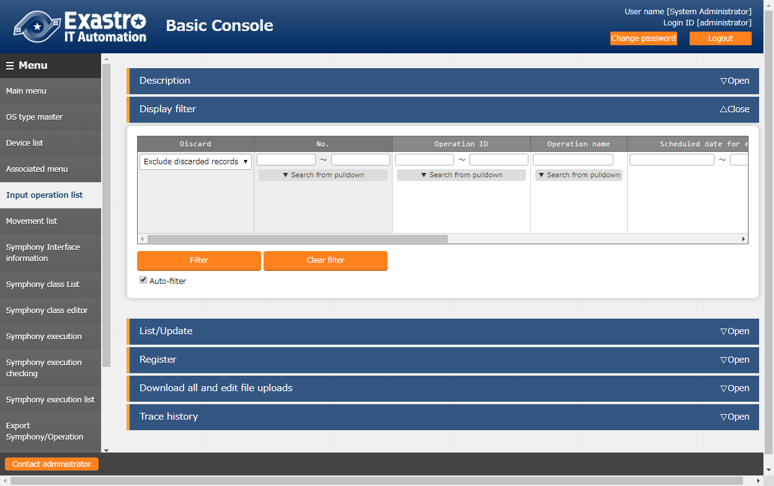

**Figure 5.2-4 Submenu screen (Input operation list)**



Figure 5.2-5 Registration screen (Input operation list)

**Table 5.2-4 Registration screen item list (Input operation list)**

|  |  |  |  |  |
| --- | --- | --- | --- | --- |
| Item | Description | Input required | Input type | Restrictions |
| Operation name | Register any desired operation name. | ○ | Manual | Maximum length 256 bytes |
| Scheduled date for execution | Enter the scheduled date and time of the operation. ※The process is not actually executed on the date specified here. ※The work history associated with the operation for which the scheduled execution date and time is set is automatically deleted after the specified reservation period. | ○ | Manual | - |
| Operation ID | The system automatically inputs a unique ID that identifies the operation. | - | Auto | - |
| Remarks | Free description field | - | Manual | Maximum length 4000 bytes |

## DSC driver console

This chapter describes the operations in DSC driver console.

### **Interface information**

Register/Update/Discard the shared directory path between ITA system, DSC driver server, and DSC server, and the connection interface information to DSC server.

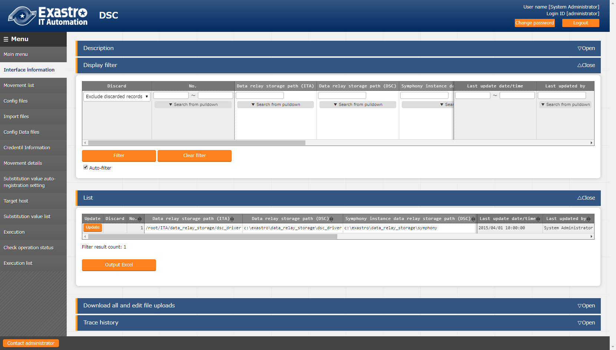

Figure 5.3-1 Interface information screen

Table 5.3-1 Description of Interface information item

|  |  |  |  |  |
| --- | --- | --- | --- | --- |
| Item | Description | Input required | Input type | Restrictions |
| Data relay storage path(ITA) | Enter the directory viewed from ITA system and DSC driver server | ○ | Manual | Maximum length 256 bytes |
| Data relay storage path(DSC) | Enter the directory viewed from DSC RestAPI | ○ | Manual | Maximum length 256 bytes |
| Protocol | Enter either http or https | ○ | Manual | As described in the description column |
| Host name | Enter the host name of server (or IP address).  Host name is recommended when using HTTPS communication. | ○ | Manual | Maximum length 128 bytes |
| Port | Enter the connection port to DSC server. Usually the port is HTTPS(443) | ○ | Manual | - |
| ACCESS_KEY_ID | Enter the access key used for authentication when connecting to DSC server | ○ | Manual | Maximum length 64 bytes |
| SECRET_ACCESS_KEY | Enter the secret access key used for authentication when connecting to DSC server | ○ | Manual | Maximum length 64 bytes |
| Status monitoring cycle(milliseconds) | Enter the refresh interval of the log displayed in "5.3.12 Check operation status" menu. Usually the value around 3000 milliseconds is recommended. | ○ | Manual | Minimum value 1000 milliseconds |
| Number of rows to display progress status | Enter the maximum display line count of the execution log, error log in "5.3.12 Check operation status".  Usually the value around 1000 lines is recommended. | ○ | Manual | - |
| NULL link | Set whether to register NULL(blank) value to substitution value list menu if the specific value in parameter sheet is NULL(blank) in the substitution value auto-registration setting menu  This value will be applied when “NULL link” in the substitution value auto-registration setting menu is blank.  ・If the "Valid" is set, any value in the parameter sheet will be registered in the substitution value list menu. (NULL value will be registered)  ・If the "Invalid" is set, only specific value in the parameter sheet will be registered in the substitution value list menu (NULL value will not be registered) | ○ | List | - |
| Remarks | free description field | － | Manual | Maximum length 4000 bytes |

**【Notes】**

**If operation is executed while interface information is not registered or multiple records are registered, unexpected errors may occur during operation execution.**

### **Movement list**

Register/Update/Discard movement name.

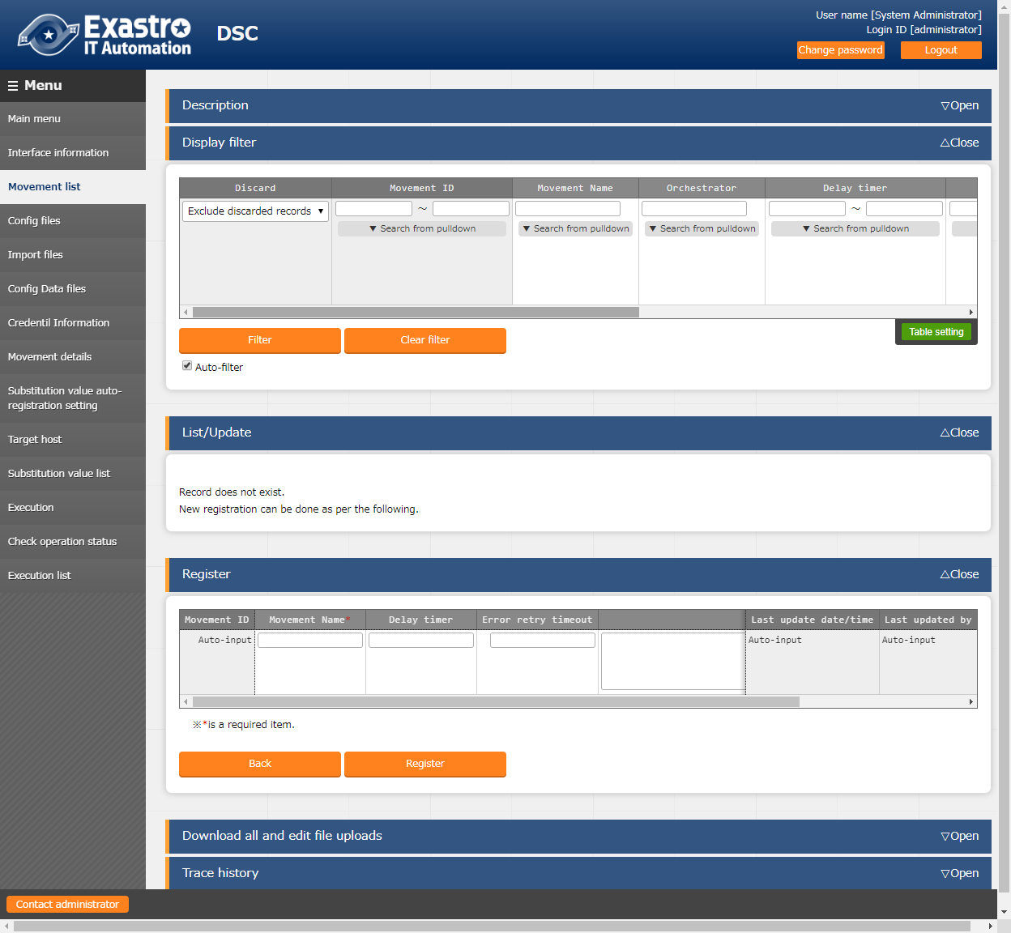

Figure 5.3-2 Movement list screen

Table 5.3-2 Description of Movement list item

|  |  |  |  |  |
| --- | --- | --- | --- | --- |
| Item | Description | Input required | Input type | Restrictions |
| Movement name | Enter the name of Movement. | ○ | Manual | Maximum length 256 bytes |
| Delay timer | Enter the specified period (1~), if you want the warning of delay to be displayed when the scheduled time of Movement has delayed. (Unit:minute)  The warning will not display if the column is not entered. | － | Manual | － |
| Error retry timeout | If error occurs in the Movement during the entered time, the Movement will be retried. (Unit: Second)  If the error continues over the entered time, it will be regarded as an unexpected error.  If the column is not entered, the movement will not be retried.  Enter if restarting the configuration target server is required. (Refer to the definition of config data for the way to set the restart of server) | － | Manual | － |
| Remarks | Free description field. | － | Manual | Maximum length 4000 bytes |

### **Config files**

Register/update/Discard the config file created by the users.

Refer to "3.2 Definition of configuration" for the description of config file.

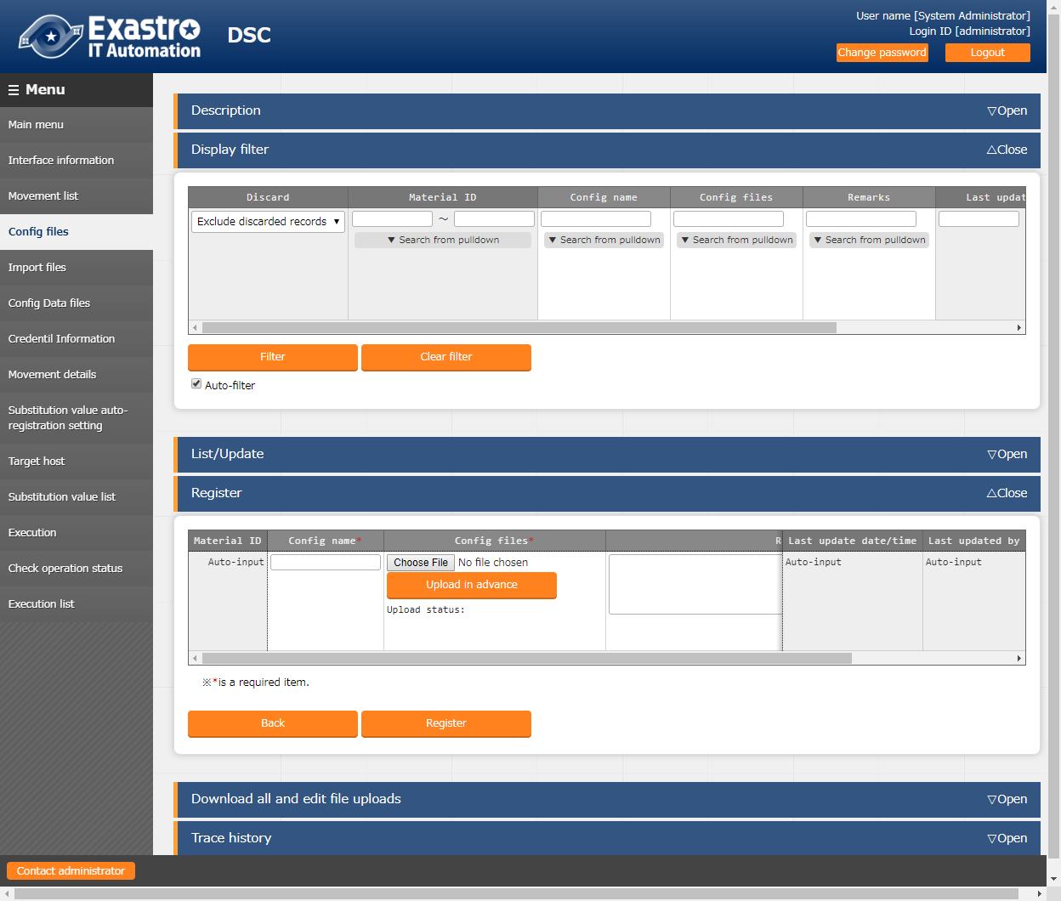

Figure 5.3-3 Config files screen

Table 5.3-3 Description of Config files item

|  |  |  |  |  |
| --- | --- | --- | --- | --- |
| Item | Description | Input required | Input type | Restrictions |
| Config name | Enter the config file name to be managed in ITA. | ○ | Manual | Maximum length 32 bytes  **half-width alphanumeric value and underscore** |
| Config files | Click the "Choose file" button to specify the config file to be uploaded.  Click the "Upload in advance" button to upload the specified config file. | ○ | File | Maximum size 20M byte |
| Remarks | Free description field. | － | Manual | Maximum length 4000 bytes |

Please "Upload in advance" the "config files" before "register". After "Upload in advance", check the displayed config file name in "Upload status" then click the "Register" button.

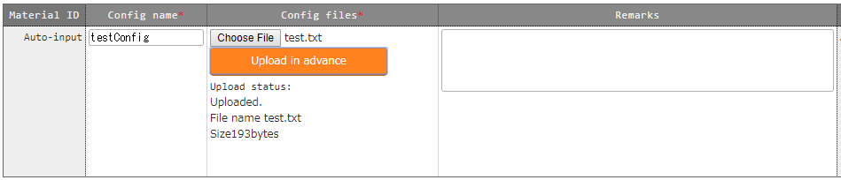

Figure 5.3-4 Config files Upload in advance screen

The variables defined in the config files are extracted by BackYard process. The specific value of the extracted variables can be registered in "5.3.10 Substitution value list".

Since the extraction timing is not in real time, it may take some time※4 until the variables can be handled in "5.3.10 Substitution value list".

※4 Depends on the startup cycle of「5.10 Change startup cycle「ky_dsc_varsautolistup-workflow/ky_dsc_valautostup-workflow」」

### **Import files**

Register/update/Discard the Import file created by users

Please refer to "3.2 Definition of configuration" for the description of Import file.

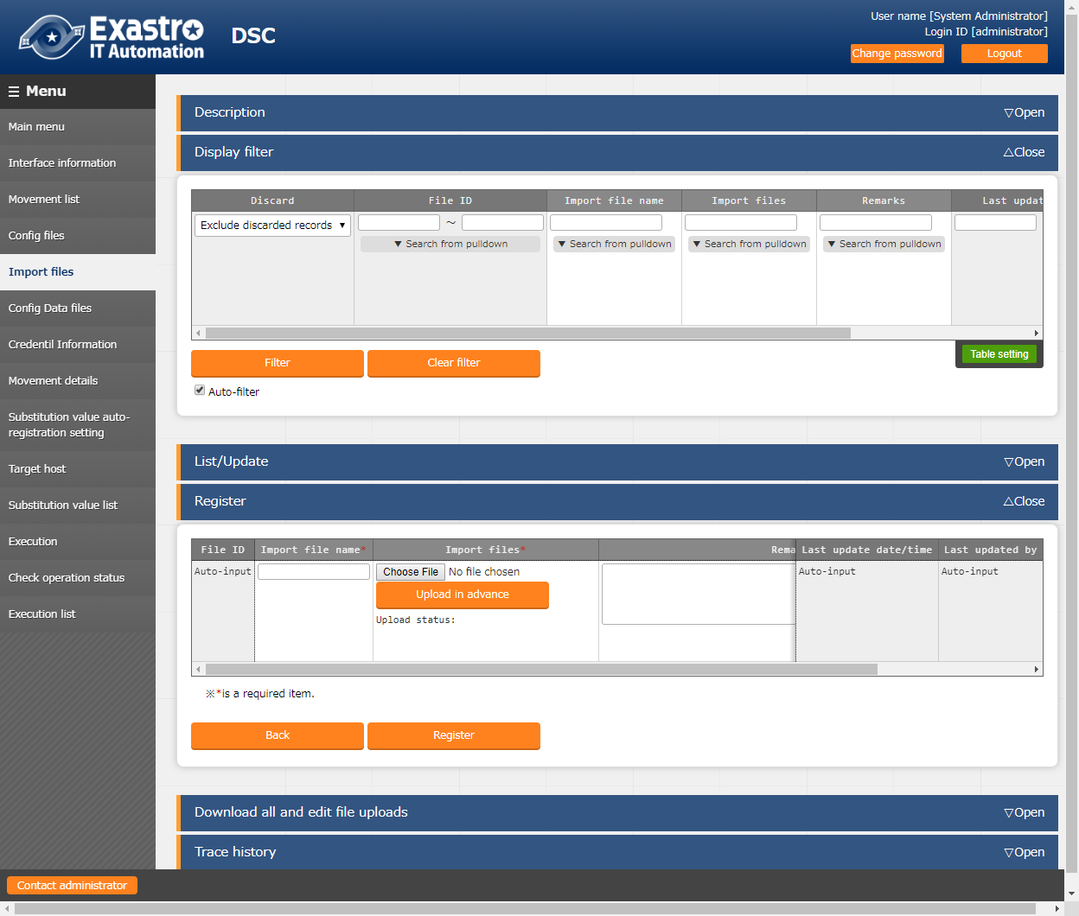

Figure 5.3-5 Import files screen

Table 5.3-4 Description of Import files item

|  |  |  |  |  |
| --- | --- | --- | --- | --- |
| Item | Description | Input required | Input type | Restrictions |
| Import file name | Enter the Import file name to be managed in ITA. | ○ | Manual | Maximum length 32 bytes  **half-width alphanumeric value and underscore** |
| Import files | Click the "Choose file" button to specify the Import file to be uploaded.  Click the "Upload in advance" button to upload the specified import file. | ○ | File | Maximum size 20M byte |
| Remarks | Free description field | － | Manual | Maximum length 4000 bytes |

Same as config files, please "Upload in advance" the "Import files" before "register". After "Upload in advance", check the displayed Import file name in "Upload status" then click the "Register" button.

### **Config data files**

Register/update/Discard the config data file created by users

Please refer to "3.2 Definition of configuration" for the description of Config data file.

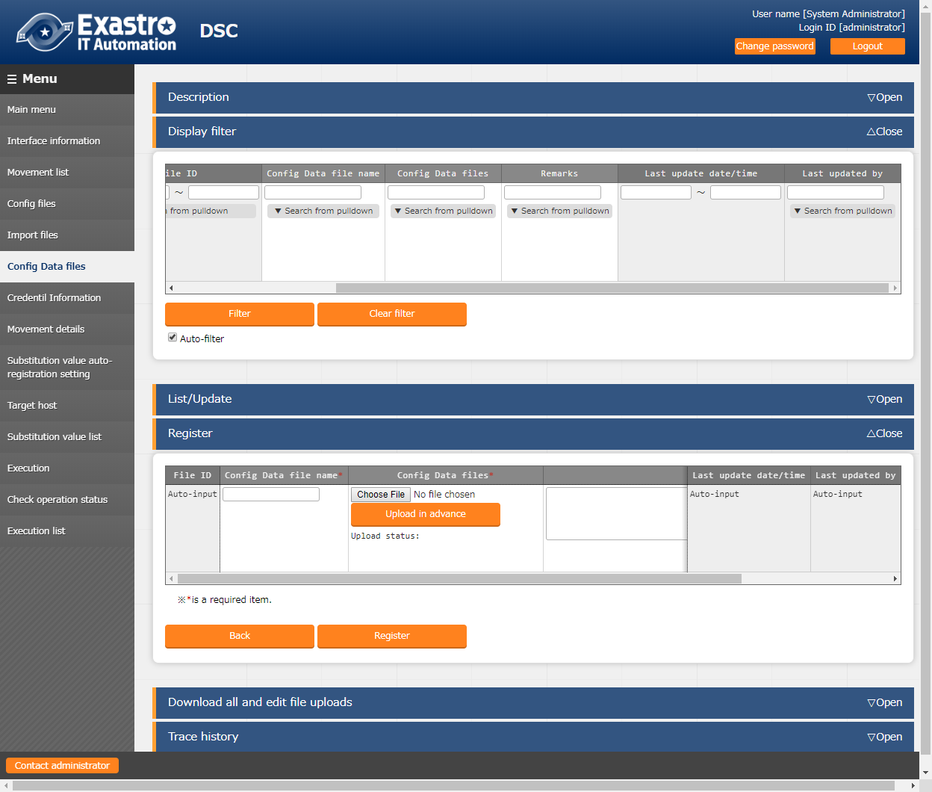

Figure 5.3-6 Config data files screen

Table 5.3-5 Description of Config data files screen

|  |  |  |  |  |
| --- | --- | --- | --- | --- |
| Item | Description | Input required | Input type | Restrictions |
| Config data file name | Enter the config data file name to be managed in ITA. | ○ | Manual | Maximum length 32 bytes  **half-width alphanumeric value and underscore** |
| Config data files | Click the "Choose file" button to specify the config file to be uploaded.  Click the "Upload in advance" button to upload specified config file. | ○ | File | Maximum size 20M byte |
| Remarks | Fee description field. | － | Manual | Maximum length 4000 bytes |

Same as config files, please "Upload in advance" the "config data files" before "register". After "Upload in advance", check the displayed config data file name in "Upload status" then click the "Register" button.

### **Credential information**

Maintain (view/register/update/discard) the credential set in the Configuration file.

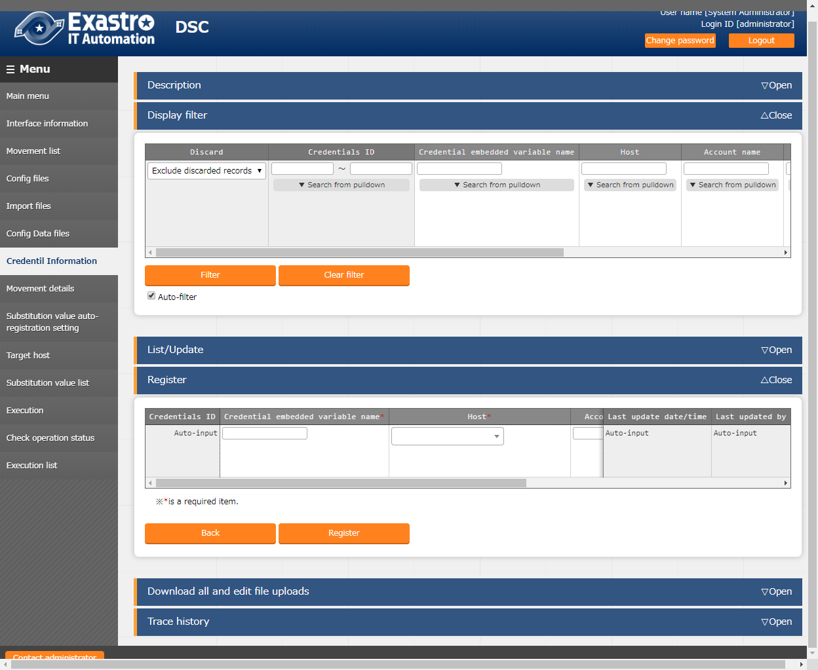

Figure 5.3-7 Credential information screen

Table 5.3-6 Description of credential information item

|  |  |  |  |  |
| --- | --- | --- | --- | --- |
| Item | Description | Input required | Input type | Restrictions |
| Credential embedded variable name | Enter the embedded variable to be descirbed in config file. Enter the variable name in "CDT_****" format.  ****: half-width alphanumeric character and underscore( _ ) can be used.(Minimum length: 1 byte, maximum length: 32 bytes) | ○ | Manual | As described in the description column |
| Host | The host name registered in device list is displayed.  Select the host to be linked with the operation. | ○ | List | － |
| Account name | Enter the account name of the credential. | ○ | Manual | Maximum length 32 bytes |
| Password | Enter the password of the credential. | － | Manual | Maximum length 40 bytes |
| Remarks | Free description field. | － | Manual | Maximum length 4000 bytes |

### **Movement details**

Register/Update/Discard the files to be executed in Movement.

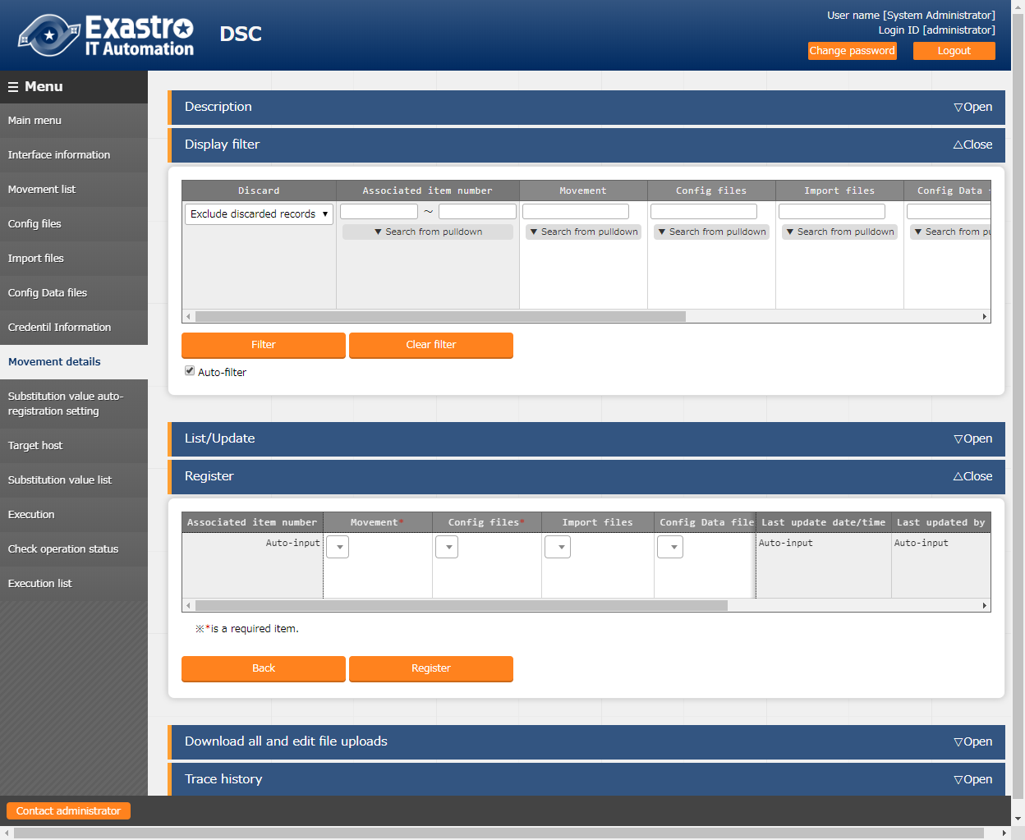

Figure 5.3-8 Movement details screen

Table 5.3-7 Description of Movement details item

|  |  |  |  |  |
| --- | --- | --- | --- | --- |
| Item | Description | Input required | Input type | Restrictions |
| Movement | Movement registered in Movement list is displayed.  Select the Movement. | ○ | List | － |
| Config files | The config file registered in "5.3.3 Config files" is displayed.  Select the Config file. | ○ | List | － |
| Import files | The Import file registered in "5.3.4 Import files" is displayed. Select the import file.  If the column is set, the content of the selected Import file will be output to configuration file. | － | List | － |
| Config data files | The config data file registered in "5.3.5 Config data files" is displayed. Select the config data file.  If the column is set, the content of the selected config data file will be output to configuration file. | － | List | － |
| Remarks | Free description field. | － | Manual | Maximum length 4000 bytes |

**【Notes】**

**Registering multiple config file to a Movement is invalid.**

### **Substitution value auto-registration setting**

Register/update/discard the Movement and variable associated to every item value of operation and host in the configuration management database which is set as the association target in "5.2.2 Associated menu".

The registered information will reflected to "substitution value list" menu and "target host" menu

by internal process.

※This is an optional function the can be associated when configuration management database

is customized. This function can't be used on default.

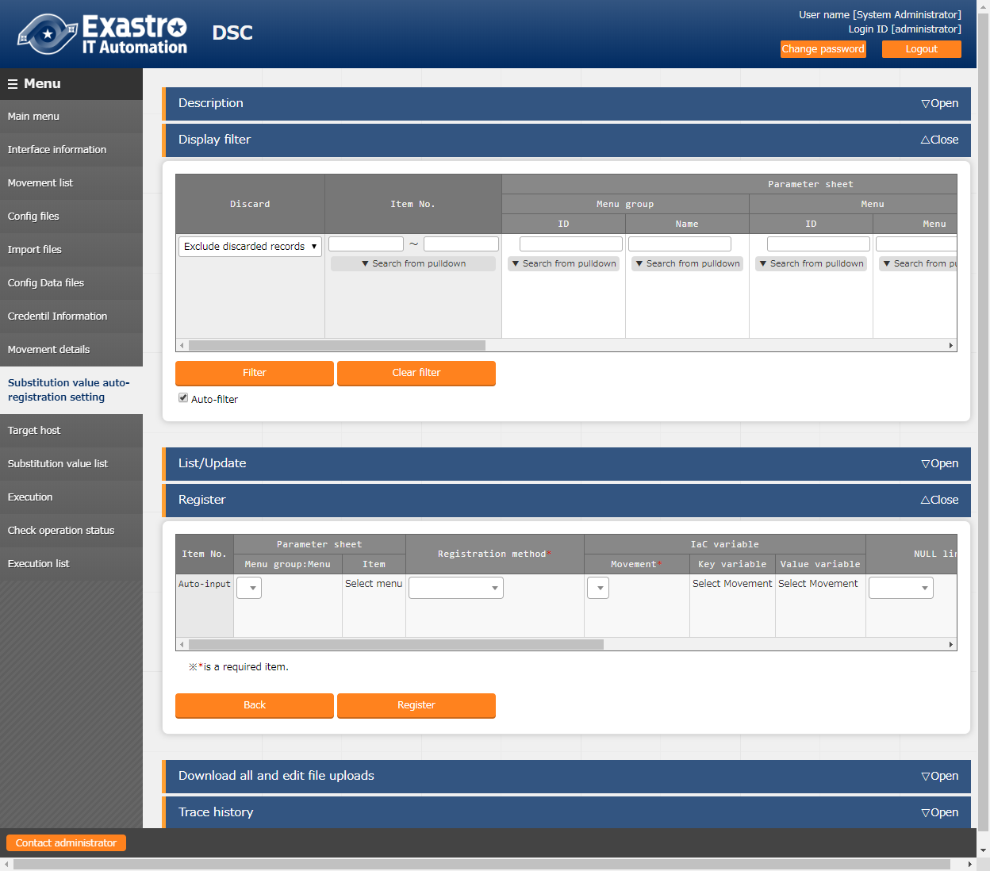

Figure 5.3-9 Substitution value auto-registration setting screen

Table 5.3-8 Description of Substitution value auto-registration setting item

|  |  |  |  |  |
| --- | --- | --- | --- | --- |
| Column | Description | Input required | Input type | Restrictions |
| Menu group: Menu | Configuration Management Database menu is displayed.  Select the Configuration Management Database menu of the association target | ○ | List | － |
| Item | The item of selected Configuration Management Database menu is displayed.  Select the Configuration Management Database menu of the association target. | ○ | List | － |
| Registration method | Value type: Select to set the setting value of item as the specific value of the associated variable. | ○ | List | － |
| Key type: Select to set the name of item as the specific value of the associated variable.  If the setting value of the item is blank, it cannot be linked. | ○ | List | － |
| Key-Value type: Select to set the name (Key) and setting value (Value) of item as the specific value of the associated variable | ○ | List | － |
| Movement | The Movement registered in the Movement list will be displayed.  Select the Movement. | ○ | List | － |
| Key variable | The variables used in the file registered in Movement details menu are displayed.  Select the variable to associate with the item name as specific value.  Required if the registration method is Key type or Key-Value type. | - | List | － |
| Value variable | The variables used in the file registered in Movement details menu are displayed.  Select the variable to associate with the item name as specific value.  Required if the registration method is Value type or Key-Value type. | - | List | － |
| NULL link | Set whether to register NULL (blank) value to substitution value list menu if the specific value in parameter sheet is NULL (blank).  ・If the "Valid" is set, any value in the parameter sheet will be registered in the substitution value list menu. (NULL value will be registered)  ・If the "Invalid" is set, only specific value in the parameter sheet will be registered in the substitution value list menu (NULL value will not be registered)  ・If the column is blank, the "NULL link" value in DSC interface information menu will be applied. | - | List | - |
| Remarks | Free description field. | － | Manual | Maximum length 4000 bytes. |

The information registered in "substitution value auto registration setting" menu is reflected to "substitution value list" menu and "target host" menu by internal process. The timing of reflection is not in real time, so it may cost some time※9 until reflecting to substitution value list menu and target host menu.

※9 Depends on the startup cycle of「5.10 Change startup cycle「ky_dsc_varsautolistup-workflow/ky_dsc_valautostup-workflow」」

### **Target host**

Register/update/discard the Movement and host associated with Operation.

The data in target host menu is automatically updated by BackYard process. Please refer to "5.5 BackYard contents" for details.

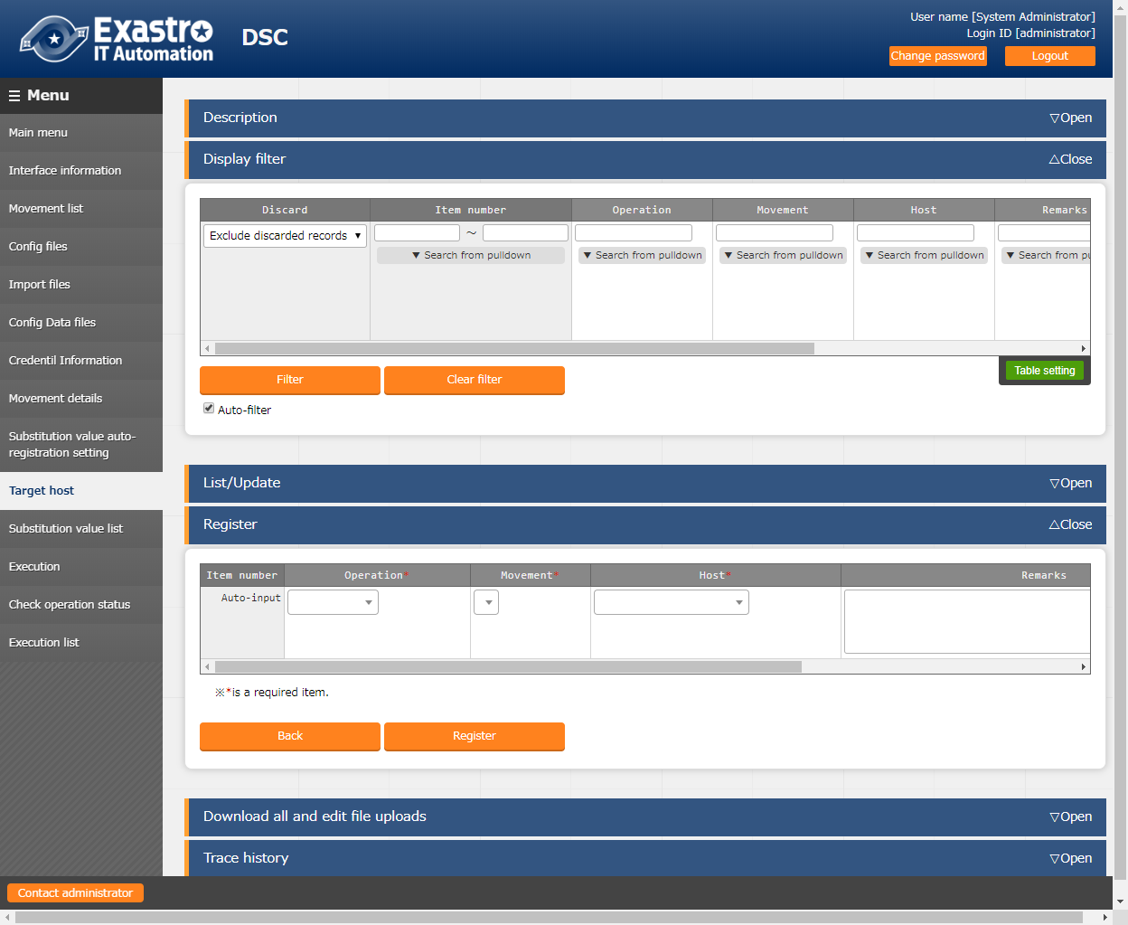

Figure 5.3-10 Target host screen

Table 5.3-9 Description of target host item

|  |  |  |  |  |
| --- | --- | --- | --- | --- |
| Item | Description | Input required | Input type | Restrictions |
| Operation | The Operation registered in the input operation list is displayed.  Select the Operation. | ○ | List | － |
| Movement | The Movement registered in the Movement list is displayed.  Select the Movement to be associated with Operation. | ○ | List | － |
| Host | The host name registered in the device list is displayed.  Select the host to be associated with the Operation. | ○ | List | － |
| Remarks | Free description field. | － | Manual | Maximum length 4000 bytes |

### **Substitution value list**

Maintain (View/Register/Update/Discard) the specific value to substitute the "VAR_" variable in the config file, Import file, Config data file used in target Movement for each Operation.

The information of registered variable are output to config file during operation execution.

The data in substitution value list is automatically updated by BackYard process. Please refer to "5.5 BackYard contents" for details.

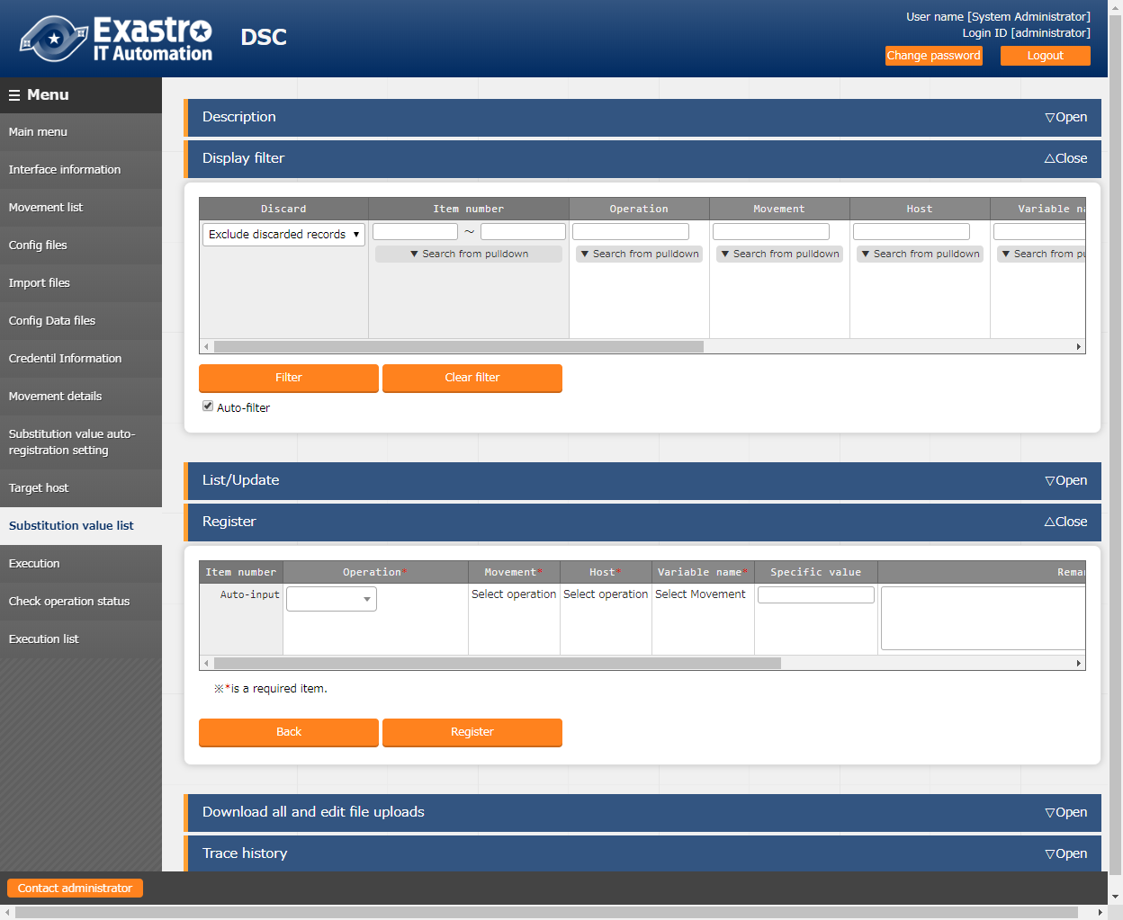

Figure 5.3-11 Substitution value list screen

Table 5.3-10 Description of substitution value list item

|  |  |  |  |  |
| --- | --- | --- | --- | --- |
| Item | Description | Input required | Input type | Restrictions |
| Operation | The Operation registered in the operation target host is displayed.  Select the Operation. | ○ | List | － |
| Movement | The Movement associated with the selected Operation from the data registered in the target host menu is displayed.  Select the Movement. | ○ | List | － |
| Host | The host associated with the Operation and Movement selected from the data registered in the target host menu is displayed. Select the host. | ○ | List | － |
| Variable name | The variable name attached with the Movement selected from the data registered in the Movement details menu is displayed.  Select the variable. | ○ | List | － |
| Specific value | Enter the specific value of variable to be used in Operation / Movement /host  **(Note) Please don't enter Kanji (2 byte character). Error will occur during execution.** | ○ | Manual | Maximum length 8192 bytes |
| Remarks | Free description field. | － | Manual | Maximum length 4000 bytes |

### **Execution**

Indicate Operation execution. Select the radio button from the Movement list and operation list and click the execution button, the screen will jump to "5.3.12 Check operation status" and the operation will be executed.

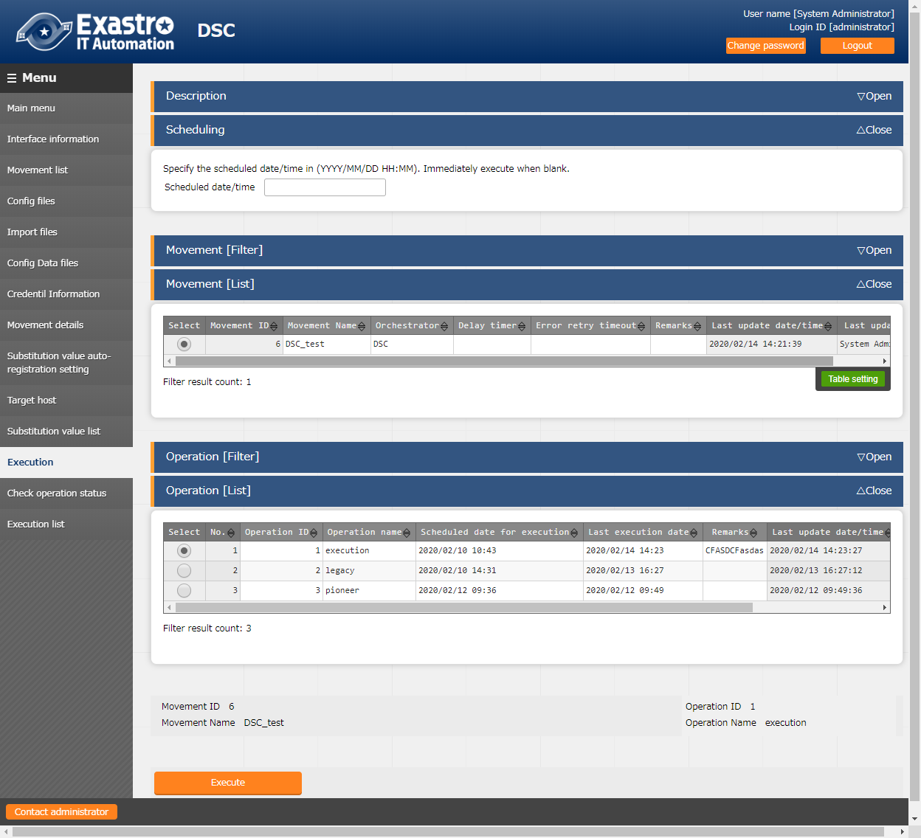

Figure 5.2-12 Execution screen

Table 5.3-11 Description of Execution

|  |  |  |  |  |
| --- | --- | --- | --- | --- |
| Item | Description | Input required | Input type | Restrictions |
| Scheduled date/time | Scheduling execution is possible by setting the "scheduled date/time".  Only future date/time can be registered for the "scheduled date/time". | － | Manual |  |
| Movement | Select the Movement displayed in Movement list. | ○ | Button |  |
| Operation | Select the Operation displayed in Operation list. | ○ | Button |  |
| Execute | Execute the selected Movement/Operation by clicking the execute button. | ○ | Execute button |  |

### **Check operation status**

Monitor the execution status of operation.

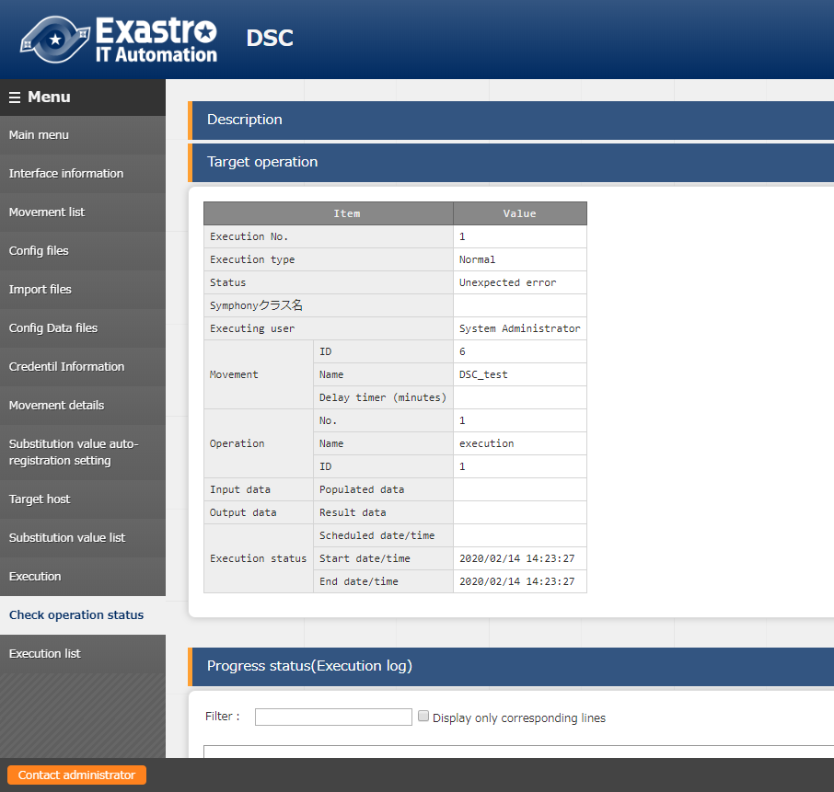

Figure 5.3-13 Check operation status screen

1. Display operation status

Table 5.3-12 Description of Check operation status item

|  |  |  |  |
| --- | --- | --- | --- |
| Item | | | Description |
| Execution No. | | | The executed execution number is displayed. |
| Execution type | | | "Normal" is displayed. |
| Status | | | The status of execution log is displayed. |
| Caller symphony | | | From which Symphony the operation is executed is displayed.  The column is empty if executed directly from DSC driver. |
| Execution user | | | The login user when clicking the "execute" button in the "execution" menu will be displayed. |
| Movement | | ID | The executed Movement ID is displayed. |
| Name | The executed Movement name is displayed. |
| Delay timer (minutes) | If the execution delayed, the delayed time (minutes) is displayed. |
| Operation | | No. | The executed Operation No. is displayed. |
| Name | The executed Operation name is displayed. |
| ID | The executed Operation ID is displayed. |
| Input data | | | The input data file name of execution target host is displayed. |
| Output data | | | The result data file name of execution target host is displayed. |
| Operation status | Scheduled date/time | | If execution is scheduled, the scheduled time is displayed. |
| Start date/time | | The start time of the execution is displayed. |
| End date/time | | The end time of the execution is displayed. |

1. Display of execution status (execution log)

The details of execution status during DSC execution is displayed.

1. Display of execution status (error log)

If the status ends with an unexpected error and the cause is incomplete registration of web contents, message will be displayed in error log.

In addition, in the case that communication with DSC RestAPI fails, message will not be displayed in error log. In this case, error information will be recorded in application log. Please check the application log if necessary.

1. Emergency stop/schedule cancellation

It is possible to stop the construction operation by clicking the "Emergency stop" button.

In addition, for the "scheduled execution" operation before execution, the "schedule cancellation" button will be displayed. Cancel the scheduled execution by clicking the "schedule cancellation" button.

1. Log filter

Execution log and error log can be filtered. By entering the string that the user wants to search in the filter box of each log and checking the "Display only corresponding lines" checkbox, only the corresponding line will be displayed.

The display refresh interval and the maximum display line count of execution and error log can be set in "Status monitoring cycle (milliseconds)" and "Number of rows to display progress status" of "5.3.1 Interface information" menu.

1. Input data

Users can download files such as executed config file.

1. Output data

Users can download files such as execution log and error log.

### **Execution list**

The history of operation can be viewed here.

By clicking the "Check execution status" button, the screen will jump to "5.3.12 Check operation status" and the details of execution status can be viewed.

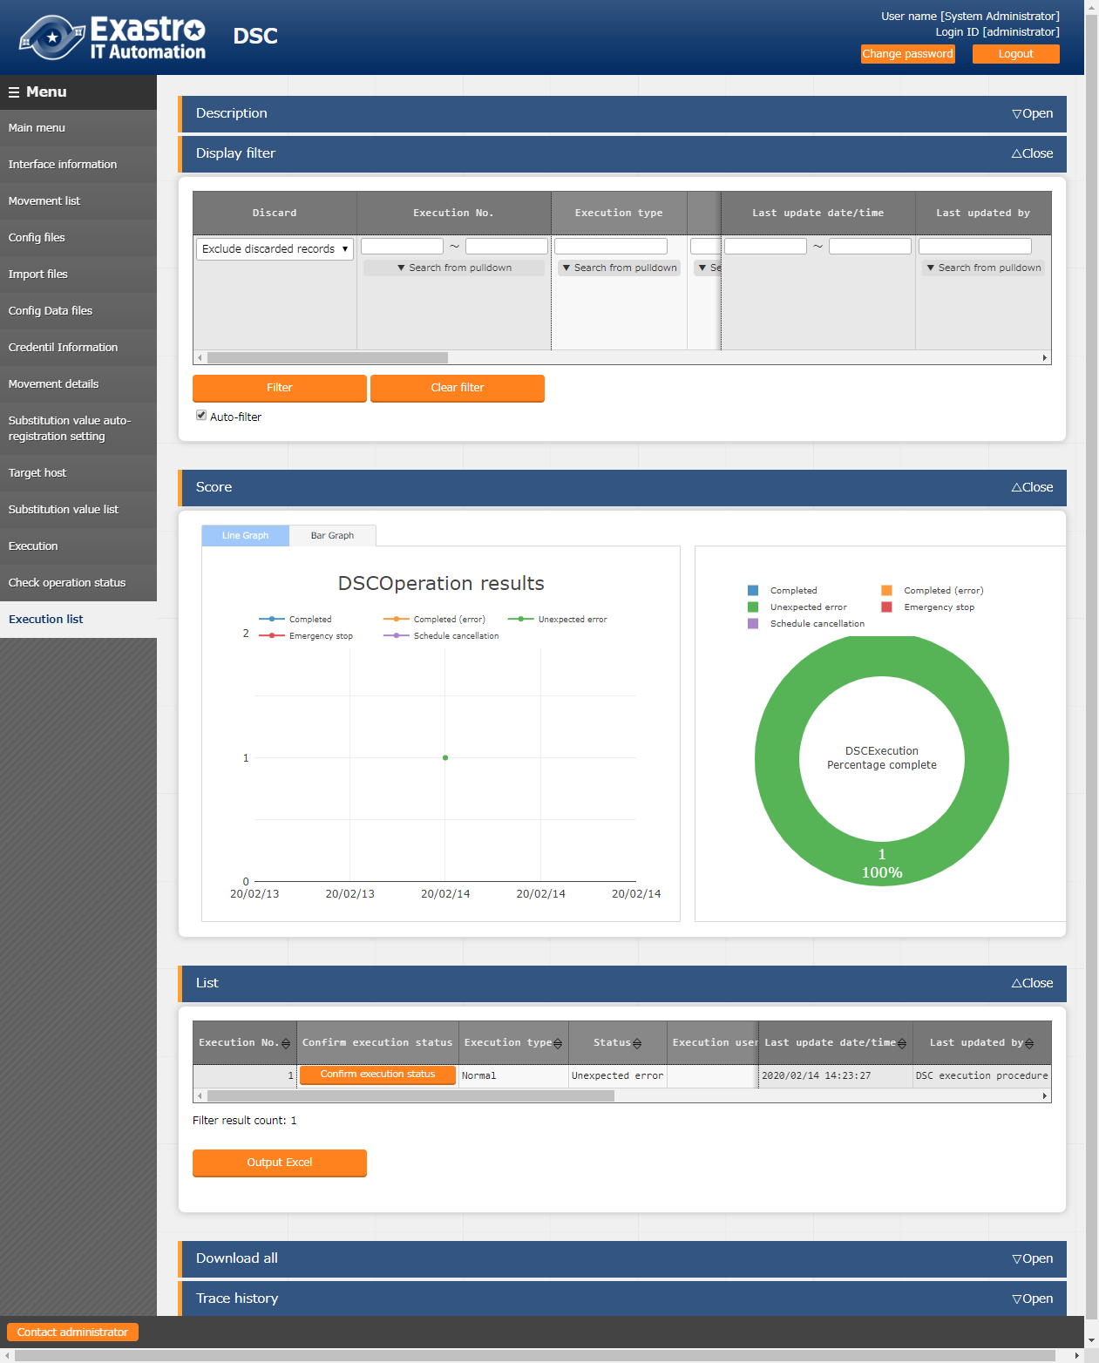

Figure 5.3-14 Execution list screen

Table 5.3-13 Description of execution list item

|  |  |
| --- | --- |
| Item | Description |
| Check execution status | Display the "Check operation status" screen by clicking the "Check execution status" button of the selected execution No. |

※Please check ” 5.3.12 Check operation status" for the description of other items.

## Description of configuration (DSC)

Please refer to the official contents of DSC for the basic format.

Please use UTF-8 for the character encoding.

Please refer to "3.2 Definition of configuration" for details of the configuration (DSC) description.

## BackYard contents

There are three types of BackYard contents.

1. **Automatic variable registration setting**

When uploading file such as resources to the “Config file” menu of DSC, the variables are extracted from the uploaded file.

The extraction timing is not in real-time, so it may take some time※10 before variables can be handled in “5.3.10 Substitution Value list”.

1. Unique management of variable names

The extracted variable names are uniquely managed from all materials uploaded to DSC.

※10 Depends on the startup cycle of "5.10 Change startup cycle" ky_dsc_varsautolistup-workflow / ky_dsc_valautostup-workflow".

1. **Substitute value auto-registration setting**

In “5.2.2 Movement list menu”, Movements that link to operation of the association target CMDB and the setting value of the item for each host, and the information of the variables are reflected to the substitution value list menu and target host menu.

Since the timing of file reading is not in real time, it may take some time※11 until the variables are reflected to “5.3.9 Target host” and “5.3.10 Substitution value list”.

Target host and substitution value list menu is updated by multiple operators. Reflection will not be performed if the last updater is other operator (not Backyard).

When user wants to reflect the data in substitution value auto-registration setting menu, please perform operations such as discard the applicable record in substitution value list value or disable the applicable record in other BackYard process.

The reflection rules to Target host menu and Substitution value list menu are as follows.

1. When reflecting the information registered in substitution value auto-registration setting to substitution value list.

|  |  |  |  |  |  |
| --- | --- | --- | --- | --- | --- |
| **The status of substitution value list** | **Doesn't exist applicable record** | **Exist applicable record** | | | **Applicable record is being discarded** |
| **=** **Specific value** | **≠** **Specific value** | |
| **Last updated by** | |
| **BackYard process** | **Other operators** |
| **Reflection in substitution value list** | Add new record | - | Update the specific value of the applicable record | - | Restore the  discarded record |

※Applicable record: The record that has same Operation+host+Movement+variable name + (member variable)+(include order)

1. When reflecting the information that is not registered in "substitution value auto-registration setting" menu (registered only in "substitution value" menu) to substitution value list

|  |  |  |
| --- | --- | --- |
| **The status of substitution value list** | **Exist applicable record** | |
| **Last updated by** | |
| **BackYard process** | **Other operators** |
| **Reflection in substitution value list** | Discard the applicable record | - |

1. When reflecting the information registered in substitution value auto-registration setting to target host menu

|  |  |  |  |
| --- | --- | --- | --- |
| **The status of operation target host** | **Doesn't exist applicable record** | **Exist applicable record** | **Applicable record is being discarded** |
| **Reflection in operation target host** | Add new record | － | Restore the discarded record |

※ Applicable record: The record that has same Operation+host+Movement

1. When reflecting the information that is not registered in substitution value auto-registration setting(only registered in target host menu) to target host menu

|  |  |  |
| --- | --- | --- |
| **The status of substitution value list** | **Exist applicable record** | |
| **Last updated by** | |
| **BackYard process** | **Other operators** |
| **Reflection in substitution value list** | Discard the applicable record | - |

1. When one variable is registered to link with multiple items.

The variable is excluded from the reflection target to substitution value list and target host.

※11 Depends on the startup cycle of "5.10 Change startup cycle" ky_dsc_varsautolistup-workflow / ky_dsc_valautostup-workflow".

1. **Delete operation instance history**

If the operation ID of the operation registered in the input operation list of ITA basic console whose scheduled execution date has passed for a certain period of time and has record in "5.3.9 Target host" or "5.3.10 Substitution value list", delete (physical deletion or discard) the record according to the passed time.

The expired date is registered in the following file. Records are deleted according to this number of days (Physically deleted or discarded).

●Registration file for expiration date

~/ita-root/confs/backyardconfs/dsc_driver/keep_day_length.txt

●File format

p1,p2　　　　　p1: Days until discard. p2: Days until physical deletion.

e.g. )

In the case: Days until discard: 30 days , Days until physical deletion: 60 days

30,60

## How to Use Public Key File Output Script

When encrypting the credential (password) while creating the MOF file, please create a public key file using the public key file output script according to the following procedure and register the created file to “5.2.1 Device list” .

The registration method is as follows.

1. Deploy public-key file output scripts

Copy the "CreateTagCert.ps1" and "New-SelfSignedCertificateEx.ps1" script files under the "~/ita_install_package/ITA/ita-contents-win/C/inetpub/wwwroot/restapi/dsc_driver" folder to any folder in the WindowServer registered in "5.2.1 Device list" menu.

1. Output public key file and display thumbprint

Run PowerShell as an administrator on the WindowServer that contains the public key file script file.

Move to the folder copied in ① and execute the following command.

Exp)

PS C:\tmp> .\CreateTagCert.ps1

Thumbprint Subject

---------- -------

5C34D190A16FAD0CA93A84BA57C47C33BABF01D2 CN=DSC-TEST

LastWriteTime : 2018/06/04 11:54:15

Length : 784

Name : DscPublicKey.cer

After executing the above command, register the output Thumbprint in "5.2.1 Device list".

1. Check the public key file output destination folder

Execute "cd $env:temp" and "dir" to confirm the folder where the public key file was output.

Exp)

PS C:\tmp> cd $env:temp

PS C:\Users\Administrator.DSC-TEST.014\AppData\Local\Temp\2> dir

Directory: C:\Users\Administrator.DSC-TEST.014\AppData\Local\Temp\2

After confirming the above command, open the output folder in File Explorer and select "DscPublicKey.cer" file.

Register the acquired file from "Device list".

## Application operation

The operation to utilize ITA system contains not only inputs by user from the browser screen of client PC but also operations according to system operation and maintenance.

The available operation and maintenance are as follows.

●Installation related

●Change log level

●Maintenance

## Installation related

Please refer to the other document "Installation Manual" for post-installation work.

## Change log level

The method of changing the log level of the ITA system process is as follows.

The process whose log level can be changed are normal independent monitoring processes.

1. Change to NORMAL level

Rewrite the 8th line of the following file from “DEBUG” to “NORMAL”.

Log level setting file： <insallation direcotory>/ita-root/confs/backyardconfs/ita_env

1. Change to DEBUG level

Rewrite the 8th line of the following file from “NORMAL” to “DEBUG”.  
Log level setting file： <installation direcotory>/ita-root/confs/backyardconfs/ita_env

After rewriting the file, **the change takes effect after restarting the process.**

Please refer to “5.11 About maintenance methods” for restart.

Log file output destinaton： <installation directory>/ita-root/logs/backyardlogs

## Change startup cycle

The method to change the startup cycle of ITA system process is as follows.

However, please use default value of startup cycle except for exceptions.

/usr/lib/systemd/system/ky_dsc_execute-workflow.service

ky_dsc_checkcondition-workflow.service

ky_dsc_varsautolistup-workflow.service

ky_dsc_valautostup-workflow.service

ky_dsc_cmdbmenuanalysis-workflow.service

・Setting startup cycle

Set the 5th parameter of ExecStart. (Unit: second)

ExecStart=/exastro/ita-root/backyards/common/ky_loopcall-php-procedure.sh /usr/local/bin/php /usr/local/bin/php /exastro/ita-root/backyards/dsc_driver/ky_varsautolistup-workflow.php /exastro/ita-root/logs/backyardlogs **60** NORMAL > /dev/null 2>&1

## About maintenance methods

### **Start/Stop/Restart DSC driver independent process**

Taking ky_dsc_checkcondition-workflow for example.

●Start process

＄/usr/bin/systemctl start ky_dsc_checkcondition-workflow 

●Stop process

＄/usr/bin/systemctl stop ky_dsc_checkcondition-workflow 

●Restart process

＄/usr/bin/systemctl restart ky_dsc_checkcondition-workflow 

Please substitute each target file name to start / stop / restart the process.

## Troubleshooting

|  |  |
| --- | --- |
| **No** | **Content** |
| Q-1 | DSC construction was executed by creating a resource using the Japanese, but an unexpected error occurred. |
| A-1 | When running DSC using Power Shell, a runtime error occurs if resources are not created with half-width characters and symbols.  Please refer to "3.2 Definition of configuration". |
| Q-2 | Japanese cannot be entered for the config name on the config file screen. |
| A-2 | Half-width characters and symbols (underscores) are valid for the configuration name, and other characters cannot be entered. |