

ITA_User instruction manual

Management console

*－*Version 1.3*－*

Copyright © NEC Corporation 2019. All rights reserved.

Disclaimer

All the contents of this document are protected by copyright owned by NEC Corporation.

Unauthorized reproduction or copying of all or part of the contents of this document is prohibited.

The contents of this document are subject to change without prior notice in the future.

NEC Corporation is not responsible for any technical or editorial errors or omissions in this document.

NEC Corporation do not guarantee accuracy, usability, certainty of the content in this document.

Trademark

* Linux is registered trademark or trademark of Linus Torvalds, registered in the U.S. and other countries.
* Red Hat is registered trademark or trademark of Red Hat, Inc., registered in the U.S. and other countries.
* Apache、Apache Tomcat、Tomcat are registered trademarks or trademarks of Apache Software Foundation.
* Ansible is registered trademark or trademark of Red Hat, Inc.
* Active Directory is registered trademark or trademark of America Microsoft Corporation, registered in the U.S. and other countries.

The names of other systems, company name and products mentioned in this document are registered trademarks or trademarks of their respective companies.

The ® mark and TM mark is not specified in this document.

※「Exastro IT Automation」 is written as 「ITA」 in this document.

# Table of Contents

Table of Contents 2

Introduction 4

1 ITA system　Overview of management console 5

1.1 About the ITA management console 5

1.1.1 Screen description Login, password registration 6

(1) Login screen 6

(2) Change password 6

(3) Logout screen (login again) 6

1.1.2 Screen description Basic screen configuration 7

1.1.3 Screen description The method to operate operation section 8

(1) Display filter 8

(2) List/Update 9

(3) Register 10

(4) Download all and edit file uploads 10

(5) Trace history 11

(6) About entering item with pull-down menu 11

(7) Table setting 12

1.1.4 Screen description ITA management console 13

(1) Main menu 13

(2) System settings 13

(3) Menu group list 14

(4) Menu list 17

(5) Role list 19

(6) User list 20

(7) Role/Menu link list 21

(8) Role/User link list 22

(9) IP address filter list 23

(10) Export menu 24

(11) Import menu 25

(12) Export/Import menu list 27

(13) Version 28

(14) Operation delete list 29

(15) File delete list 31

1.2 BackYard contents 32

1.2.1 BackYard operation list 32

1.2.2 Description of BackYard operation 33

(1) Send mail 33

(2) Role link checking + cleaning 38

(3) Input operation checking + cleaning 38

(4) File checking + cleaning 38

(5) Menu import execution 38

(6) Menu import cleaning 38

(7) ActiveDirectory information mirroring 38

1.3 Usage of ActiveDirectory association function 39

1.3.1 Getting started 39

1.3.2 Function overview 40

(1) AD information mirroring function 40

(2) AD authentication（Kerberos authentication）function 40

1.3.3 AD information mirroring function 41

1.3.4 AD authentication（Kerberos authentication）function 43

1.3.5 About the exception of this function 44

(1) Non-association target record 44

(2) Non AD authentication target user (ITA internal authentication) 44

2 Application operation 45

2.1 Start of installation 45

2.2 Delete operation execution history routinely 45

2.3 Change log level 47

2.4 Maintenance 48

2.4.1 Start/Stop/Restart ITA system individual process 48

3 Appendix 49

3.1 Troubleshooting 49

# Introduction

This document describes the overview and instructions of the management console in ITA system.

# ITA system　Overview of management console

This chapter explains the management console which is required for ITA operating

## About the ITA management console

Register/Update/Delete of ITA user (account) or execution permission of operation menu is performed in ITA management console.

Also, excluding the default menu in ITA, when the operation department manages their own database on ITA, it's possible to make individual menus that meets their management level.

When registering/updating/deleting individual menu, please contact the product support.

Table 1.1-1　Web contents menu/screen list

|  |  |  |
| --- | --- | --- |
| **No** | **Menu group** | **Menu・Screen** |
| 1 | Common section | Login screen |
| 2 | Password changing screen |
| 3 | Logout screen |
| 4 | ITA management screen | Main menu |
| 5 | System settings |
| 6 | Menu group list |
| 7 | Menu list |
| 8 | Contents list |
| 9 | Role list |
| 10 | User list |
| 11 | Role/Menu link list |
| 12 | Role/User link list |
| 13 | IP address filter list (hidden on default) |
| 14 | Export menu |
| 15 | Import menu |
| 16 | Import menu list |
| 17 | Operation delete list (hidden on default) |
| 18 | File delete list (hidden on default) |

### Screen description Login, password registration

1. Login screen

If the ITA system menu screen is accessed without login, "Login screen" will display.

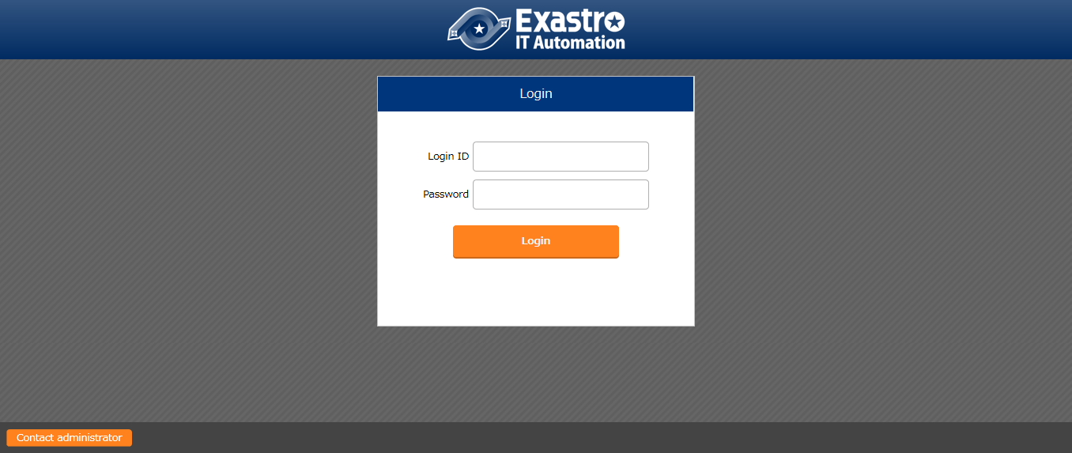

Figure 1.1-1 login screen of ITA

Please login with the following login ID and password after installing ITA system.

Login ID ：administrator

Default password ：password

Screen will be redirected to the "Password changing screen" when login for the first time after installation.

1. Change password

Logged-in user can change their password at any time.

Please click the "Change password" button on the top-right of each menu screen to move to the "Change password" screen and change the password.

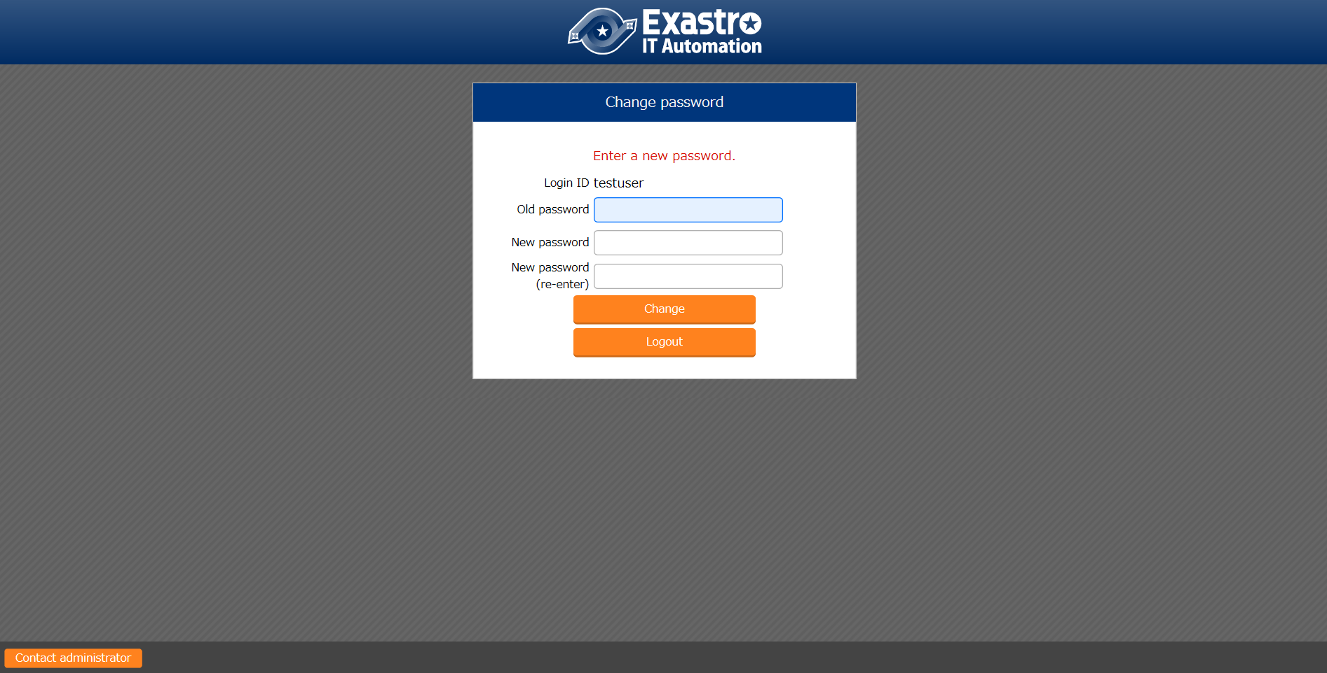

Figure 1.1-2 "Change password" screen of ITA

1. Logout screen (login again)

Click the “Logout” button at the top-right of each menu screen to log out of the system.

Click the displayed "Login again" link to move to the login screen.

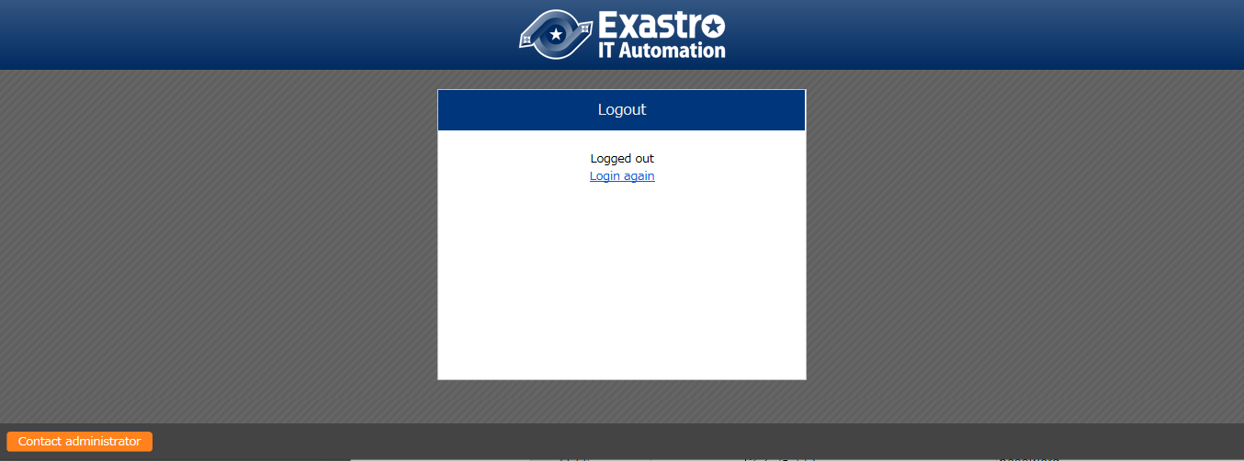

図 1.1‑1 ITAログアウト画面

### Screen description Basic screen configuration

Each menu screen provided in ITA system is basically configured with same elements.

The configuration is as below.

**Login information**

**Console menu group name**

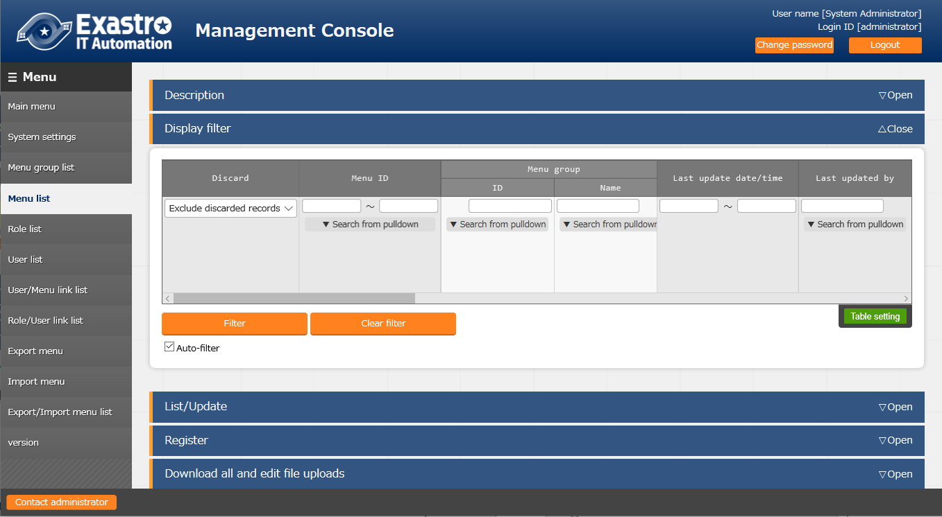

**Menu operation section**

**Submenu**

**Administrator mail address**

Figure 2.2-1 screen configuration

Table 2.2-1 Screen configuration list

|  |  |  |
| --- | --- | --- |
| **No** | **Screen name** | **Description** |
| 1 | Console menu group name | The group name which each submenu belongs to. The name of menu group displayed on the screen is displayed. |
| 2 | Submenu | The menu that can be operated/displayed in current console menu is displayed in a list. |
| 3 | Menu operation section | The section that users can perform registration and setting corresponding to each menu. ※Details are described later. |
| 4 | Login information | The account name logged in currently is displayed.  Users can change their password or log out. |
| 5 | System administrator | The link of the system administrator’s email address. |

### Screen description The method to operate operation section

This section describes the method to operate the elements of each menu operation section.

1. Display filter

Specify the search criteria which is for displaying the item registered in each menu.

The search criteria and items are different in each menu. Only common function is described here.

d

a

B

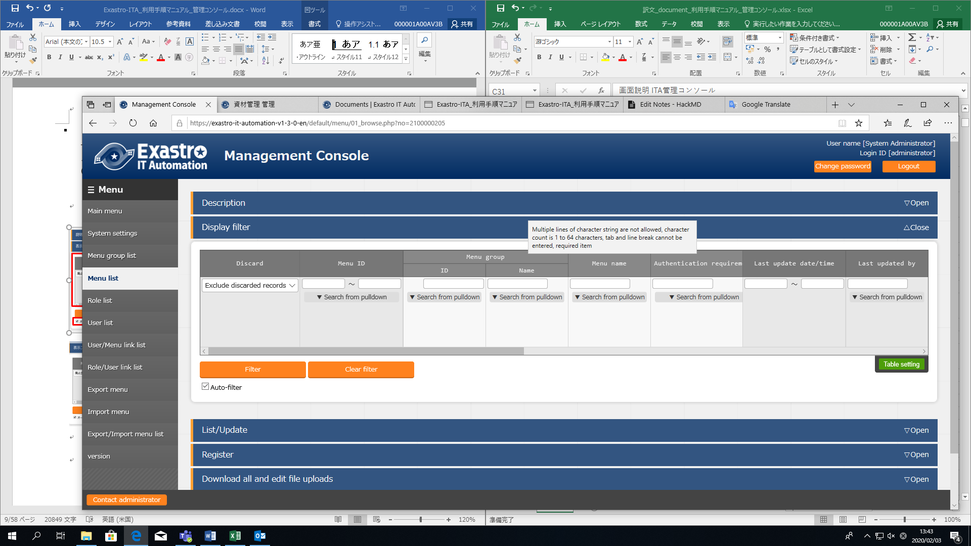

E

ca

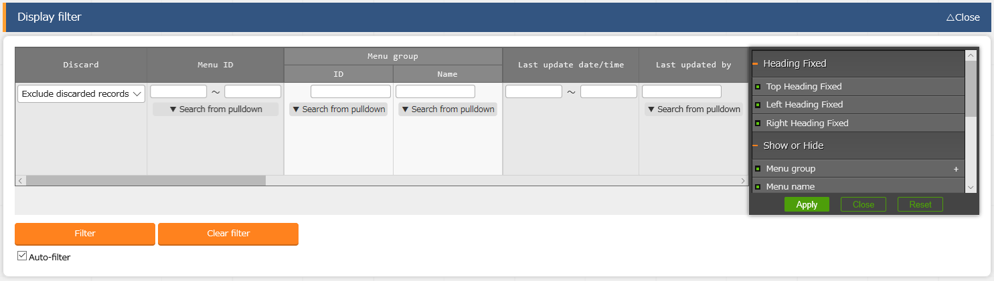

**Figure 2.3-1 Display filter screen**

1. Discard column

・”Exclude discarded records” is set on default.

・”All records”, “,Only discarded records” can be selected freely, specify the desired display method. Either one of them is required to be selected.

1. Search criteria

・Specify the search criteria.

・For items like system name and remarks that can be specified in characters, results displayed can be filtered with “ambiguous search” or “pull-down menu search”.

1. Auto-filter

・By checking “Auto filter”, the list of result that meets the search criteria will be displayed automatically once any of the search criteria is selected.

・It is possible to set if the “Auto filter” is checked when entering the screen in “Auto filter check” of “Menu list” in the Management console.

1. Column description

・The description of the column is displayed when hovering the mouse cursor over the column.

1. Table setting

・Switching the show/hidden state of table items and set the section to be fixed when scrolling the table.

・Table setting can be performed in Display filter, List/Update, and Trace history.

※The details of the function is described in (7)Table setting.

1. List/Update

The list of the items that meets the search criteria is displayed.

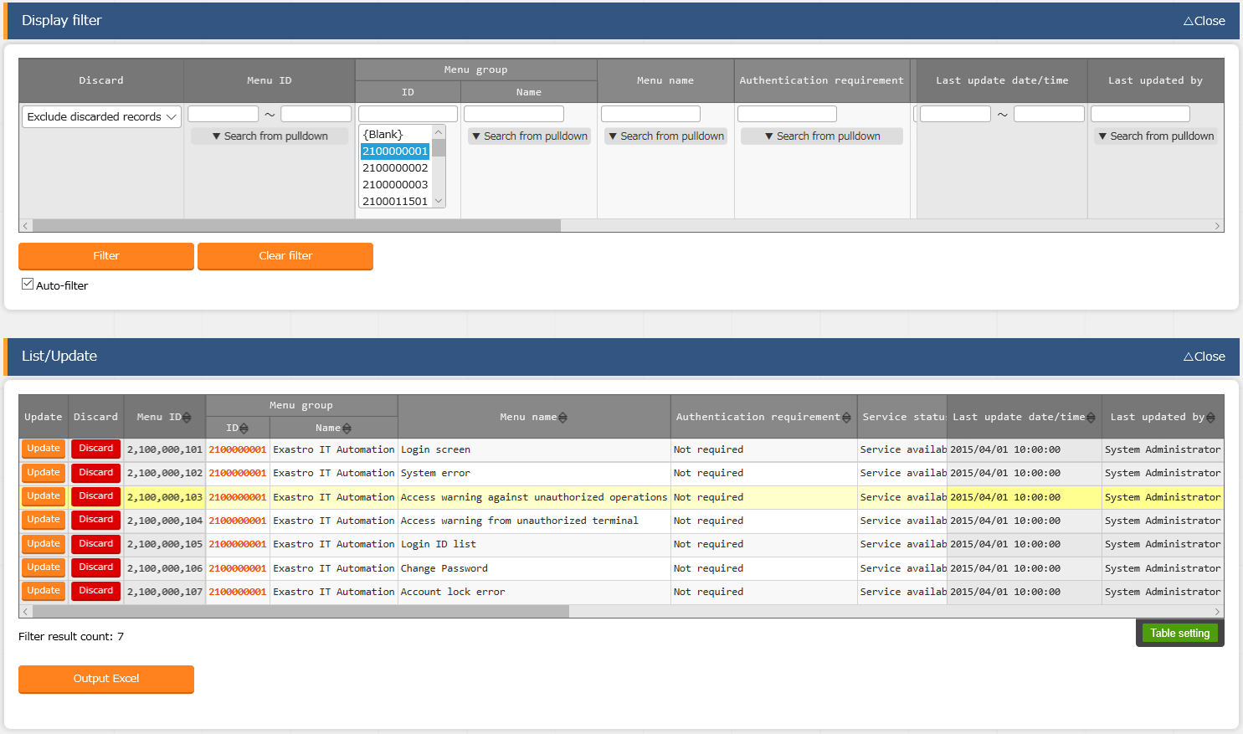

B

C

A

A

**Figure 2.3-2 List/Update (List) screen**

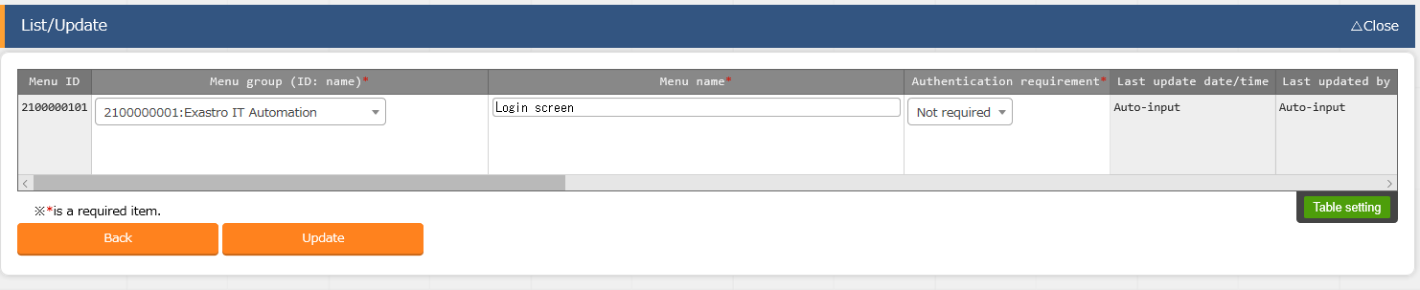

**Figure 2.3-2 List/Update (Update) screen**

B

Ｂ

A. Filter

・By entering the search criteria and pressing the Enter key or clicking the “Filter button”, the registered information will be displayed in “List/Update” submenu.

B. Update

・Move to the update screen by clicking the “Update button” of each item.

・Update the information and click the “Update” button to finish update.

C. Discard

・Click the “Discard” button to move to the discard screen.

・Click the “Discard” button to disable the registered information.

※Disabled information can be restored.

Select “Only discarded records” to display the information. Click the “Restore” button, then the information will become available.

1. Register

　　　　　　 Register new items to each menu.

The registration content differs from each menu, so please refer to each user instruction manual.

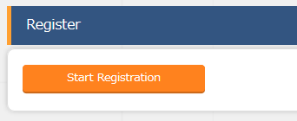

A

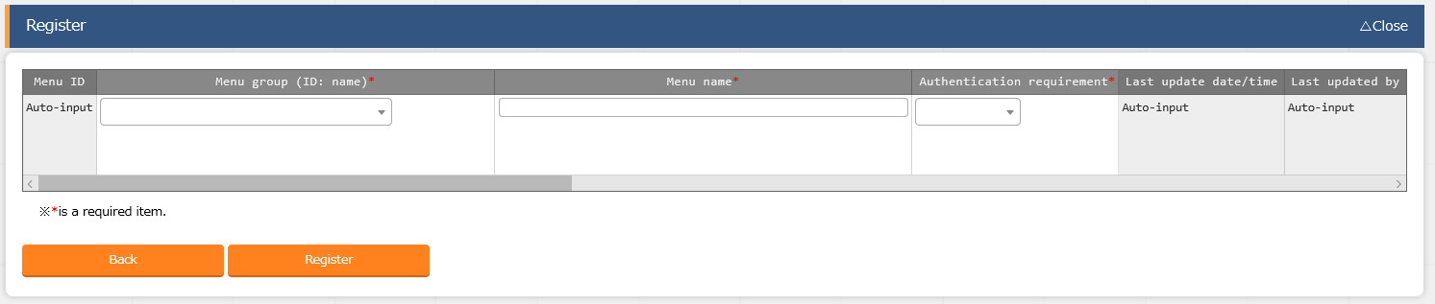

A

Ａ

**Figure 2.3-4 Register (one in a time) screen**

1. Register

・Open the “Register” submenu and click the “Start Registration” button to display the registration form. Enter the required information then click the “Register” button.

1. Download all and edit file uploads

The information register in each menu screen can be downloaded together at once in Excel format.

In addition, registering information together at once with the file in same format is also possible.

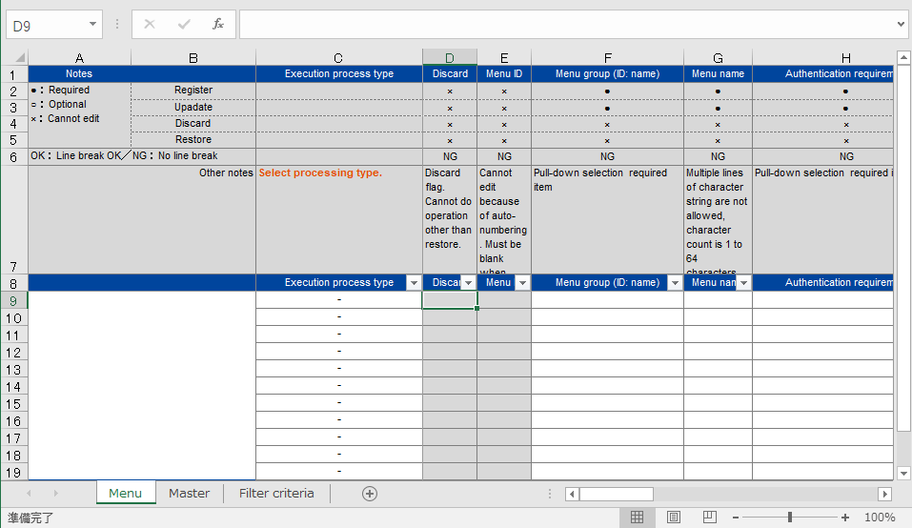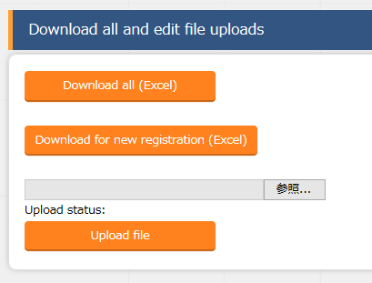

Ａ

B

A

A

**Figure 2.3-5 Register（all）screen**

A．Download all, Download for new registration

　　　　・By clicking Download all, users can download the item list registered in each menu in excel format.

・By clicking “Download for new registration”, users can download the Excel sheet which is for new registrations corresponding to each menu.

B．Upload file

・Edit the Excel file downloaded in Download all, Download for new registration of A, upload and register the information at once in here.  
・Please click “Choose file” to specify the file and click “Upload file”.

1. Trace history

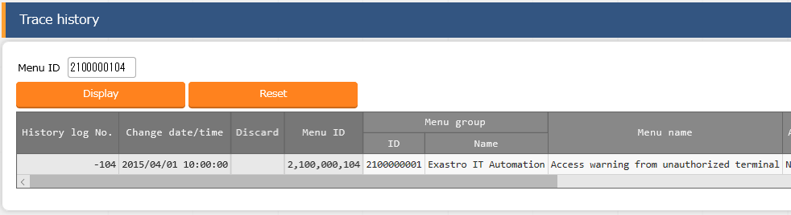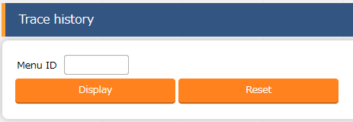The change history of the item registered in each menu can be displayed here.

B

A

**Figure 2.3-6 Trace history screen**

A．By specifying “Management system ID”, the primary key of each menu, to system ID, the change history of the corresponding item will be displayed.

B．The information is displayed in the order of latest update/time in list, and content changed from the previous time is displayed in blue bold characters.

1. About entering item with pull-down menu

The specification of the item that can be selected from pull-down menu during registration/update is as follows.

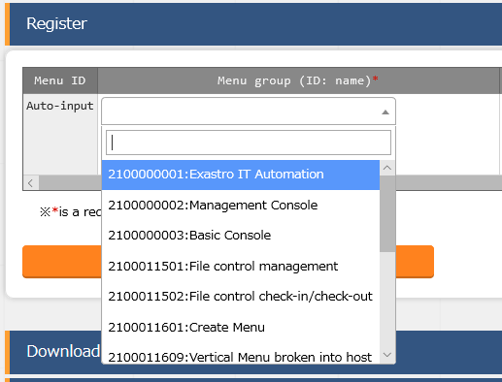

Ａ

B

**Figure 2.3-7 Entering item via pull-down menu**

A. Search windows is displayed. Users can narrow down items by entering the phrases that they want to search for. The search is partial match search, uppercase/lowercase and full-width/half-width characters are case-insensitive.

B．The item for selection are displayed.

1. Table setting

・Switching the show/hidden state of table items and set the section to be fixed when scrolling the table.

・Table setting can be performed in Display filter, List/Update, and Trace history submenu.

A

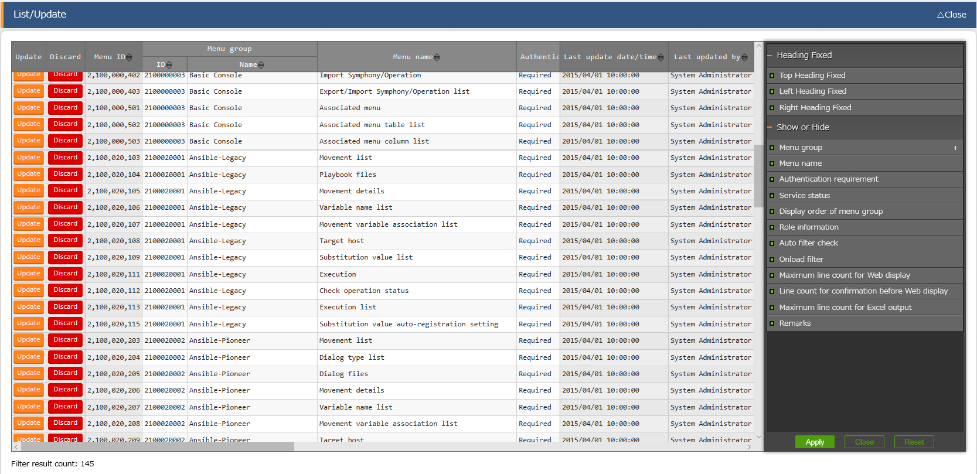

D

C

B

　　　　　　Figure 2.3‑8 Display of table setting menu（List/Update）

1. Heading Fixed

・Set the fixed part when scrolling the table.

・All heading are set to fixed on default.

・The description of each heading are as bellows.

Top Heading Fixed・・・The item name on the top of table.

Left Heading Fixed・・・”Update”, “Discard”, and unique items(e.g. Menu ID in “Menu list” menu) on the left of the table.

Right Heading Fixed・・・”Last update date/time” and “Last updated by” column on the right of table.

1. Show or Hide

・Set the show/hidden state of the selected item.

・All items are set to be displayed on default.

1. Button

・The setting execution button and menu.

・The state of the selected/unselected items will be reflected to the setting when clicking the Apply button.

・The table setting menu will close when clicking the Close button.

・All selected/unselected items will return to the default state when clicking the Reset button.

1. Display of the hidden item count.

・The number of the hidden items in “Show or Hide” is displayed.

・The number will not display if all items are displayed.

### Screen description ITA management console

#### Main menu

The URL of the main menu of each group menu is displayed in the main menu. Move to the main menu of specific menu group by clicking the icons.

The menu on the menu list screen along with the displayed main menu are displayed only for the installed driver.

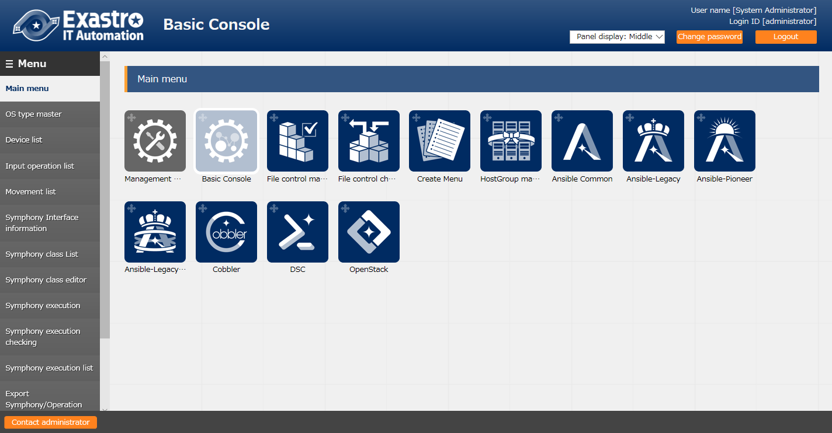

**Figure 1.1-4 Main menu screen**

#### System settings

Register/Update/Discard information that should be set when installing or operating the ITA system.

**[Note]**

**The "System settings" in the submenu is a menu for the product support, so please don't use the menu.**

**If the setting is changed, the behavior of ITA is not guaranteed.**

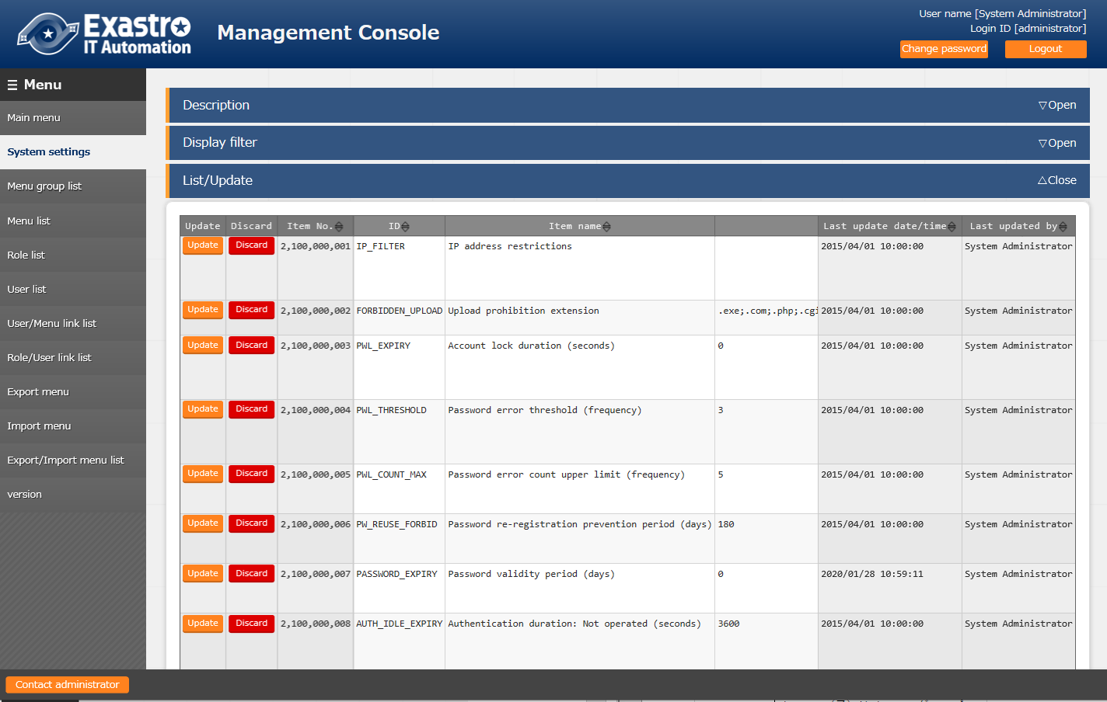

Figure 1.1-5 Management console screen

#### Menu group list

Menu (child) belongs to menu group (parent).Perform register/update/discard in this parent menu group screen. Menu group names must be unique.

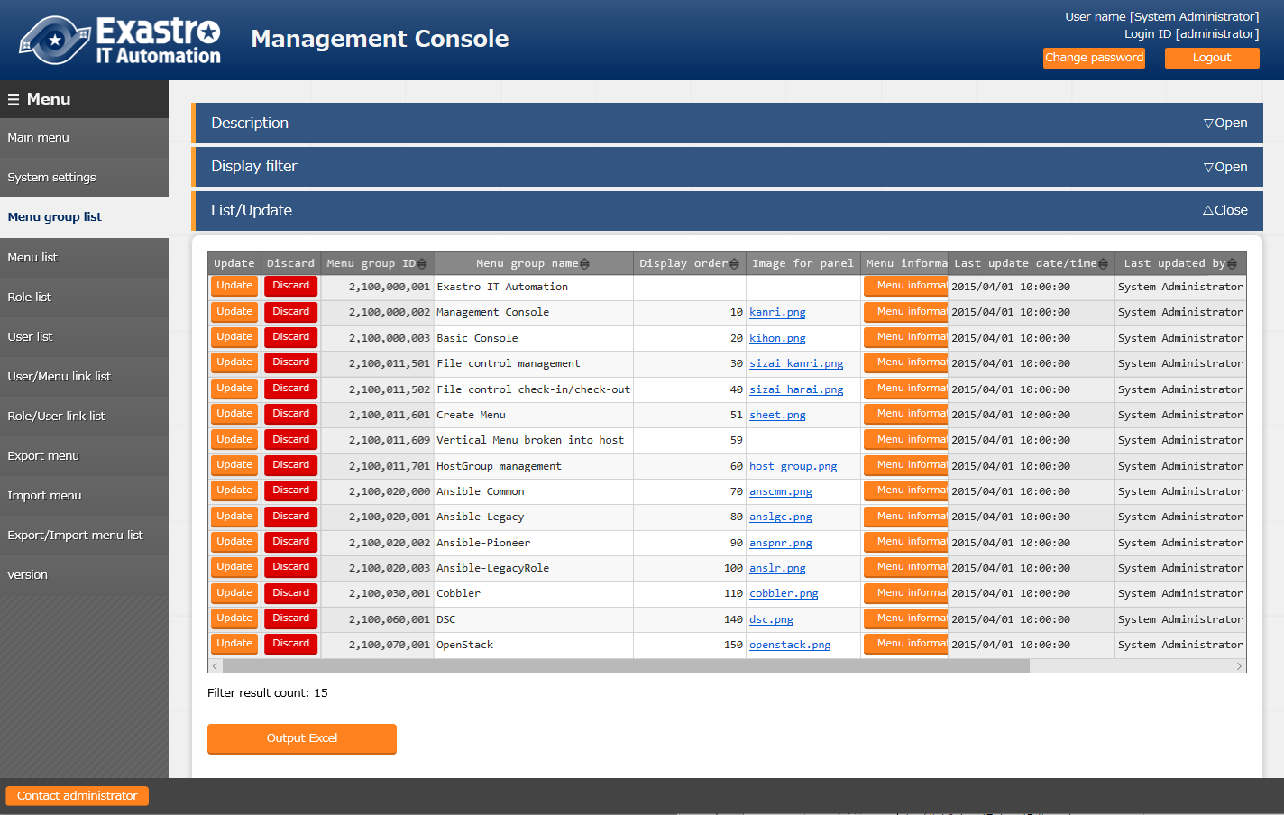

Figure 1.1-6 Menu group list screen

The operation for each submenu is explained here. The operation in other menu is the same.

For performing data update operations, please log in as system administrator.

(Update/discard of registered content - update/discard/restore one data at a time)

The operation for updating/discarding/restoring the menu group one by one.

①　Display the registered information in the “List/Update” submenu.

After entering the search criteria in "Display filter", press the Enter key or click the "Filter" button.

1) Update the registered content -Click the "Update" button to enter the editing mode and update the value

2) Disable the item -Click the "Discard" button

3) Enable the disabled (discarded) item -Click the "Restore" button

②　Click "OK" or "Cancel" when the operation checking pop-up screen display.

(Register - Register items one by one）

The operation for registering menu group one by one.

##### Open the "Register" sub menu and click the "Start Registration" button to display the register form.

##### Enter the "Menu group name" column and click the "Register" button.

※ Duplicate menu group names cannot be registered.

※ "Display order" is optional but the menu group will not be displayed in the main menu if left blank.

※ Menu groups are displayed in ascending order of "Display order". If the "Display order" is　same, the menu groups are display in ascending order of "Menu group ID"

※ "Remarks" is optional.

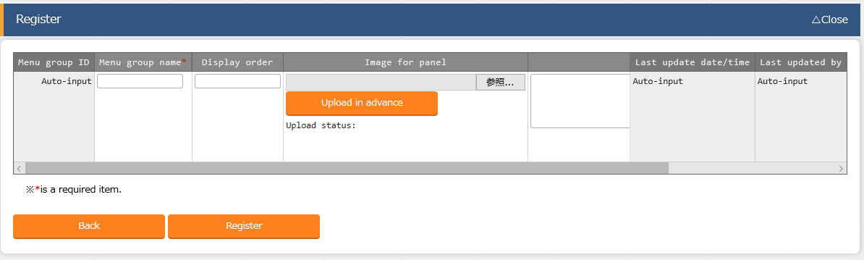

**Figure 1.1-7 menu group list screen(Register)**

(Update/discard of registered content - update/discard items all together)

The operation for registering multiple menu groups at once.

1. Open the "Download all and edit file uploads" sub menu and download the registration sheet by clicking the "Download for new registration (Excel) button.
2. Enter the following items and save the file.

Execution process type = select register/update/discard/restore

* Menu group name = updated name
* Display order = updated content
* Remarks = updated content

##### Press the “choose file” button to assign the file in ② and press "Upload file" to upload the file.

※ If "Execution process type" is not selected or the correct process type is not selected, registration will not be executed.

(Register - Register items all together)

The operation for registering multiple menu groups at once.

1. Open the "Download all and edit file uploads" sub menu and download the registration sheet by clicking the "Download for new registration (Excel) button.
2. Enter the following items and save the file.

* Execution process type = register
* Menu group name = The name of new menu group name to register
* Display order = the display order of menu group

1. Press the “choose file” button to assign the file in ②and press "Upload file" to upload the file.

※ If "Execution process type" is other than "register" , registration will not be executed.

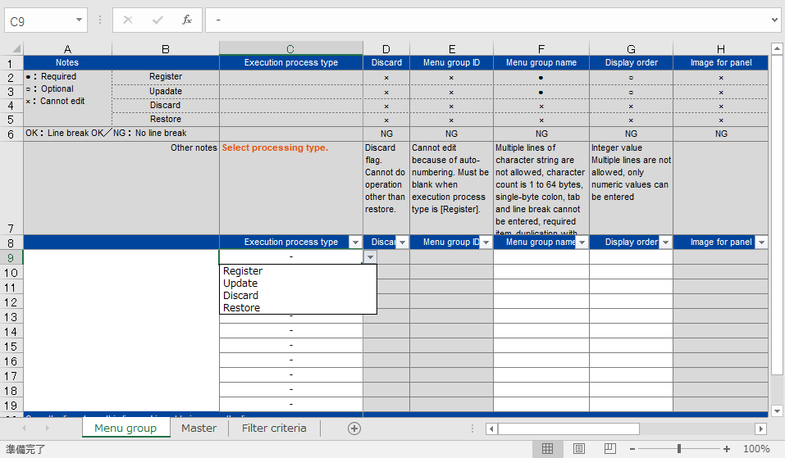

②Select "Register" for execution process type

②Enter desired name for menu group name

②Enter desired value for display order

Figure 1.1-8 Menu group list screen

※ When a menu group is registered, the “Main Menu” is automatically registered under the created menu group and the menu group can be referenced by users of the “System Administrator” role.

In particular, the following menu will be registered automatically.

* "Menu list" menu
* "Content File list" menu
* "Role/Menu link list" menu"

#### Menu list

Register/update/discard of function contents is operated in this screen. The menu name must be unique.

1. Check the role information / content file according to the menu.

Check the correspondence between role information and content files of function from the "list/update" submenu

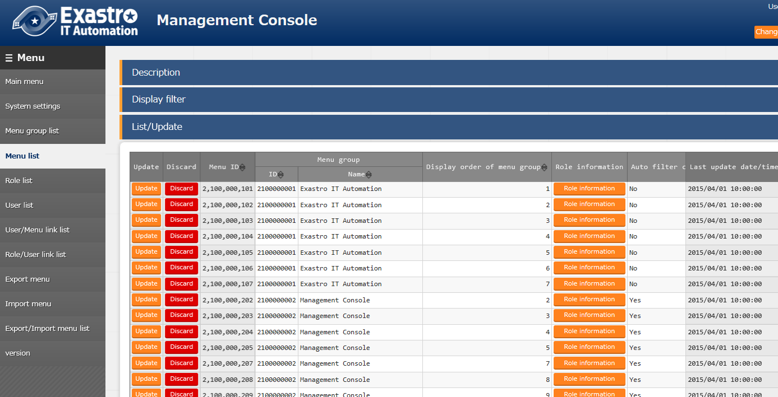

**Figure 1.1-9 Menu list**

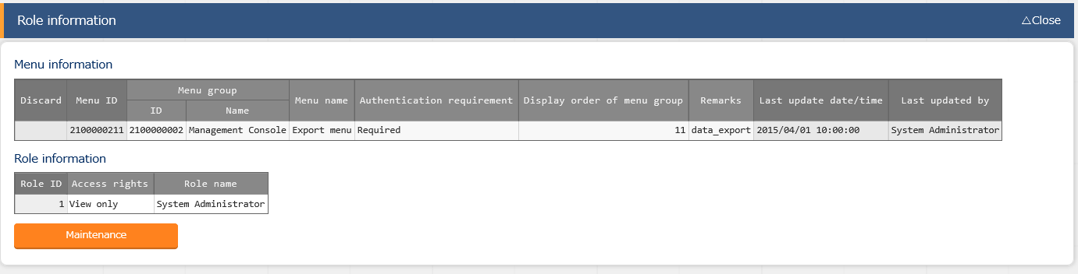

Figure 1.1-10 Role information screen (menu list)

##### Parameter

Information registered in the menu includes the following items.

Table 1.1-2 parameter of "menu list"

|  |  |  |  |  |
| --- | --- | --- | --- | --- |
|  | **Item name** | **Description** | | |
| 1 | Authentication requirement | Not required: | Accessible without login | |
| Required: | Accessible only after login | |
| ２ | Service status | Service available: | | Active state. Normal user can access. |
| Menu under development: | | Only system manager can access. |
| ３ | Display order in menu group | The order of submenu displaying in the menu group. Submenu displays in ascending order from the top. | | |
| ４ | Auto filter check | The setting whether the "auto filter" checkbox being checked or not when the menu displays. | | |
| ５ | Onload filter | The setting of whether the "filter" button is pressed or not when the menu displays. | | |
| ６ | Maximum line count for Web display | The maximum number of lines to display in "list/update" | | |
| ７ | Line count for confirmation before Web display | The maximum number of lines to display in the confirmation dialog before outputting to "list/update". | | |
| ８ | Maximum line count for Excel output | The maximum number of lines to output to Excel. | | |

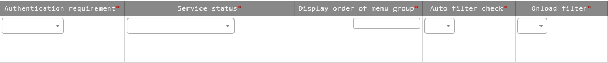

②

①

⑤

④

③

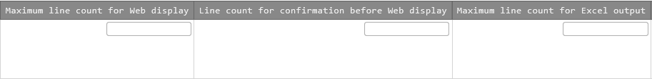

⑧

⑦

⑥

**Figure 1.1-11 Menu register screen (menu list)**

The relationship between "Maximum line count for Web display" and "Line count for confirmation before Web display" is as below.

⑥Maximum line count for Web display

Error: over the maximum line count

⑦Line count for confirmation

before Web display

Display as it is

Confirmation of display

Yes/No

Line counts over

Request over

Line counts under

Request under

: Process result

: Process image

**Figure 1.1-12 Overview of maximum web**

**display line count operation**

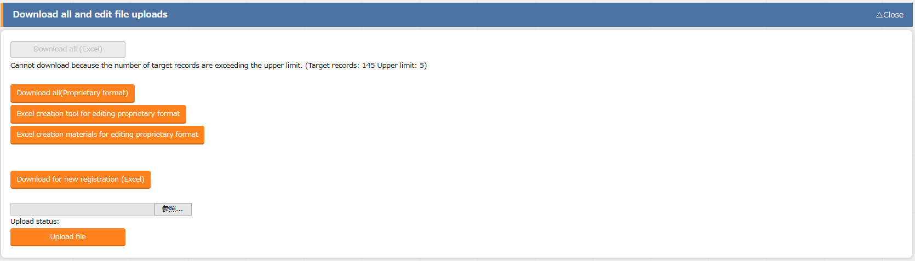If the line count of output file is larger than "Maximum line count for Excel output", the display of items in "Download all and edit file uploads" will become as below.

Figure 1.1-13 Error display screen (Menu list)

File that can be downloaded from this screen are not Excel files but CSV files in original format.

When users want to edit and upload using this file, please click the "Original format editing Excel creation tool" button to download the tool and follow the "Readme" file in the downloaded file to operate.

#### Role list

Register/update/discard roles.

The role can only check the user it owns and the menu that associates with it.

Role names must be unique. 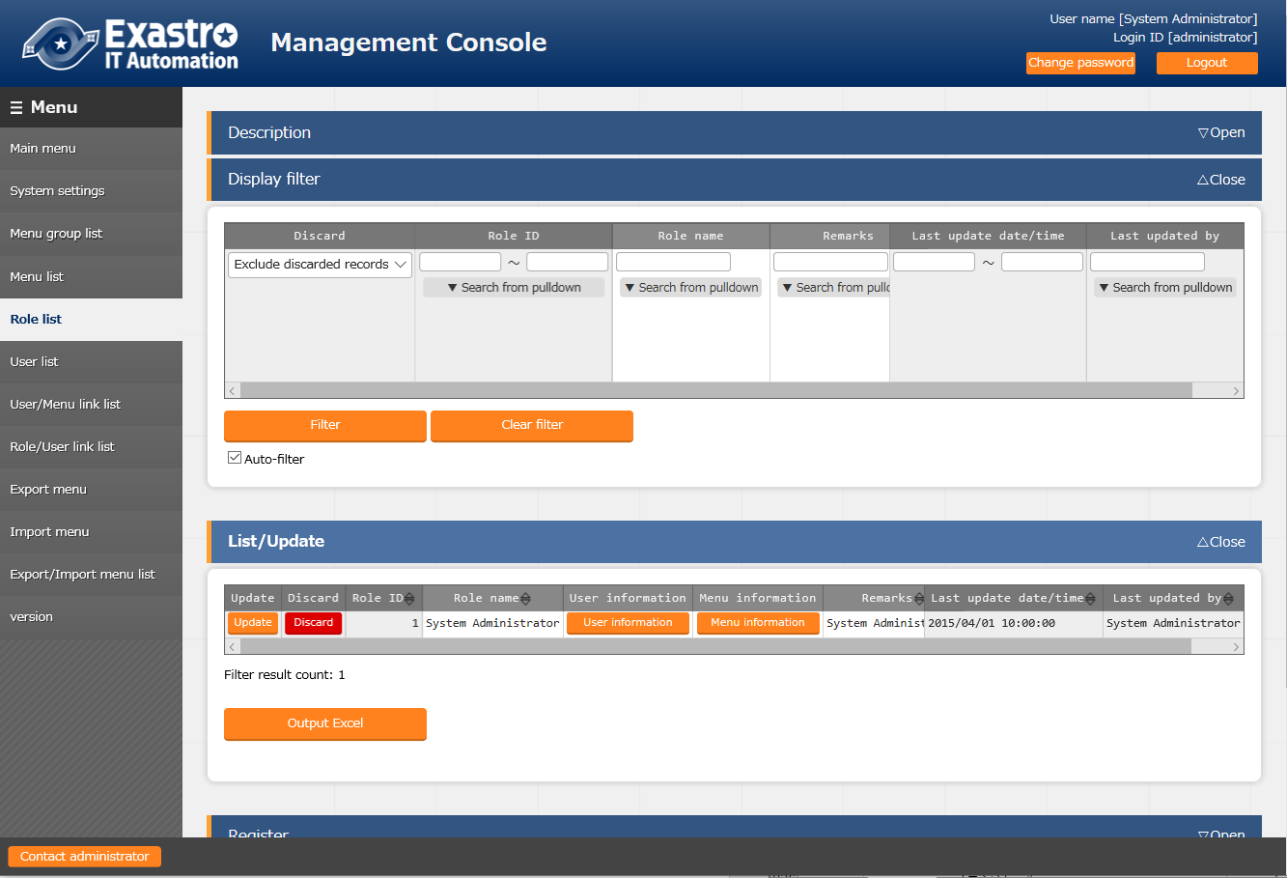

**Figure 1.1-14 Role list screen**

#### User list

Register/update/Discard user (account).

Maintain the association between user and the role (operate permission) by pressing the "Role information" button.

If account is locked, unlock it in this screen.

Login ID must be unique.

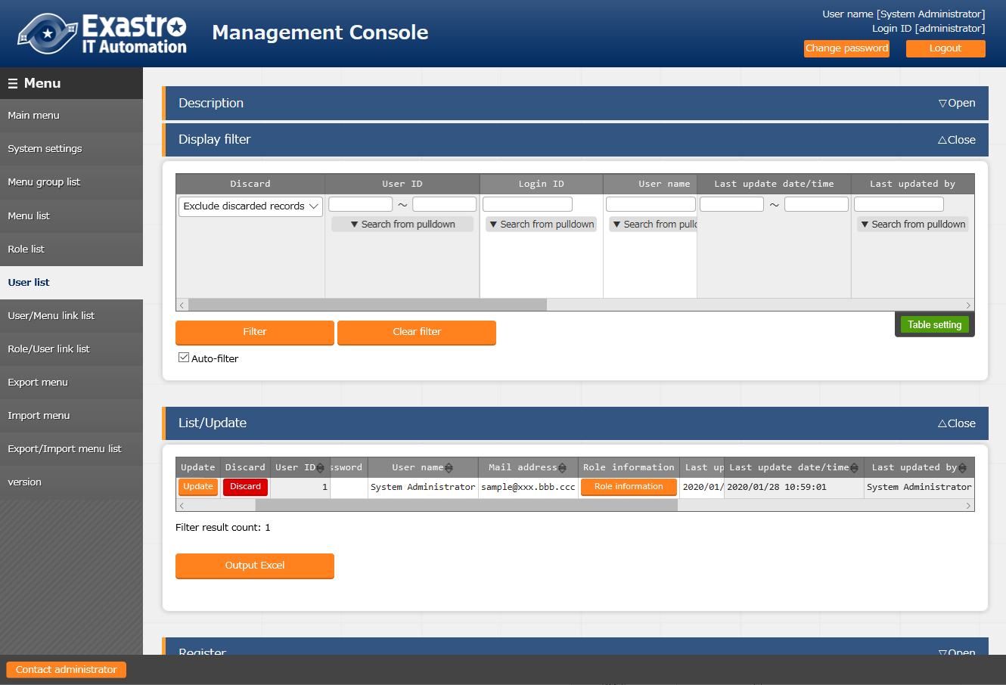

Figure 1.1-15 Screen of transiting to role setting screen (User List)

#### Role/Menu link list

Register/update/discard the link between each role and menu.

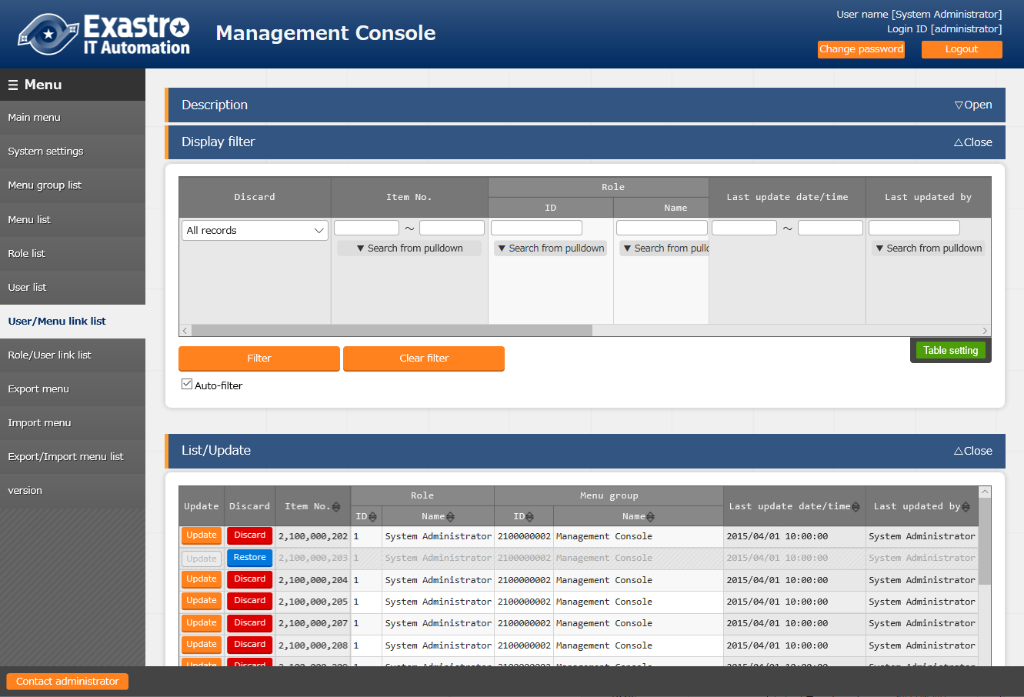Menu screens that doesn't associate with the role will not be displayed in the role's user group.

**Figure 1.1-16 Role/menu link list screen**

Role and menu registered in "④menu list" and "⑤role list" will display in the list box(①,② in the Figure below), so please select each of them and select their "associate"(③ in the Figure below).

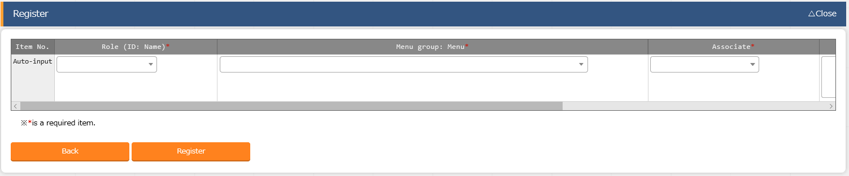

①

②

③

Figure 1.1-17 Group menu permission setting screen (role/menu link list)

#### Role/User link list

Register/update/discard the link between each user (account) and role (execution permission).

The user (account) that is not linked to role can't access each menu screen.

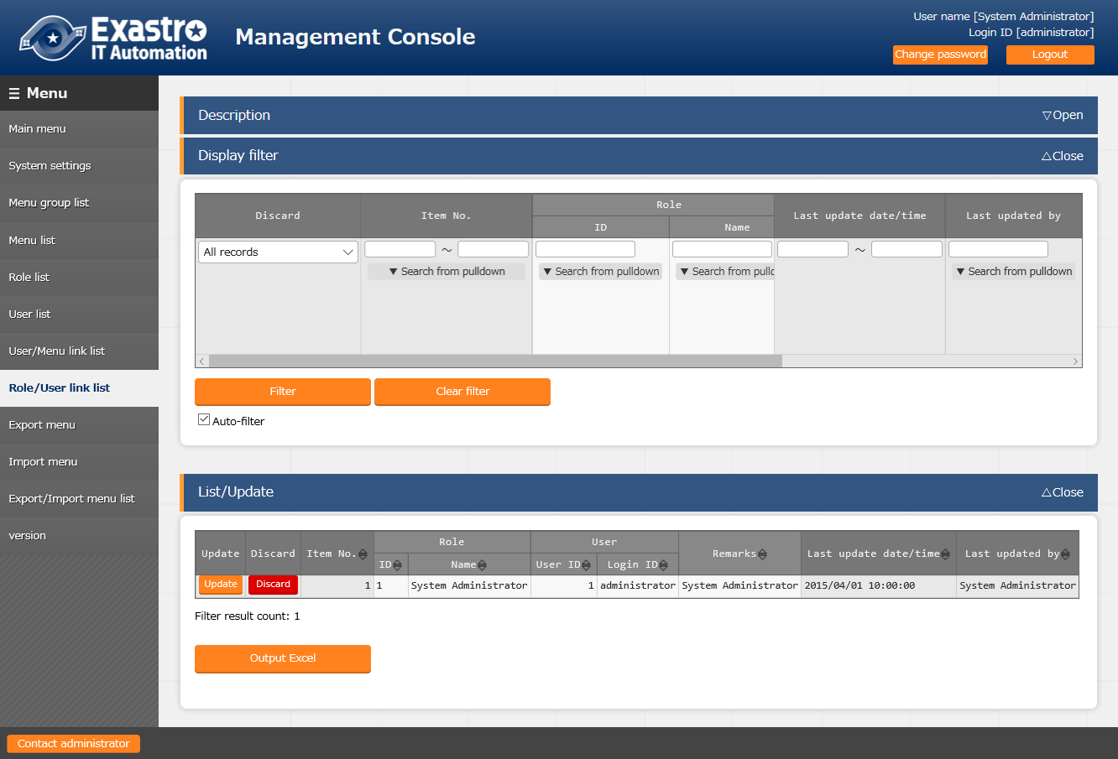

**Figure 1.1-18 Role/user link list screen**

Role and user registered in "⑤role list" and "⑥user list" will display in the list box(①,② in the Figure below), so please select each of them.

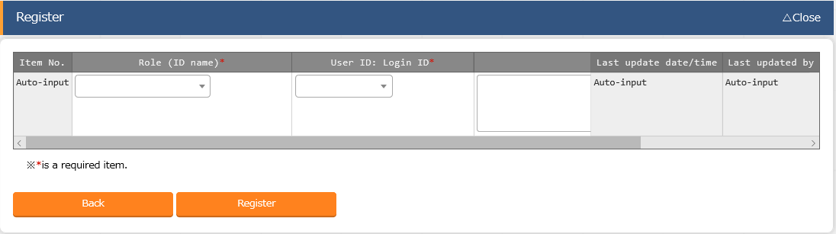

①

②

Figure 1.1-19 User permission setting screen (Role / User link list)

#### IP address filter list

Register/update/discard the user devices that can connect to ITA system.

This function is not displayed because it's disabled during installation on default.

Please follow the instructions below to enable the function when using it.

1. Open the "Role/menu link list" menu
2. Select "management console" from the pulldown menu of "Display filter" → "Menu group".
3. "Restore" "IP address filter list"
4. Reload the screen

Register address in IPv4 format and if "IP address restrictions" in the "System settings" menu is enabled, it's only possible to access the system from registered device.

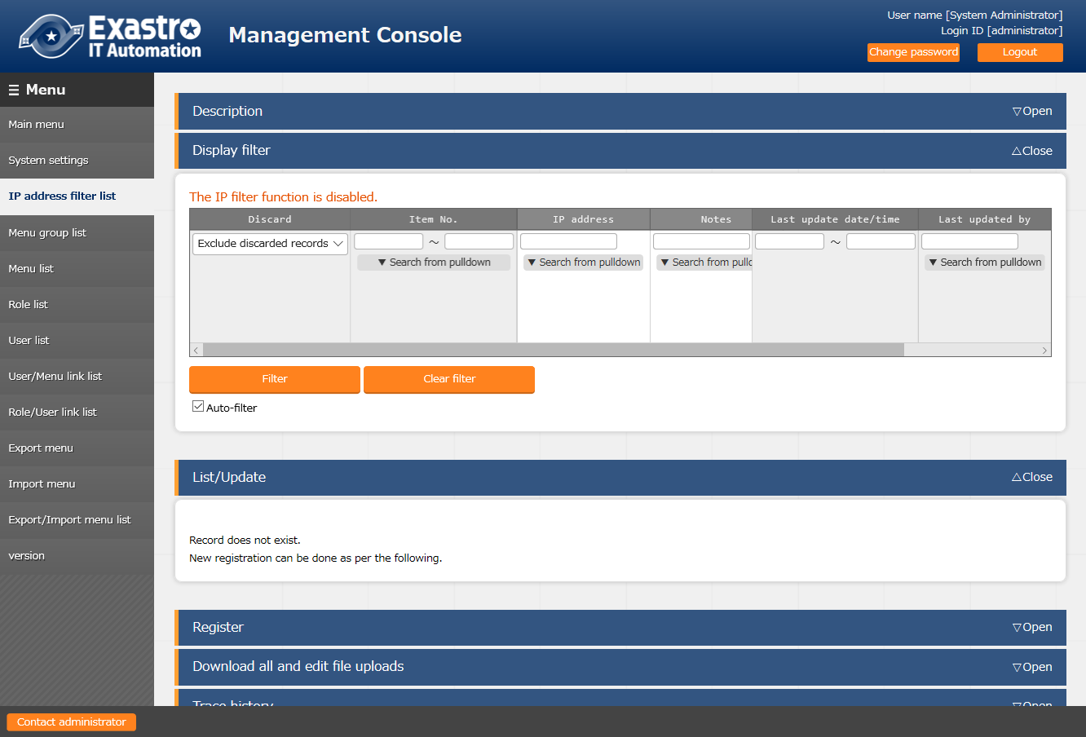

Figure 1.1-20 IP address list screen

※ If "IP address restrictions" in the "System settings" menu is disabled, the "The IP filter function is disabled." message will display.

**[Note]**

Please enable "IP address restrictions" in the "System settings" menu after registering devices that is able to connect the system. If "IP address restrictions" is enabled without registering valid devices, it will be unable to connect to the ITA system.

#### Export menu

Export data registered in the ITA system in each menu.

※When moving data to another ITA environment, the integrity of data may corrupt if the whole menu is not moved together.

1. Select the menu to export

C:\Users\113414A009FT8\Desktop\20160220131903.png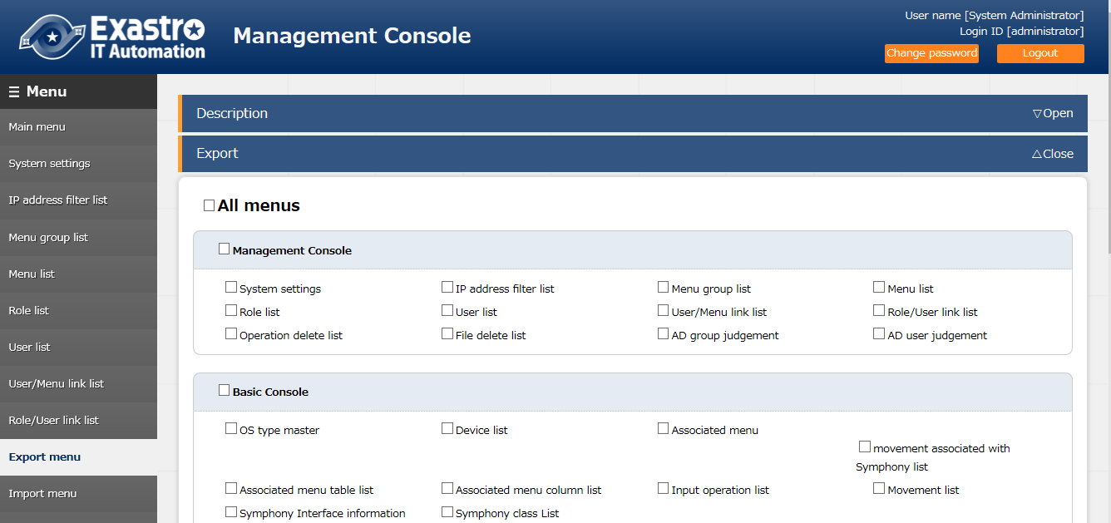

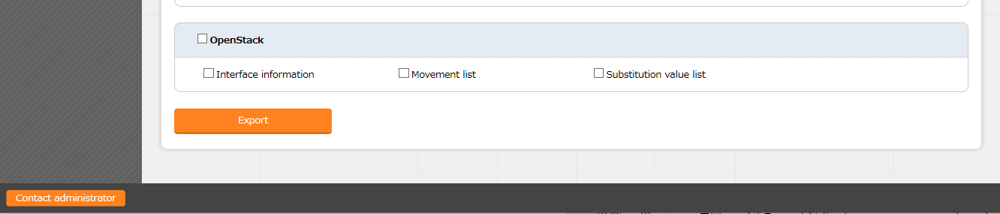

②

**Figure 1.1-21 export menu screen**

##### Click the export button after selecting the menu.

The execution number of export operation is displayed, so please check the status of execution in the "Export/Import menu list" screen.

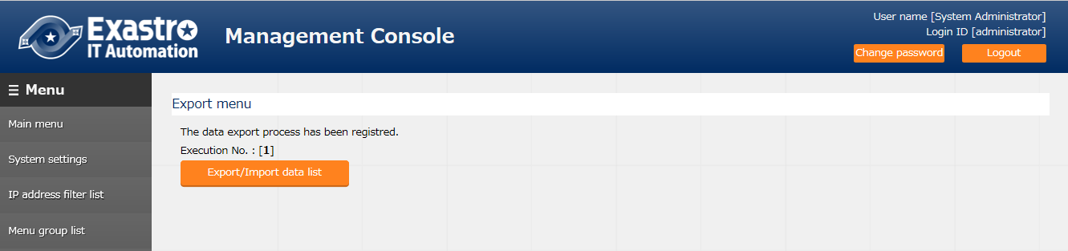

#### Import menu

Upload the kym file saved from "(10) Export menu".

1. Select the kym file to be uploaded.
2. Click the upload button.

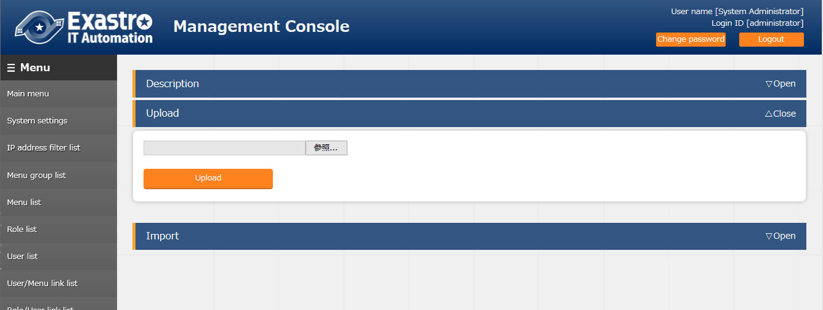

②

Figure 1.1-22 Import menu screen (1)

##### Select the menu to import

The menu whose checkbox is checked will be imported.  
Please uncheck the menus that are not needed to be imported.

##### Click the import button

Click "Import (without discarded data)" to import the menu without discarded data.

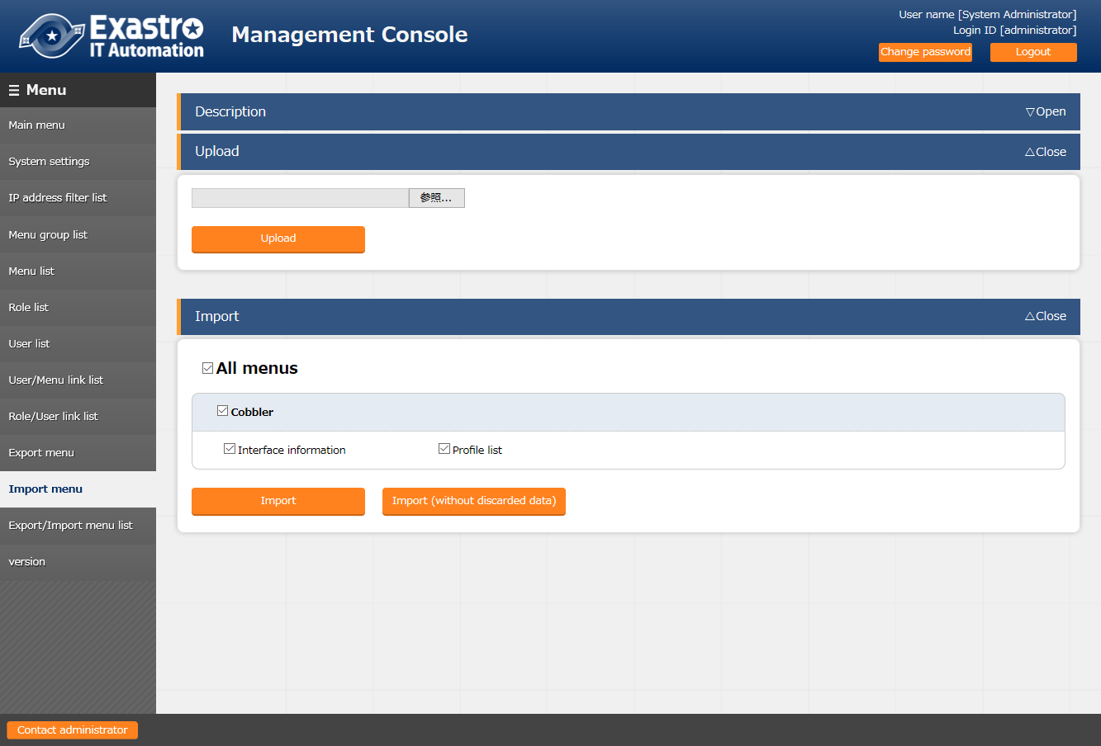

④

③

Figure 1.1-23 Import menu screen (2)

##### Click the menu import button

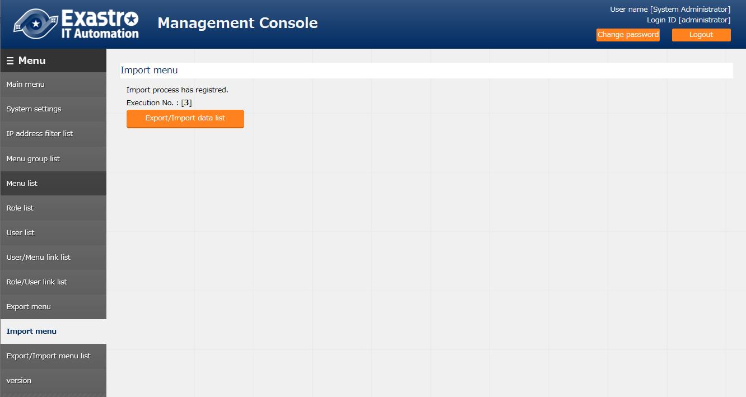The execution number of import operation is displayed, so please check the status of execution in the "Import menu list" screen.

⑤

Figure 1.1-24 Import menu screen (3)

#### Export/Import menu list

Check the status of export and import

The status will change in the order of "Unexecuted", "Executing", "Completed".

The execution type will display "Export" or "Import"

The import type will be "Normal" or "Without discarded data" if the execution type is import.

Click the filter button and confirm that the status is "Completed".

If error occurred during import execution, the status will become "Completed (error)".

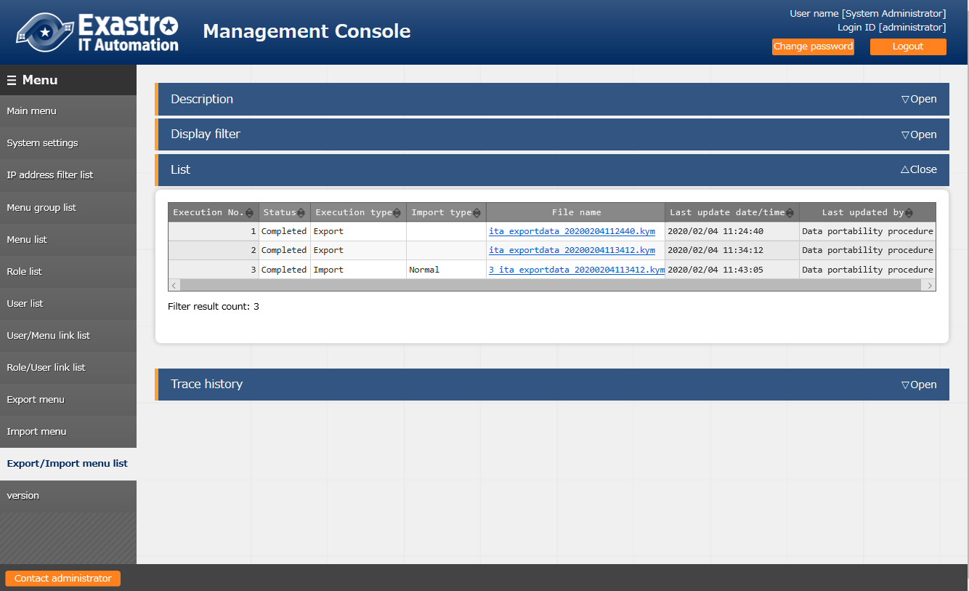

Figure 1.1-25 Import menu list screen

#### Version

Check the version of each ITA function.

Only installed function can be checked.

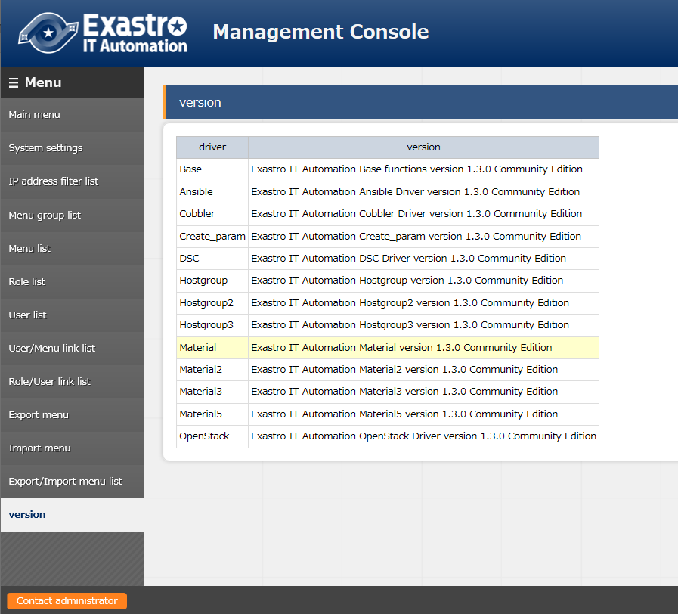

Figure 1.1-26 Version screen

#### Operation delete list

Configure settings to delete the data associated with the scheduled operation date registered in the basic console "Input operation list" according to the specified "Logical deletion days" and "Physical deletion days".

Operation will be discarded after the "Logical deletion days" and will be deleted from the DB after the "Physical deletion days".

This function is not displayed because it's disabled during installation on default.

Please follow the instructions below to enable the function when using it.

1. Open the "Role/menu link list" menu
2. Select "management console" from the pulldown menu of "Display filter" → "Menu group".
3. "Restore" "Operation delete list"
4. Reload the screen

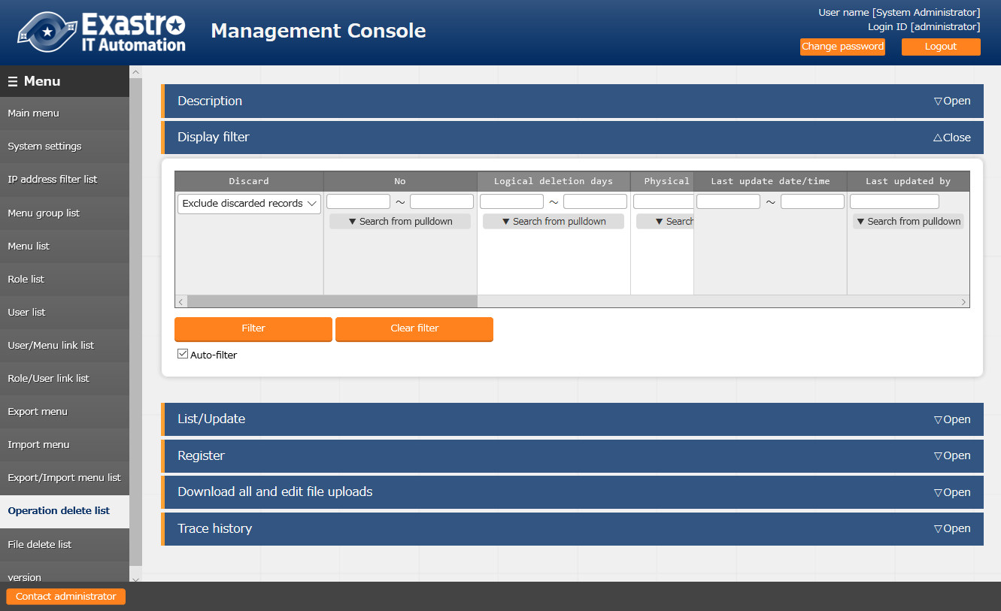

Figure 1.1-27 Operation delete list screen

The item list of the screen is as below

**Table 1.2-3 Item list of registration screen (Operation delete list)**

|  |  |  |  |  |
| --- | --- | --- | --- | --- |
| **Item** | **Description** | **Input required** | **Input type** | **Restrictions** |
| Logical deletion days | Based on the machine date and time, operation will be logically deleted (discarded) after the specified days after the scheduled execution date. | ○ | Manual | Numeric |
| Physical deletion days | Based on the machine date and time, operation will be physically deleted (deleted from the database record) after the specified days after the scheduled execution date. | ○ | Manual | Numeric |
| Table name | Specify the name of the table to be deleted. | ○ | Manual | Maximum length 256 bytes |
| Primary key column name | Specify the column name of the primary key of the table | ○ | Manual | Maximum length 256 bytes |
| Operation ID column name | Specify the column name in the table that stores the operation ID | ○ | Manual | Maximum length 256 bytes |
| Data storage path acquisition SQL | Specify the SELECT statement for obtaining the data storage information from the interface information if the path of interface information under data storage is specified in history data path 1~4.  This is optional when the path under data storage is not assigned.  e.g. )  select ANSIBLE_STORAGE_PATH_LNX AS **PATH** from B_ANSIBLE_IF_INFO where DISUSE_FLAG='0' ※Please set PATH for the alias name. | - | Manual | Maximum length 1024 bytes |
| History data path 1 | History data path 1(optional) If operation instance directory of the input data history or the result data history is store under ~/ita-root/, enter the relative path after ~/ita-root/  　e.g. )  　 In the case of Ansible Legacy input data history  　 uploadfiles/2100020113/FILE_INPUT  　In the case of Ansible Legacy result data history  　uploadfiles/2100020113 /FILE_RESULT For paths under the data storage of interface information such as the work instance directory (data storage), please enter the path that has the keyword "/__data_relay_storage__/" which shows the data storage.  　e.g.)  　 In the case of Ansible Legacy operation instance directory  　 /__data_relay_storage__/legacy/ns/ Please enter absolute path if the path is under ~/ita-root/ or other than the path under data storage 　e.g.)  　 /var/log/hoge The same applies to history data path 2 ~ 4 | - | Manual | Maximum length 1024 bytes |
| History data path 2 | History data path 2 (Optional) | - | Manual | Maximum length 1024 bytes |
| History data path 3 | History data path 3 (Optional) | - | Manual | Maximum length 1024 bytes |
| History data path 4 | History data path 4 (Optional) | - | Manual | Maximum length 1024 bytes |
| Remarks | Free description field | - | Manual | Maximum length 1024 bytes |

#### File delete list

Check the last update date of the files on the server and delete the files whose expiration time has passed.

This function is not displayed because it's disabled during installation on default.

Please follow the instructions below to enable the function when using it.

1. Open the "Role/menu link list" menu
2. Select "management console" from the pulldown menu of "Display filter" → "Menu group".
3. "Restore" "File delete list"
4. Reload the screen

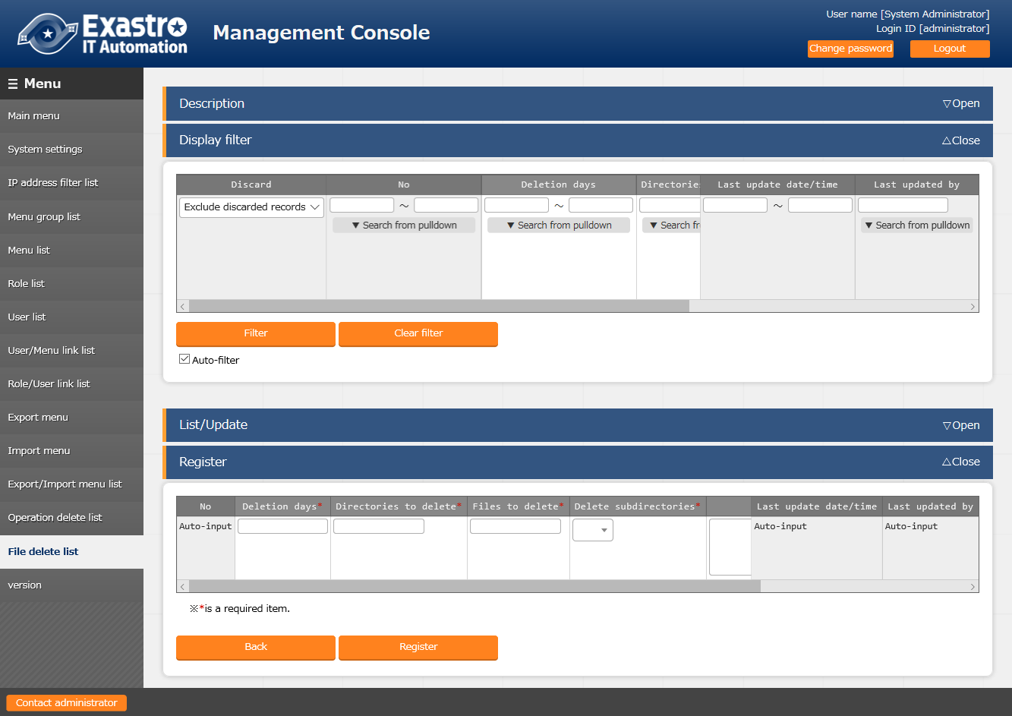

**Figure 1.1-28 File delete list screen**

The item list of the screen is as below.

**Table 1.2-4 Item list of registration screen (File delete list screen)**

|  |  |  |  |  |
| --- | --- | --- | --- | --- |
| **Item** | **Description** | **Input required** | **Input type** | **Restrictions** |
| Deletion days | Execute deletion if the assigned expiration day based on the last update date passed. | ○ | Manual | Numeric |
| Directories to delete | Specify the directory which stores the file to be deleted. | ○ | Manual | Maximum length 1024 bytes |
| Files to delete | Specify the name of the file to be deleted.  Wildcard can be used for the specification. | ○ | Manual | Maximum length 1024 bytes |
| Delete subdirectories | Set whether the subdirectory under the deletion target directory has also to be deleted or not.  If "Yes" is set, then the name and the last update time of subdirectory of the deletion target directory will be checked and deleted if it is also the deletion target. | ○ | List | Yes/No |

## BackYard contents

This part describes the Backyard contents in the basic functions of ITA.

BackYard is resident processes that works independently in the server.

Unlike the web content that is operated on the web browser, users will not notice the existence of BackYard.

Please perform controls such as start or stop of operation in command line

### BackYard operation list

The list of BackYard operation is as below.

Table 1.2-1 BackYard function

|  |  |  |  |
| --- | --- | --- | --- |
| **No** | **Operation name** | **File name（※）** | **Description** |
| 1 | Send mail | ky_mail※1 | Can be stopped if not needed |
| 2 | Role link checking + cleaning | ky_std_checkcondition-linklist※1 | resident |
| 3 | Input operation checking + cleaning | ky_execinstance_dataautoclean-workflow.sh※2 | Start by Cron |
| 4 | File checking + cleaning | ky_file_autoclean-workflow.sh※3 | Start by Cron |
| 5 | Menu import execution | ky_data_portability_execute-workflow | Resident |
| 6 | Menu import cleaning | ky_data_portability_dataautoclean-workflow.sh | Start by Cron |
| 7 | ActiveDirectory information mirroring | ky_activedirectory_roleuser_replication-workflow.php※7 | Resident |

※1 The file locates in ~/ita-root/backyards/webdbcore

※2, 5, 6, 7 The file locates in ~/ita-root/backyards/ita-base

※3, 4 The file locates in ~/ita-root/backyards/common

### Description of BackYard operation

The description of Backyard operation is as below

#### Send mail

The send mail function dynamically replaces sender address, destination address and content variables and send mail automatically.

The send mail function refer to three files including template list, template, mail request file(details are mentioned later) and operates while judging if the execution is needed or not.

There are three patterns of mail, including free type, safe type, and free format type. The following table shows the necessity and requirement of each file according to each pattern.

Table 1.2-2 Contents of reference type according to mail type

|  |  |  |  |  |  |  |  |  |  |
| --- | --- | --- | --- | --- | --- | --- | --- | --- | --- |
| File name | **Template** | **Template list** | | | | **Mail request file** | | | |
|  | Items in  the file | Template ID | Number of word substitutions | from, to | cc | Title | from, to | cc | String for substitution |
| Mail type | Position | 1st column | 2nd column | 3rd column | 4th column | 1st row | 2nd,3rd row | 4th row | 5th and later row |
| Free type | Required | Required | Numeric(0 or more) | Not required | | Required | Required | Optional | Strings according to specified number |
| Safe type | Required | Optional | Not required | |
| Free format type | Not required(※) | X　(fixed) | Not required |

※ The content of the mail is written in mail request file

The explanation and sample of each file are as below

[Important] Please edit each file with **character encoding [UTF-8]** and **newline character (LF)**.

##### Template list

・File name ： sysmail.list

・Deployment directory ： ~/ita-root/confs/backyardconfs/

This file lists the number of variables and destination address used in the email template.

Mail are sent based on the list.

■ Template list example

１

２

001 3

002 3 from_add@ita.com to_add@ita.com cc_add@ita.jp

003 7 from_add@ita.com to1@ita.com,to2@ita.com null

004 X from_004@ita.com to_004@ita.com null

５

４

３

Free type

Safe type

Free format type

Separated by tab

Figure 1.2-1 Example of template list

Table 1.2-3 List of required parameter in the template list

|  |  |  |  |
| --- | --- | --- | --- |
| **No** | **Item** | **Required** | **Remarks** |
| 1 | Template ID | ○ | 001~999 (000 is reserved so can’t be used). |
| 2 | Number of word substitutions | ○ | Number of variable strings.  E.g.) Date, person name, etc. |
| 3 | Source mail address | △ | Required if not written in the mail request file. |
| 4 | Destination mail address | △ | Same as above |
| 5 | cc address | × | Specify "null" if not required |

※ ④Separate with comma when assigning multiple addresses

##### Template

・File name ： sysmail_body_nnn.txt

・Deployment directory ： ~/ita-root/confs/backyardconfs/

The body of the mail. Please enter [template ID] for the [nnn] in the file name.]

e.g.) ○ sysmail_body_001.txt

× sysmail_body_1.txt

Write the variable for substitution（%%001%% ～ %%999%%）in the mail body if there is part that needs substitution.

Variables have to be consecutive and has same amount as the "Number of word substitutions" specified in the template list file.

■ Template example [OK]

To： Everyone in %%001%%

This is a notice from the management department.

The password of %%003%% hasn’t’ been changed for %%002%% days.

Please set a new password within 7 days.

OK to replace the order

※ Number of word substitutions = 3

■ Template example [NG]

NG because the numbers are not consecutive

To： Everyone in %%001%%

This is a notice from the management department.

The password of %%002%% hasn’t’ been changed for %%005%% days.

Please set a new password within 7 days.

##### Mail request file

・File name ： sysmail_nnn_desired alphanumeric characters.txt

・Deployment directory ： ~/ita-root/temp/ky_mail_queues/ky_sysmail_0_queue/

Specify the strings to insert to the template.

Please enter [template ID] for the [nnn] in the file name.

Please enter any unique alphanumeric strings after [nnn].

e.g.) Example of file names

○ sysmail_001_20140813123025_123456789

○ sysmail_001_a001.txt

× sysmail_001_

× sysmail_001_.txt

After preparing the template list and the template file, the mail will be sent by placing this file in the deployment directory.

When the mail is sent, the substitution strings are inserted into the variables in the template file.

After sending the mail, the send request file will be moved to the following directory according to the status of mail delivery.

Successfully sent → ~/ita-root/temp/ky_mail_queues/ky_sysmail_1_success

Failed to sent → ~/ita-root/temp/ky_mail_queues/ky_sysmail_2_error

■ Mail request file format

The mail request file decides the meaning by each row.

1st row … Mail title

2nd row … Source email address

3rd row … Destination mail address

(Separate with comma when assigning multiple addresses)

4th row … cc mail address (Empty line if not needed)

5th ~ row … String for substitution

※ 2nd ~4th row is needed for free type only.

※ Error occurs if the line count after the 5th row is not same with the number of variables in the template or the number of substitution word in template list.

Presenting example of mail request file using "①template list" and "template" as example.

■ Example of mail request file

1) Example of free type: Template ID = 001

sysmail_001_20160401_0001.txt

Request for changing password > Mail title

admin@ita.jp > Sender mail address

ml_dev1@ita.jp > Destination mail address

ml_sup1@ita.jp > cc address

system department > %%001%% Substitution string

90 > %%002%% Substitution string

development portal > %%003%% Substitution string

Mail sent: places replaced by mail request file (red highlight)

Request for changing password

from: admin@ita.jp

to: ml_dev1@ita.jp

cc: ml_sup1@ita.jp

To: Everyone in system department

This is a notice from the management department.

The password of development portal hasn't been changed for 90 days.

Please set a new password within 7 days.

2) Safe type example: template ID = 002

sysmail_002_20160401_0001.txt

Request for changing password > Mail title

system department > %%001%% Substitution string

90 > %%002%% Substitution string

development portal > %%003%% Substitution string

※ The mail address is assigned by template list.

Mail sent: places replaced by mail request file (red highlight)

Request for changing password

from: from_add@ita.com

to: to_add@ita.com

cc: cc_add@ita.com

To: Everyone in system department

This is a notice from the management department.

The password of development portal hasn't been changed for 90 days.

Please set a new password within 7 days.

places replaced by template list(blue highlight)

3) Free format type： template ID = 004

sysmail_004_20160401_0001.txt

Request for changing password

To: Everyone in system department

This is a notice from the management department.

The password of development portal hasn't been changed for 90 days.

Please set a new password within 7 days.

Mail sent: places replaced by template list (blue highlight)

Request for changing password

from: from_004@ita.com

to: to_004@ita.com

cc:

To: Everyone in system department

This is a notice from the management department.

The password of development portal hasn't been changed for 90 days.

Please set a new password within 7 days.

Send mail

Template

list file



Mail receiver

Mail request file

Template

file

Successfully sent directory

Failed to send directory

Sent result = normal

Sent result = error

［sysmail.list］

［sysmail_body_nnn.txt］

［sysmail_nnn_yyyymmdd_xxx.txt］

Send queue

directory

**Figure 1.2-2 Operation image of send mail function**

##### Procedure of sending mail

Explaining the procedure from deciding the template ID to the mail being sent.

For the file format and naming rules, please refer to "p35①Template list ~ p36③Mail request file”

1. Edit the template list file and decide the template ID

Open the template list file in editor and decide the template ID (unique number). Add a line and enter the decided ID on the first row.

If users want to use substitutable string when using free type or safe type, enter the number of substitution strings on the second row.

Mail address is also entered depending on the mail type.

1. Create template file (except free format type)

Enter the content of mail.

If there are places that needs substitution, enter them as variables.

※If there is no need of substitution, the template file is not needed.

1. Create mail request file
2. Place files in specified directory

・Template list → ~/ita-root/confs/backyardconfs/

・Template → ~/ita-root/confs/backyardconfs/

・Mail request file → ~/ita-root/temp/ky_mail_queues/ky_sysmail_0_queue/

#### Role link checking + cleaning

Check role link list (role/user, role/menu) and delete the information if invalid relationship between role/user and role/menu.

Executes as a stand-alone resident process

#### Input operation checking + cleaning

Delete the data according to the setting in "Operation delete list" menu

#### File checking + cleaning

Delete the files according to the setting in "File delete list" menu

#### Menu import execution

Execute menu importation based on the information in "Import menu" menu.

The result of execution can be checked in the "Import menu list" menu.

#### Menu import cleaning

Delete the temporary file used in menu import execution after certain period of time

#### ActiveDirectory information mirroring

Process mirroring (one-way synchronization) is performed according to the ActiveDirectory association function which is described later

※For details about the ActiveDirectory association function , please refer to " 1.3 Usage of ActiveDirectory association function".

## Usage of ActiveDirectory association function

By using ActiveDirectory(refer to as AD), it's able to associate with ITA with the domain controller composed by the AD domain that the user is using.

If the following environment requirements are met, users can start the association by modifying the ITA side setting without making any modification to the setting on AD side.

I For the details of ITA side system construction and configuration, please refer to ”System Configuration / Environment Construction Guide_ActiveDirectory association"

**※ In the content of this chapter, the meaning of the following term is as below.**

・(Term) sign-in ID → (Meaning) The value on the left side of @ mark of the property "userPrincipalName" in AD.

・(Term) group name → (Meaning) The value of security group of "sAMAccountName".

### Getting started

【Environment requirement】

The following condition must met in AD side to use the function.

・WindowsServer 2000 or higher

・The name of the user on the AD associated with ITA is set to userPrincipalName

**※ITA only supports the login name of "userPrincipalName" while login authentication.**

【Enabling AD association function】

The function will be automatically enabled only if the two following conditions are met.

1. "External authentication configuration file" exists in following directory

(Specified directory)

・~/ita-root/confs/webconfs/

1. There is at least one valid line in the external authentication configuration file which is mentioned later

【Preparation of external authentication configuration file】

The external authentication configuration file should be written properly as the following ①～③ requirements

##### File name

The file must be the following file name

(File name)

・ExternalAuthSettings.ini

##### Specifying the DomainController to connect to

■Section：『DomainController_1（DomainController_2）（DomainController_3）』

・host --- Specify the host of connection target DomainController.

・port --- specify the port used when connecting to the DomainController specified above.

Any function introduced in later chapter "1.4.2 function overview", the host of connection target DomainController and the port used when connecting to the DomainController uses the configuration value specified above.

##### Specifing the user for mirroring

■Section 『Replication_Connect』

・ConnectionUser --- Specify the user to search for the information on AD to perform mirroring

・UserPassword --- Specify the password of user specified above

・basedn --- Specify the base dn of the domain(Also specify the OU in the case of assigning the search range)

The user specified here is for searching AD in order to perform mirroring operation. Therefore, the specified ConnectionUser is required to have the permission to search AD.

**Note: Even if these settings are incorrect, this function is still valid if the external authentication file exists. In this case, users beside the "non-association target user" and the "non-association target role" which are mentioned later can't log into ITA.**

### Function overview

Two functions are provided in this feature.

#### AD information mirroring function

In order to log in to the ITA as an AD user, it is necessary to register records in the three tables of “User list” and “Role list” and “Role / User Link list” on the ITA.

AD information mirroring function automatically registers and updates these tables base on the AD information mentioned later.

Once a role is registered, its record will always be mirrored (one-way synchronization) as long as the AD linkage function is enabled, so any changes made on AD will be reflected on the corresponding record on ITA.

The details of mirroring function is described in "1.3.4 AD information mirroring function".

### AD information mirroring function

#### AD authentication（Kerberos authentication）function

When it happens to authentication of login attempt, the Kerberos authentication function of the association target AD is used.

Automatic AD authentication happens only when AD association function is available.

The details of AD authentication function is described in "1.3.5 AD authentication（Kerberos authentication）function".

### AD information mirroring function

AD association function treats the relation between the user on AD and the security group it belongs to as permission (excluding the non-association target user which is mentioned later).

Mirroring function is a function that automatically reflects the relation between the user on AD and the security group it belongs to on ITA.

【Register and Update】

The following AD information will be mirrored to ITA.

The AD information that hasn't been registered on ITA will be operated as "Register" and the AD information that has been registered on ITA even once will be operated as "Update".*[1]

##### “User Information” on AD → “User list” on ITA

・Sign-in ID － Login ID

・Display name *[2] － User name

・Email *[3] － Mail address

##### "Security group information" on AD → "Role list" on ITA

・Group name － Role name

##### "Security group information which the user belongs to" on AD → "Role/User link list" on ITA

・The role ID and name registered on ITA in ② 　 － role(ID:name) *[4]

・The user ID and name registered on ITA in ① of ② － user(UserID:LoginID)

**※Note: OU is not treated as permission. Therefore, it is not treated as the Role name on ITA.**

**※Note: Manual setting is required in the "Role/Menu link list" menu**

The last updater of the mirrored record is set to "ActiveDirectory user synchronization procedure"

The mirroring process is always in execution when the AD association function is enabled.

Therefore, although the above ①～③ record is updated on ITA, the AD information will overwrite and update the records

Discard and Restore operation will be mirrored base on the enabled/disabled status on AD.

The details of discard and restore is described later in this section.

**※In the case of creating and editing the records on ITA with AD association function enabled, setting up the "special user" and the "special role" mentioned in the following is required.**

**Please refer to "1.3.6 About the exception of this function" for details.**

【Discard】

In the following cases, the record on ITA will be discarded by mirroring operation if the record is in active state.

・User or security group is deleted on AD

・User account is disabled on AD

・The "userPrincipleName" of user is deleted on AD

・The type of group from security group to distribution group is changed on AD

【Restore】

In the follwing cases, the record on ITA will be restored by mirroring operation if the record is discarded.

・Deleted user or security group is restored on AD *[5]

・Disabled user account enabled on AD

・The "userPrincipalName" of the user whose "userPrincipalName" has been deleted was set on AD

・The type of group from distribution group to security group was changed on AD

Table 1.4-1 List of discard/restore operation by case

|  |  |  |
| --- | --- | --- |
| **Information operation on AD** | **The activation status of record on ITA (before mirroring)** | |
|  | **Discarded** | **Active** |
| Delete user or group | Do nothing | Discard |
| Disable user account | Do nothing | Discard |
| Delete the "userPrincipleName" of user | Do nothing | Discard |
| Change the group type (security group→distribution group) | Do nothing | Discard |
| Restore deleted user or group | Restore | Do nothing |
| Enable the disabled user account | Restore | Do nothing |
| Reset the "userPrincipalName" of user | Restore | Do nothing |
| Change the group type (distribution group→security group) | Restore | Do nothing |

### AD authentication（Kerberos authentication）function

If the AD association function is available, please use the sign-in ID and password that users normally use on AD to perform Kerberos authentication to the using domain.

However, user who matches one of the following conditions can't login with this function

・Non-association target user *[6] (details in next section)

・User whose "Do not require Kerberos pre-authentication" flag is on in AD

・User whose "User must change password at next logon" flag is on in AD

・User whose account is in locked status on AD

・User who wants to login ITA with the log on information other than sign-in ID

・User who is not registered in "User list" for some reason

・User whose link permission is not registered in "Role/User link list" for some reason

Also, the screen of users who isn't given permission to access to the menu in "Role/Menu link list" will move to the "illegal access screen" although the user passed the authentication process.

**※Note: If AD association function is enabled, lockout counter on AD will count if login on ITA fails. (Not including the "non-association target user" described in next section)**

### About the exception of this function

There are exceptions in 「1.3.4 AD information mirroring function」 and 「1.3.5 AD authentication（Kerberos authentication）function」.

This section explains about the exceptions.

#### Non-association target record

In principle, the "User list" record, "Role list" record , "Role/User link list" record created on ITA will be automatically discarded during mirroring process.

However, exception ①～⑤ is treated as non-association target of AD association function and is not discarded.

1. The "User list" record of the ITA default system administrator user(userID:1)
2. The "Role list" record of the ITA default system administrator role(roleID:1)
3. The "User list" record which is assigned as special user
4. The "Role list" record which is assigned as special role
5. The "Role/user link list" record which either the property of user or role is specified special.

If the AD user's sign-in ID is duplicated with the **non-association target user's**\*[7] login ID, the information of the AD user will not be mirrored.

Also, if the group name on AD is duplicated with the **non-association target role's**\*[8] role name, the information of the AD group will not be mirrored.

**※Special user and special role can be set in the external authentication configuration file.**

According to the property of function, the setting of special user and special role can be specified from the record mirrored from AD. However, it is not recommended.

The configuration function of special user and special role is provided assuming that the function is only used for excluding the record created on ITA from mirroring target.

**※In the case of setting the records mirrored from AD as special user or special role, the records are not only won't be discarded but also won't be updated or restored.**

#### Non AD authentication target user (ITA internal authentication)

Even though the non-association target user is active on AD, the authentication process is always based on the login ID and password managed on ITA. (ITA internal authentication)

**※If the user originally mirrored from AD is assigned as special user, ITA internal authentication is performed.**

# Application operation

The operations on ITA system are not only user inputs from browser screen but also operations and maintenances of system via ssh console or FTP software. The targets of operation and maintenance are as follow.

* Installation related
* Delete operation execution history routinely
* Change log level
* Maintenance

## Start of installation

For the post-installation work, please refer to the three operation check in "Installation manual"

## Delete operation execution history routinely

The operation history that is linked to the Operations registered in the "Input operation list" whose execution date is specified will be deleted after the specified reservation time.(Treated as discard)

The operation histories are as below.

・ITA ‐ Information managed by symphony

・The driver of each orchestrator ‐ Information managed by Ansible driver

The reservation time can be assigned in the following file

・ITA

~/ita-root/confs/backyardconfs/ita_base/keep_day_length.txt

・Ansible

~/ita-root/confs/backyardconfs/ansible_driver/keep_day_length.txt

・Driver common

~/ita-root/confs/backyardconfs/ita_base/dataautoclean_conf.txt

This function is exeucuted according to the date and time registered in Cron.

In Cron, by entering the lines below after the command {crontab -e}, the execution time can be specified.

・ITA

mm hh * * * su - -c '/exastro/ita-root/backyards/ita_base/ky_std_symphony-dataautoclean.sh'

・Ansible

mm hh * * * su - -c '/exastro/ita-root/backyards/ansible_driver/ky_ansible_dataautoclean-workflow.sh'

・Driver common

mm hh * * * su - -c '/exastro/ita-root/backyardconfs/commn/ky_execinstance_dataautoclean-workflow.sh confs/backyardconfs/ita_base/dataautoclean_conf.txt'

mm: startup time(minute)

hh: startup time(hour)

## Change log level

The method to change the log level of individual process in ITA system is as follow

■ Target file

~/ita-root/backyards/webdbcore/ky_mail

~/ita-root/backyards/webdbcore/ky_std_checkcondition-linklist

~/ita-root/backyards/ita_base/ky_std_symphony-dataautoclean.sh

~/ita-root/backyardconfs/commn/ky_execinstance_dataautoclean-workflow.sh

##### NORMAL level

Enable 「LOG_LEVEL='NORMAL'」

# Log output level

# DEBUG ： Output log at analysis level

# NORMAL： Only output critical information to log

#LOG_LEVEL='DEBUG'

LOG_LEVEL='NORMAL'

##### DEBUG level

Enable 「LOG_LEVEL='DEBUG'」

# Log output level

# DEBUG ：Output log at analysis level

# NORMAL：Only output critical information to log

LOG_LEVEL='DEBUG'

#LOG_LEVEL='NORMAL'

* + The log level change is available after restarting the process (refer to " 2.4 Maintenance”)

## Maintenance

### Start/Stop/Restart ITA system individual process

Taking send mail function for example.

In the case of "Role link checking + cleaning", please replace "ky_mail" with "ky_std_checkcondition-linklist"

##### Start process

＄ service ky_mail start 

##### Stop process

＄ service ky_mail stop 

##### Restart process

＄ service ky_mail restart 

# Appendix

## Troubleshooting

| **No** | **Content** |
| --- | --- |
| Q-1 | Display becomes slower.  Takes too long to download large files.  Operation times out.  PHP script crashes. |
| A-1 | The memory setting of PHP maybe insufficient .  Please check the value of following parameter in PHP configuration file "php.ini" and set the maximum memory size that is able to allocate to PHP.  ・memory_limit The maximum memory size that PHP can be allocated  Since similar cases may happen to file upload, please check the following parameter value as well.  ・post_max_size The maximum size allowed for POST data  ・upload_max_filesize The maximum size per file |
| Q-2 | What are the precautions for creating "ita-root" (ITA system root directory)? |
| A-2 | Please make sure that the directory location is within 1024 characters, including the "absolute path" and the "file name" specified by the browser.  If the full path name is too long, the operation of server may be adversely affected (slow / freeze). |
| Q-3 | On the Web screen of ITA, although keyword search and ambiguous search in the "Display filter" submenu system can be performed, the result of ambiguous search with wildcard symbol ("*","#" for example) **only** may not as expected when **the RDBMS is Oracle**. |
| A-3 | When performing ambiguous search with symbols on Oracle, please perform search with the string before/after the symbol together.  (e.g.) × ： 「*」  ○ ： 「fo*」、「b*r」, etc. |
| Q-4 | The account is locked and can't login |
| A-4 | The account will be locked if log in fails several times.  The number of lock failures attempts can be set according to the parameter configuration in "System settings" menu.  ・PWL_THRESHOLD Password failure threshold(number of times)  The duration of account lock can also be changed according to the parameter in "System settings" menu.  ・PWL_EXPIRY Account lock duration(seconds)  ※If the value of parameter "PWL_EXPIRY" is set to zero, the account will not get locked no matter how many times the login fails. |
| Q-5 | Is it possible to set the DomainController of different domain when setting multiple DomainControllers in the external authentication configuration file of the AD association function? |
| A-5 | No.  ITA will obtain SID - the unique domain key of AD during the internal process of AD association. Since SID may duplicate between different domain, it's not able to synchronize the AD information to ITA if the DomainControllers are set to different domains. |
| Q-6 | After reconstructing the AD domain that has once associated with ITA, AD association became unavailable. |
| A-6 | After reconstruction (including backup), the SID obtained during internal process may duplicate with the SID in ITA database.  When duplication happens, the process of AD association function will not work correctly.  In the case of associating ITA with the reconstructing AD that has once associated with ITA, please reconstruct ITA itself. |
| Q-7 | The AD association function is disable after once enabled because it's no longer needed. However the user/role record mirrored to ITA was not discarded. |
| A-7 | It's a specification.  Please manually discard the records from the web console or use the file upload function to remove all records at once. |
| Q-8 | Some AD users can't login although their record have been mirrored to ITA. |
| A-8 | If the content in external authentication file has difference between ① and ② and the users are not in the range of ①, the AD users can't login although their record have been mirrored to ITA.  ①【basedn】 of 『DomainController_1（DomainController_2）（DomainController_3）』  ②【basedn】 of 『Replication_Connect』  Please refer to "System configuration/environment construction guide - ActiveDirectory association function" for details |
| Q-9 | Is it possible to specify multiple OU when specifying search range with OU? |
| A-9 | No.  In case of specifying multiple OU, please create a OU at the layer above those OU and specify it as the search range. |
| Q-10 | Is it possible to perform AD association function to ITA with Azure ActiveDirectory( referred to as Azure AD below)? |
| A-10 | No. |
| Q-11 | Sometimes the group name of group created or edited in Azure AD will not reflect to the role name on ITA when using the AD association function of ITA to associate with the AD synchronizing to Azure AD with "Azure AD Connect" |
| A-11 | The group name that the AD association function obtains is the sAMAccountName of the group.  As the product specifications of AD, group names created or edited on Azure AD are not necessarily reflected to sAMAccountName on AD. If they are not reflected, they will not be reflected in role names on ITA.  ※For detailed specification of AD, please refer to the support or official document of Microsoft. |

1. * If the ①～③ information above is not updated, the update operation will not be performed.
2. * If display name is not set on AD, the function will set the same ID as the sign-in ID to ITA automatically.
3. * If email address is not set on AD, a dummy value will be set to ITA automatically.
4. * If there is no user in the group in AD, then the record cannot be created.
5. In situations such as restoring by using the backup of AD itself or the full backup of server OS
6. Please login with ITA internal authentication (the authentication based on the login ID and password managed on ITA).
7. * User that meets the above ①③
8. * Role that meets the above ②④