

ITA_User instruction Manual

Menu creation function

*－*Version 1.5*－*

Copyright © NEC Corporation 2020. All rights reserved.

Disclaimer

All the contents of this document are protected by copyright owned by NEC Corporation.

Unauthorized reproduction or copying of all or part of the contents of this document is prohibited.

The contents of this document are subject to change without prior notice in the future.

NEC Corporation is not responsible for any technical or editorial errors or omissions in this document.

NEC Corporation do not guarantee accuracy, usability, certainty of the content in this document.

Trademark

* Linux is registered trademark or trademark of　Linus Torvalds, registered in the U.S. and other countries.
* Red Hat is registered trademark or trademark of Red Hat, Inc. registered in the U.S. and other countries.
* Apache, Apache Tomcat, and Tomcat are registered trademarks or trademarks of the Apache Software Foundation.
* Ansible is registered trademark or trademark of Red Hat, Inc.

The names of other systems, company name and products mentioned in this document are registered trademarks or trademarks of their respective companies.

The ® mark and TM mark are not specified in this document.

※「Exastro IT Automation」 is written as 「ITA」 in this document.

**Table of contents­­**

Introduction 3

1 Overview of menu creation function. 4

2 Main functions of menu creation function 5

3 Menu group of menu creation function 6

4 Menu Description 7

5 Operation description of menu creation function (Define/Create Menu) 9

5.1 (A) Setting items and column groups for parameter sheet 9

5.2 (B) Menu creation information panel 12

5.3 (C) Execute menu creation 15

5.4 Usage of 「Define/Create Menu」after menu creation 15

5.5 Check created menu in「Menu definition information」 17

5.6 Check the status of creation using「Menu creation history」 20

5.7 Check the created menu 21

6 Operation description of menu creation function (Hidden menus) 26

6.1 Register a column group using 「Column Group list」 26

6.2 Register items to be set using「Menu item creation information」 28

6.3 Vertical registration using「Vertical menu creation information」 31

6.4 Create menu using「Create menu」 33

7 Applicational operation 35

7.1 Maintenance 35

7.2 Change log level 36

8 Appendix 37

8.1 Placing PHP files 37

8.2 Menu / Table link list 38

8.3 Other menu link 39

8.4 Menu conversion information 40

8.5 Trace history when「Pulldown selection」is included in the sheet 41

# Introduction

This document describes the functions and operation methods of the ITA menu creation function (here after referred to as menu creation) system.

# Overview of menu creation function.

The menu creation functions is for creating menus that can be operated on ITA.

The created menu can be operated from Web, Excel,　RestAPI like other other menu.

You can freely design the number, format, size, and input limit of menu items.

The menu types users can create include parameter sheets and data sheets.

1. Parameter Sheet

Manage IaC variable values  
This menu can be set with the function 「Substitution value auto registration setting」 of each driver.  
The items, 「host」 and 「operation」 are automatically assigned to be used in the 「Substitution value automatic registration setting」.  
By setting 「Substitution value automatic registration setting」, it is possible to manage the value asssigned to the variable in IaC with the created parameter sheet.

Associate / link with host group function  
By linking with the 「host group function」 of ITA , it is possible to manage the IAC variable values for the host group.

1. Data Sheet

Data management within ITA  
This menu cannot be used with the function 「Substitution value auto registration setting」 of each driver.

Can be used as a CMDB (Configuration Management Database) to manage the information on ITA.

All menu items can be created freely.

# Main functions of menu creation function

The main functions of the parameter sheet creation function are classified into the following categories.

Web  
Web contents. A screen that allows users to use the function of creating a parameter sheet provided in the browser.

BackYard  
A resident process that runs on a server independently from Web content.

# Menu group of menu creation function

The menu group of the menu creation function and the menu that belongs to it are as follows.

|  |  |  |  |
| --- | --- | --- | --- |
| **Menu**  **group** | **Menu** | **Section** | **Description** |
| Create menu | Create/Define menu | **5.1~5.4** | Create/update parameter sheet or datasheet |
| Menu definition information | **5.5** | The menu names of the parameter sheet or datasheet to be created can be maintained (View/Update/Discard/Restore). |
| Menu creation history | **5.6** | Users can check the status of menu creation |
| Column Group list | **6.1** | The column groups of the parameter sheet or datasheet to be created can be maintained (View/Update/Discard/Restore).  ※This menu is hidden after installation. |
| Menu item creation information | **6.2** | The items of the parameter sheet or datasheet to be created can be maintained (View/Update/Discard/Restore)  ※This menu is hidden after installation. |
| Vertical Menu creation information | **6.3** | Select the menu name and start item name of the parameter sheet or data sheet to be created, and specify the number of items in vertical management display and number of repetitions.  ※This menu is hidden after installation. |
| Create menu | **6.4** | Create the menu of the parameter sheet or data sheet in the menugroup that is specified in 「Menu creation information」 menu.  ※This menu is hidden after installation. |
| Menu / table link list | **8.2** | Displays the link between the created menu and the DB table  ※This menu is hidden after installation. |
| Other menu link | **8.3** | Displays the link / association between menu group, menu, item, and DB table of created menu  ※This menu is hidden after installation. |
| Menu conversion information | **8.4** | Displays the link of the menu that is horizontal from vertical menu.  ※This menu is hidden after installation. |

# Menu Description

* Types of sheets can be created.

When user enters the menu information to create a menu, if 「Parameter Sheet」 is selected as the creation target and menu creation is executed, a Parameter Sheet that allows users to set the items in the 「Substitution value auto registration setting」 of each driver will be created.  
If 「Data Sheet」 is selected as the creation target and menu creation is executed, a Data Sheet that is not available in 「Substitute value auto registration setting」 will be created.

Comparison between parameter sheets and data sheets.

|  |  |  |  |
| --- | --- | --- | --- |
| Selected value of Creation target | Substitute value auto registration setting | Menu items | Relationship with host/operation |
| “Parameter Sheet” | Configurable | 「Host」 and 「Operation」 items are automatically added. Other items can be created freely. | Associated with specific host/operation. |
| “Data Sheet” | Not configurable | All items can be created freely. | Not associated with specific host/operation |

※The Data Sheet is intended to be used as a source of reference for items selected by pulldown from other menus, and to be used as a CMDB（Configuration Management Database） for centralized management of data on ITA.

* Menu creation pattern

The five menu creation patterns that can be created with the menu creation function are shown below.

Among them, the menu for creating the parameter sheet has 4 creation patterns depending on the combination of the menu group with or without 「Host Group」 and with or without 「Vertical Management」.

The menu for creating a data sheet specifies one menu group and has 1 creation pattern.

The menu group that can Register/Update/Discard/Restore parameters according to each creation pattern of parameter sheet and datasheet are shown in the red frame of the figure below. Register /Update/Discard/Restore can't be performed in other menu groups.

**For Host （vertical） reference**

**Host group**

**（Horizontal）**

**Host （Vertical）**

**Host group**

**（Vertical）**

**Host（Horizonal）**

**For Host （vertical） reference**

**For Host （Horizontal） reference**

**Register/Update/Restore**

操作画面が目

**With vertical management With host group**

**With vertical management**

**No host group**

**Host group**

**（Horizontal）**

**Host （Horizontall）**

**No vertical management**

**No host group**

**No vertical management**

**With host group**

**Host （Horizontal）**

**For Host （Horizontal） reference**

**Host （Horizontal）**

**Data Sheet**

**Data Sheet**

**Parameter sheet**

・Using 「Vertical management」 or not

It is recommended to use 「Vertical management」 when it is necessary to enumerate repeatedly the fixed number of items such as IP address+domain as in hosts file.

If you do not need to enumerate a fixed number of items repeatedly like the kernel parameters, we recommend that you do not use the 「Vertical management」 and use the default format.

・Using 「Host group」 or not

When grouping the target hosts by using the host group function, it is recommended to use the host group.

Please refer to 「User instruction Manual_Host Group Function」 for the Host group function.

# Operation description of menu creation function (Define/Create Menu)

Menu creation and parameter sheet/data sheet definition are performed in “Define/Create Menu” screen.

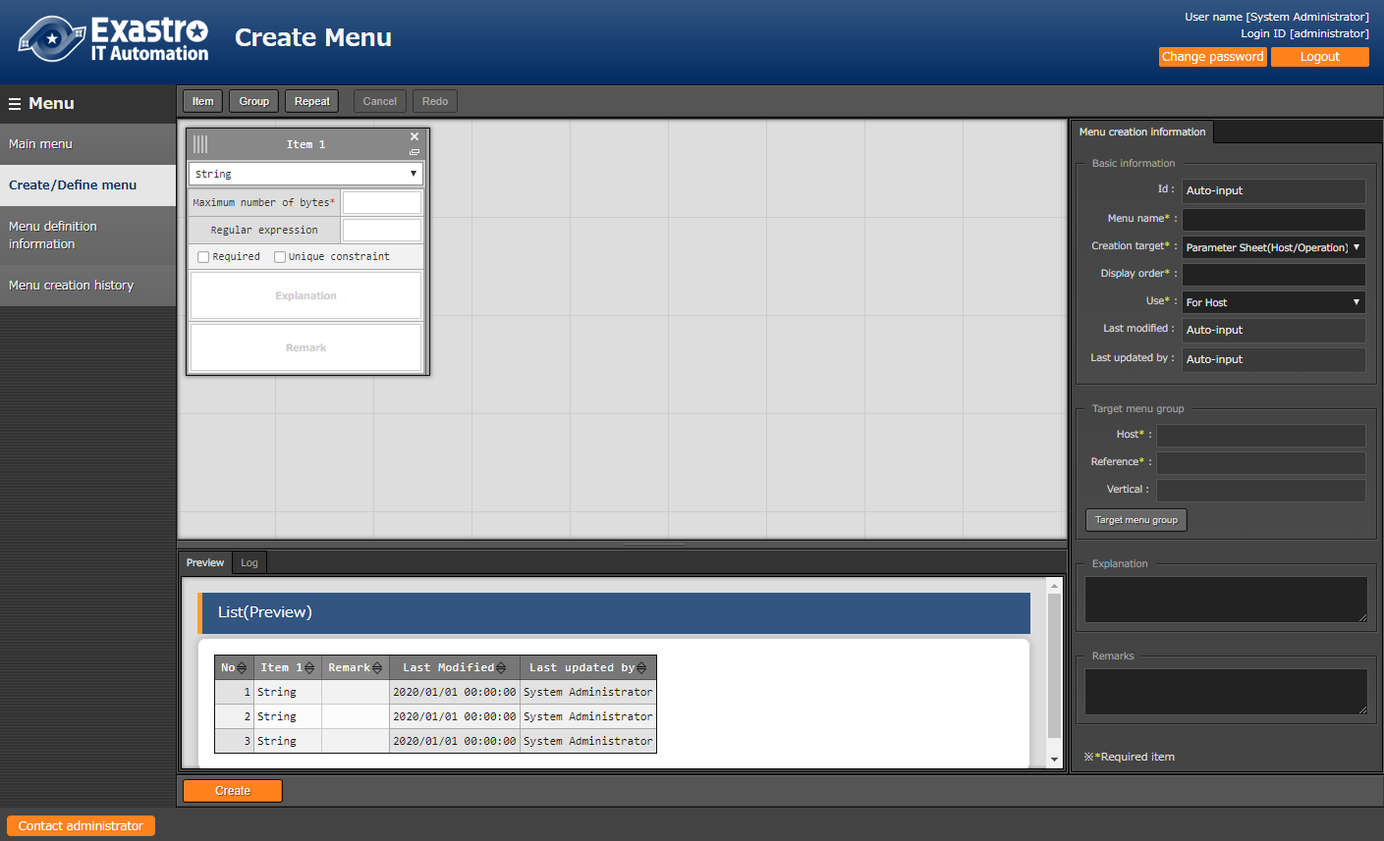

B

A

C

## (A) Setting items and column groups for parameter sheet

Set the items for parameter sheet

* Item button

Click “Item” button to add new item and set it.

Select the input method then enter required columns to set the parameter sheet.

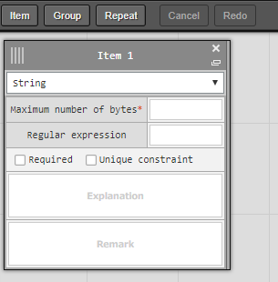

| **Item name** | | **Description** |
| --- | --- | --- |
| Item name  (Item 1 is set on default) | | Enter the item name to be displayed on the menu  .※ Do not use 「/」 in the item names. When 「/」 is used, the  「Substitute value auto registration setting」 in each driver may not work properly. |
| Pulldown menu  (Input method) | | Selecte “String”, “Multi string”, “Integer”, “Decimal number”, “Date”, “Date/time”, “Pull down selection” from the pulldown menu.  When “String” is selected, the item is a text box with single line input.  When “Multi string” is selected, the item is a text box with multiple line input.  When “Integer” is selected, the item is a text box that only integer can be entered.  When “Decimal number” is selected, the item is a text box that integer/decimal number can be entered.  When “Date” and “Date/time” is selected, the item is entered by calendar selection.  When “Pulldown selection” is selected, the item is a pulldown menu item.  ※ About the trace history of the menu created with 「Pulldown selection」 is selected, the supplement is described in 「8.5 Trace history when「Pulldown selection」is included in the sheet」.  ※The association target item in “Substitution value automatic registration setting” are “String”, “Multi string”, “Integer”, and “Decimal number”. “Date/time”, and “Date” can’t be associated. “Pulldown selection” can’t be associated if the item of pulldown selection are “Multi string”, “Date/time”, and “Date”. |
| Required | | To make it a required item, check the check box. |
| Unique constraint | | To make it a unique item, check the check box. |
| String | Maximum number of bytes | Enter the maximum number of bytes.  The maximum size is 8192 bytes.  The byte count of half-width alphanumeric characters are equivalent to the number of characters.  For full-width characters, the number of characters x 3 + 2 bytes is required.  Required if “Input Method” is “String”.  Can’t be entered if “Input method” is “Multi string”, “Integer”, “Decimal number”, “Date/time”, “Date”, and “Pulldown selection”. |
| Regular expression | If you want to check input values with regular expression, enter the regular expression.  Example: For half-width numeric items of 0 bytes or more: /^[0-9]*$/  For half-width alphanumeric characters of 1 byte or more:/^[a-zA-Z0-9]+$/  Can’t be entered if “Input method” is “Multi string”, “Integer”, “Decimal number”, “Date/time”, “Date”, and “Pulldown selection”. |
| Multi string | Maximum number of bytes | Enter the maximum number of bytes.  The maximum size is 8192 bytes.  The byte count of half-width alphanumeric characters are equivalent to the number of characters.  For full-width characters, the number of characters x 3 + 2 bytes is required.  Required if “Input Method” is “Multi String”.  Can’t be entered if “Input method” is “String”, “Integer”, “Decimal number”, “Date/time”, “Date”, and “Pulldown selection”. |
| Regular expression | If you want to check input values with regular expression, enter the regular expression.  Example: For half-width numeric items of 0 bytes or more: /^[0-9]*$/  For half-width alphanumeric characters of 1 byte or more:/^[a-zA-Z0-9]+$/  Can’t be entered if “Input method” is “String”, “Integer”, “Decimal number”, “Date/time”, “Date”, and “Pulldown selection”. |
| Integer | Minimum value | Enter the minimum value of the column. Integer value from -2147483648 to 2147483647 can be entered.  The value will be -2147483648 if not entered.  Please enter value smaller than the maximum value.  Can’t be entered if “Input method” is “String”, “Multi string”, “Decimal number”, “Date/time”, “Date”, and “Pulldown selection”. |
| Maximum value | Enter the maximum value of the column. Integer value from -2147483648 to 2147483647 can be entered.  The value will be 2147483647 if not entered.  Please enter value larger than the minimum value.  Can’t be entered if “Input method” is “String”, “Multi string”, “Decimal number”, “Date/time”, “Date”, and “Pulldown selection”. |
| Decimal number | Minimum value | Enter the minimum value of the column. Integer value from -99999999999999 to 99999999999999 with total digit for whole number + fraction part less than 14 digits can be entered.  The value will be -99999999999999 if not entered.  Please enter value smaller than the maximum value.  Can’t be entered if “Input method” is “String”, “Multi string”, “Integer”, “Date/time”, “Date”, and “Pulldown selection”. |
| Maximum value | Enter the maximum value of the column. Integer value from -99999999999999 to 99999999999999 with total digit for whole number + fraction part less than 14 digits can be entered.  The value will be 99999999999999 if not entered.  Please enter value larger than the minimum value.  Can’t be entered if “Input method” is “String”, “Multi string”, “Integer”, “Date/time”, “Date”, and “Pulldown selection”. |
| Digits | Enter the upper limit of the total digit for whole number + fraction part.  Example: 0.123 has 4 digits (whole number 1 digit, fraction part 3 digits)  11.1111 has 6 digits (whole number 2 digit2, fraction part 3 digits)  Integer value from 1 to 14 can be entered.  Can’t be entered if “Input method” is “String”, “Multi string”, “Integer”, “Date/time”, “Date”, and “Pulldown selection”. |
| Pulldown selection | Menu group: Menu: Item | Select the item to be referenced in the pulldown menu from the pull-down menu.  ※Items that satisfy the following conditions are displayed in the pull-down menu .  Menu: 「Basic Console: Device List」 and menu created with this function  Item: String, required and unique constraint item.  Input required if “Input method” is “Pulldown selection”.  Can’t be entered if “Input method” is “String”, “Multi string”, “Integer”, “Decimal number”, “Date/time”, and “Date”. |
| Explanation | | Enter the description that will be displayed when users hover mouse cursor over the item name. |
| Remarks | | Enter the remarks column. |

* Group button

Click the “Group” button to add a column group.

Drag and drop items into the body area of column group to add items into column group.

Column groups can also be added into column groups. Multiple items can be set into single column group.

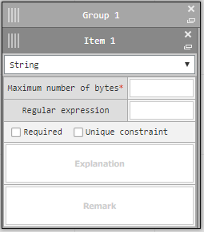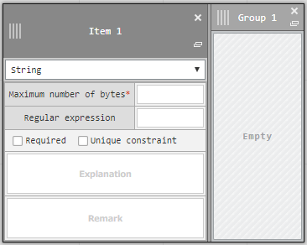

* Repeat button

Click the “Repeat” button to set repeat items.

Repeat items and repeat count will automatically applied to vertical menu.

Drag and drop items into the body area of repeat column to set items as repeat item.

(※)Vertical function is not applicable for data sheet.

Multiple items can be set in repeat column but only one repeat column can be set in a parameter sheet.

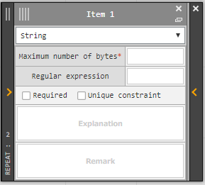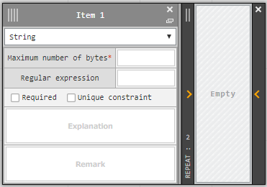

Enter the repeat count.

* Cancel button

Undo the previous modification.

* Redo button

Redo the cancelled modification.

## (B) Menu creation information panel

Enter required information for menu creation.

* Basic information

| **Item name** | **Description** | **Selected value of creation target** | |
| --- | --- | --- | --- |
| **Parameter**  **Sheet** | **Data Sheet** |
| Id | “Auto-input” is set on default when creating new menu.  The ID of menu will be displayed when editing existing menu. | Displayed | Displayed |
| Menu name | Enter the menu name of the menu to be created. The menu name “Main menu” cannot be used. | Displayed | Displayed |
| Creation target | Select 「Parameter Sheet (Host / Operation)」 or 「Data Sheet (master available)」 from the pull-down menu.  When 「Parameter sheet (host / operation)」 is selected, then 「Menu group for data sheet」 is hidden, and 「Use」, 「Menu group for host group」, 「Menu group for host」, 「Menu group for view」 and 「Vertical menu group」 are displayed.  When 「Data Sheet (master available)」 is selected , 「Use」, 「Menu group for host group」, 「Menu group for host」, 「Menu group for View」, 「Vertical menu group」 is hidden and 「Menu group for Data Sheet」 is displayed.  「Parameter Sheet (Host / Operation)」 is set on default. | Displayed | Displayed |
| Display order | Enter the display order in the menu group. They are displayed in ascending order. | Displayed | Displayed |
| Use | Select either 「For Host」 or 「For Host Group」 from the pull-down menu.  When 「For Host」 is selected, parameter sheet for the host to link with 「Substitute value auto-registration setting」 is created.  When 「For Host group」 is selected, a parameter sheet to be used in the host group function is created. | Displayed | Hidden |
| Last modified | “Auto-input” is set on default when creating new menu.  The time of last modification will be displayed in view/edit mode. | Displayed | Displayed |
| Last updated by | “Auto-input” is set on default when creating new menu.  The name of the user who last modified the menu will be displayed in view/edit mode. | Displayed | Displayed |

* Target menu group

The menu groups that the menu to be created belongs to is displayed.

Click the “Target menu group” button to display the “Target menu group” modal to select the menu group for the menu to be created.

| **Item name** | **Description** | **Selected value of creation target** | |
| --- | --- | --- | --- |
| **Parameter**  **Sheet** | **Data Sheet** |
| Host | The name of menu group selected for “Host” in “Target group menu” modal is displayed. This column is required. | Displayed | Hidden |
| Host Group | The name of menu group selected for “Host group” in “Target group menu” modal is displayed. ※This column is only displayed when “For HostGroup” is selected for “use”. This column is required when displayed. | Displayed | Hidden |
| Reference | The name of menu group selected for “Reference” in “Target group menu” modal is displayed. This column is required. | Displayed | Hidden |
| Vertical | The name of menu group selected for “Vertical” in “Target group menu” modal is displayed. | Displayed | Hidden |
| Data sheet | The name of menu group selected for “Data sheet” in “Target group menu” modal is displayed. ※This column is only displayed when “Data Sheet (master available)” is selected for “Creation target”. This column is required when displayed. | Hidden | Displayed |

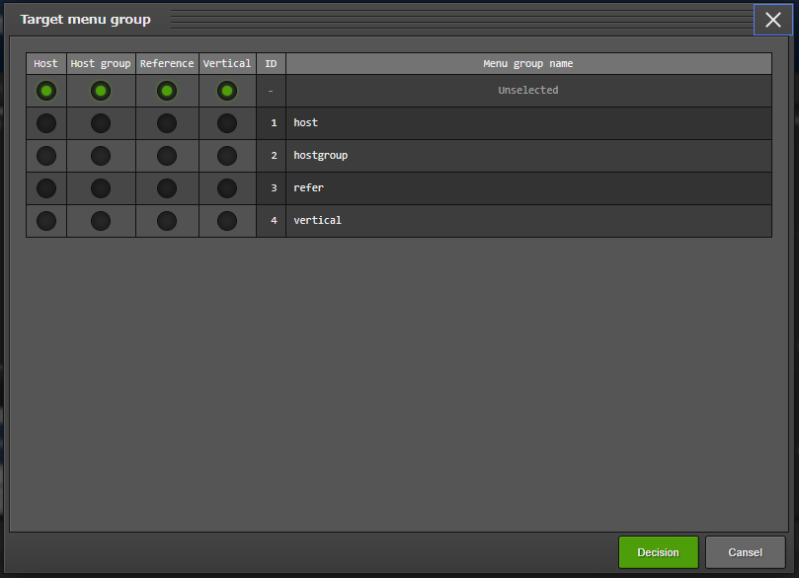

* Target menu group modal

Select the menu group for the menu to be created then click the decide button.

“Unselected” is set on default.

Click the “Cancel” button to return to Define/Create menu screen.

“Data sheet” can be selected when Creation Target is Datasheet, “Host group” can be selected when “Host group” is selected for use.

Please create host groups in “Management console: Menu group list” beforehand.

For the details of creating host groups, please refer to “User instruction manual_Management console”.

## (C) Execute menu creation

* Preview

The items to be created is displayed in table format.

* Log

The result of menu creation after clicking the create button will be displayed.

* Create button (When creating new menu)

Menu creation will be performed when clicking “Create” button after entering all required item.

The following pop-out modal will be displayed after clicking “OK” button of confirmation pop-out modal.

Please move the “Menu creation history” menu to check if the menu is created normally after the creation is performed.

When creating menus in “Define/Create menu” screen, the information of the created menu will be automatically registered to “Menu definition information”, “Column group list”, “Menu item creation information”, “Vertical menu creation information”.

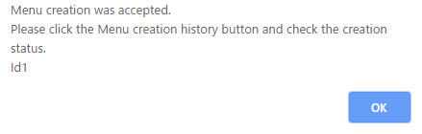

## Usage of 「Define/Create Menu」after menu creation

Users can update created menu or use created menu as template to create new menu after creating menu in “Define/Create Menu”.

* “View mode screen”

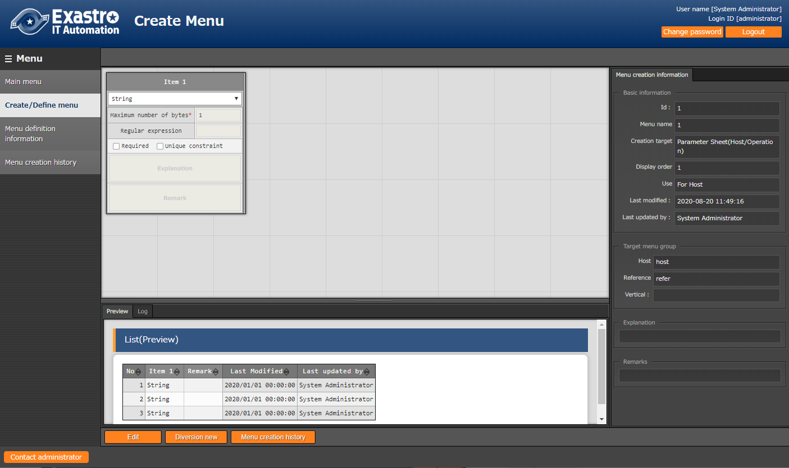

After creating new menu, the screen will move to above screen (referred to as view mode here). “Edit”, “Diversion new”, “Menu creation history” button is displayed in view mode.

Users can’t edit or create menu in view mode.

* Edit button

Click edit button to edit the menu.

The edited menu will be created.

* Diversion new button

Move to the create menu screen using the menu as template.

Please enter new menu name and display order for the new menu.

The new menu name has to be different with the original menu.

* Menu creation history button

Move to the “Menu creation history” menu of the corresponding menu.

* “Edit mode screen”

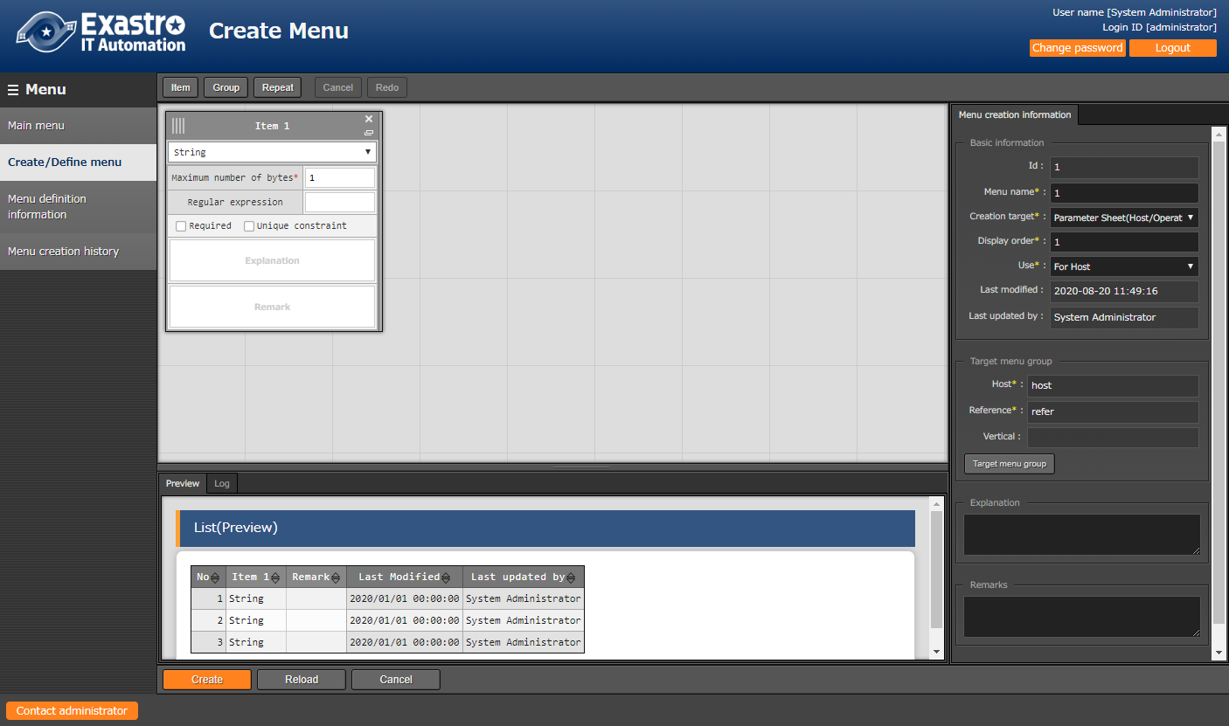

Click the edit button to switch view mode to edit mode to edit the menu.

Click the create button will overwrite the original menu then create a new menu.

※When editing existing menu, since exchanging the name of items among the items is invalid, error may occur when changing the name of items.

* Reload button

Discard the edited content then return to the status of the original menu.

* Cancel button

Return to the status before clicking the edit button.

## Check created menu in「Menu definition information」

Users can check created menu, and created/maintain (View/Update/Discard/Restore) menu in “Menu definition information” menu.

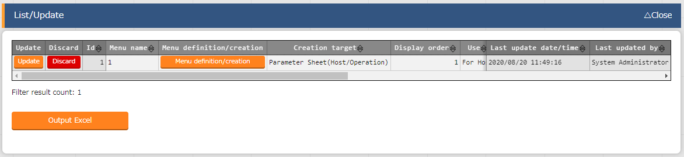

Created menu is displayed in List/Update. Click “Filter” button in display filter to show all menus.

Click the “Menu definition/creation” button to move to “Define/Create menu” menu in view mode.

※The following are the steps to create menu in “Menu definition information” menu. These steps are not needed to create menu in “Define/Create menu” menu.

Users can maintain (View/Update/Discard/Restore) the menu of parameter sheet or data sheet in “Menu definition information” menu.

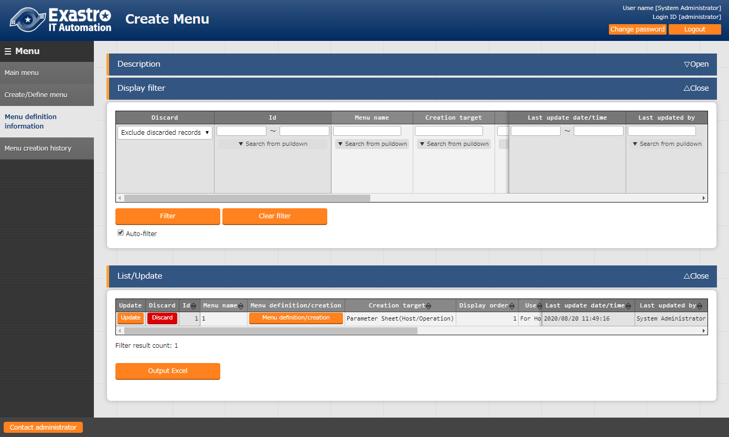

| **Item name** | **Description** | **Selected value of creation target** | |
| --- | --- | --- | --- |
| **Parameter**  **Sheet** | **Data Sheet** |
| Menu name | Enter the menu name of the menu to be created. The menu name “Main menu” cannot be used. | Displayed | Displayed |
| Creation target | Select 「Parameter Sheet (Host / Operation)」 or 「Data Sheet (master available)」 from the pull-down menu.  When 「Parameter sheet (host / operation)」 is selected, then 「Menu group for data sheet」 is hidden, and 「Use」, 「Menu group for host group」, 「Menu group for host」, 「Menu group for view」 and 「Vertical menu group」 are displayed.  When 「Data Sheet (master available)」 is selected , 「Use」, 「Menu group for host group」, 「Menu group for host」, 「Menu group for View」, 「Vertical menu group」 is hidden and 「Menu group for Data Sheet」 is displayed. | Displayed | Displayed |
| Display order | Enter the display order in the menu group. They are displayed in ascending order. | Displayed | Displayed |
| Use | Select either 「For Host」 or 「For Host Group」 from the pull-down menu.  When 「For Host」 is selected, parameter sheet for the host to link with 「Substitute value auto-registration setting」 is created.  When 「For Host group」 is selected, a parameter sheet to be used in the host group function is created. | Displayed | Hidden |
| Menu group for data sheet (**※**) | Select the menu group for creating the data sheet from the pull-down menu. When 「Datasheet」 is selected in 「Creation target」, selection is required. | Hidden | Displayed |
| Menu group for host group (**※**) | Select the menu group for creating the parameter sheet for the host group from the pull-down menu. The selection is required when the use is 「For host group」 and cannot be selected when it is 「For Host」. | Displayed | Hidden |
| Menu group for Host (**※**) | Select the menu group for creating the parameter sheet for the host from the pull-down menu. When 「Parameter sheet」 is selected in 「Creation target」,selection is required. |
| Menu group for view (**※**) | Select a menu group for creating a parameter sheet for view from the pull-down menu. When 「Parameter sheet」 is selected in 「Creation target」, selection is required. |
| Vertical menu group (**※**) | Select the menu group for creating the parameter sheet for vertical menu group from the pull-down menu. |
| Description | Enter the content to be displayed in the description column of the menu screen. | Displayed | Displayed |
| Item creation information | This button is displayed only in 「List」. When clicked, the 「Menu item creation information」 menu is displayed in separate tab, and is displayed in a list filtered by 「Menu name」. | Displayed | Displayed |
| Remarks | Free description field | Displayed | Displayed |

(**※**) Please create the menu group using 「Management Console:Menu Group Management」 in advance. Please refer to 「User Instruction Manaual_Management Console」 for how to create a menu.

## Check the status of creation using「Menu creation history」

Check the status of menu creation list on the parameter sheet or data sheet.

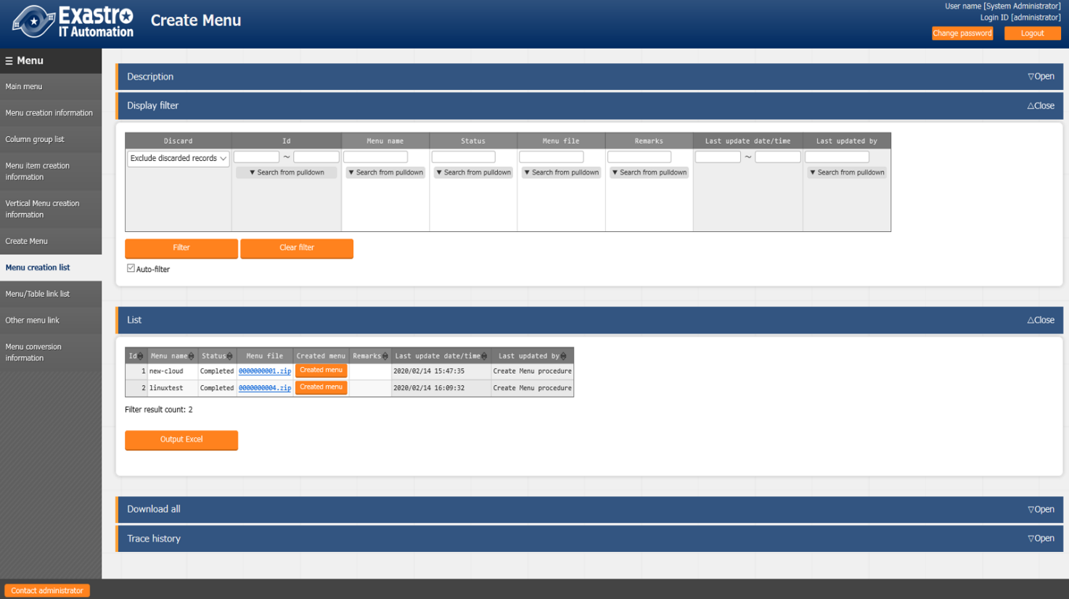

BackYard monitors the status「unexecuted」, and creates a menu screen setting file based on the unexecuted data, which executes SQL Commands to create a table and registers the menu screen program.　After several tens of seconds, when the status changes to 「Completed」,　the menu will be created.

|  |  |
| --- | --- |
| **Item name** | **Description** |
| Menu name | Name of the menu to be created |
| Status | Menu creation status.  Unexecuted: status before menu creation  Executing: BackYard is executing the menu creation process  Completed: Menu creation completed successfully  Completed (error): When creating the menu ended with an error |
| Menu file | The PHP file and SQL file used in the menu.  If BackYard is seperated from the web server, this file is required to be placed on the web server. Refer to 「8.1 Placing PHP files」 |
| Created menu | If the status is 「Complete」, the created menu opens.  If 「Use」 is 「For Menu group」, menu created under the menu group specified in 「menu group for Host group」 opens. And if 「Use」 is 「For Host」, the menu created under the menu group specified in 「Host menu group」 opens. If 「Creation target」is 「Data Sheet」, the menu created under the menu group specified in「menu group for Data Sheet」 is opened. |
| Remarks | Free description field |

## Check the created menu

(1) When “Parameter sheet” is selected for 「Creation target」

* If you specify 「For Host Group」 in 「Use」 of the 「Menu Creation Information」 menu, please make sure that the menu is added under the menu group specified in 「Menu Group for Host Group」.

※The reference date and time is set to the last execution date and time if the last execution date and time of the operation are included, and the scheduled execution date and time is set to the last execution date and time of the operation.

**Menu group for host group**

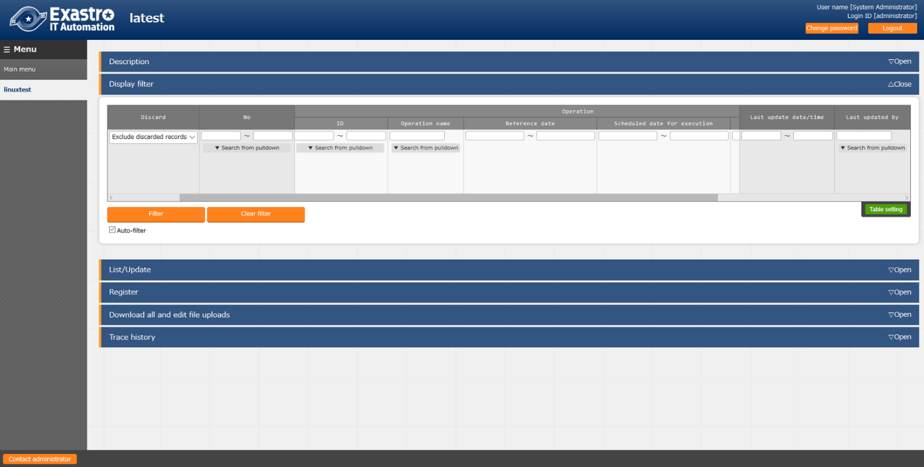

* Please make sure that the menu is added under the menu group specified in 「Host Menu Group」 of the 「Menu creation Information」 menu.

※The reference date and time is set to the last execution date and time if the last execution date and time of the operation are included, and the scheduled execution date and time is set to the last execution date and time of the operation.

**Host menu group**

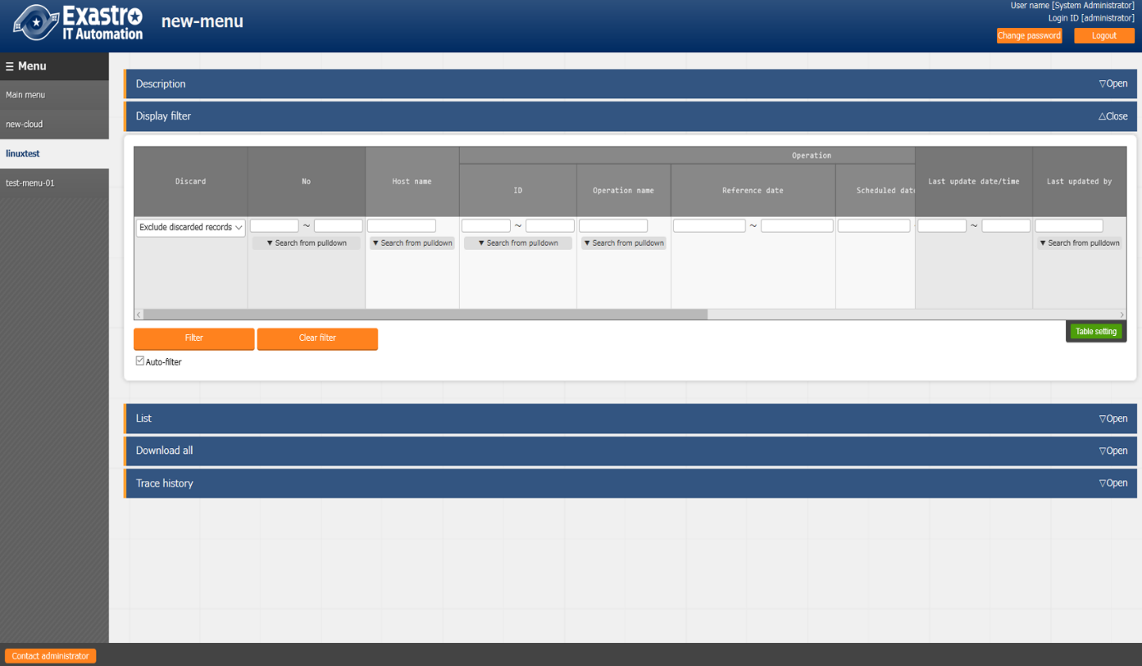

* Please make sure that the menu is added under the menu group specified in 「Menu group for view」 in the 「Menu creation information」 menu .

In this menu, the data registered for the host is displayed only with the latest operation/ reference date and time for each host name.

If you specify the operation / reference date and time of the search condition, the latest data before the specified date will be displayed. By using this menu, you can get the latest setting information for each host and the setting information as of the specified reference date and time.

※The reference date and time is set to the last execution date and time if the last execution date and time of the operation are included, and the scheduled execution date and time is set to the last execution date and time of the operation.

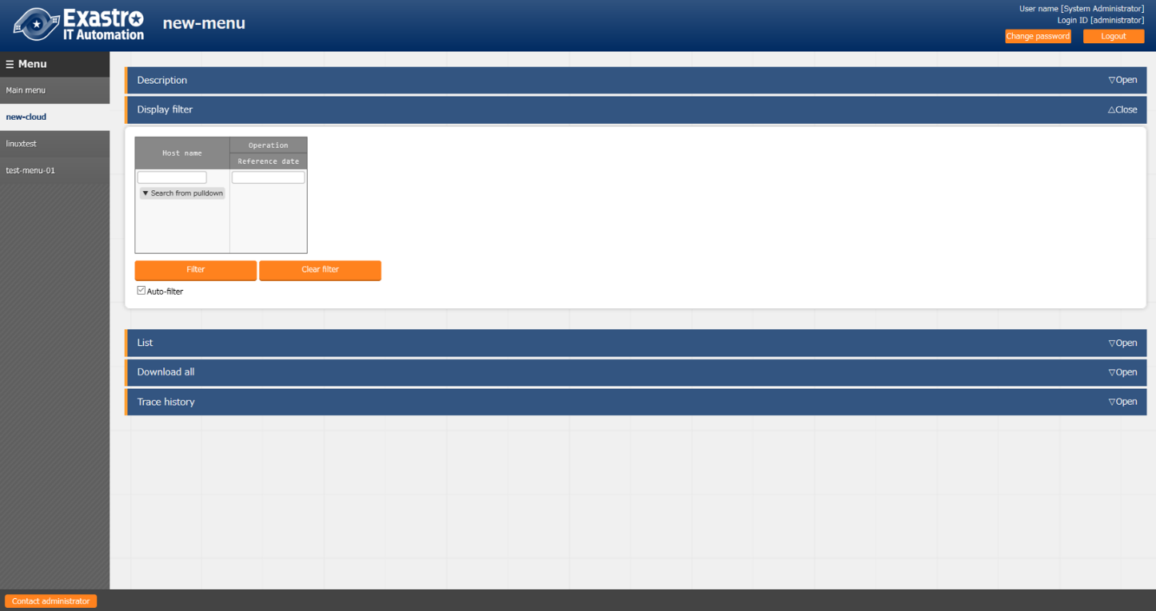

* Please make sure that the menu is added under the menu group specified in the 「Vertical menu group」 in the 「Menu creation information」 menu .

In this menu, vertical display is performed according to the number of items and the number of repetition count registered in the (vertical) menu creation information.

※The reference date and time is set to the last execution date and time if the last execution date and time of the operation are included, and the scheduled execution date and time is set to the last execution date and time of the operation.

**Menu group for vertical menu**

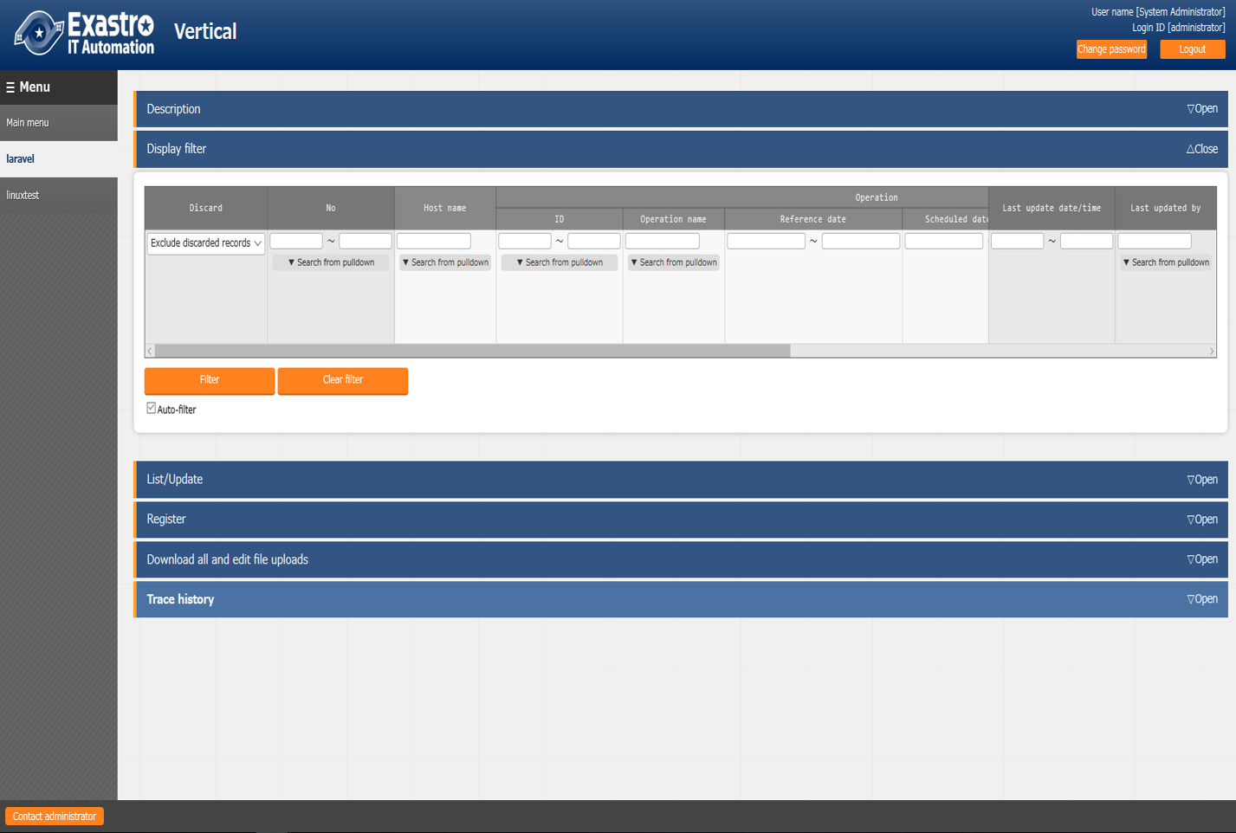

(2) When “Datasheet” is selected for 「Creation target」.

* Please make sure that the menu has been added under the menu group specified in 「Menu group for data sheet」 in the 「Menu creation information」 menu.

※Since the Data Sheet is not linked to a specific host / operation, the host / operation items are not displayed.

**Menu group for data sheet**

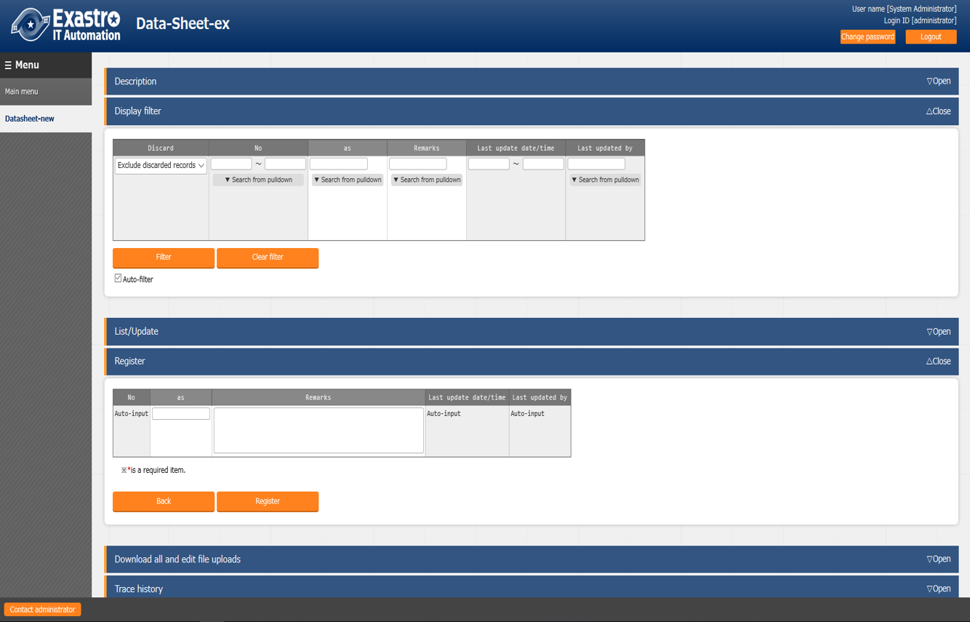

# Operation description of menu creation function (Hidden menus)

## Register a column group using 「Column Group list」

The column groups of sheets that belong to the menu to be created can be maintained (View/Update/Discard/restore).

A column group is a group that displays the heading portion of a menu item. The menu creation function allows users to create a column groups of items that they want to create. The red marked frame in the following example is the column group that can be created by the menu creation function 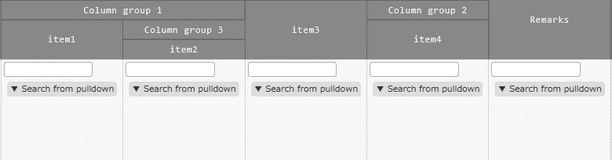

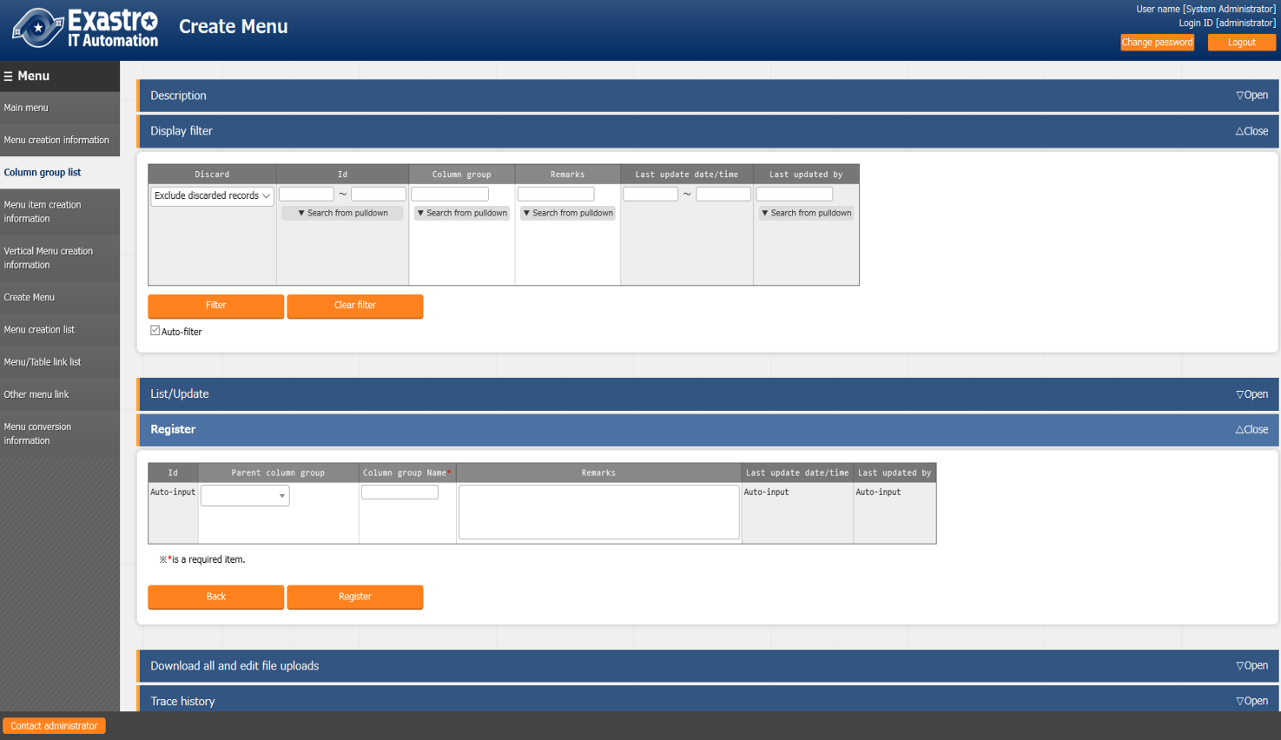

|  |  |
| --- | --- |
| **Item name** | **Description** |
| Parent column group | ※Displayed in register / update only  Select the parent column group from the pull-down. |
| Column group name | ※Displayed in register / update only  Enter the column group name |
| Column group | ※Displayed in list / discard / restore only  Parent column group and column group name are connected by 「/」 and displayed |
| Remarks | Free description field |

The following checks are performed at the time of updating / discard.

1. The data itself cannot be selected as a parent column group.
2. If it is specified in the parent group of other data, it cannot be discarded.
3. A parent-child relationship that results in a loop relationship cannot be set. (If the parent-child relationship is A⇒B⇒C, C cannot be specified as the parent of A.).

## Register items to be set using「Menu item creation information」

The items managed in the parameter sheet or data sheet menu to be created can be maintained (View/Update/Discard/restore).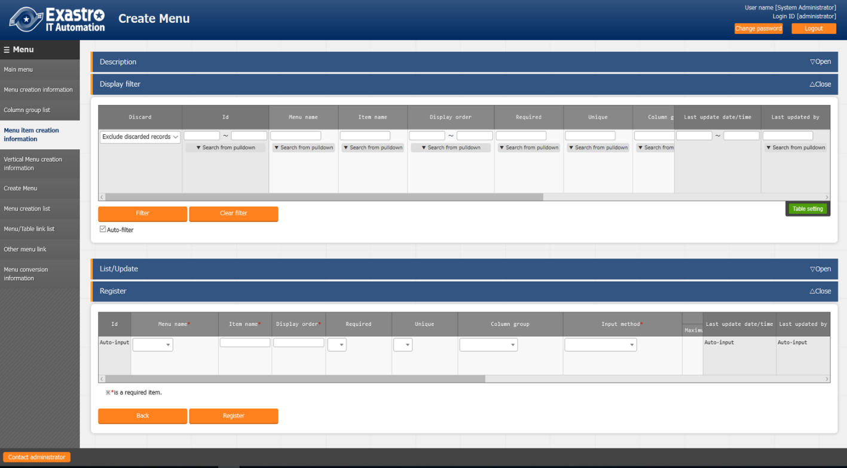

| **Item name** | | **Description** |
| --- | --- | --- |
| Menu name | | Select the menu to be linked with the parameter from the pull-down menu. |
| Item name | | Enter the item name to be displayed on the menu  .※ Do not use 「/」 in the item names. When 「/」 is used, the  「Substitute value auto registration setting」 in each driver may not work properly. |
| Display order | | Enter the order of the columns displayed in the menu. They are displayed in ascending order from the left. |
| Required | | To make it a required item, select 「●」 from the pull-down menu. |
| Unique | | To make it a unique item, select 「●」 from the pull-down menu. |
| Column group | | Select the column group to which it belong from the pull-down menu. |
| Input method | | Selecte “String”, “Multi string”, “Integer”, “Decimal number”, “Date”, “Date/time”, “Pull down selection” from the pulldown menu.  When “String” is selected, the item is a text box with single line input.  When “Multi string” is selected, the item is a text box with multiple line input.  When “Integer” is selected, the item is a text box that only integer can be entered.  When “Decimal number” is selected, the item is a text box that integer/decimal number can be entered.  When “Date” and “Date/time” is selected, the item is entered by calendar selection.  When “Pulldown selection” is selected, the item is a pulldown menu item.  ※ About the trace history of the menu created with 「Pulldown selection」 is selected, the supplement is described in 「7.5 Trace history when「Pulldown selection」is included in the sheet」.  ※The association target item in “Substitution value automatic registration setting” are “String”, “Multi string”, “Integer”, and “Decimal number”. “Date/time”, and “Date” can’t be associated. “Pulldown selection” can’t be associated if the item of pulldown selection are “Multi string”, “Date/time”, and “Date”. |
| String | Maximum number of bytes | Enter the maximum number of bytes.  The maximum size is 8192 bytes.  The byte count of half-width alphanumeric characters are equivalent to the number of characters.  For full-width characters, the number of characters x 3 + 2 bytes is required.  Required if “Input Method” is “String”.  Can’t be entered if “Input method” is “Multi string”, “Integer”, “Decimal number”, “Date/time”, “Date”, and “Pulldown selection”. |
| Regular expression | If you want to check input values with regular expression, enter the regular expression.  Example: For half-width numeric items of 0 bytes or more: /^[0-9]*$/  For half-width alphanumeric characters of 1 byte or more:/^[a-zA-Z0-9]+$/  Can’t be entered if “Input method” is “Multi string”, “Integer”, “Decimal number”, “Date/time”, “Date”, and “Pulldown selection”. |
| Multi string | Maximum number of bytes | Enter the maximum number of bytes.  The maximum size is 8192 bytes.  The byte count of half-width alphanumeric characters are equivalent to the number of characters.  For full-width characters, the number of characters x 3 + 2 bytes is required.  Required if “Input Method” is “Multi String”.  Can’t be entered if “Input method” is “String”, “Integer”, “Decimal number”, “Date/time”, “Date”, and “Pulldown selection”. |
| Regular expression | If you want to check input values with regular expression, enter the regular expression.  Example: For half-width numeric items of 0 bytes or more: /^[0-9]*$/  For half-width alphanumeric characters of 1 byte or more:/^[a-zA-Z0-9]+$/  Can’t be entered if “Input method” is “String”, “Integer”, “Decimal number”, “Date/time”, “Date”, and “Pulldown selection”. |
| Integer | Minimum value | Enter the minimum value of the column. Integer value from -2147483648 to 2147483647 can be entered.  The value will be -2147483648 if not entered.  Please enter value smaller than the maximum value.  Can’t be entered if “Input method” is “String”, “Multi string”, “Decimal number”, “Date/time”, “Date”, and “Pulldown selection”. |
| Maximum value | Enter the maximum value of the column. Integer value from -2147483648 to 2147483647 can be entered.  The value will be 2147483647 if not entered.  Please enter value larger than the minimum value.  Can’t be entered if “Input method” is “String”, “Multi string”, “Decimal number”, “Date/time”, “Date”, and “Pulldown selection”. |
| Decimal number | Minimum value | Enter the minimum value of the column. Integer value from -99999999999999 to 99999999999999 with total digit for whole number + fraction part less than 14 digits can be entered.  The value will be -99999999999999 if not entered.  Please enter value smaller than the maximum value.  Can’t be entered if “Input method” is “String”, “Multi string”, “Integer”, “Date/time”, “Date”, and “Pulldown selection”. |
| Maximum value | Enter the maximum value of the column. Integer value from -99999999999999 to 99999999999999 with total digit for whole number + fraction part less than 14 digits can be entered.  The value will be 99999999999999 if not entered.  Please enter value larger than the minimum value.  Can’t be entered if “Input method” is “String”, “Multi string”, “Integer”, “Date/time”, “Date”, and “Pulldown selection”. |
| Digits | Enter the upper limit of the total digit for whole number + fraction part.  Example: 0.123 has 4 digits (whole number 1 digit, fraction part 3 digits)  11.1111 has 6 digits (whole number 2 digit2, fraction part 3 digits)  Integer value from 1 to 14 can be entered.  Can’t be entered if “Input method” is “String”, “Multi string”, “Integer”, “Date/time”, “Date”, and “Pulldown selection”. |
| Pulldown selection | Menu group: Menu: Item | Select the item to be referenced in the pulldown menu from the pull-down menu.  ※Items that satisfy the following conditions are displayed in the pull-down menu .  Menu: 「Basic Console: Device List」 and menu created with this function  Item: String, required and unique constraint item.  Input required if “Input method” is “Pulldown selection”.  Can’t be entered if “Input method” is “String”, “Multi string”, “Integer”, “Decimal number”, “Date/time”, and “Date”. |
| Description | | Enter the description that will be displayed when users hover mouse cursor over the item name. |
| Remarks | | Free description field |

## Vertical registration using「Vertical menu creation information」

Users can select the menu and start item name of the parameter sheet to be created, and specify the number of items and the number of repetitions for vertical management display.

(※) The 「Vertical management」 function cannot be used in the data sheet.

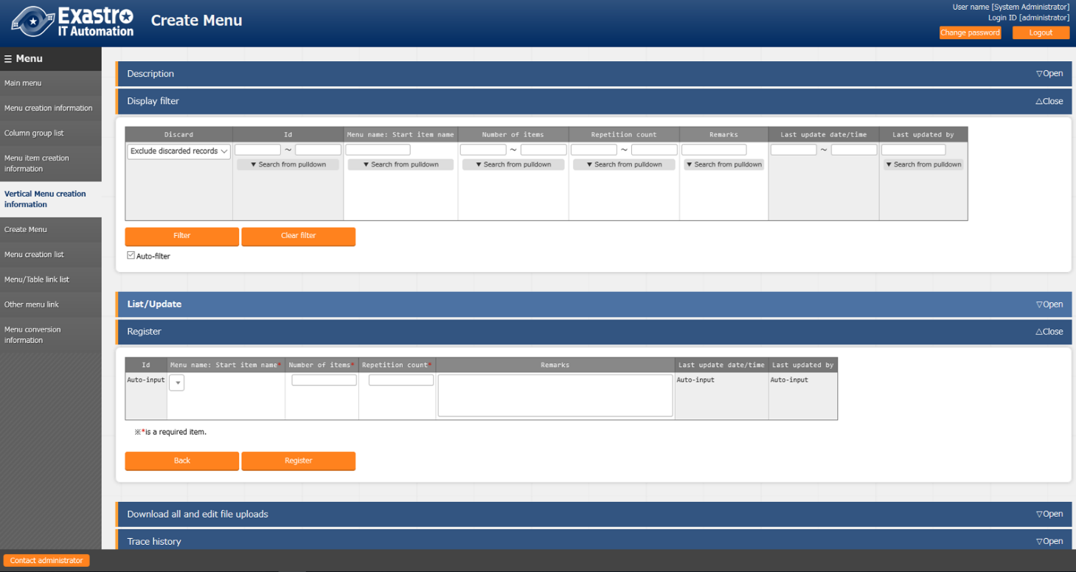

|  |  |
| --- | --- |
| Item name | Description |
| Menu name: Start item name | Select menu and start item name of the parameter sheet from pull-down menu. |
| Number of items | Enter the number of items from the start item. |
| Repetition count | Enter the number of repetition count in the vertical display. |
| Remarks | Free description field |

Example) Manage the parameters described in the hosts file.

hosts File

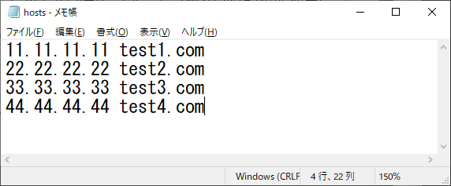

When specifying IP address + domain name in set as described above , use 「Vertical menu (vertical) creation information」 and by setting the menu name: start item name to 「role: IP address」 and specify the number of items as 「2」 and repetition count as「4」, vertical display conversion is performed as below becoming more readable and management becomes easier.

Vertical menu creation information



In the example, the start item name specifies the leftmost 「IP address」 in the red frame below

Horizontal display



Counting from the specified 「IP address」, the items until the second item 「domain name」 is displayed

Vertical display

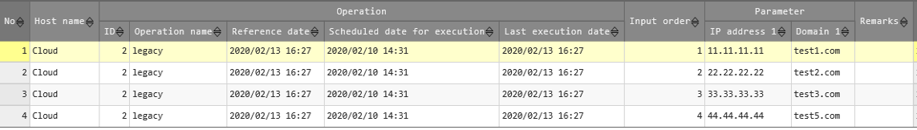

The parameter for the 2 items is displayed vertically for 4 times repeatedly.

## Create menu using「Create menu」

Create a menu of the parameter sheet or data sheet in the menu group specified in 「Menu creation Information」.

The created menu will be associated to System Administrator and the role of the user who executed menu creation.

A list of parameter sheet and data sheet whose menu names and items has already registered is displayed so please check the parameter sheet you want to create and click the 「Menu creation list」 button.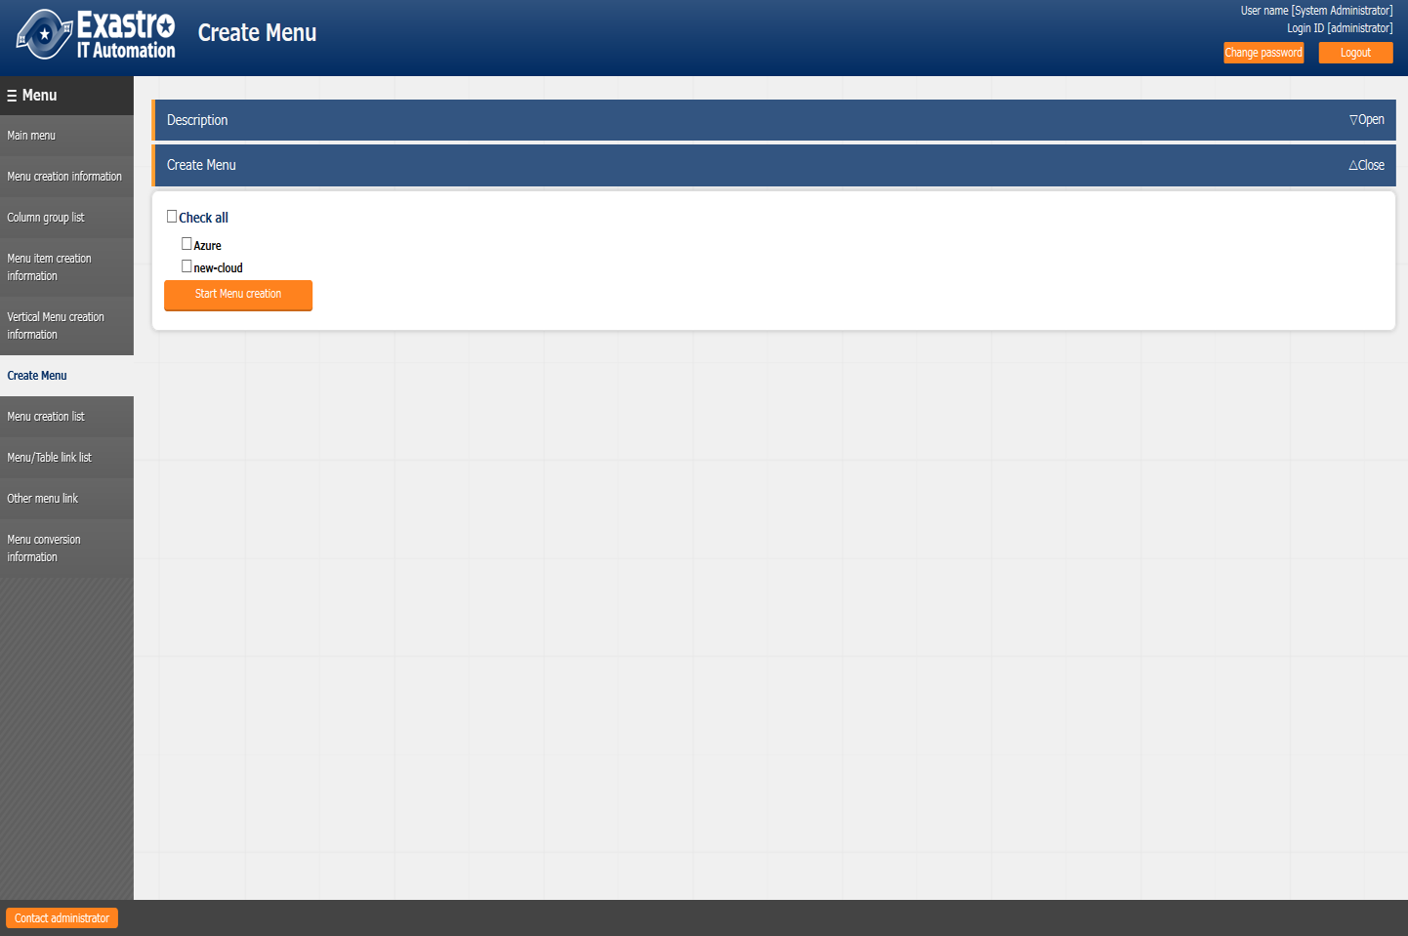

* If a menu with the same ID or same menu of 「Menu creation information」 already exists , the new menu is created by overwriting and the registered data is deleted. If you need the registered data, please select 「Cancel」 and back up the data

If the 「OK」 button in the confirmation dialog is clicked, the create request will be accepted.

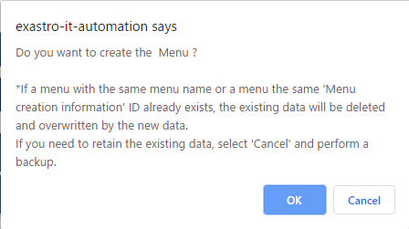

When you click the 「Menu Creation list」 button, the screen changes to 「Menu Creation list」 menu , which is displayed in a state filtered by 「ID」.

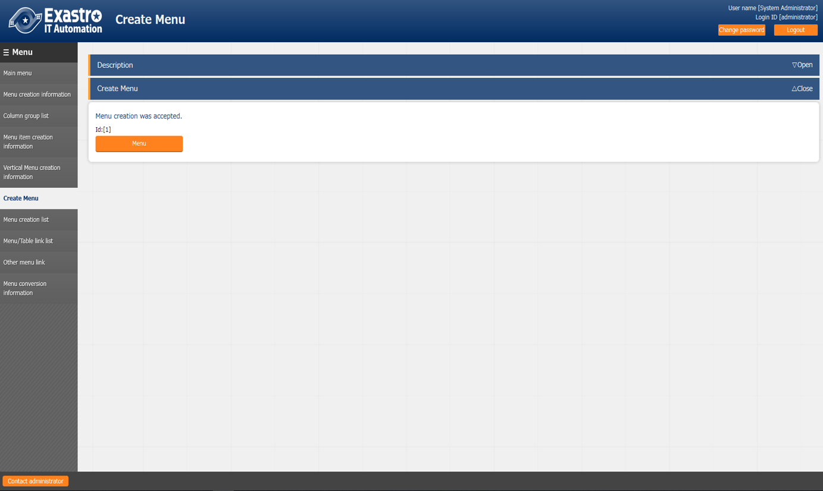

# Applicational operation

Operation that utilize the Menu creation function include not only user input from the browser screen of the client PC, but also system operation and maintenance. The operation and maintenance are as follows.

■　Maintenance

■　Change log level

## Maintenance

The following files are required to Start/Stop/Restart the process of the Menu creation function.

|  |  |
| --- | --- |
| **Description** | **Target file name** |
| Menu creation function .this function creates a parameter sheet menu based on the information entered in the web | ky_create_param_menu_execute.service |
| Menu update function for linking with other menus  This is a function to create items to be displayed in the pull-down menu of 「Menu group: Menu: Item」 in the 「Menu item creation information」 menu. | ky_createOtherMenuLink.service |

The target file is located in 「<installation directory>/ita-root/backyards/create_param_menu」 and a link is created in 「/usr/lib/systemd/system」. Please do not delete them.

The method of Starting/Stopping/Restarting a process is as follows. Please execute the command with root permission.

1. Start the process

# systemctl start ky_create_param_menu_execute.service 

1. Stop the process

# systemctl stop ky_create_param_menu_execute.service 

1. Restart the process

# systemctl restart ky_create_param_menu_execute.service 

## Change log level

1. Change to NORMAL level

Rewrite 「DEBUG」 to 「NORMAL」 on the 8th line of the target file .  
Local level setting file： <installation directory>/ita-root/confs/backyardconfs/ita_env

1. Change to DEBUG level

Rewrite 「NORMAL」 to 「DEBUG」 on the 8th line of the target file  
Local level setting file： <installation directory>/ita-root/confs/backyardconfs/ita_env

After rewriting the file, effect takes place after the process is (restart).

For restarting, refer to 「7.1 Maintenance」.

Log file output destination： < installation directory >/ita-root/logs/backyardlogs

# Appendix

## Placing PHP files

※If the ITA web server is on the same server as BackYard, the parameter management menu will be added by the previous operation. However, if the web server is on a different server from BackYard, the created menu is not displayed because the files are not automatically arranged. PHP files must be manually placed on the web server so that they can be displayed on the web.

Status of PHP file placement

└ita-root

├webconfs

│└users

　　　│ │

│ ├XXXXXXXXXX_loadTable.php（XXXXXXXXXX: Menu ID）

　　　│ │

　　　│

Method to place PHP file

1. Download the zip file from 「Menu creation list」 or 「Master creation list」.



1. After unzipping the Zip file, place the 「XXXXXXXXXX_loadTable.php」 file in the /ita-root/webconfs/users/ on the web server with root user permission using WinSCP, etc.

※ XXXXXXXXXX： Menu ID (From left 0 is filled with 10 digits) .→10 digits with0 filled on the left ※ If there are multiple 「XXXXXXXXXX_loadTable.php」 files, place them all.

## Menu / Table link list

A menu that displays the link between the created menu and the DB table

The menu is set hidden during installation. The menu is used by BackYard so no user operation can be performed. Even if you change the link directly after creating the menu, this menu will not change.

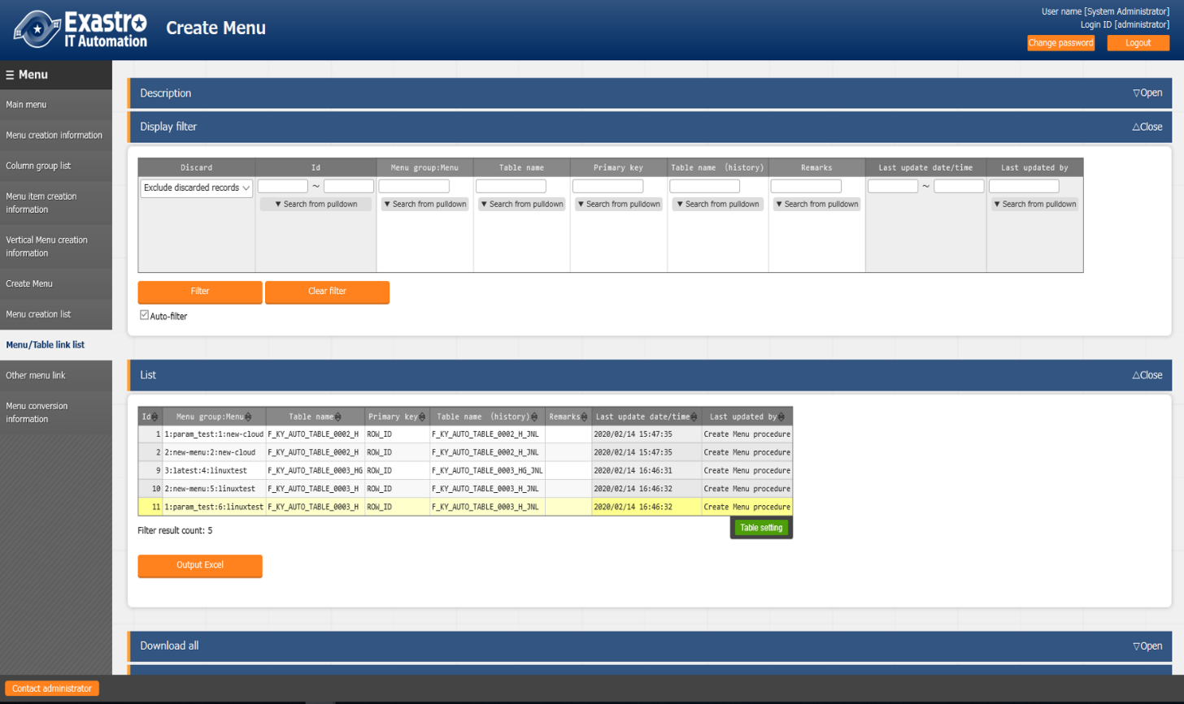

|  |  |
| --- | --- |
| **Item name** | **Decription** |
| Menu group: Menu name | Menu name associated with DB. |
| Table name | Name of the created table. |
| Primary key | Primary key of the created table. |
| Table name(history) | The name of the created history table. |
| Remarks | Free description field |

## Other menu link

Displays the link between the created menu item name and the DB column name.

The menu is set hidden during installation. The menu is used by BackYard so no user operation can be performed. Even if you change the link directly after creating the menu, this menu will not change.

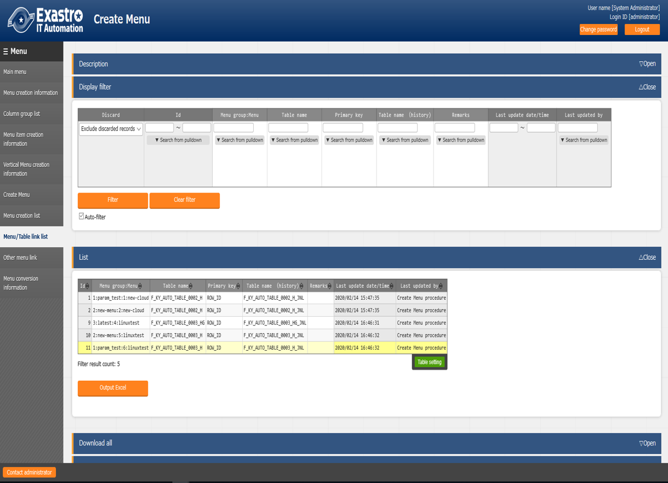

|  |  |
| --- | --- |
| **Item name** | **Description** |
| Menu group | Menu group name associated with DB. |
| Menu | Menu name of created parameter sheet or data sheet |
| Item name | The column name that is associated. |
| Table name | Name of the created table. |
| Primary key | Primary key of the created table. |
| Column name | The column name that is linked. |
| Remarks | Free description field |

## Menu conversion information

Displays the link of the menu that is converted to horizontal from the created vertical menu.

The menu is set hidden during installation. The menu is used by BackYard so no user operation can be performed. Even if you change the link directly after creating the menu, this menu will not change.

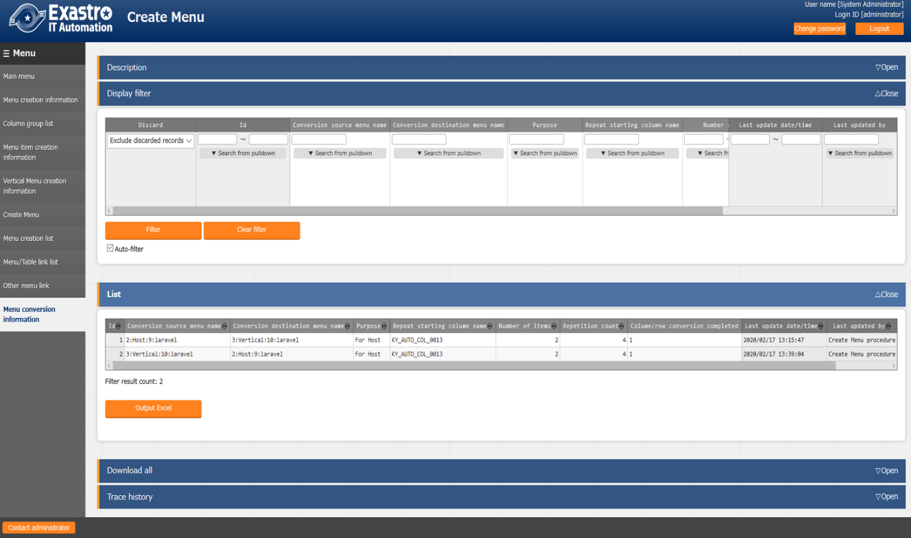

|  |  |
| --- | --- |
| **Item name** | **Description** |
| Conversion source menu name | The vertical menu name of the source. |
| Conversion destination menu name | Horizontal menu name of the destination. |
| Use | The purpose of the sheet menu. |
| Repeat start column | The name of the repeat start item of the horizontal menu |
| Number of items | The number of items in the horizontal menu. |
| Number of repetitions | The number of repetitions of the horizontal menu. |
| Vertical and horizontal converted flag | Specify the vertical and horizontal converted flag. |
| Remarks | Free description field |

## Trace history when「Pulldown selection」is included in the sheet

This section describes how to display the history when items include 「Pulldown selection」 when creating a parameter sheet or data sheet.

When the parameter of the reference destination (hereinafter, master) is changed, the parameter referred to is also changed automatically.

「Trace history」 displays the value of the master when the parameter is edited (registered / updated / Discarded / restored)

Example:

In, Parameter sheet, Item of 「Param 1」 - 「Param 1-2」 refers to Item of 「Master」 - 「Master」.

Operation：

1. Register the value 「mas1-1」 in 「Master」
2. One entry is registered in 「Param1」.
3. Update the 「Param1」.
4. Update 「Master」 with value 「mas1-2」.
5. Update 「Master」 with value 「mas1-3」
6. Update the 「Param1」.
7. Update 「Master」 with value 「mas1-4」
8. Update 「Master」 with value 「mas1-5」
9. Update the 「Param1」

Display：

Display of 「Param1」

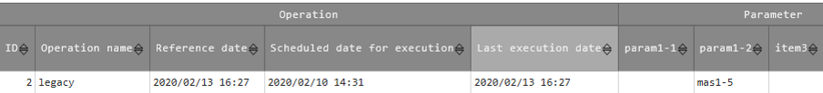

Trace history of 「Param1」

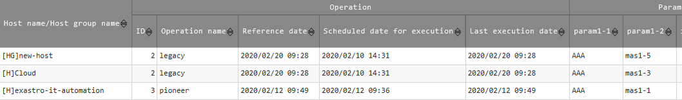

**⑤**

**⑧**

**①**

Display of 「master」

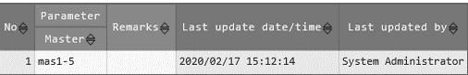

Trace history of 「master」

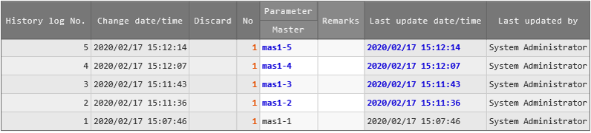

**⑨**

**④**

**⑤**

**⑦**