



ITA_Instruction_Manual

Symphony

*－*Version 1.8*－*

Copyright © NEC Corporation 2020. All rights reserved.

Disclaimer

All the contents of this document are protected by copyright owned by NEC Corporation.

Unauthorized reproduction or copying of all or part of the contents of this document is prohibited.

The contents of this document are subject to change without prior notice in the future.

NEC Corporation is not responsible for any technical or editorial errors or omissions in this document.

NEC Corporation do not guarantee accuracy, usability or certainty of the content in this document.

Trademark

* Linux is registered trademark or trademark of Linus Torvalds, registered in the U.S. and other countries.
* Red had is registered trademark or trademark of Red Hat Inc. registered in the U.S. and other countries.
* Apache, Apache Tomcat, and Tomcat are registered trademarks or trademarks of the Apache Software foundation.
* Ansible is registered trademark or trademark of Red Hat Inc.
* Ansible tower is registered trademark or trademark of Red Hat Inc.

The names of other systems, company names and products mentioned in this document are registered trademarks or trademarks of their respective companies.

The ® mark and the TM Mark are not specified in this document

※「Exastro IT Automation」is written as「ITA」in this document

**Table of contents**

Introduction 4

1 Overview of Symphony 5

2 Symphony Menu screen configuration 6

2.1 Symphony menu list 6

3 Symphony user manual 7

3.1 Workflow 7

4 Function and operation method description 8

4.1 Symphony 8

4.1.1 Symphony interface information. 8

4.1.2 Symphony class list 9

4.1.3 Symphony class edit 10

4.1.4 Symphony execution 13

4.1.5 Symphony execution checking. 16

4.1.6 Symphony execution list 18

4.1.7 Symphony regularly execution 18

Introduction

This document describes the functions and operation methods of the ITA Symphony function.

# Overview of Symphony

This chapter describes the functions and operation methods of the Symphony menu.  
Symphony provides the following functions that are commonly required to perform work using ITA.

・Create, manage, execute workflow.

Refer to the “First Step Guide” for the position of the Symphony in the ITA Operation procedure.

# Symphony Menu screen configuration

This chapter explains Symphony menu and screen configuration.



## Symphony menu list

The ITA Common/Symphony menu is shown below

**Table 2.1-1 ITA Screen list**

|  |  |  |  |
| --- | --- | --- | --- |
| **No** | **Menu Group** | **Menu group ・ Screen** | **Description** |
| 1 | Symphony console | Symphony interface information | Maintain (View/Register/Update/Discard) settings such as shared directory path of Movement when executing Symphony. |
| 2 | Symphony class list | Maintain (View/Discard) Symphony class Click “Details” to move to Class edit menu. |
| 3 | Symphony class editor | Edit Symphony class |
| 4 | Symphony execution | Execute Symphony class |
| 5 | Symphony execution checking | Check the result of Symphony operation execution |
| 6 | Symphony execution list | View the Symphony execution list ( Execution history)  Click “Details” to move to Symphony confirmation. |
| 7 | Symphony Regularly execution | Manage regularly executed Symphony operations. |

# Symphony user manual

## Workflow

The standard workflow in Symphony is as follows.

Details of each operation are described in the next section.

* It is possible to use the Movement’s shared directory path, even when a Symphony is running.

If you need information to be delivered between Movements, you can do so by using a shared directory path. However, only Ansible_Driver can use this function.

For more information, please see Exastro-ITA_User_Instruction_Manual_Ansible-driver.

1. **Register / check device information**

**②Register / check Operation**

**⑥Register Symphony**

**⑦Check Symphony**

**⑧Execute Symphony**

**⑨Check Symphony execution result**

**⑩Check Symphony execution history**

**④Check Movement**

**③Registering Movement in each driver of ITA**

**⑤Register Symphony interface information**

Basic console

Symphony

**Figure 3.1-1 Workflow**

# Function and operation description

## Symphony

### Symphony interface information.

1. In the “Symphony interface information” screen, users can set the path of shared directory for each Movement executed by Symphony and the refresh interval for “Symphony confirmation” screen.

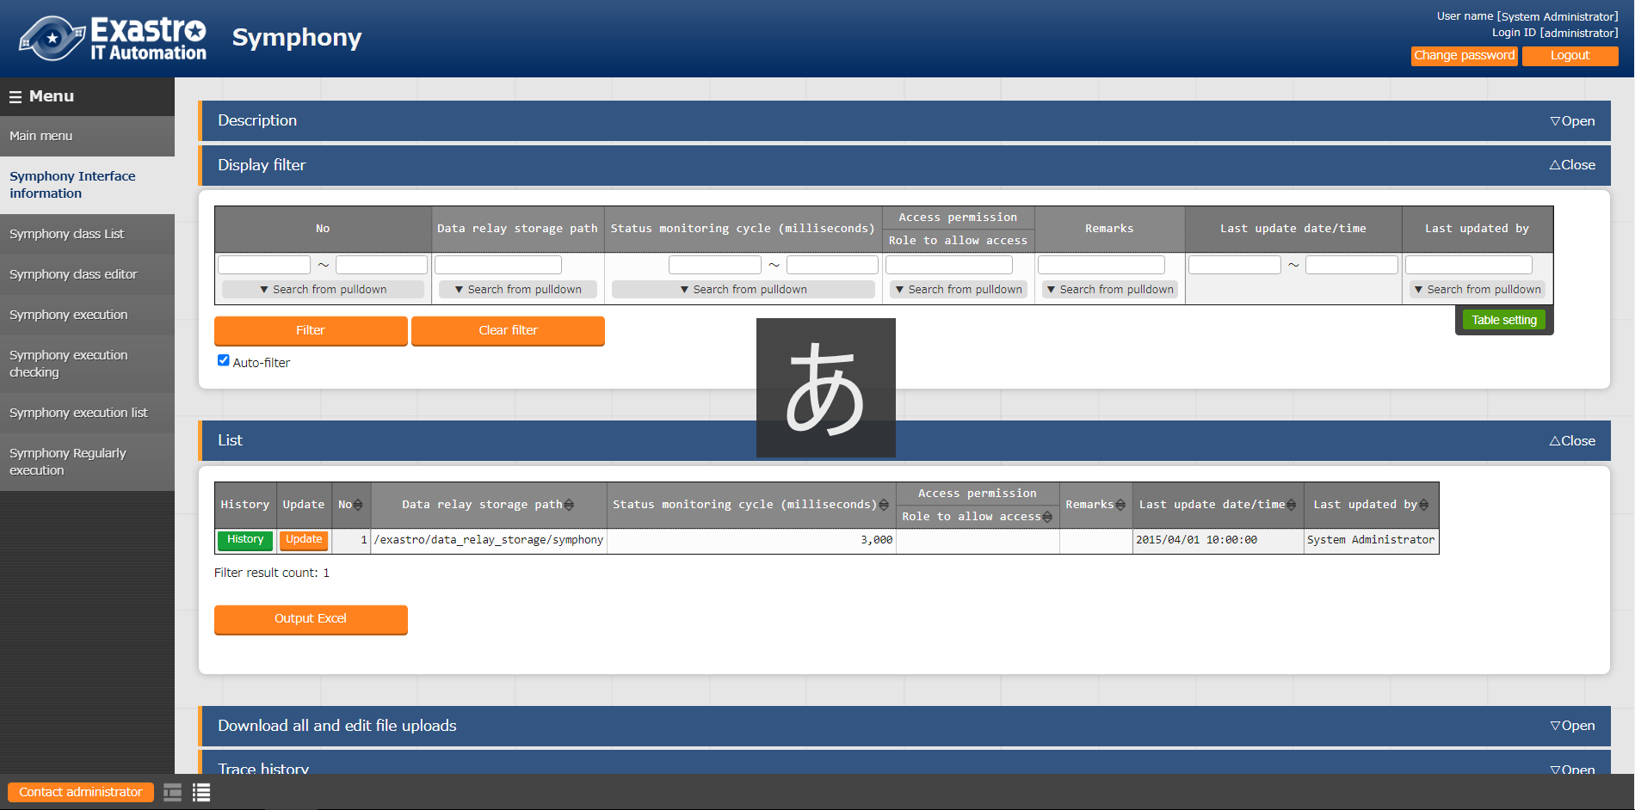

**Figure 4.1‑1 Sub menu screen (Symphony interface information)**

1. The list of common items on the registration screen is as follows.

**Table 4.1‑1 List of Registration Screen Items (Input operation list).**

|  |  |  |  |  |
| --- | --- | --- | --- | --- |
| **Items** | **Description** | **Input Required** | **Input method** | **Restrictions** |
| Data relay storage path | When executing Symphony, enter the directory shared by each Movement with the directory path viewed from the ITA server. For the path viewed from each driver, please refer to the interface information in the instruction manual for each driver.  Drivers that can share the directory are as follows. ・Ansible ・Ansible-Tower | ○ | Manual input | Maximum length 128 bytes |
| Status monitoring cycle (Milliseconds) | Enter the interval for refreshing the display of “4.1.4 Symphonic execute”. Generally, it is recommended to set the number to 3000 milliseconds. | ○ | Manual input | Shortest value: 1000 milliseconds |
| Remarks | Free description field. | - | Manual input | - |

Symphony class list

1. In the “Symphony class list” screen, users can refer to /cancel already registered symphony classes.

Click the “Details” button to move the selected symphony class edit screen “4.1.3 Symphony class edit”.

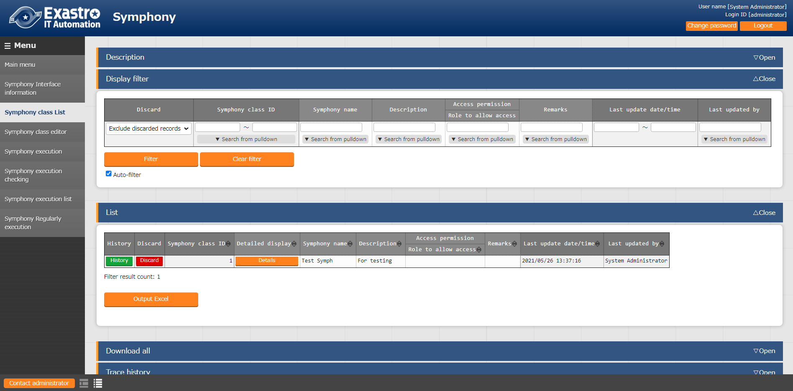

admin@nec.amc.jp

~

~

~

~

:set bin noeol

**Figure 4.1‑2 Submenu screen（Symphony class list）**

Symphony class edit

1. In the “Symphony class edit” screen, Users can register symphony class titles and work flow movements.

admin@nec.amc.jp

~

~

~

~

:set bin noeol

* Registered Movements is displayed in the area on the top-right side of the screen.

・　Users can set Movement by dragging and dropping them on the right side of the screen.

* Users can switch Movement by dragging and dropping them in the Movement flow edit area.
* Users can temporarily stop the set Movement by checking the box under it.
* Users can memo the description of the operation of the comments in the “Description” column and the column below the dropped Movement name.  
  The column is only for reference on the web and will not affect operation execution.
* Users can select access permission. The default settings depends on the Role/User linkage settings.
* Press the “Register” button after setting up Movement flow to register the Symphony class.

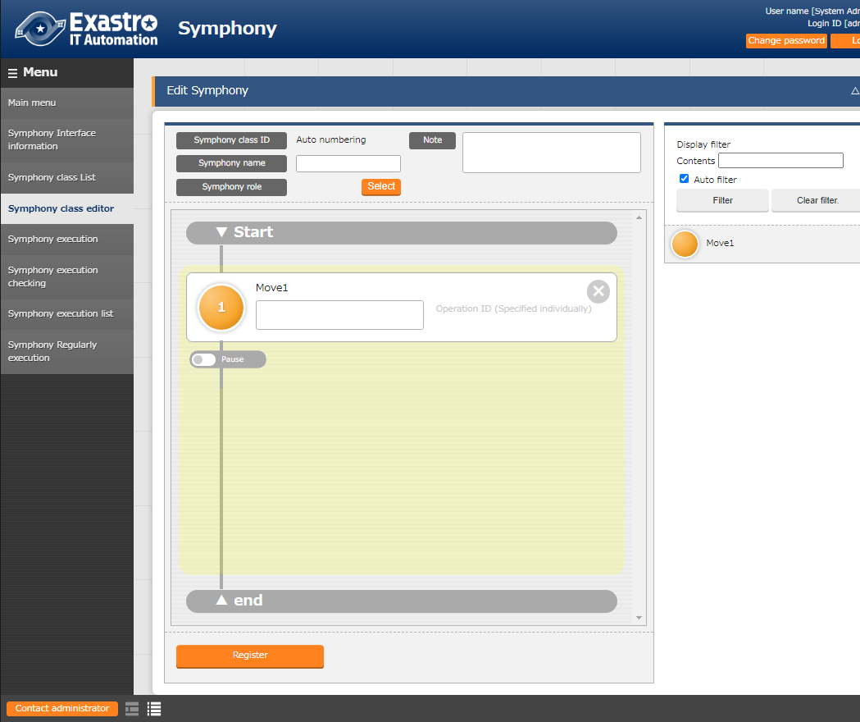

**Pause**

**Drag and drop spheres**

**Shown filter area**

**Movement Area**

**Figure 4.1‑3 Submenu screen (Symphony class edit)**

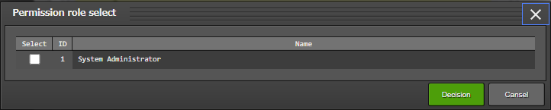**Figure 4.1-4 Sub menu screen (When the “select” button in the “Symphony class edit: Symphony role” is pressed)**

The Symphony class edit screen item list is as shown below.

**Table 4.1‑2　Registered screen item list.(Symphony class edit)**

|  |  |  |  |  |
| --- | --- | --- | --- | --- |
| **Item** | **Description** | **Input required** | **Input method.** | **Restrictions** |
| Symphony class ID | Unique ID for Symphony is auto-numbered. | - | Automatic input | - |
| Symphony name | Enter any desired name for Symphony class | ○ | Manual input | - |
| Description | Enter description and comment for Symphony class | - | Manual input | - |
| Movement Description | Enter description and comment for Movement | - | Manual input | - |
| Operation ID (Specified individually) | Enter the desired operation ID for to individually specify it. | - | Manual input | - |
| Pause | Check the box to pause the movement after it has been activated | - | Check box | - |
| Delete | Delete Movement | - | Button | - |

1. 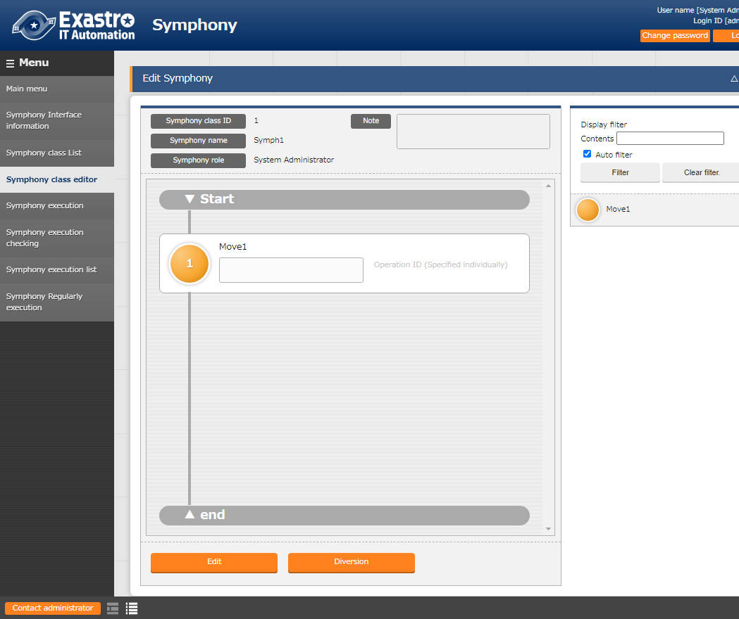The screen below will appear if the user has moved from the Symphony class list screen or has finished registering a symphony.

admin@nec.amc.jp

~

~

~

~

:set bin noeol

* Users can edit registered Symphonies by clicking the 「Edit」 button
* Click the “Diversion” button to copy registered Symphony then create as a new one.

1. 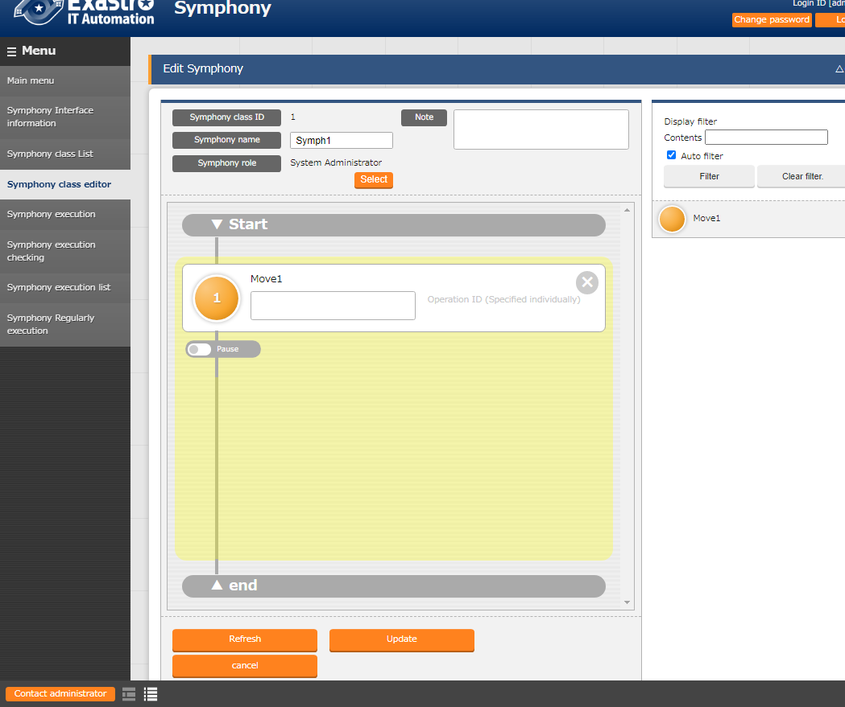If the 「Edit」button is pressed, the screen shown below will appear.

admin@nec.amc.jp

~

~

~

~

:set bin noeol

* Click the “Reload” button to discard the edited content then return to the state before any edits.

・　Click the "Update" button to save edited content

・　Click the "Cancel" button to return to the status before any edits

Symphony execution

1. The Symphony execution instructions are displayed in the "Symphony execution" screen

* “Symphony [List]” displays the Symphonies registered in “4.1.2 Symphony class list”.
* “Operation [List]” displays the Operations registered in “Basic console-Input operation list"
* Select radio button in “Symphony [List]” and “Operation [List]”, then click the “Execution” button to move to “4.1.5 Symphony confirmation” then start tracing of execution.
* Pressing the "Execution" button after scheduled date/time has been entered will schedule the execution. The scheduled execution can be checked in “4.1.6 Symphony execution list”. ※Date/Time before current time can’t be entered.
* Check the "Skip" box next to the Movement symbol to execute without executing the selected Movement.

**Figure 4.1-4Sub Menu screen (Symphony execution check)**

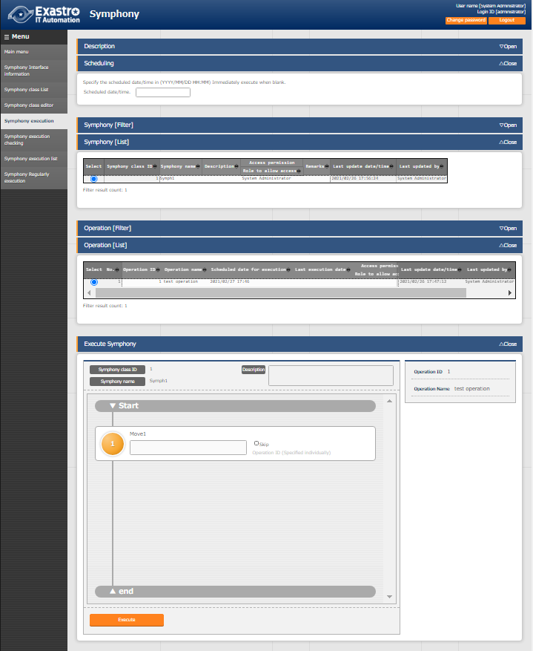

The list of common items in Symphony execution screen is as follows.

**Table 4.1-3 Register screen item list (Symphony execution)**

|  |  |  |  |  |
| --- | --- | --- | --- | --- |
| **Items** | **Description** | **Input required** | **Input method** | **Restrictions** |
| Scheduled date/time | Specify the scheduled date and time of Symphony execution | - | Manual input | Date and time before the current time cannot be entered. |
| Symphony 「List」 | The symphony registered in “4.1.7 Symphony Class list” will be displayed. | ○ | Radio button |  |
| Operation「List」 | The operation registered in 4.1.4 Input operation list will be displayed. | ○ | Radio button |  |
| Skip | Target operation will be skipped if checked | - | Check box |  |
| Operation ID（Specified Individually） | ※Refer to the following " About Individually specified Operation ID" | - | Manual input |  |
| Execute | Registered Symphony will be executed. | ○ | Button |  |

* About Individually specified Operation ID

Press the grey “Operation ID (Specified Individually)” text to display the text box.

Users can enter a different operation ID than the operation ID specified by radio button in this text box.  
Accordingly, that Movement can be executed with the “Specific value” (e.g. “Substitution value list” in ITA Ansible-Legacy console) substituted with the value registered for other Operation ID in the “Substitution value list” menu of the orchestrator which that Movement belongs to

The Operation ID specified in Symphony class edit screen is saved according to the register/update.

Moreover, users can change Operation ID already registered in the Symphony edit menu for each step of the Symphony before execution.

However, the settings in Symphony execution screen only reflects the Symphony execution. The settings will not be saved.

Users can use this function to diverse the Movement to operate another server.

※Operation Access permission.

If even one of the Movements or the individually specified Operation in the Symphony execution screen contains a target without access permission, a validation error will occur when “Execute” button is clicked.

Symphony execution checking.

1. In the “Symphony execution checking” screen, the status of the Symphony execution is displayed.

By clicking the “Details” button in “4.1.6 Symphony execution list”, the status of the selected Symphony will be displayed.

Users can execute “Cancel reservation”, “Resume” or “Emergency stop” according to the situation

It is also possible to move to the different operation confirmation screens by clicking the Movement

Flow sphere.

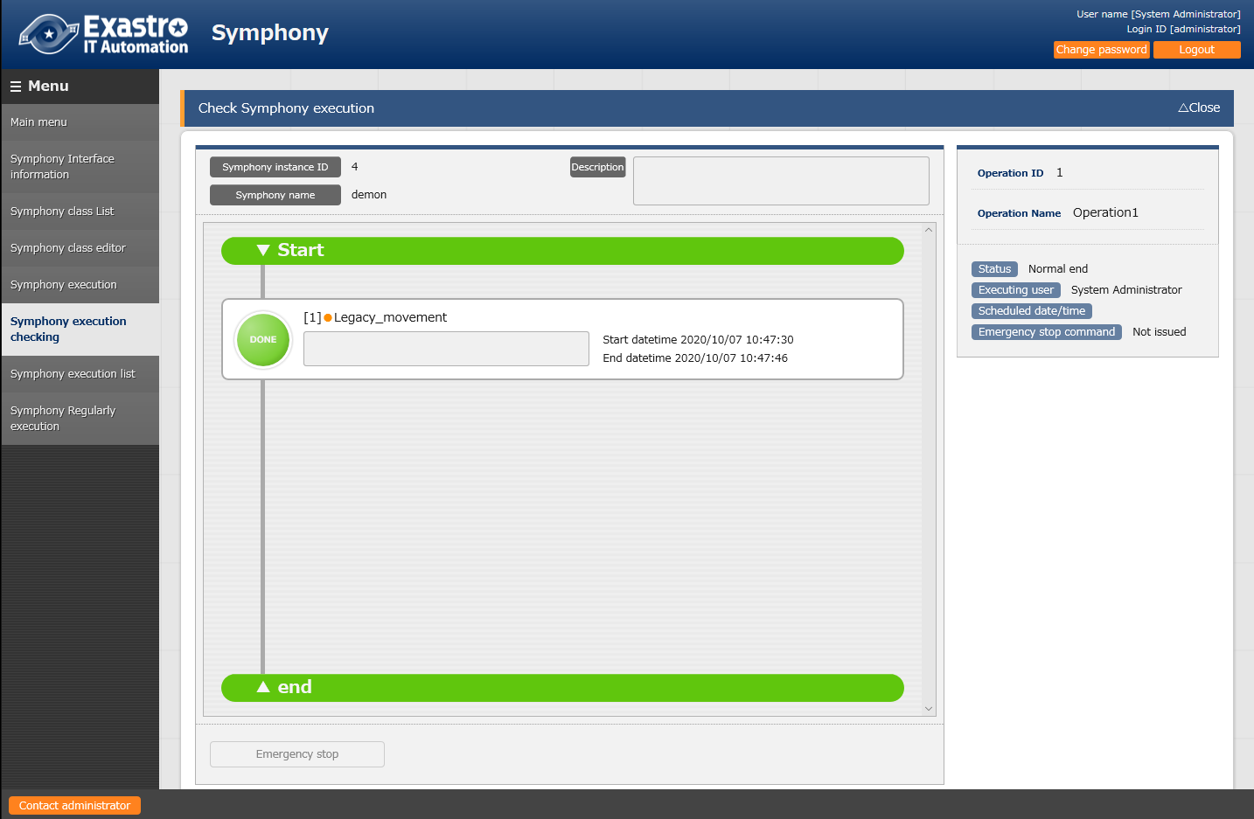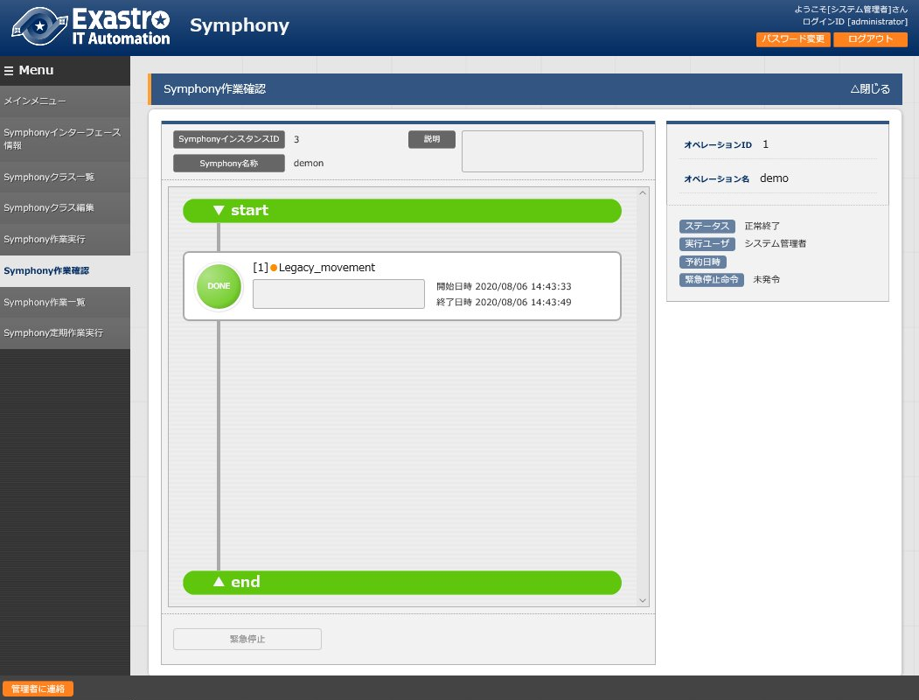

**Figure 4.1-5 Submenu screen (Symphony execution checking)**

If the selected Symphony has a set reservation and has yet to be executed, a “Cancel

Reservation” button will be displayed.  
If the button is clicked, the status in “4.1.6 Conductor list” will change to “Unexecuted (Schedule)” and will not be executed.

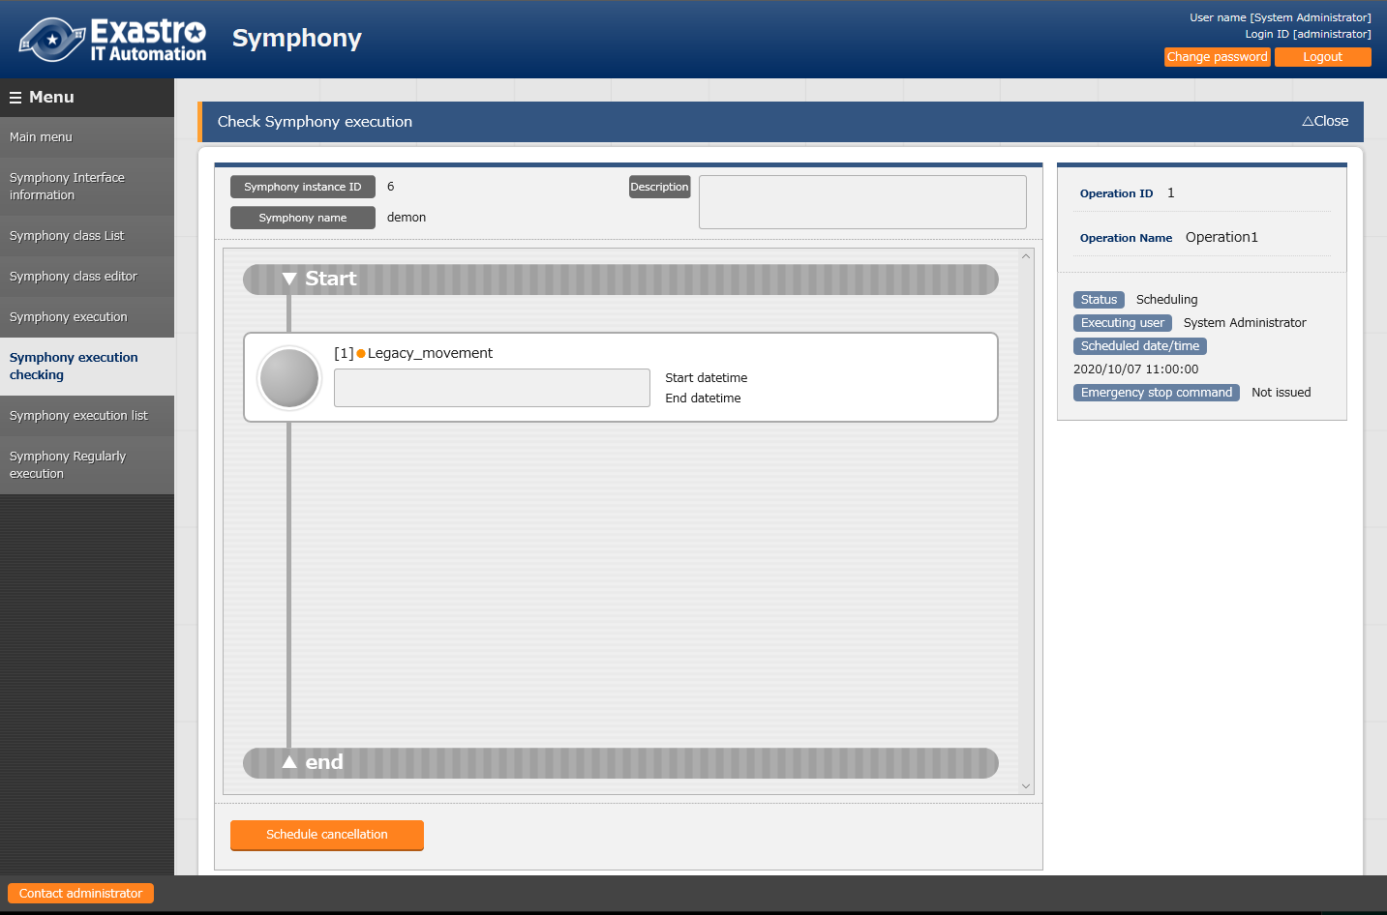**Figure 4.1-6 Submenu screen (Symphony execution checking - Cancel reservation)**

The list of items in the Symphony confirmation screen is as follows.

**Table 4.1-4 Registration screen list (Symphony confirmation)**

|  |  |  |  |  |
| --- | --- | --- | --- | --- |
| **Items** | **Descriptions** | **Input required** | **Input method** | **Restrictions** |
| Resume | Cancel pause and continue Movement | - | Button | - |
| Emergency Stop | Stop Symphony execution | - | Button | - |
| Cancel reservation | Cancel scheduled Symphony execution | - | Button | Displayed only when execution is scheduled and is yet to be executed |

Symphony execution list

1. Users can manage executed Symphony operations in “Symphony execution list” screen.

By specifying the criteria and clicking the “Filter” button, The Symphony table, list and graphs will be displayed.

Clicking the “Details” button in the operation column will take you to the “4.1.5 Symphony Confirmation” screen

Clicking “Download(.zip) for “Input data type(zip)” will download all of the data from the executed Movements in Symphony.

Clicking “Download(.zip) for “DataFormat(.zip) will download all the execution and error logs for all the executed Movements in Symphony.

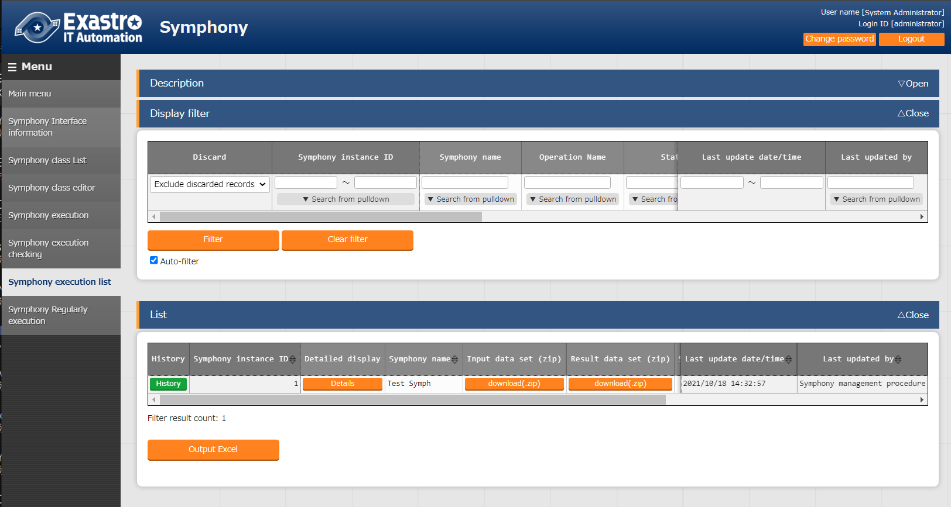

**Figure 4.1-7 Submenu screen (Symphony execution list)**

Symphony regularly execution

1. Users can manage regular execution of Symphony operation in “Symphony regularly execution” screen.

Clicking the “Check the work list” in “List” will move to “4.1.6 Symphony execution list” screen with the target executed by regular execution.

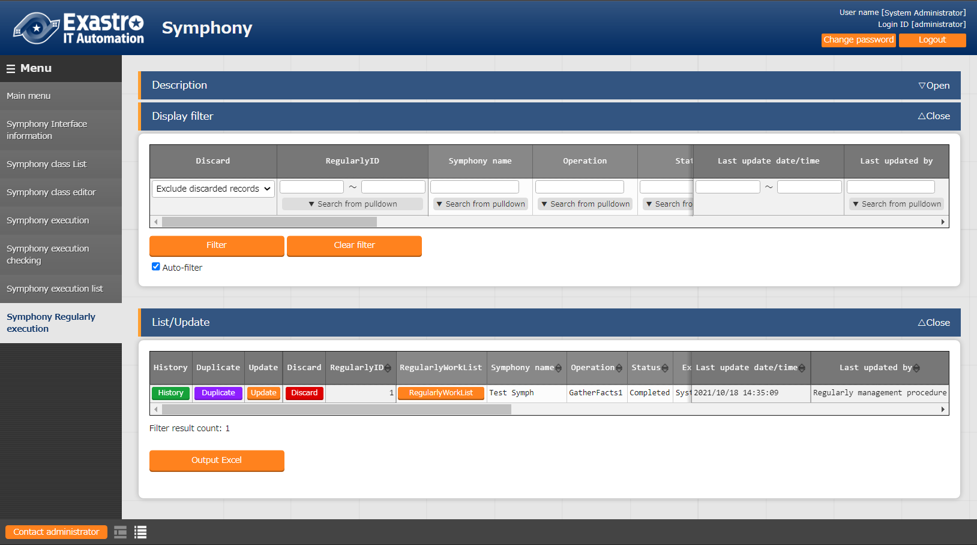

**Figure4.1-8 Sub menu screen (Symphony regularly execution)**

1. Click “Register” - “Start Registration” button to register Symphony regular execution.

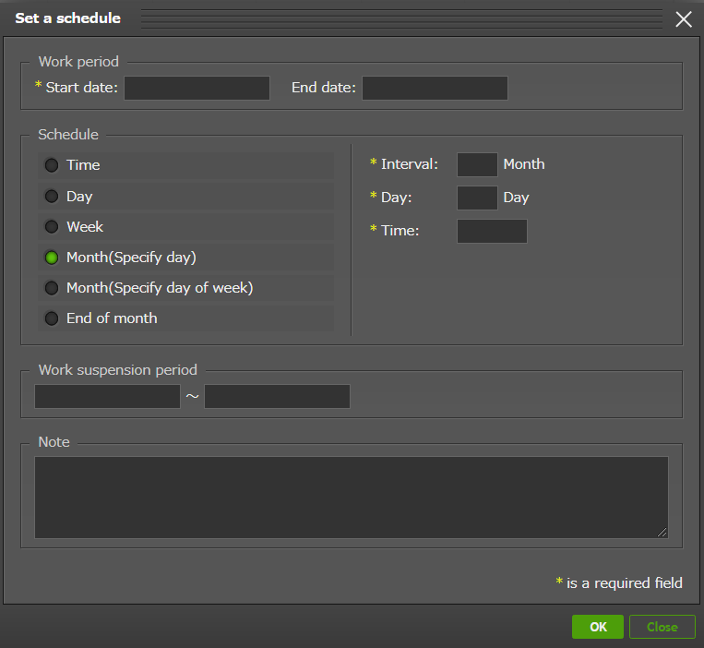Schedule can only be set in the setting window by clicking “Schedule settings” button.

**Figure 4.1-9 Schedule settings screen (Symphony regular execution)**

1. The register screen item list is as shown below.

**Table 4.1-5 Register screen item list (Symphony regularly execution)**

|  |  |  |  |  |  |
| --- | --- | --- | --- | --- | --- |
| **Items** | | **Descriptions** | **Input required** | **Input method** | **Restrictions** |
| Symphony class name | | The symphonies registered in 「4.1.2 Symphony class list」will be displayed in the list | ○ | Choose from list | - |
| Operation name | | Operation registered in "Basic Console-Input operation" Input operation list will be displayed. | ○ | Choose from list | - |
| Executing user | | Any user who did any registration or update to the operation will be registered as an “Executing user”. When a regularly executed operation is registered to 4.1.6 Symphony list, a new Executing user will be registered. If the “Executing user” cannot execute the selected “Symphony class name” (e.g does not have access to the Movement), the status will show up as “Link error”. | - | Automatic input |  |
| Status | | Refer to the following " Table 4.2.11 Status list (Symphony regular execution) | - | Automatic input | - |
| Schedule settings | | Opens the window where one can configure Schedule settings. | - | - | - |
| Schedule | Next execution date | The next execution date will be automatically updated after registering schedule settings. | - | Automatic input | - |
| Start date | Enter the date when the Symphony regular execution will start.  " The next execution date will always be updated to be a date after the set "Start date" | ○ | Manual input | Can only enter data from Schedule settings |
| End date | Enter the date when the Symphony regular execution will end.  If the " Next execution date" exceeds the " Final date" the status will be changed to " Completed" | - | Automatic input | Can only enter data from Schedule settings |
| Period | Choose the period of the regular execution  “Time”, “Day”, “Week”, “Month (Specify day)”, “Month (Specify day of week)”, ”End of month” can be selected. | ○ | Radio button | Can only enter data from Schedule settings |
| Interval | Select the regular execution interval based on the selected period | ○ | Manual input | Can only enter data from Schedule settings |
| Week number | Used when period is “Month (Specify day of week)”, select the week number to execute work. | ※1 | Choose from list | Can only enter data from Schedule settings |
| Day of week | Used when period is “Week” or “Month (Specify day of week)”, select the day of week to execute work. | ※2 | Choose from list | Can only enter data from Schedule settings |
| Date | Used when period is “Month (Specify day)”, select the date to execute work. | ※3 | Manual input | Can only enter data from Schedule settings |
| Time | Enter the time of regular execution. | ※4 | Manual input | Can only enter data from Schedule settings |
| Work suspension period | Start | Enter the start date/time of work suspension period.  Registered Symphony will not be executed during the time between the start and end time. | ※5 | Manual input | Can only enter data from Schedule settings |
| End | Enter the date/time of work suspension period.  The registered Symphony will not be executed during the time between the start and end time. | ※5 | Manual input | Can only enter data from Schedule settings |
| Remarks | | Free description field | - | Manual input | - |

※1 Week number is required when period is “Month (Specify day of week)”.

※2 Day of week is required when period is “Month (Specify day of week)”.

※3 Day is required when period is “Month (Specify day)”.

※4 Time is required when period is “Day”, “Week”, “Month (Specify day)”, “Month (Specify day of week)”, ”End of month”.

※5 When setting work suspension period, both “Start” and “End” are required.

**Table 4.1-6 Status list (Symphony regular execution)**

|  |  |
| --- | --- |
| **Status** | **Description** |
| In preparation | The status immediately after registration.  The status will become "In operation" when backyard updates "Next execution date" automatically. |
| In operation | The status of normal execution.  The system registers operation to “4.1.6 Symphony execution list” 3 minutes before “Next execution date”,  then updates “Next execution date” based on the schedule setting |
| Completed | The status when “Next execution date” passed “End date”. Further Symphony registration will not be performed. |
| Mismatch error | The status when setting value of schedule is not correct. |
| Linking error | The status when registering execution failed in “4.1.6 Symphony execution list”.  Same as the status “In operation”, system registered execution in “4.1.6 Symphony execution list”, then updates “Next execution date” based on the schedule setting. If registration of execution failed again, the status will remain “Linking error”. |
| Unexpected error | The status when errors other than “Mismatch error” and “Linking error” happens. |
| Symphony discard | The status when the registered Symphony is discarded. The status will be updated to “In preparation” if the discarded Symphony is restored. |
| Operation discard | The status when the registered Operation is discarded. The status will be updated to “In preparation” if the discarded Operation is restored. |

1. The status will become “In preparation” immediately after registered in “Symphony regular execution” menu.

Backyard will update “Next execution date” based on the registered schedule setting, then the

status will become “In operation”

If the status is “In operation” or “Linking error”, the system registers operation to “4.1.6 Symphony execution list” 3 minutes before “Next execution date”, then updates “Next execution date” based on the schedule setting.

※ When pause is set in the Symphony which is registered in regularly execution, if users don’t

“resume” in “4.1.5 Symphony execution check” after operation is registered, the status in “4.1.6

Symphony execution list” will remain “Executing”.