PRACTICE: TCP/IP, PORTS, PROTOCOLS

TCP 3-Way Handshake
The TCP 3-Way Handshake is the process by which a client and a server establish a reliable TCP connection before any application data is transmitted.
It involves the exchange of three control packets: SYN → SYN-ACK → ACK

LAB 1️⃣ — TCP/IP 3-Way Handshake (PROOF)

🎯 LAB OBJECTIVE
To visually and logically prove the TCP 3-Way Handshake using real network traffic instead of theory.

Step A — Prepare Windows 11 (Victim)

1️⃣ Allow inbound TCP 4444 (Admin PowerShell)
netsh advfirewall firewall add rule name="Allow TCP 4444" dir=in action=allow protocol=TCP localport=4444
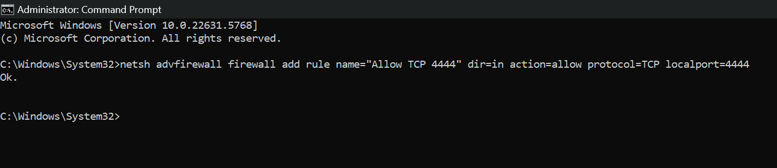

2️⃣ Start listener (Windows 10)
Assumption: Nmap is installed
"C:\Program Files (x86)\Nmap\ncat.exe" -lvnp 4444
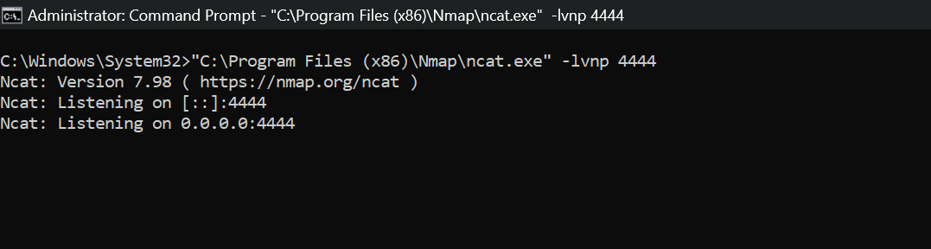

Step B — Connect from Kali (Attacker)
nc <WIN11_IP> 4444

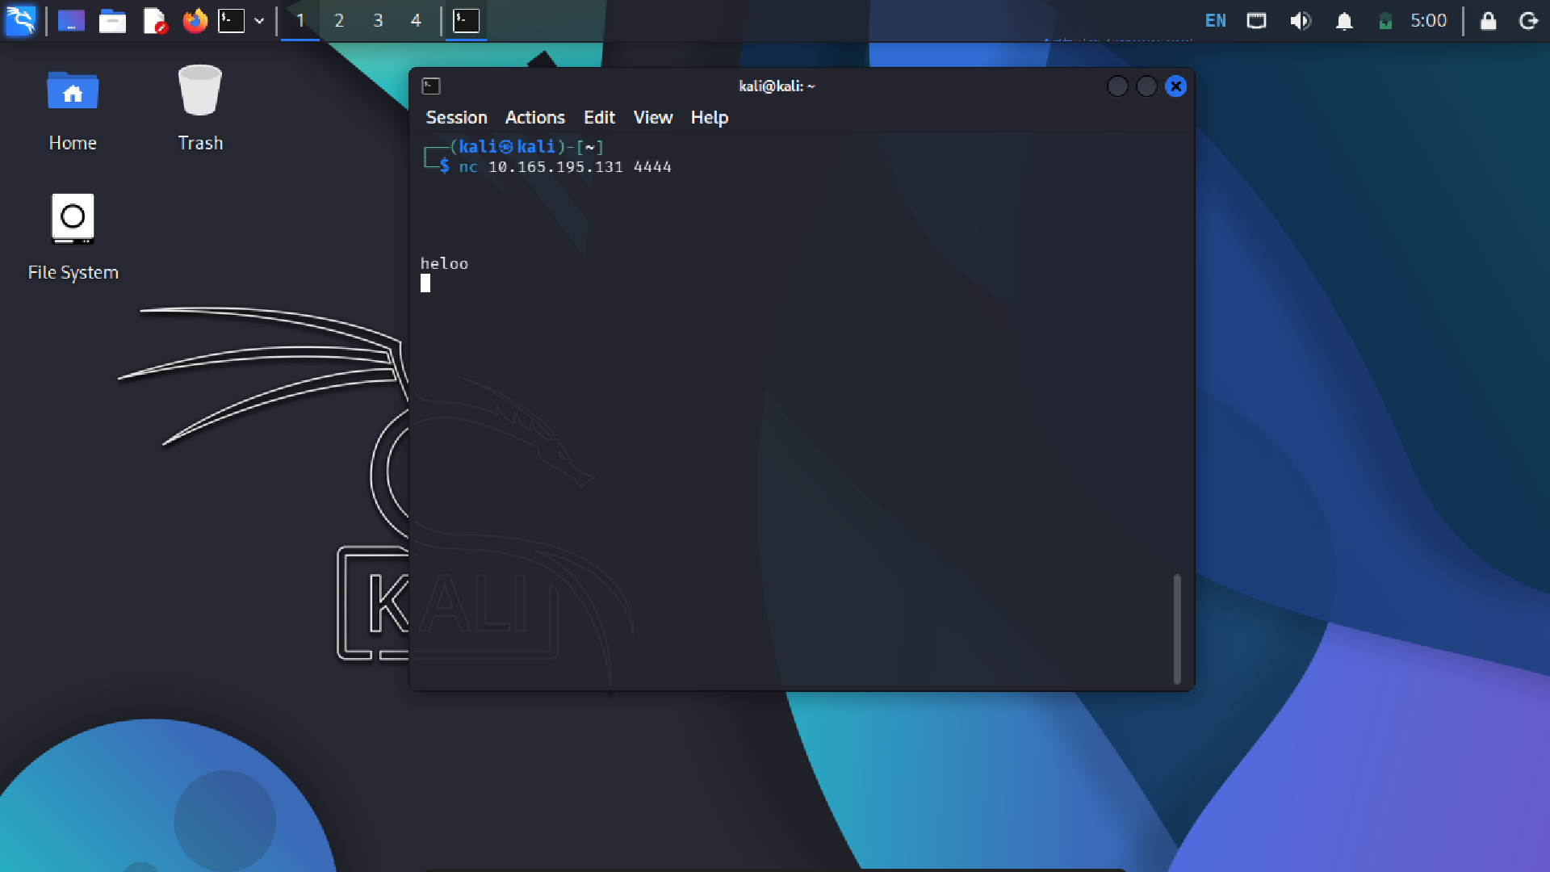

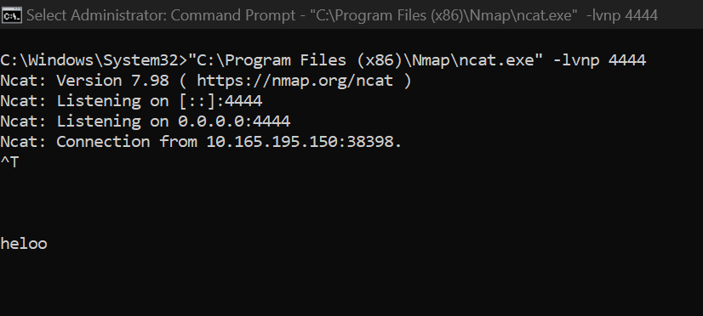

Step C — Observe handshake (Kali)
sudo tcpdump -n tcp and port 4444
You must see:
- SYN
- SYN-ACK
- ACK
If you don’t → firewall / routing issue.

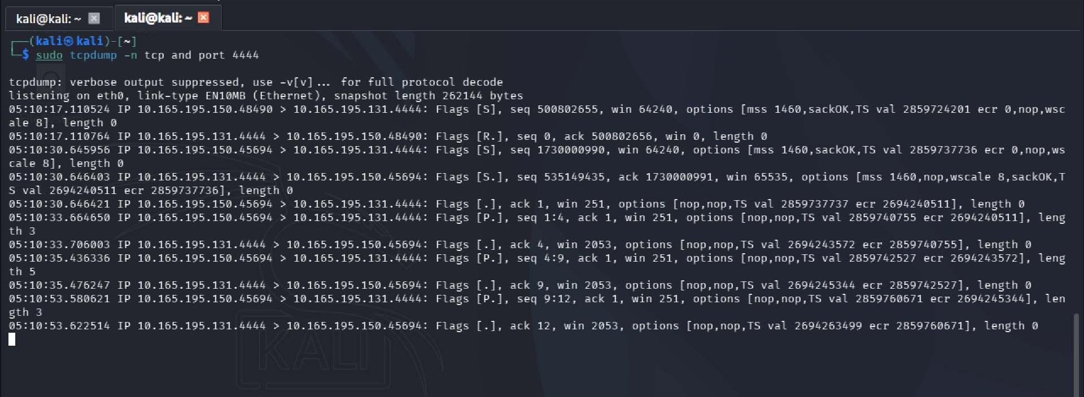

[S] --- SYN
[S.] ---SYN-ACK
[.] ----ACK

🧪 LAB SUMMARY (What was done)
- A TCP listener was started on port 4444 on the Windows host after explicitly allowing the port through Windows Defender Firewall.
- A connection was initiated from the Kali Linux system using Netcat.
- Packet-level traffic was captured on Kali using tcpdump to observe the handshake in real time.

🔍 OBSERVATION (Packet-Level Proof)
Using tcpdump, the following TCP flags were observed:
- [S] → SYN (connection request from client)
- [S.] → SYN-ACK (server acknowledgment and acceptance)
- [.] → ACK (client acknowledgment, connection established)
This sequence confirms the successful completion of the TCP 3-Way Handshake.

✅ CONCLUSION (What this proves)
The lab successfully demonstrates that:
- A TCP connection is not established immediately
- The connection is created only after the SYN → SYN-ACK → ACK exchange
- Packet capture (tcpdump) provides direct, indisputable proof of TCP behavior
- Firewall and routing configuration directly affect whether the handshake completes
This validates the TCP 3-Way Handshake at the packet level, not just conceptually, and reflects how SOC analysts confirm real network activity during investigations.

LAB 2️⃣ — Normal vs Abnormal Ports (SOC Judgment)

PORT:
A port is a logical communication endpoint on a system that allows the operating system to deliver network traffic to the correct application or service.
An IP address identifies which system to reach.
A port identifies which application on that system should receive the data.

🎯 LAB OBJECTIVE
To distinguish between normal, expected port activity and abnormal, suspicious port behavior, and to practice SOC decision-making instead of panic-based detection.

Step A — Observe NORMAL state (Windows 10)
netstat -ano
Expected:
- 135, 445 (Windows infra)
- 3389 (if RDP enabled)
- High ephemeral outbound ports

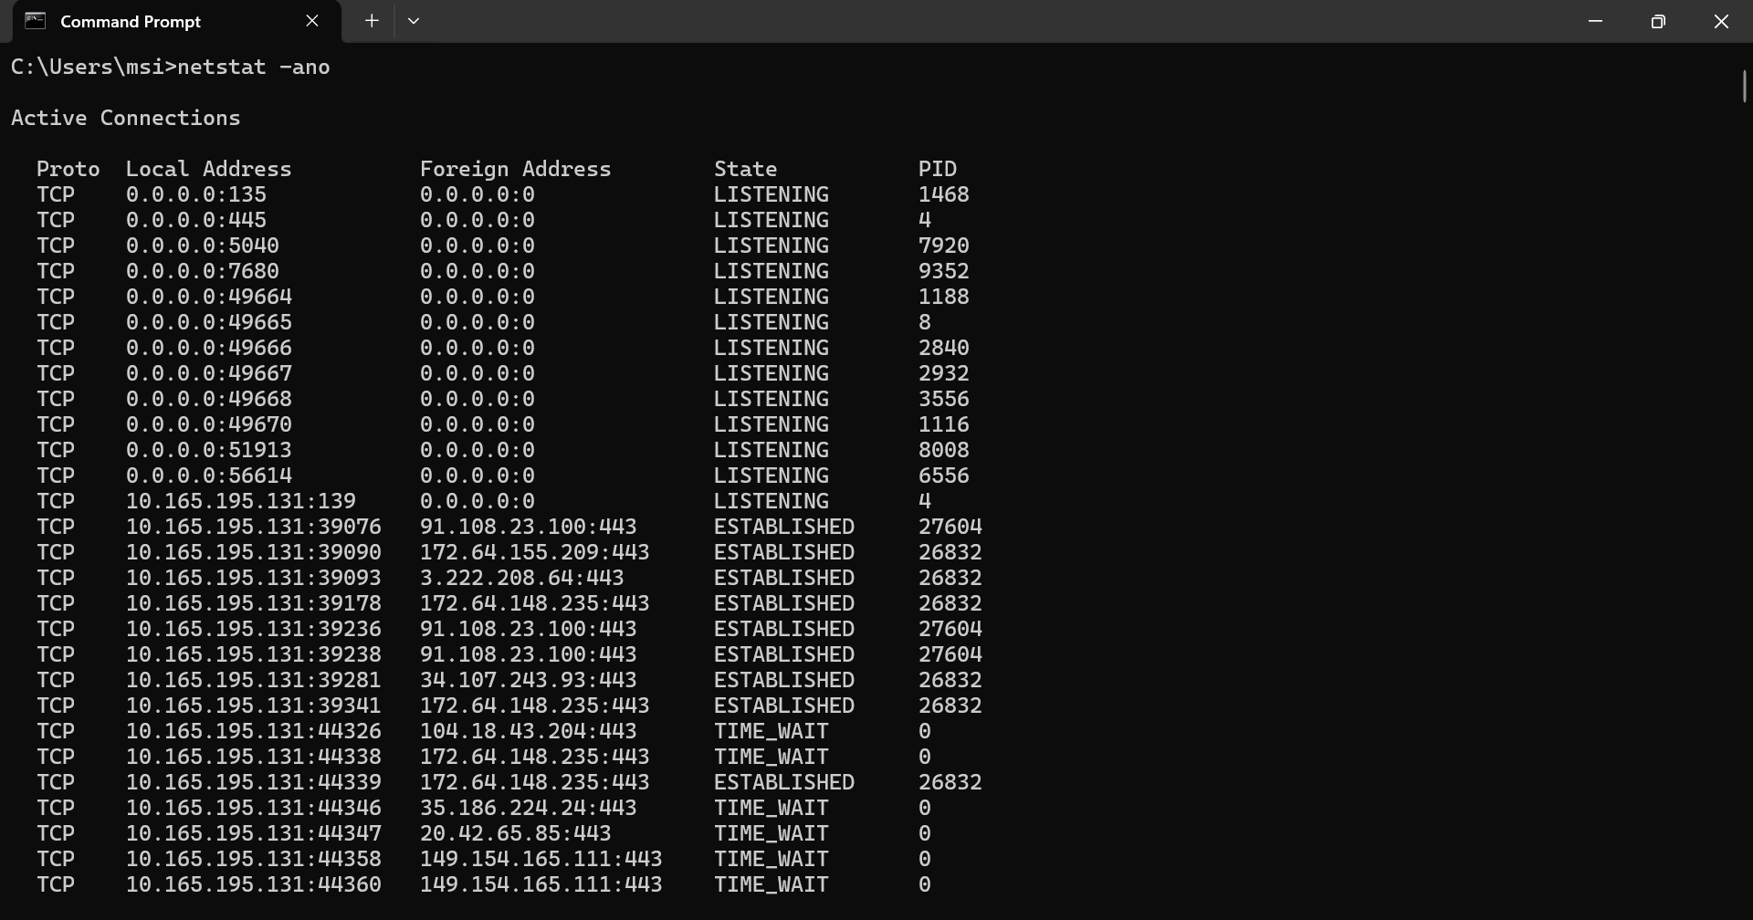

Step B — Create ABNORMAL listener (Windows 7)

1️⃣ Allow port (Admin)
netsh advfirewall firewall add rule name="Allow TCP 1337" dir=in action=allow protocol=TCP localport= 1337
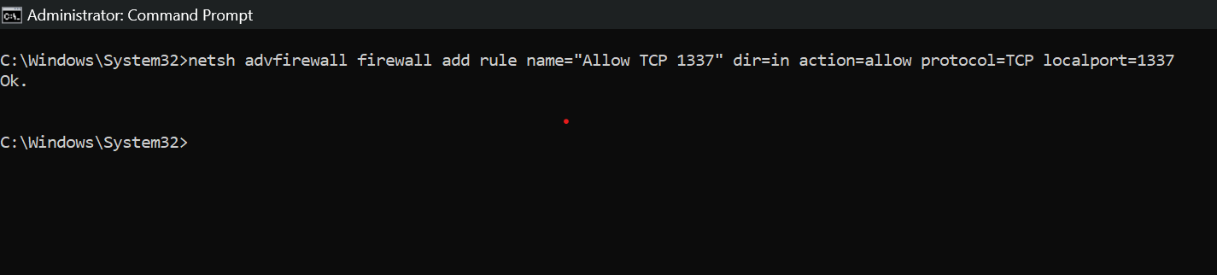

2️⃣ Start listener
"C:\Program Files (x86)\Nmap\ncat.exe" -lvnp 1337

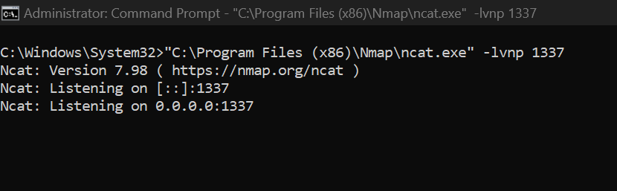

Step C — Connect from Kali
nc <WIN- 11_IP> 1337
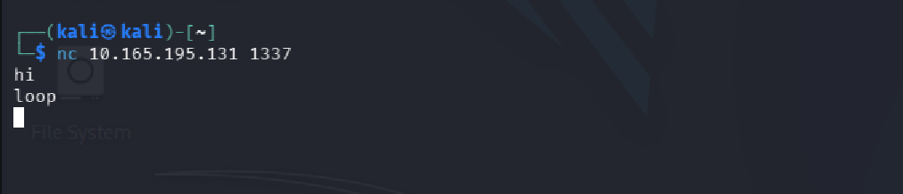

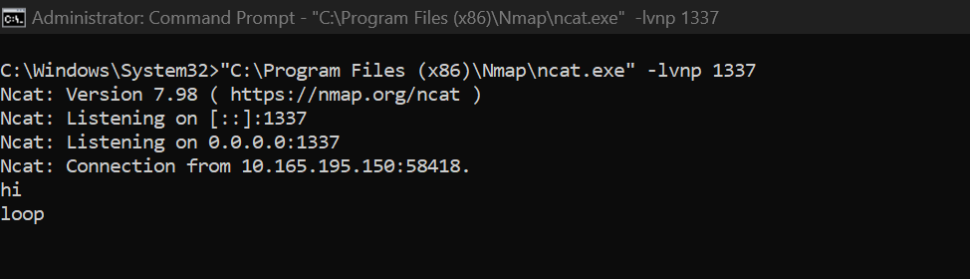

SOC DECISION (THIS IS THE POINT)
- Port 1337 is not malicious by itself
- But:
  - No service install
  - No business justification
  - User-initiated listener
➡️ Investigate origin, parent process, intent

🧪 LAB SUMMARY (What was done)

Step A — Normal State Observation
Using netstat -ano on a Windows 10 system, common and expected listening ports were observed, including:
- 135 (RPC)
- 445 (SMB)
- 3389 (RDP, if enabled)
- Multiple high ephemeral ports used for outbound connections
These ports were associated with legitimate Windows services or normal user activity and had clear system-level justification.

Step B — Abnormal Listener Creation
On a Windows 7 system:
- An inbound firewall rule was manually created to allow TCP port 1337
- A listener was started using ncat.exe in user context
This created a new listening port that:
- Was not tied to any installed service
- Was not registered as a Windows service
- Was manually initiated by a user process

Step C — External Connection
A connection was initiated from Kali Linux to the Windows host on port 1337, establishing an interactive TCP session.

🔍 OBSERVATION (SOC-Relevant Evidence)
- netstat -ano showed TCP 1337 in LISTENING state
- The port was owned by a user-initiated process (ncat.exe)
- The listener was not persistent, not documented, and not business-related
- Network traffic confirmed an active inbound interactive session

🧠 SOC ANALYSIS (This is the key learning)
- Port 1337 is not malicious by itself
- However, the context makes it suspicious:
  - No legitimate service installation
  - No business justification
  - Manually opened firewall rule
  - User-launched listener
  - Inbound interactive access

SOC Decision:
Investigate the origin, parent process, execution context, and intent of the listener.
This behavior represents a potential unauthorized remote access mechanism, commonly associated with:
- Reverse shells
- Backdoors
- Insider misuse
- Living-off-the-land techniques

✅ FINAL SOC CONCLUSION
This lab demonstrates that ports cannot be judged in isolation.
Legitimate ports can be abused, and non-standard ports can be benign only when justified.
SOC analysts must evaluate process ownership, execution context, persistence, and business relevance before determining maliciousness.

LAB 3️⃣ — Port Scanning (REAL ATTACKER BEHAVIOR)

🎯 Objective
Understand port-scan behavior and defender-side evidence, not just Nmap output.

Step A — Scan from Kali
nmap -sS -p 1-1000 <WIN10_IP>

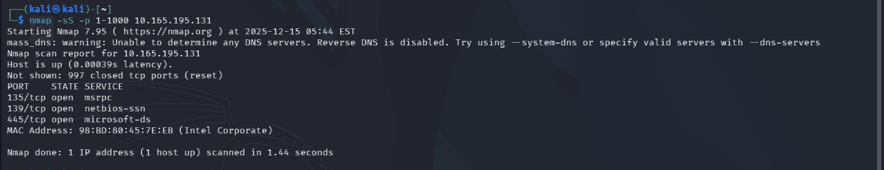

What this scan REALLY does
- -sS = SYN scan (half-open)
- Sends SYN
- If open → SYN-ACK → attacker sends RST
- If closed → RST back
- Connection never completes

Step B — Observe on Windows 10
Enable firewall logging:
netsh advfirewall set allprofiles logging allowedconnections enable

netsh advfirewall set allprofiles logging droppedconnections enable
Review:
- Windows Defender Firewall logs

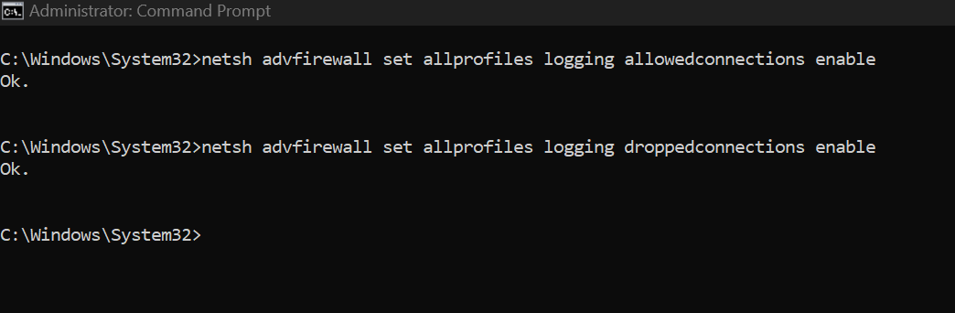

STEP B — Defender View (Windows 10)

Where to check logs

1️⃣ Firewall log (primary proof)

C:\Windows\System32\LogFiles\Firewall\pfirewall.log
Open with:
notepad C:\Windows\System32\LogFiles\Firewall\pfirewall.log

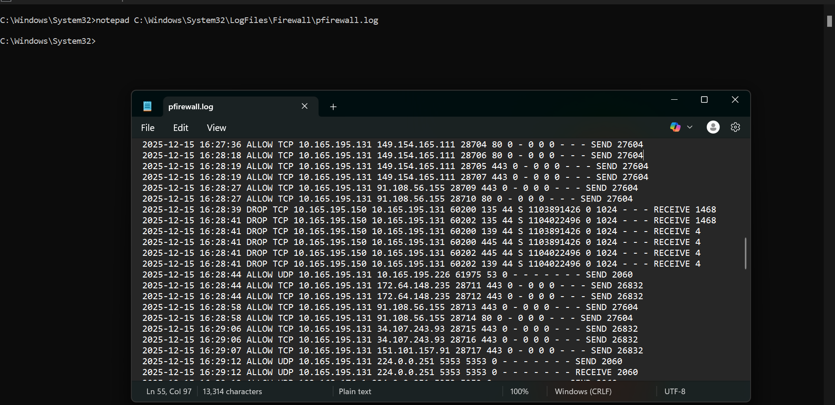

🔚 FINAL CONCLUSION — LAB 3: PORT SCANNING (DEFENDER VIEW)
During this lab, a TCP SYN port scan was performed from a Kali Linux host against a Windows 10 system using Nmap (-sS scan). The scan generated inbound TCP SYN packets targeting multiple destination ports (1–1000) on the Windows host.
Windows Defender Firewall logs (pfirewall.log) recorded repeated DROP actions for inbound TCP packets with the SYN flag set, indicating that the firewall blocked the packets before TCP session establishment. No completed TCP handshakes (SYN-ACK → ACK) were observed for the scanned ports, confirming that no connections were established.
The observed pattern consisted of:
- A single source IP repeatedly probing
- Multiple destination ports
- Incomplete TCP sessions
- High-frequency SYN packets
- No business justification
This behavior is consistent with network reconnaissance via port scanning and maps to MITRE ATT&CK technique T1046 (Network Service Scanning).
The lab demonstrates that even when ports are closed and traffic is blocked, reconnaissance activity is still detectable through host-based firewall telemetry, reinforcing the importance of monitoring firewall logs and correlating scan patterns rather than relying solely on successful connections

🔚 FINAL CONCLUSION — LAB 3
During this lab, a TCP SYN port scan was performed from a Kali Linux host against a Windows 10 system using Nmap (-sS). The scan generated inbound TCP SYN packets targeting multiple ports (1–1000) on the Windows host.
Windows Defender Firewall logs (pfirewall.log) recorded repeated DROP actions for inbound SYN packets, indicating that the firewall blocked the traffic before TCP session establishment. No SYN-ACK → ACK handshakes were completed, confirming that no TCP connections were established.
The observed behavior—single source IP probing multiple ports with incomplete TCP sessions—clearly indicates network reconnaissance activity consistent with MITRE ATT&CK technique T1046.
This lab demonstrates that reconnaissance activity is detectable even when all ports are closed and traffic is blocked, emphasizing the importance of analyzing firewall telemetry and behavioral patterns rather than relying only on successful connections.

🔬 LAB 4️⃣ — Trusted Port Abuse (443 ≠ HTTPS)

🎯 Objective
To demonstrate that port numbers do not define protocols, and that trusted ports such as TCP 443 can be abused to carry non-HTTPS, unencrypted traffic.

🧠 Key Concept
Ports are logical routing identifiers, while protocols are defined by behavior and packet structure.
Attackers commonly abuse trusted ports to hide malicious traffic, relying on incorrect assumptions that “allowed ports are safe.”

🧪 Step A — Start a Fake Service on a Trusted Port (Windows)

1️⃣ Allow inbound TCP 443
Run as Administrator:
netsh advfirewall firewall add rule name="Allow TCP 443" dir=in action=allow protocol =TCP localport=443

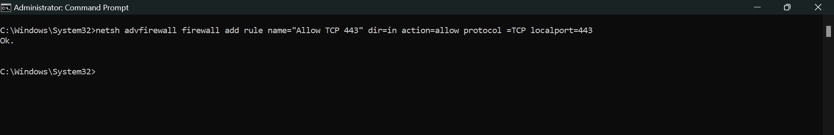

2️⃣ Start a raw TCP listener on port 443
Assumption: Nmap (ncat) is installed
"C:\Program Files (x86)\Nmap\ncat.exe" -lvnp 443

This creates:
A raw TCP listener
No TLS
No certificates
No HTTPS service

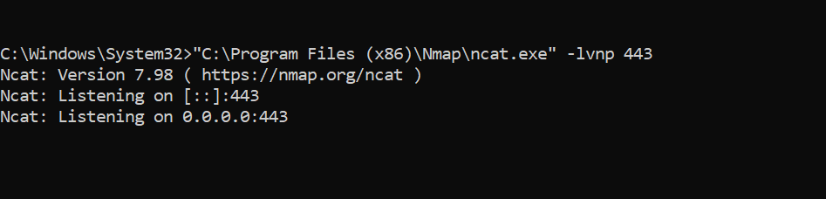

🧪 Step B — Connect from Kali Linux
From Kali:
nc <WINDOWS_IP> 443
Send test data:
hi
Successful data exchange confirms that TCP communication on port 443 is active

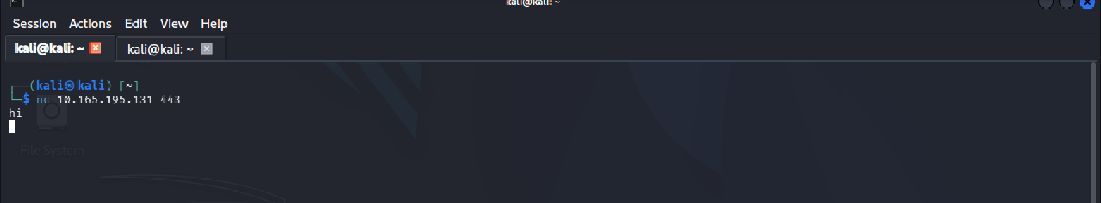

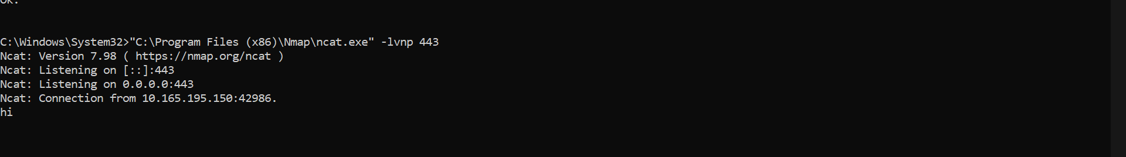

🔚 Final Conclusion
This lab demonstrates that traffic on TCP port 443 is not inherently secure. By running a raw TCP listener on a commonly trusted port, it was shown that unencrypted, non-HTTPS communication can successfully pass through firewall rules that allow port 443.
The absence of TLS handshake and encryption confirms that HTTPS is determined by protocol behavior, not by port number. This technique mirrors real-world attacker behavior where trusted ports are abused to evade detection and blend malicious traffic with legitimate network activity.

🧹 LAB CLEANUP — Firewall Rules & Listeners (Post-Lab Reset)
Purpose: Safely revert all changes made during the SOC networking labs by removing temporary firewall rules (TCP 4444, 1337, 443), stopping any ncat listeners, and restoring firewall logging to default.
Outcome: System returned to a clean, baseline state with no residual exposure.
