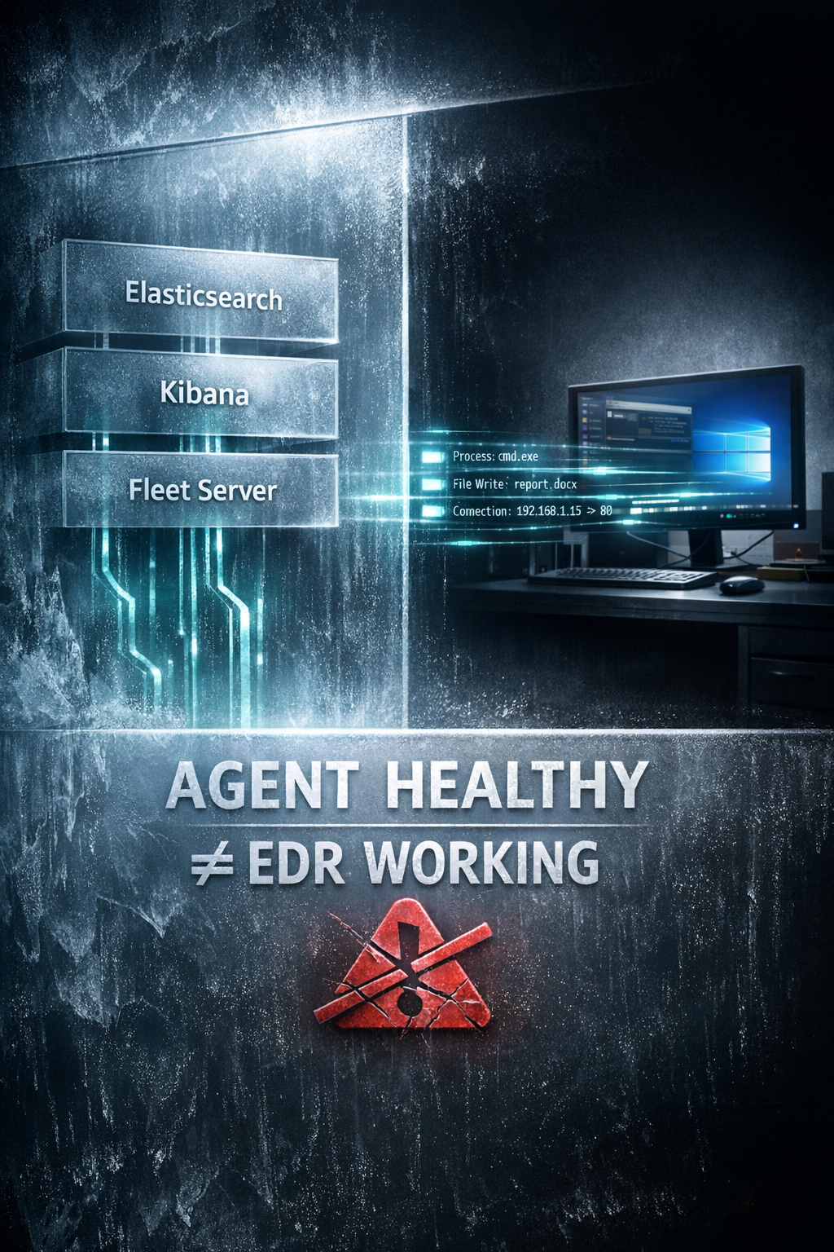

INTRODUCTION

Purpose of This Guide
This document is a line-by-line lab build guide for Elastic Security (EDR + SIEM) designed for beginners who want correct, enterprise-grade understanding, not demo-level success.
The goal is not just to install Elastic, but to:
- Build a functioning EDR pipeline
- Verify real endpoint telemetry
- Avoid false confidence caused by UI-only validation
If you follow this guide exactly, you will understand why Elastic works, not just how to install it.

Design Principles (Read Before Proceeding)
This lab is built on the following non-negotiable principles:
- Deterministic outcomes
Every step has a clear success or failure condition. There are no “it should work” states.
- No version mismatch tolerance
All Elastic components must run on compatible versions. Mixing versions silently breaks telemetry.
- No blind copy-paste
Commands are explained by intent. You are expected to understand what each layer does.
- Strict role separation
Each system has a single responsibility. Mixing roles creates invalid troubleshooting paths.
This lab mirrors controlled enterprise Elastic deployments, not shortcut-based YouTube or demo labs.

How the Lab Is Structured
Elastic Security is a distributed system, not a single product.
Because of this, the lab is built in strict, dependent layers.

Build Order (DO NOT REORDER)
- Lab Architecture & Host Prerequisites
Ensures the environment can support Elastic reliably.
- Ubuntu Server — Elastic Control Plane
Elasticsearch, Kibana, Fleet Server. This is the foundation.
- Windows 10 — EDR Endpoint
Endpoint telemetry, Sysmon, Elastic Agent.
- Validation Gates (Must-Pass)
Raw telemetry verification. No data = lab failed.
Reordering or skipping layers leads to:
- Agents showing HEALTHY but sending no data
- Silent telemetry failure
- Incorrect confidence in detections

What “Working” Means in This Lab
In this guide, working does NOT mean:
- Agent service is running
- Fleet shows “Connected”
- Dashboards load
- Alerts appear
Those can all happen without real telemetry.

Working means:
- Raw endpoint events are visible in Discover
- Process, file, and network events are present
- Timestamps are current and continuous
- Telemetry can explain detections
If raw data is missing, the lab is considered failed, regardless of UI status.

Who Should Use This Guide
This guide is intended for:
- SOC beginners
- Blue team learners
- Analysts preparing for real SOC roles
- Anyone who wants to understand EDR internals properly
It assumes:
- Basic Linux and Windows familiarity
- Willingness to stop and fix issues when validation fails
It does not assume prior Elastic experience.

Critical Rule to Remember
Elastic Agent does not decide anything.
It blindly follows Fleet configuration.
If Kibana or Fleet is misconfigured:
- All agents will fail
- Across all operating systems
- Even if installation succeeds

Understanding this rule is essential before continuing.

0️⃣ LAB ARCHITECTURE (LOCK THIS FIRST)
Before creating any virtual machine, lock the architecture.
Each VM must have one role only.

Final VM Roles
VM | Role
Ubuntu Server 22.04 | Elastic Stack + Fleet Server
Windows 10 | Primary EDR Endpoint

Hard Rules
- ❌ Do NOT mix roles on the same VM
- ❌ Do NOT reuse an existing Splunk / SIEM Ubuntu VM
- ❌ Do NOT install Elastic components “temporarily” on Windows
Breaking role isolation causes:
- Invalid troubleshooting paths
- Unrealistic telemetry behavior
- Broken understanding of EDR architecture

1️⃣ HOST MACHINE PREREQUISITES
Before touching any VM, ensure the host system meets the minimum requirements.

Host Requirements
- Virtualization enabled (Intel VT-x / AMD-V)
- 8 GB RAM minimum (more strongly recommended)
- VMware Workstation or VirtualBox installed
- At least 100 GB free disk
(250 GB recommended if using snapshots)

Why This Matters
If the host is undersized:
- Elasticsearch behaves unpredictably
- Agents may connect but drop data
- EDR behavior becomes misleading and non-deterministic
If the host does not meet these requirements, stop here.
Fix the host before proceeding.

PART A — UBUNTU SERVER (ELASTIC CONTROL PLANE)
This is the most critical system in the lab.

1️⃣ Create Ubuntu Server VM

VM Settings
- OS: Ubuntu Server 22.04 LTS
- Install type: Minimal
- Hostname: any

Hardware (DO NOT UNDERSIZE)
Resource | Value
RAM | 8 GB (4 GB absolute minimum)
CPU | 4 vCPU
Disk | 120 GB
Network | NAT or Host-Only
Elasticsearch is JVM + disk heavy. Undersizing breaks realism.

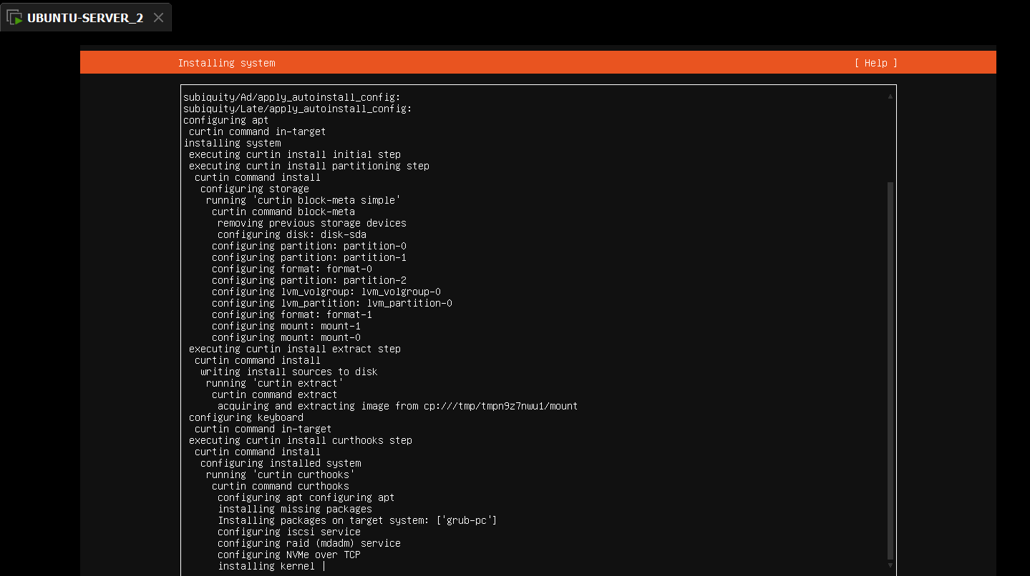

2️⃣ Ubuntu Initial Setup (Post-Install)
Login as the created user.

Update OS
sudo apt update && sudo apt upgrade -y

Set timezone
timedatectl set-timezone Asia/Kolkata

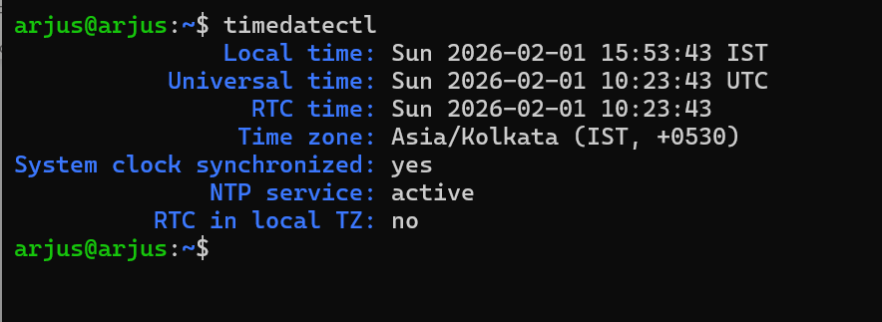

Disable swap (MANDATORY)
sudo swapoff -a
sudo sed -i '/ swap / s/^/#/' /etc/fstab

Optional : sudo rm -f /swap.img

Increase file descriptor limits
sudo nano /etc/security/limits.conf
Add:
* soft nofile 65535
* hard nofile 65535

Reboot:
sudo reboot

3️⃣ Download Elastic Packages
From host machine browser (Windows / main OS):
Download matching 8.x versions of:
- elasticsearch-8.x.x-amd64.deb
- kibana-8.x.x-amd64.deb
- elastic-agent-8.x.x-amd64.deb
Source:
- Elastic → Downloads → Self-managed → Linux
⚠️ Version mismatch = breakage
Keep all components on the same version.

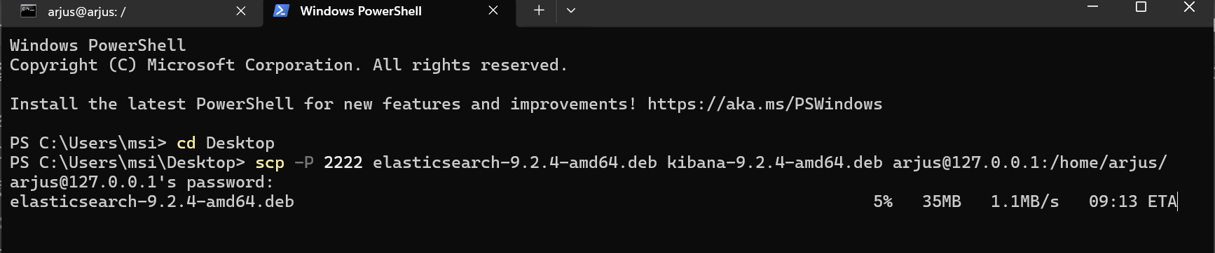

I installed the file from the outside of ubuntu (windows 11-host OS) and copied to ubuntu by using scp command-line tool

4️⃣ Install Elasticsearch (LOCAL PACKAGE)
Download the Debian package first, then install:
sudo dpkg -i elasticsearch-8.x.x-amd64.deb
If dependency errors occur (common on minimal systems):
sudo apt --fix-broken install -y
✔ This is officially supported for offline / local installs
⚠ Elastic recommends APT repo for updates, but .deb is valid
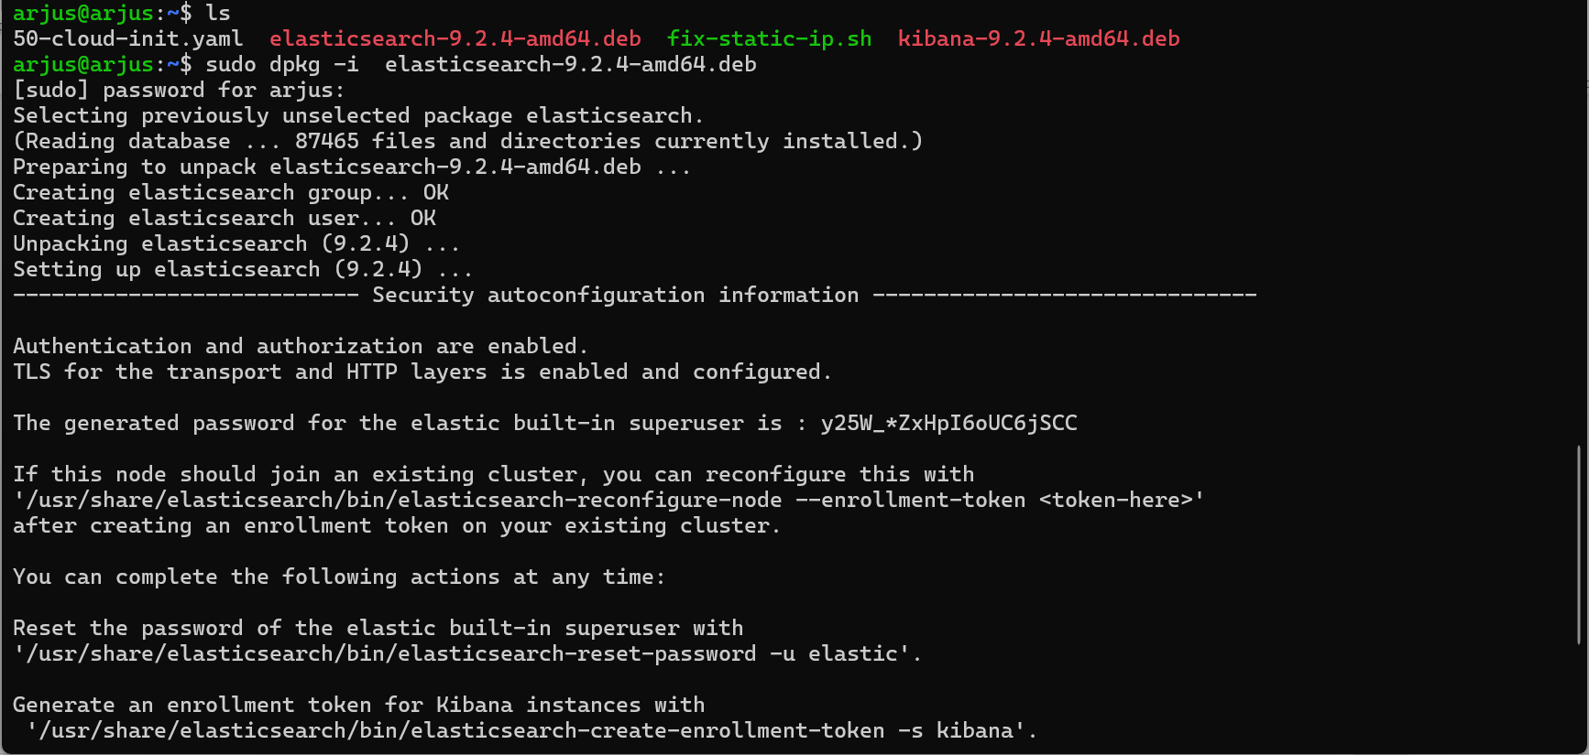

2️⃣ Configure Elasticsearch (Single-Node Lab)
Edit the config file:
sudo nano /etc/elasticsearch/elasticsearch.yml
Set only what is required:
cluster.name: elastic-lab
node.name: elastic-node-1

network.host: 0.0.0.0
discovery.type: single-node

❗ Important clarifications (official behavior)
- DO NOT add xpack.security.enabled: true
  - Elasticsearch 8.x enables security by default
- TLS (HTTPS) is enabled automatically
- Certificates are auto-generated during install
⚠ network.host: 0.0.0.0 exposes Elasticsearch
→ acceptable for lab only if firewall-restricted

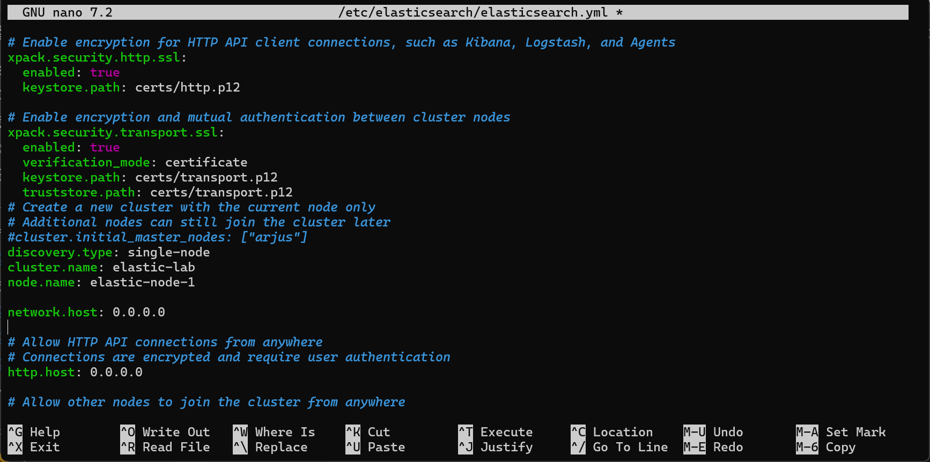

3️⃣ Enable & Start Elasticsearch Service
sudo systemctl enable elasticsearch
sudo systemctl start elasticsearch
Verify status:
sudo systemctl status elasticsearch
Elasticsearch should now be listening on 9200 (HTTPS).

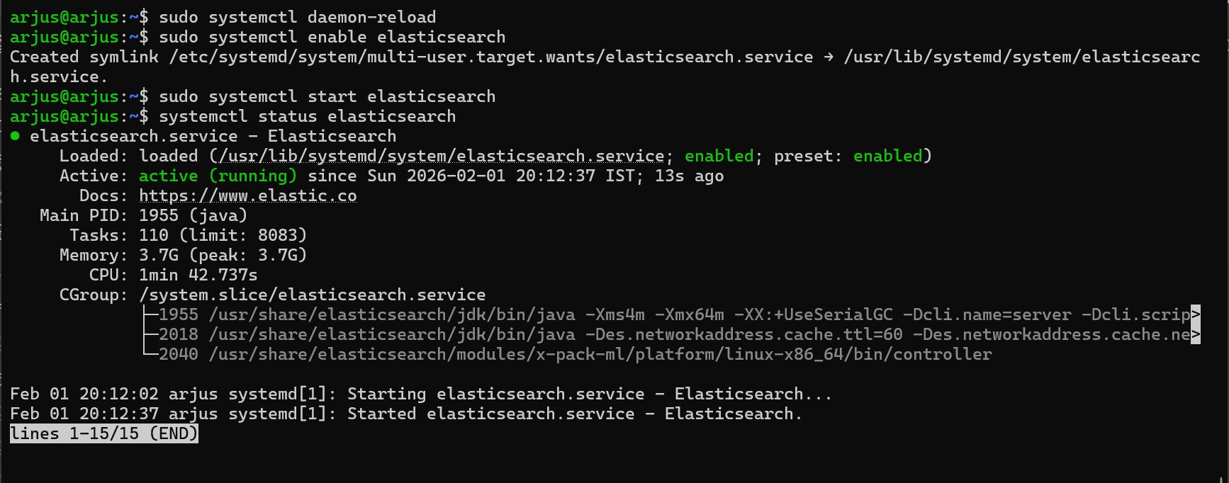

4️⃣ Get / Set elastic User Password (CRITICAL)

🔹 What happens officially in 8.x
- During installation, Elasticsearch prints a bootstrap password
- That password is for the built-in elastic superuser
- If you missed it, you must reset it

🔹 Reset / Generate a new password (official tool)
sudo /usr/share/elasticsearch/bin/elasticsearch-reset-password -u elastic
Options:
- Interactive prompt (recommended for labs)
- Or auto-generate and display a password
📌 elasticsearch-setup-passwords → deprecated
📌 elasticsearch-reset-password → correct tool

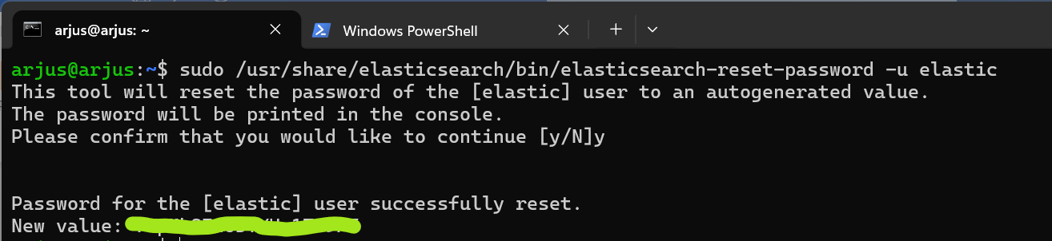

5️⃣ Test Elasticsearch (Auth + TLS)
curl -k -u elastic https://localhost:9200
Expected output (example):
{
"name" : "elastic-node-1",
"cluster_name" : "elastic-lab",
"cluster_uuid" : "...",
"version" : {
"number" : "8.x.x"
},
"tagline" : "You Know, for Search"
}
✔ Confirms:
- Service running
- Authentication working
- TLS enabled

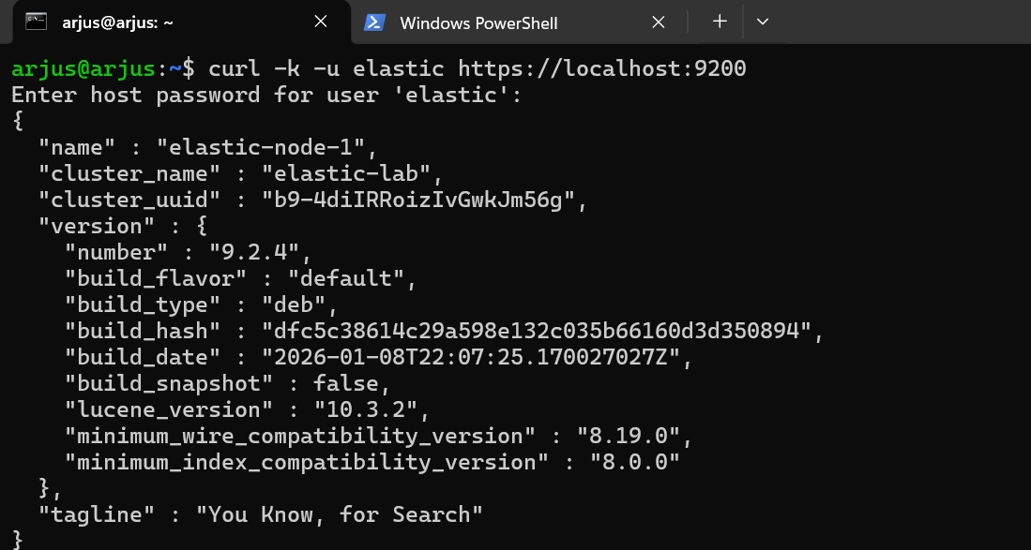

5️⃣ Install Kibana (LOCAL PACKAGE)
sudo dpkg -i ~/kibana-9.2.4-amd64.deb
sudo apt --fix-broken install -y
✔ This unpacks Kibana and resolves dependencies.

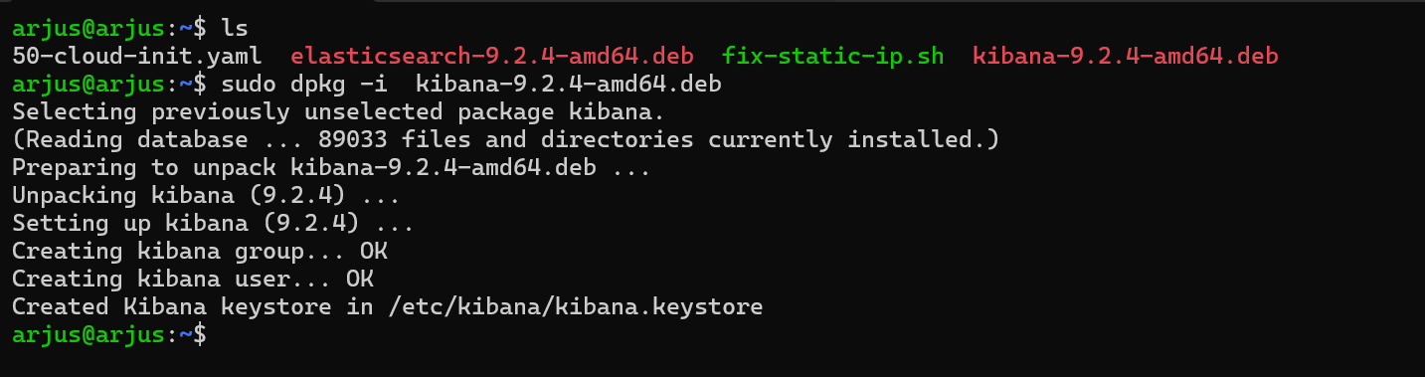

2) Configure Kibana
Open the config file:
sudo nano /etc/kibana/kibana.yml
Set exactly these lines:
server.host: "0.0.0.0"

elasticsearch.hosts: ["https://localhost:9200"] (Don’t add this ok )…………….
🚫 Do not add username/password here.
🚫 Kibana will trust Elasticsearch via the enrollment token.
Save and exit
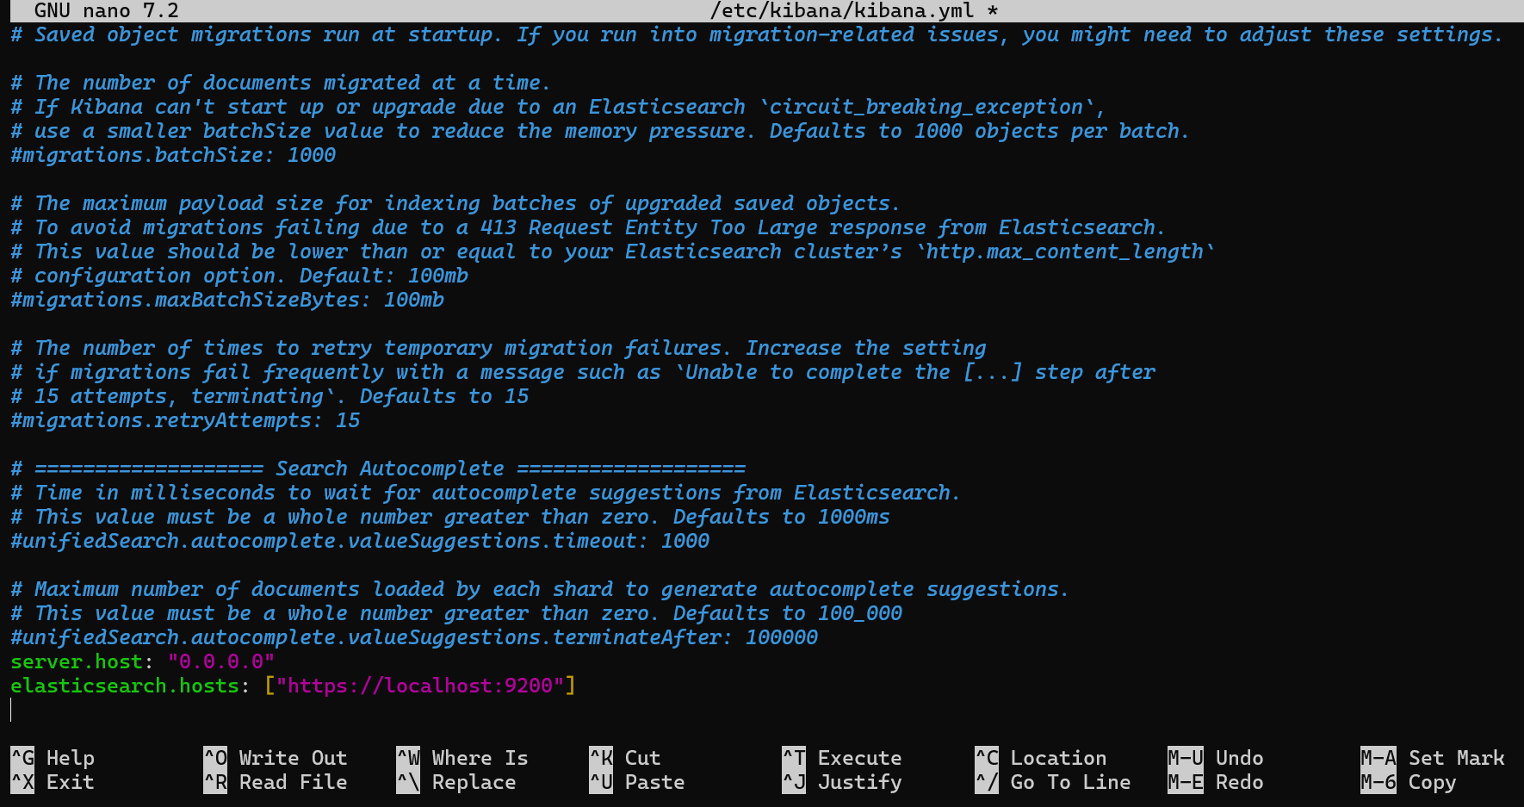

3) Generate Kibana enrollment token
Run:
sudo /usr/share/elasticsearch/bin/elasticsearch-create-enrollment-token -s kibana
✔ This token allows Kibana to initialize trust with Elasticsearch securely.
Keep the token — it will be needed in the next step.

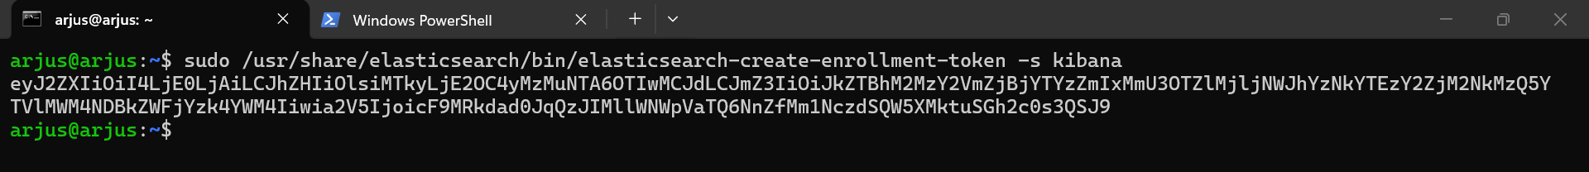

4) Enable & start Kibana
sudo systemctl enable kibana
sudo systemctl start kibana
Check status:
systemctl status kibana
Look for:
Active: active (running)

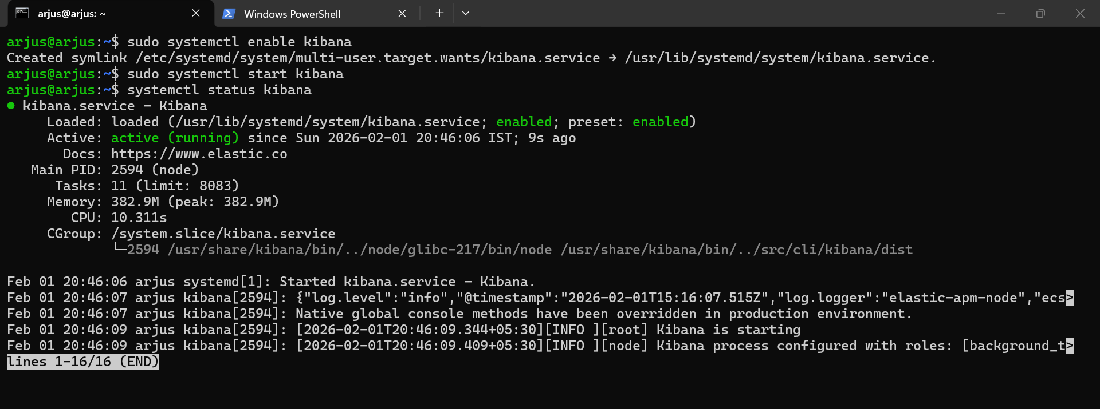

5) Access the Kibana UI from your browser
Use one of the addresses:
🔹 If VM uses NAT + forwarded port:
http://localhost:5601
🔹 If VM uses bridged networking:
http://<VM_IP_ADDRESS>:5601
You’ll see the Kibana setup page.

6) Complete the first-time Kibana setup
- Paste the Kibana enrollment token (from Step 3)
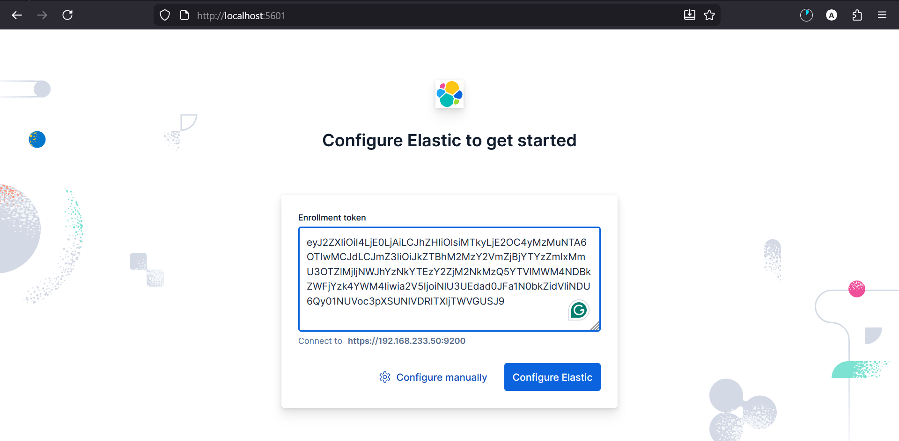

It may ask for a verification code when you click the Configure button. If so, follow the steps below.
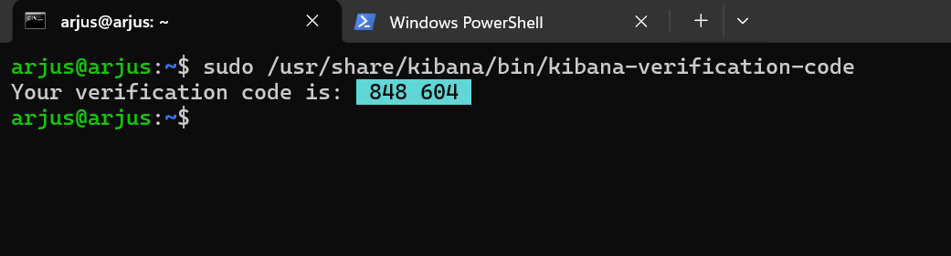

- You will be prompted to log in:
  - Username: elastic
  - Password: (the one you set/reset for the elastic user)
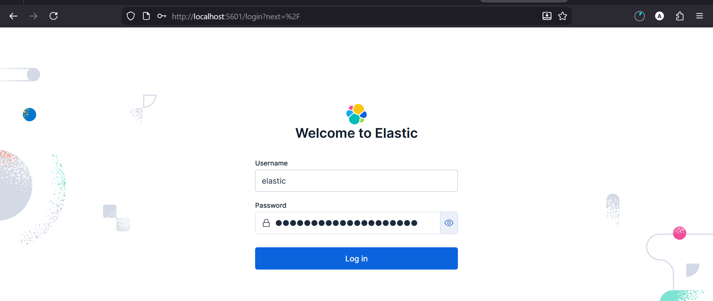

- Kibana finishes initializing

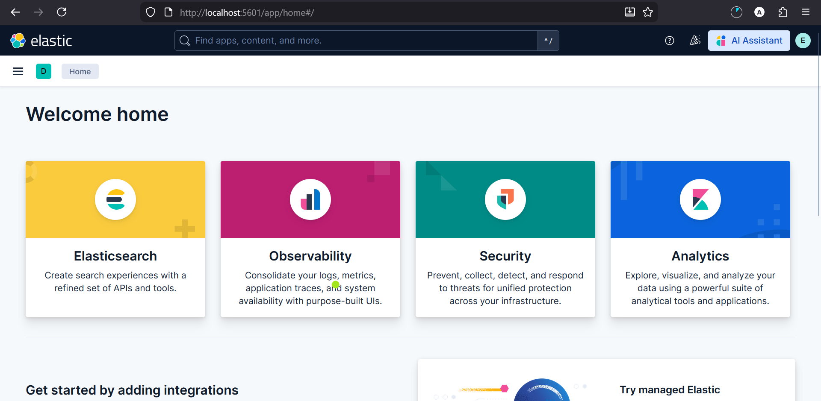

6️⃣Enable Fleet (MANDATORY)
In Kibana:
- Management → Fleet
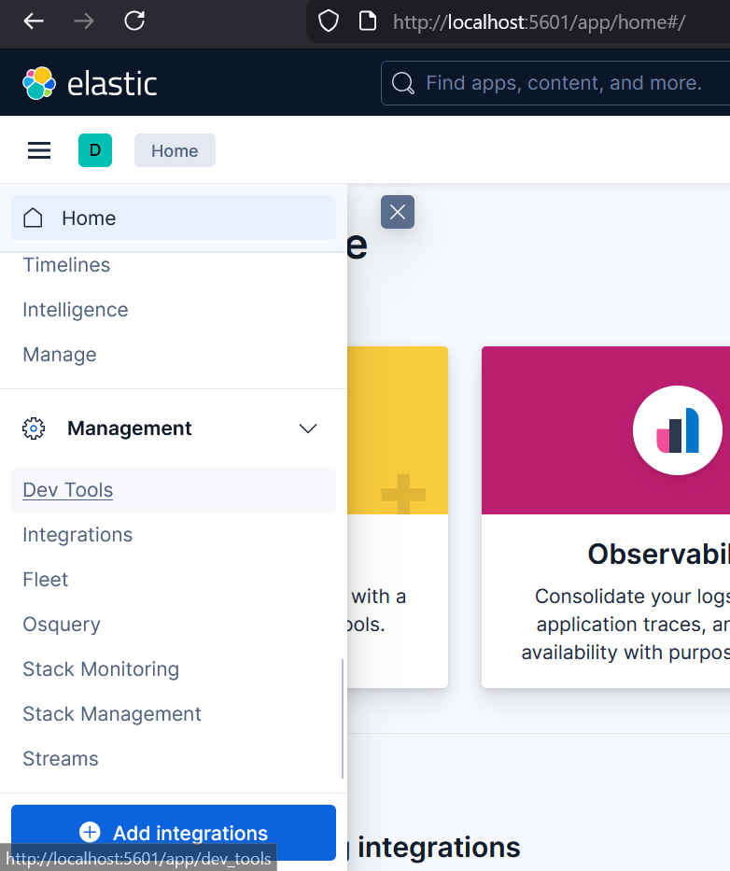
- Click Enable Fleet
If Fleet fails → stop.
EDR cannot exist without Fleet.

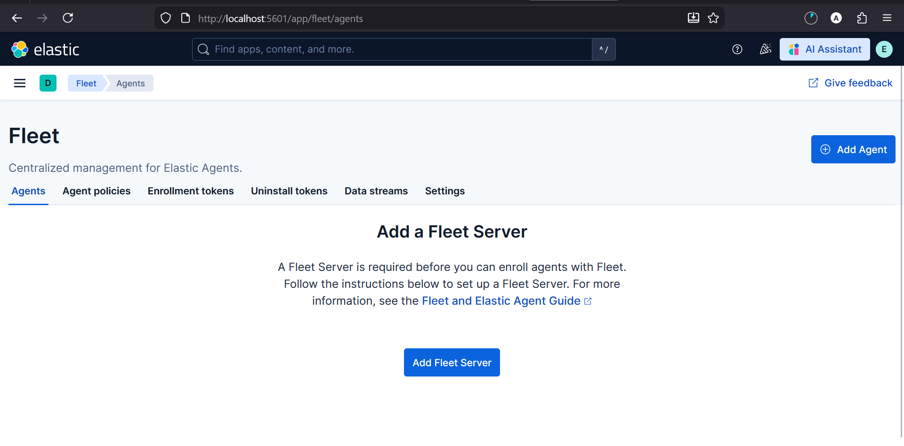

7️⃣ Install Fleet Server (Elastic Agent on Ubuntu)
sudo dpkg -i elastic-agent-8.x.x-amd64.deb (if not downloaded yet pls download it )

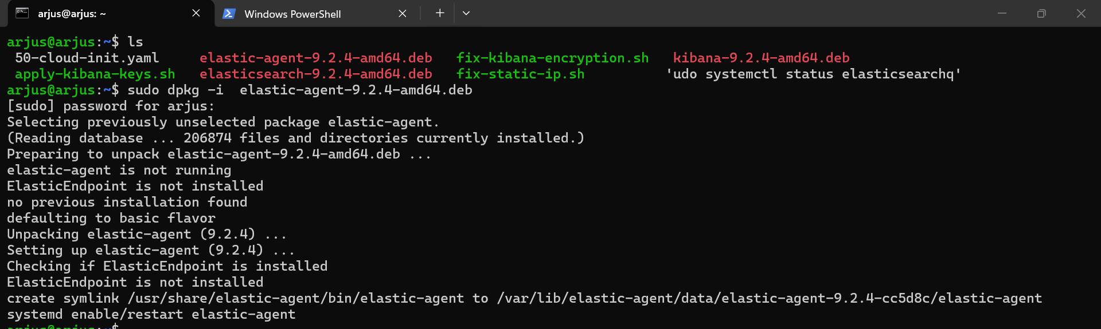
Then enroll as Fleet Server (command copied from Kibana):
sudo elastic-agent install \
--url=https://<elastic-ip>:8220 \
--enrollment-token=<fleet-server-token>
Verify:
- Fleet Server = Healthy
- Agent connected

Preconditions (check before proceeding)
On Ubuntu, confirm Elasticsearch is running:
sudo systemctl status elasticsearch
You should see:
active (running)
If not → STOP.

Step 1: Get Fleet Server enrollment command (DO NOT GUESS)
In Kibana UI:
Management → Fleet → Agents
Click: Add Fleet Server

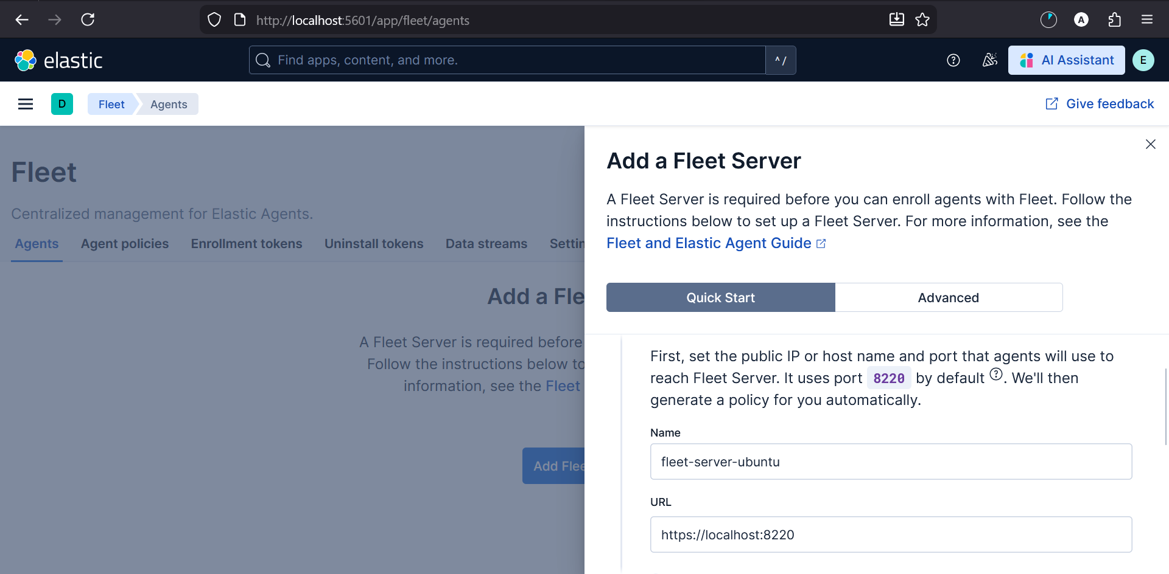
Kibana will:
- Generate a Fleet Server policy
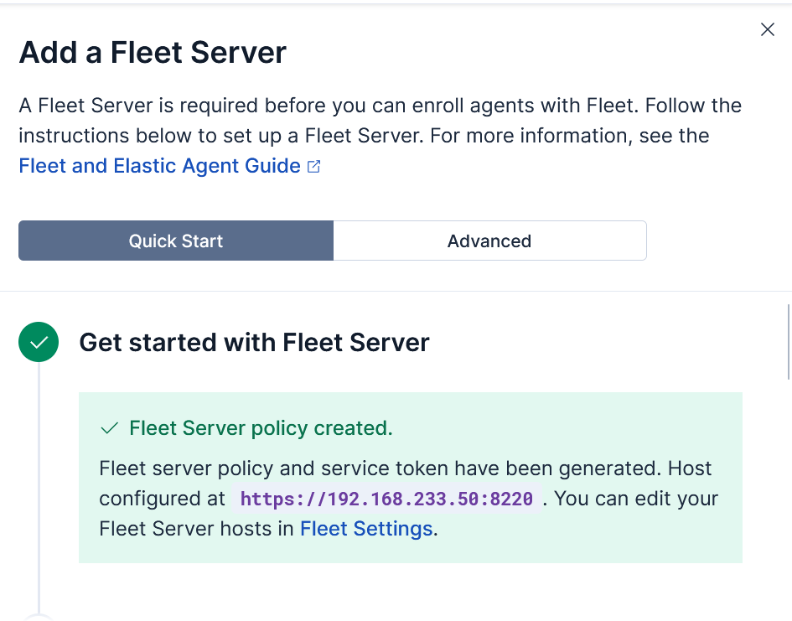
- Install Fleet Server to a centralized host
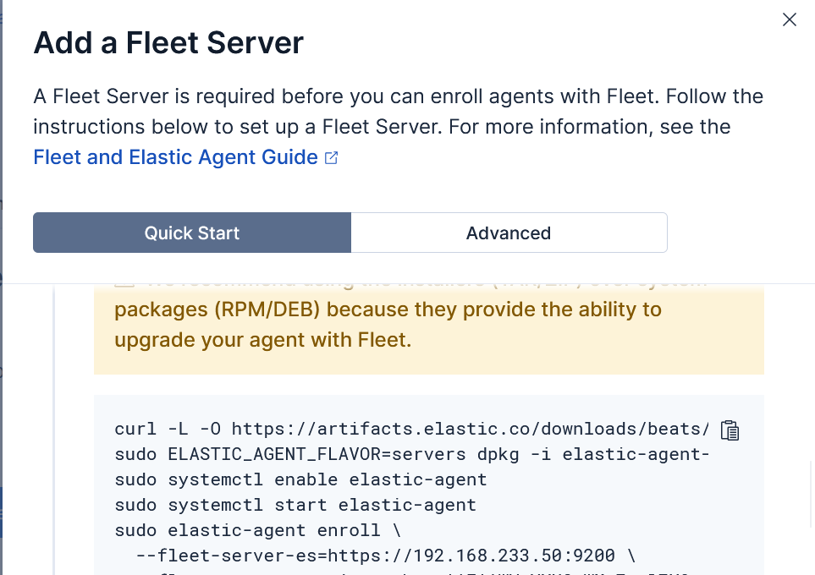

⚠️ DO NOT manually invent the command
⚠️ DO NOT reuse Windows agent token

Step 2: Enroll Ubuntu as Fleet Server (REAL command)
It will look like this (example):
sudo elastic-agent install \
--fleet-server \
--url=https://192.168.233.50:8220 \
--enrollment-token=FLEET_SERVER_TOKEN_HERE \

Important flags explained (not optional knowledge)
- --fleet-server
→ This turns the agent into Fleet Server
- --url :8220
→ Fleet Server listens on 8220, NOT 9200
- --enrollment-token
→ Special token only for Fleet Server

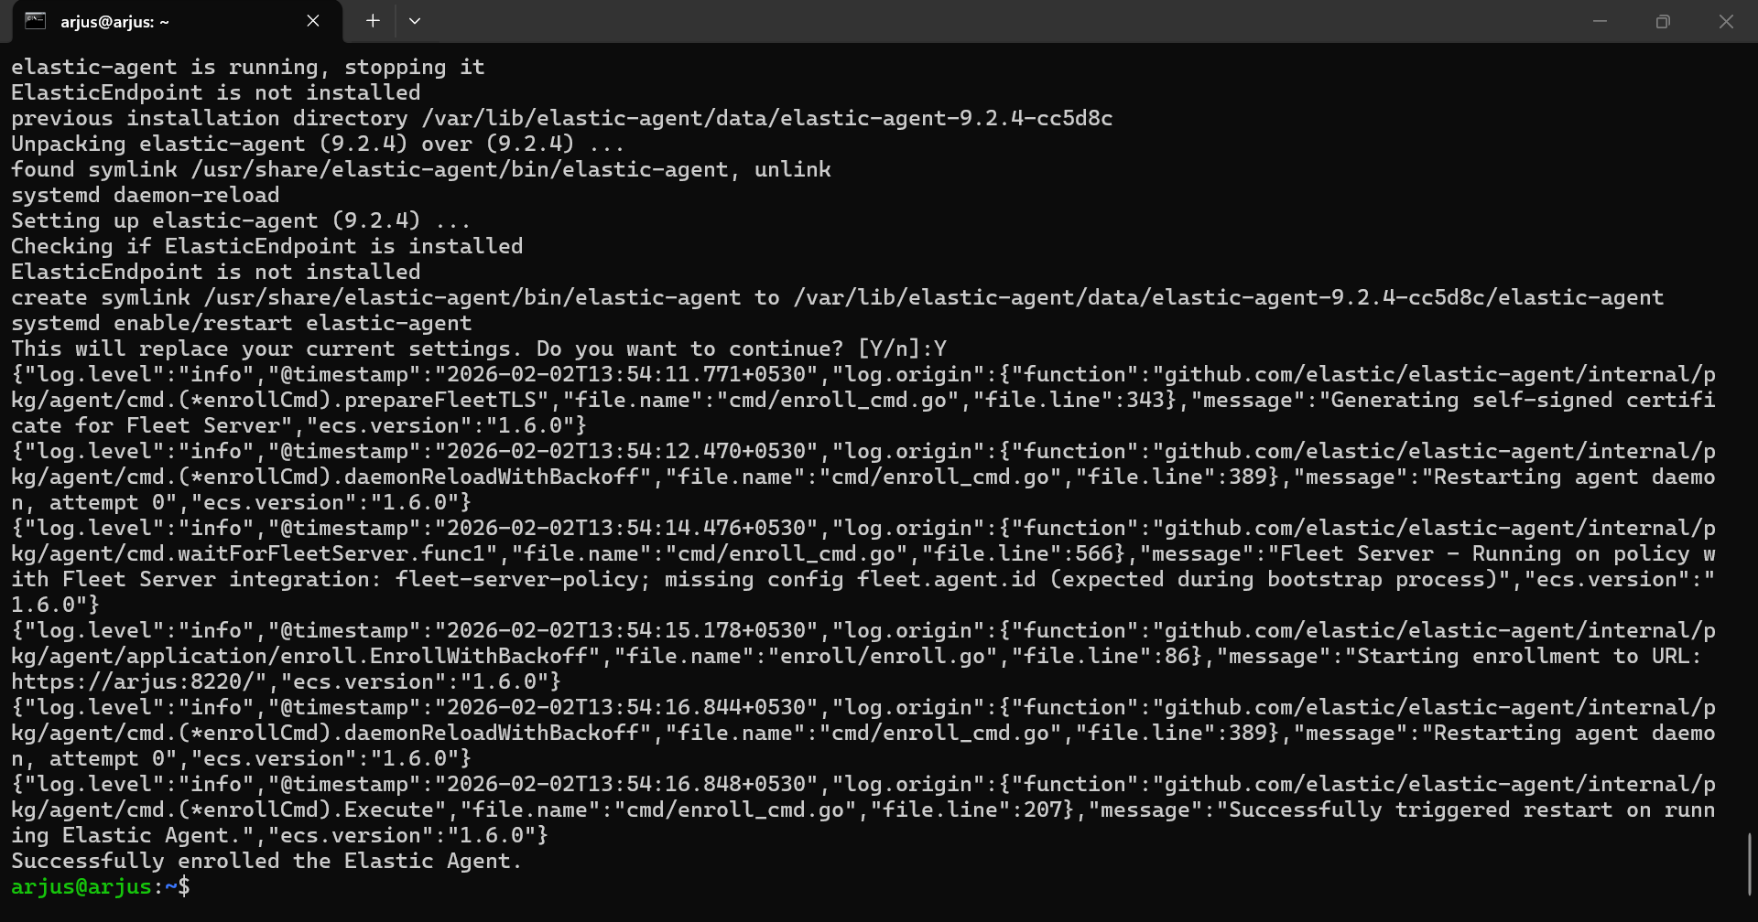

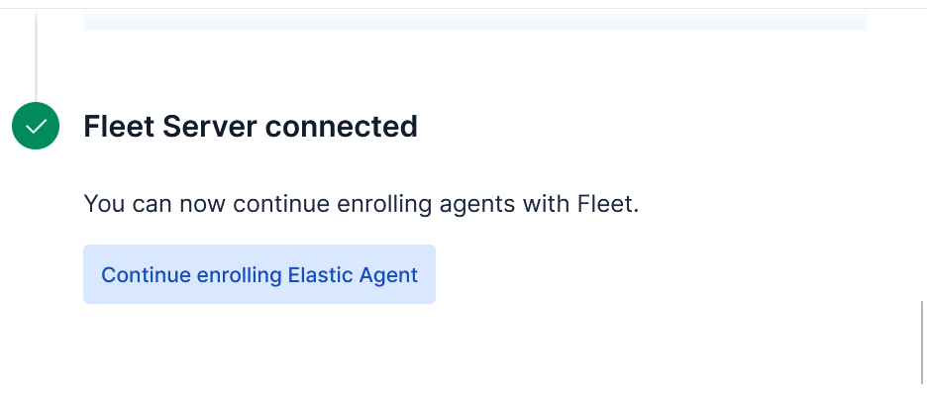

PART B — WINDOWS 10 (EDR ENDPOINT)

Objective
Onboard a Windows 10 endpoint into Elastic Security with deterministic, high-fidelity telemetry suitable for EDR detections.
Alerts are meaningless until raw telemetry is verified.

B1️⃣ Prepare Windows 10 (Baseline)

1. Defender & AV State
Goal: Avoid telemetry conflicts while preserving realism.
- Windows Defender enabled
- No third-party AV / EDR installed
- Real-time protection ON
Defender can coexist with Elastic Endpoint. Do not disable it unless explicitly testing AV conflicts.

2. System State Control
Goal: Deterministic rollback.
- Fully updated Windows 10 (x64)
- Take VM snapshots:
  - Snapshot before Sysmon
  - Snapshot before Elastic Agent
No snapshot = unreliable lab and invalid troubleshooting.

3. Enable Native Command-Line Logging (Mandatory)
Why: Enables command-line arguments in Event 4688 (baseline Windows visibility).

Enable via Group Policy
- gpedit.msc
- Computer Configuration
- → Administrative Templates
- → System
- → Audit Process Creation
- ✔ Include command line in process creation events

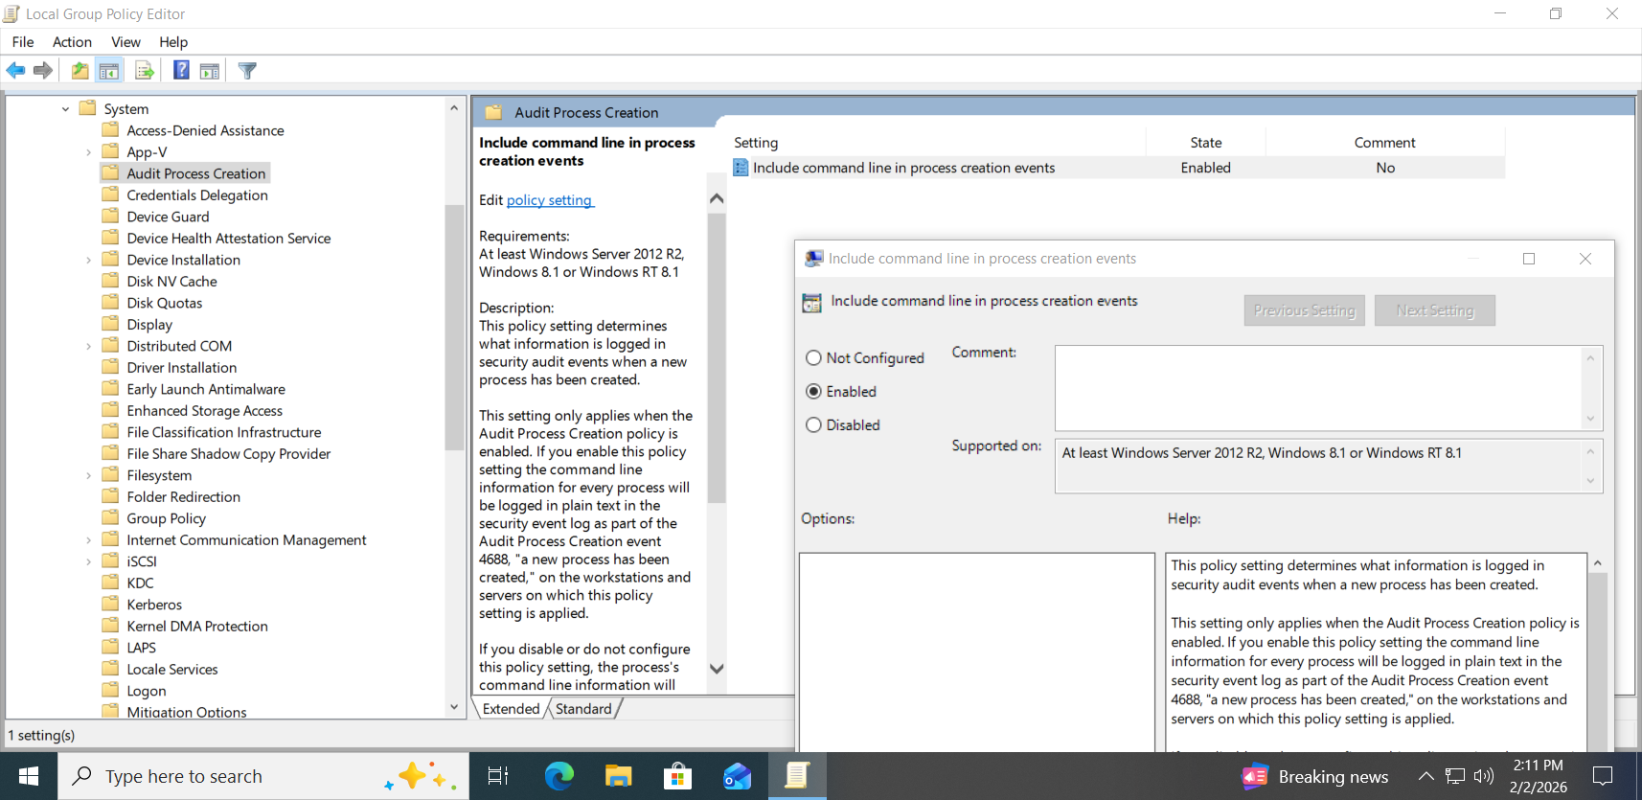

Enforce via Audit Policy
Run PowerShell as Administrator:
auditpol /set /subcategory:"Process Creation" /success:enable /failure:enable
auditpol /get /subcategory:"Process Creation"
Expected:
Success and Failure
⚠️ If this is misconfigured, Sysmon will not save you.
You lose baseline parity and investigative confidence.

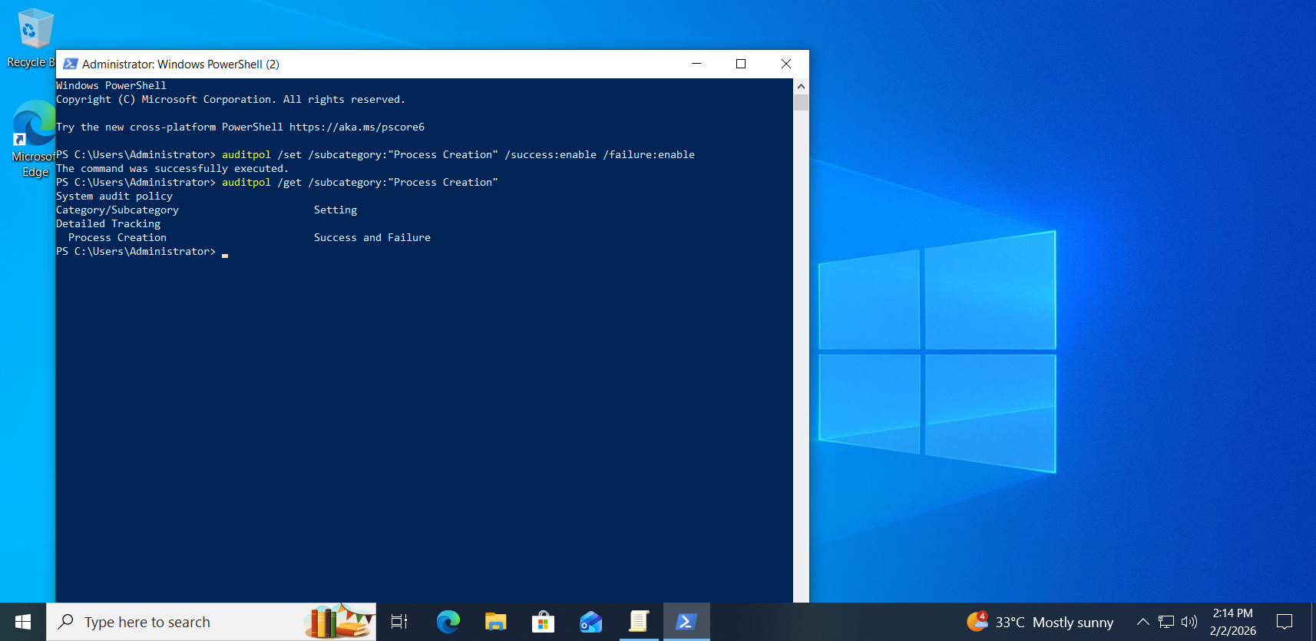

B2️⃣ Install Sysmon (Critical Telemetry Layer)

Why Sysmon is mandatory
- Native Windows logs are coarse and delayed
- Sysmon provides high-fidelity lineage:
  - Process ancestry
  - Network connections
  - File and registry activity
- Elastic EDR detections assume this depth

1. Download Sysmon
From Microsoft Sysinternals:
- Sysmon64.exe

2. Use a Real Sysmon Config (Do NOT use default)
Use one:
- SwiftOnSecurity config (review & trim)
- Olaf Hartong modular config (recommended)
⚠️ Default Sysmon config is insufficient
⚠️ Untuned configs = noise + storage bloat

3. Install Sysmon
.\Sysmon64.exe -accepteula -i sysmonconfig.xml
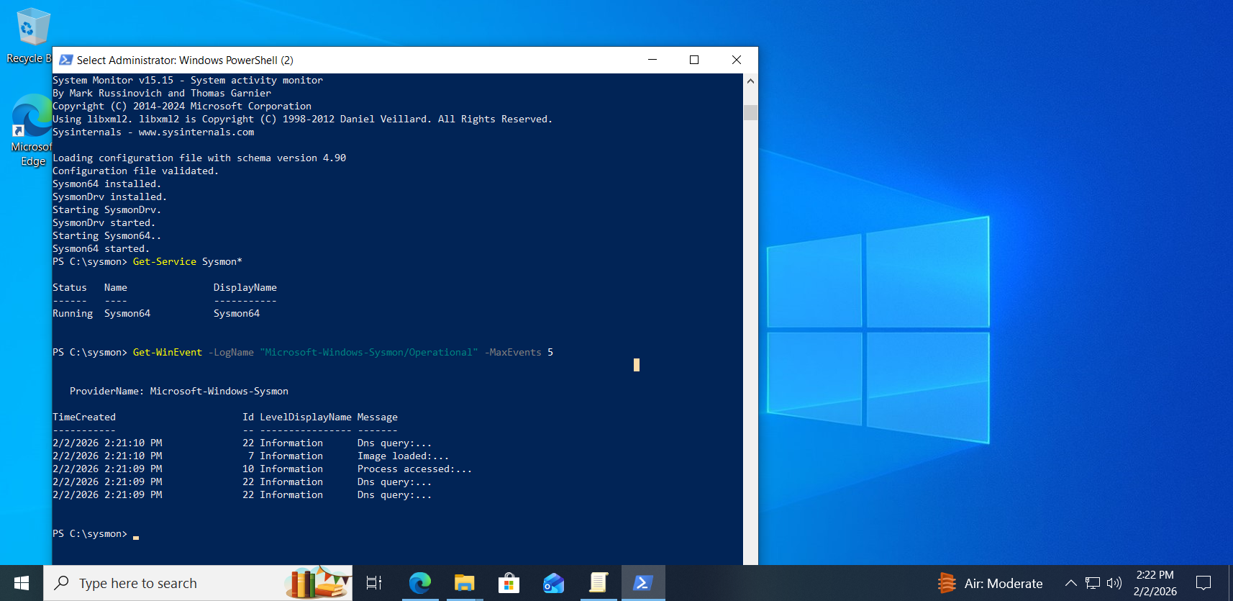

4. Mandatory Sysmon Event IDs
At minimum, enable:
- 1 — Process Create
- 3 — Network Connection
- 7 — Image Load
- 11 — File Create
- 13 — Registry Set
- 22 — DNS Query

5. Verify Sysmon
sysmon.exe -c
Logs:
Applications and Services Logs
→ Microsoft
→ Windows
→ Sysmon
→ Operational
❌ Sysmon missing → STOP LAB
❌ Sysmon too noisy → tune config before proceeding

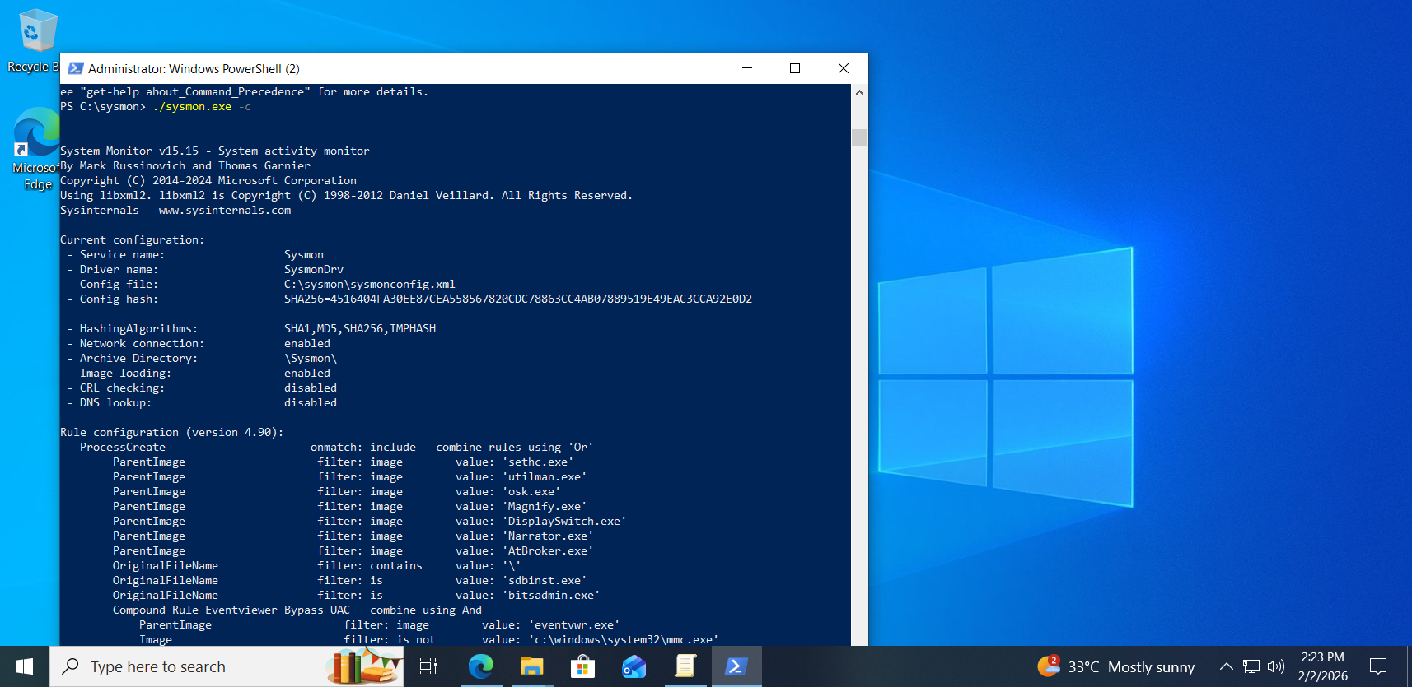

B3️⃣ Elastic Agent Version & Source (Rule, Not a Step)

Non-Negotiable Rule
Elastic Agent MAJOR VERSION MUST MATCH Fleet Server.
Your environment:
- Fleet Server: 9.2.x
- Windows Elastic Agent: 9.2.x
❌ Never mix:
- 8.x agent → 9.x Fleet Server
- Cached / reused EXE files

Implementation Rule
- Always use the Windows enrollment command generated by Kibana
- Do NOT manually download agent binaries
- Do NOT reuse old installers
Kibana’s enrollment command already:
- Downloads the correct version
- Installs the agent
- Enrolls it
- Registers it as a service

B4️⃣ INSTALL ELASTIC AGENT ON WINDOWS (ENDPOINT)
🚨 Prerequisites — Go Through This Before Installing Any Elastic Agents
Read this section fully before installing Elastic Agent on Windows or Linux.
Most agent failures are caused by backend misconfiguration, not the agent itself.

1️⃣ What You Are About to Build (Simple Mental Model)
Elastic Agent does not work in isolation.
Control flow is always:
Elastic Agent (Endpoint)
↓
Fleet Server (Control Plane)
↓
Kibana (Policy + Config Manager)
↓
Elasticsearch (Data + TLS)

Critical rule
Agents blindly follow what Fleet tells them.
If Fleet or Kibana is misconfigured, every agent will fail — even if installation succeeds.

2️⃣ Environment Assumptions (Know What Exists)
This guide assumes:
Component | Purpose | OS
Elasticsearch | Data store + TLS authority | Ubuntu
Kibana | UI + Fleet management | Ubuntu
Fleet Server | Agent controller | Ubuntu
Elastic Agent | Endpoint sensor | Windows (later)
Important endpoints:
- Elasticsearch → https://192.168.233.50:9200
- Kibana → http://<kibana-host>:5601
- Fleet Server → https://<fleet-server-ip>:8220

3️⃣ Why Agents Commonly Fail (Beginner Trap)
Many beginners see:
- “Agent installed successfully”
- Service = running
- Fleet = connected
…and assume EDR is working.
This is wrong.
If the backend is misconfigured:
- Agents become DEGRADED
- Telemetry silently fails
- EDR appears “installed” but does nothing

4️⃣ Common Root Cause We Hit (Very Important)

Error seen in Kibana logs
EACCES: permission denied, open '/etc/elasticsearch/certs/http_ca.crt'

What this means (plain English)
- Elasticsearch auto-generated a TLS CA certificate during install
- That file belongs to Elasticsearch
- Kibana runs as user kibana
- Linux permissions blocked Kibana from reading the certificate
This is not an Elastic bug — it is Linux security working correctly.

5️⃣ Why This Breaks Agents Later
Fleet output configuration is centrally pushed to all agents.
If Fleet output references:
/etc/elasticsearch/certs/http_ca.crt
Then:
- Linux agents → may work
- Windows agents → always fail
- Reason: Windows cannot read Linux paths
So a single backend mistake breaks every endpoint.

6️⃣ Correct Fix (What We Actually Did)
We did not regenerate certificates.
We reused the existing trusted CA, but placed it where Kibana can legally read it.

Fix Kibana access to the CA certificate
- sudo mkdir -p /etc/kibana/certs

- sudo cp /etc/elasticsearch/certs/http_ca.crt /etc/kibana/certs/

- sudo chown kibana:kibana /etc/kibana/certs/http_ca.crt

- sudo chmod 644 /etc/kibana/certs/http_ca.crt
Why this is correct:
- Same CA (no trust mismatch)
- No TLS weakening
- Safe for Fleet and agents
- Common real-world fix

7️⃣ Verify Kibana Configuration Is Clean
File: /etc/kibana/kibana.yml
Minimum required correctness:
elasticsearch.hosts:
- https://192.168.233.50:9200

elasticsearch.serviceAccountToken: <SERVICE_ACCOUNT_TOKEN>

elasticsearch.ssl.certificateAuthorities:
- /etc/kibana/certs/http_ca.crt

xpack.fleet.outputs:
- id: fleet-default-output
name: default
type: elasticsearch
hosts:
- https://192.168.233.50:9200
is_default: true
is_default_monitoring: true
# ⚠ Do NOT reference Linux-only file paths here
Hard rule
Anything under xpack.fleet.outputs is sent to every agent, regardless of OS.

8️⃣ Restart and Validate Backend Health
- sudo systemctl daemon-reload
- sudo systemctl restart kibana
- sudo systemctl status kibana

Expected:
Active: active (running)
If Kibana is not stable:
- ❌ Do not install agents
- ❌ Do not debug Windows yet

9️⃣ Pre-Agent Installation Checklist (Must Be TRUE)
Before installing any Elastic Agent:
- ✔ Elasticsearch reachable over HTTPS
- ✔ Kibana starts cleanly
- ✔ No EACCES errors in Kibana logs
- ✔ Fleet UI loads without errors
- ✔ Fleet output does not reference OS-specific paths
Only when all above are true should you proceed to agent installation.

🟢 Only AFTER the above is correct → move to Windows

B4️⃣ Install Elastic Agent on Windows

1️⃣ Generate Enrollment Command
Kibana path:
Fleet → Agents → Add agent → Windows

Rules
- ✅ Select endpoint agent policy
- ❌ DO NOT select Fleet Server policy
- Copy the exact PowerShell command

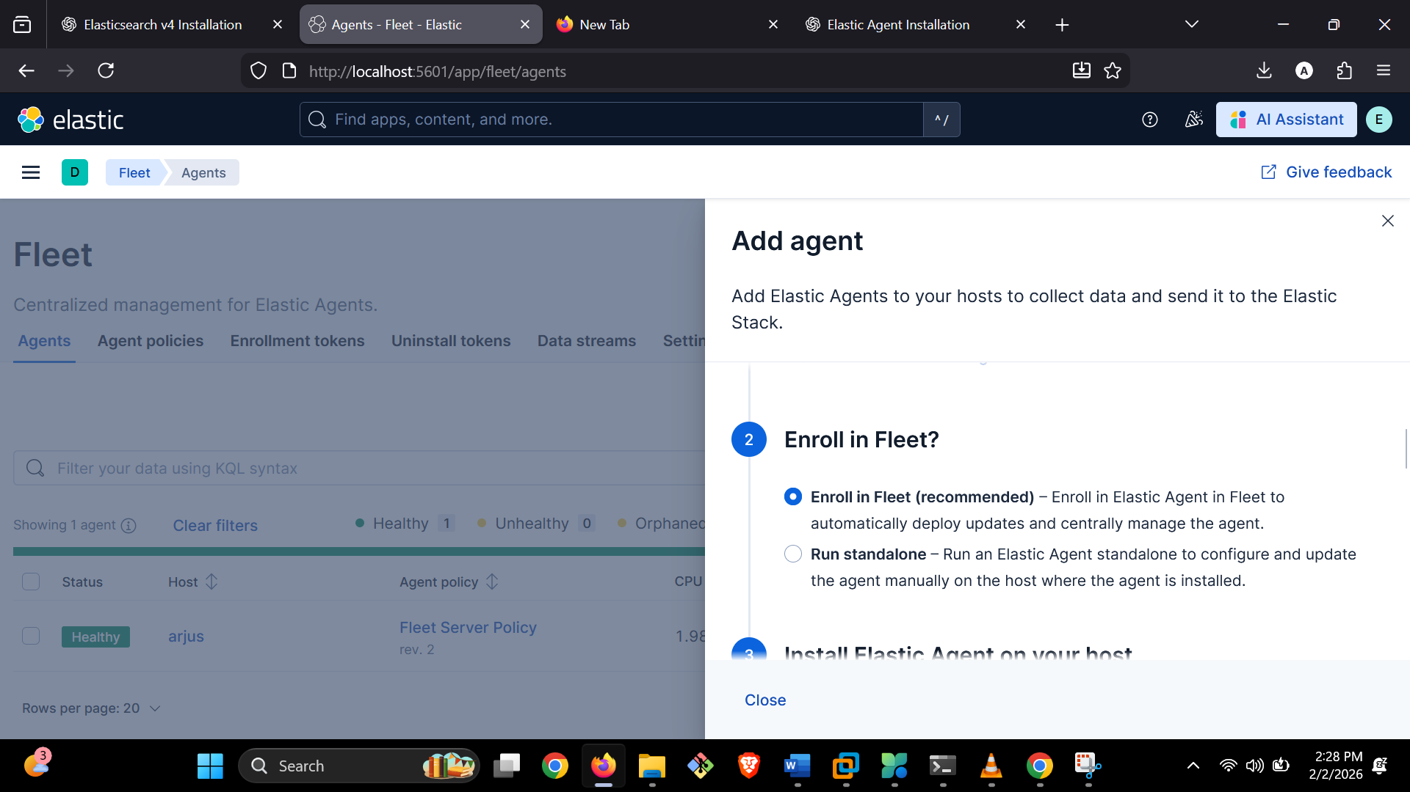

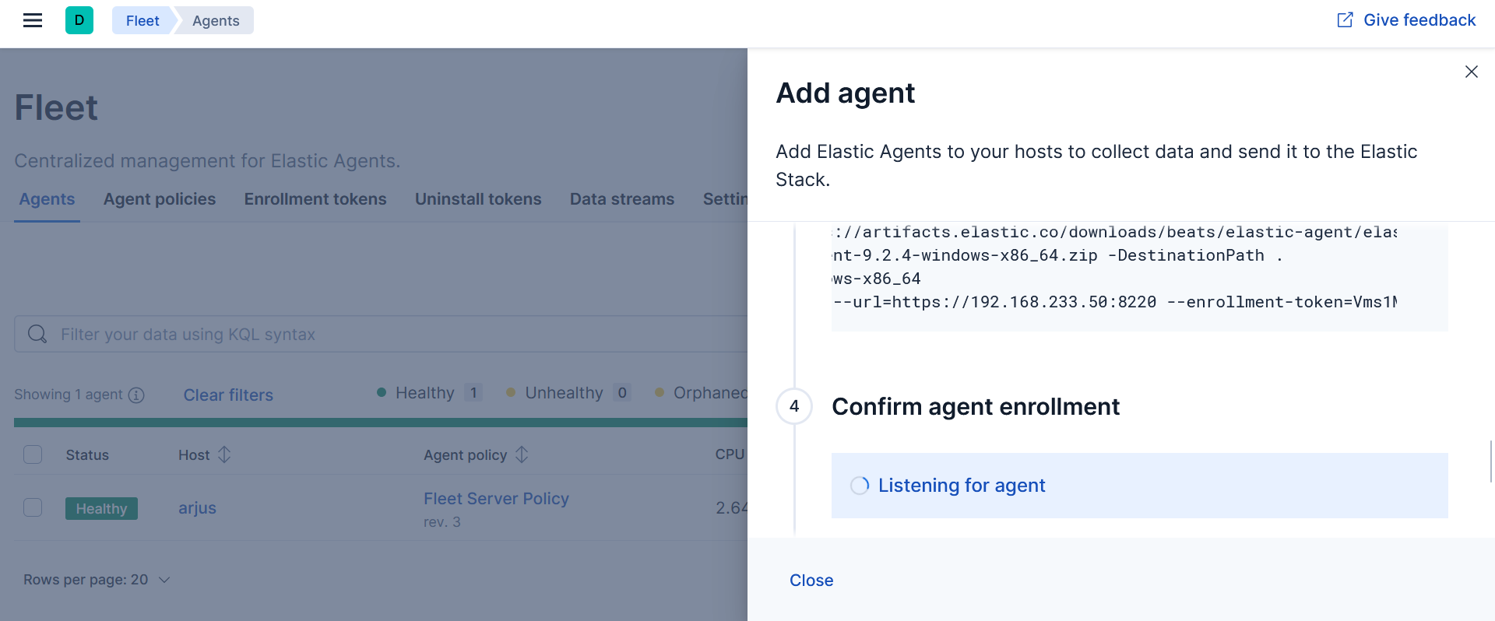

2️⃣ Install Elastic Agent (Admin PowerShell)
Run PowerShell as Administrator:
elastic-agent.exe install `
--url=https://<FLEET_SERVER_IP>:8220 `
--enrollment-token=<ENDPOINT_ENROLLMENT_TOKEN>

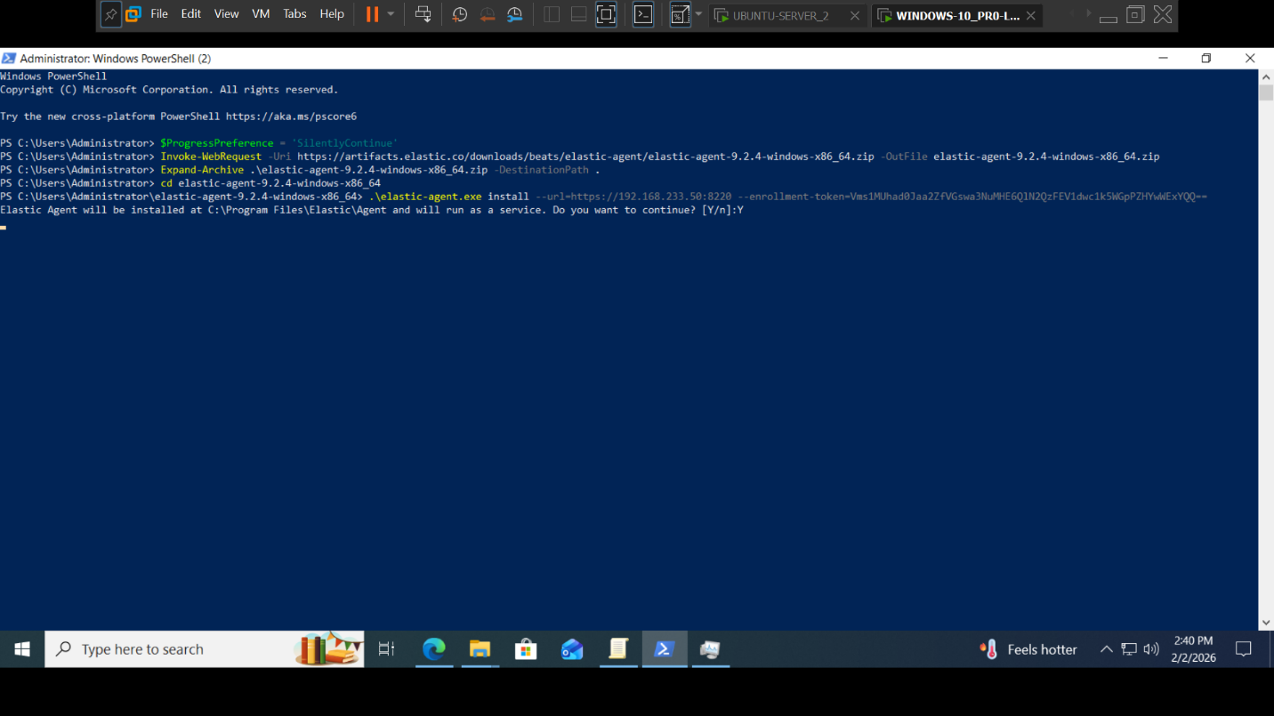

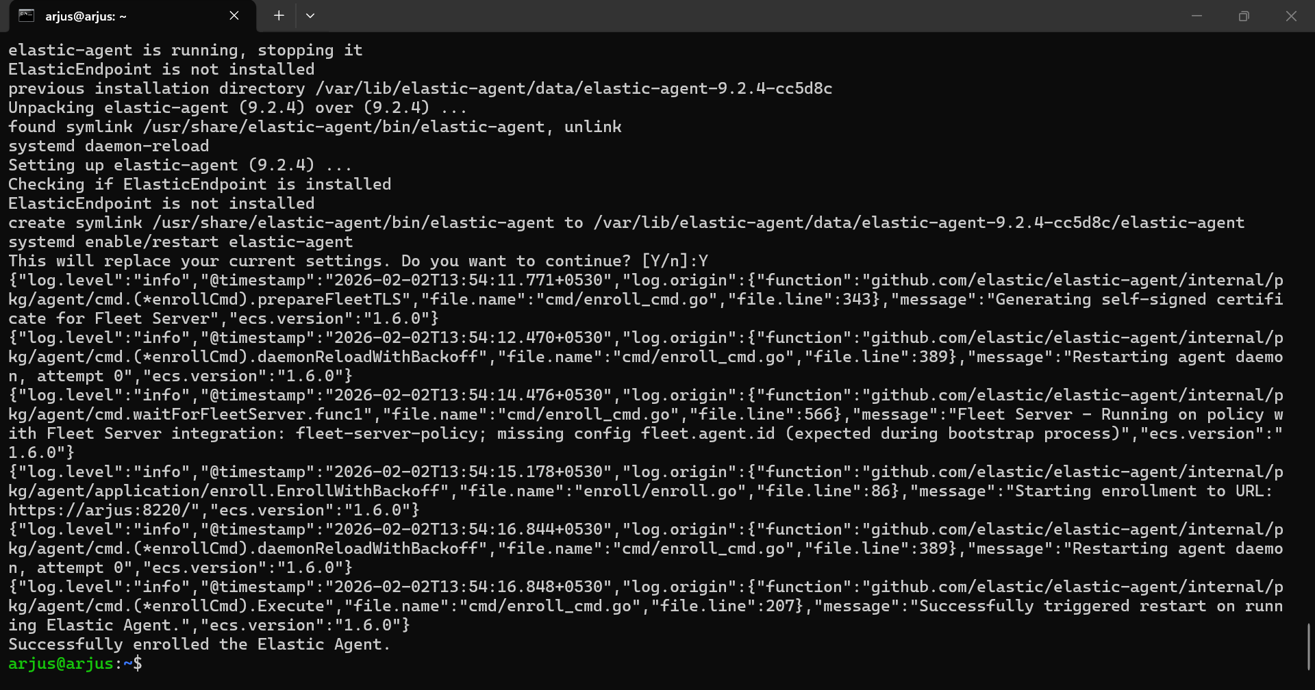

Rules (Non-Negotiable)
Item | Correct
--url | Fleet Server (8220)
❌ Wrong | Elasticsearch (9200)
Token | Agent enrollment token

3️⃣ Post-install health check
& "C:\Program Files\Elastic\Agent\elastic-agent.exe" status
Expected:
fleet: HEALTHY
elastic-agent: HEALTHY
If DEGRADED → check Fleet output immediately.
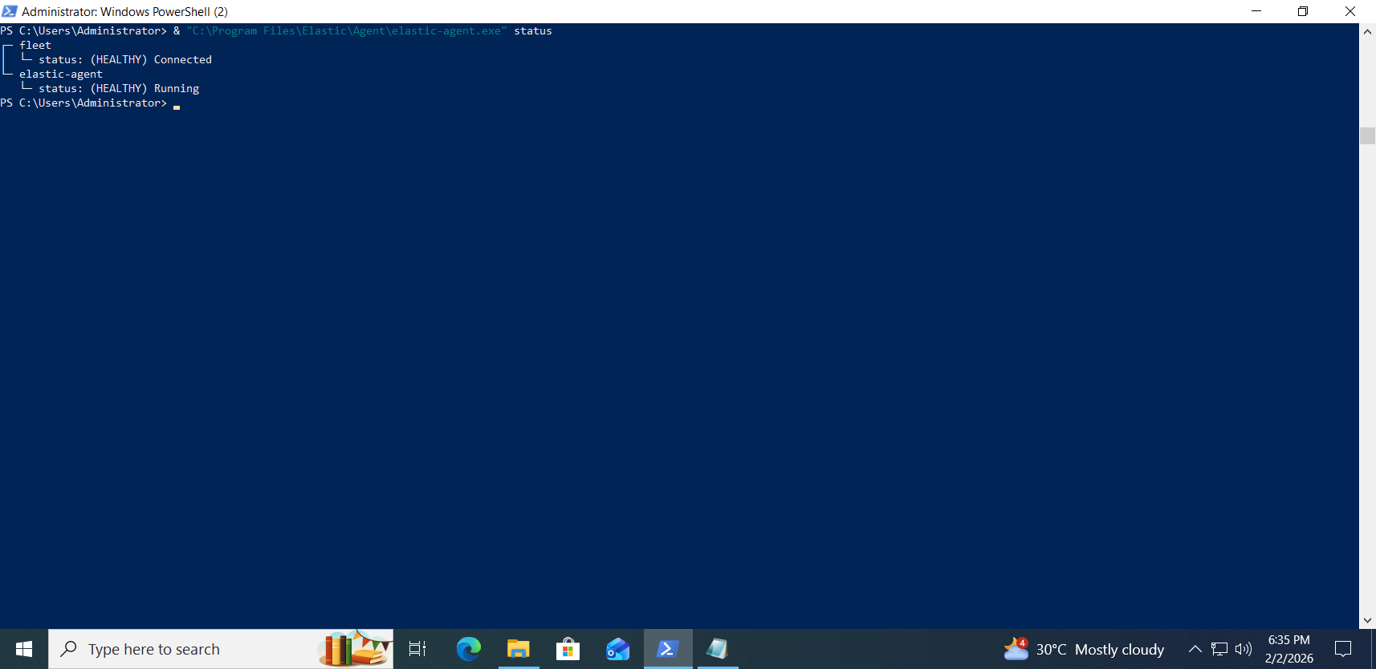

🔧 Windows Agent Error We Saw (and Fixed)

Error
open /etc/elasticsearch/certs/http_ca.crt
The system cannot find the path specified

Root cause
Fleet output referenced Linux CA path, pushed to Windows.

Fix
- Remove Linux CA path from Fleet output
- Use:
  - CA fingerprint OR
  - Windows-safe CA distribution
- Restart agent

B5️⃣ Verify Telemetry (HARD GATE – DO NOT SKIP)
Rule:
If data is not visible in Discover, EDR is NOT working, regardless of UI status elsewhere.
Discover is the ground truth. Everything else is derived.

1️⃣ Open Discover (Raw Data View)
Path:
Kibana → Discover
Set:
- Data view: logs-*
- Time range: Last 15 minutes (or Today)
If Discover shows zero documents, stop immediately — the agent is not sending data.

2️⃣ Basic Endpoint Presence Check (Required)
Run this KQL:
agent.type : "endpoint"
Expected result
- Documents returned
- Fields like:
  - agent.id
  - agent.name
  - agent.version
  - data_stream.dataset : endpoint.events.*
This confirms:
- Elastic Agent is enrolled
- Elastic Defend integration is active
- Endpoint is sending security telemetry
If this query returns no results, EDR is not active.

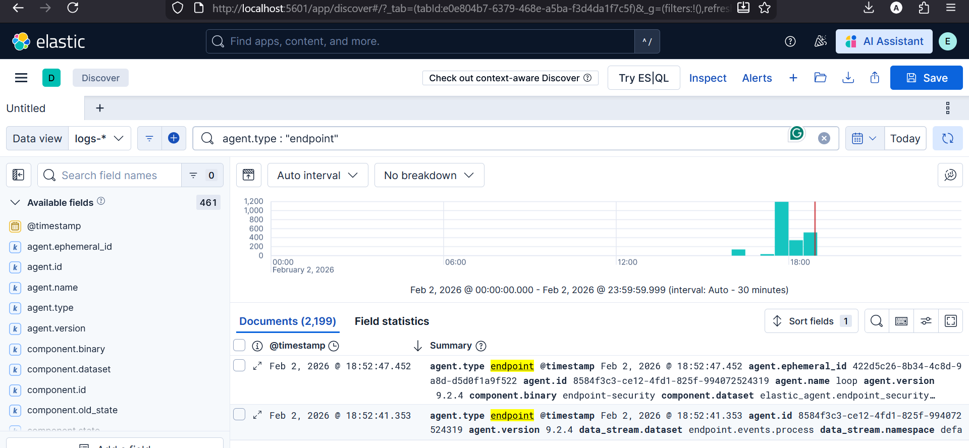

3️⃣ Validate Core EDR Event Types (Authoritative)
Run these one by one in Discover:

Process events
data_stream.dataset : "endpoint.events.process"

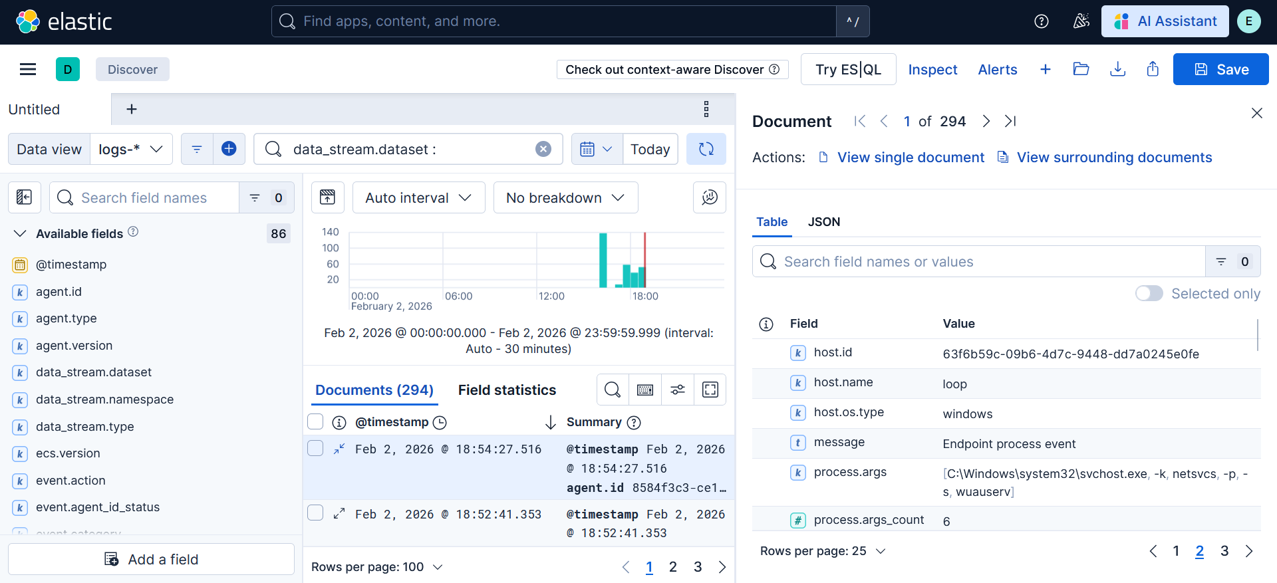

File activity
data_stream.dataset : "endpoint.events.file"

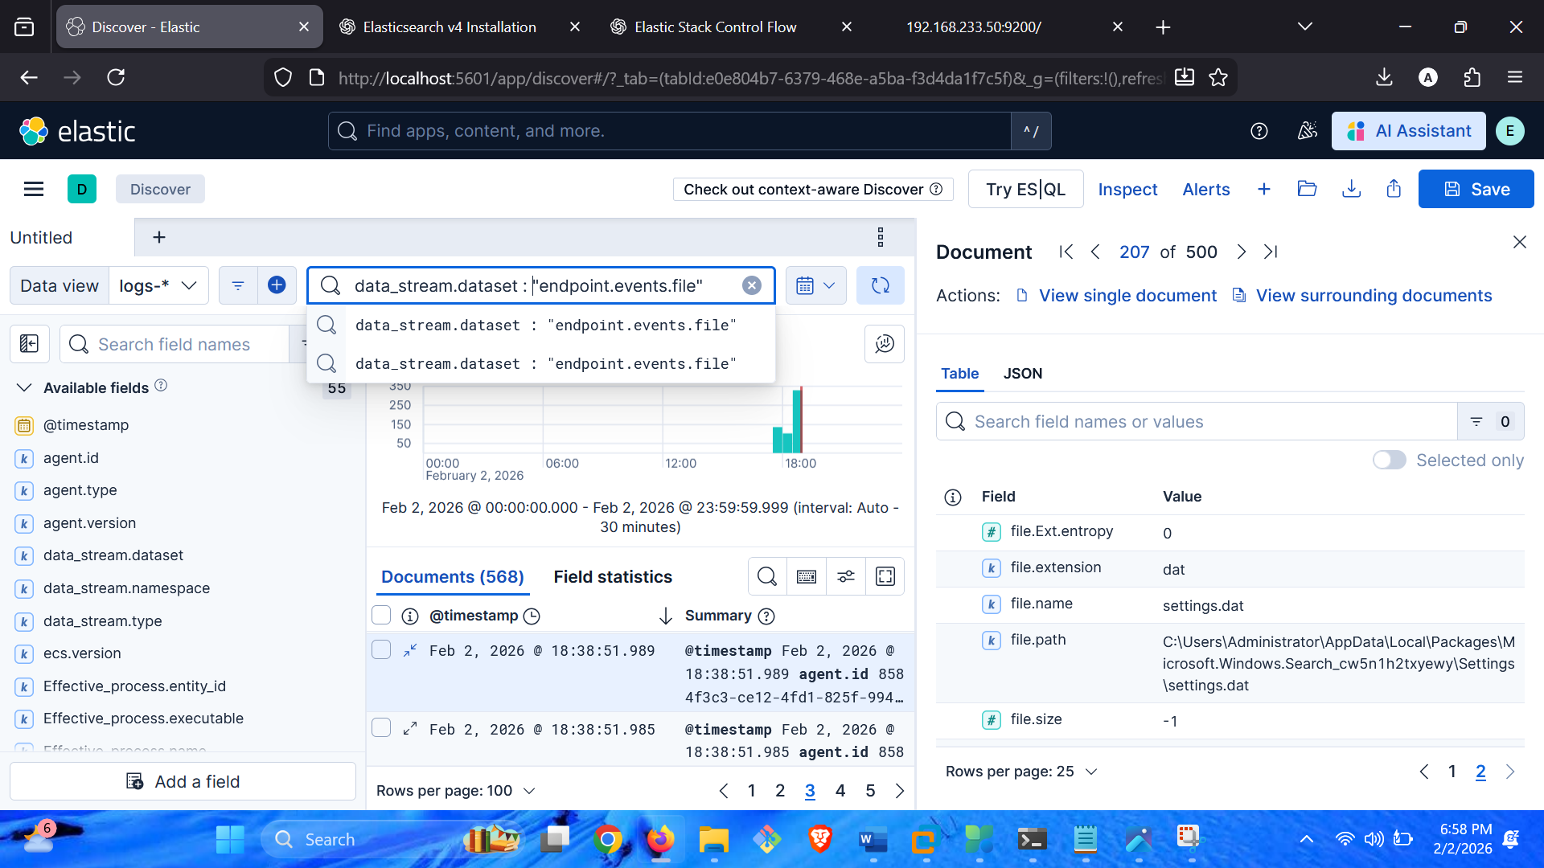

Network activity
data_stream.dataset : "endpoint.events.network"

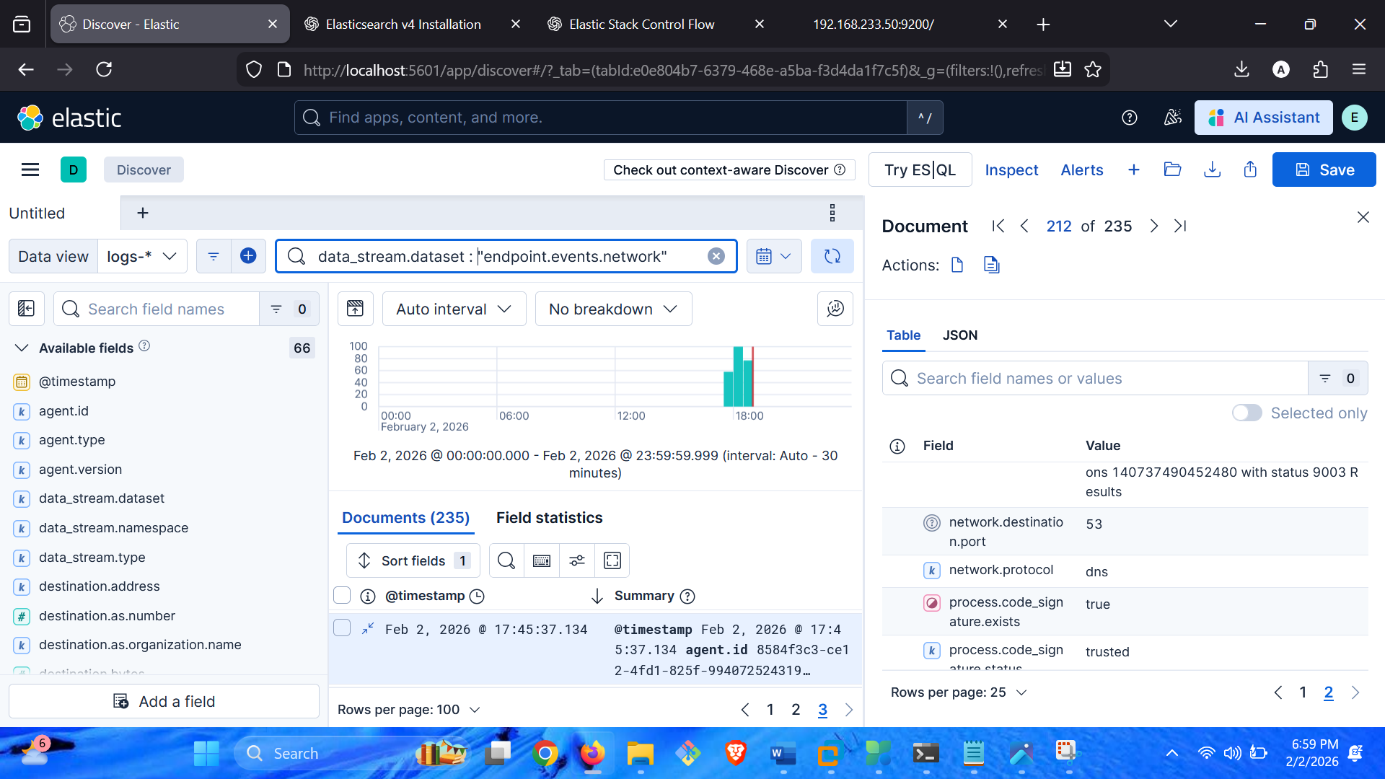
Expected
- Continuous events
- Timestamps updating
- Real endpoint activity reflected
This proves the endpoint sensor is functioning.

4️⃣ What NOT to Use (Beginner Trap)
❌ Do not rely on:
- “Agent is running” in Windows services
- Fleet = Connected
- Security dashboards loading
- Rules / Alerts pages
Those can work without telemetry.

5️⃣ If Discover Shows NO Endpoint Events — STOP
Do not proceed to detections.
Common causes:
- Wrong agent policy
- Elastic Defend integration missing
- Fleet output misconfigured
- TLS / CA issues
- Agent enrolled but not receiving policy
Fix telemetry before trusting anything else.

✅ Final Success Criteria (Only This Matters)
You are done only when:
- ✔ agent.type : "endpoint" returns data
- ✔ endpoint.events.process visible
- ✔ endpoint.events.file visible
- ✔ endpoint.events.network visible
- ✔ Events are recent and continuous
At this point:
Elastic Defend is operational. EDR detections now have meaning.

FINAL CONCLUSION
This lab was intentionally designed to move you beyond installation-level success and into operational understanding of Elastic Security as an EDR platform.
If you completed this guide correctly, you did not just deploy software. You built and validated a full EDR pipeline, end to end:
- A correctly isolated control plane (Elasticsearch, Kibana, Fleet Server)
- A properly instrumented endpoint with high-fidelity telemetry
- A verification process grounded in raw data, not UI indicators
You learned that:
- EDR effectiveness depends on telemetry first, not alerts
- “Agent healthy” does not mean “EDR working”
- Fleet and Kibana configuration errors silently break every endpoint
- Discover is the ground truth for security validation
- TLS, permissions, and version alignment matter more than installers
Most importantly, you now understand why Elastic behaves the way it does:
- Why agents fail even when they install successfully
- Why backend misconfiguration is the root cause of most EDR issues
- Why enterprise SOCs validate detections from raw events upward
This mindset is what separates:
- Tool users from security analysts
- Demo labs from production reality
- UI-driven confidence from data-driven certainty
If your lab meets the final success criteria—continuous process, file, and network events visible in Discover—then Elastic Defend is operational, and detections have real investigative value.
If it does not, the lab has correctly shown you where your understanding or configuration is incomplete.
That outcome is intentional.
At this point, you are ready to:
- Investigate alerts using timelines and raw events
- Decide when no response is the correct response
- Identify missing telemetry instead of trusting dashboards
- Reason about EDR behavior the way a real SOC analyst does
This guide did not aim to make Elastic “work.”
It aimed to make you understand EDR.

