🔬 EFFECTIVE SOC LAB — Firewall + Endpoint + Attacker

🎯 Objective
To detect, analyze, and correlate firewall activity involving:
- inbound attacks
- blocked scans
- allowed outbound traffic
across Windows endpoint + Linux server + attacker system.
This lab proves you understand network + host context, not just logs.

🧱 Lab Architecture
Kali Linux (Attacker)
|
v
Ubuntu Server (Firewall + Logs)
|
v
Windows 11 (Endpoint / Client)
Ubuntu = control + visibility
Windows = real user system
Kali = threat actor

🔧 Pre-Lab Setup (MANDATORY)

Ubuntu Server
sudo ufw enable ufw(Uncomplicated Firewall)
sudo ufw logging on
sudo ufw logging medium
sudo ufw allow ssh
sudo ufw allow from <WINDOWS_IP>

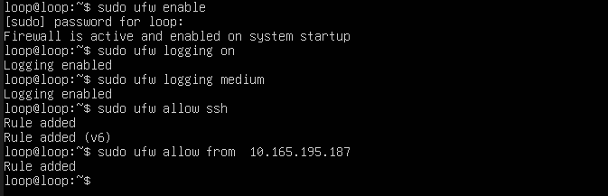
Logs here:
/var/log/syslog

Windows 11
- Ensure Windows Defender Firewall is ON
- Note Windows IP:
ipconfig

Kali Linux
Ensure the tool is available:
nmap

LAB 1️⃣ — Inbound Attack (Kali → Ubuntu)

🎯 Goal
Detect external scan & blocked traffic.

From Kali
nmap -p 1-200 <UBUNTU_IP>

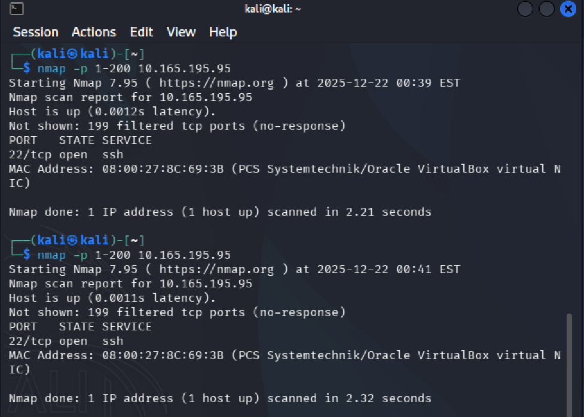

On Ubuntu
sudo tail -f /var/log/syslog

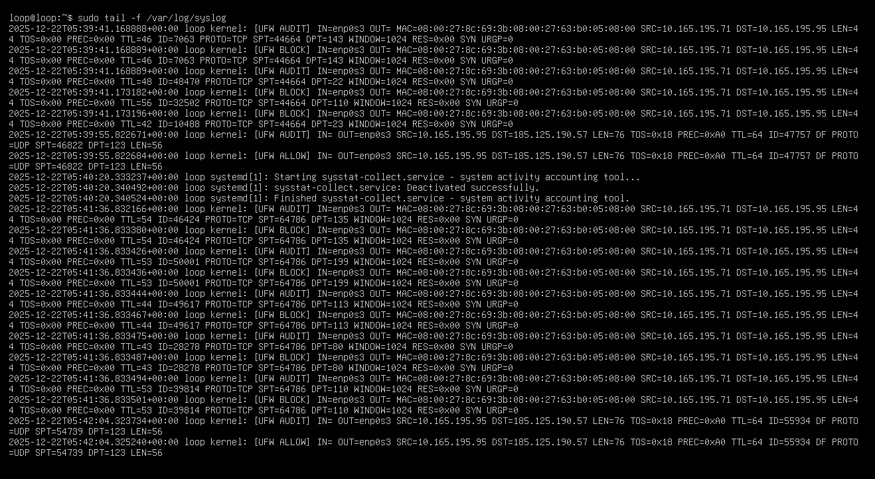

Evidence Seen
UFW BLOCK IN
SRC=<KALI_IP>
DST=<UBUNTU_IP>
DPT=22 / 80 / 443
PROTO=TCP

SOC Meaning
- One source
- Many destination ports
- Mostly BLOCK
➡ Port scanning

LAB 2️⃣ — Legitimate Access (Windows → Ubuntu)

🎯 Goal
Differentiate normal allowed traffic from attack traffic.

From Windows 11 (PowerShell)
ssh <ubuntu_user>@<UBUNTU_IP>

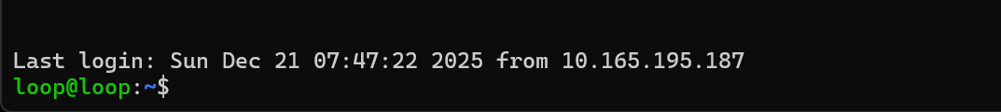

On Ubuntu logs
UFW ALLOW IN
SRC=<WINDOWS_IP>
DST=<UBUNTU_IP>
DPT=22
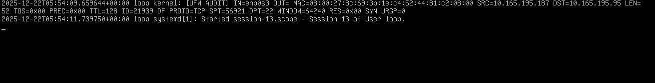

SOC Meaning
- Known internal source
- Single service
- Allowed
➡ Normal business access

LAB 3️⃣ — Outbound Traffic (Ubuntu → Internet)

🎯 Goal
Understand allowed outbound traffic (malware-style).

On Ubuntu
curl http://example.com
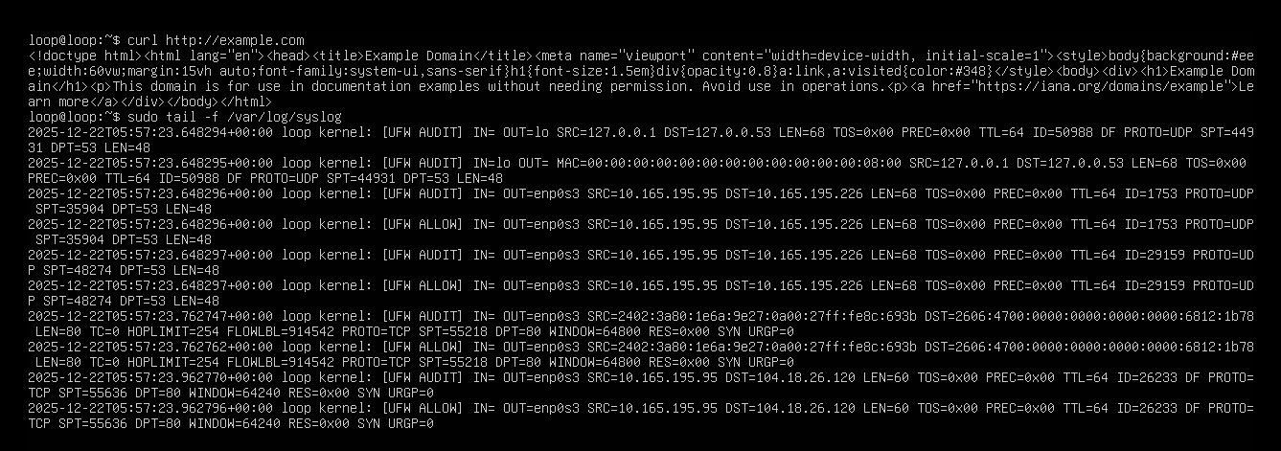
Logs
UFW ALLOW OUT
SRC=<UBUNTU_IP>
DST=<EXTERNAL_IP>
DPT=80

SOC Meaning
⚠️ Allowed outbound ≠ safe
This is how C2 traffic hides

LAB 4️⃣ — Windows Endpoint Traffic (Windows → Internet)

🎯 Goal
Prove endpoint-initiated traffic.

On Windows
Open browser → any website
(Optional)
ping 8.8.8.8

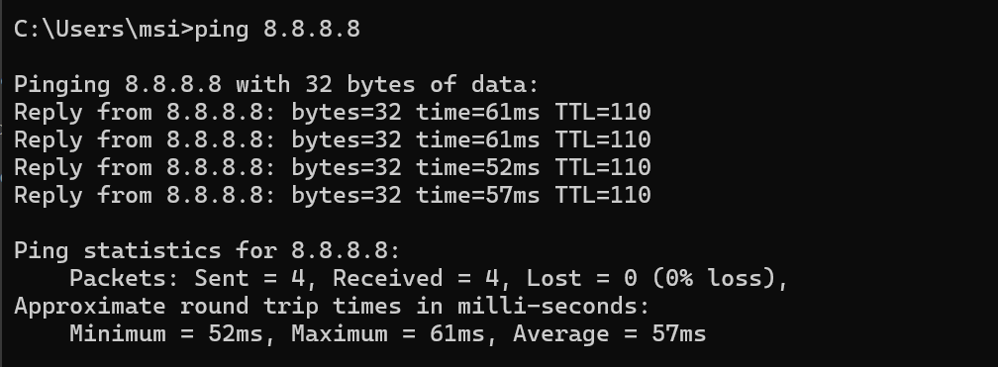

Observation
- Ubuntu firewall does NOT log
- Traffic never touched Ubuntu

SOC Insight
Firewalls only log what passes through them
This proves visibility boundaries.

LAB 5️⃣ — Correlation Thinking (KEY LAB)
Answer these from evidence:
Question | Answer
Who scanned Ubuntu? | Kali
Which traffic was blocked? | Scan
Which traffic was allowed? | Windows SSH
Which traffic is risky despite allow? | Outbound HTTP
Which system is victim? | Ubuntu
Which system is endpoint? | Windows

🔎 Detection Logic
- If one source → many ports → BLOCK
→ scanning
- If known internal IP → single port → ALLOW
→ normal
- If repeated ALLOW outbound → same external IP
→ investigate C2

✅ Full Lab Conclusion
This lab demonstrated how a SOC analyst:
- Differentiates attack traffic vs legitimate traffic
- Uses firewall logs with context
- Understands endpoint vs server visibility
- Treats allowed outbound traffic as high-risk
- Correlates activity across attacker, firewall, and endpoint
This setup reflects real SOC investigations, not isolated labs.

