SOC LAB — DNS Query/Response Basics & DNS Abuse Patterns

1. Objective
To understand normal DNS query/response behavior and identify common DNS abuse patterns used by attackers, from a SOC analyst perspective.
This lab focuses only on DNS to isolate signals before correlating with other protocols.

2. Lab Environment
Component | Details
Host OS | Windows 11
Attacker / Observer | Kali Linux
Network | Local network (default DNS resolver)
Tools | nslookup, bash
No dedicated DNS server was deployed. This reflects real SOC scenarios where analysts observe DNS activity generated by endpoints using enterprise or ISP resolvers.

3. DNS Concepts Covered
- DNS query and response flow
- NXDOMAIN responses
- Query frequency analysis
- High-entropy (random) domain detection
- TXT record awareness

4. Lab Exercises & Observations

Lab 1 — Normal DNS Resolution (Baseline)
Action
DNS queries were performed for well-known domains.
Commands
nslookup google.com
nslookup microsoft.com

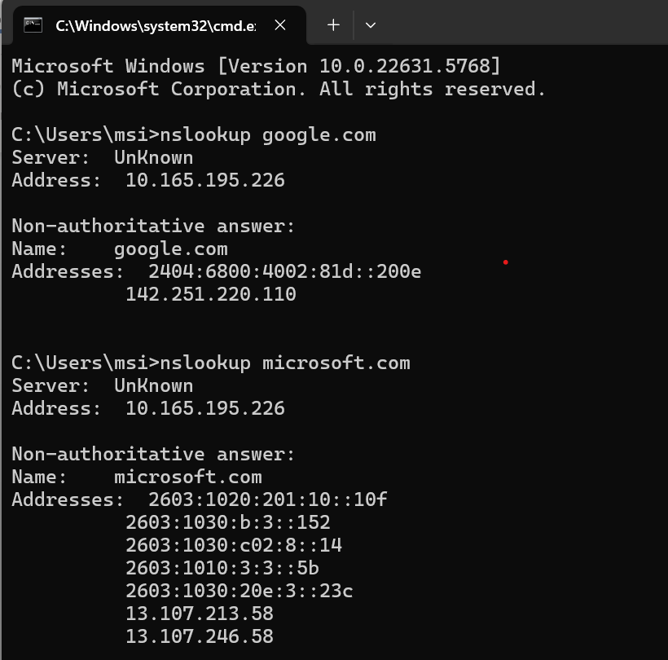

Observations
- DNS responses were successful
- Domains were human-readable
- Resolution was fast
- No errors returned
SOC Interpretation
Successful DNS resolution for known domains represents baseline, expected behavior.

Lab 2 — NXDOMAIN Responses
Action
DNS query was performed for a non-existent domain.
Command
nslookup thisdomainshouldnotexist123456.com

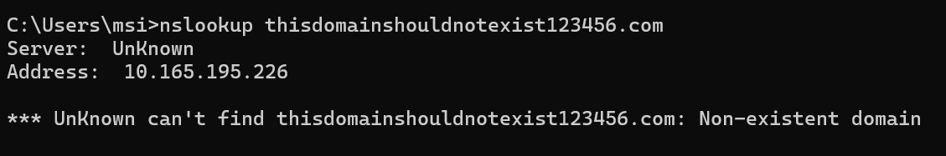

Observations
- DNS response returned NXDOMAIN
- No IP address resolved
SOC Interpretation
- Occasional NXDOMAIN responses are normal (user typos)
- Repeated NXDOMAIN responses may indicate malware using DGA techniques

Lab 3 — Repetitive DNS Queries (Beaconing Simulation)
Action
Repeated DNS queries were generated at fixed intervals.
Command
for i in {1..10}; do nslookup google.com; sleep 2; done

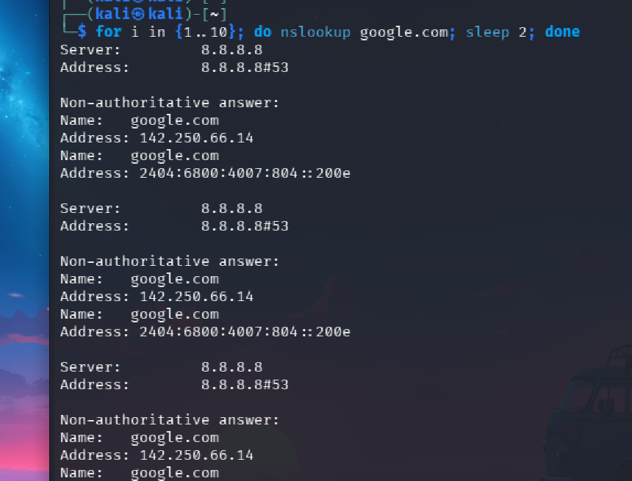
Observations
- Same domain queried repeatedly
- Fixed time interval between queries
SOC Interpretation
Repetitive DNS queries at consistent intervals may indicate beaconing behavior, even if the domain itself is benign.

Lab 4 — High-Entropy Domain Queries (DGA Simulation)
Action
Random domain names were generated and queried.
Command
for i in {1..10}; do
domain=$(head /dev/urandom | tr -dc a-z0-9 | head -c 15)
nslookup $domain.com
done

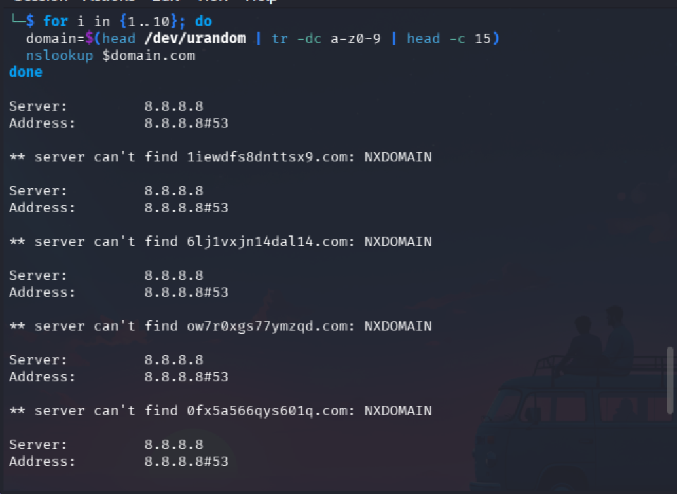

Observations
- Domains were random and non-human-readable
- Majority of responses returned NXDOMAIN
SOC Interpretation
High volumes of random-looking domain queries with NXDOMAIN responses strongly indicate Domain Generation Algorithm (DGA) activity.
MITRE Mapping
- T1568 — Domain Generation Algorithms

Lab 5 — TXT Record Awareness
Action
TXT record queries were performed on legitimate domains.
Commands
nslookup -type=TXT google.com

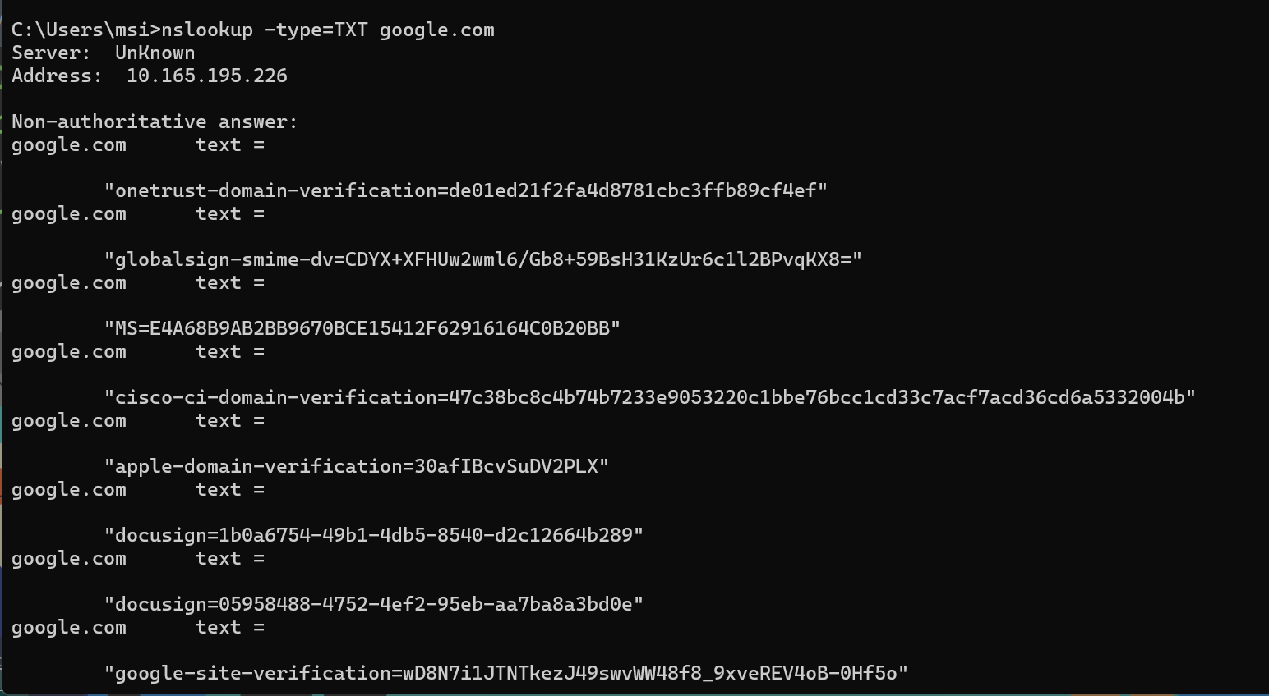
Observations
- TXT records were present and legitimate
- Records contained verification and policy data
SOC Interpretation
TXT records are commonly abused by attackers for DNS-based C2 or data exfiltration, making their frequency and size important indicators.

5. SOC Detection Logic (Key Takeaways)

High-Signal DNS Indicators
- High NXDOMAIN response rate
- Random or high-entropy domain names
- Repetitive DNS queries at fixed intervals
- Excessive use of TXT records
- DNS activity occurring before suspicious network connections

6. If–Then Detection Rules
- If a host generates many NXDOMAIN responses with random domains
Then suspect DGA-based malware activity
- If a host queries the same domain at fixed time intervals
Then suspect DNS beaconing behavior
- If TXT record queries are unusually frequent or large
Then investigate possible DNS tunneling

7. Conclusion
This lab demonstrated that DNS activity provides early indicators of compromise, often before payload delivery or command-and-control communication.
Understanding DNS behavior allows SOC analysts to detect malicious activity

