SOC LAB — HTTP Basics, Headers & Common Web Indicators

1. Objective
To analyze HTTP request and response behavior, understand HTTP headers, and identify common web indicators of malicious activity from a SOC analyst perspective.
This lab focuses only on HTTP traffic, without DNS or HTTPS correlation, to isolate web-layer signals.

2. Lab Environment
Component | Details
Client / Attacker | Kali Linux
Endpoint / Network | Windows 11 (Host OS)
Protocol | HTTP
Tools | curl

3. HTTP Concepts Practiced
- HTTP request–response model
- HTTP methods (GET, POST)
- HTTP headers (Host, User-Agent, Content-Type)
- HTTP status codes
- Common malicious web indicators

4. Lab Exercises & Observations

Lab 1 — Normal HTTP GET Request (Baseline)
Action
A standard HTTP GET request was generated to establish baseline web traffic.
Command
curl -v http://example.com


Observations
- HTTP method: GET
- Valid Host header
- Browser-like User-Agent
- Status code: 200 OK
SOC Interpretation
Normal web browsing traffic used as a baseline for anomaly detection.

Lab 2 — HTTP Header Visibility
Action
HTTP response headers were inspected to identify metadata available to SOC tools.
Command
curl -I http://example.com
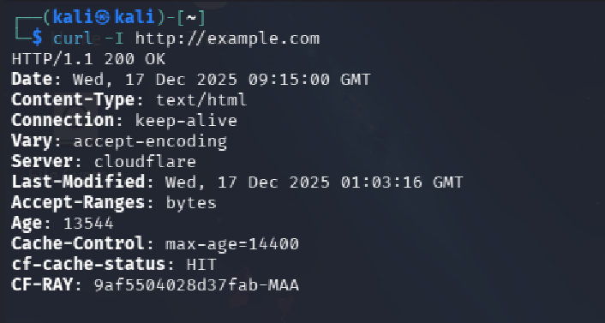
Observed Headers
- Server
- Content-Type
- Content-Length
- Date
SOC Interpretation
HTTP headers provide critical visibility into content type, server behavior, and response characteristics.

Lab 3 — User-Agent Analysis
Action
HTTP requests were generated using different User-Agent strings.
Commands
curl -A "Mozilla/5.0 (Windows NT 10.0; Win64; x64)" http://example.com
curl -A "curl/7.81.0" http://example.com
curl -A "" http://example.com

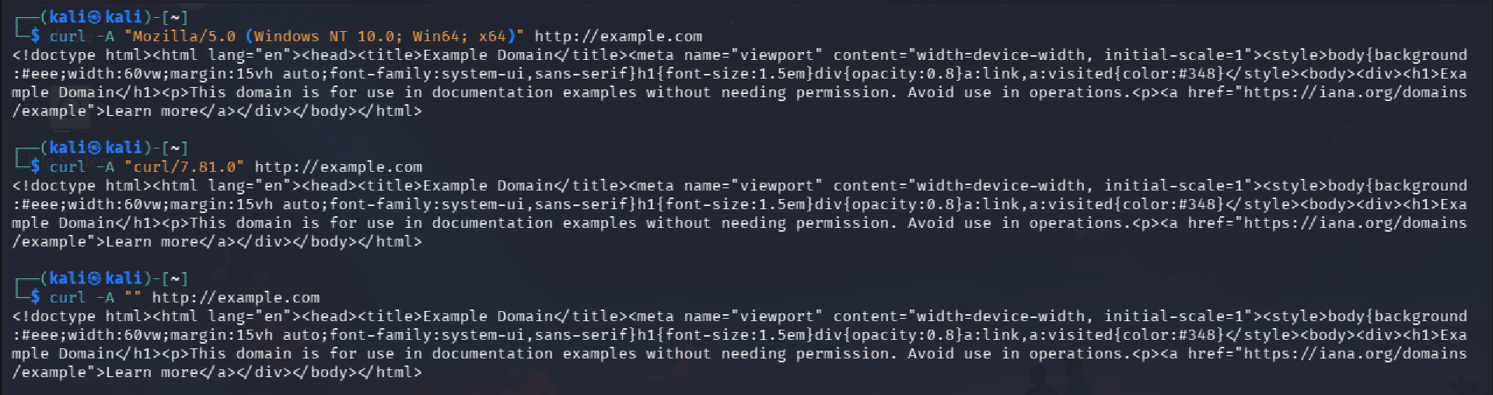
Observations
- Browser-like User-Agent appeared normal
- Script-based or empty User-Agent appeared abnormal
SOC Interpretation
Malware and automated tools often use generic or missing User-Agent values, making this a high-confidence indicator.

Lab 4 — HTTP POST Request (Data Submission)
Action
A POST request was sent to simulate data transmission over HTTP.
Command
curl -X POST -d "user=test&pass=test" http://httpbin.org/post

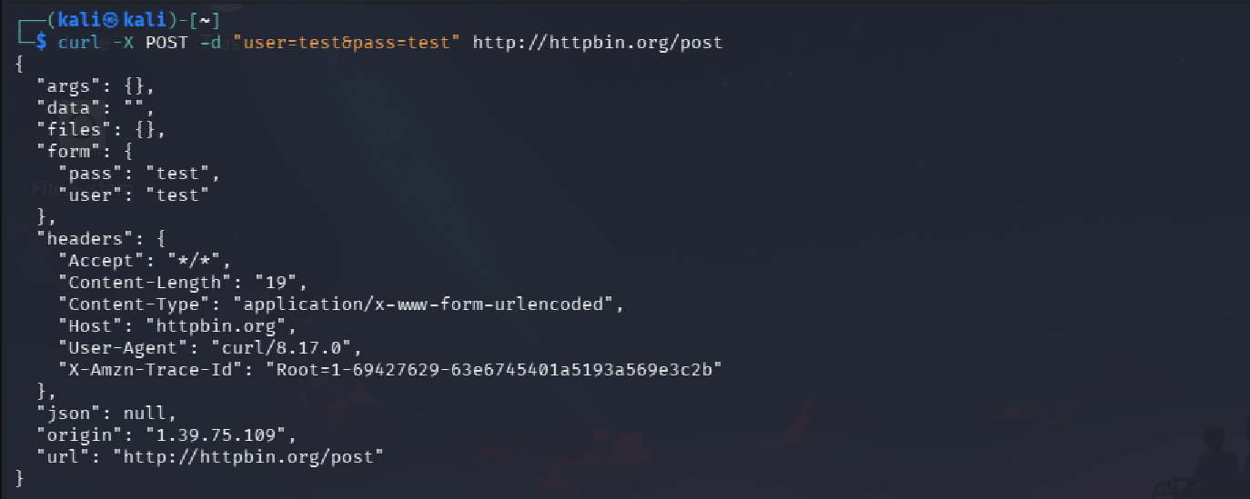
Observations
- HTTP method: POST
- Data transmitted in request body
- Server response echoed submitted data
SOC Interpretation
Unexpected or repetitive POST requests without user interaction may indicate C2 communication or data exfiltration.

Lab 5 — Suspicious URI Patterns
Action
Requests were sent to generic and suspicious-looking URI paths.
Commands
curl http://example.com/update.php
curl http://example.com/gate.php
curl http://example.com/.hidden/

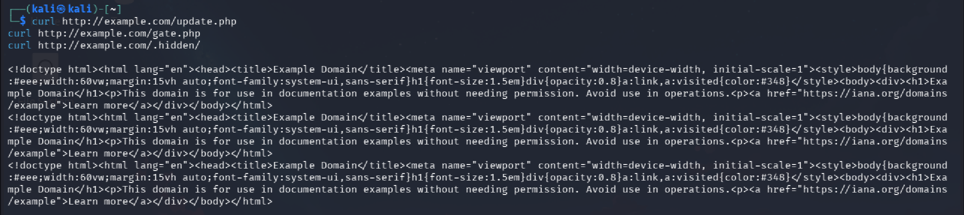
Observations
- Generic file names
- Mixed status codes (200 / 404)
SOC Interpretation
Malware and web shells commonly use non-descriptive or hidden URI paths.

Lab 6 — HTTP Status Code Awareness
Action
HTTP responses with different status codes were observed.
Commands
curl -I http://example.com/notfound
curl -I http://github.com

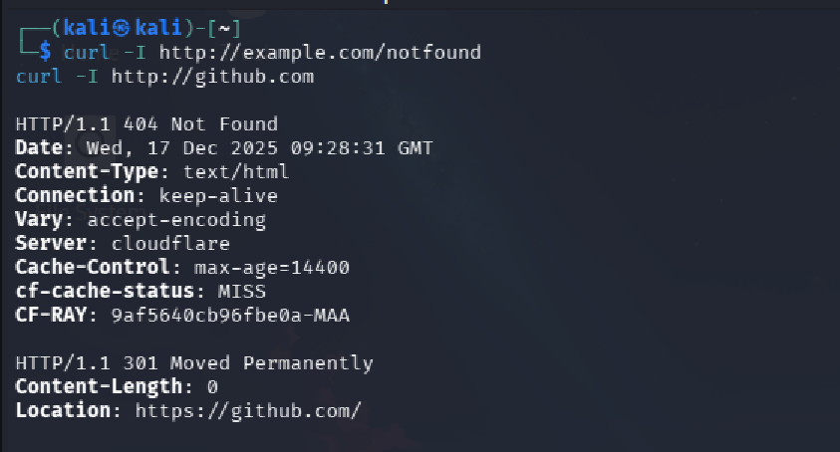
Observations
- 404 Not Found
- 301 / 302 Redirect
SOC Interpretation
- Repeated 404 responses may indicate reconnaissance or scanning
- Redirect chains are often associated with phishing or tracking activity

Lab 7 — Repetitive HTTP Requests (Beacon Simulation)
Action
Repeated HTTP requests were generated at fixed intervals.
Command
for i in {1..10}; do curl -s http://example.com > /dev/null; sleep 3; done

for i in {1..3}; do
curl -s http://example.com
sleep 3
done
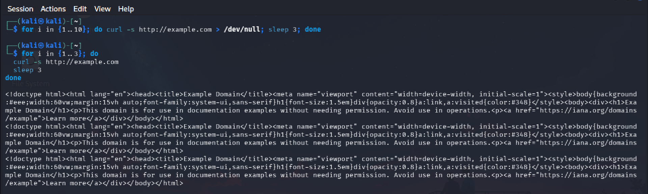
Observations
- Identical requests
- Fixed time intervals
- No user interaction
SOC Interpretation
Periodic HTTP requests indicate beaconing behavior commonly used by malware.

Lab 8 — Content-Type Awareness
Action
HTTP responses were inspected for Content-Type values.
Commands
curl -I http://httpbin.org/xml
curl -I http://httpbin.org/image/png
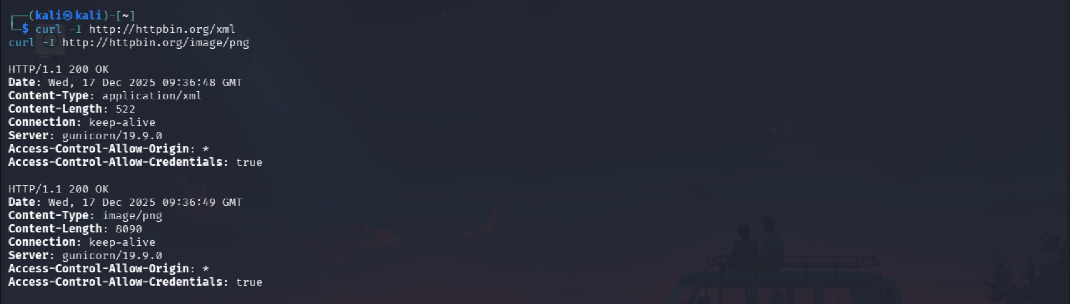
Observations
- Content-Type accurately reflected returned data
SOC Interpretation
SOC analysts validate Content-Type, not file extensions, to detect disguised payloads.

5. SOC Detection Logic (Key Indicators)
- Empty or script-based User-Agent strings
- Repetitive HTTP requests at fixed intervals
- Unexpected POST requests
- Suspicious or generic URI paths
- Abnormal HTTP status code patterns

6. If–Then Detection Rules
- If HTTP requests contain empty or tool-based User-Agent strings
Then flag for suspicious automated activity
- If a host sends repetitive HTTP requests at consistent intervals
Then suspect HTTP-based beaconing
- If POST requests occur without user interaction
Then investigate potential C2 or data exfiltration

7. SOC Conclusion
This lab demonstrated that HTTP traffic provides strong behavioral indicators that allow SOC analysts to distinguish between legitimate user activity and automated or malicious communication.
Understanding HTTP headers, request patterns, and status codes is critical for detecting malware delivery, C2 communication, and web-based abuse.

