🔬 SOC LAB — Linux Logging (Ubuntu Server + kali/windows 11

🎯 Objective
To generate and analyze Linux authentication, privilege escalation, and persistence logs using native log sources (auth.log, syslog, journalctl) from a SOC analyst perspective.

🧱 Lab Environment
- Victim: Ubuntu Server
- Attacker: Kali Linux/Windows 11
- Access: SSH
- Logs:
  - /var/log/auth.log
  - /var/log/syslog
  - journalctl

🔧 Pre-Lab Validation
On Ubuntu Server, verify logging is available:
ls /var/log/auth.log
ls /var/log/syslog
journalctl --no-pager | head
systemctl status ssh
If SSH is not running:
sudo systemctl enable ssh / install it
sudo systemctl start ssh

LAB 1 — SSH Failed Login Attempts

Objective
Detect failed authentication attempts.

Action (Kali)
ssh fakeuser@<UBUNTU_IP>
Enter wrong password 3–5 times.
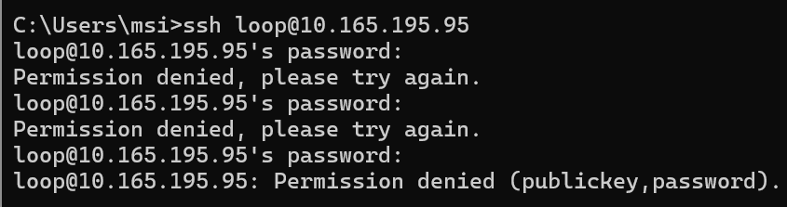

Observation (Ubuntu)
sudo tail -f /var/log/auth.log
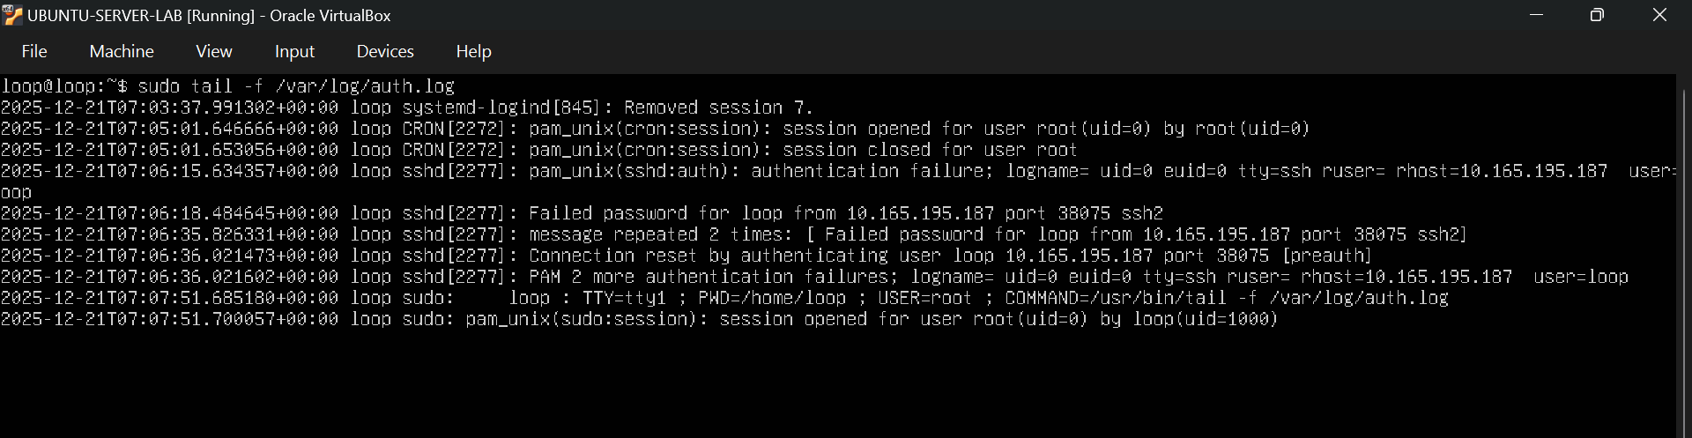

Evidence
- Failed password
- Invalid user
- Source IP (Kali)

LAB 2 — SSH Successful Login

Objective
Observe successful authentication.

Action (Kali)
ssh <valid_user>@<UBUNTU_IP>
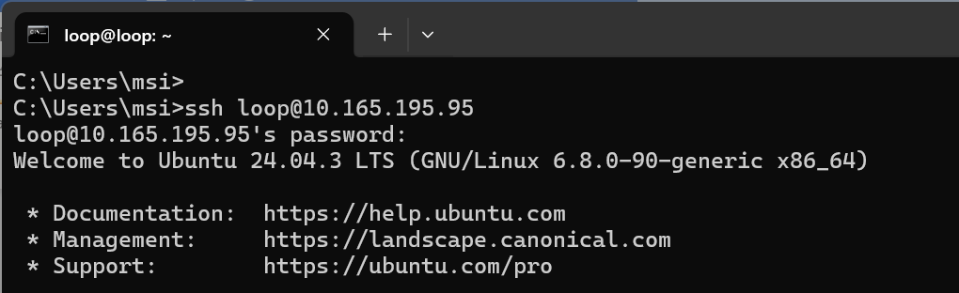

Observation (Ubuntu)
sudo tail /var/log/auth.log

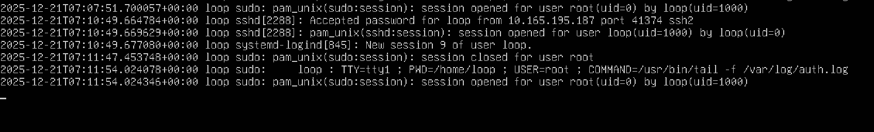

Evidence
- Accepted password or Accepted publickey
- Username
- Source IP

LAB 3 — Successful Sudo (Privilege Escalation)

Objective
Log privilege escalation activity.

Action (Ubuntu)
sudo whoami

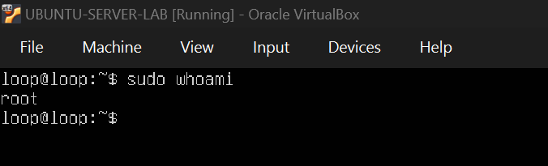

Observation
sudo tail /var/log/auth.log

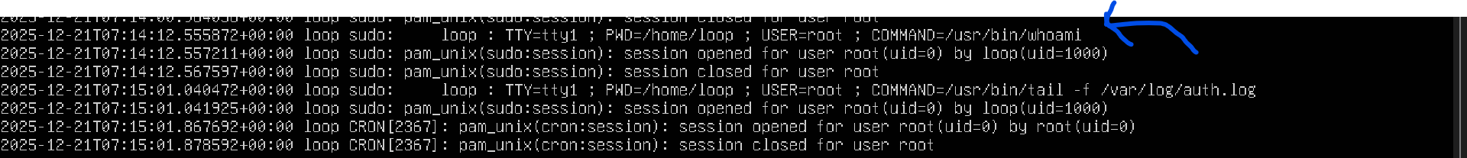

Evidence
- sudo: entry
- Command executed
- Target user = root

LAB 4 — Failed Sudo Attempts

Objective
Detect privilege probing.

Action (Ubuntu)
sudo su
Enter wrong password multiple times.
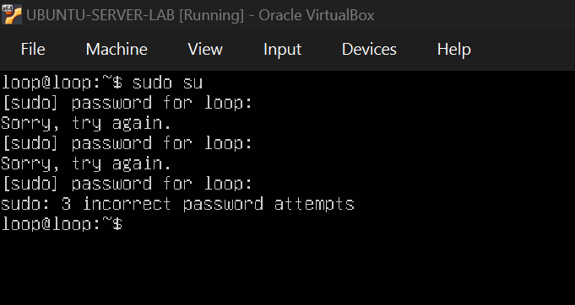

Observation
sudo tail /var/log/auth.log

Evidence
- authentication failure
- Repeated sudo failures

LAB 5 — Cron Job Creation (Persistence)

Objective
Detect persistence via scheduled tasks.

Action (Ubuntu)
crontab -e
Add:
* * * * * echo "cron-test" >> /tmp/cron_test.log
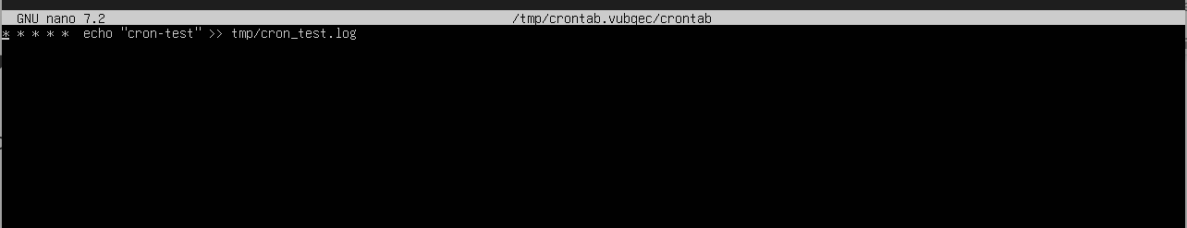

Observation
sudo tail /var/log/syslog
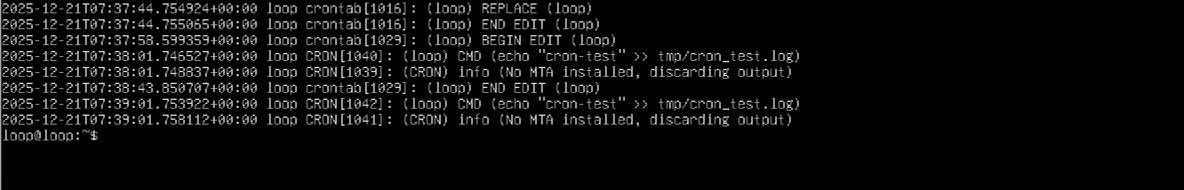

Evidence
- CRON entries
- User
- Executed command

LAB 6 — Log Correlation Using journalctl

Objective
Correlate events using systemd journal.

Action
sudo journalctl _COMM=sshd --since "30 minutes ago"
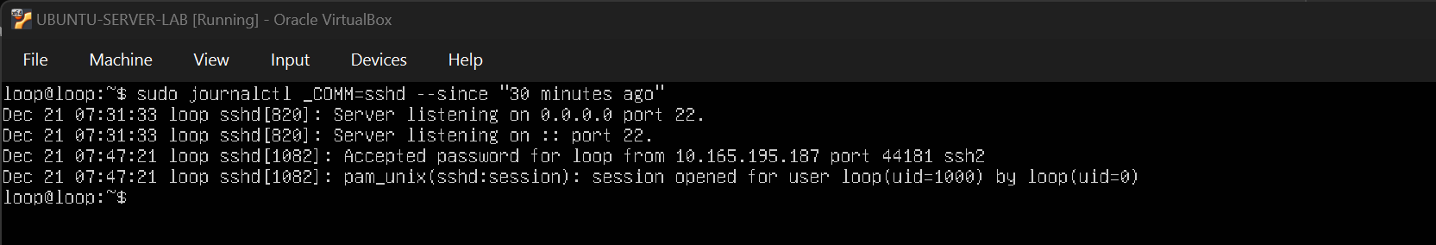

sudo journalctl _COMM=sudo --since "15 minutes ago"
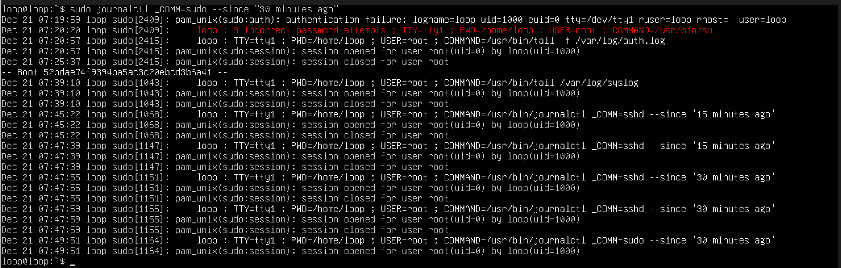

Evidence
- SSH and sudo events grouped by time
- Structured metadata (PID, user, service)

LAB 7 — Log Rotation Awareness

Objective
Identify rotated authentication logs.

Action
ls /var/log/auth.log*
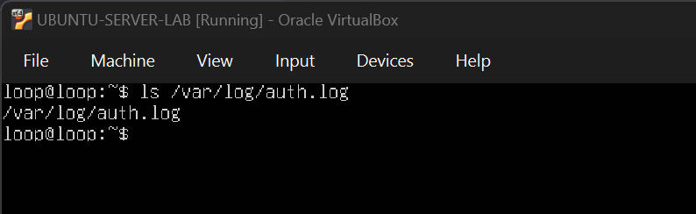

Evidence
- auth.log.1 - not
- auth.log.*.gz – not

🔹 Observation
- On the freshly installed Ubuntu Server, only the active authentication log /var/log/auth.log was present. No rotated authentication logs (auth.log.1 or auth.log.*.gz) were observed at this time.

🔹 Explanation
- Log rotation had not yet occurred because the system was newly installed and the authentication log had not reached the configured rotation threshold (time-based or size-based). Ubuntu uses logrotate to rotate logs periodically.

🔹 Awareness / SOC Insight (THIS is important)
- Although rotated logs were not yet available, older authentication events would be stored in rotated files such as /var/log/auth.log.1 and compressed archives (/var/log/auth.log.*.gz) once rotation occurs. During incident investigations, SOC analysts must always check both active and rotated logs to avoid missing historical events.

🔹 Command Used
- ls /var/log/auth.log*

🔹 Expected Files (when rotation occurs)
- /var/log/auth.log /var/log/auth.log.1 /var/log/auth.log.2.gz

Perfect. Below is the final, clean, SOC-style documentation for LAB 8 — Timeline Reconstruction, written exactly for pasting into your document / PDF / GitHub.
No explanations. No teaching. Just the lab content.

LAB 8 — Timeline Reconstruction

Objective
Reconstruct an attack sequence by correlating authentication, privilege escalation, and persistence events from system logs.

Log Sources Used
Activity | Log Source
SSH authentication events | /var/log/auth.log
Privilege escalation (sudo) | journalctl _COMM=sudo
Cron job activity | /var/log/syslog

1. First SSH Failed Login
Command Used
sudo grep "Failed password" /var/log/auth.log | head -n 1
Log Evidence
2025-12-21T07:06:18.484645+00:00 loop sshd[2277]: Failed password for loop from 10.165.195.187 port 38075 ssh2
Finding
The first SSH failed login occurred on 2025-12-21 at 07:06:18 UTC for user loop from source IP 10.165.195.187.

2. Successful SSH Login
Command Used
sudo grep "Accepted password" /var/log/auth.log | head -n 1
Log Evidence
2025-12-21T07:03:33.640459+00:00 loop sshd[2163]: Accepted password for loop from 10.165.195.187 port 10117 ssh2
Finding
A successful SSH login was recorded on 2025-12-21 at 07:03:33 UTC for user loop from source IP 10.165.195.187.

3. Sudo Usage Time (Privilege Escalation)
Command Used
sudo journalctl _COMM=sudo --since "1 hour ago"
Log Evidence
Dec 21 07:11:54 loop sudo[2357]: loop : TTY=tty1 ; PWD=/home/loop ; USER=root ; COMMAND=/usr/bin/tail -f /var/log/auth.log
Finding
The first sudo usage was observed on 2025-12-21 at 07:11:54 UTC, where user loop escalated privileges to root and executed /usr/bin/tail -f /var/log/auth.log.

4. Cron Job Creation Time (Persistence)
Command Used
sudo grep CRON /var/log/syslog
Log Evidence
2025-12-21T07:38:01.746527+00:00 loop CRON[1040]: (loop) CMD (echo "cron-test" >> /tmp/cron_test.log)
Finding
Cron job activity associated with user loop began on 2025-12-21 at 07:38:01 UTC, indicating the establishment of cron-based persistence.

Final Timeline Reconstruction
Time (UTC) | Event
07:03:33 | Successful SSH login
07:06:18 | SSH failed login attempt
07:11:54 | Privilege escalation via sudo
07:38:01 | Cron-based persistence established

Conclusion – timeline- reconstruction
The reconstructed timeline demonstrates a typical post-authentication attack sequence involving SSH access, privilege escalation using sudo, and persistence via a cron job. Correlating multiple log sources enabled accurate reconstruction of the activity sequence.

✅ Full Lab Conclusion
This lab demonstrated that native Linux logging mechanisms alone are sufficient to provide SOC-level visibility into multiple stages of an attack lifecycle, without the need for additional security tools or agents.
Through controlled attack simulation and systematic log analysis, the lab validated that common adversary techniques — including authentication abuse, privilege escalation, persistence, and post-access activity — can be reliably detected and reconstructed using default Linux log sources.
By analyzing:
- /var/log/auth.log for SSH authentication events and sudo privilege escalation,
- /var/log/syslog for scheduled task execution and cron-based persistence,
- journalctl for structured event correlation and accurate timeline reconstruction,
a SOC analyst can effectively identify malicious behavior, establish attacker intent, and reconstruct a complete sequence of events from initial access through persistence.
The timeline reconstruction exercise highlighted that context, frequency, and chronological sequencing of events are more critical than individual log entries when performing incident investigations. Correlating failed authentication attempts, successful access, privilege escalation, and persistence mechanisms provides a clear and defensible understanding of attacker behavior.
Overall, this lab reinforces the importance of log awareness, source correlation, and investigative discipline as foundational SOC skills, and demonstrates how Linux systems can be monitored and investigated effectively using native logging capabilities alone.

