🧭 WINDOWS ENDPOINT + SPLUNK

EFFECTIVE SOC INVESTIGATION ROADMAP
Tool focus: Splunk
Scope: Windows endpoint only (no AD yet)
Goal: Investigate Windows endpoint behavior with confidence (not alerts)

🔴 PHASE 0 — DATA TRUST (WINDOWS) ❗ NON-NEGOTIABLE
If this phase fails, investigation stops.

What you learn
- Windows event time vs Splunk _time
- Why Windows logs arrive late
- Why “no logs” ≠ no activity
- Why wrong sourcetype breaks everything
- Why Windows lies more than Linux

Practical checks
- Confirm Security log is generated on endpoint
- Verify ingestion into Splunk
- Compare Event Time vs _time
- Validate event breaking (1 event ≠ many lines)
- Identify correct Windows sourcetype
- Confirm logging still works after the incident window
🚫 No searching
🚫 No Event IDs
🚫 No dashboards

Outcome
You trust or reject Windows data before analysis.

STEP-BY-STEP PRACTICAL

🟥 STEP 1 — CONFIRM LOGS EXIST ON WINDOWS (GROUND TRUTH)
👉 Do this on the Windows 10 endpoint
- Open Event Viewer
- Go to
Windows Logs → Security
- Click Refresh

Check ONLY this:
- Do you see events listed?
Now do a quick action:
- Lock the screen
- Unlock / log back in
- Refresh Security log again
✅ Pass condition
- New event appears after your action
❌ If not → STOP
Splunk is irrelevant until this works.
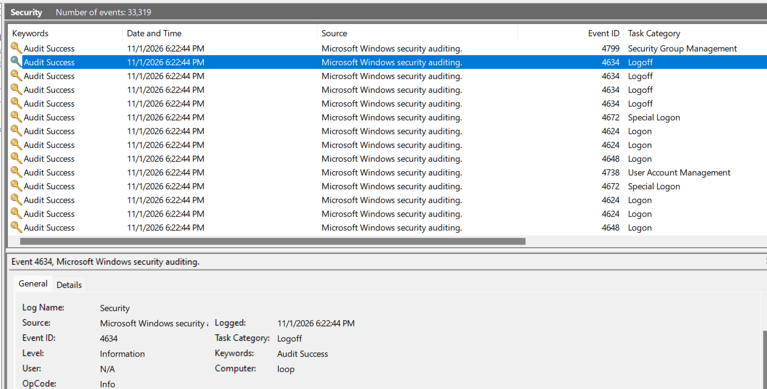

🟥 STEP 2 — CONFIRM LOGS ARRIVE IN SPLUNK (NO FILTERING)
👉 Do this in Splunk Web
- Open Search & Reporting
- Set time range to Last 24 hours
- Run only:
index=windows

Check ONLY this:
- Do you see events?
❌ If nothing appears:
- Stop
- Check forwarder / receiving port
- Do NOT investigate
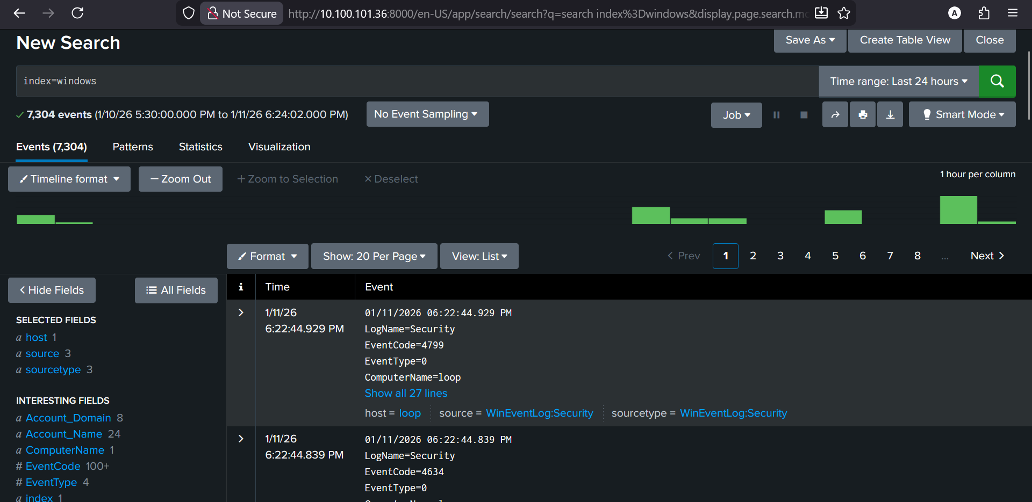

🟥 STEP 3 — IDENTIFY THE SOURCETYPE (CRITICAL)
- Click one event
- Expand it fully

Look for:
sourcetype = WinEventLog:Security
✅ Pass
- Exactly WinEventLog:Security
❌ Fail
- Generic sourcetype
- Wrong channel
If fail → parsing is broken → STOP.

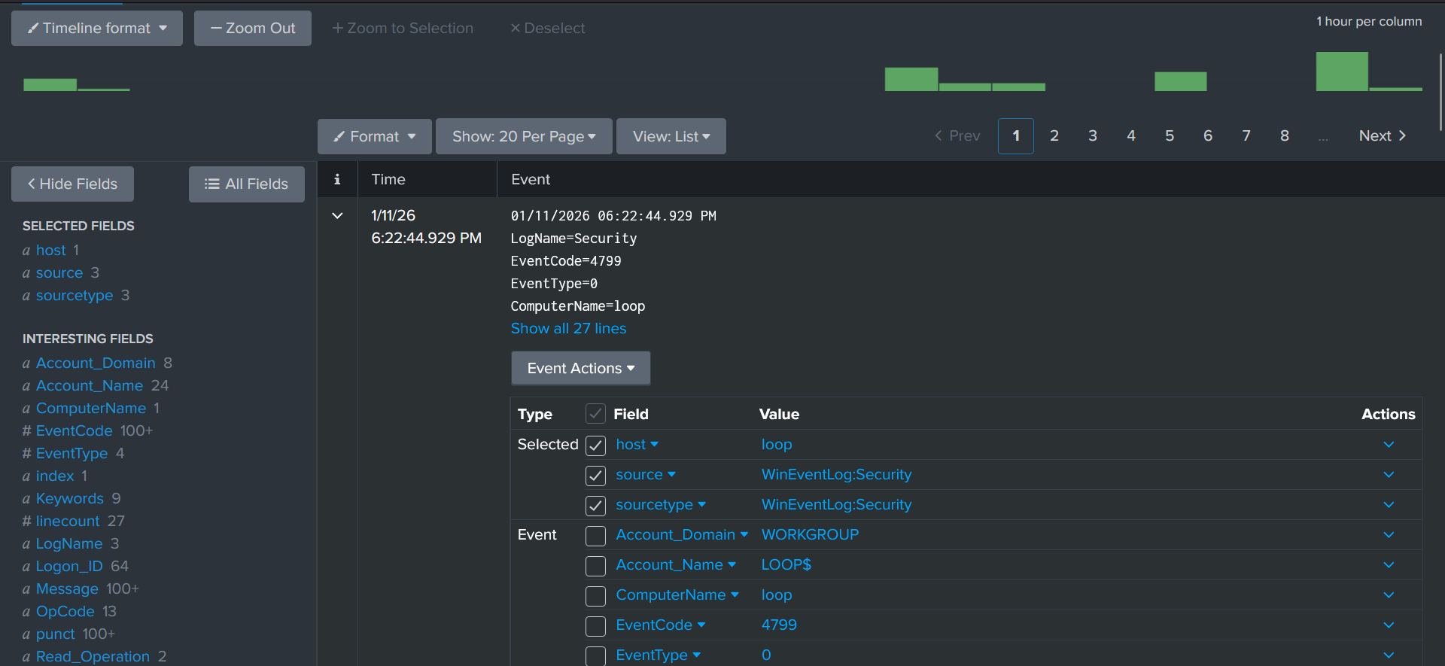

🟥 STEP 4 — EVENT TIME vs SPLUNK _time
In the same expanded event:

Compare:
- Event time shown in the raw message
- _time field in Splunk
✅ Acceptable
- Few seconds difference
- Small consistent delay
❌ Fail
- Minutes or hours difference
- Events clearly out of order

If fail → timelines will lie → STOP.

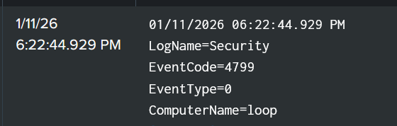

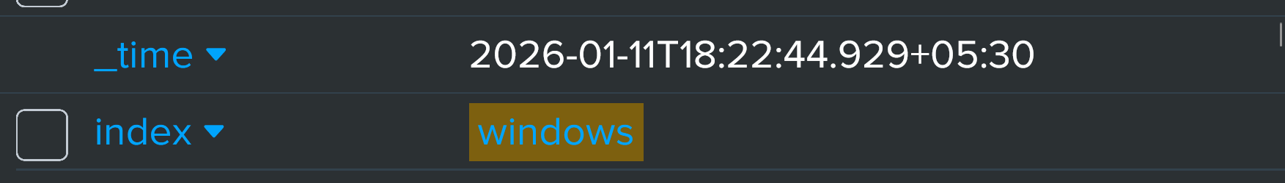

🟥 STEP 5 — VALIDATE EVENT BREAKING
Still in the same event:

Confirm:
- One Windows Security event
= one Splunk event
❌ Red flags:
- Multiple Windows events merged
- One event split into many
If breaking is wrong → STOP.

🟥 STEP 6 — CONFIRM REQUIRED FIELDS EXIST
In the expanded event, confirm you can see:
- EventCode
- ComputerName
- TargetUserName
- LogonType
- IpAddress (may be empty)
❌ If fields missing:
- Evidence layer is broken
- Investigation will fail

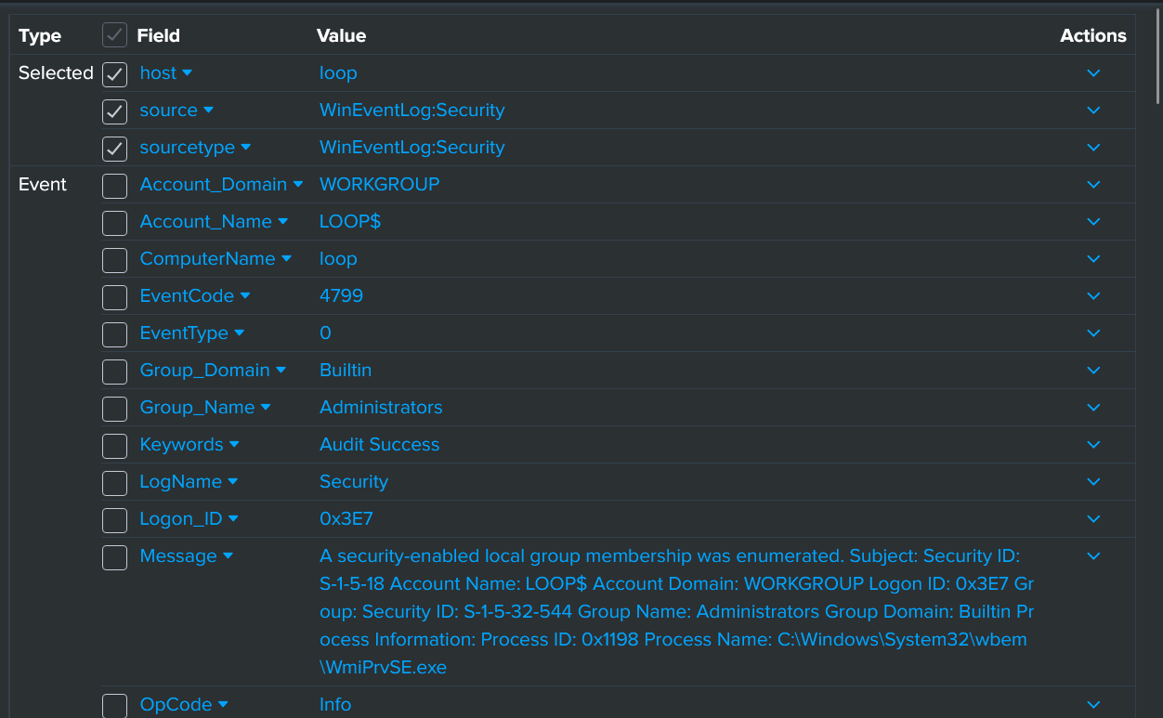

🟥 STEP 7 — CONFIRM LOGGING CONTINUES (NO DEAD ZONES)
Change time range:
- Last 15 minutes
- Last 1 hour
- Last 24 hours

Check:
- Events appear in all ranges
- No long silent gaps
This ensures:
Logging didn’t silently stop: checked all time windows

🟥 STEP 8 — FINAL DATA TRUST DECISION
Answer YES or NO to this sentence:
“I trust Windows Security logs enough to reconstruct a timeline.”
If NO → do not proceed
If YES → Phase 0 passed

🔥 PHASE A — WINDOWS LOG REALITY (TIME & NOISE)
Windows looks quiet when it’s not.

What you learn
- Why Windows logs are extremely noisy
- Why default time ranges hide behavior
- Why “Last 15 minutes” is dangerous
- Why silence can be false

Practical
- Search only:
- index=windows
- Compare:
  - 15 minutes
  - 1 hour
  - 24 hours
- Observe:
  - bursts
  - gaps
  - delayed indexing
  - sudden silence

Outcome
You stop trusting “quiet Windows”.

STEP-BY-STEP PRACTICAL

🟥 STEP 1 — OPEN A CLEAN VIEW
👉 In Splunk → Search & Reporting
- Set Time Range = Last 24 hours
- Run ONLY this search:
index=windows

Do NOT:
- add filters
- click Event IDs
- scroll fast

Just answer this to yourself:
- Do you see many events or very few? Many events (6,708 events)
👉 Don’t judge. Just notice.

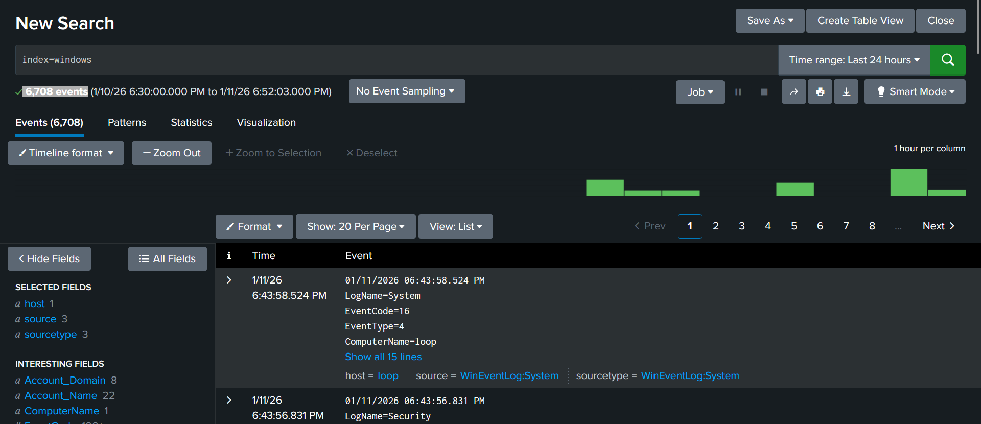

🟥 STEP 2 — MAKE WINDOWS “LOOK QUIET” (ON PURPOSE)
Now do only one change.
- Change Time Range → Last 15 minutes
- Run the same search:
index=windows

Look carefully:
- Did the number of events drop a lot? Yes (6,708 events ------7 events)
- Does it look quiet or almost empty?
⚠️ Do NOT conclude anything yet.
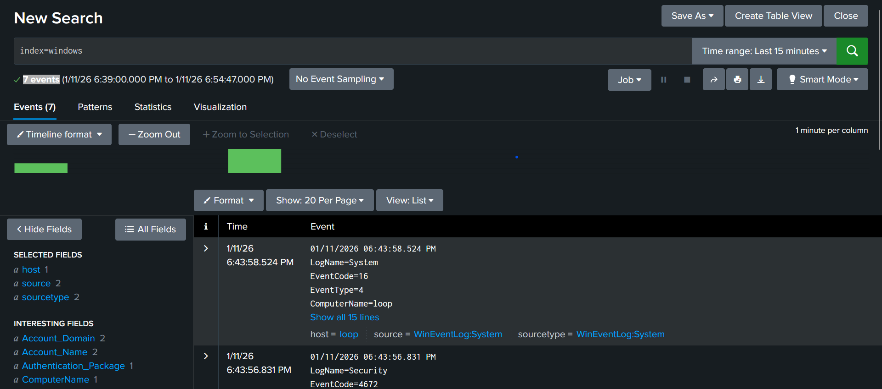

🟥 STEP 3 — WIDEN A LITTLE
Now do this:
- Change Time Range → Last 1 hour
- Same search:
index=windows

Observe:
- Do events suddenly appear again? Yes (855 events) Total
- Do you see small clusters? Yes
👉 Note this mentally.

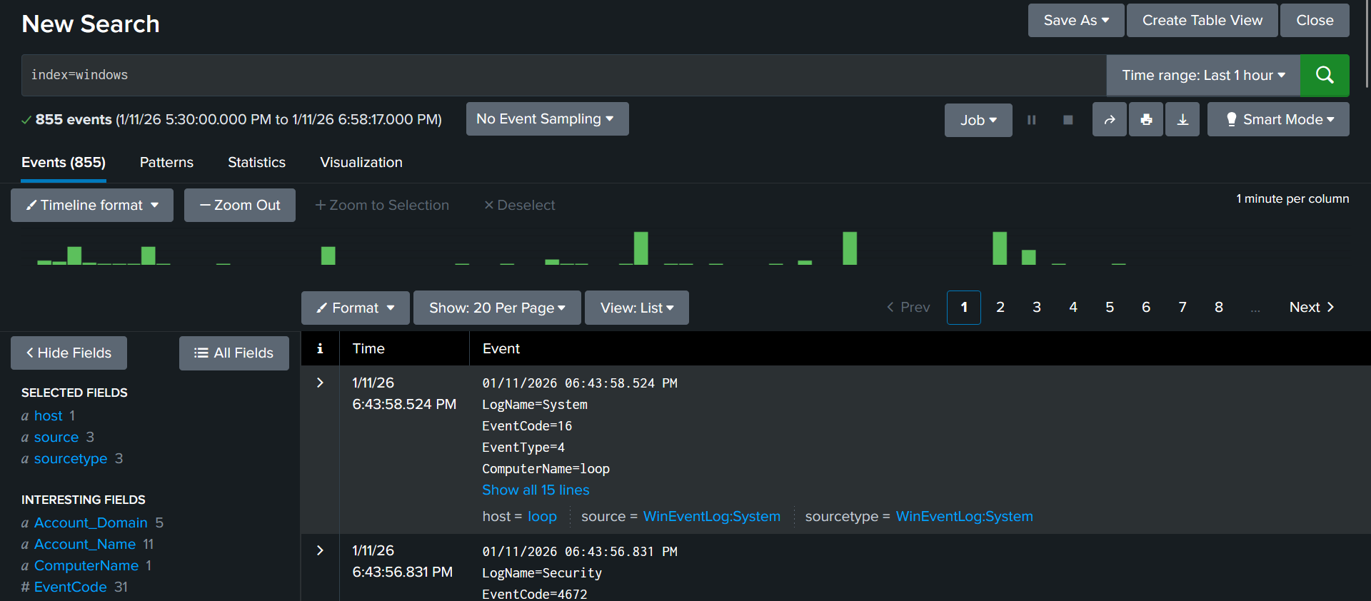

🟥 STEP 4 — GO BACK TO TRUTH VIEW
Now:
- Change Time Range → Last 24 hours
- Same search:
index=windows

Observe:
✅ Bursts of events → green blocks
✅ Quiet gaps → empty spaces
✅ Not evenly spaced → blocks + gaps pattern

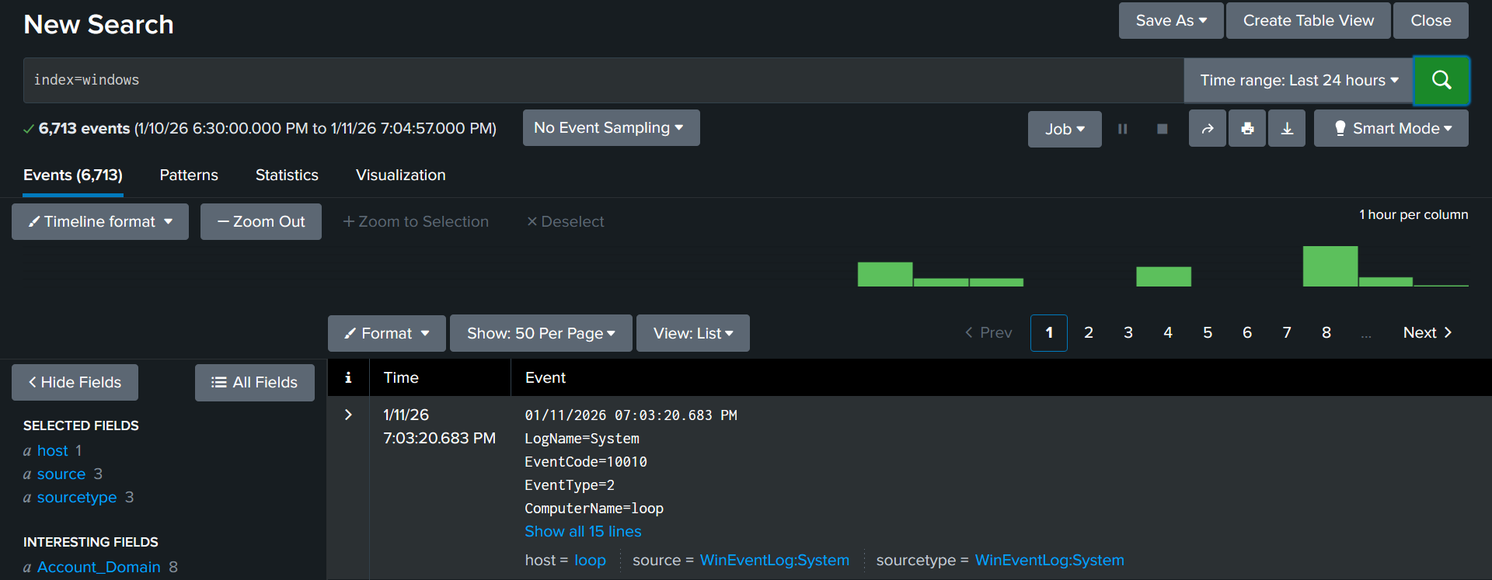

🟥 STEP 5 — COMPARE (THIS IS THE CORE LESSON)
Answer YES or NO (mentally):
- Did 15 minutes show “nothing”?
- Did 1 hour / 24 hours show activity?
If YES → you just saw false silence.

🟥 STEP 6 — CHECK FOR BURSTS & GAPS
Still on 24 hours view:
Slowly scroll and notice:
- Groups of many events close together
- Long quiet gaps between them
👉 This is normal Windows behavior.
Windows logs in bursts, not streams.
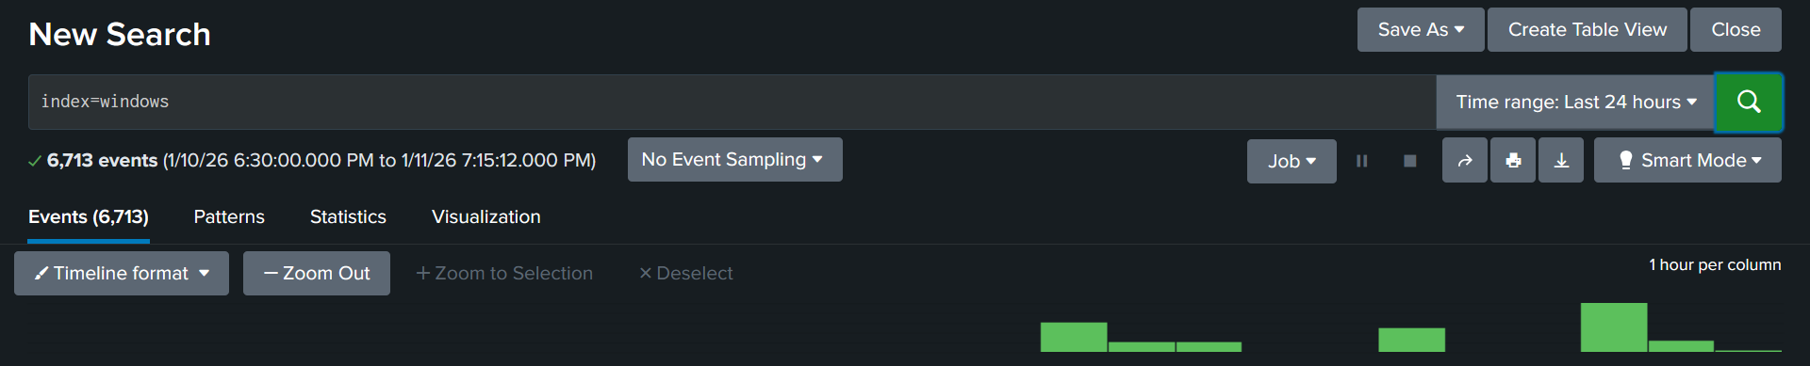

🟥 STEP 7 — FINAL PRACTICAL TEST
Do this once more to lock it in:
- Switch to Last 15 minutes
- See few/no logs
- Immediately switch back to Last 24 hours
- See logs again
This proves:
“No logs” ≠ “No activity”
DONE……

🔥 PHASE B — QUESTION-FIRST SEARCHING (WINDOWS)
Questions come before searches.

Investigative questions
- Who attempted to log on?
- From where?
- Local or network?
- Human or automated?

Practical
- Broad search first
- Keyword exploration only
- Write the question before the search
🚫 No Event ID memorization
🚫 No filtering yet

Outcome
You investigate intent, not numbers.

PRACTICAL — STEP BY STEP

🟥 STEP 1 — START BROAD (MANDATORY)
👉 In Splunk → Search & Reporting
- Set Time Range = Last 24 hours
- Run ONLY this:
index=windows

Do NOT:
- add keywords
- add filters
- scroll fast

What you are doing (important)
You are asking:
“What kind of Windows activity exists at all?”
You are not investigating yet.
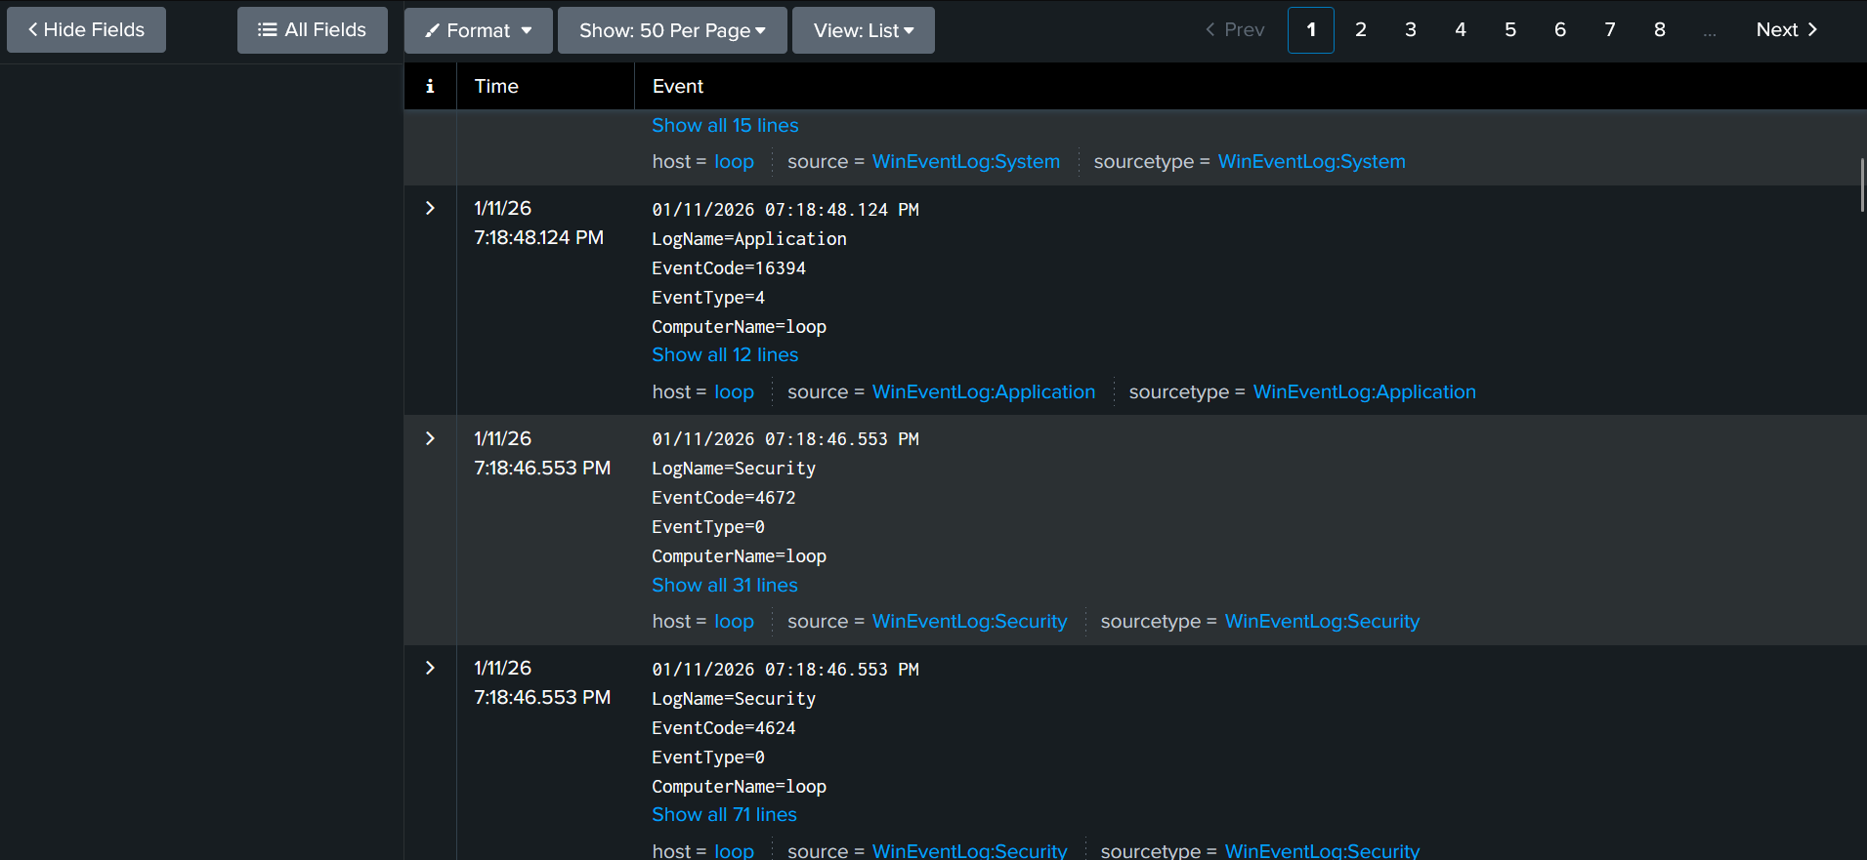

🟥 STEP 2 — SLOWLY SCROLL (TRAIN YOUR EYES)
Slowly scroll down through events.
Just notice:
- Different LogName values (Security, System, etc.)
- Different message styles
- Repeated words

Do NOT decide anything.
You are learning Windows language.

🟥 STEP 3 — WRITE THE FIRST QUESTION (MENTALLY)
Before touching the search bar, say this in your head:
“Who attempted to log on?”
Do NOT think about how to search yet.
This step is about intent, not Splunk.

🟥 STEP 4 — KEYWORD EXPLORATION (NOT FILTERING)
Now you are allowed to add a keyword, not a filter.
Run:
index=windows logon

Important difference
- This does not mean “only logon events”
- It means “show me events that mention logon”

What to do now
- Scroll slowly
- Read raw messages
- Notice:
  - usernames
  - wording
  - patterns
You are answering:
“Do I see user-related activity?”
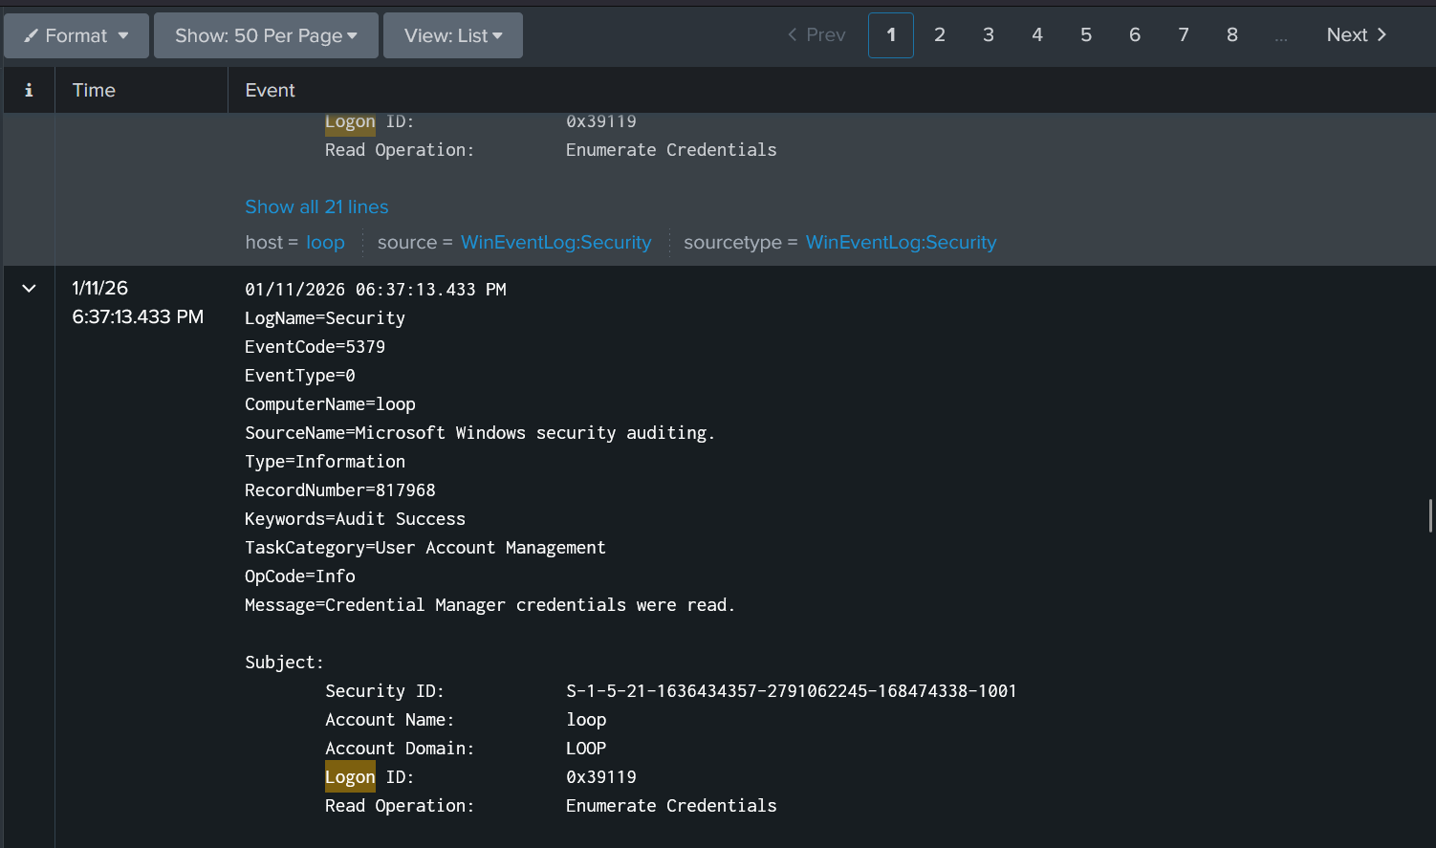

🟥 STEP 5 — WRITE THE SECOND QUESTION
Before changing the search, say:
“From where?”
Again — do NOT jump to IPs yet.

🟥 STEP 6 — OBSERVE SOURCE INFORMATION (NO FILTERS)
Stay on:
index=windows logon
Now just look inside events.
Notice:
- Sometimes you see IP information
- Sometimes it’s missing
- Sometimes it looks local
This teaches you:
“Windows does not always log source the same way.”
That’s critical knowledge.

🟥 STEP 7 — WRITE THE THIRD QUESTION
Say this in your head:
“Local or network?”
You are not answering it yet.
You are learning how Windows expresses it.

🟥 STEP 8 — KEYWORD EXPLORATION AGAIN (OPTIONAL)
WE may now try another keyword one at a time.
Examples (pick ONE, not all):
index=windows authentication
or
index=windows failed

What to do
- Scroll
- Read wording
- Compare with previous view
You are learning:
- How Windows talks about access
- Not which access is bad

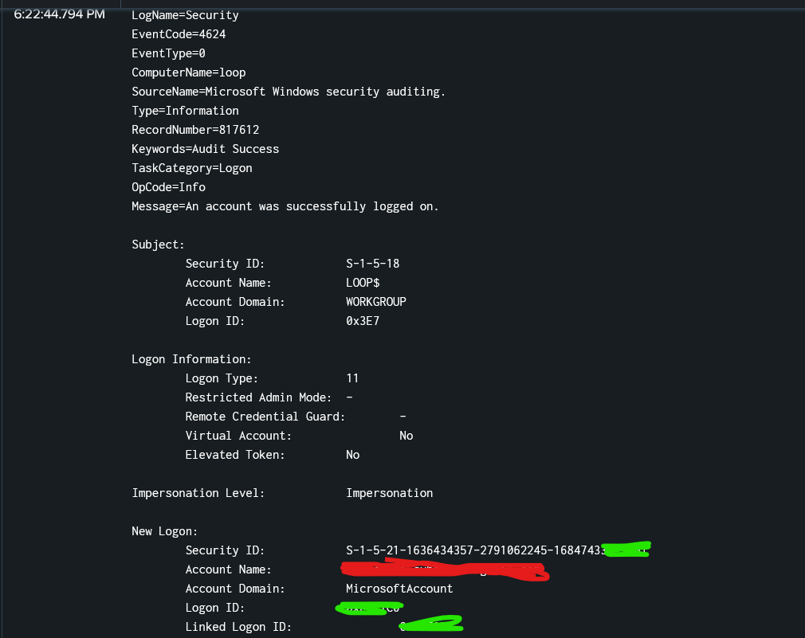

🟥 STEP 9 — WRITE THE FOURTH QUESTION
Say clearly:
“Human or automated?”
Now connect to Phase A.

🟥 STEP 10 — USE TIME PATTERNS (NO COUNTS)
Still using keyword searches, just look at timestamps.
Notice:
- Single isolated events → likely human
- Tight repeated bursts → possibly automated
- Long gaps → Windows buffering
You are using:
time + pattern, not numbers

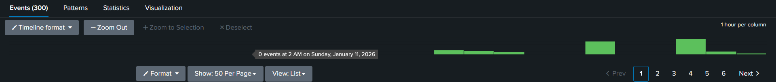

🟥 STEP 11 — STOP (IMPORTANT)
At this point, you must STOP SEARCHING.
Do NOT:
- add Event IDs
- add stats
- add filters
- count anything

🔥 PHASE C — FIELDS = EVIDENCE (WINDOWS CORE SKILL)
Fields are claims. Raw logs are proof.

Mandatory Windows fields to recognize
(Not memorize)
- EventCode
- TargetUserName
- IpAddress
- LogonType
- WorkstationName
- ComputerName
- Process names (when present)

Practical
- Expand one event fully
- Map raw message → fields
- Prove the same answer using:
  - raw text
  - extracted fields

Outcome
You can defend Windows investigations in writing.

STEP-BY-STEP PRACTICAL

🟥 STEP 1 — OPEN A SINGLE EVENT (ONLY ONE)
👉 In Splunk → Search & Reporting
- Time range: Last 24 hours
- Run:
index=windows
- Click ONE event (any Security event)
- Click the ▸ arrow to fully expand it
⚠️ Do NOT open multiple events
⚠️ Do NOT scroll yet
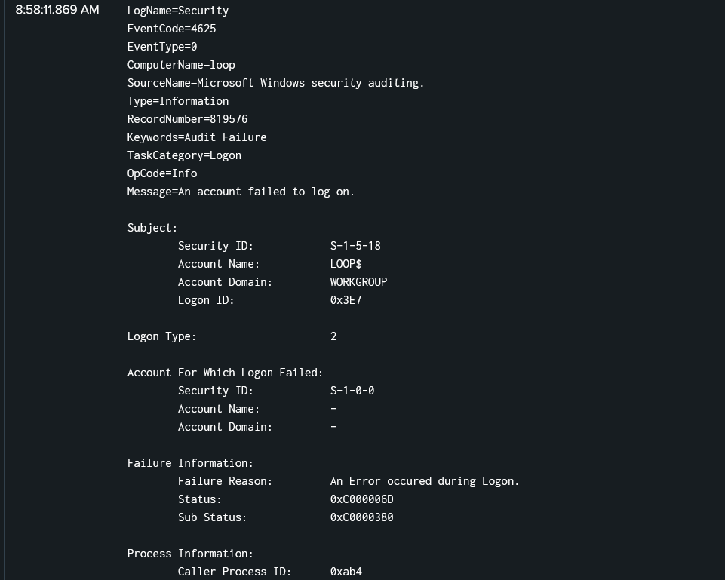

🟥 STEP 2 — READ THE RAW MESSAGE (LIKE A HUMAN)
In the expanded event, ignore fields for now.
Read only the raw message text.
Ask yourself (mentally):
- What happened? An account failed to logon
- Who? LOOP
- From where? Not specified in the raw message
- Any machine name? The event was recorded on computer LOOP
👉 Do NOT conclude anything.
You are just understanding the sentence.

🟥 STEP 3 — FIND THE SAME INFORMATION IN FIELDS
Now shift your eyes to the Fields panel (left side).
Slowly find these fields if present:
- TargetUserName
- IpAddress
- LogonType
- ComputerName
- WorkstationName
⚠️ If a field is missing → that is NORMAL
Do NOT panic.

🟥 STEP 4 — MAP RAW TEXT → FIELD (MOST IMPORTANT STEP)
Now do one-to-one mapping in your head.
Example:
- Raw text says:
“Account Name: john”
→ Field: TargetUserName = john
- Raw text says:
“Source Network Address: 192.168.1.10”
→ Field: IpAddress = 192.168.1.10
👉 You are learning Windows → Splunk translation.

🟥 STEP 5 — ANSWER ONE QUESTION USING RAW TEXT ❌
Answer this using only the message text:
Who attempted to log on?
Example answer:
“The message shows Account Name = NIL”
This answer is not defensible yet.
That’s OK.

🟥 STEP 6 — ANSWER THE SAME QUESTION USING FIELDS ✅
Now answer the same question using fields only:
Who attempted to log on?
Correct style:
“The TargetUserName field is NIL.”
👉 This is defensible evidence.

🟥 STEP 7 — DO THE SAME FOR “FROM WHERE?”
Again, two ways.

❌ Raw text way
“The message mentions Source Network Address.”

✅ Field way
“The IpAddress field shows the source.”
If IpAddress is empty:
- That itself is evidence (likely local activity) yes

🟥 STEP 8 — DISTINGUISH THESE TWO (CRITICAL)
Look carefully at both fields if present:
- ComputerName
- WorkstationName
Ask:
- Which system recorded the event? Host : loop
- Which system initiated the action? unknown
👉 This confusion breaks investigations if not fixed early.

🟥 STEP 9 — CHECK EVENTCODE (NO MEMORIZATION)
Look at:
- EventCode : 4625
Do NOT memorize the number.
Just understand:
“This number categorizes what type of event this is.”
That’s all for now.

🟥 STEP 10 — WRITE A DEFENSIBLE STATEMENT (FINAL TEST)
In your head (or notes), form one sentence like this:
“Based on the TargetUserName, IpAddress, and ComputerName fields, this event represents a logon attempt involving <user> from <source> recorded on <system>.”
If you can form this sentence → Phase C passed.

Based on the available fields, this event represents a failed logon attempt involving the computer account LOOP$, originating from the local system (127.0.0.1), and recorded on the host loop. The TargetUserName field is not populated for this event.

🔥 PHASE D — FILTERING (WINDOWS PERSPECTIVES)
Same data. Different stories.

You filter by:
- Single user
- Single IP
- Single host
- Single logon type

You observe:
- Narrative changes
- Analyst bias
- Why one lens lies
🚫 No stacking filters
🚫 No conclusions

Outcome
You control scope instead of drowning in noise.

STEP-BY-STEP PRACTICAL
Rule: one filter → observe → remove → next filter
If you stack filters, you fail this phase.

🟥 STEP 0 — BASELINE (REFERENCE VIEW)
👉 In Splunk → Search & Reporting
- Time range: Last 24 hours
- Run:
index=windows

Do nothing else.
Just look:
- Timeline shape
- Event volume
- Bursts + gaps
This is your control view.

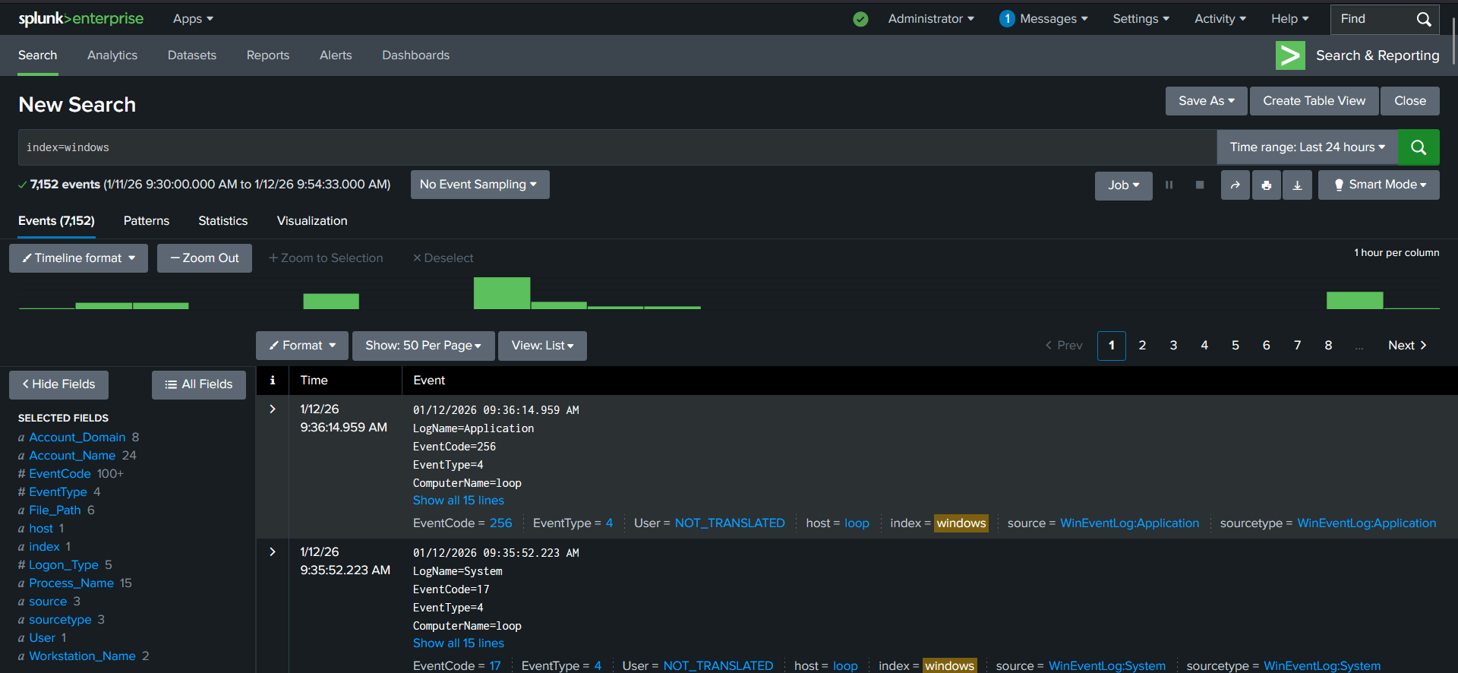

🟥 STEP 1 — FILTER BY SINGLE USER (FIRST LENS)
👉 Use the Fields panel (do NOT type).
- Find field:
Account_Name or TargetUserName
- Click ONE value only
(example: LOOP$ or any user you see)
Your search now looks like:
index=windows Account_Name=LOOP$

Observe ONLY:
- Timeline changes?
- Fewer events?
- Story feels “cleaner”?
🚫 Do NOT decide if it’s normal or bad.
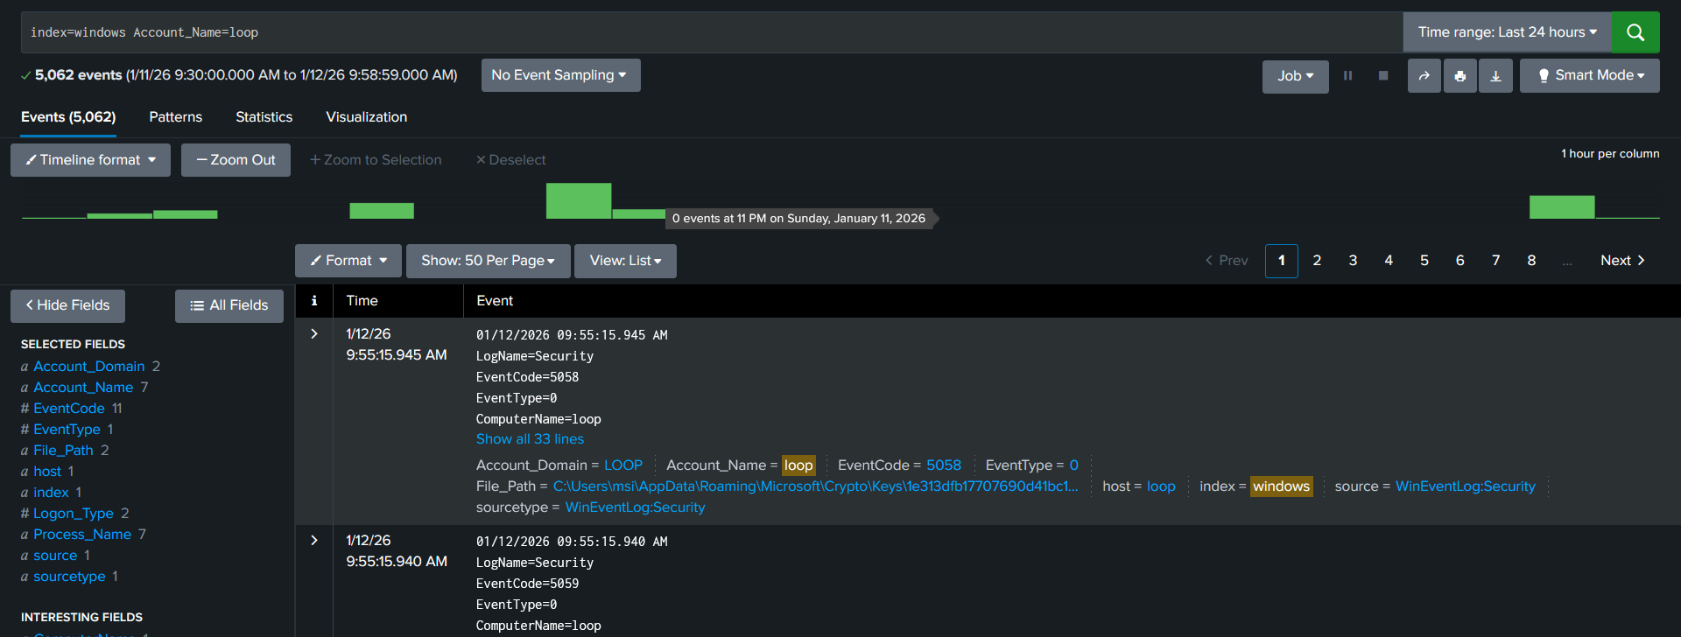

🟥 STEP 2 — RESET (MANDATORY)
Remove the filter.
Back to:
index=windows
If you don’t reset, everything after this is wrong.

🟥 STEP 3 — FILTER BY SINGLE IP (SECOND LENS)
- In Fields, find:

Source_Network_Address

- Click ONE IP only
(example: 127.0.0.1)
Search becomes:

index=windows Source_Network_Address="127.0.0.1"

Observe:
- Activity looks local?
- Fewer events?
- Some activity disappears?
Just notice the change.

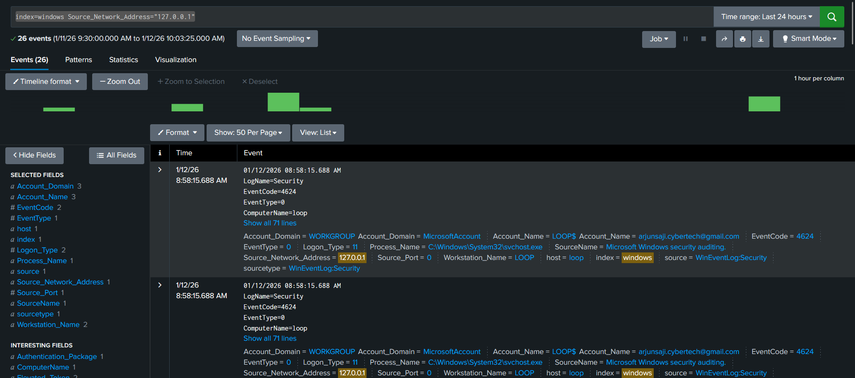

🟥 STEP 4 — RESET AGAIN
Back to:
index=windows
Always reset between lenses.

🟥 STEP 5 — FILTER BY SINGLE HOST (THIRD LENS)
- Find field:
  - host
- Click:
  - host=loop (or your host)
Search becomes:
index=windows host=loop

Observe:
- Very focused view
- Looks “contained”
- Timeline feels simple
⚠️ Don’t trust that feeling.

🟥 STEP 6 — RESET AGAIN
Back to:
index=windows

🟥 STEP 7 — FILTER BY SINGLE LOGON TYPE (FOURTH LENS)
- Find field:
  - Logon_Type
- Click ONE value only
(example: 2)
Search becomes:
index=windows Logon_Type=2

Observe:
- Different timeline again
- Some events gone
- Story feels very specific
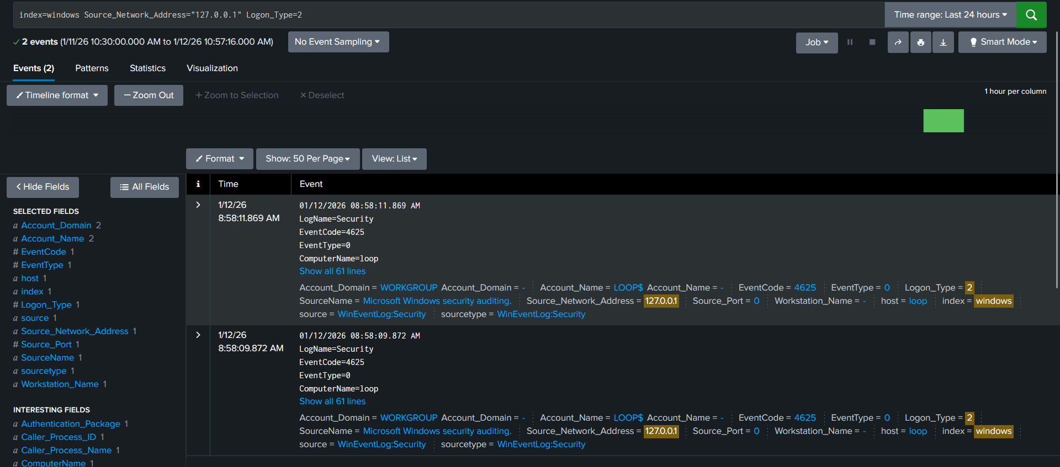

🟥 STEP 8 — STOP AND THINK (MOST IMPORTANT)
Now ask yourself (mentally):
- Did each filter change the story?
- Did some filters make activity disappear?
- Did some filters make things look harmless?
If yes → Phase D is working. Yes

🔥 PHASE E — WINDOWS TIMELINE (REAL SOC WORK)
Attacks are stories over time.

You reconstruct:
- Before activity
- During activity
- After activity

You analyze:
- Failed → success patterns
- LogonType transitions
- Human vs scripted timing
- Pauses and silence
- Initial process context (when visible)

Example story
- Failed network logons
- Tight timing
- Successful logon
- Privilege usage or silence
- Post-access pause

Outcome
You can explain what happened first — always.

STEP-BY-STEP PRACTICAL
Rule of Phase E:
If you can’t say what happened first, stop.

🟥 STEP 0 — SET THE INVESTIGATION FRAME
👉 In Splunk → Search & Reporting
- Time range: Last 24 hours
- Search:
index=windows
Do nothing else yet.
This is your full reality.

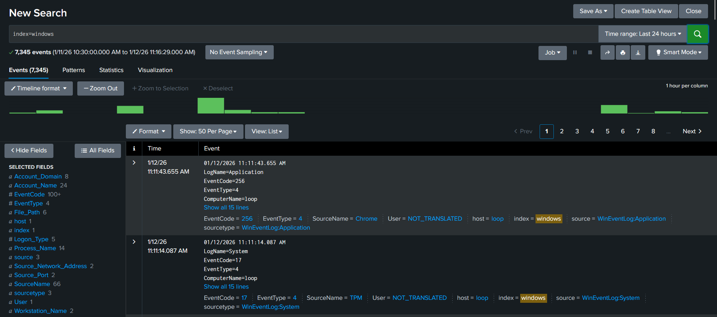

🟥 STEP 1 — SWITCH TO TIME ORDER (MANDATORY)
Make sure events are ordered oldest → newest
(Scroll from top to bottom, don’t jump around.)
You are now asking:
“How did this day unfold?”
Not:
“What looks bad?”

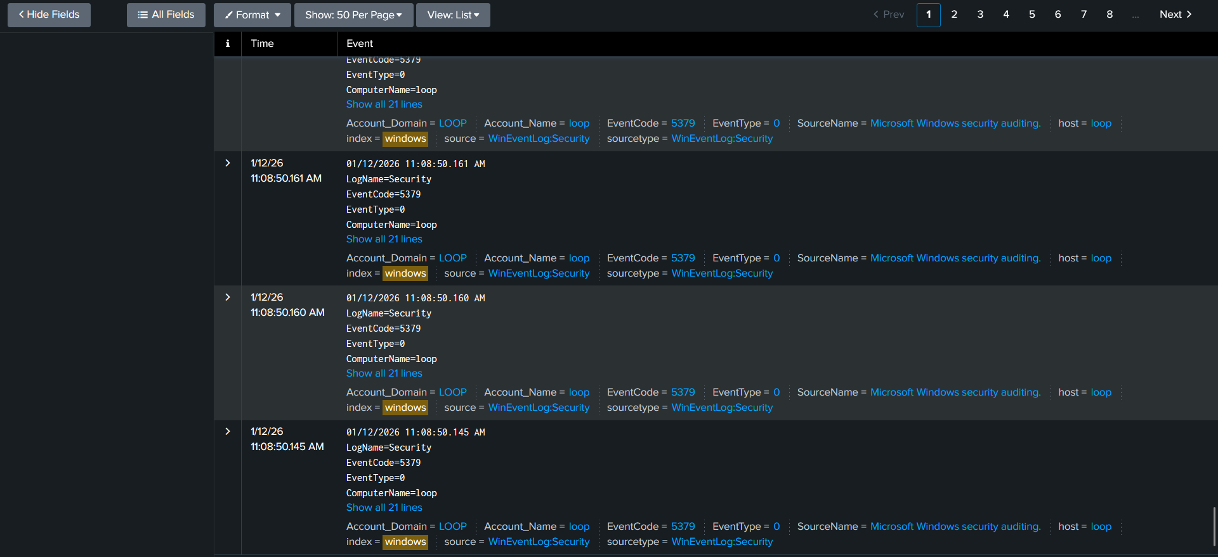

🟥 STEP 2 — FIND THE FIRST “CHANGE” (ANCHOR POINT)
Slowly scroll and look for:
- A cluster of failed logons
- Or a sudden increase in auth-related activity
⚠️ Do NOT click Event IDs
⚠️ Do NOT filter yet
Just notice where behavior changes.
That timestamp = anchor point.

🟥 STEP 3 — DEFINE “BEFORE ACTIVITY”
Scroll upwards (earlier than the anchor).
Observe:
- Normal background noise?
- Occasional logons?
- No tight repetition?
👉 This is BEFORE.
In your head, say:
“Before this time, activity looked normal.”

🟥 STEP 4 — DEFINE “DURING ACTIVITY”
Now focus on the anchor window and after it.
Look for:
- Multiple failed logons
- Tight timing (seconds apart)
- Same account or pattern
- Same access style
You are NOT counting.
You are watching the pattern.
This is DURING.

🟥 STEP 5 — WATCH FOR TRANSITION (FAILED → SUCCESS)
Keep scrolling forward in time.
Ask:
- Do failures stop?
- Does a successful logon appear?
- Does access style change?
If you see:
- Failures → success
That transition is critical.
⚠️ A success is only important because of what came before.

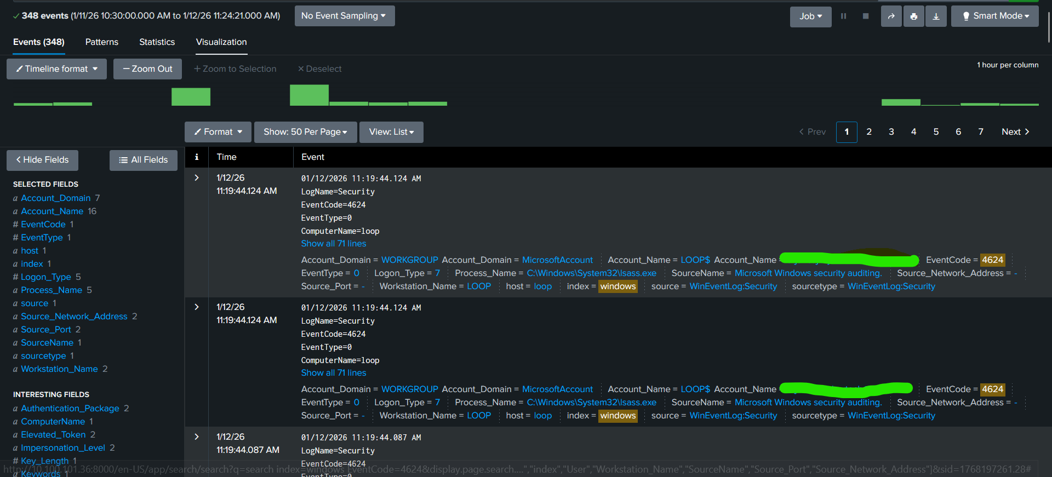

🟥 STEP 6 — DEFINE “AFTER ACTIVITY”
Continue scrolling after the success (or after failures stop).
Look for:
- Privilege-related activity
- Process execution (if present)
- OR sudden silence
Silence matters.
Ask:
“What happened after access?”
This is AFTER.

🟥 STEP 7 — ANALYZE TIMING (HUMAN vs SCRIPT)
Now zoom into the timestamps.
Observe:
- Are events seconds apart?
- Very consistent spacing?
- Or irregular with pauses?
Interpretation (no conclusion yet):
- Tight + consistent → likely scripted
- Irregular + pauses → likely human
This is behavioral evidence, not numbers.

🟥 STEP 8 — NOTE PAUSES & GAPS (IMPORTANT)
Look for:
- Failures → pause → success
- Success → long silence
Ask:
“Is this a system pause, or an attacker pause?”
You don’t answer yet.
You record the pause mentally.

🟥 STEP 9 — BUILD THE STORY (NO JUDGMENT)
Now, in your head or notes, narrate only facts in order:
Template:
- Before: what was normal
- During: what changed
- After: what followed
Example:
“Before X, authentication activity was normal. During X–Y, repeated failed logons appeared with tight timing. After Y, a successful logon occurred followed by a period of silence.”
No attack labels.
No severity.
Just sequence.

🟦 Before
Before ~08:58 AM, Windows authentication activity on host loop appeared normal and sparse, with no tight repetition of similar events.
Why this is valid:
- You scrolled earlier
- Events were spread out
- Mixed log types
- No dense pattern

🟥 During
Between ~08:58 AM and ~11:19 AM, repeated failed authentication events were observed involving the computer account LOOP$, originating from the local system (127.0.0.1), occurring with very tight timing.
Why this is valid:
- Same account
- Same source
- Same logon style
- Millisecond spacing
- Clear density change (anchor)

🟩 After
At approximately 11:19 AM, a successful logon event occurred involving the account arjunxxxxxxx@gmail.com using a different logon type. Following this event, activity becomes sparse, with no immediate continuation of the earlier failure pattern.

🔥 PHASE F — SUPPORTING METRICS (VALIDATION ONLY)
Counts confirm stories. They never define them.

What you learn
- Counting by user, IP, host
- Comparing incident vs baseline
- Why thresholds lie
- Why low volume can still matter

Practical
- Count events after timeline
- Compare normal vs abnormal frequency
- Tie numbers back to time order
🚫 No detection rules
🚫 No dashboards

Outcome
You can numerically defend your timeline.

PRACTICAL (STEP-BY-STEP)
Rule: Timeline first (you already did it).
Now: Use numbers to support that story.

🟥 STEP 0 — LOCK THE INCIDENT WINDOW (DO NOT SKIP)
You already identified the timeline:
- During window: ~08:58 AM → 11:19 AM
- Host: loop
Set Time Range in Splunk to Custom:
- Start: 08:50 AM
- End: 11:30 AM
This is your incident window.
Do not use “Last 24 hours”.
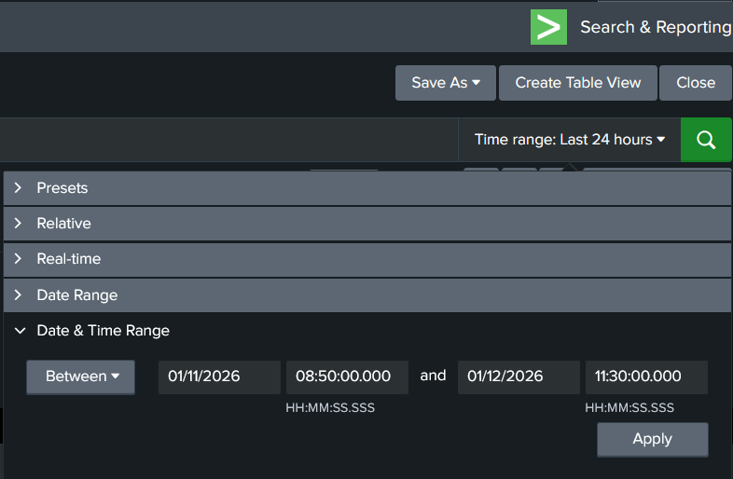

🟥 STEP 1 — BASELINE COUNT (CONTROL)
We need a comparison point.
- Change Time Range to:
  - Same host, earlier period (example: previous day, same hours)
- Run:
index=windows host=loop

Observe (don’t calculate):
- Rough volume
- How spread out events are
- No tight bursts
This is your baseline.
👉 Remember it mentally. Don’t write conclusions.

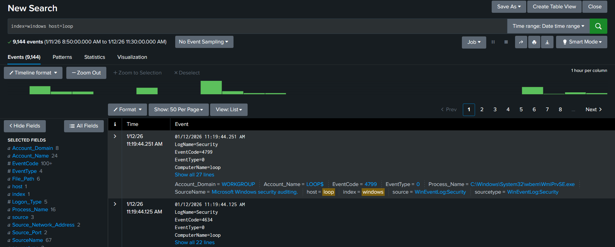

🟥 STEP 2 — INCIDENT WINDOW COUNT (VALIDATION)
Switch Time Range back to:
- 08:50 AM → 11:30 AM
Run the same search:
index=windows host=loop

Observe:
- Volume increased?
- Events denser?
- Clusters appear?
You are not deciding severity.
You’re checking difference vs baseline.

🟥 STEP 3 — COUNT BY USER (ONE LENS)
Now validate who dominated activity.
Run:
index=windows host=loop
In the Fields panel:
- Look at Account_Name
- Note which account appears most during the incident window

Ask:
- Was this account dominant only during the window?
- Was it quiet in baseline?
If yes → metrics support your timeline.

🟥 STEP 4 — COUNT BY SOURCE (IP) (SECOND LENS)
Still in the same incident window, look at:
- Source_Network_Address / IpAddress

Observe:
- Is one IP dominating?
- Does that IP appear much less in baseline?
Do not say attacker.
Just say: concentration changed.

During the incident window, authentication-related activity is heavily concentrated from a single source IP (127.0.0.1).”

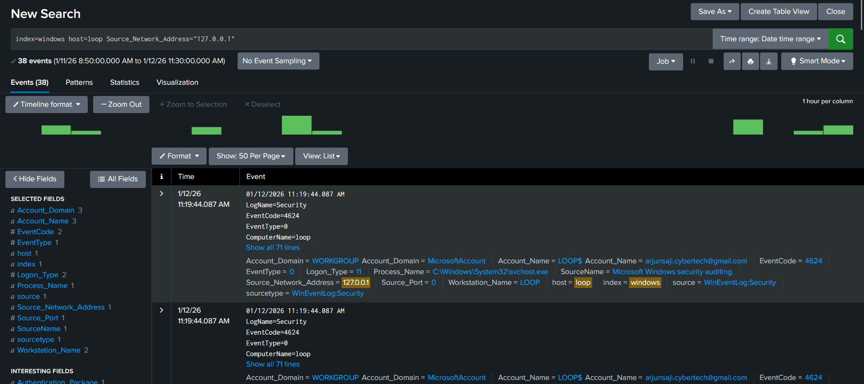

🟥 STEP 5 — COUNT BY LOGON TYPE (THIRD LENS)
Still same window.
Check:
- Logon_Type

Observe:
- Which logon type appears most during? 11
- Did it shift compared to before?
This supports:
- Your failed → success
- Your transition observation
“During the incident window, authentication activity is dominated by a single logon type (Logon_Type 11), representing a clear shift in access method compared to earlier activity.”

🟥 STEP 6 — TIE NUMBERS BACK TO TIME (MOST IMPORTANT)
Now mentally connect:
- Timeline showed bursts between 08:58–11:19
- Metrics show:
  - Higher counts in that window
  - Concentration by account / source
  - Different distribution vs baseline
👉 This is validation, not discovery.

The increased event volume and concentration observed during the identified time window align with the previously reconstructed timeline, validating the observed authentication activity pattern without introducing new findings.”

🟥 STEP 7 — WRITE THE METRIC SUPPORT (ONE PARAGRAPH)
Write one neutral sentence like this:
“During the identified incident window, authentication activity volume increased compared to baseline, with a higher concentration of events associated with a single account and source, supporting the timeline observation of clustered authentication behavior.”
No numbers required.
No thresholds.
Just support.

“During the identified incident window, authentication activity on host loop increased compared to baseline behavior, with events showing a clear concentration associated with locally initiated activity from a single source and a dominant logon type, supporting the previously reconstructed timeline of clustered authentication behavior.”

🔥 EVENT IDs AS ANCHORS — THEORY (FINAL)

Core truth (non-negotiable)
Event IDs label behavior. They do NOT explain behavior.
If you remember only one line from this phase, remember that.

1️⃣ WHAT “EVENT IDS AS ANCHORS” ACTUALLY MEANS
An anchor is a reference point you attach after understanding something.
Event IDs are used to:
- name a behavior
- reference it consistently
- communicate it precisely to others
They are not used to discover the behavior.

2️⃣ THE WRONG WAY (WHY MEMORIZATION FAILS)
This is how beginners are taught (and why they fail):
4625 = failed logon
4624 = success
4672 = admin
→ therefore incident
Why this fails:
- 4625 happens in normal environments
- 4624 happens constantly
- 4672 appears in legitimate admin activity
- IDs without time, sequence, and context lie
This is exactly why you got confused earlier.

3️⃣ THE CORRECT SOC ORDER (THIS IS THE SKILL)
SOC analysts work in this exact order:
Behavior → Timeline → Validation → Event ID
Not the other way around.
So you:
- Observe what happens over time
- Describe it in plain language
- Validate it with metrics
- THEN attach Event IDs as labels

4️⃣ REAL EXAMPLE (FROM THIS LAB)
What you actually did (correct order):

Step A — Behavior (no IDs)
- Repeated authentication attempts
- Tight timing
- Same account
- Same host
- Then success
- Then logoff / silence

Step B — Timeline
- Before: normal noise
- During: clustered auth activity
- After: session end events

Step C — Validation
- Counts higher in incident window
- Concentration by account / source

Step D — NOW anchor with Event IDs

Only now do IDs matter:
Behavior | Event ID
Authentication failure | 4625
Authentication success | 4624
Privileged context | 4672 (if present)
Session end | 4634
Notice:
👉 IDs did not create the story
👉 IDs only named parts of the story

