🧭 WINDOWS ACTIVE DIRECTORY + WINDOWS 10 (DOMAIN JOINED) & SPLUNK ROADMAP-LABS-OVERVIEW

EFFECTIVE SOC INVESTIGATION ROADMAP
Tool focus: Splunk
Scope: AD + Domain-joined Windows endpoints
Not included yet: EDR tuning, SIEM alerts, Sigma rules
Goal: Investigate identity-based attacks with confidence, not Event IDs

🟥 PHASE 0 — AD DATA TRUST (NON-NEGOTIABLE)
If AD data lies, everything lies.

What you learn
- Why AD logs are more fragile than endpoint logs
- DC event time vs Splunk _time
- Replication delay vs attacker delay
- Why “DC logs look clean” is dangerous
- Why missing DC logs = blind SOC

Practical checks (MANDATORY)
- Confirm Security logs exist on DC
- Confirm logs arrive in Splunk
- Validate WinEventLog:Security sourcetype
- Compare DC EventTime vs _time
- Confirm multiple DCs (if any) send logs
- Verify logging continues after the incident window
🚫 No searching
🚫 No Event IDs
🚫 No dashboards
Outcome:
You decide whether AD evidence is trustworthy before analysis.

PRACTICAL CHECKS

🟥 STEP 1 — CONFIRM SECURITY LOGS EXIST ON THE DC (GROUND TRUTH)
Do this on the Domain Controller itself.
- Open Event Viewer
- Go to Windows Logs → Security
- Click Refresh
- Perform a controlled action:
  - Log off a domain user
  - Log back in
- Refresh again
PASS if:
- New Security events appear immediately.
FAIL if:
- Security log is empty
- No new events appear after the action
If FAIL → STOP.
Splunk is irrelevant if Windows isn’t logging.

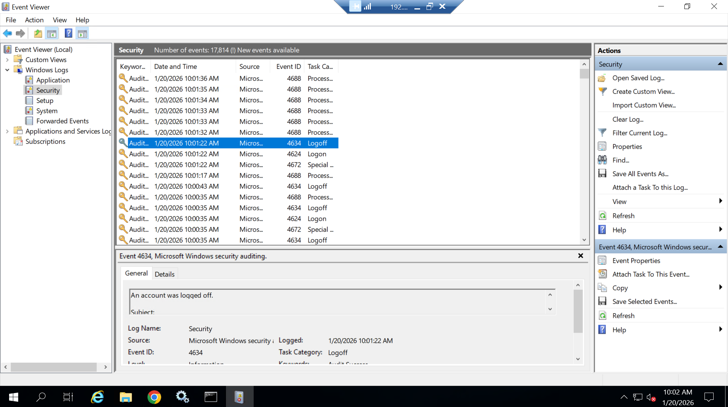

🟥 STEP 2 — CONFIRM DC LOGS ARRIVE IN SPLUNK (NO FILTERING)
Do this in Splunk Web.
- Set Time Range: Last 24 hours
- Run only:
index=ad
(If you didn’t separate indexes, use index=windows and identify DC by host.)
PASS if:
- Events are visible
- host shows the DC hostname
FAIL if:
- No events
- Only endpoint hosts appear
If FAIL → STOP.
Check forwarder service, receiving port, and outputs.

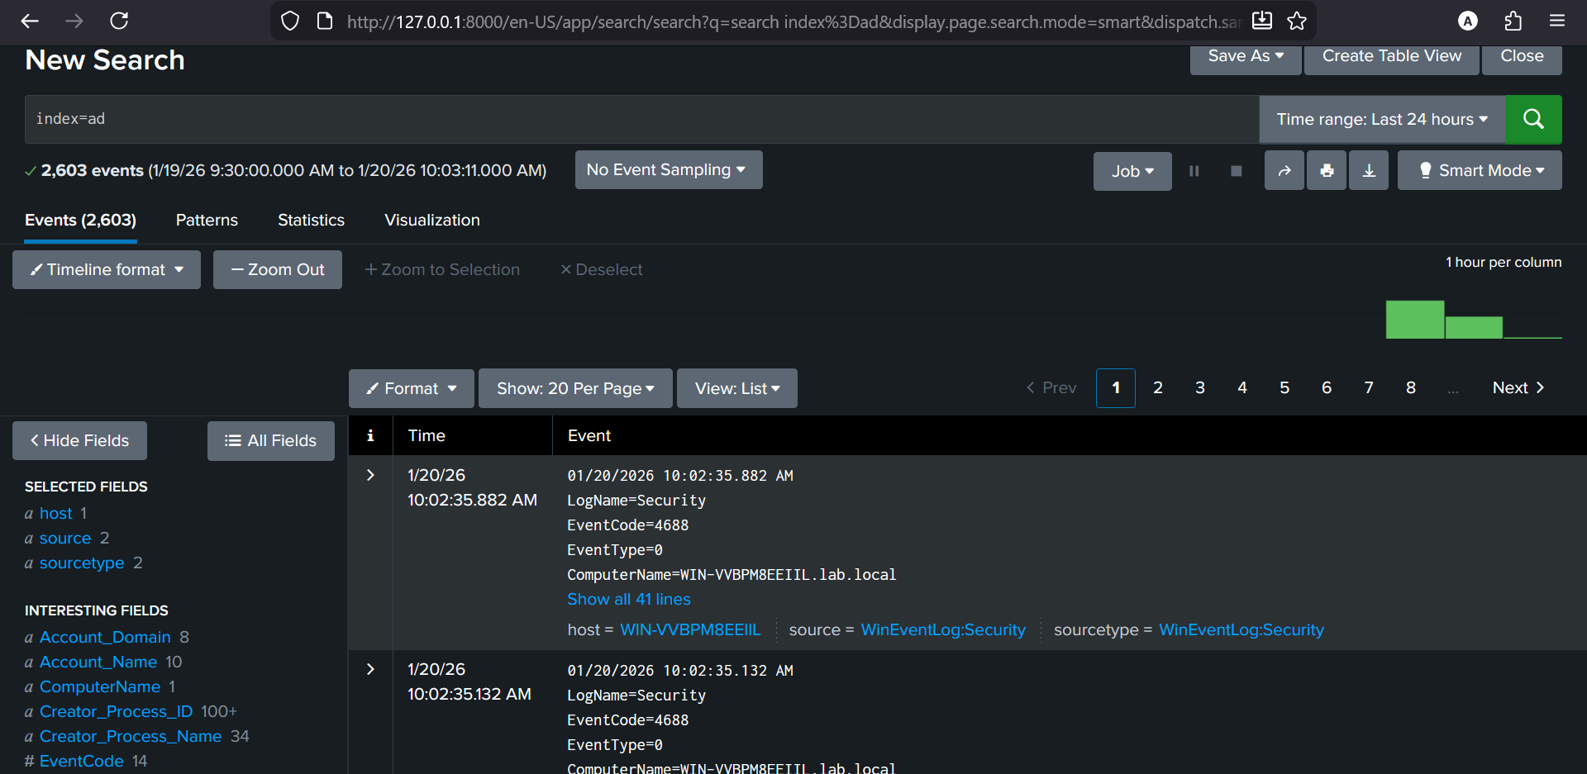

🟥 STEP 3 — VALIDATE THE SOURCETYPE (CRITICAL)
Expand one DC event fully.
Look for:
sourcetype = WinEventLog:Security
PASS if:
- Exactly WinEventLog:Security
FAIL if:
- Generic sourcetype
- Mismatched channel
- Custom/unknown parsing
Why this matters:
Wrong sourcetype = wrong field extraction = false narratives.
If FAIL → STOP.
Fix parsing before any analysis.

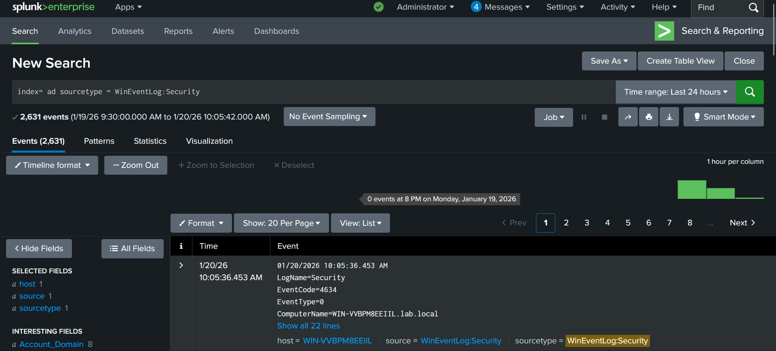

🟥 STEP 4 — DC EVENT TIME vs SPLUNK _time
In the same expanded event, compare:
- Event time shown in the raw message
- _time shown by Splunk

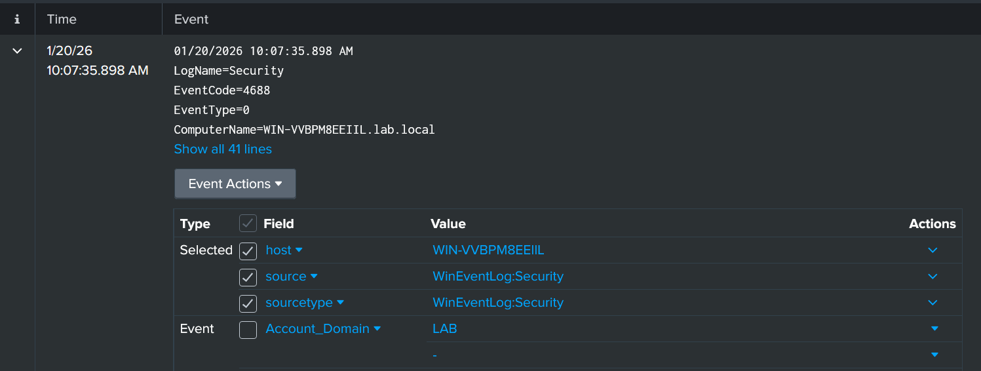

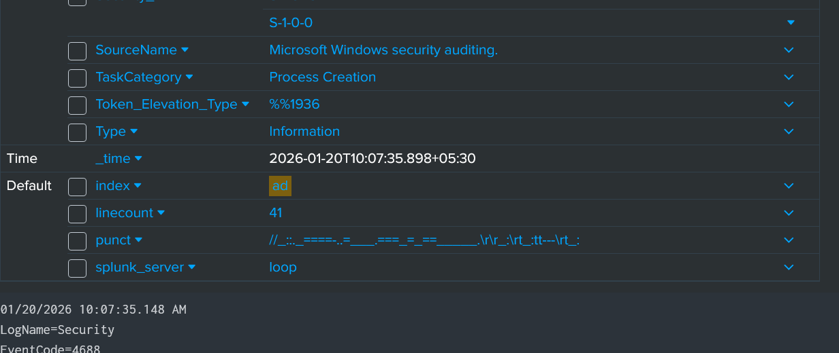
PASS if:
- Small, consistent delay (seconds)
- Ordering makes sense
FAIL if:
- Minutes/hours of drift
- Events appear out of order
Why this matters:
AD investigations are sequence-based.
Time skew destroys cause-and-effect.
If FAIL → STOP.
Fix time sync (DC first).

🟥 STEP 5 — REPLICATION DELAY vs ATTACKER DELAY (CONCEPT CHECK)
If you have multiple DCs:
- Confirm each DC sends logs to Splunk
- Check that events from different DCs:
  - Appear with reasonable timing
  - Do not “arrive late” relative to each other
Interpretation guidance:
- Replication delay = events appear later but still ordered
- Attacker delay = pauses between actions that still make sense chronologically
Single-DC lab note:
Replication is conceptual here; you’re validating the habit, not the topology.

🟥 STEP 6 — CONFIRM LOGGING CONTINUES AFTER THE INCIDENT WINDOW
This prevents the most dangerous SOC mistake: assuming logging didn’t stop.
- Change time ranges:
  - Last 15 minutes
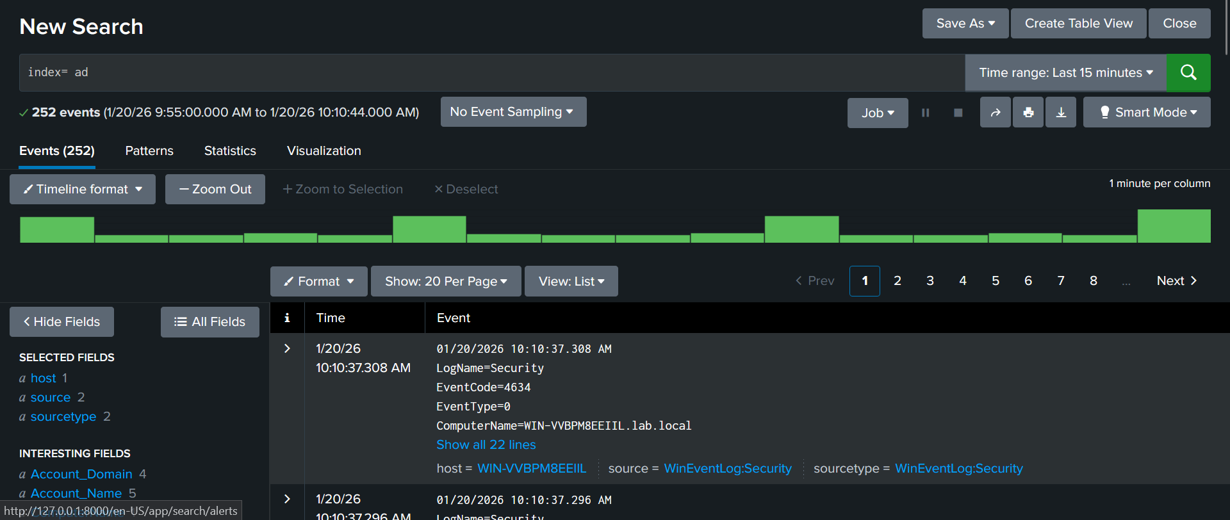
  - Last 1 hour
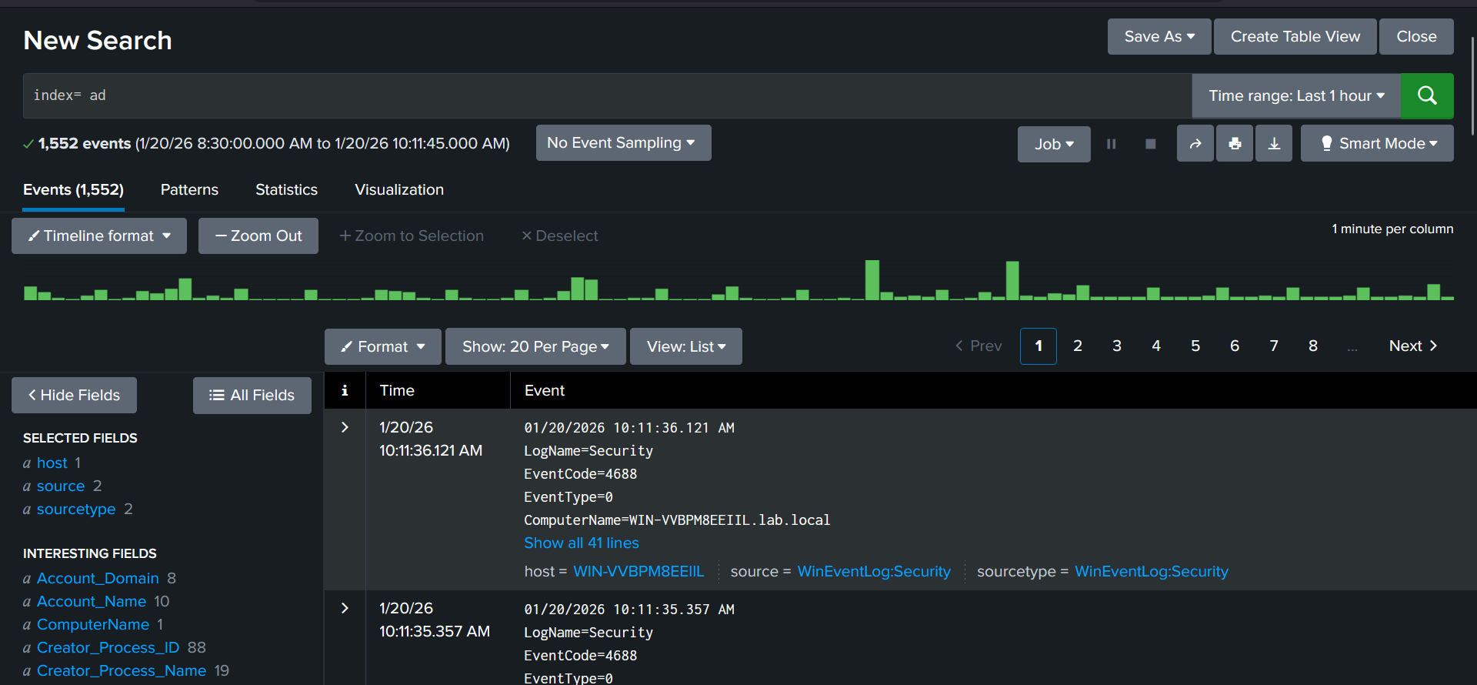
  - Last 24 hours
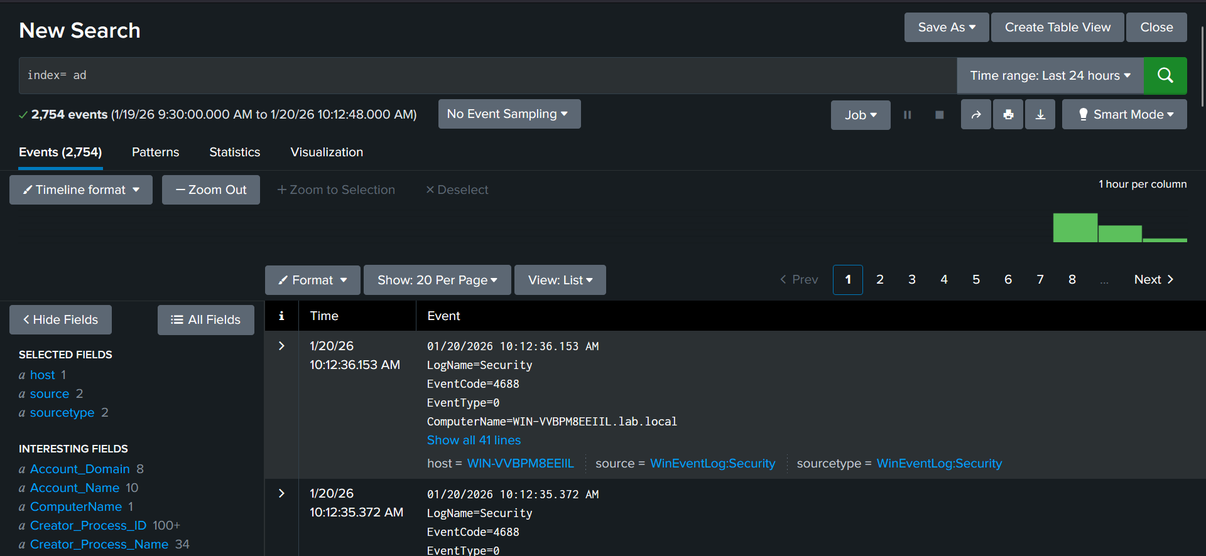
- Ensure DC events appear in all ranges.
PASS if:
- Events continue beyond the moment you care about
FAIL if:
- Logging silently stops
- Gaps appear with no explanation
If FAIL → STOP.
You cannot trust conclusions drawn from partial data.

🔥 PHASE A — ACTIVE DIRECTORY REALITY (IDENTITY ≠ ENDPOINT)
Endpoints authenticate. AD decides.

What you learn
- Why AD attacks don’t look noisy
- Why failures can be intentional
- Why success is often the real red flag
- Why AD activity appears “spread out”
- Why attackers avoid brute force in domains

Practical
- Broad search:
- index=windows
- Compare:
  - DC vs workstation logs
  - Quiet DC ≠ safe DC
- Observe:
  - Sparse but meaningful events
  - No obvious bursts
  - Long gaps that still matter
Outcome:
You stop expecting AD attacks to “look loud.”

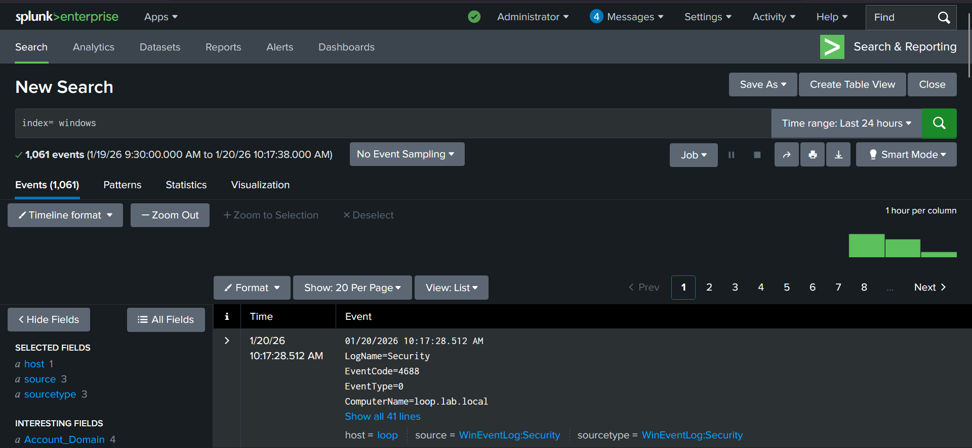

Good example for comparison : BOTH AD AND WINDOWS
4688 on a DC answers: “Who was allowed to act?”
4688 on a workstation answers: “What happened?”

🔥 PHASE B — IDENTITY-FIRST QUESTIONS (CRITICAL SHIFT)
In AD, the account is the attack surface.

Investigative questions
- Which identity was used?
- Where was it validated?
- Interactive or delegated?
- Human, service, or machine?
- First use or reuse?

Practical
- Broad searches first
- No Event IDs
- No filters
- Question → observation → refinement
Outcome:
You investigate identity behavior, not hosts.

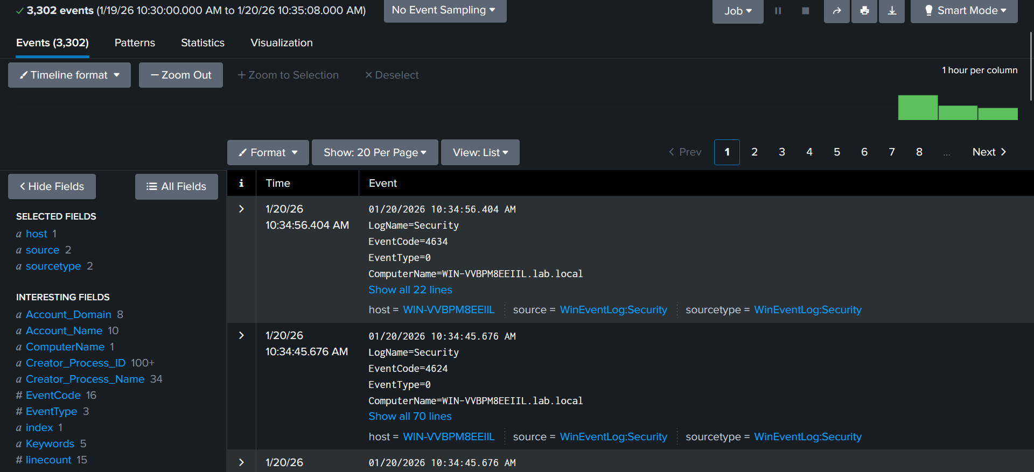

Observed Sequence

Event 1
EventCode = 4624
→ Successful logon

Event 2
EventCode = 4634
→ Logoff
Both occur on:
- ComputerName = WIN-VVBP8EEIIL.lab.local
- This is a Domain Controller
The timestamps are seconds apart.

What This Mean (Identity-First Interpretation)

1️⃣ An identity was validated by the Domain Controller
4624 on a DC means:
- AD approved an authentication
- Trust was granted
- Credentials were accepted
This is not endpoint activity.
This is domain authority in action.

2️⃣ The session was short-lived
The quick 4624 → 4634 sequence tells you:
- No interactive user session
- No human typing
- No workstation login
This pattern is typical of:
- Kerberos authentication
- Service validation
- Network-based access
- Ticket issuance
This is delegated authentication, not a human login.

3️⃣ This is NOT “a user logged in”
This is where beginners get it wrong.
A human login on a DC would show:
- Longer session duration
- Multiple follow-on events
- Possibly 4688 executions

🔥 PHASE C — AD FIELDS = IDENTITY EVIDENCE
In AD, fields matter more than messages.

Mandatory AD fields (recognize, not memorize)
- TargetUserName
- SubjectUserName
- Account_Name
- LogonType
- Authentication_Package
- WorkstationName
- ComputerName
- ServiceName (when present)
- IpAddress

Practical
- Expand one DC event
- Map:
  - Who requested auth
  - Who was validated
  - Where it was validated
- Prove claims using fields only
Outcome:
You can defend who authenticated where and how.

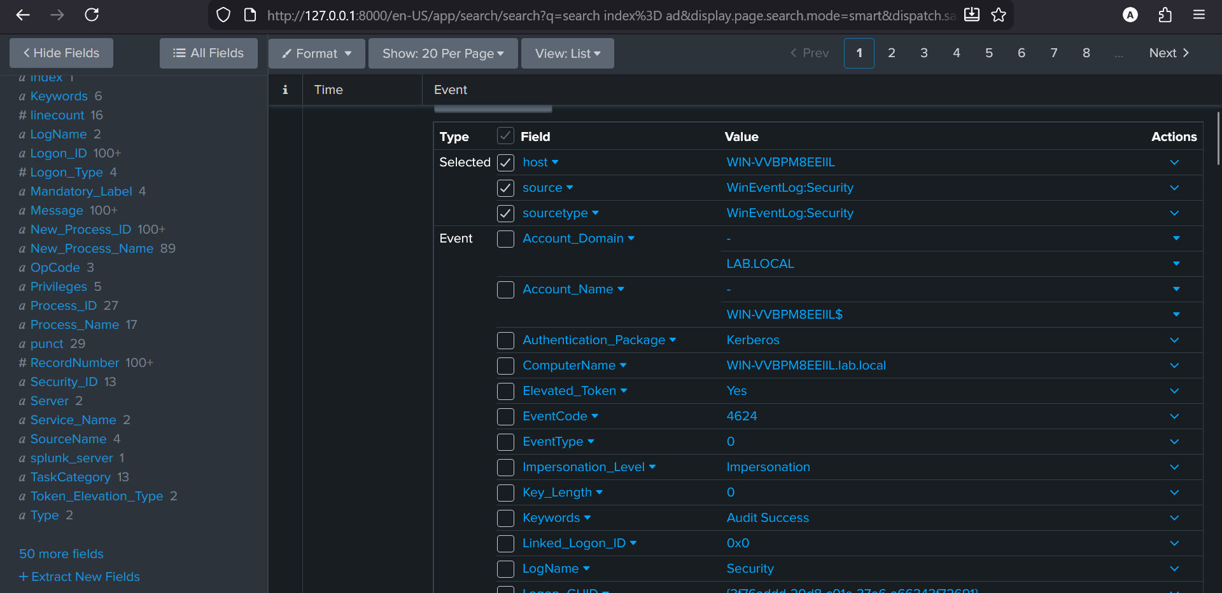

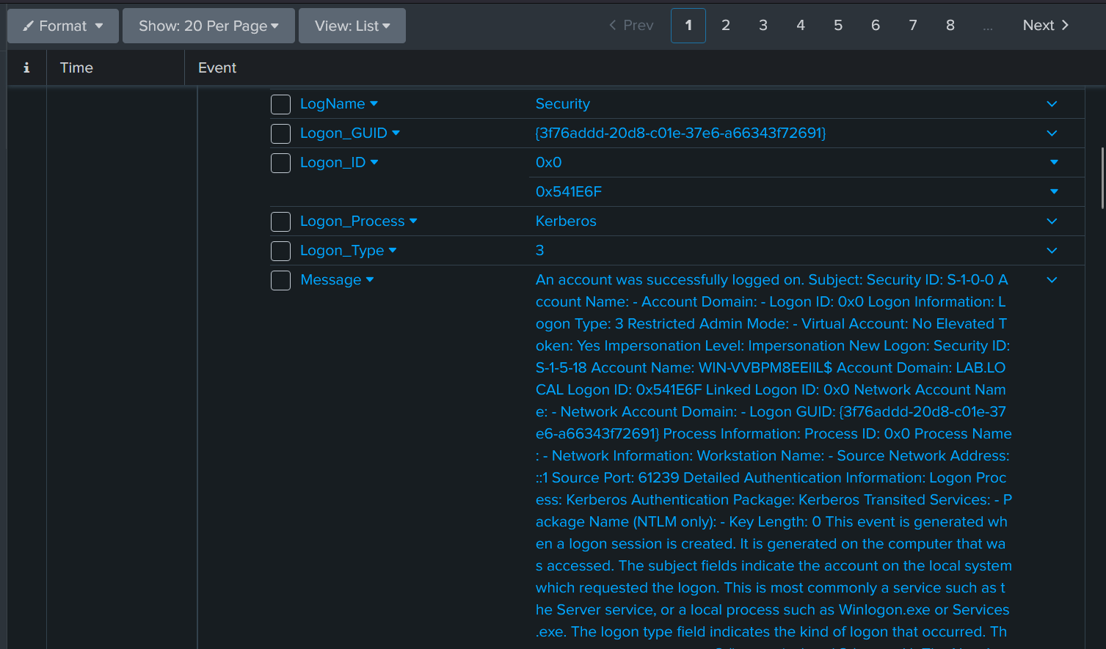

The Domain Controller validated a Kerberos network authentication for its own machine account (WIN-VVBP8EEIIL$).
The authentication was delegated, non-interactive, short-lived, and system-initiated.
There is no evidence of human login, lateral movement, or abuse in this event alone.
This conclusion is defensible because every claim is tied to a field.

🔥 PHASE D — AD FILTERING (PERSPECTIVES, NOT TRUTHS)
Each AD filter tells a different lie.

Filters (one at a time)
- Single user
- Single service account
- Single workstation
- Single DC
- Single logon type

Observe
- Narrative distortion
- What disappears
- What suddenly looks “clean”
🚫 No stacking
🚫 No conclusions
Outcome:
You control scope without losing context.

🔥 PHASE E — AD TIMELINE (IDENTITY STORY)
AD attacks are identity journeys, not events.

You reconstruct
- First credential use
- Validation location (DC)
- Lateral movement attempts
- Privilege boundary crossings
- Pauses and reuse

You analyze
- Fail → success ≠ brute force
- LogonType transitions
- DC hopping
- Identity reuse timing
Outcome:
You can explain how an identity moved, step by step.

🔥 PHASE F — METRICS (AD VALIDATION ONLY)
Counts validate identity behavior — they don’t detect it.

You validate
- Identity concentration
- DC concentration
- LogonType shifts
- Incident window vs baseline
🚫 No thresholds
🚫 No alert logic
Outcome:
You can numerically defend identity timelines.

🔥 PHASE G — EVENT IDs AS IDENTITY ANCHORS (ONLY NOW)
Event IDs label identity behavior — they don’t explain it.

Example chain
- Behavior: failed auth → success → ticket use
- Anchors:
  - 4625 → 4624 → 4768 / 4769

Correct usage
- IDs added after timeline
- Used for:
  - reporting
  - detection engineering later
  - communication
Outcome:
You use AD Event IDs confidently and correctly.

🔥 PHASE H — COMMON AD ATTACK CHAINS (BEHAVIOR-FIRST)
Learn attacks as sequences, not signatures.
You’ll cover (in order):
- Password spraying
- Kerberoasting
- NTLM relay
- Pass-the-hash
- Golden / Silver ticket (conceptual first)
- DC sync (later)
Each taught as:
Behavior → Timeline → Validation → Anchors

