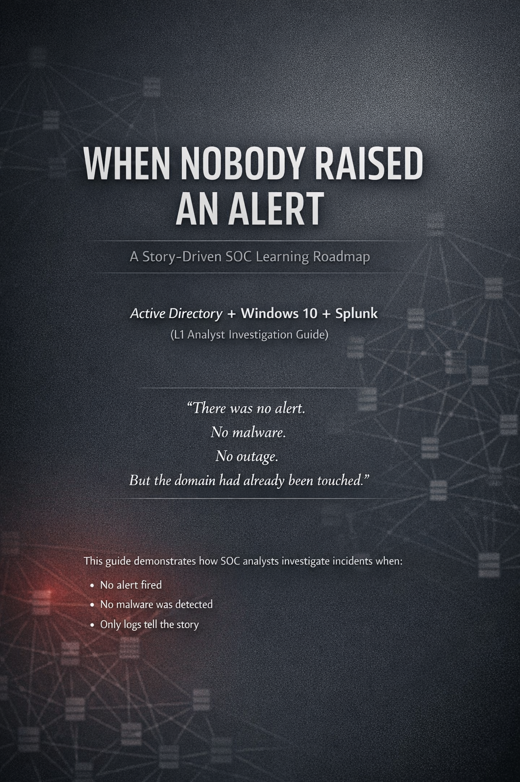

🟥 THE ENVIRONMENT (REALISTIC COMPANY SETUP)
You are an L1 SOC analyst in a mid-size company.

Infrastructure
- Active Directory 2019 (Domain Controller)
- Windows 10 (domain-joined endpoint)
- Ubuntu Server running Splunk
No detections.
No dashboards.
No SIEM rules.
Only logs and reasoning.

🟥 THE LEARNING RULES (CRITICAL)
- ❌ No “learn Splunk first”
- ❌ No random SPL practice
- ❌ No dashboards or alerts
- ❌ No Sigma / detection engineering
- ❌ No copying queries blindly
You will always follow this loop:
Read the story → Think like an analyst →
Write SPL on paper → Run it in Splunk → Interpret results
This builds real investigation skill, not tool dependency.

🔴 MASTER STORY — “THE DOMAIN THAT LOOKED NORMAL”
This is one continuous breach, told in phases.
You do not jump between unrelated labs.
Everything connects.

🔴 PHASE 1 — The Login That Meant Nothing
(Initial access, unnoticed)

What happened (before SOC noticed)
An attacker guessed a password.
Not loudly.
Not fast.
Just slowly.
One domain user authenticated successfully.
Logged in.
Logged out.
No one noticed.

SOC moment
A vague internal request arrives:
“Can you review AD activity from yesterday?
No alerts, but something feels off.”
That’s all you have.

🧠 THINK FIRST (Before Splunk)
You ask yourself:
- What systems decide trust? → AD
- What evidence proves trust? → Authentication logs
- What’s the safest starting point? → Broad, no assumptions

✍️ WRITE SPL ON PAPER (First time ever)
You write:
Show me all AD activity.
Then translate to SPL:
index=ad

▶️ RUN IN SPLUNK & OBSERVE
You learn
- Time range control
- How quiet AD normally is
- Why silence ≠ safety

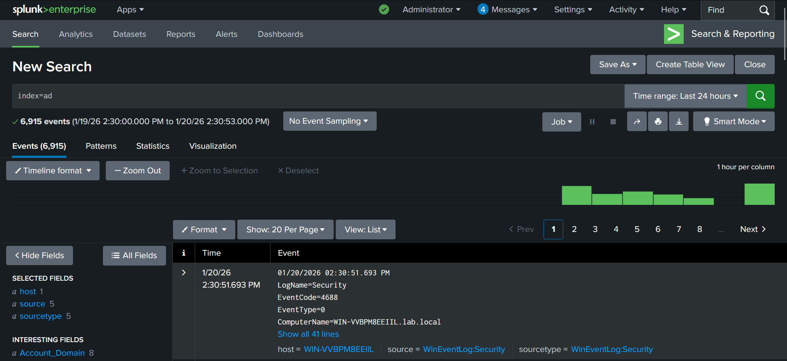

🧠 NEXT QUESTION — Which identities were active?
Think first
- Attacks use identities
- Count activity per user
Write on paper
Count events by user.
Translate to SPL
index=ad | stats count by Account_Name

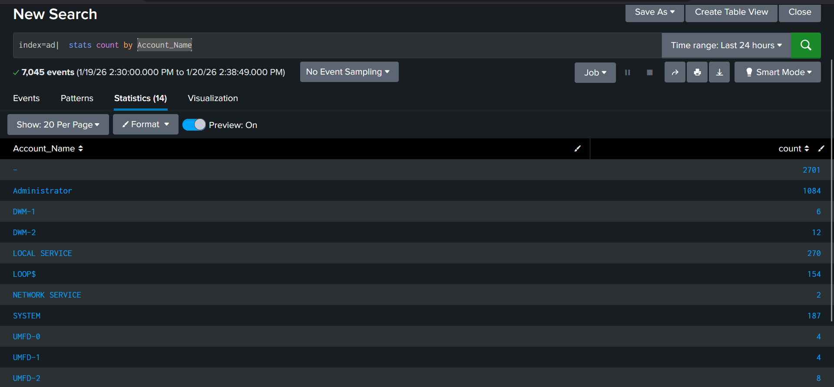

🧠 NEXT QUESTION — Was this a mistake or an attack?
Think first
- Attacks often show fail → success
- Order matters
Write on paper
Show this user’s events in time order.

SPL
index=ad Account_Name="Administrator"
| sort _time

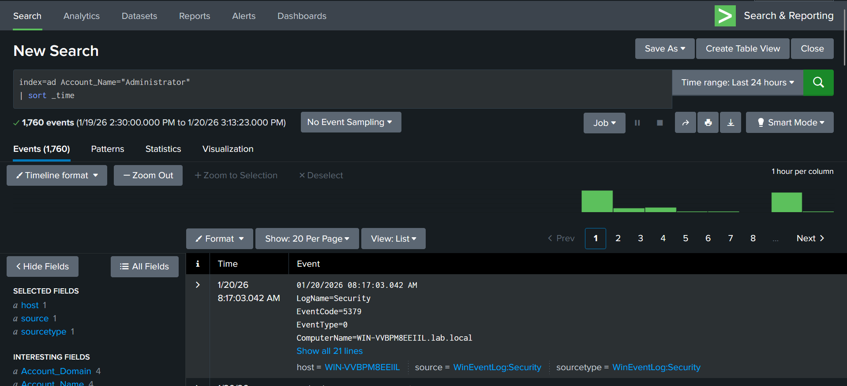

🧠 NEXT QUESTION — Where was trust granted?
Think first
- AD validates
- Workstations request
Write
Show DC vs workstation context.
SPL
index=ad Account_Name="Administrator"
| table _time ComputerName WorkstationName LogonType

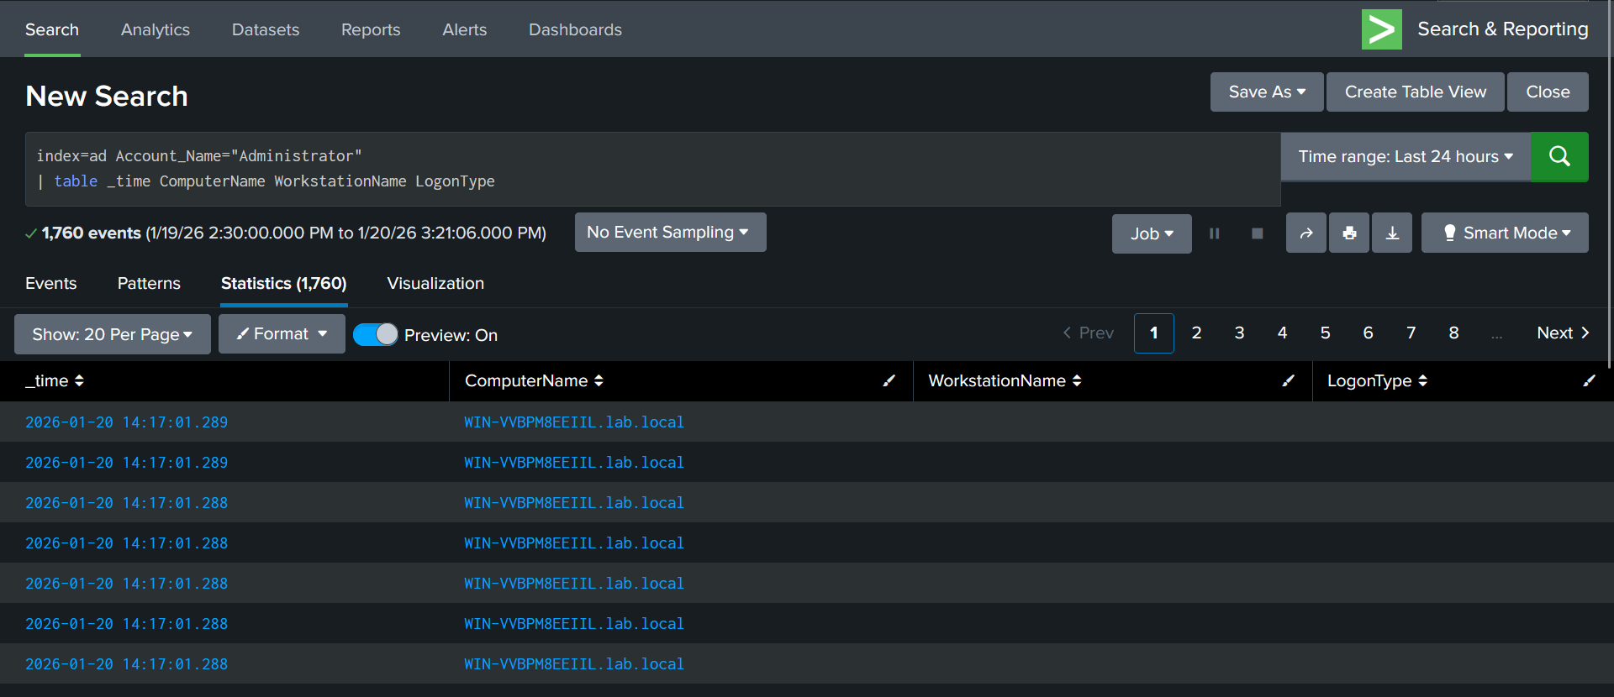

🧠 NEXT QUESTION — Human login or delegated access?
Think
- Humans type
- Services don’t
Write
Group by logon behavior.
SPL
index=ad Account_Name="Administrator"
| stats count by Logon_Type Authentication_Package

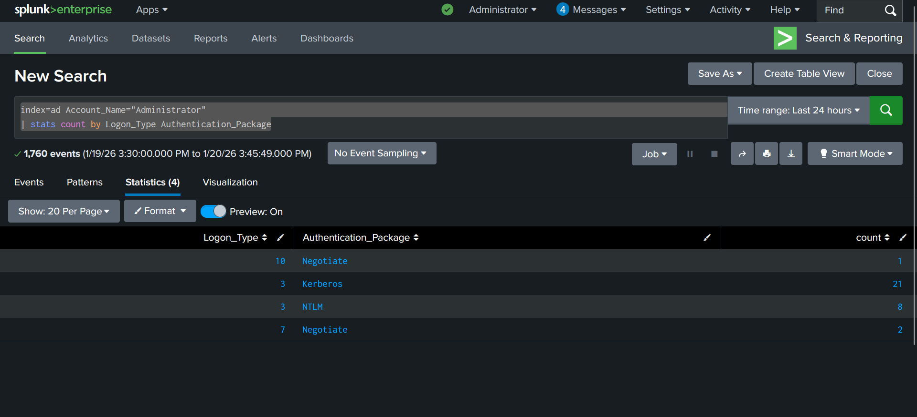

Authentication activity for the Administrator account was dominated by network logons using Kerberos and NTLM, with no service or batch logons observed, indicating human-initiated access rather than delegated or service-based authentication.

✅ End of Phase 1 Outcome
- You reconstructed initial access
- You learned core SPL naturally
- You proved trust was granted by AD

🔴 PHASE 2 — The Service That Started Talking
(Kerberos abuse, no malware)

What happened
The attacker already had access.
They didn’t move machines.
They didn’t exploit anything.
They asked AD questions.
Multiple service tickets were requested.
Days later, a service account authenticated.

🧠 THINK FIRST
- Normal users don’t touch many services
- Service accounts shouldn’t appear suddenly

✍️ WRITE SPL ON PAPER
Show users requesting services.
SPL
index=ad EventCode=4769
| stats count by Account_Name Service_Name

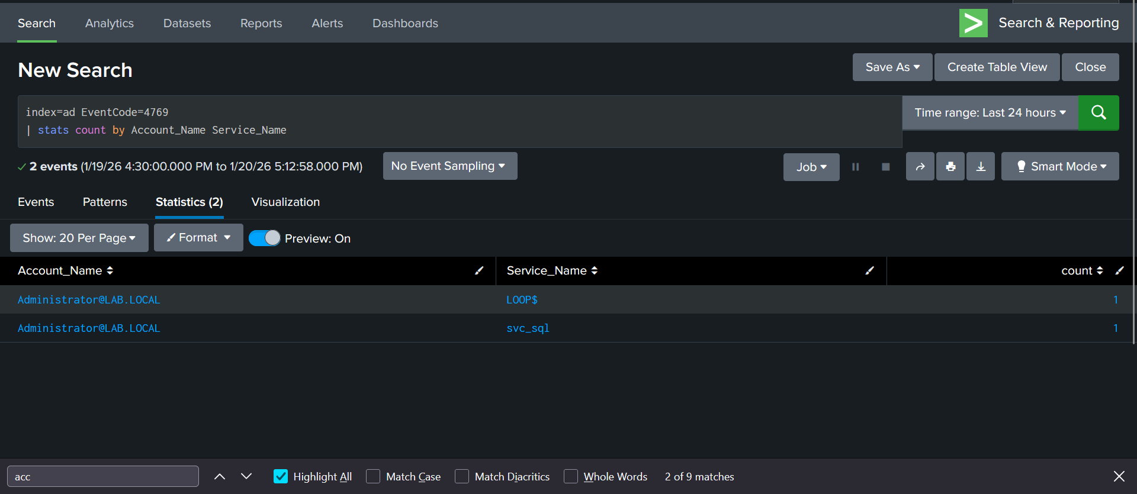

FOLLOW-UP THINKING
Did the service account start authenticating later?
SPL
index=ad EventCode=4624 Account_Name=svc_sql
| sort _time

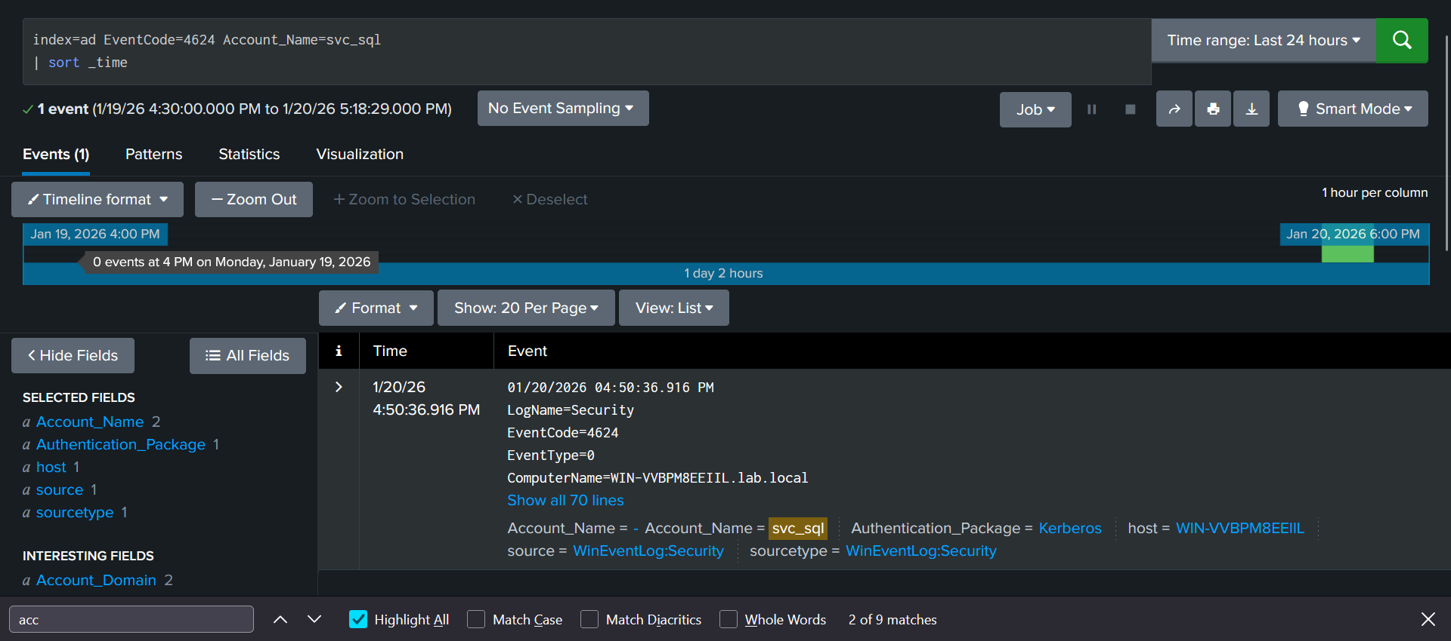

✅ End of Phase 2 Outcome
Identified anomalous service ticket request patterns
• Understood how Kerberos abuse appears without malware
• Distinguished reconnaissance from exploitation
• Correlated delayed service account authentication with prior ticket activity
• Reinforced identity-centric investigation thinking

CONTROLLED ATTACK SIMULATION ROADMAP

(Behavior Generation Guide — NOT Exploitation)
This is how real SOC training labs and purple-team environments are designed.
You are not “attacking AD”.
You are causing specific identity behaviors to exist in logs.

🔐 CORE PRINCIPLE (NON-NEGOTIABLE)
SOC analysts investigate effects, not exploits.
Your goal is to produce log evidence, not to “hack”.
So the question is never:
“What command do I run?”
The correct question is:
“What behavior must appear in AD logs?”

🟥 OFFENSIVE LAB RULES (VERY IMPORTANT)
✔ No malware
✔ No privilege escalation
✔ No persistence
✔ No credential dumping
✔ No domain compromise
✔ No destructive actions
This keeps the lab:

- Legal
- Ethical
- Interview-safe
- SOC-accurate

🔴 MASTER OFFENSIVE STORY — HOW TO CREATE IT
You will generate behaviors, phase by phase.
Each phase answers one SOC question.

🔴 PHASE 1 — INITIAL ACCESS BEHAVIOR
“The Login That Meant Nothing”

🎯 Behavior you must generate
- Multiple authentication failures
- One successful authentication
- Short session
- Same user
- Same source

🔍 What AD must log
- Failed logon attempts
- Successful logon
- Immediate logoff
- Network or delegated logon type

🧠 How you generate it (high level)
- Use legitimate credentials
- Authenticate incorrectly a few times
- Authenticate correctly once
- End the session quickly
⚠️ You are not brute-forcing.
You are simulating guessing behavior.

🛑 STOP HERE
Do not continue to next phase until:
- Logs appear on DC
- Splunk shows the pattern
- Your Phase-1 SOC queries work

🔴 PHASE 2 — KERBEROS / SERVICE INTERACTION BEHAVIOR
“The Service That Started Talking”

🎯 Behavior you must generate
- A user requesting multiple service tickets
- No immediate abuse
- Time gap
- Later, a service account authentication

🔍 What AD must log
- Service ticket requests
- ServiceName fields populated
- Service account appearing later, not immediately

🧠 How you generate it (high level)
- Use normal domain authentication
- Access services that naturally require tickets
- Do not crack or reuse anything
- Later, authenticate as the service account normally
⚠️ This simulates Kerberoasting behavior, not exploitation.

🛑 STOP
Validate Phase-2 SOC story before moving on.

