AUTOMATION ON MAKE MY TRIP

SUBMITTED TO THE VISHWAKARMA INSTITUTE OF INFORMATION TECHNOLOGY, PUNE UNDER THE GUIDENCE OF PROF DISHA WANKHEDE
IN THE PARTIAL FULFILLMENT OF THE REQUIREMENTS

BACHELOR OF TECHNOLOGY (COMPUTER ENGINEERING)

SUBMITTED BY

ROSHAN GUPTA 22211261
ROBIN PATEL 22210451
BISHAL GUPTA 22211262
INDRAJEET GUPTA 22211263



DEPARTMENT OF COMPUTER ENGINEERING

BRACT’S
VISHWAKARMA INSTITUTE OF INFORMATION TECHNOLOGY
KONDHWA (BUDRUK), PUNE – 411048, MAHARASHTRA (INDIA).

Sr. No. |  |  |  | Title of Chapter | Page No.
01 |  |  |  | Introduction
 | 1.1 |  |  | Overview
 | 1.2 |  |  | Motivation
 | 1.3 |  |  | Problem Definition and Objectives
 | 1.4 |  |  | Project Scope & Limitations
 | 1.5 |  |  | Methodologies of Problem solving
02 |  |  |  | Literature Survey
03 |  |  |  | System Design
 |  | 3.1 |  | System Architecture
04 |  |  |  | Project Implementation
 |  |  | 4.1 | Overview of Project Modules
 |  |  | 4.2 | Tools and Technologies Used
 |  |  | 4.3 | Algorithm Details
05 |  |  |  | Results
 |  |  | 5.1 | Outcomes
 |  |  | 5.2 | Screen Shots
06 |  |  |  | Conclusions
 |  | 9.1 |  | Conclusions
 |  | 9.2 |  | Future Work
 |  | 9.3 |  | Applications
References
Thomas Noltey, Hans Hanssony, Lucia Lo Belloz,”Communication Buses for Automotive Applications” In Proceedings of the 3rd Information Survivability Workshop (ISW-2007), Boston, Massachusetts, USA, October 2007. IEEE Computer Society.

- Introduction

  - Overview

The project 'Automation on MakeMyTrip' focuses on automating functionalities of the MakeMyTrip website using Automation Anywhere, a leading Robotic Process Automation (RPA) tool. The goal is to streamline and test travel-related booking processes including flights, hotels, and trains. Automation improves efficiency, minimizes manual effort, and enables accurate data extraction.

  - Motivation

Travel websites involve repetitive and time-consuming tasks like checking bookings, sending confirmations, and updating status. By automating these using RPA, we can ensure accuracy, reduce manual workload, and accelerate the overall workflow.

  - Problem Definition and Objectives

Problem: Manual handling of travel booking processes is prone to errors and inefficiencies.
Objective:
- Automate booking processes on MakeMyTrip.
- Validate and test website functionalities.
- Extract relevant travel data like fares, airlines, and timings.
- Save time by reducing repetitive manual operations using bots.

  - Project Scope & Limitations

Scope:
- Automate selected operations on Make My Trip using Automation Anywhere.
- Enhance accuracy and reduce processing time.
Limitations:
- CAPTCHA and OTP-based logins may still require manual handling.
- Dynamic webpage changes can impact bot performance.
- Licensing costs associated with enterprise RPA tools.

  - Methodologies of Problem Solving

Step 1: Environment Setup - Install Automation Anywhere and access Control Room.
Step 2: Open MakeMyTrip - Use bot to launch browser and navigate to https://www.makemytrip.com.
Step 3: Handle UI Components - Record and customize interactions like closing popups.
Step 4: Automate Booking Flow - Automate inputs for cities, dates, and searches.
Step 5: Extract Data - Capture flight details and store in Excel/CSV.
Step 6: Execute & Monitor - Run bot and validate outcomes using Control Room.

- Literature Survey

RPA has been widely used in banking, insurance, and travel industries. Research shows that tools like Automation Anywhere and UiPath can automate up to 70% of repetitive tasks. The integration of RPA with travel systems has shown significant time and cost savings.

- System Design

  - System Architecture

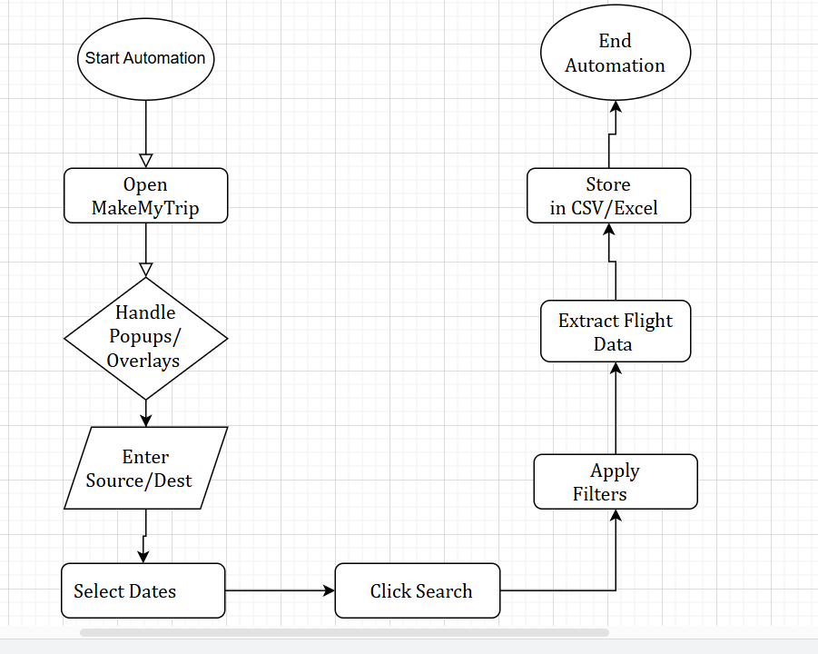

4.Project Implementation

4.1 Overview of Project Modules

In this project, a bot is developed using Automation Anywhere to automate the process of finding the cheapest flight available on Make My Trip based on user-defined inputs. The input details—source, destination, and date of travel—are fetched from an Excel sheet. The bot navigates the Make My Trip website, performs the flight search, scrapes the results, and identifies the most affordable flight. The complete automation process is divided into the following modules:

4.1.1 Input Extraction Module
This module is responsible for extracting input data from an Excel sheet. The user provides the source city, destination city, and date of travel in the specified format. The bot reads this information using Automation Anywhere's Excel commands and stores the values for further processing.

4.1.2 Website Navigation and Data Entry Module
After retrieving the inputs, the bot opens the Make My Trip website using a browser. It fills in the source, destination, and date fields with the extracted values from the Excel sheet. This module automates the process of initiating the flight search as a user would do manually.

4.1.3 Data Scraping Module
Once the flight search results are displayed, this module scrapes the flight details from the webpage. It extracts relevant information such as flight names, departure and arrival times, and ticket prices. The data is stored temporarily for analysis.

4.1.4 Cheapest Flight Identification Module
This module compares the scraped flight prices and identifies the flight with the lowest fare. It selects the most economical option among all the available flights for the given source, destination, and date.

4.1.5 Output Display and Logging Module
Finally, the identified cheapest flight details are displayed to the user or stored in a new Excel sheet. This module ensures that the results are saved in a structured format for easy reference or future use.

4.2 Tools and Technologies Used

Tool/Technology | Purpose
Automation Anywhere | RPA tool used for building automation bots
Automation Anywhere Recorder | Captures user interactions for automation
Automation Anywhere Control Room | Bot deployment and monitoring
Excel / CSV | Data storage
Chrome Browser | Target for web automation
Windows OS | Execution environment

4.3 Algorithm Details

4.3.1 Web Interaction Algorithm

- Read Input from Excel File

- Open the Excel file using Automation Anywhere’s Excel commands.
- Read columns such as: Source City, Destination City, Departure Date, Return Date, Passenger Count, etc.

- Open Browser
- Use the “Open Browser” command to launch the default browser (Chrome/Edge).

- Navigate to Make My Trip
- Enter the URL: https://www.makemytrip.com
- Wait for the page to load.

- Automate Form-Filling and Selection
- Use Object Cloning/Recorder to:
  - Select travel mode (Flights/Trains/Hotels)
  - Enter From and To cities
  - Select travel dates using the date picker
  - Choose number of passengers

4.3.2 Data Extraction Algorithm

- Scrape Booking Data

- After results load, use Web Recorder or Object Cloning to extract:
  - Airline/Train Name
  - Departure & Arrival Times
  - Fare Amount
  - Duration and Stops (if flights)
- Use loops to extract data from multiple result entries.

- Store in Structured Format

- Format the extracted data into rows and columns.
- Write the data back to:
  - A new sheet in the Excel file or
  - A separate .CSV file or database table

- Results

5.1 Outcomes

Booking workflow automation using Automation Anywhere was successful. The bots extracted accurate data from dynamic pages, handled UI elements efficiently, and reduced human effort significantly.

5.2 Screen Shots
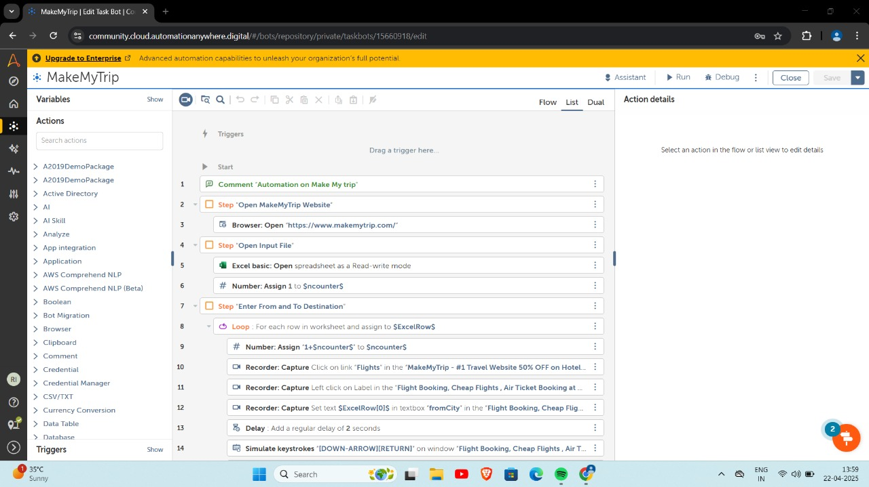
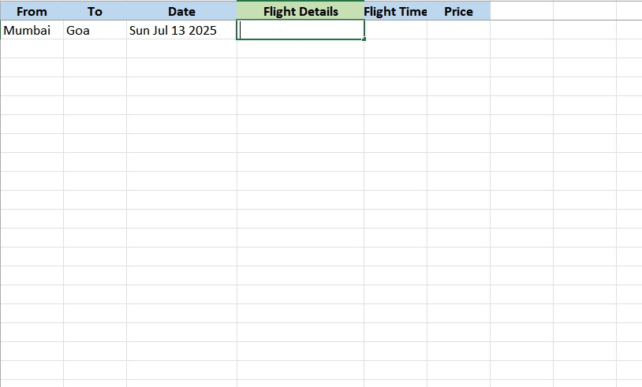
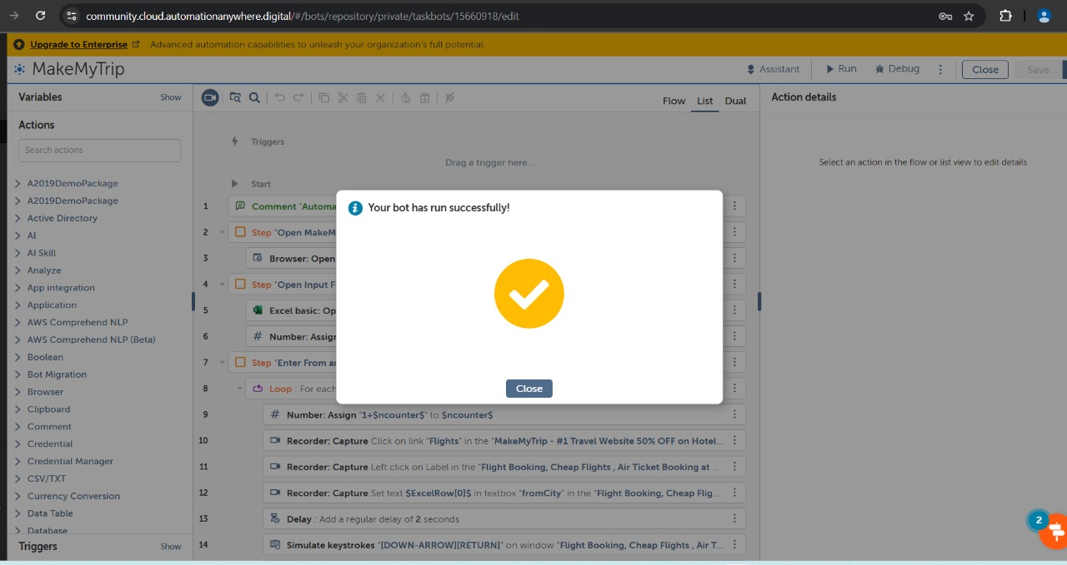
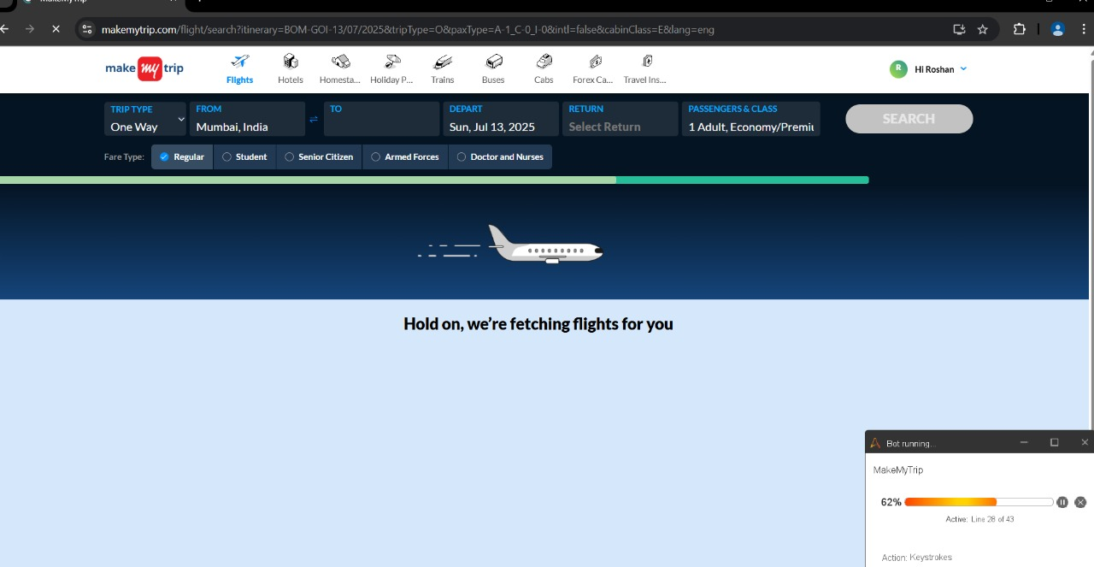
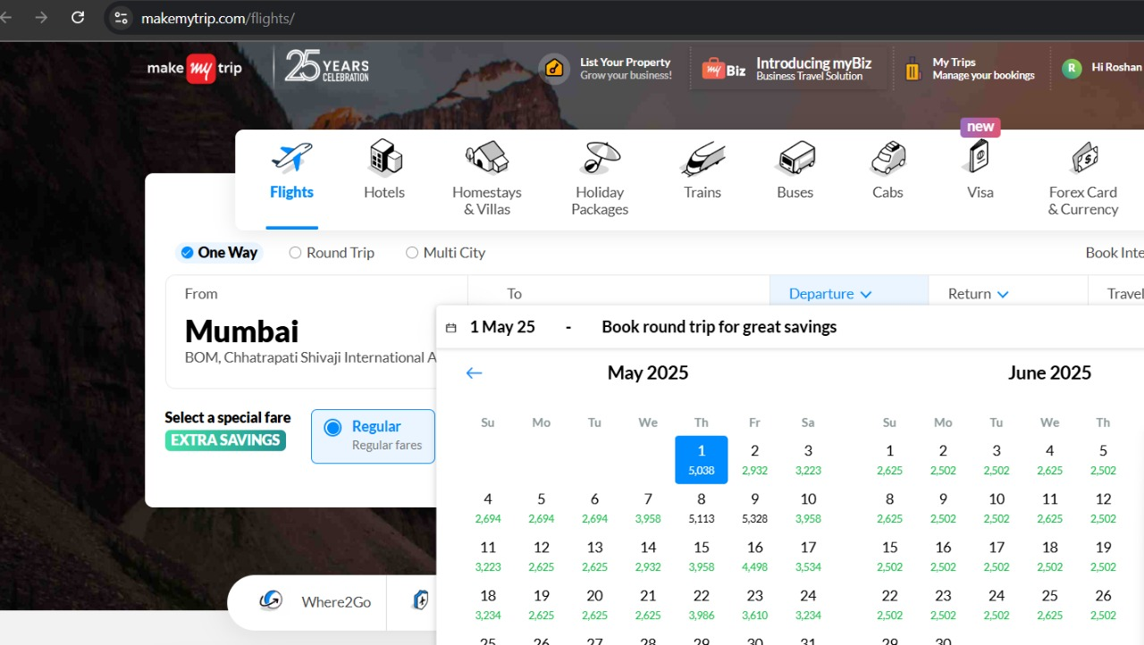
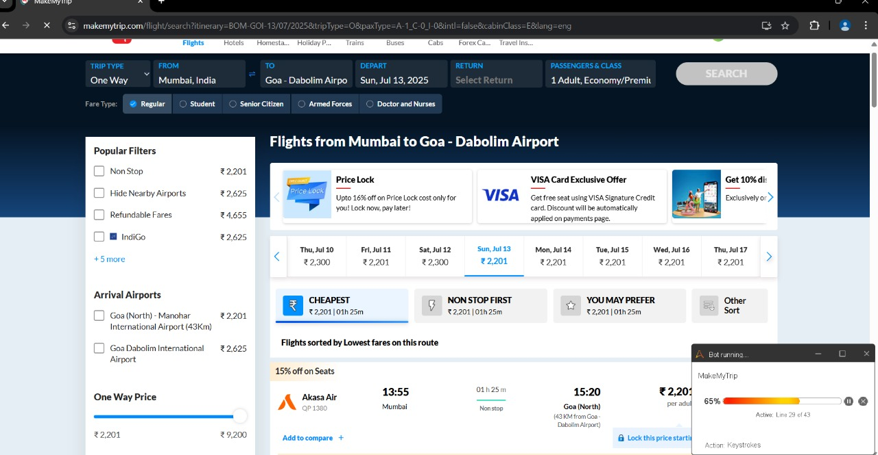

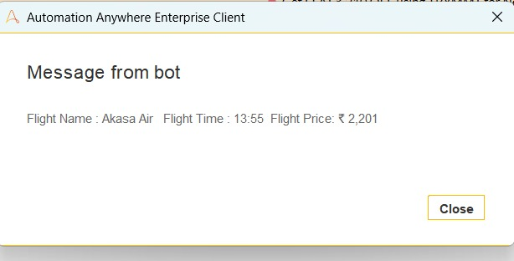

- Conclusions

The project demonstrates effective use of Automation Anywhere for automating the MakeMyTrip website. It simplifies testing and data collection tasks while offering scalable and reliable performance. Facilitates to get the cheapest flight out of all the available flights with respect to the source , destination and date which makes the booking process faster with the work done by the automation tool itself.

9.2 Future Work

- Extend bots to handle hotel and train bookings.
- Integrate email alerts for completed tasks.
- Incorporate AI modules for intelligent decision making.
- Visualize data with reporting dashboards.

9.3 Applications

1. Travel Booking Automation
By automating the search for the cheapest flights based on user inputs, the bot significantly reduces manual effort and enhances user convenience. With future extensions to include hotel and train bookings, the system can evolve into a comprehensive travel assistant, capable of managing end-to-end itinerary planning.

2. Personalized User Services
With the integration of AI-based decision-making modules, the system can analyze user preferences, travel history, and pricing trends to offer personalized travel recommendations, enhancing the user experience on the platform.

3. Enterprise Automation for Travel Agencies
Travel agencies and corporate travel planners can use this bot to automate bulk bookings, track fare fluctuations, and optimize travel plans. The automated email alerts feature will keep them informed of booking confirmations and updates in real time, improving service delivery.

4. Real-Time Alerts and Notifications
The inclusion of email alerts for task completions will make the system proactive in communication. Users or travel managers can be notified instantly when a booking search is completed or when a price drops, allowing for time-sensitive decisions.

5. Operational Dashboards and Analytics
By integrating reporting dashboards, businesses can visualize key data metrics such as frequently booked routes, pricing trends, and user behavior. These insights can help optimize offerings, predict high-demand periods, and enhance operational strategies.

References
- Thomas Noltey, Hans Hanssony, Lucia Lo Belloz, “Communication Buses for Automotive Applications,” ISW-2007, IEEE.
- A. Srivastava, S. Bhardwaj, and S. Saraswat, “Scrum model for agile
- methodology,” in 2017 International Conference on Computing, Com-
- munication and Automation (ICCCA), 2017, pp. 864–869.
- [14] A. Jurado-Navas and R. Munoz-Luna, “Scrum methodology in higher ed-
- ucation: Innovation in teaching, learning and assessment.” International
- Journal of Higher Education, vol. 6, no. 6, pp. 1–18, 2017.
- A. Srivastava, S. Bhardwaj, and S. Saraswat, “Scrum model for agile
- methodology,” in 2017 International Conference on Computing, Com-
- munication and Automation (ICCCA), 2017, pp. 864–869.
- [14] A. Jurado-Navas and R. Munoz-Luna, “Scrum methodology in higher ed-
- ucation: Innovation in teaching, learning and assessment.” International
- Journal of Higher Education, vol. 6, no. 6, pp. 1–18, 2017.
- A. Srivastava, S. Bhardwaj, and S. Saraswat, “Scrum model for agile
- methodology,” in 2017 International Conference on Computing, Com-
- munication and Automation (ICCCA), 2017, pp. 864–869.
- [14] A. Jurado-Navas and R. Munoz-Luna, “Scrum methodology in higher ed-
- ucation: Innovation in teaching, learning and assessment.” International
- Journal of Higher Education, vol. 6, no. 6, pp. 1–18, 2017.
- A. Srivastava, S. Bhardwaj, and S. Saraswat, “Scrum model for agile
- methodology,” in 2017 International Conference on Computing, Com-
- munication and Automation (ICCCA), 2017, pp. 864–869.
- [14] A. Jurado-Navas and R. Munoz-Luna, “Scrum methodology in higher ed-
- ucation: Innovation in teaching, learning and assessment.” International
- Journal of Higher Education, vol. 6, no. 6, pp. 1–18, 2017.
- A.srivastava , s. bhardwaj and s. saraswat , “scrum model for agile mehtodolo” , in 2017 international conference on coputing , communication and automation (ICCA),2017 pp.864-869

