Amanda Vital

Observable Trends

1. While doing the calculations for the age demographics I wondered in which category would majority fall. After printing out the DataFrame I noticed that most of the users were between the ages of 20 – 24.

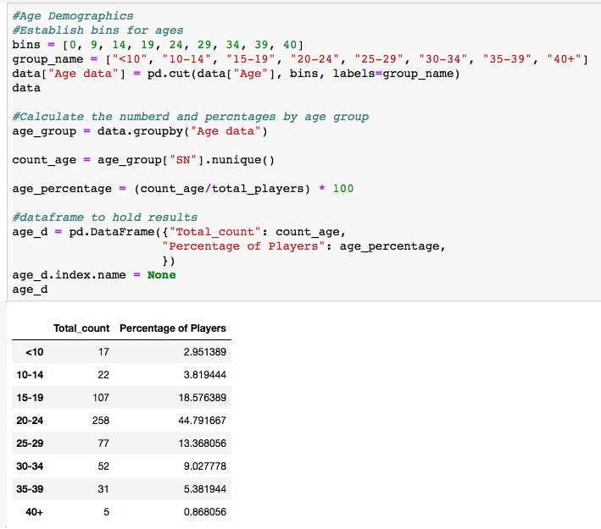

2. While calculating the top spenders, I noticed a trend. If we look at the chart we see that even though a user purchased 4 items, their average purchase price was still less than another spender who only purchased three items. This tells us that there is little correlation between purchase count and the average purchase price. Average purchase price is solely based off of how much the item costs rather than how many items were purchased.

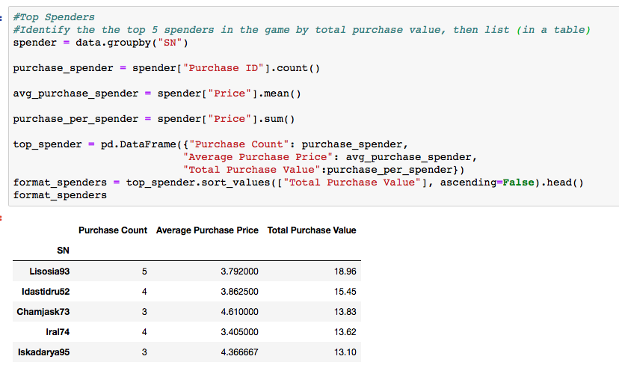

3. Lastly, I noticed that even though an item may be the most popular that does not mean it is also the most profitable. Just take a look below at the results produced by these two Data Frame’s .

