Ticket ID: CVNP1601-W1-001
Made a map of root file system 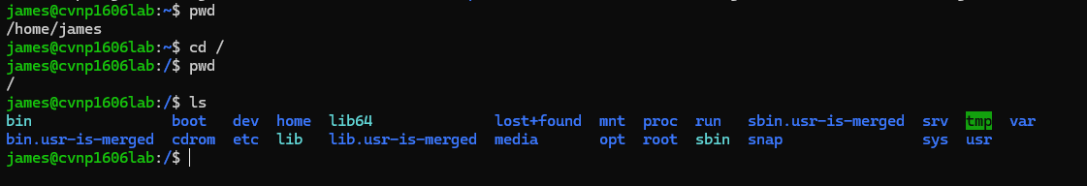
/etc contains system and application config files 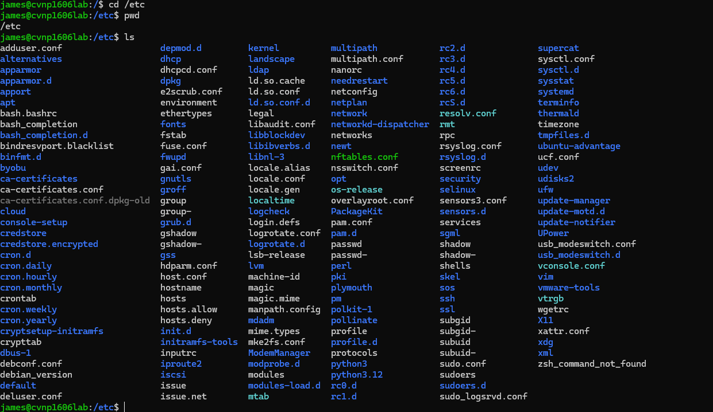
/var/log contatins variable data like logs directores and other system data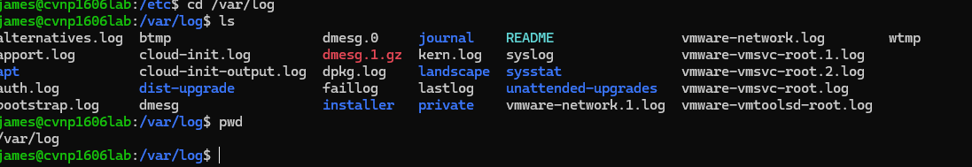
/home stores personal files and directories that the user owns 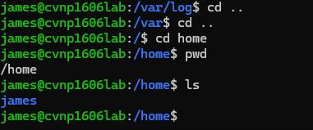
/usr/bin containes most exe programs and command line binares that are avalibe to users 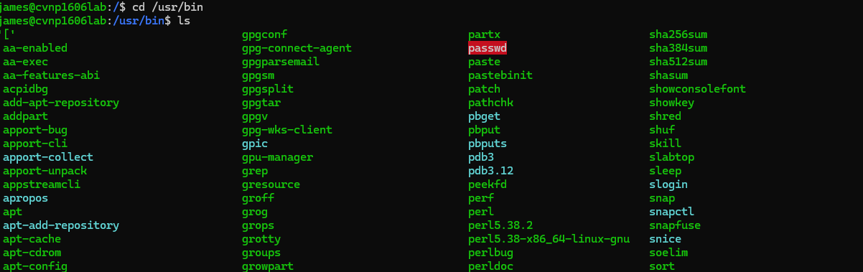 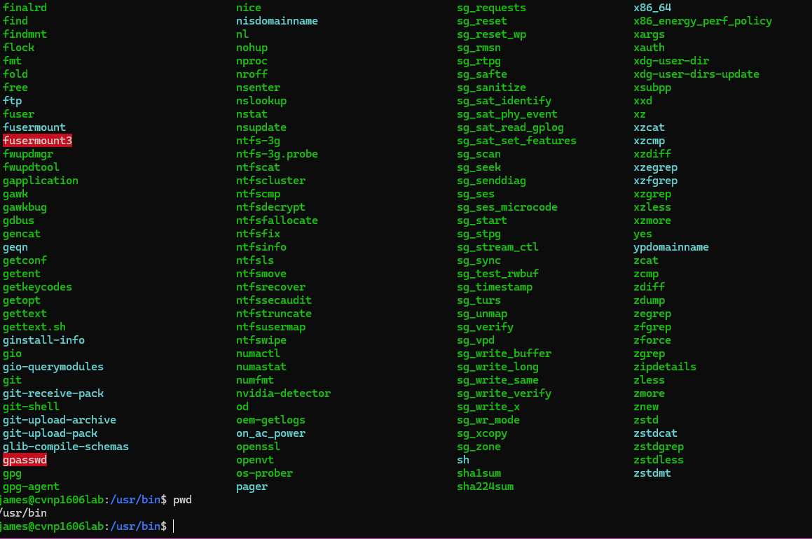
/tmp contains temp files that apps and users create they can be cleared appon reset 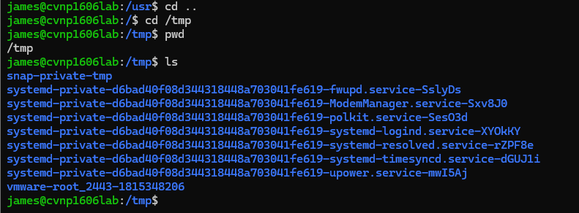
Tired to run a cd etc from /home it failed because the only directory in there is james 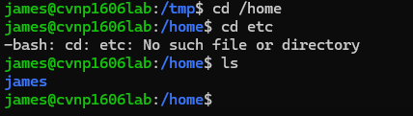
Ran a ls -lh /var/log 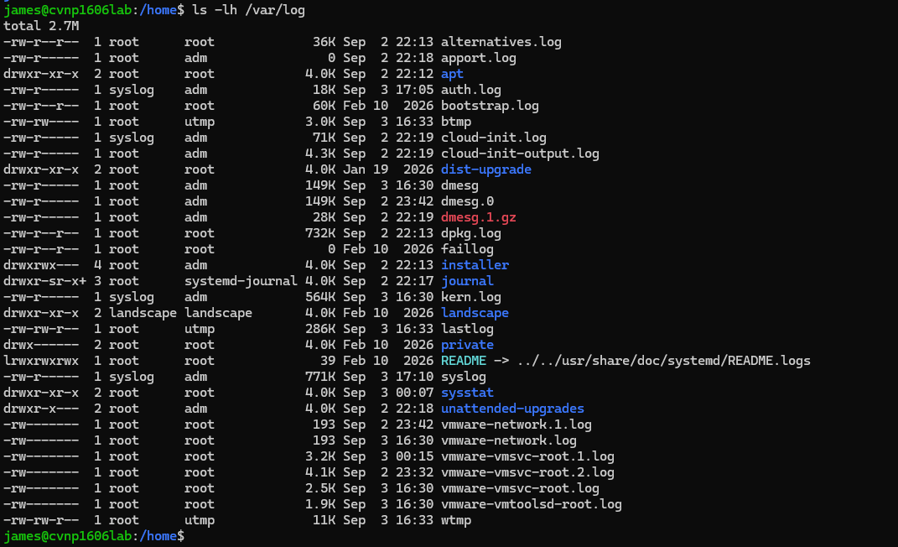
Auth.log is a records authentication and security related events like logins and ssh activity
Its 18K
Syslog is responsible for general system messages and events generated by the operating system and other services.
Its 771k
Kern.log is containing messages related to the Linux kernel or core of the OS
Its 564k
Returned to root ran first command 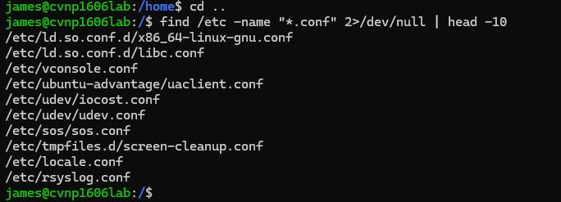
Ran the following other 2 commands 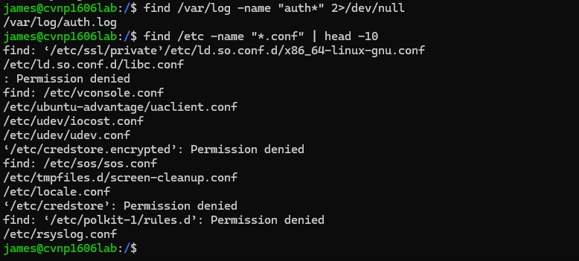
Explanation the 2>dev/null redirects standard error (stderr) to /dev/null which then discards error messages when the redirection is removed these messages are displayed in terminal allowing you to see what locations find couldn’t not gain access to access denied is normal and doesn’t always mean there is something that needs to be fixed
Navigated to week01-shell

Filterd output 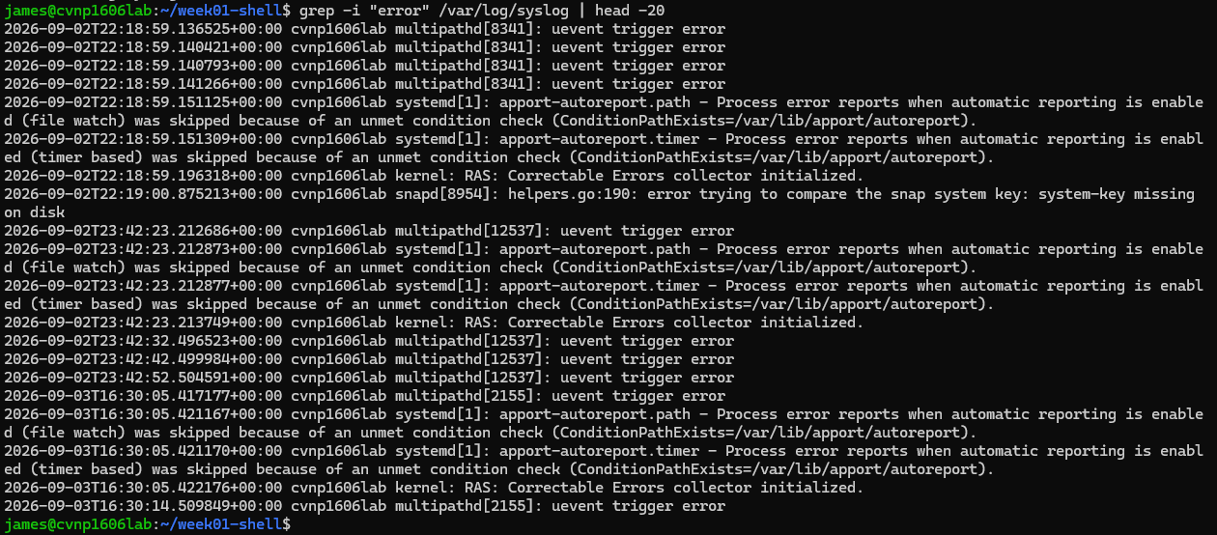
The count on errors
Ran commands to add warning to the errors 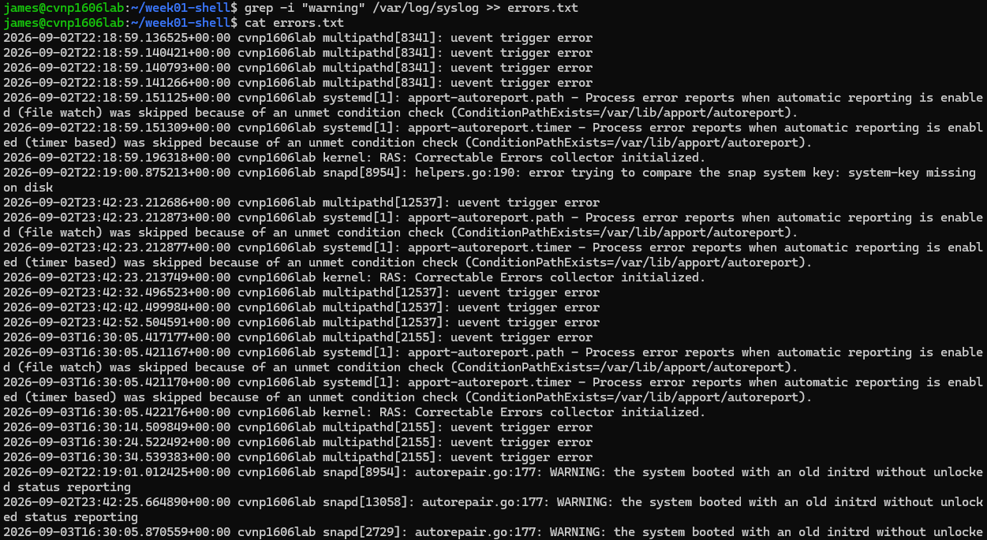
There are 25 error.txt
Ran head and tail errors 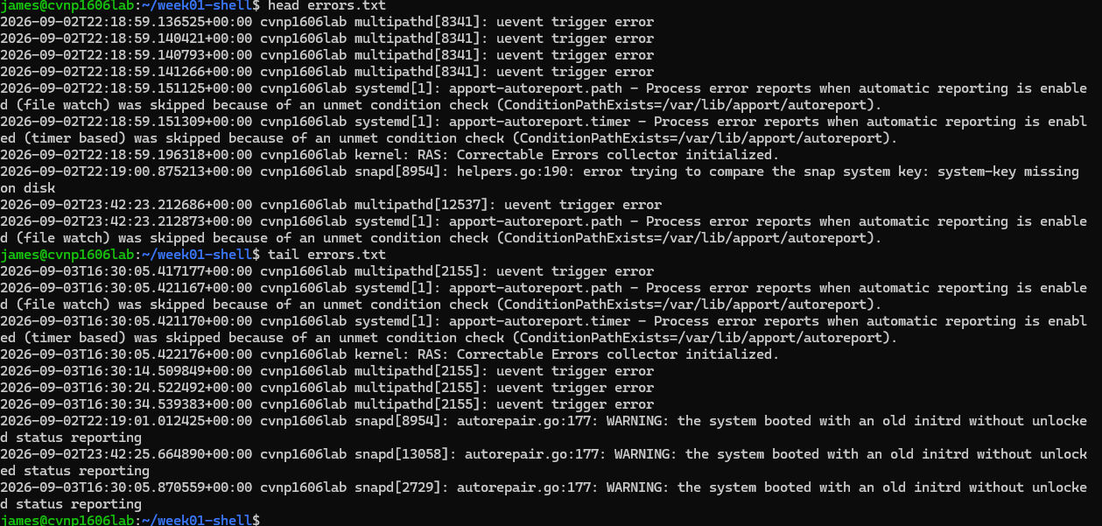
Explanation The > r redirects output to a file and over writes the file if it already exisits the >> appends the output to the end of a existing file without removing its previous contents using >> is safer when trying to preserve previous evidence
Made the cheatsheet 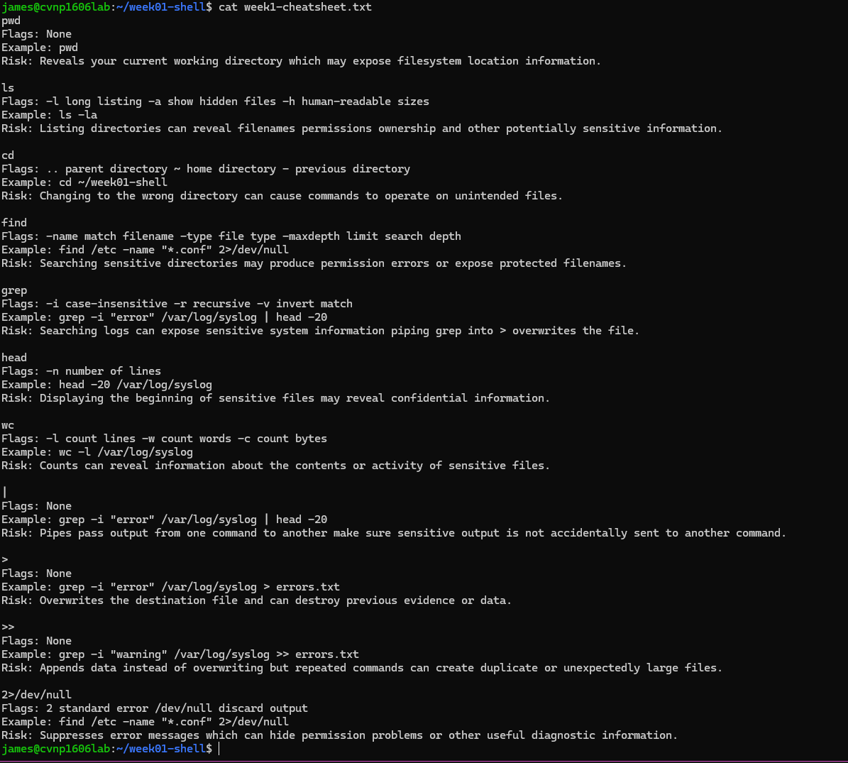
Wrote the diagnosis for the ticket 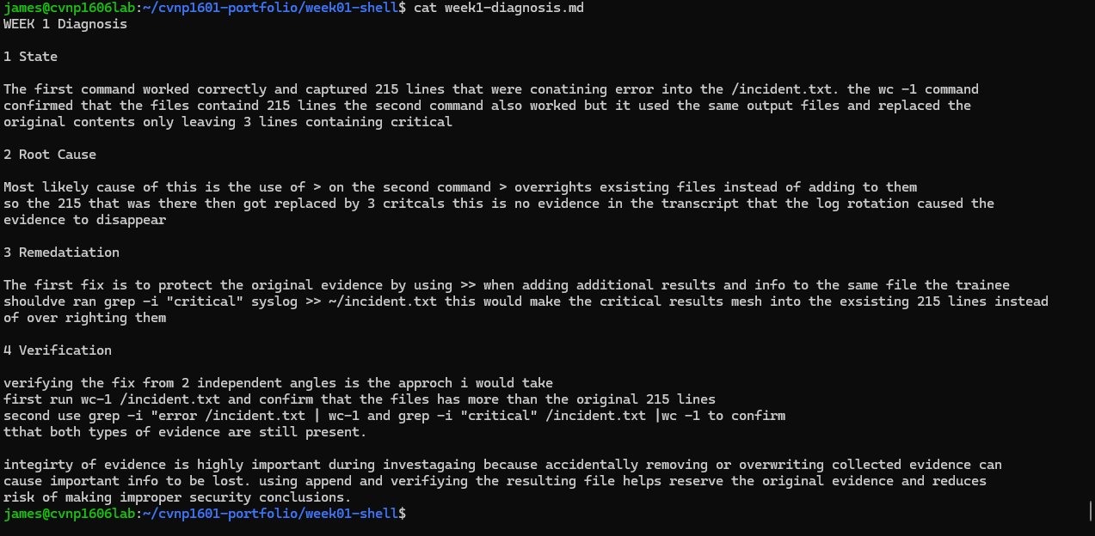
Trouble shooting narrative created 