Checked to see if the keys were there then generated a new key for week7
I added it to my james account I was having a issue with the student account 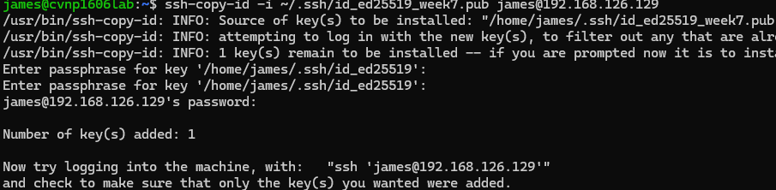
Logged in 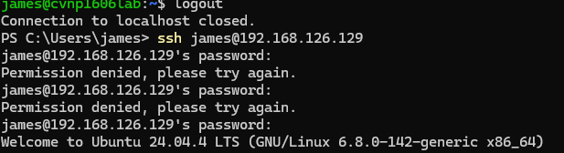
Made change to password auth and pubkey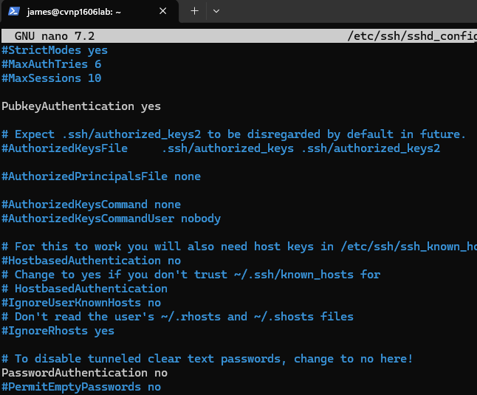
Validated they were configured 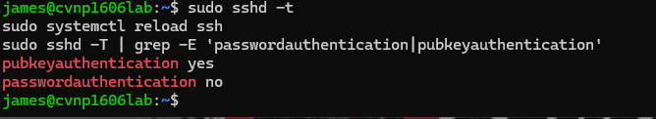
Configured firewall settings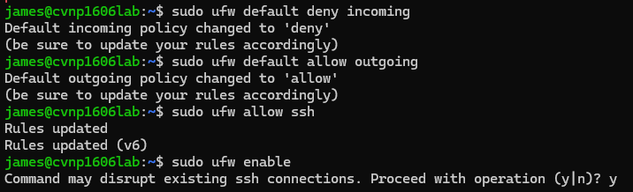made sure firewall was active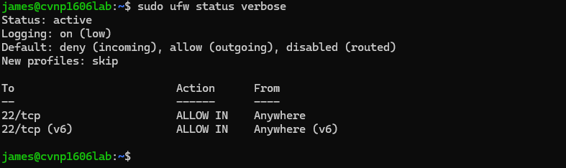

Locked down permissions 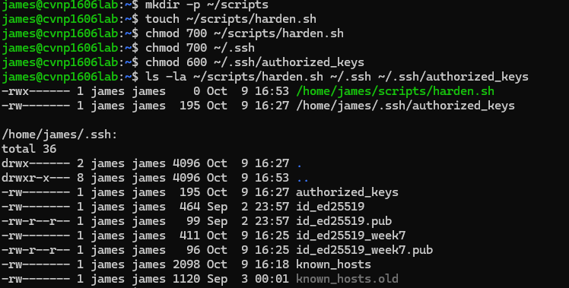
Confirmed it
Final verification 