Logged into the server ran the commands to find the cpu maxing process 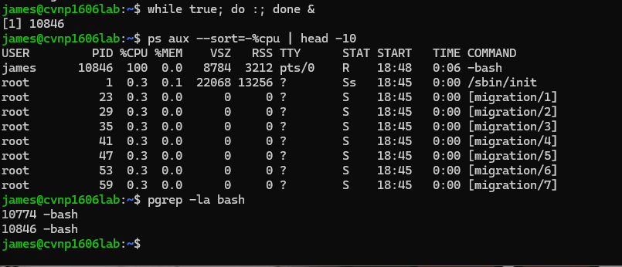
Killed the process and verified 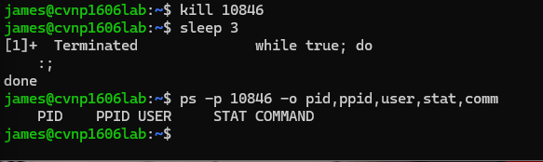
Sigterm asks a process to terminate gracefully allowing it to clean up sigkill -9 is a force stop which stops that process immediately sig term worked I didn’t use sig kill
Stopped the ngix process 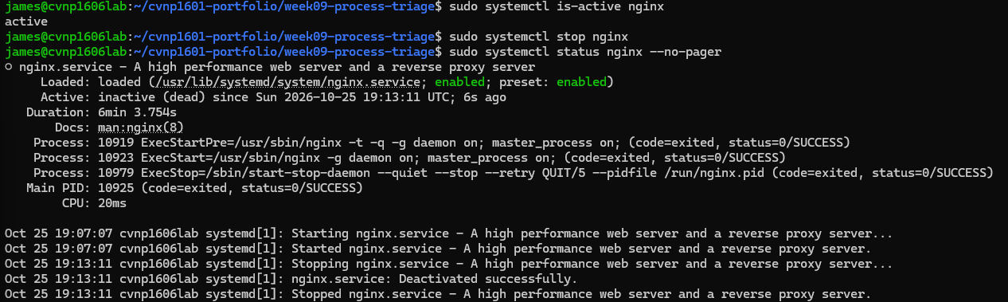
I had to go back and fix the error display it didn’t output properly so this is the retouched snip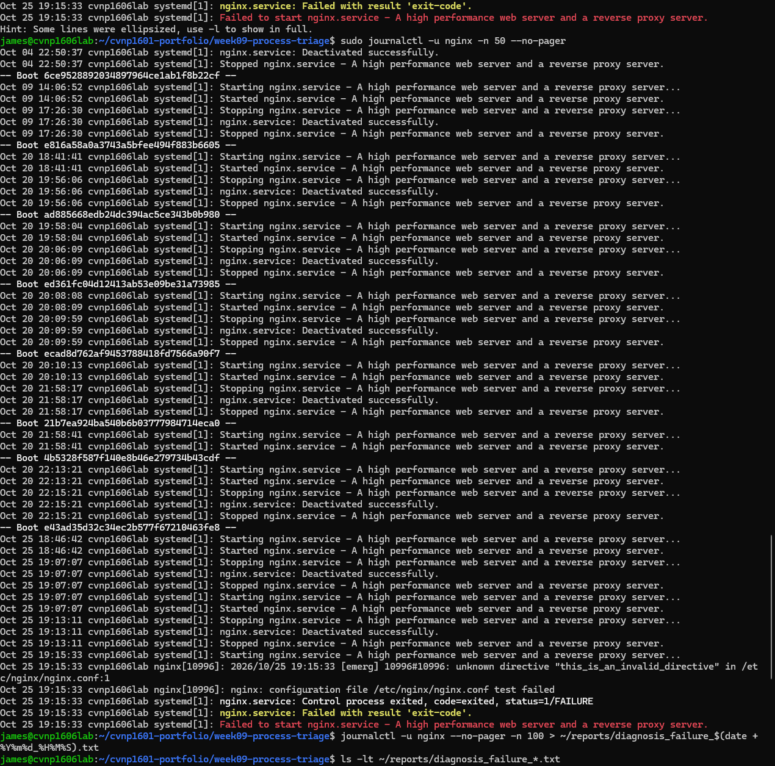

Created a invalid line in ngix 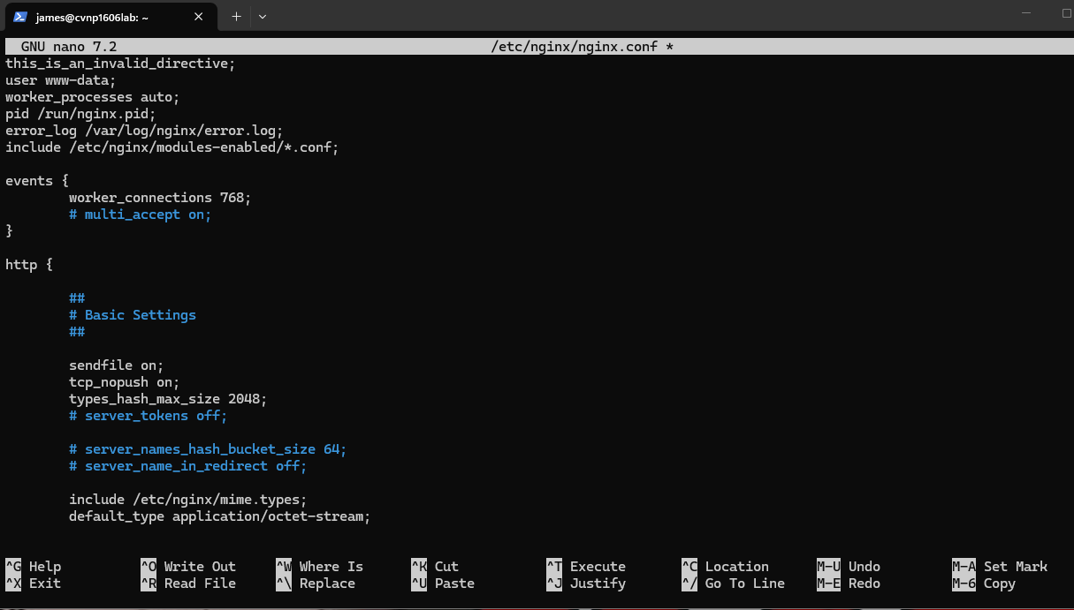

Captured the evidence file 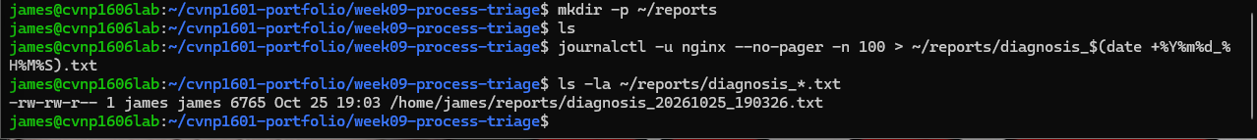
Made another evidence file 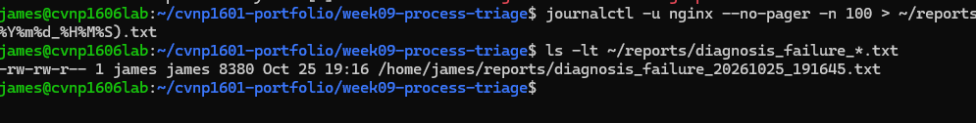
Removed the line causing the error 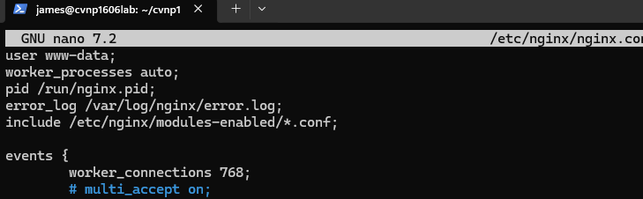
Proof of fix 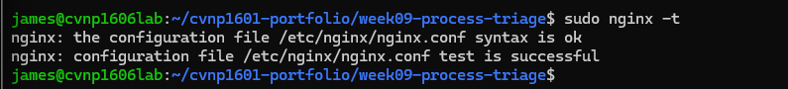
And verification of the fix 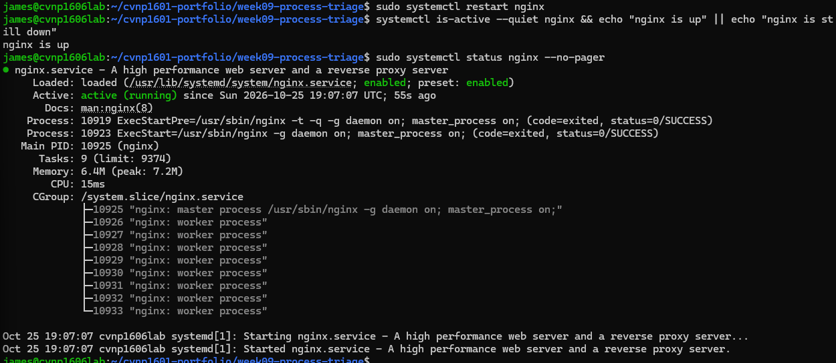
Second verification of the fix 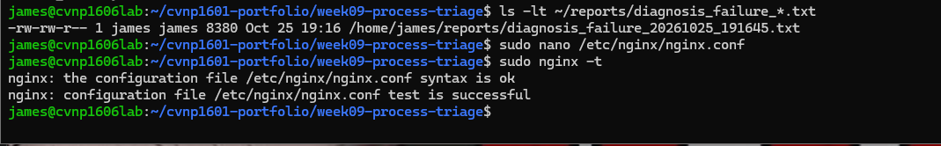
Proof of it being back up and active again for the second time 