Sorry documentation is just not great this time but ran through the setup made the directory made the script 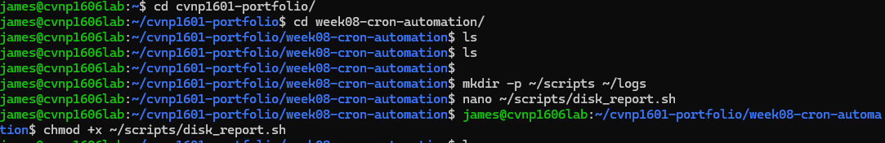
After some adjustments made to it which I didn’t take a picture of unfortunately I got it running 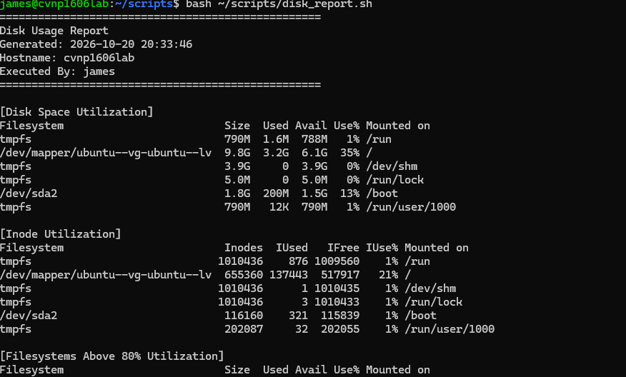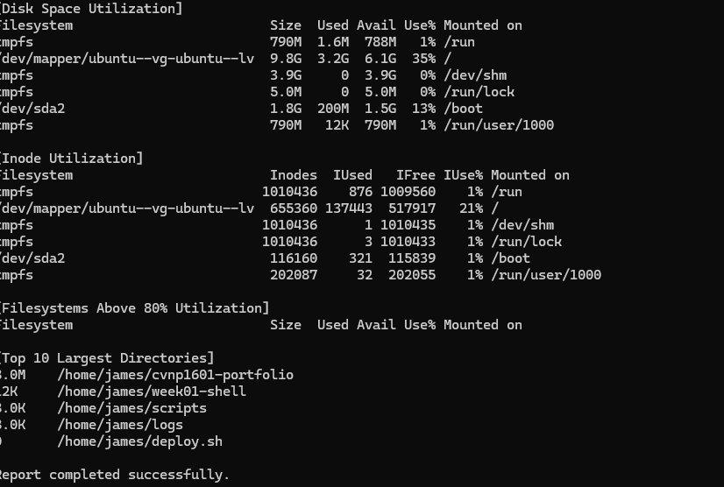
Next I cat the report and ran the tail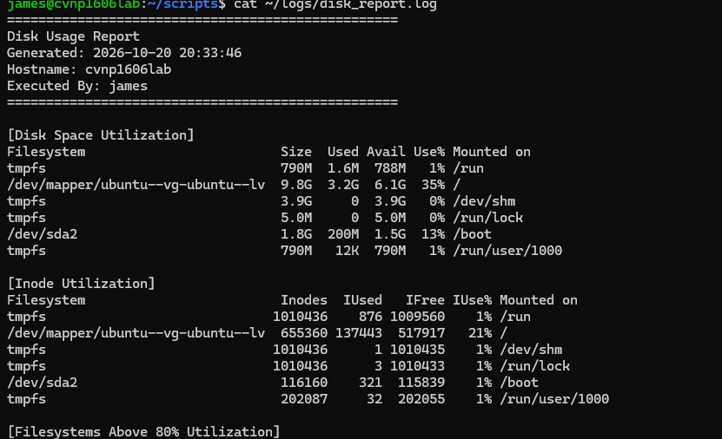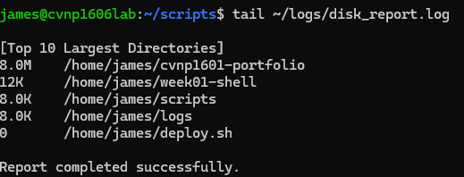
Fought with cron tab but eventually just started doing it right and not messing it up lol 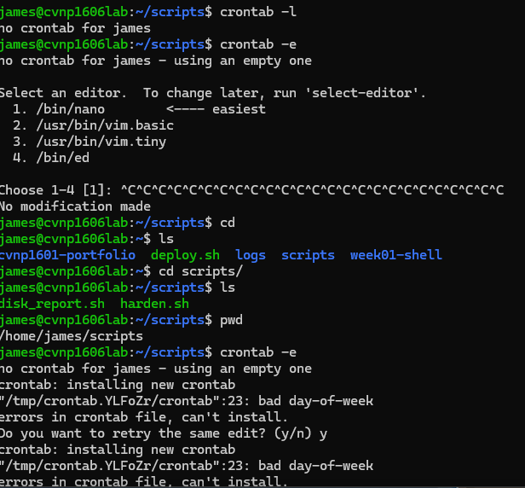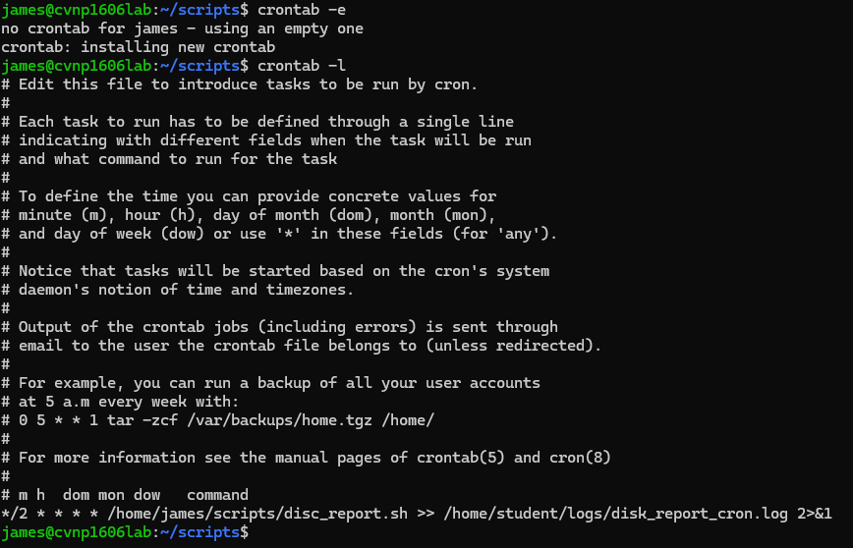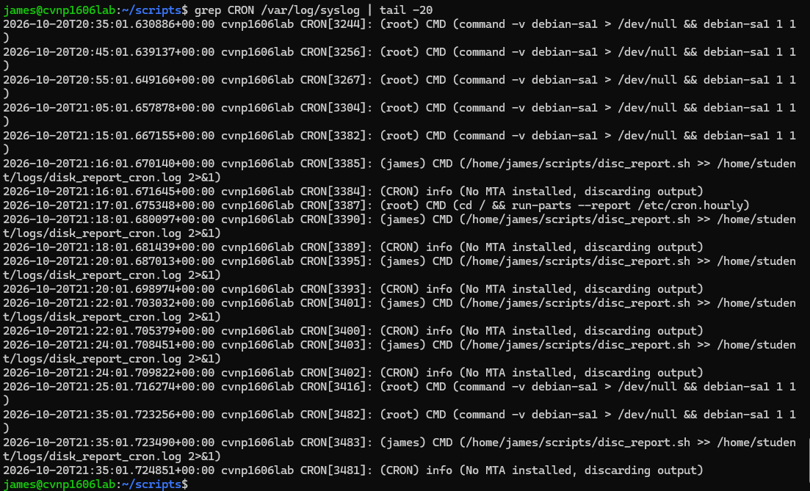
Changed the schedule 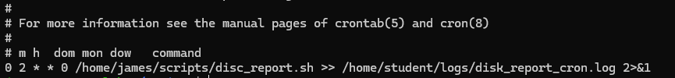

Using a full path such as /home/james/scripts/disk_report.sh ensures cron can always locate and execute the script. The 2>&1 redirection sends error messages to the same log as normal output ensuring failures are recorded and available for troubleshooting and auditing.

