Made the script dir and used nano to make the script 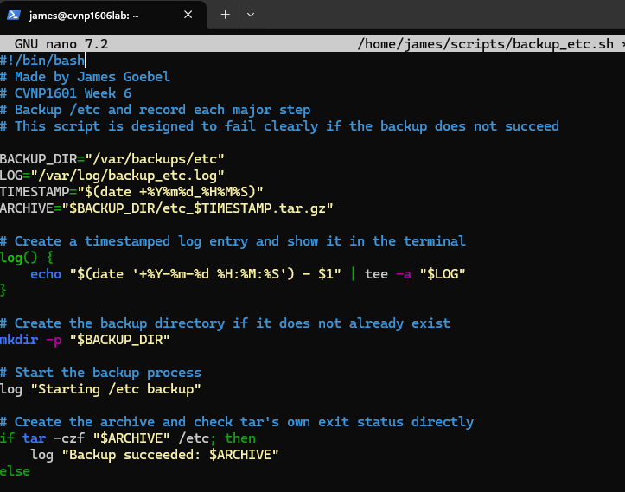
Picture showing chmod was ran to make it executable 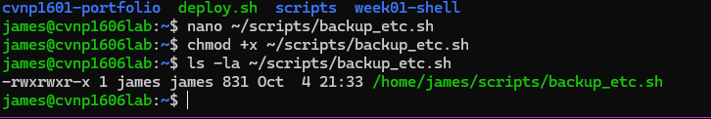
Task one explanation
The shebang tells Linux to use Bash when running the script. The variables store the backup directory, log file, timestamp, and archive name so they can be reused throughout the script. Quoting the variables helps prevent problems with paths or values that contain special characters.

Ran the script properly 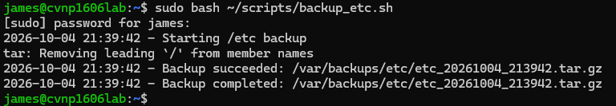
Ran the tail -20 command to confirm functionality
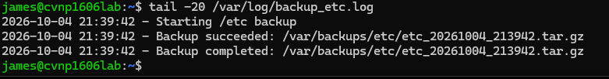
Ran ls to show archive file in location 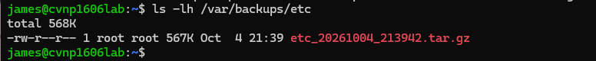
Tee -a lets the script display the log message on the terminal while also writing to the log file -a appends the message instead of making a new one this allows the administrator immediate output while also keeping a log that can be looked at later
This shows the git was initialized on the Linux system and it recognizes your script as an untracked file 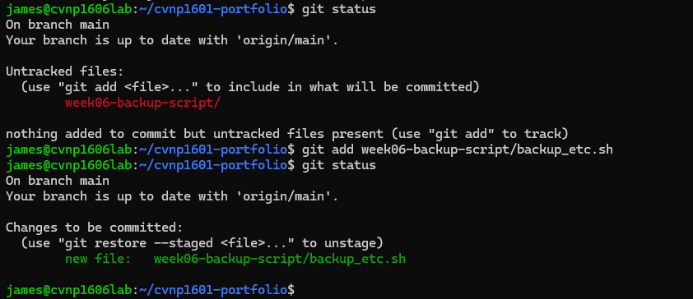
Updated fi statement 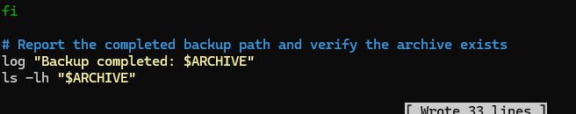
Verified change 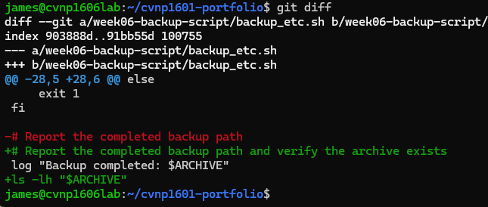
Ran a git status as well 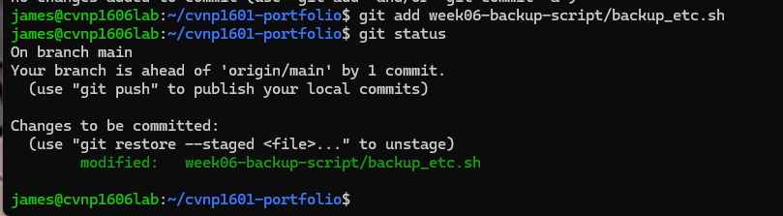
Made cheatsheat 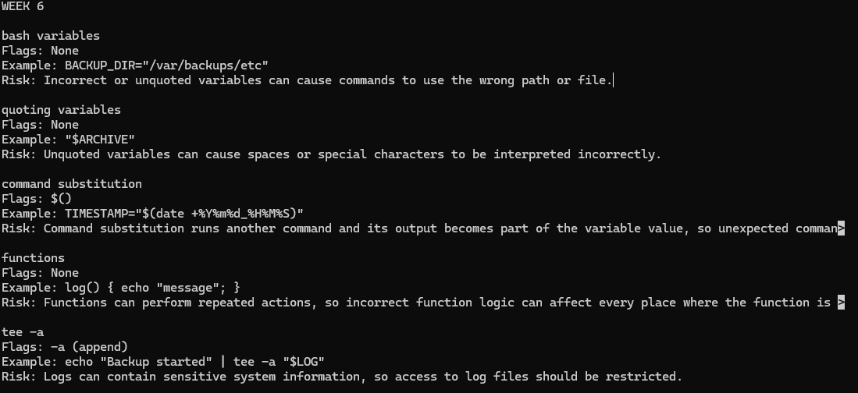
Staged the cheat sheet and commited it

