To: JohnoReilly@gmail.com
Subject: Website Update
Hello John,
We are informing you that the website is making good progress so far. We have added contact form in the contact page which allows user to enter his details for us to contact with him later. While entering his details in form, he would be asked to enter his name, email and question which he might want to ask. When data entered, user get message regarded sending and that his message has been saved locally.
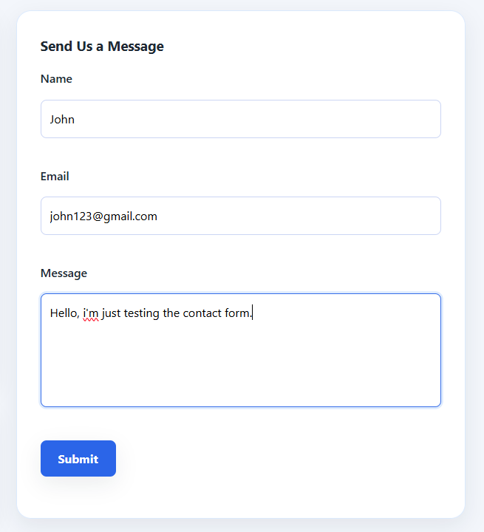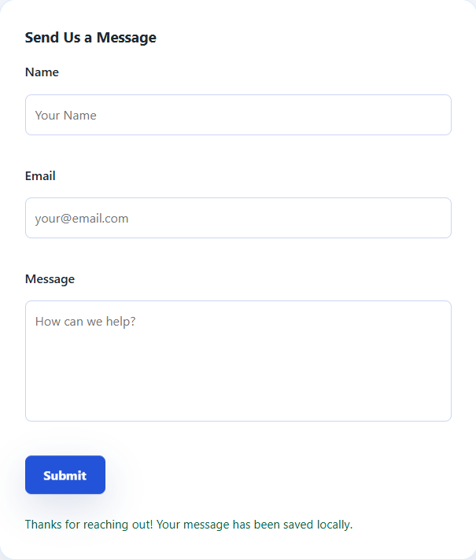
We also made a data validation for our form. For example, if user would enter numbers in field “Name”, he would get a message that name field is not allowed to have any numbers. For email entered without @ symbol and single dot, user would get a message about valid email address. For message, it says that message should be at least 10 characters, if user entered less.

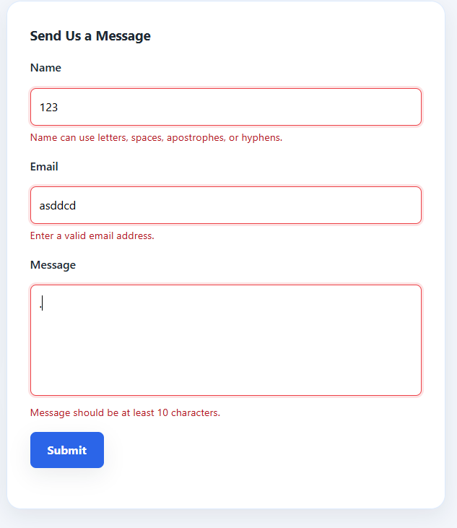
This is the link for the GitHub Repository: https://github.com/A00027507/WebDev_Project_super-car-boys.git
This is the link for the GitHub Pages:
https://a00027507.github.io/WebDev_Project_super-car-boys/

Kind Regards
The Team: Yaroslav Shulhin, Sean Power, Ruairi Black

