To: JohnoReilly@gmail.com
Subject: Website Update
Hello John,
We are informing you that the website is making good progress so far. We have added features to resize the page to fit other devices like phones and tablets while keeping the UI accessible. We have also added an extra page to the website to display the car collection as well as some changes to the CSS to make the website look nicer. We have added an events page to let users aware of upcoming events. With all that, it should only be a few more weeks until it’s finished.
We also have made an accessibility check with lighthouse just to be sure that our website is accessible for everyone. We’ve got 100% for accessibility, which means that our website designed perfectly and suitable for everyone. As a proof we will show screenshot with our result.
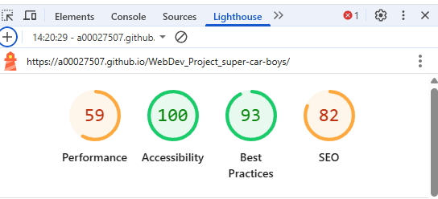
This is the link for the GitHub: https://github.com/A00027507/WebDev_Project_super-car-boys.git

Kind Regards,
The Team

