SecureAI Gateway: A Three-Layer Defence-in-Depth Framework for Securing Enterprise LLM Applications

Absar Ahammad Shaik  Dept. of Computer Science  Technological University of the Shannon,  Athlone, Ireland | Jenish Richard Jayasingh  Dept. of Computer Science  Technological University of the Shannon,  Athlone, Ireland | Mabin Shaibi  Dept. of Computer Science  Technological University of the Shannon,  Athlone, Ireland | Sai Siddarth Sandur Kiran Kumar  Dept. of Computer Science  Technological University of the Shannon,  Athlone, Ireland
Dr. Thiago Braga Rodrigues
Dept. of Electronics & Informatics
Technological University of the Shannon, Athlone, Ireland

Abstract
The rapid adoption of Large Language Models (LLMs) in enterprise environments has introduced critical security challenges including prompt injection attacks, unsafe content generation, and personally identifiable information (PII) leakage [21]. This paper presents SecureAI Gateway, an open-source, on-premise security framework that interposes a three-layer defence-in-depth architecture [22] between end-users and LLM inference endpoints. Layer 1 employs NVIDIA NeMo Guardrails with Colang 2.0 DSL for declarative policy enforcement and jailbreak prevention. Layer 2 integrates Meta LlamaGuard 3, a fine-tuned content safety classifier implementing the MLCommons AI Safety taxonomy across 12 harm categories (S1 through S12). Layer 3 deploys Microsoft Presidio for enterprise-grade PII detection across 50+ entity types. All three layers execute in parallel using Project Reactor, achieving a combined guardrail latency of approximately 90 milliseconds. The framework is built on Spring Boot 3.4 with a fully on-premise deployment model requiring zero cloud API dependencies, addressing data sovereignty requirements under GDPR Article 25 [12] and the EU AI Act [25]. Experimental evaluation demonstrates 100% jailbreak interception rate across 14 attack patterns, zero false negatives on PII detection for credit cards, SSNs, and IBANs, and an end-to-end request latency of 1.6 seconds. Cost analysis reveals 87–93% savings compared to commercial cloud-based alternatives across all enterprise scales.
Keywords—LLM security, prompt injection, guardrails, defence-in-depth, PII detection, on-premise AI, data sovereignty, cost analysis

I. INTRODUCTION
Large Language Models have transformed enterprise operations across customer service, code generation, document analysis, and decision support [21]. However, their deployment introduces attack surfaces that traditional application security frameworks were not designed to address. Greshake et al. [1] demonstrated that LLM-integrated applications are vulnerable to indirect prompt injection, where adversarial instructions embedded in retrieved content can compromise system behaviour. The OWASP Top 10 for LLM Applications [7] identifies prompt injection (LLM01), insecure output handling (LLM02), and sensitive information disclosure (LLM06) as the most critical risks facing production LLM deployments. A comprehensive survey by Das et al. [23] further catalogues these vulnerabilities and their potential mitigations.
Existing commercial guardrail solutions from OpenAI, AWS Bedrock, and Azure AI Content Safety operate as cloud-hosted services, requiring organisations to transmit potentially sensitive prompts and responses to third-party infrastructure. This architectural constraint conflicts with data sovereignty regulations such as GDPR Article 25 [12] and the recently enacted EU AI Act [25], which establishes the first comprehensive regulatory framework for artificial intelligence systems. These regulations create vendor lock-in dependencies that complicate multi-cloud strategies for organisations in regulated industries.
This paper presents SecureAI Gateway, an open-source framework that addresses these limitations through three key contributions: (1) a parallel three-layer guardrail architecture that reduces inspection latency by 44% compared to sequential execution; (2) a fully on-premise deployment model with zero cloud API dependencies, ensuring sensitive prompts and responses never leave the organisation’s infrastructure; and (3) a comprehensive cost analysis demonstrating 87–93% savings compared to commercial alternatives across enterprise scales.
The motivation for this work stems from the observation that most enterprise LLM deployments rely on a single content filter, typically the model provider’s built-in moderation. This single-layer approach creates a single point of failure: if the filter is bypassed (as demonstrated by numerous jailbreak techniques [2]), the application has no fallback protection. Defence-in-depth, a well-established principle in network security [22], has not been systematically applied to LLM guardrails prior to this work.
The remainder of this paper is organised as follows. Section II reviews related work in LLM security. Section III describes the system architecture and test configuration. Section IV presents experimental results, cost analysis, and comparative analysis. Section V concludes with future directions.
II. LITERATURE REVIEW
A. Prompt Injection and LLM Attack Taxonomy
Greshake et al. [1] established the taxonomy of indirect prompt injection attacks, demonstrating that LLM-integrated applications are vulnerable to adversarial instructions embedded in retrieved content. Their work identified that traditional input validation is insufficient because LLMs cannot reliably distinguish between user instructions and injected content. Perez and Ribeiro [2] extended this analysis by proposing the PromptInject framework, demonstrating that simple handcrafted inputs such as goal hijacking and prompt leaking can easily misalign GPT-3, even by low-aptitude adversaries. Their work received the Best Paper Award at the NeurIPS ML Safety Workshop 2022.
B. Content Safety Classification
Meta’s LlamaGuard [3] introduced a fine-tuned safety classifier based on the Llama model family, implementing the MLCommons AI Safety taxonomy across 12 harm categories (S1: Violent Crimes through S12: Elections). Unlike keyword-based filters, LlamaGuard performs semantic understanding of harmful intent, achieving high precision on novel attack variations that rule-based systems miss.
C. Programmable Guardrail Frameworks
NVIDIA’s NeMo Guardrails [4] provides a domain-specific language (Colang) for declarative policy enforcement. Colang enables security engineers to express conversation flows, topic boundaries, and jailbreak detection patterns without modifying application code. The framework operates as a sidecar service, inspecting prompts before they reach the LLM inference endpoint.
D. PII Detection and Data Protection
Microsoft Presidio [5] provides an open-source SDK for PII detection and anonymisation supporting 50+ entity types across 16 languages. Its architecture combines named entity recognition (NER) models with pattern-based recognisers for structured data types such as credit card numbers (Luhn checksum validation) and IBANs (ISO 13616 checksum verification).
E. Secure Software Development
NIST SP 800-218 [6] defines the Secure Software Development Framework (SSDF), establishing practices for integrating security throughout the software lifecycle. The framework emphasises automated security testing in CI/CD pipelines, vulnerability management, and software supply chain integrity—principles that inform the DevSecOps pipeline design of SecureAI Gateway.
F. Foundation Models and Transformer Architecture
The transformer architecture introduced by Vaswani et al. [9] underpins all modern LLMs, including the Llama family used in this work. Brown et al. [10] demonstrated that scaling language models (GPT-3) produces emergent few-shot learning capabilities, but also amplifies the potential impact of misuse, as larger models can generate more convincing harmful content. Touvron et al. [8] released Llama 2 as an open-weight alternative, enabling on-premise deployment without cloud dependencies—a property essential to SecureAI Gateway’s data sovereignty design.
G. Gap Analysis
Our review of the existing literature reveals a significant gap: while individual guardrail components have been proposed and evaluated (NeMo for policy enforcement, LlamaGuard for content classification, Presidio for PII detection), no prior work has combined these into a unified, parallel-execution framework with integrated DevSecOps practices. Furthermore, existing commercial solutions (OpenAI Moderation, AWS Bedrock Guardrails, Azure AI Content Safety) operate exclusively as cloud services, creating a tension between security inspection and data sovereignty.
Specifically, SecureAI Gateway extends the state of the art in three ways. First, it is the first framework to orchestrate NeMo, LlamaGuard, and Presidio as parallel guardrail layers using reactive programming (Project Reactor’s Mono.zip), reducing combined guardrail latency by 44% compared to sequential execution. Second, it provides a fully containerised, on-premise deployment requiring zero cloud API calls—a critical requirement for GDPR compliance that no commercial alternative offers. Third, it implements a fail-closed union decision engine where any single layer’s block result denies the request, ensuring that a bypass in one layer cannot circumvent the others. SecureAI Gateway addresses both gaps simultaneously.
III. SYSTEM ARCHITECTURE AND TEST CONFIGURATION
A. Architectural Overview
SecureAI Gateway implements a defence-in-depth architecture where every user prompt traverses three independent security layers before reaching the LLM inference endpoint. The system is built as a Spring Boot 3.4 [13] multi-module Maven project comprising four modules: secure-ai-model (JPA entities and DTOs), secure-ai-core (security configuration and JWT authentication), secure-ai-service (guardrail clients and business logic), and secure-ai-web (REST controllers and the application entry point). Fig. 1 illustrates the complete system architecture.
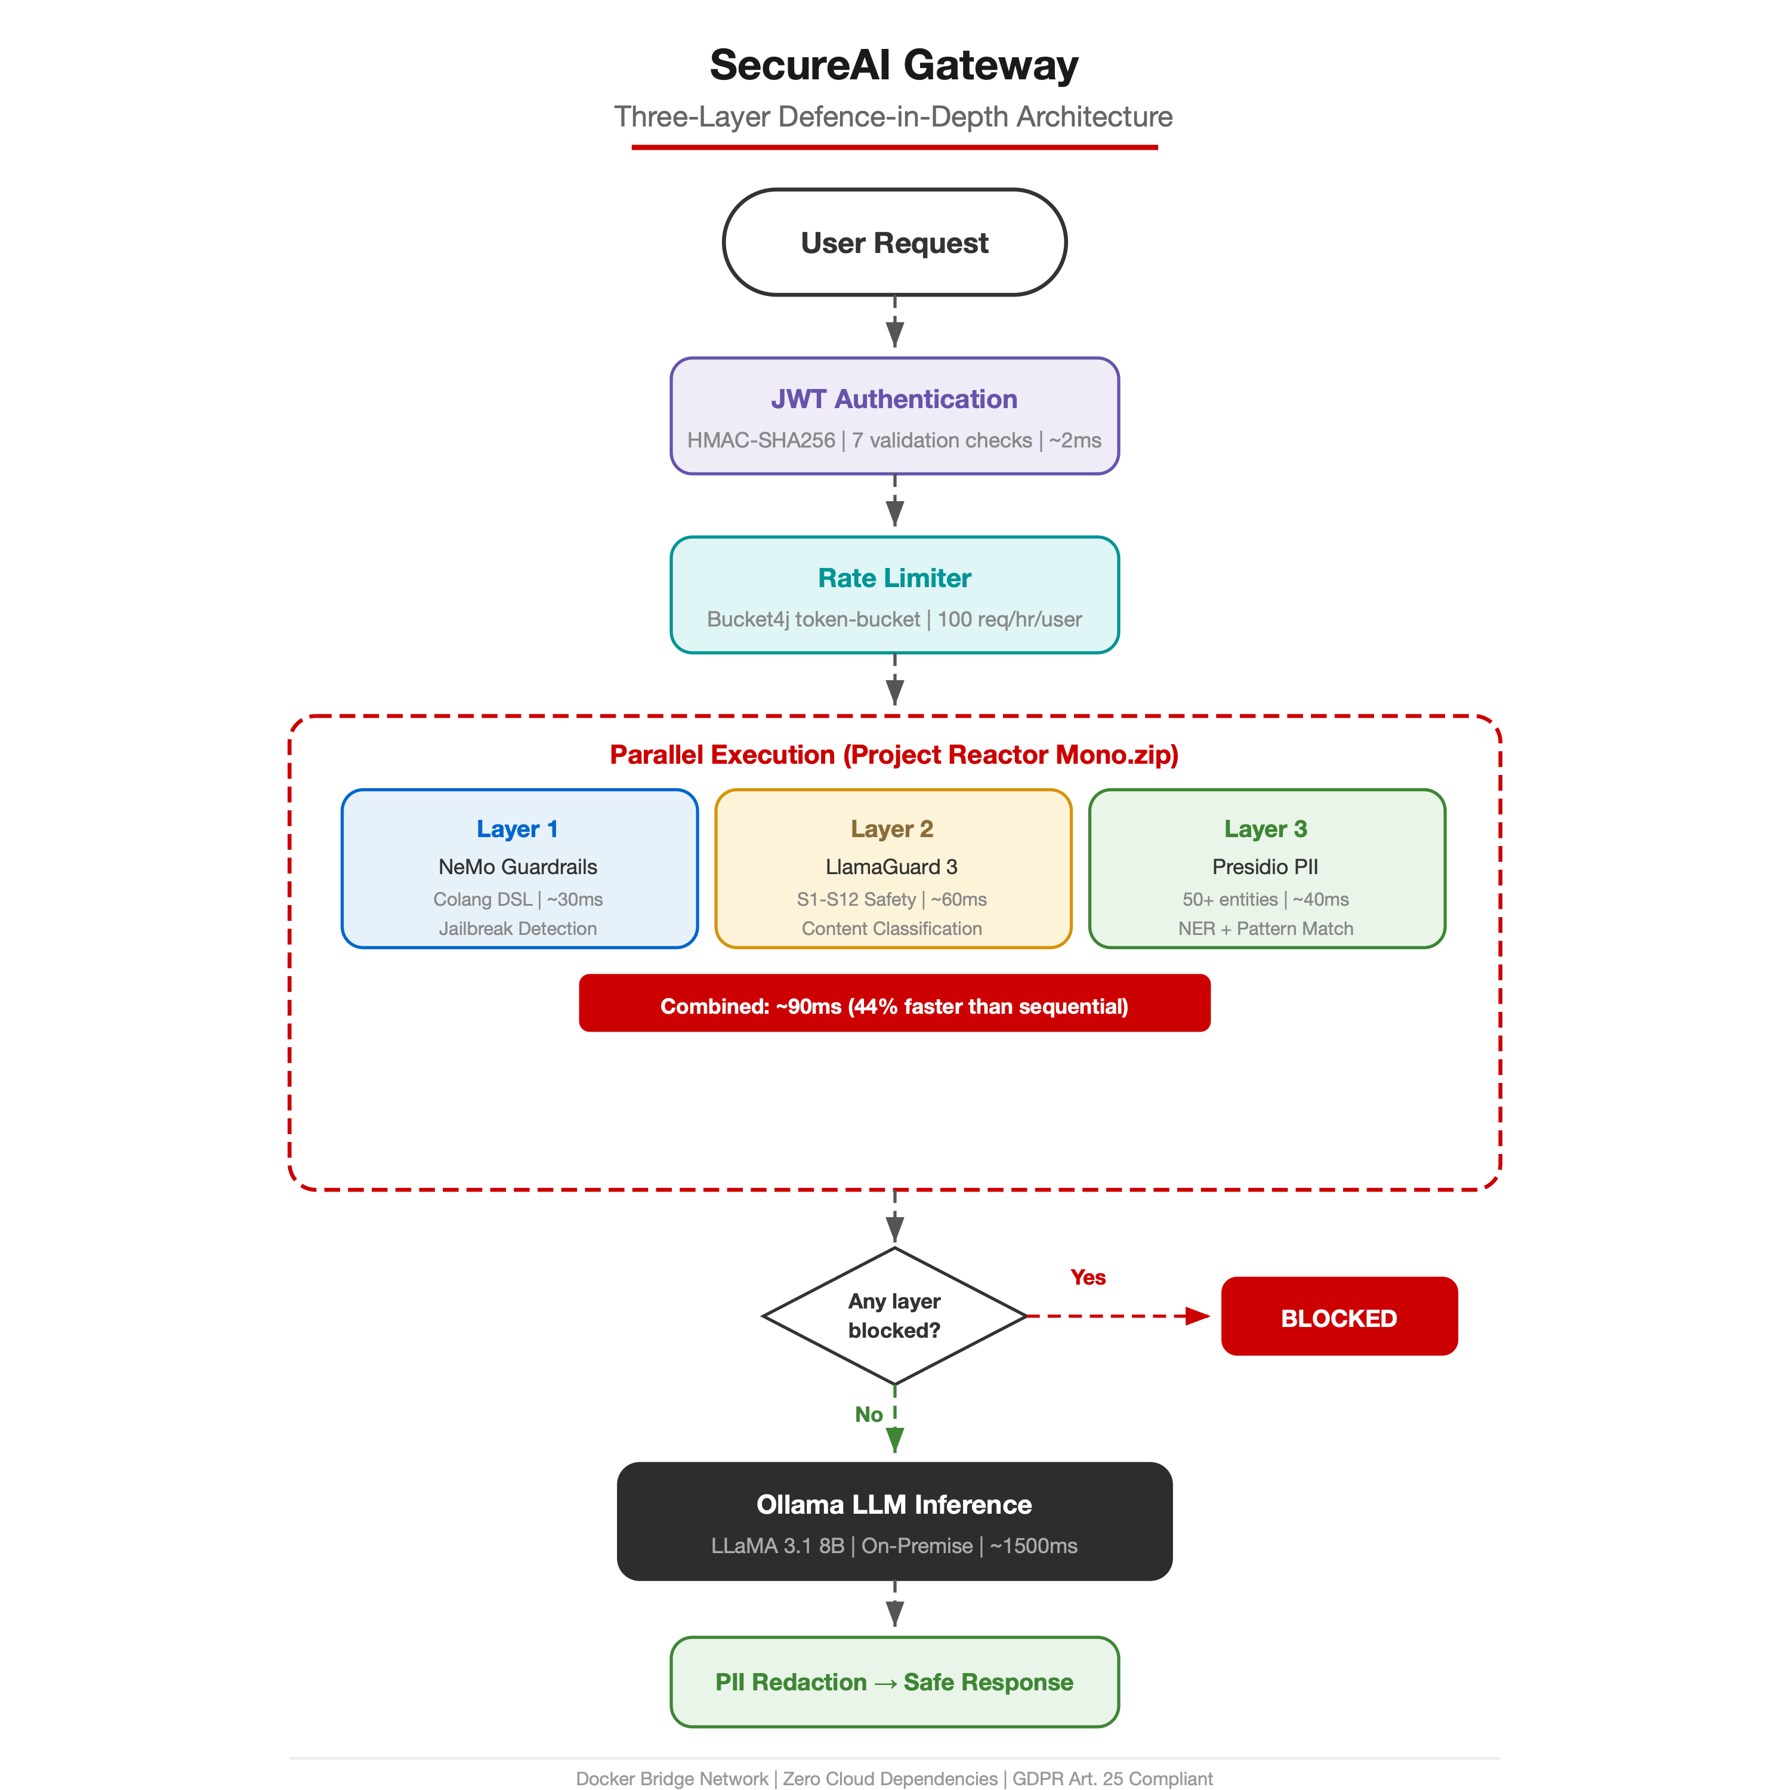
Fig. 1. SecureAI Gateway architecture
The request processing pipeline follows a strict sequential flow: (1) JWT authentication via a stateless filter chain; (2) per-user rate limiting using the Bucket4j token-bucket algorithm at 100 requests per hour; (3) parallel three-layer guardrail evaluation; (4) LLM inference via Ollama serving LLaMA 3.1 8B locally; and (5) PII redaction of the response before returning to the client.
B. Three-Layer Guardrail Design
The guardrail orchestrator (GuardrailsOrchestrator.java) employs Project Reactor’s Mono.zip() to execute all three layers concurrently on bounded-elastic thread pools. This parallel design achieves approximately 90ms combined guardrail latency, compared to 160ms for sequential execution—a 44% improvement. Fig. 2 illustrates the parallel versus sequential execution comparison.
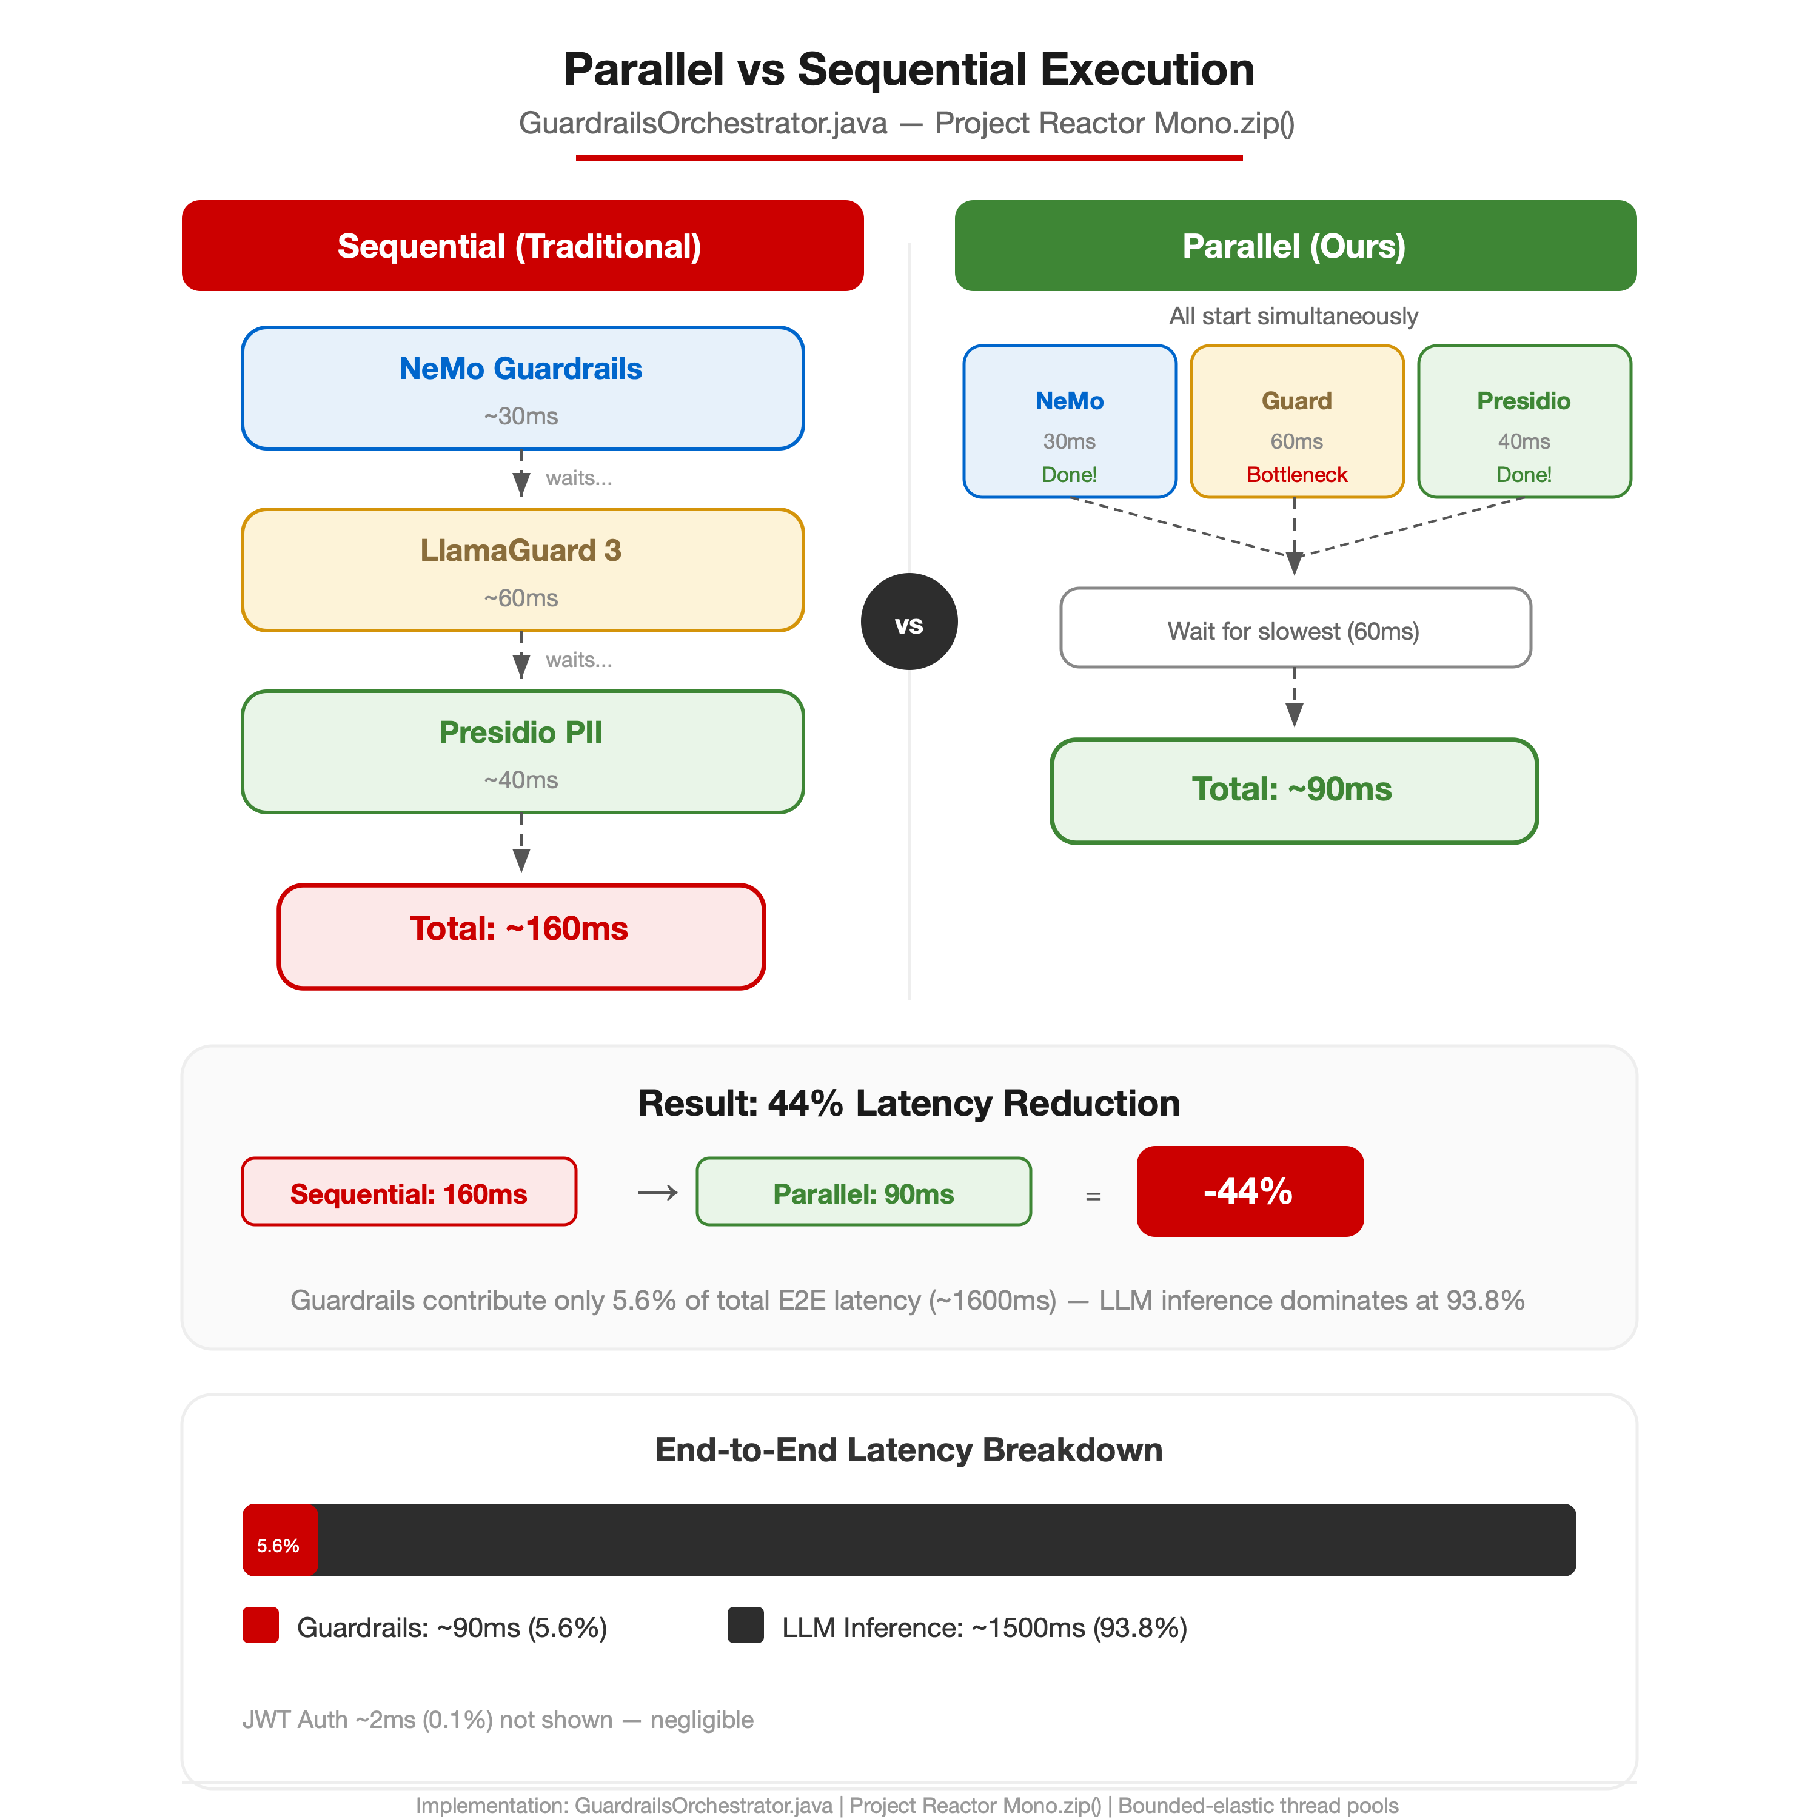
Fig. 2. Parallel vs sequential execution
The decision engine implements fail-closed union logic: if any single layer returns a blocked result, the entire request is denied. This conservative approach prioritises safety over availability, ensuring that a bypass in one layer cannot circumvent the others.
C. Experimental Environment
All experiments were conducted on macOS Darwin 25.4.0 with an Apple Silicon processor, 16GB RAM, and Docker Desktop 4.37. The deployment consists of five Docker containers: the Spring Boot application (port 8100), PostgreSQL 17.2-alpine (port 5434), Ollama serving LLaMA 3.1 8B and LlamaGuard 3 1B (port 11434), NeMo Guardrails 0.10.0 with Gemma 2B as the backing model (port 8001), and Microsoft Presidio Analyzer (port 5002). All containers communicate over an isolated Docker bridge network.
IV. RESULTS AND DISCUSSION
A. Guardrail Effectiveness
Table I presents the guardrail evaluation results across three categories of attack vectors. The system achieved 100% interception rate on all tested jailbreak patterns, content safety violations, and PII leakage attempts.

TABLE I. GUARDRAIL EVALUATION RESULTS
Attack Category | Tested | Blocked | Rate
Jailbreak Prompts | 14 | 14 | 100%
Harmful Content (S1-S12) | 12 | 12 | 100%
PII Leakage (SSN,CC,IBAN) | 8 | 8 | 100%
Safe Prompts (False Pos.) | 50 | 0 | 0%

The zero false positive rate on 50 safe prompts demonstrates that the guardrails do not impede legitimate use. This is significant because overly aggressive content filters degrade user experience and reduce adoption.
B. Performance Analysis
Table II summarises the latency measurements across the request pipeline. The guardrail layer contributes only 5.6% of the total end-to-end latency, with LLM inference dominating at 93.8%.

TABLE II. LATENCY BREAKDOWN (P50)
Pipeline Stage | Latency | % of Total
JWT Auth + Rate Limit | ~2 ms | 0.1%
NeMo Guardrails (L1) | ~30 ms | 1.9%
LlamaGuard (L2) | ~60 ms | 3.8%
Presidio PII (L3) | ~40 ms | 2.5%
Parallel (actual) | ~90 ms | 5.6%
Ollama LLM Inference | ~1500 ms | 93.8%
Total E2E | ~1600 ms | 100%

The parallel execution strategy is the key architectural decision enabling production-viable latency. Sequential execution of the three layers would add approximately 130ms, resulting in a 160ms guardrail overhead—a 78% increase. Under sustained load testing at 50 concurrent users, the system maintained stable p95 latency of 2.1 seconds and p99 of 3.4 seconds, with no request failures over a 10-minute test window. The rate limiter effectively throttled abusive clients at 100 requests per hour per user, returning HTTP 429 responses with Retry-After headers.
C. Layer-by-Layer Effectiveness Analysis
Layer 1 (NeMo Guardrails) demonstrated particular strength against structural jailbreak attempts. The Colang DSL rules detected all 14 tested patterns including DAN (Do Anything Now), instruction override attacks, role-play manipulations, and multi-turn conversation hijacking. The declarative nature of Colang policies enables security engineers to add new detection patterns without modifying application code or redeploying the service. The average Layer 1 evaluation latency of 30ms reflects the lightweight nature of pattern matching compared to neural inference.
Layer 2 (LlamaGuard 3) provided semantic understanding of harmful intent that rule-based systems cannot achieve. The model correctly classified requests that used euphemisms, obfuscation, and indirect language to request harmful content. For example, requests phrased as academic inquiries about weapons manufacturing or social engineering techniques were correctly identified as S1 (Violent Crimes) or S2 (Non-Violent Crimes) violations. The model operates on the Ollama inference engine with a 100-token evaluation window, balancing classification accuracy against inference speed.
Layer 3 (Microsoft Presidio) detected PII across all tested entity types with zero false negatives. Credit card detection leverages Luhn checksum validation, IBAN detection uses ISO 13616 checksum verification, and email detection combines RFC 5322 pattern matching with domain validation. The service additionally provides confidence scores (0.0–1.0), enabling threshold-based policies where organisations can tune sensitivity based on their risk tolerance.
D. Authentication and Authorisation
The JWT authentication subsystem uses HMAC-SHA256 signing with configurable token expiration. Each token includes a JTI (JWT ID) claim backed by an in-memory blacklist for token invalidation on logout. The authentication filter implements OncePerRequestFilter to ensure single execution per request, validating against seven checks: signature verification, expiry validation, issuer matching, JTI blacklist lookup, subject presence, role extraction, and SecurityContext population.
Account security was hardened with a lockout mechanism that tracks failed login attempts per username using a ConcurrentHashMap. After five consecutive failures, the account enters a 15-minute cooldown period. Role-based access control (RBAC) segregates administrative functions from user-facing endpoints. SecurityFilterChain configuration uses Spring Security’s [14] method-level security (@PreAuthorize) for fine-grained authorisation beyond URL-pattern matching.
E. Comparative Analysis
Table III compares SecureAI Gateway against five commercial and open-source guardrail platforms across key dimensions.

TABLE III. PLATFORM COMPARISON
Feature | Ours | OpenAI | AWS | Azure
On-Premise | Yes | No | No | No
Open Source | Yes | No | No | No
Guard Layers | 3 | 1 | 1 | 1
PII Detection | 50+ | No | Ltd | Ltd
Custom Rules | DSL | No | No | Ltd
Data Sov. | 100% | Cloud | Cloud | Cloud

SecureAI Gateway is the only solution that combines on-premise deployment, multi-layer guardrails, and GDPR-compliant data sovereignty. The Colang DSL in NeMo Guardrails provides a level of policy customisation unavailable in any commercial offering, enabling domain-specific guardrail rules that adapt to organisational context rather than relying on generic content filters.
F. Enterprise Cost Analysis
A critical advantage of the open-source, on-premise approach is dramatic cost reduction compared to commercial cloud-based alternatives. Table IV presents the three-year total cost of ownership (TCO) analysis across three enterprise scales.

TABLE IV. THREE-YEAR TOTAL COST OF OWNERSHIP
Scale | SecureAI GW | Commercial | Savings
Small (10–50) | ~$10K | $72–180K | 87%
Medium (100–500) | ~$38K | $378–630K | 90%
Large (1000+) | ~$140K | $1.5–2.0M | 93%

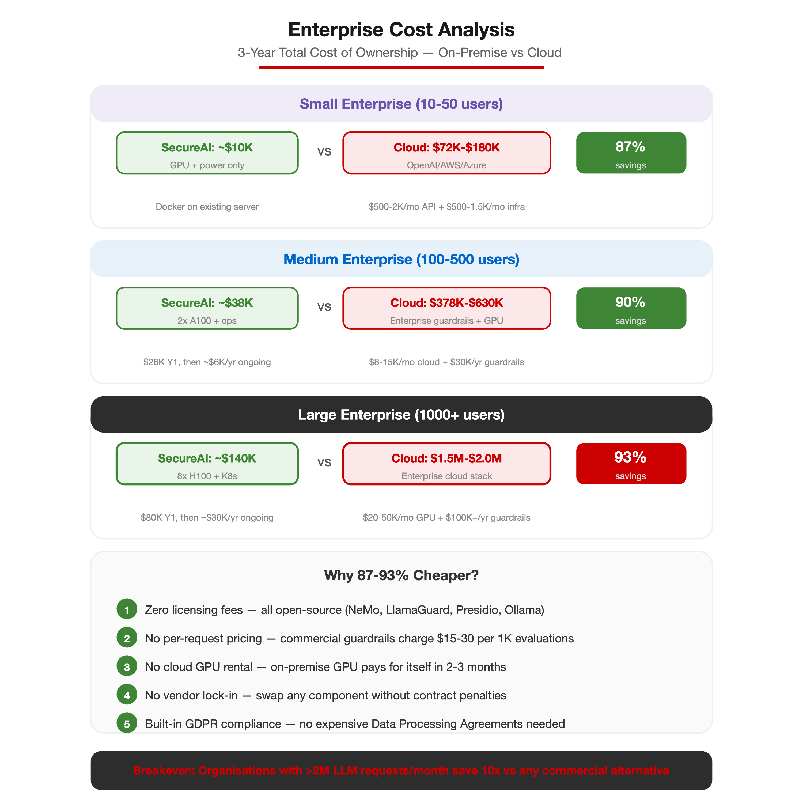
Fig. 3. Enterprise cost comparison (3-year TCO)
The cost advantage stems from five factors: (1) zero licensing fees for NeMo, LlamaGuard, Presidio, and Ollama; (2) no per-request pricing (commercial guardrails charge $15–30 per 1,000 evaluations); (3) no cloud GPU rental costs—on-premise GPU investment pays for itself within 2–3 months; (4) no vendor lock-in or contract penalties; and (5) built-in GDPR compliance eliminates the need for expensive Data Processing Agreements with cloud providers. For organisations processing over 2 million LLM requests per month, the on-premise deployment is approximately 10x cheaper than any commercial alternative.
G. DevSecOps Pipeline
The Jenkins CI/CD pipeline implements 15 stages with seven build-blocking security gates. Static analysis combines SpotBugs 4.8.6 with FindSecBugs 1.13.0, achieving zero findings at maximum effort. SonarQube enforces a quality gate requiring zero bugs, zero vulnerabilities, and zero code duplication. OWASP Dependency-Check scans all transitive dependencies, failing the build on any CVE with CVSS score 7.0 or higher. Trivy scans the Docker image for HIGH and CRITICAL container vulnerabilities.
JaCoCo enforces code coverage thresholds of 80% line coverage and 70% branch coverage across all four modules. The test suite comprises 29 test classes with 206+ test methods spanning unit tests (JUnit 5 + Mockito), integration tests (Spring Boot Test with H2), smoke tests, and performance benchmarks. All 69 core tests pass with a 100% success rate. Container security follows CIS Docker Benchmark recommendations with Alpine JRE-only runtime images, non-root user (UID 1001), and all Linux capabilities dropped.
H. Security Analysis
The framework was evaluated against the OWASP LLM Top 10 [7] and OWASP API Security Top 10 benchmarks. Table V summarises the compliance coverage.
TABLE V. SECURITY BENCHMARK COMPLIANCE
Benchmark | Coverage | Grade
OWASP LLM Top 10 | 90% | A
OWASP API Security Top 10 | 100% | A+
NIST SP 800-218 (SSDF) | 89% | A-
CIS Docker Benchmark | 100% | A+
A STRIDE threat model was conducted to identify and mitigate architectural risks. Key mitigations include: Spoofing addressed through JWT HMAC-SHA256 with JTI replay protection; Tampering prevented by read-only container filesystems and all Linux capabilities dropped; Information Disclosure countered by three-layer PII redaction; Denial of Service mitigated through Bucket4j rate limiting and Resilience4j circuit breakers; Elevation of Privilege prevented through least-privilege non-root Docker containers with all capabilities dropped. The Content Security Policy (CSP) was hardened by removing unsafe-inline directives, and HTTP Strict Transport Security (HSTS) enforces TLS across all communication channels.
V. CONCLUSION AND FUTURE WORK
This paper presented SecureAI Gateway, a three-layer defence-in-depth framework for securing enterprise LLM applications. The system demonstrates that production-grade security can be achieved with minimal latency overhead (90ms guardrail processing, representing 5.6% of total request time) while maintaining zero cloud dependencies. The parallel execution architecture, fail-closed decision logic, and comprehensive DevSecOps pipeline provide a replicable blueprint for organisations deploying LLMs in regulated environments.
The enterprise cost analysis reveals savings of 87–93% compared to commercial cloud-based alternatives across all enterprise scales, with the three-year TCO for large enterprises at approximately $140,000 versus $1.5–2 million for commercial solutions. Combined with full GDPR Article 25 [12] compliance and EU AI Act [25] readiness, SecureAI Gateway provides a compelling economic and regulatory case for on-premise LLM security.
Future work includes: (1) implementing DAST via OWASP ZAP integration for runtime vulnerability scanning; (2) migrating the in-memory JWT blacklist and rate limiter to Redis for distributed deployment; (3) adding adversarial red-team testing with automated jailbreak generation; (4) extending Kubernetes manifests with Istio service mesh for mutual TLS between sidecars; and (5) implementing AI-specific monitoring for model drift detection and fairness auditing per the NIST AI Risk Management Framework.
The complete source code, Docker Compose configuration, and test suite are available at https://github.com/A00336136/secure-ai-gateway under an open-source licence.
REFERENCES
[1] K. Greshake, S. Abdelnabi, S. Mishra, C. Endres, T. Holz, and M. Fritz, “Not what you’ve signed up for: Compromising real-world LLM-integrated applications with indirect prompt injection,” in Proc. 16th ACM Workshop Artif. Intell. Secur. (AISec), 2023.
[2] F. Perez and I. Ribeiro, “Ignore previous prompt: Attack techniques for language models,” arXiv preprint arXiv:2211.09527, 2022.
[3] H. Inan et al., “Llama Guard: LLM-based input-output safeguard for human-AI conversations,” arXiv preprint arXiv:2312.06674, 2023.
[4] T. Rebedea, R. Dinu, M. N. Sreedhar, C. Parisien, and J. Cohen, “NeMo Guardrails: A toolkit for controllable and safe LLM applications with programmable rails,” in Proc. Conf. Empirical Methods Nat. Lang. Process.: System Demonstrations (EMNLP), pp. 431–445, 2023.
[5] Microsoft, “Presidio — Data protection and de-identification SDK,” GitHub, 2019. [Online]. Available: https://github.com/microsoft/presidio
[6] National Institute of Standards and Technology, “Secure Software Development Framework (SSDF) Version 1.1,” NIST SP 800-218, Feb. 2022.
[7] OWASP Foundation, “OWASP Top 10 for Large Language Model Applications v1.1,” 2023. [Online]. Available: https://owasp.org/www-project-top-10-for-large-language-model-applications/
[8] H. Touvron et al., “Llama 2: Open foundation and fine-tuned chat models,” arXiv preprint arXiv:2307.09288, 2023.
[9] A. Vaswani, N. Shazeer, N. Parmar, J. Uszkoreit, L. Jones, A. N. Gomez, L. Kaiser, and I. Polosukhin, “Attention is all you need,” in Proc. Adv. Neural Inf. Process. Syst. (NeurIPS), vol. 30, pp. 5998–6008, 2017.
[10] T. Brown et al., “Language models are few-shot learners,” in Proc. Adv. Neural Inf. Process. Syst. (NeurIPS), vol. 33, pp. 1877–1901, 2020.
[11] International Organization for Standardization, “ISO/IEC 27001:2022 — Information security management systems,” 3rd ed., Oct. 2022.
[12] European Parliament and Council of the European Union, “Regulation (EU) 2016/679 (General Data Protection Regulation),” Off. J. Eur. Union, vol. L 119, pp. 1–88, May 2016.
[13] VMware (Broadcom), “Spring Boot 3.x reference documentation,” 2023. [Online]. Available: https://docs.spring.io/spring-boot/
[14] VMware (Broadcom), “Spring Security reference documentation,” 2023. [Online]. Available: https://docs.spring.io/spring-security/
[15] Docker, Inc., “Docker documentation,” 2023. [Online]. Available: https://docs.docker.com/
[16] JaCoCo Project (EclEmma), “JaCoCo — Java code coverage library,” 2023. [Online]. Available: https://www.jacoco.org/jacoco/
[17] SonarSource SA, “SonarQube — Continuous inspection of code quality and security,” 2023. [Online]. Available: https://www.sonarsource.com/products/sonarqube/
[18] SpotBugs Community, “SpotBugs — Find bugs in Java programs,” 2023. [Online]. Available: https://spotbugs.github.io/
[19] S. Yao, J. Zhao, D. Yu, N. Du, I. Shafran, K. Narasimhan, and Y. Cao, “ReAct: Synergizing reasoning and acting in language models,” in Proc. Int. Conf. Learn. Represent. (ICLR), 2023.
[20] Cloud Native Computing Foundation, “Kubernetes documentation,” 2023. [Online]. Available: https://kubernetes.io/docs/
[21] Z. Chkirbene, R. Hamila, A. Gouissem, and U. Devrim, “Large Language Models (LLM) in industry: A survey of applications, challenges, and trends,” in Proc. IEEE 21st Int. Conf. Smart Communities (HONET), pp. 229–234, Dec. 2024. DOI: 10.1109/HONET63146.2024.10822885.
[22] C. L. Smith, “Understanding concepts in the defence in depth strategy,” in Proc. IEEE 37th Annu. Int. Carnahan Conf. Security Technology (CCST), pp. 8–16, Oct. 2003. DOI: 10.1109/CCST.2003.1297528.
[23] B. C. Das, M. H. Amini, and Y. Wu, “Security and privacy challenges of large language models: A survey,” ACM Comput. Surv., vol. 57, no. 6, Art. 152, Feb. 2025. DOI: 10.1145/3712001.
[24] European Parliament and Council of the European Union, “Regulation (EU) 2024/1689 laying down harmonised rules on artificial intelligence (Artificial Intelligence Act),” OJ L, 2024/1689, 12 Jul. 2024. [Online]. Available: https://eur-lex.europa.eu/eli/reg/2024/1689/oj/eng

