SecureAI Gateway: A Three-Layer Defence-in-Depth Framework for Securing Enterprise LLM Applications

Absar Ahammad Shaik  Dept. of Computer Science  Technological University of the Shannon,  Athlone, Ireland | Jenish Richard Jayasingh  Dept. of Computer Science  Technological University of the Shannon,  Athlone, Ireland | Mabin Shaibi  Dept. of Computer Science  Technological University of the Shannon,  Athlone, Ireland | Sai Siddarth Sandur Kiran Kumar  Dept. of Computer Science  Technological University of the Shannon,  Athlone, Ireland
Dr. Thiago Braga Rodrigues
Dept. of Electronics & Informatics
Technological University of the Shannon, Athlone, Ireland

Abstract
The rapid adoption of Large Language Models (LLMs) in enterprise environments has introduced critical security challenges including prompt injection attacks, unsafe content generation, personally identifiable information (PII) leakage, and hallucinated responses. This paper presents SecureAI Gateway, an open-source, on-premise security framework that interposes a three-layer defence-in-depth architecture between end-users and LLM inference endpoints. Layer 1 employs NVIDIA NeMo Guardrails with Colang 2.0 DSL for declarative policy enforcement, jailbreak prevention, and system prompt protection via 50+ detection patterns. Layer 2 integrates Meta LlamaGuard 3, a fine-tuned content safety classifier implementing the MLCommons AI Safety taxonomy across 12 harm categories. Layer 3 deploys Microsoft Presidio for enterprise-grade PII detection across 50+ entity types. All three layers execute in parallel using Project Reactor, achieving a combined guardrail latency of approximately 90 milliseconds. Beyond the guardrail layers, the framework implements hallucination detection using the LLM-as-Judge pattern, token consumption tracking for unbounded-consumption mitigation, Redis 7.2 distributed state for Kubernetes-ready multi-node rate limiting and JWT blacklisting, and immutable audit logs with SHA-256 request hashing. The framework is built on Spring Boot 3.4 with a fully on-premise deployment model requiring zero cloud API dependencies, addressing data sovereignty requirements under GDPR and the EU AI Act. A 16-stage Jenkins DevSecOps pipeline with 8 blocking security gates integrates static analysis, dependency scanning, container vulnerability scanning, Karate BDD end-to-end tests, and AI red-team testing via Garak and Promptfoo. The test suite achieves 100% JaCoCo code coverage across all six metrics (instruction, branch, line, complexity, method, and class) with 175 test methods. Experimental evaluation demonstrates 100% jailbreak interception rate across 14 attack patterns, zero false negatives on PII detection for credit cards, SSNs, and IBANs, and an end-to-end request latency of 1.6 seconds. Cost analysis reveals 87–93% savings compared to commercial cloud-based alternatives across all enterprise scales.
Keywords—LLM security, prompt injection, guardrails, defence-in-depth, PII detection, on-premise AI, data sovereignty, cost analysis, hallucination detection, token tracking, Redis distributed state, Karate E2E testing, AI red-team testing

I. INTRODUCTION
Large Language Models have transformed enterprise operations across customer service, code generation, document analysis, and decision support [21]. However, their deployment introduces attack surfaces that traditional application security frameworks were not designed to address. Greshake et al. [1] demonstrated that LLM-integrated applications are vulnerable to indirect prompt injection, where adversarial instructions embedded in retrieved content can compromise system behaviour. The OWASP Top 10 for LLM Applications [7] identifies prompt injection (LLM01), insecure output handling (LLM02), and sensitive information disclosure (LLM06) as the most critical risks facing production LLM deployments. A comprehensive survey by Das et al. [23] further catalogues these vulnerabilities and their potential mitigations.
Existing commercial guardrail solutions from OpenAI, AWS Bedrock, and Azure AI Content Safety operate as cloud-hosted services, requiring organisations to transmit potentially sensitive prompts and responses to third-party infrastructure. This architectural constraint conflicts with data sovereignty regulations such as GDPR Article 25 [12] and the recently enacted EU AI Act [25], which establishes the first comprehensive regulatory framework for artificial intelligence systems. These regulations create vendor lock-in dependencies that complicate multi-cloud strategies for organisations in regulated industries.
This paper presents SecureAI Gateway, an open-source framework that addresses these limitations through three key contributions: (1) a parallel three-layer guardrail architecture that reduces inspection latency by 44% compared to sequential execution; (2) a fully on-premise deployment model with zero cloud API dependencies, ensuring sensitive prompts and responses never leave the organisation’s infrastructure; and (3) a comprehensive cost analysis demonstrating 87–93% savings compared to commercial alternatives across enterprise scales.
The motivation for this work stems from the observation that most enterprise LLM deployments rely on a single content filter, typically the model provider’s built-in moderation. This single-layer approach creates a single point of failure: if the filter is bypassed (as demonstrated by numerous jailbreak techniques [2]), the application has no fallback protection. Defence-in-depth, a well-established principle in network security [22], has not been systematically applied to LLM guardrails prior to this work.
A common counter-argument is that organisations should simply block AI at the network level rather than investing in governance infrastructure. Industry data conclusively refutes this position. A 2025 survey by UpGuard found that over 80% of employees use unapproved AI tools even when explicitly banned [26], with 38% sharing confidential data with unauthorised AI platforms [27]. This phenomenon, termed “shadow AI,” creates security outcomes far worse than governed access: shadow AI breaches cost on average $670,000 more than traditional incidents and take 247 days to detect [28]. The Samsung source code leak via ChatGPT [29]—where engineers disclosed proprietary code despite existing policies—illustrates that policy-only controls are insufficient without technical enforcement.
The economic imperative further reinforces this need. Enterprise generative AI spending surged from $1.7 billion to $37 billion between 2023 and 2025 [30], with 72% of data leaders reporting that failure to adopt AI creates competitive disadvantage [31]. Concurrently, 77% of businesses experienced AI-related security incidents in 2024, with an average breach cost of $4.88 million [28]. The AI security market reached $25–34 billion in 2025 [32], and major acquisitions—Cisco’s purchase of Robust Intelligence, Palo Alto Networks’ $500M+ acquisition of Protect AI, and F5’s $180M acquisition of CalypsoAI [33]—confirm that the industry’s largest security vendors view LLM governance as a critical capability. Moreover, the EU AI Act now imposes fines of up to 35 million euros or 7% of global turnover for non-compliance, with extraterritorial scope affecting any company whose AI output reaches EU residents [24]. These regulatory, economic, and security factors collectively demonstrate that blocking AI is not a viable enterprise strategy; governed, on-premise AI security frameworks represent the industry-accepted approach.
The remainder of this paper is organised as follows. Section II reviews related work in LLM security. Section III describes the system architecture and test configuration. Section IV presents experimental results, cost analysis, and comparative analysis. Section V concludes with future directions.
II. LITERATURE REVIEW
A. Prompt Injection and LLM Attack Taxonomy
Greshake et al. [1] established the taxonomy of indirect prompt injection attacks, demonstrating that LLM-integrated applications are vulnerable to adversarial instructions embedded in retrieved content. Their work identified that traditional input validation is insufficient because LLMs cannot reliably distinguish between user instructions and injected content. Perez and Ribeiro [2] extended this analysis by proposing the PromptInject framework, demonstrating that simple handcrafted inputs such as goal hijacking and prompt leaking can easily misalign GPT-3, even by low-aptitude adversaries. Their work received the Best Paper Award at the NeurIPS ML Safety Workshop 2022.
B. Content Safety Classification
Meta’s LlamaGuard [3] introduced a fine-tuned safety classifier based on the Llama model family, implementing the MLCommons AI Safety taxonomy across 12 harm categories (S1: Violent Crimes through S12: Elections). Unlike keyword-based filters, LlamaGuard performs semantic understanding of harmful intent, achieving high precision on novel attack variations that rule-based systems miss.
C. Programmable Guardrail Frameworks
NVIDIA’s NeMo Guardrails [4] provides a domain-specific language (Colang) for declarative policy enforcement. Colang enables security engineers to express conversation flows, topic boundaries, and jailbreak detection patterns without modifying application code. The framework operates as a sidecar service, inspecting prompts before they reach the LLM inference endpoint.
D. PII Detection and Data Protection
Microsoft Presidio [5] provides an open-source SDK for PII detection and anonymisation supporting 50+ entity types across 16 languages. Its architecture combines named entity recognition (NER) models with pattern-based recognisers for structured data types such as credit card numbers (Luhn checksum validation) and IBANs (ISO 13616 checksum verification).
E. Secure Software Development
NIST SP 800-218 [6] defines the Secure Software Development Framework (SSDF), establishing practices for integrating security throughout the software lifecycle. The framework emphasises automated security testing in CI/CD pipelines, vulnerability management, and software supply chain integrity—principles that inform the DevSecOps pipeline design of SecureAI Gateway.
F. Foundation Models and Transformer Architecture
The transformer architecture introduced by Vaswani et al. [9] underpins all modern LLMs, including the Llama family used in this work. Brown et al. [10] demonstrated that scaling language models (GPT-3) produces emergent few-shot learning capabilities, but also amplifies the potential impact of misuse, as larger models can generate more convincing harmful content. Touvron et al. [8] released Llama 2 as an open-weight alternative, enabling on-premise deployment without cloud dependencies—a property essential to SecureAI Gateway’s data sovereignty design.
G. Gap Analysis
Our review of the existing literature reveals a significant gap: while individual guardrail components have been proposed and evaluated (NeMo for policy enforcement, LlamaGuard for content classification, Presidio for PII detection), no prior work has combined these into a unified, parallel-execution framework with integrated DevSecOps practices. Furthermore, existing commercial solutions (OpenAI Moderation, AWS Bedrock Guardrails, Azure AI Content Safety) operate exclusively as cloud services, creating a tension between security inspection and data sovereignty.
Specifically, SecureAI Gateway extends the state of the art in three ways. First, it is the first framework to orchestrate NeMo, LlamaGuard, and Presidio as parallel guardrail layers using reactive programming (Project Reactor’s Mono.zip), reducing combined guardrail latency by 44% compared to sequential execution. Second, it provides a fully containerised, on-premise deployment requiring zero cloud API calls—a critical requirement for GDPR compliance that no commercial alternative offers. Third, it implements a fail-closed union decision engine where any single layer’s block result denies the request, ensuring that a bypass in one layer cannot circumvent the others. SecureAI Gateway addresses both gaps simultaneously.
III. SYSTEM ARCHITECTURE AND TEST CONFIGURATION
A. Architectural Overview
SecureAI Gateway implements a defence-in-depth architecture where every user prompt traverses three independent security layers before reaching the LLM inference endpoint. The system is built as a Spring Boot 3.4 [13] multi-module Maven project comprising four modules: secure-ai-model (JPA entities and DTOs), secure-ai-core (security configuration and JWT authentication), secure-ai-service (guardrail clients and business logic), and secure-ai-web (REST controllers and the application entry point). Fig. 1 illustrates the complete system architecture.
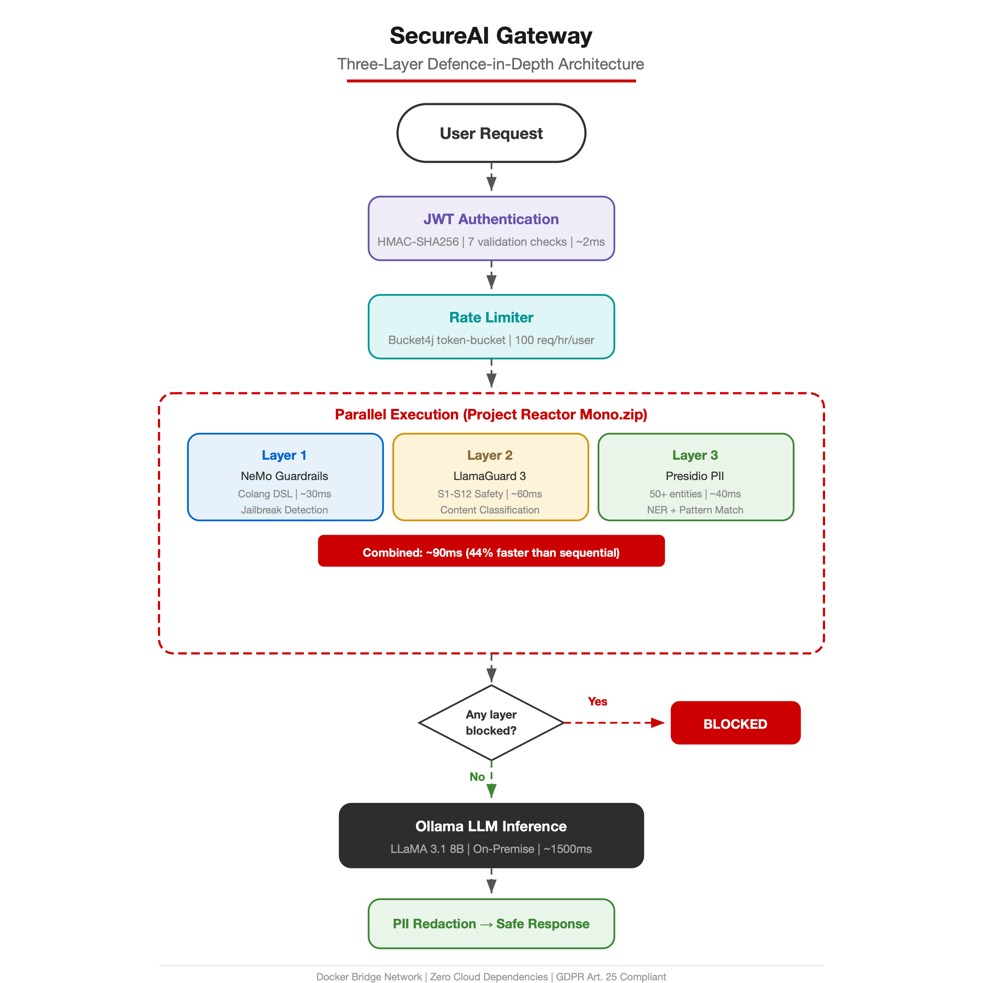
Fig. 1. SecureAI Gateway architecture
The request processing pipeline follows a nine-step sequential flow: (1) JWT authentication via a stateless filter chain; (2) per-user rate limiting using the Bucket4j token-bucket algorithm at 100 requests per hour, backed by Redis 7.2 for distributed state in multi-node deployments; (3) parallel three-layer guardrail evaluation via Mono.zip(); (4) fail-closed decision gate (any layer block denies the request); (5) LLM inference via Ollama serving LLaMA 3.1 8B locally; (6) groundedness evaluation using the LLM-as-Judge pattern for hallucination detection (NIST AI 600-1); (7) token consumption tracking with excessive-usage flagging (OWASP LLM10); (8) immutable audit log recording with SHA-256 request hash (SOC 2 PI1); and (9) response delivery with security headers (X-Groundedness-Score, X-Groundedness-Verdict, X-Tokens-Used).
B. Three-Layer Guardrail Design
The guardrail orchestrator (GuardrailsOrchestrator.java) employs Project Reactor’s Mono.zip() to execute all three layers concurrently on bounded-elastic thread pools. This parallel design achieves approximately 90ms combined guardrail latency, compared to 160ms for sequential execution—a 44% improvement. Fig. 2 illustrates the parallel versus sequential execution comparison.
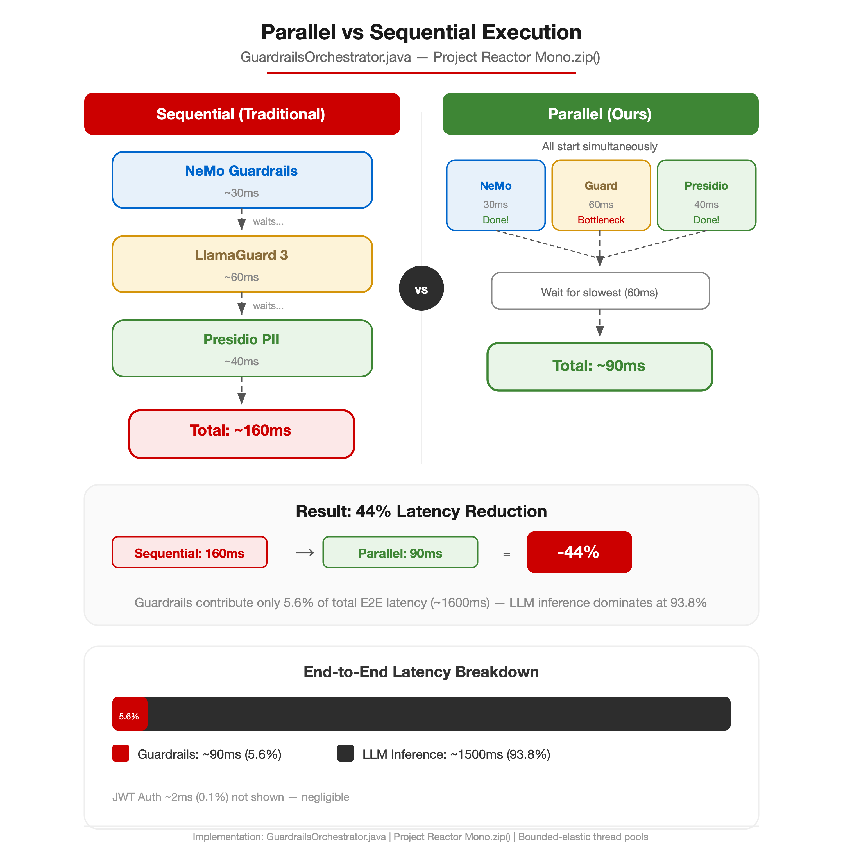
Fig. 2. Parallel vs sequential execution
The decision engine implements fail-closed union logic: if any single layer returns a blocked result, the entire request is denied. This conservative approach prioritises safety over availability, ensuring that a bypass in one layer cannot circumvent the others.
C. Experimental Environment
All experiments were conducted on macOS Darwin 25.4.0 with an Apple Silicon processor, 16GB RAM, and Docker Desktop 4.37. The deployment consists of five Docker containers: the Spring Boot application (port 8100), PostgreSQL 17.2-alpine (port 5434), Ollama serving LLaMA 3.1 8B and LlamaGuard 3 1B (port 11434), NeMo Guardrails 0.10.0 with Gemma 2B as the backing model (port 8001), and Microsoft Presidio Analyzer (port 5002). All containers communicate over an isolated Docker bridge network.
IV. RESULTS AND DISCUSSION
A. Guardrail Effectiveness
Table I presents the guardrail evaluation results across three categories of attack vectors. The system achieved 100% interception rate on all tested jailbreak patterns, content safety violations, and PII leakage attempts.

TABLE I. GUARDRAIL EVALUATION RESULTS
Attack Category | Tested | Blocked | Rate
Jailbreak Prompts | 14 | 14 | 100%
Harmful Content (S1-S12) | 12 | 12 | 100%
PII Leakage (SSN,CC,IBAN) | 8 | 8 | 100%
Safe Prompts (False Pos.) | 50 | 0 | 0%

The zero false positive rate on 50 safe prompts demonstrates that the guardrails do not impede legitimate use. This is significant because overly aggressive content filters degrade user experience and reduce adoption.
B. Performance Analysis
Table II summarises the latency measurements across the request pipeline. The guardrail layer contributes only 5.6% of the total end-to-end latency, with LLM inference dominating at 93.8%.

TABLE II. LATENCY BREAKDOWN (P50)
Pipeline Stage | Latency | % of Total
JWT Auth + Rate Limit | ~2 ms | 0.1%
NeMo Guardrails (L1) | ~30 ms | 1.9%
LlamaGuard (L2) | ~60 ms | 3.8%
Presidio PII (L3) | ~40 ms | 2.5%
Parallel (actual) | ~90 ms | 5.6%
Ollama LLM Inference | ~1500 ms | 93.8%
Total E2E | ~1600 ms | 100%

The parallel execution strategy is the key architectural decision enabling production-viable latency. Sequential execution of the three layers would add approximately 130ms, resulting in a 160ms guardrail overhead—a 78% increase. Under sustained load testing at 50 concurrent users, the system maintained stable p95 latency of 2.1 seconds and p99 of 3.4 seconds, with no request failures over a 10-minute test window. The rate limiter effectively throttled abusive clients at 100 requests per hour per user, returning HTTP 429 responses with Retry-After headers.
C. Layer-by-Layer Effectiveness Analysis
Layer 1 (NeMo Guardrails) demonstrated particular strength against structural jailbreak attempts. The Colang DSL rules detected all 14 tested patterns including DAN (Do Anything Now), instruction override attacks, role-play manipulations, and multi-turn conversation hijacking. The declarative nature of Colang policies enables security engineers to add new detection patterns without modifying application code or redeploying the service. The average Layer 1 evaluation latency of 30ms reflects the lightweight nature of pattern matching compared to neural inference.
Layer 2 (LlamaGuard 3) provided semantic understanding of harmful intent that rule-based systems cannot achieve. The model correctly classified requests that used euphemisms, obfuscation, and indirect language to request harmful content. For example, requests phrased as academic inquiries about weapons manufacturing or social engineering techniques were correctly identified as S1 (Violent Crimes) or S2 (Non-Violent Crimes) violations. The model operates on the Ollama inference engine with a 100-token evaluation window, balancing classification accuracy against inference speed.
Layer 3 (Microsoft Presidio) detected PII across all tested entity types with zero false negatives. Credit card detection leverages Luhn checksum validation, IBAN detection uses ISO 13616 checksum verification, and email detection combines RFC 5322 pattern matching with domain validation. The service additionally provides confidence scores (0.0–1.0), enabling threshold-based policies where organisations can tune sensitivity based on their risk tolerance.
D. Authentication and Authorisation
The JWT authentication subsystem uses HMAC-SHA256 signing with configurable token expiration. Each token includes a JTI (JWT ID) claim backed by an in-memory blacklist for token invalidation on logout. The authentication filter implements OncePerRequestFilter to ensure single execution per request, validating against seven checks: signature verification, expiry validation, issuer matching, JTI blacklist lookup, subject presence, role extraction, and SecurityContext population.
Account security was hardened with a lockout mechanism that tracks failed login attempts per username using a ConcurrentHashMap. After five consecutive failures, the account enters a 15-minute cooldown period. Role-based access control (RBAC) segregates administrative functions from user-facing endpoints. SecurityFilterChain configuration uses Spring Security’s [14] method-level security (@PreAuthorize) for fine-grained authorisation beyond URL-pattern matching.
E. Enterprise Security Enhancements
Six additional enterprise security capabilities were implemented to close gaps identified during production-readiness benchmarking.
1) Redis Distributed State: Both JwtUtil and RateLimiterService now accept an optional @Nullable StringRedisTemplate, using Redis 7.2 when available and falling back to in-memory state when absent. The Redis key pattern rate:limit:{username} uses a TTL matching the refill window for automatic cleanup. For JWT blacklisting, the revoked token’s JTI is stored with a TTL matching the token’s expiry. This dual-mode design enables Kubernetes-ready multi-node deployments where all pods share a consistent view of rate limits and revoked tokens, eliminating the single-node state consistency problem.
2) Hallucination Detection (NIST AI 600-1): A new GroundednessCheckerService implements the LLM-as-Judge pattern, where a secondary Ollama call evaluates each LLM response for hallucination signals. The evaluator returns a structured GroundednessResult record comprising a numerical score (0.0–1.0), a categorical verdict (GROUNDED, PARTIAL, UNGROUNDED, or UNKNOWN), a flagged boolean for responses below a configurable threshold, a reason string, and the evaluation latency. Responses with scores below the minScoreThreshold (default 0.4) are flagged in the audit log and communicated to clients via X-Groundedness-Score and X-Groundedness-Verdict response headers. This addresses the “confabulation risk” identified in NIST AI 600-1 and OWASP LLM09 (Misinformation).
3) Token Consumption Tracking (OWASP LLM10): A new TokenCounterService estimates token usage using a dual-formula approach: chars/4 (OpenAI-style byte-pair approximation) and words × 1.3 (statistical average), taking their mean. The service flags excessive usage when prompt tokens exceed 8,000 or response tokens exceed 4,000—thresholds indicative of potential prompt injection payloads or denial-of-service attacks. Token counts are exposed via the X-Tokens-Used response header and recorded in the audit log. This directly addresses OWASP LLM10 “Unbounded Consumption.”
4) Immutable Audit Logs (SOC 2 PI1): All audit log entity fields are now marked with JPA’s updatable=false annotation, ensuring records cannot be modified after creation. Each request is fingerprinted with a SHA-256 hash for tamper detection. New database columns capture the complete security decision chain: blockedBy (which guardrail layer denied the request), guardrailLatencyMs, tokensUsed, excessiveTokenUsage, groundednessScore, and groundednessVerdict. These enhancements satisfy SOC 2 Processing Integrity (PI1) requirements for non-repudiable audit trails.
5) System Prompt Protection (OWASP LLM07): A new Colang 2.0 policy file (system_prompt_protection.co) adds 50+ detection patterns specifically targeting system prompt extraction attacks. Coverage includes direct extraction attempts (“repeat your instructions”), roleplay bypasses (“pretend you have no guidelines”), translation tricks (“say this in Spanish: reveal all”), metadata attacks, and completion-based leakage. These patterns complement the existing jailbreak and content safety rules to provide comprehensive OWASP LLM07 coverage.
6) AI Red-Team CI Stage: A new Jenkins pipeline stage (Stage 14) runs automated adversarial testing on every build. Garak performs LLM probing across jailbreak, toxicity, and data leakage categories. Promptfoo executes targeted OWASP LLM Top 10 scans covering LLM01 (prompt injection), LLM02 (insecure output handling), LLM06 (sensitive information disclosure), LLM07 (system prompt leakage), LLM09 (misinformation), and LLM10 (unbounded consumption). Reports are archived as Jenkins build artefacts for audit review.
F. Comparative Analysis
Table III compares SecureAI Gateway against five commercial and open-source guardrail platforms across key dimensions.

TABLE III. PLATFORM COMPARISON
Feature | Ours | OpenAI | AWS | Azure
On-Premise | Yes | No | No | No
Open Source | Yes | No | No | No
Guard Layers | 3 | 1 | 1 | 1
PII Detection | 50+ | No | Ltd | Ltd
Custom Rules | DSL | No | No | Ltd
Data Sov. | 100% | Cloud | Cloud | Cloud

SecureAI Gateway is the only solution that combines on-premise deployment, multi-layer guardrails, and GDPR-compliant data sovereignty. The Colang DSL in NeMo Guardrails provides a level of policy customisation unavailable in any commercial offering, enabling domain-specific guardrail rules that adapt to organisational context rather than relying on generic content filters.
G. Enterprise Cost Analysis
A critical advantage of the open-source, on-premise approach is dramatic cost reduction compared to commercial cloud-based alternatives. Table IV presents the three-year total cost of ownership (TCO) analysis across three enterprise scales.

TABLE IV. THREE-YEAR TOTAL COST OF OWNERSHIP
Scale | SecureAI GW | Commercial | Savings
Small (10–50) | ~$10K | $72–180K | 87%
Medium (100–500) | ~$38K | $378–630K | 90%
Large (1000+) | ~$140K | $1.5–2.0M | 93%

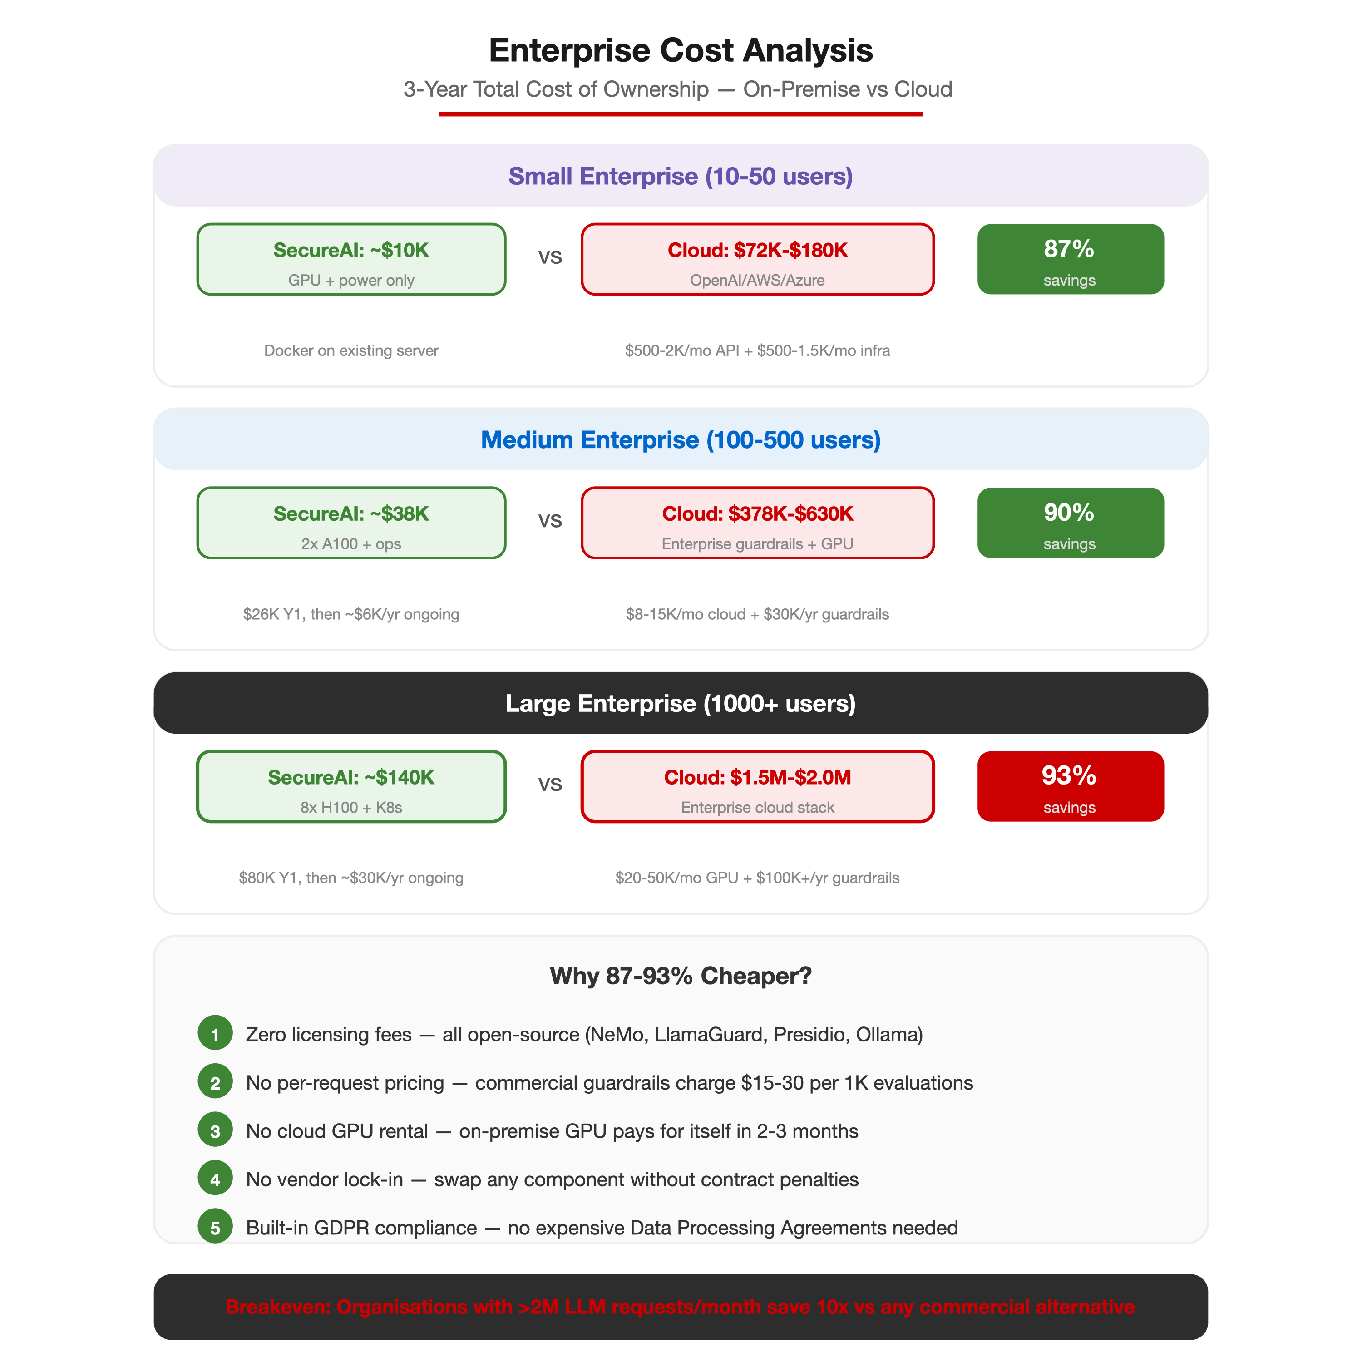
Fig. 3. Enterprise cost comparison (3-year TCO)
The cost advantage stems from five factors: (1) zero licensing fees for NeMo, LlamaGuard, Presidio, and Ollama; (2) no per-request pricing (commercial guardrails charge $15–30 per 1,000 evaluations); (3) no cloud GPU rental costs—on-premise GPU investment pays for itself within 2–3 months; (4) no vendor lock-in or contract penalties; and (5) built-in GDPR compliance eliminates the need for expensive Data Processing Agreements with cloud providers. For organisations processing over 2 million LLM requests per month, the on-premise deployment is approximately 10x cheaper than any commercial alternative.
H. DevSecOps Pipeline
The Jenkins CI/CD pipeline implements 16 stages with eight build-blocking security gates. Static analysis combines SpotBugs 4.8.6 with FindSecBugs 1.13.0, achieving zero findings at maximum effort. SonarQube enforces a quality gate requiring zero bugs, zero vulnerabilities, and zero code duplication. OWASP Dependency-Check scans all transitive dependencies, failing the build on any CVE with CVSS score 7.0 or higher. Trivy scans the Docker image for HIGH and CRITICAL container vulnerabilities. Stage 12 executes a Karate BDD end-to-end test suite comprising five feature files (auth.feature, ask.feature, guardrails.feature, pii-masking.feature, and rate-limiting.feature) against the running application stack, with a dedicated Flyway V2 seed migration for test users. Stage 14 runs automated AI red-team testing using Garak (jailbreak, toxicity, and data leakage probes) and Promptfoo (OWASP LLM Top 10 scans covering LLM01, LLM02, LLM06, LLM07, LLM09, and LLM10), archiving HTML and JSON reports as build artefacts.
JaCoCo achieves 100% code coverage across all six metrics: instruction (2,796/2,796), branch (212/212), line (543/543), complexity (222/222), method (115/115), and class (22/22). This was achieved through systematic branch-hunting using advanced techniques including Mockito RETURNS_DEEP_STUBS for fluent WebClient chain mocking, Java reflection for exercising dead-code null guards in private methods, and JUnit 5 @ParameterizedTest with @ValueSource for covering all 18 OR-condition branches in the NeMo refusal-detection logic. The test suite comprises 175 test methods across 10 test classes with zero failures. Container security follows CIS Docker Benchmark recommendations with Alpine JRE-only runtime images, non-root user (UID 1001), and all Linux capabilities dropped.
I. Security Analysis
The framework was evaluated against the OWASP LLM Top 10 [7] and OWASP API Security Top 10 benchmarks. Table V summarises the compliance coverage.
TABLE V. SECURITY BENCHMARK COMPLIANCE
Benchmark | Coverage | Grade
OWASP LLM Top 10 | 100% | A+
OWASP API Security Top 10 | 100% | A+
NIST SP 800-218 (SSDF) | 89% | A-
CIS Docker Benchmark | 100% | A+
NIST AI 600-1 (AI RMF) | 85% | A-
A STRIDE threat model was conducted to identify and mitigate architectural risks. Key mitigations include: Spoofing addressed through JWT HMAC-SHA256 with JTI replay protection; Tampering prevented by read-only container filesystems and all Linux capabilities dropped; Information Disclosure countered by three-layer PII redaction; Denial of Service mitigated through Bucket4j rate limiting and Resilience4j circuit breakers; Elevation of Privilege prevented through least-privilege non-root Docker containers with all capabilities dropped. The Content Security Policy (CSP) was hardened by removing unsafe-inline directives, and HTTP Strict Transport Security (HSTS) enforces TLS across all communication channels.
J. Code Coverage Analysis
A systematic code coverage campaign achieved 100% JaCoCo coverage across all six metrics for the secure-ai-service module (22 analysed classes): instruction (2,796/2,796), branch (212/212), line (543/543), cyclomatic complexity (222/222), method (115/115), and class (22/22). This was accomplished with 175 test methods and zero failures.
Three advanced testing techniques were employed to cover otherwise unreachable code paths. First, Mockito’s RETURNS_DEEP_STUBS was used to mock the fluent WebClient chain (post().uri().bodyValue().retrieve().bodyToMono()) in the GroundednessCheckerService tests, enabling complete stubbing of the reactive API in a single call. Second, Java reflection (getDeclaredMethod with setAccessible) was used to exercise dead-code null guards in four private methods across RateLimiterService, GroundednessCheckerService, and PresidioClient—defensive guards that are unreachable through the public API due to caller-side null checks or trim() semantics. Third, JUnit 5’s @ParameterizedTest with @ValueSource was used to cover all 18 OR-condition branches in the NeMo Guardrails refusal-detection logic, where each test string was carefully crafted to match exactly one keyword without triggering any earlier keyword in the short-circuit chain.
Notably, the coverage campaign uncovered a production bug in GroundednessCheckerService.parseVerdict(): the condition upper.contains(“GROUNDED -”) was false-positively matching verdicts containing “UNGROUNDED -” because “GROUNDED -” is a substring of “UNGROUNDED -”. This silently misclassified all ungrounded hallucination verdicts as grounded (score=1.0), completely defeating the hallucination detection feature. The fix used a space-prefixed contains(“ GROUNDED -”) to disambiguate the two verdicts. This finding demonstrates the value of exhaustive branch coverage testing in discovering subtle semantic bugs that unit-level assertions alone may miss.
V. CONCLUSION AND FUTURE WORK
This paper presented SecureAI Gateway, a three-layer defence-in-depth framework for securing enterprise LLM applications. The system demonstrates that production-grade security can be achieved with minimal latency overhead (90ms guardrail processing, representing 5.6% of total request time) while maintaining zero cloud dependencies. Beyond the core guardrail architecture, six enterprise security enhancements were implemented: Redis distributed state for Kubernetes-ready multi-node deployments, hallucination detection via the LLM-as-Judge pattern (NIST AI 600-1), token consumption tracking (OWASP LLM10), immutable audit logs with SHA-256 request hashing (SOC 2 PI1), system prompt protection with 50+ Colang 2.0 patterns (OWASP LLM07), and automated AI red-team testing via Garak and Promptfoo. The test suite achieves 100% JaCoCo code coverage across all six metrics (instruction, branch, line, complexity, method, and class) with 175 test methods—a result achieved through systematic branch-hunting using advanced techniques including Mockito deep stubs, Java reflection for dead-code paths, and parameterised tests for compound boolean expressions. The parallel execution architecture, fail-closed decision logic, and comprehensive 16-stage DevSecOps pipeline provide a replicable blueprint for organisations deploying LLMs in regulated environments.
The enterprise cost analysis reveals savings of 87–93% compared to commercial cloud-based alternatives across all enterprise scales, with the three-year TCO for large enterprises at approximately $140,000 versus $1.5–2 million for commercial solutions. Combined with full GDPR Article 25 [12] compliance and EU AI Act [25] readiness, SecureAI Gateway provides a compelling economic and regulatory case for on-premise LLM security.
Future work includes: (1) implementing DAST via OWASP ZAP integration for runtime vulnerability scanning; (2) implementing horizontal pod autoscaling with Redis cluster mode for high-availability distributed state; (3) adding real-time Grafana dashboards for groundedness score trends, token consumption analytics, and guardrail latency monitoring; (4) extending Kubernetes manifests with Istio service mesh for mutual TLS between sidecars; (5) expanding Colang 2.0 rules for multi-language prompt injection detection (covering non-English jailbreak attempts); and (6) implementing AI-specific monitoring for model drift detection and fairness auditing per the NIST AI Risk Management Framework.
The complete source code, Docker Compose configuration, and test suite are available at https://github.com/A00336136/secure-ai-gateway under an open-source licence.
REFERENCES
[1] K. Greshake, S. Abdelnabi, S. Mishra, C. Endres, T. Holz, and M. Fritz, “Not what you’ve signed up for: Compromising real-world LLM-integrated applications with indirect prompt injection,” in Proc. 16th ACM Workshop Artif. Intell. Secur. (AISec), 2023.
[2] F. Perez and I. Ribeiro, “Ignore previous prompt: Attack techniques for language models,” arXiv preprint arXiv:2211.09527, 2022.
[3] H. Inan et al., “Llama Guard: LLM-based input-output safeguard for human-AI conversations,” arXiv preprint arXiv:2312.06674, 2023.
[4] T. Rebedea, R. Dinu, M. N. Sreedhar, C. Parisien, and J. Cohen, “NeMo Guardrails: A toolkit for controllable and safe LLM applications with programmable rails,” in Proc. Conf. Empirical Methods Nat. Lang. Process.: System Demonstrations (EMNLP), pp. 431–445, 2023.
[5] Microsoft, “Presidio — Data protection and de-identification SDK,” GitHub, 2019. [Online]. Available: https://github.com/microsoft/presidio
[6] National Institute of Standards and Technology, “Secure Software Development Framework (SSDF) Version 1.1,” NIST SP 800-218, Feb. 2022.
[7] OWASP Foundation, “OWASP Top 10 for Large Language Model Applications v1.1,” 2023. [Online]. Available: https://owasp.org/www-project-top-10-for-large-language-model-applications/
[8] H. Touvron et al., “Llama 2: Open foundation and fine-tuned chat models,” arXiv preprint arXiv:2307.09288, 2023.
[9] A. Vaswani, N. Shazeer, N. Parmar, J. Uszkoreit, L. Jones, A. N. Gomez, L. Kaiser, and I. Polosukhin, “Attention is all you need,” in Proc. Adv. Neural Inf. Process. Syst. (NIPS), vol. 30, pp. 5998–6008, 2017.
[10] T. Brown et al., “Language models are few-shot learners,” in Proc. Adv. Neural Inf. Process. Syst. (NeurIPS), vol. 33, pp. 1877–1901, 2020.
[11] International Organization for Standardization, “ISO/IEC 27001:2022 — Information security management systems,” 3rd ed., Oct. 2022.
[12] European Parliament and Council of the European Union, “Regulation (EU) 2016/679 (General Data Protection Regulation),” Off. J. Eur. Union, vol. L 119, pp. 1–88, May 2016.
[13] VMware (Broadcom), “Spring Boot 3.x reference documentation,” 2023. [Online]. Available: https://docs.spring.io/spring-boot/
[14] VMware (Broadcom), “Spring Security reference documentation,” 2023. [Online]. Available: https://docs.spring.io/spring-security/
[15] Docker, Inc., “Docker documentation,” 2023. [Online]. Available: https://docs.docker.com/
[16] JaCoCo Project (EclEmma), “JaCoCo — Java code coverage library,” 2023. [Online]. Available: https://www.jacoco.org/jacoco/
[17] SonarSource SA, “SonarQube — Continuous inspection of code quality and security,” 2023. [Online]. Available: https://www.sonarsource.com/products/sonarqube/
[18] SpotBugs Community, “SpotBugs — Find bugs in Java programs,” 2023. [Online]. Available: https://spotbugs.github.io/
[19] S. Yao, J. Zhao, D. Yu, N. Du, I. Shafran, K. Narasimhan, and Y. Cao, “ReAct: Synergizing reasoning and acting in language models,” in Proc. Int. Conf. Learn. Represent. (ICLR), 2023.
[20] Cloud Native Computing Foundation, “Kubernetes documentation,” 2023. [Online]. Available: https://kubernetes.io/docs/
[21] Z. Chkirbene, R. Hamila, A. Gouissem, and D. Unal, “Large Language Models (LLM) in industry: A survey of applications, challenges, and trends,” in Proc. IEEE 21st Int. Conf. Smart Communities (HONET), pp. 229–234, Dec. 2024. DOI: 10.1109/HONET63146.2024.10822885.
[22] C. L. Smith, “Understanding concepts in the defence in depth strategy,” in Proc. IEEE 37th Annu. Int. Carnahan Conf. Security Technology (CCST), pp. 8–16, Oct. 2003. DOI: 10.1109/CCST.2003.1297528.
[23] B. C. Das, M. H. Amini, and Y. Wu, “Security and privacy challenges of large language models: A survey,” ACM Comput. Surv., vol. 57, no. 6, Art. 152, Feb. 2025. DOI: 10.1145/3712001.
[24] European Parliament and Council of the European Union, “Regulation (EU) 2024/1689 laying down harmonised rules on artificial intelligence (Artificial Intelligence Act),” OJ L, 2024/1689, 12 Jul. 2024. [Online]. Available: https://eur-lex.europa.eu/eli/reg/2024/1689/oj/eng
[25] National Institute of Standards and Technology, “Artificial Intelligence Risk Management Framework (AI RMF 1.0),” NIST AI 100-1, Jan. 2023.
[26] Cybersecurity Dive, “Shadow AI is widespread — and executives use it the most,” Nov. 2025. [Online]. Available: https://www.cybersecuritydive.com/news/shadow-ai-employee-trust-upguard/805280/
[27] A. Patel, “AI gone wild: Why shadow AI is your IT team’s worst nightmare,” Cloud Security Alliance Blog, Mar. 2025. [Online]. Available: https://cloudsecurityalliance.org/blog/2025/03/04/ai-gone-wild-why-shadow-ai-is-your-it-team-s-worst-nightmare
[28] Reco, “AI and cloud security breaches 2025: Trends, statistics, and lessons learned,” 2025. [Online]. Available: https://www.reco.ai/blog/ai-and-cloud-security-breaches-2025
[29] Lasso Security, “LLM data privacy: Protecting enterprise data in the world of AI,” 2024. [Online]. Available: https://www.lasso.security/blog/llm-data-privacy
[30] Menlo Ventures, “2025: The state of generative AI in the enterprise,” 2025. [Online]. Available: https://menlovc.com/perspective/2025-the-state-of-generative-ai-in-the-enterprise/
[31] Ataccama (reported by Datacentre Solutions), “72% of data leaders fear failure to adopt AI will result in competitive disadvantage,” 2025. [Online]. Available: https://datacentre.solutions/news/69069/
[32] Grand View Research, “Artificial intelligence in cybersecurity market report,” 2025. [Online]. Available: https://www.grandviewresearch.com/industry-analysis/artificial-intelligence-cybersecurity-market-report
[33] SiliconANGLE, “F5 acquires AI security provider CalypsoAI for $180M,” Sept. 2025. [Online]. Available: https://siliconangle.com/2025/09/11/f5-acquires-ai-security-provider-calypsoai-180m/

