**Alteryx Designer Installation Guide for Students**

Go to Alteryx Designer.com <https://www.alteryx.com/>

Click on Free Trial



Click on the click here button for If you are a student or Educator

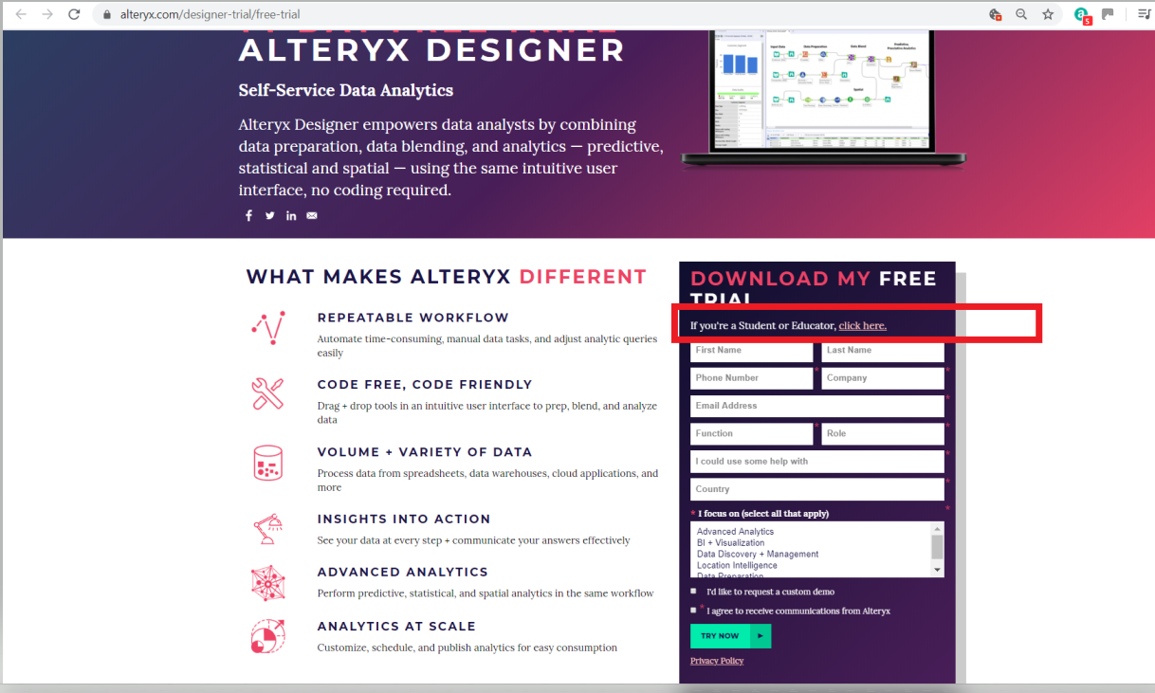

Click on Apply now button and an alert box for student Information pops up , please enter all the details and click next

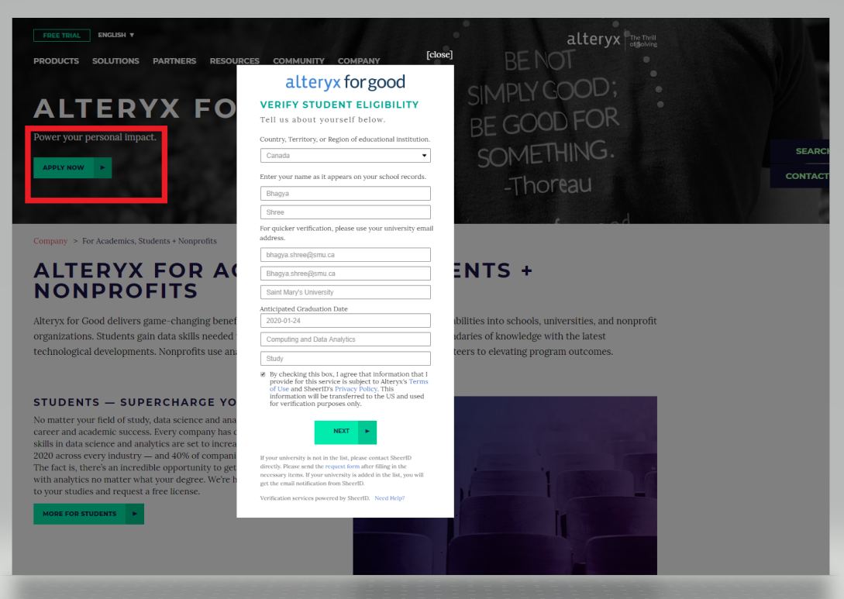

In the next page : you : will be asked to submit a document confirming your student status

* Doument upload : The document uploaded should have an issue date and the issue date should be less than 6 months from today.
* I uploaded : Academic Transcript from the Student banner

Once you submit a document,

You will land to this page. Please check your email for the product key

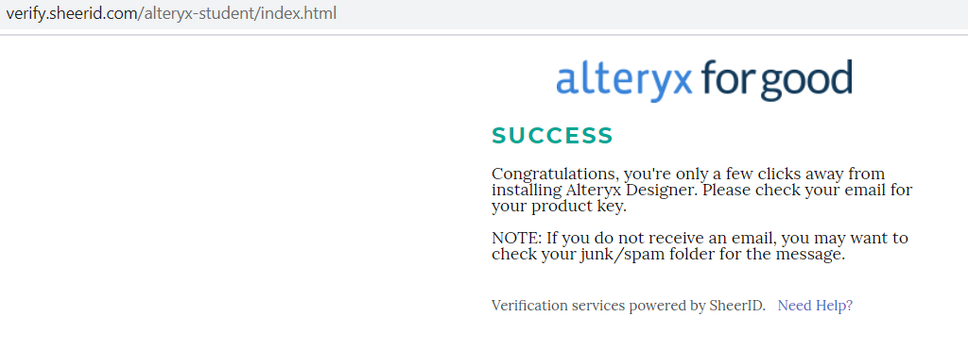

The Email looks as below: Click on the link for alteryx downloads

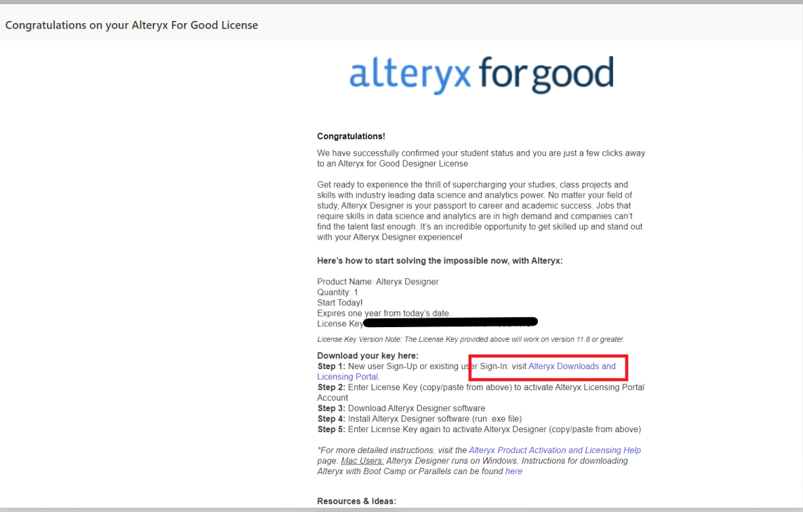

Once you have downloaded the Alteryx Installer file, navigate to installaler file and double click the installer file, it will kickstart the Installation process,

click on the second option and select language as English, click Next and complete the Installation process

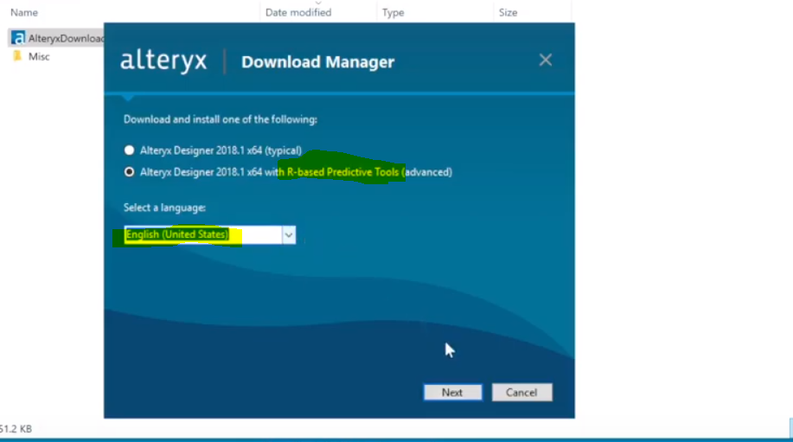

Once the Installation is complete and you start the alteryx designer, it will ask you to enter the License key , copy and paste the license key from your email.

You are now ready to explore the Alteryx Designer !!!