# Question1

**Query :**

1. (a) Get the names and locations of the suppliers who have shipped part with pno = 3.

Output:

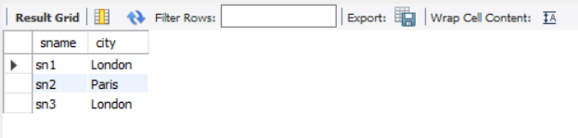

**Query**

1. (b) Get the part numbers and names of parts that have been shipped by suppliers located in Paris with status at least 20.

**Output:**

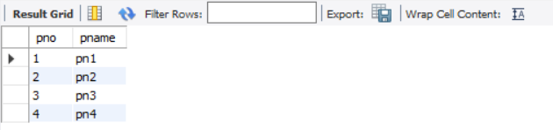

**Query :3**

1. (c) For each part, show the part number, name, and the number of suppliers who have supplied the part.

**Output:**

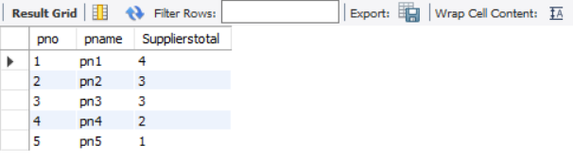

**Query :**

1. (d) For each London supplier who has shipped at least 1000 parts, show the name of the supplier and the total number of parts he/she has shipped.

**Output:**

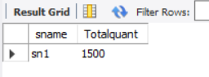

**Query :**

1. (e) Get the names and cities of the suppliers who have supplied all parts that weigh less than 4 grams.

**Output:**

