# Question 3

**Query :**

1. (a) **Goal:** Summarizing Data in Groups

**Table:** customer

**Query:** Write a query that displays the following statistics for each country:

- Total number of customers

- Total number of male customers

- Total number of female customers

- Percent of all customers that are male (Percent Male).

Display the result by value of Percent Male so that the country with the lowest value is listed first, with the remaining countries following in ascending order.

**Output:**

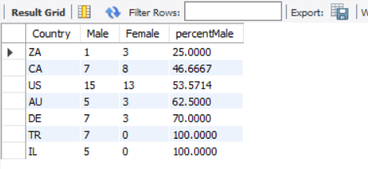

**Query :**

(b) **Goal:** Summarizing Data in Groups

**Table:** product_dim, order_fact

**Query:** Create a result by combining two tables.

- Include columns Product_ID, Product_Name from product_dim table.

- Include a column with the label Total Sold. Use a summary function to create this column, which displays the quantity sold for each product.

- Specifies the tables product_dim, with the alias p and order_fact with the alias o.

- Join the tables by matching the values of the appropriate columns in each table.

- Groups the results by Product_ID from product_dim table and Product_Name.

- Orders the rows so that products with the highest number sold appear at the top of the report and then by Product_Name.

Note: DO NOT use nested queries

**Output:**

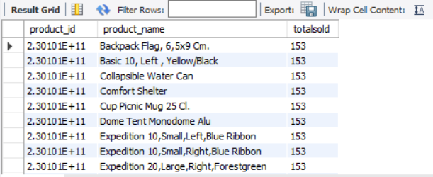

**Query :**

1. (c) **Goal:** Create a result with a self-join.

**Table:** employee_addresses, staff

**Query:** Display result of all trainees and workers at company. For each trainee or temporary worker, the report should include the employee ID, name and job title, and manager ID and name. The report should be ordered by Employee_ID.

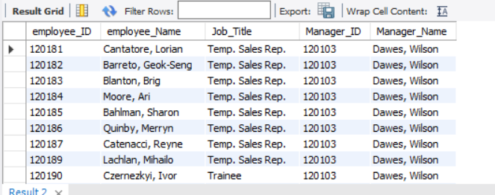

**Query :**

1. (d) **Goal:** LEAD and LAG functions

**Table:** employee_payroll

**Query:** 1) Calculate the difference between the salary of the current row and the previous row. 2) Calculate the difference between the salary of current row and the following row.

**Output:**

