Hotel Management System

**Detailed Design Document**

**Revised Version: SDD 1.0**

**Prepared by**

**Bhagya Shree**

**Bhavya Ahuja**

**Maninder Kaur**

**Ravneet Singh Oberoi**

**SanthaMohan Manivannan**

**Vivekanand Boopathy**

**MSCDA5510 Software Development in Business Environment**

# Preface

This document is Software Design Document for our project named as Hotel Management System. In this document, system modul will be documented clearly.

TABLE OF CONTENT

Preface 2

INTRODUCTION 3

1.1. Purpose 4

1.2. Scope 4

1.3. Definitions, Acronyms & Abbreviations 4

**1.4.** **REFERENCES** 5

3. System Components 7

3.1. Decomposition Description 7

3.1.1. Module Decomposition 7

3.1.2. Data Decomposition 21

3.2. Dependency Description 21

3.2.1. Intermodule Description 21

3.2.2. Data dependencies 23

A user can book several rooms. A room can be reserved by one user. 24

3.3. 3.3 Interface Description 25

3.3.1. Module Interfaces 25

3.3.2. User Interfaces (GUI) 26

4. DetaIled DesIgn 31

4.1. Module Detailed Design 31

4.1.1. Login Module 31

4.1.2. Register Module 31

4.1.3. Messaging Module 31

4.2. RTM 32

4.3. Data Detailed Design 33

4.4. Appendix 1 – ER Diagram 36

4.5. Appendix 2 - Class Diagram 36

4.6. Appendix 3 – Interface Codes 37

4.6.1. Main Page Interface Codes (index.html) 38

4.6.2. Sign Up Interface Codes 39

4.6.3. Sign In Interface Codes 43

4.6.4. Administrator Interface Codes 45

4.6.5. Messaging Interface Codes 47

4.6.6. Reservation Interface Codes 50

4.6.7. Booking Interface 57

4.6.8. User(Authorized) Interface Codes 60

**1. Introduction**

## 1.1. Purpose

The purpose of Software Design Description is to identify what need to coded that is specified in SRS. In this document, brief information of Hotel Management System will be given.

## 1.2. Scope

In this document, the detailed description of Hotel Management System will be given. Our hotel management system project will have a web interface.

In the web interface, there are 3 types of user and which are;

-Administration

-Staff

-Authorized user

Each user type will have a different authorization to access to the system.

## Definitions, Acronyms & Abbreviations

|  |  |  |
| --- | --- | --- |
| **DB** | Database | |
| **FP** | Function Points | |
| **GUI** | Graphic User Interface | |
| **HTML** | Hypertext Markup Language | |
| **HW** | Hardware | |
| **IDE** | Integrated Development Environment | |
| **IE** | Internet Explorer | |
| **IEEE** | Institute of Electrical and Electronics Engineers | |
| **I/O** | Input / Output | |
| **IP** | Initial Plan | |
| **KU** | Knowledge Unit | |
| **LOC** | Line Of Code | |
| **MS** | Microsoft | |
| **PS** | Problem Statement | |
| **RAM:** | Random Access Memory | |
| **SDD** | Software Design Description | |
| **SPS** | Student Portal System | |
| **SPMP** | Software Project Management Plan | |
| **SQL** | Structured Query Language | |
| **SRS** | Software Requirements Specification | |
| **SW** | Software | |
| * 1. **REFERENCES** * IEEE Std 1058-1998, IEEE Standard for Software Project Management Plans * Pressman, Roger S., Software Engineering, 4th edition, McGraw-Hill, 1997 * Fairley, R. E., Work breakdown Structure, Software Engineering Project Management, IEEE CS Press, 1997 | |  |

1. **System Overview**

Hotel management system is a web based project, which helps to hotel management to manage the business online. Customers can access the portal online for Web based booking of rooms ,ordering food and other facilities available at the hotel.This will allow Management to maintain repository and all other information to bring it online.The Information will be maintained in database .Administrative staffs and managements will have the privilege to update,insert and delete information from database.

# 3. System Components

## Decomposition Description

### Module Decomposition

The way followed while making module decomposition is to divide the system into modules so that the operations are done under each module will be higly related with each other, but they are not so much related with other operations in other modules. Taking this into consideration, hotel management system project’s main services are as follows;

**3.1.1.1 Payment Option**

**Identification:** Payment Module

**Type:** Application

**Purpose:** This module provides the customer an option to pay for reservation.

This module also provides the owner to process the payment with API call.

**Function:**

The customer enter the payment details for the reservation and presses the submit button.

**Subordinates:** None

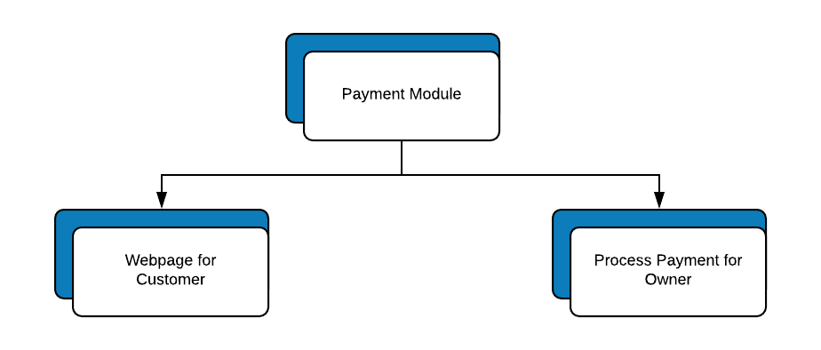

**3.1.1.2 Modify Reservation**

**Identification:** Modify Reservation

**Type:** Application

**Purpose:** Provides customer to change their reservation information.

**Funtion:**  Customer clicks on modify reservation button. They can change any information about the reservation.And click on the confirm button and the updated price is shown.Any difference in the prices is compensated.Reservation is edited.

**Subordinates:** Cancel Reservation

**3.1.1.3 Cancel Reservation**

**Identification:** Cancel Reservation

**Type:** Application

**Purpose:** Provides customer to cancel the reservation. Any related data in the reservation table will be erased.

**Funtion:**  Customer clicks on cancel reservation button. Reservation is canceled.

**Subordinates:** Refund Processing

**3.1.1.4 Refund Processing**

**Identification:** Refund Processing

**Type:** Process

**Purpose:**Provides the customer to get the refund for the reservation.

**Funtion:**  This process is automatically called when user cancels a reservation.

**Subordinates:** None

**3.1.1.5 Search Room**

**Identification:** Search Room

**Type:** Application

**Purpose:** Provides a search tool for the customer to filter rooms based on various criterias.

**Funtion:**  Customer enters the capacity and price intervals to the module.

All suitable rooms are listed.

**Subordinates:**None

**3.1.1.6 Display Restaurant Menu**

**Identification:** Restaurant Menu Module

**Type:** Application

**Purpose:** This module provides information about food available on the menu on a day with their prices.

**Function:** The user select the day, price and filter based on the them results are shown.

**Subordinates:** None

**3.1.1.7 Feedback Page:**

**Identification:** Feedback Module

**Type:** Application

**Purpose:** This module provides the options for the user give a rating and a review for a particular room.

**Function:** The user will select one of the rooms.The user will select “Write a Review” button and the user is asked to giver rating out of 5 stars and Review textbox (Optional) and upon pressing the Submit Button , the review is added to Room page under reviews.

**Subordinates:** None

**3.1.1.8 Sign in**

**Identification:** Sign in

**Type:** Application

**Purpose:** Provides user to get their authorization level which is recorded in corresponding cell of the user table.

**Function:** A user enters their required information (e-mail, password) to the web form. If those information match with a row of the user table, user gets their authorization level.

**Subordinates:**

Social Media Login

**3.1.1.9 Social Media Login**

**Identification:** Social Media Login Module

**Type:** Process

**Purpose:** This module provides the options for the user to use one of his social networking profile(Google +, Facebook or Twitter) for Login

**Function:** The user will select one of the Social networking sites.The User is redirected to the social netowrking site and upon the user entering the correct credentials the user is allowed to Login and the Home page is displayed.

**Subordinates:** None

**3.1.1.10 Member Registration**

**Identification:** Member Registration Module

**Type:** Application

**Purpose:** This module provides the options for the user to register as a member of the hotel to eligible for more offers.

**Function:** The user will click on the “Register as Member” button and is redirected to a form where the user will be inputting all his information and upon succesful validation he will be registered as member and on failing the user will be notified of the mistake. By Default the user will be logged in on registering

**Subordinates:** Sign in

**3.1.1.11 Member Booking**

**Identification:** Member Booking Module

**Type:** Application

**Purpose:** This module provides the members a discount on the original prices

**Function:** The user will login on the member page.The user will select a room and the discounted price must be displayed .The user will click on the Book button to book the room.

**Subordinates:** None

**3.1.1.12 Reports on Payment information for customer**

**Identification:** Member Booking Module

**Type:** Application

**Purpose:** The user can get the report for transaction they made with the booking receipt.

**Function:** User will get fullfledged report of his payment details for his own recods.

**Subordinates:** None

**3.1.1.13 Reports on Payment information for Owner**

**Identification:** Member Booking Module

**Type:** Application

**Purpose:** The user can get the report for transaction they made with the booking receipt.

**Function:** User will get fullfledged report of his payment details for his own recods.

**Subordinates:** None

**3.1.1.14 Discount Alerts**

**Identification:** Discount Alerts

**Type:** Application

**Purpose:** This module sends messages about the discounts to the members

**Function:** The members will be recieving the information about the discounts in thier email.

**Subordinates:** None

# 

# Interface Description

# Module Interfaces

In this part of SDD, communication between modules is explained in detail.

|  |  |  |  |  |
| --- | --- | --- | --- | --- |
| Hotel Information Module | < - > | viewInformation viewReservedRoom viewMessages  viewImages | < - > | Profile Module |
| Reservation Module | < - > | viewRooms  setDate  setNoOfPeople makePayment viewInvoice  editReservation | < - > | Message Module |
| Payment Module | < - > | setTransactionDetails passwordTransections | < - > | Authentication Module |
| Member Information Module | < - > | login registration passwordTransections | < - > | Alerts Module |
| Service Information Module | < - > | viewServices makePayment | < - > | Authentication Module |

# User Interfaces (GUI)

In this part of SDD, user interfaces are explained in detail. There may be some incompatibility issues with other browsers such as Internet Explorer because of CSS. However, they will be tested and handled during the application development process.

This interface will be variated according to different user types. For unauthorized users, there will be a common interface which contains advertisements, announcements, and sign in, sign up menu. When user signed in, according to their type, users will be shown different main pages and those are;

# Main Page Interface

Authorized user: This type of users menu will have standard options (HOME, CONTACT, ABOUT US, and LOG OUT) and RESERVATION option. Also their

Profile information can be seen.

Administrator: This interface will have ROOMS, MESSAGES, SUPPLIER, CUSTOMERS and LOG OUT menu.

Accounter: This interface will have ROOMS, MESSAGES, ACCOUNTING, CUSTOMERS and LOG OUT menus. Latest activities will be shown in this menu. Those activities will be recorded to database in activity history section.

Staff: This interface will have ROOMS, MESSAGES and LOG OUT menus. Staff also can operate offline reservations.

**3.3.2.2 Registration Interface**

All types of users will have to sign up using this interface. They will have to give their names, e-mail addresses, passwords and authentication level to complete their registration. Also a security image will be shown and user will be forced to enter the text in this image for security issues.

**3.3.2.3 Login Interface**

To login, all users will have to use this interface. It will ask the e-mail and password to users.

**3.3.2.5 Messaging Interface**

Administrators, staffs and Accounters can use this interface to send and receive messages or alerts. Also deleting and organizing messages features will be included.

**3.3.2.6 Reservation Interface**

In this interface, authorized users(customers) can choose and book a room according to their needs.

There will be profile pages for each user which show the information for each user such as registration date, name, SSN.

# Detailed Design

## Module Detailed Design

### Hotel Information Module

Method Name: Login

Description: allows users to enter the system

Share Type: public

Return Type: Boolean

Parameters: username, password, imageVerification

### Register Module

Method Name: registration

Description: registers a new user to the system

Share Type: public

Return Type: boolean

Parameters: firstName, lastName, password, email, birthDate, gender, country, city, district.

### Adding Announcement/Alerts

Method Name: adding announcement/alerts

Description: allows Staffs/Managers to add announcements

Share Type: public

Return Type: Boolean

Parameters: login information, payment Status

* 1. **RTM**

|  |  |  |  |  |
| --- | --- | --- | --- | --- |
| Requirement # | Requirement Description | Requirement ref. | Design reference | Module name |
| 1 | User Authentication | 4.1.1.3 | **3.1.1.8** | User Authentication Module -Log-in -Sign-up -change Password - Forgotten Password |
| 2 | Discount Alerts | 4.1.3.2 | 3.1.1.14. | Messaging Module(Customer Specific)  - Send Alerts  - Deactivate Alerts |
| 3 | Searching | 4.1.3.1 | 3.1.1.5. | Searching Module(Customer)  -Search Room  -Search Restaurant  -Search Service available |
| 4 | Online Reservation | 4.1.1 | 3.1.1.5. | Online Reservation Module  - Reserve Room |
| 5 | Edit Reservation | 4.1.1.8 | 3.1.1.2. | Online Reservation Module  -Edit Reservation |
| 6 | Food Information Module | 4.1.2.1 | 3.1.1.6 | Search different Cuisines |
| 7 | Cancel Reservation | 4.1.1.7 | 3.1.1.3 | Online Reservation Module  -Cancel Reservation  -Payment Refund |
| 8 | Payment Module | 4.1.4 | 3.1.1.1 | Online Reservation Module  -Pay for Rooms  -Pay for Food  -Pay for Service |
| 9 | Reports(Customer) | 4.1.1.12 | 3.1.1.12 | Online Reservation Module  - Invoice  - Booking Report |
| 10 | Troubleshooting Payments | 4.1.1 | 3.1.1.4 | Online Reservation Module  - Check Firewall  - Check proxy  - Check API |
| 11 | Feedback Page | 4.1.1.10 | 3.1.1.7 | Online Reservation Module  - Feedback for Room  - Feedback for Service |

## Data Detailed Design

Table Name: Books

This table holds Booksavailable in the library information.

|  |  |  |  |
| --- | --- | --- | --- |
| Column Name | Data Type | Description | Example |
| Book_ID (PK) | INT | primary key, auto increment, not null | 1 |
| Book_Name | VARCHAR(15) | holds name of the book | Wings of Fire |

Table 1: Books

Table Name: Customer

This table holds customers information.

|  |  |  |  |
| --- | --- | --- | --- |
| Column Name | Data Type | Description | Example |
| Customer_ID (PK) | INT | primary key, auto increment, not null | 1 |
| FName | VARCHAR(15) | holds first name of user | Vivek |
| LName | VARCHAR(15) | holds last name of user | Shah |
| Password | VARCHAR(15) | holds password of user | $1234 |
| Email | VARCHAR(45) | holds email of user | [murat@gmail.com](mailto:murat@gmail.com) |
| Mobile | INT | holds the mobile of the user | 902902 |
| Loyalty_points | INT | holds the loyalty of the user | 90 |

Customer Info

Table Name: Transaction_ID

This table holds the transactions information.

|  |  |  |  |
| --- | --- | --- | --- |
| Column Name | Data Type | Description | Example |
| Transaction_ID (PK) | INT | primary key, auto increment, not null | 1 |
| Quantity | INT | holds the quantity | 1 |
| Quantity_price | FLOAT | holds the price for quantity | 109.1 |
| Book_ID | INT | holds the Booking ID | 1 |
| Customer_ID | INT | holds the Customer ID | 1 |
| Room_No | INT | Holds the room number | 1 |
| Service_ID | INT | Holds the service number | 1 |

Transaction_ID Table

|  |  |  |  |
| --- | --- | --- | --- |
| Table Name: Transaction  This table holds the transactions amounts. | | |  |
| Column Name | Data Type | Description | Example | |
| Card_No(PK) | INT | primary key, auto increment, not null | 1 | |
| EXPDATE | DATE | shows the expiry date of credit card | 22.05.2010 | |
| Amount | FLOAT | shows the amount paid | 12.3 | |
| Transaction_ID | INT | shows Trnsaction_ID | 1 | |

Transaction

|  |  |  |  |
| --- | --- | --- | --- |
| Table Name: Services  This table holds information about services. | | |  |
| Column Name | Data Type | Description | Example | |
| Service_ID(PK) | INT | primary key,auto increment, not null | 1 | |
| Service_Name | VARCHAR(15) | holds the description of the Service | Spa services | |

Services

Table Name: Room

|  |  |  |  |
| --- | --- | --- | --- |
| This table holds information about rooms. | | |  |
| Column Name | Data Type | Description | Example | |
| Room_No(PK) | INT | primary key,auto increment, not null | 1 | |
| Room_Type | VARCHAR | holds the description of the Room | DELUXE | |
| View | VARCHAR | holds the View type of the Room | Seaface | |
| Price | FLOAT | holds the price of the Room | 100.1 | |

Room

Table Name: Food

|  |  |  |  |
| --- | --- | --- | --- |
| This table holds information about Food. | | |  |
| Column Name | Data Type | Description | Example | |
| Food_ID(PK) | INT | primary key,auto increment, not null | 1 | |
| Cuisine_name | VARCHAR | holds the cuisine of the food | Continental | |
| Speciality | VARCHAR | holds the speciality of the food | Dinner | |
| Service_ID | VARCHAR | holds the Service_Id of the food | 1 | |

Food

## Appendix 1 – ER Diagram

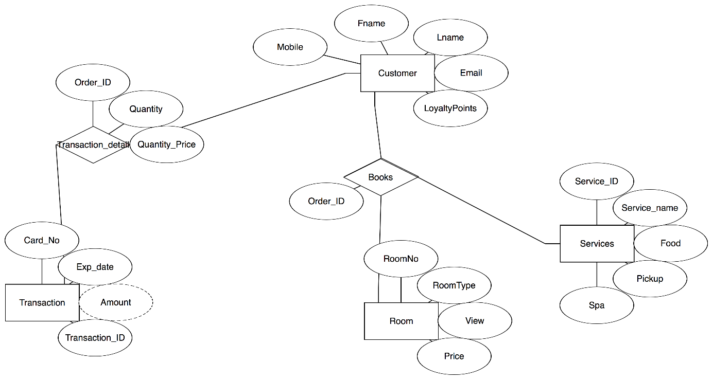

## Appendix 2 - Class Diagram



 