Hotel Management System

High Level Design Document

Group Members

Bhagya Shree

Bhavya Ahuja

Maninder Kaur

Ravneet Singh Oberoi

SanthaMohan Manivannan

Vivekanand Boopathy

**MSCDA5510 Software Development in Business Environment**

# Table of Contents

1. Abstract 4
2. Introduction 5
3. Definitions and Acronyms 5
4. Proposed system 6
5. Feasibility report 6
   1. General requirement feasibility report 6
6. Technical feasibility 7
7. Technical description 7
8. User interface 8
9. Project Design Description 9
   1. Purpose 9
   2. Scope 9
10. Functional requirements 10
11. Scope of the development project 11
    1. Database tier 11
    2. User tier 11
    3. Database connectivity tier 11
12. Software requirement specification 12
    1. Requirement hardware 12
    2. Requirement software 12
13. Modules description 12
    1. Hotel Information Module 12
    2. Reservation information 12
    3. Payment module 13
    4. Member Information module 13
    5. Service Information module 13
14. Number of views 14
    1. Administrative view 14
    2. Member view 14
15. Performance requirements 15
16. Front end or User interface design 16
17. Eclipse IDE 16

18.1. Eclipse software features 16

1. Dataflow diagrams 17
2. E-R-Diagrams 18
3. Unified modeling language diagram 19
4. Sequence Diagram 21
5. Testing 23
6. Conclusions and recommendations 24
7. References 25

# Revision History

**Change Record**

|  |  |  |  |
| --- | --- | --- | --- |
| **Date** | **Author** | **Version** | **Change reference** |
| 11/11//2018 | Bhagya Shree | 0.1 | Initial Version |
| 14/11/2018 | SanthaMohan Manivanna | 0.2 | Changes in ER |
| 16/11/2018 | Vivekanand | 0.3 | Formatting |

**Reviewers**

|  |  |  |  |
| --- | --- | --- | --- |
| **Name** | **Version approved** | | **Date** |
| Bhavya Ahuja | 0.1 | 13/11/2018 | |
| Maninder Kaur | 0.2 | 15/11/2018 | |
| Ravneet Singh Oberoi | 0.3 | 17/11/2018 | |

# Abstract

The Online portal provides the flexibility to book rooms and services in hotel and other services for customers. There is change in the booking pattern from manual to web-based system. It will help them to manage the customer’s booking easily and also to keep the customers data safer. It will also help staffs to keep in track of their customer’s online booking request easily. This documentation shows how the web-based system will be implemented.

The total front end will be designed using HTML standards applied with the dynamism of JAVA server pages. The communicating client will be designed using servlet and JSP’s. The database connectivity will ensure that the authorization and authentication will be cross checked at all stages. The user level accessibility has been restricted into two zones the administrative and the normal user zone.

# Introduction

The entire project will be developed keeping in view of the Distributed client server computing technology in mind. The specification has been normalized up to 3NF to eliminate all the anomalies that may arise due to the database transactions that are executed by the actual administration and users. The user interfaces are browser specific to give distributed accessibility for the overall system. The internal database has been selected as mongo db. The basic constructs of the tablespaces, clusters and indexes have been exploited to provide higher consistency and reliability for the data storage.

The mongo db is chosen as it provides the constructs of high-level reliability and security. The total front end will be designed using HTML standards applied with the dynamism of JAVA server pages. The communicating client will be designed using servlets.

# Definitions and Acronyms.

HTTP- Hypertext transfer Protocol HTML- Hypertext Markup Language FR – Functional Requirement

NFR –Nonfunctional requirement GUI – Graphical user interface

# Proposed Functionality:

The Online Portal can support the following functionalities.

1. Customer/Members can make reservation of the room 24*7 using online portal.
2. The registration of new member is online. Registration process is convenient.
3. Customers can edit or delete their bookings.
4. Customers can avail other services in hotel.
5. Customers can order food from the hotel.
6. The Customers will be provided with up to minute information related to the room availability and their status.

# FEASIBILTY REPORT

* 1. **GENERAL REQUIREMENTS FEASIBILTY REPORT:**
  + The new system should be cost effective
  + To improve productivity and services.
  + To enhance user interface.
  + To improve information presentation and durability.
  + To upgrade systems reliability, availability and flexibility.
  + To address human factors for better and user acceptance.

# TECHINICAL FEASIBILITY:

A number of issues have to be considered while doing a technical Analysis:

* + Before commencing the project, we have to be very clear about what are the technologies that are to be required for the development of the new system.
  + Understand the different technologies involved in the proposed system.

# Technical Description

The major part of the Databases is categorized as Administrative components and the user components.

The administrative view is designed such that, they can be able to edit any of the fields in database or update it. Also, they can generate reports on weekly or daily basis.

The user view is designed to handle the transactional state that may arise upon the portal whenever the customer makes a visit into the system for either checking the details on portal or for reservations.

The user view is scheduled to accept the request as per requirement.

# USER INTERFACE

The user Interface has been designed keeping in mind the flexibility of users. It can be accessed through browser.

The GUI’s at the top level has been categorized as:

1. **Administrative/Staff user interface**
2. **Customer or general user interface**

The administrative user interface concentrates on the consistent information that is practically, part of the organizational activities and which needs proper authentication for the data insertion or updation. The interfaces help the staffs with all the transactional states like Data insertion, Data deletion and Data updating with the data search capabilities.

The member user interface helps the users to perform transactions for the required services that are provided upon the system. The user interface also helps the members to manage their own information in a customized manner as per their flexibilities.

# Project Design Description

# Purpose:

The main purpose for preparing this document is to give a general insight into the design of the portal as per the analysis of requirement for determining the operating characteristics of the

# Scope:

This Document plays a vital role in the Software development life cycle (SDLC). The HLD will

* present all of the design aspects.
* describe the hardware and software interfaces
* describe the performance requirements
* includes design features and schemas and use cases for the project
* list and describe the non-functional attributes like: security, reliability, maintainability, portability, reusability, application compatibility, resource utilization ,serviceability, resource utilization.

1. **Functional Requirements**: Inputs:

The major inputs for online Booking System can be categorized module -wise.

Basically, all the information is produced based on authentication. One has to produce one's identity by entering the user-id and password.

Every user has their own domain of access beyond which the access is dynamically refrained denied.

Output:

The major output of the portal for administrative or staff members is reports on bookings done and for the customers are the information on rooms available, services and their prices.

# Scope of The Development Project:

# Database Tier:

The concentration is applied by adopting the MongoDB 3.6. NoSQL is taken as the standard query language. The overall business rules are designed by using JavaScript’s and database triggers.

# User Tier:

The use interface is developed in a browser specific environment to have distributed architecture. The components are designed using HTML standards and the Java server pages powers the dynamic of the page design.

# Data Base Connectivity Tier:

The communication architecture is designed based on the standards of servlets and JSP’s. The database connectivity is established using the Java Database connectivity.

# Software Requirement Specification

**For Client**

* 1. **Minimum required Hardware**
     + Ethernet card with an Internet and Internet zone**.**

# Required Software

* + - Internet explorer or Google Chrome.

# Modules Description

Number of Modules:

* Hotel Information Module.
* Reservation Module.
* Payment Module
* Member Information Module.
* Services Information Module.

# HOTEL INFORMATION MODULE:

This module maintains all the details of the Hotel availability under different categories and the rooms that are available.

# RESERVATION MODULE

This module maintains the information of all the booking of the rooms, as per the guest requirements, it searches itself with the rooms database and the specific registered guest who have raised the demand upon the booking.

# PAYMENT MODULE:

This module takes cares of payment activities that the user performs to reserve a room in the hotel.

# MEMBER INFORMATION MODULE:

This module maintains the overall activities through which a member is uniquely registered in the domain and allow the member privileges.

# SERVICE INFORMATION MODULE

This module maintains the overall activities in the facilities that are available to the customers. The different services available in the hotel are Food, Spa etc.

# NUMBER OF VIEWS:

* Administrative View
* Guest View

# Administrative View

This view is designed for staffs and Mangement members to maintain the information and edit and delete as per the requirement.

This view is accessible only to registered administrators who are recognized by the Management of the hotel.

This Module takes care of the responsibility of the major Table management for

* Data Insertion
* Data Deletion
* Data Updating
* Data Selection

All the activities are validated and authenticated to proper profile to avoid un authorized

# Member View

In this view the member can view complete details of available rooms and services list and make reservations on them.

# Performance Requirements:

Performance is measured in terms of number of times the functionality was not responsive and also Performance is measured in terms of reports generated weekly and monthly.

# Front end or User Interface Design

The entire user interface is planned to be developed in browser specific environment with a touch of Intranet-Based Architecture for achieving the Distributed Concept.

The browser specific components are designed by using the HTML standards, and the dynamism of the designed by concentrating on the constructs of the Java Server Pages.

# Eclipse IDE

Eclipse is an open-source software framework written primarily in Java. In its default form it is an Integrated Development Environment (IDE) for Java developers, consisting of the Java Development Tools (JDT) and the Eclipse Compiler for Java (ECJ). Users can extend its capabilities by installing plug-ins written for the Eclipse software framework, such as development toolkits for other programming languages, and can write and contribute their own plug-in modules. Language packs are available for over a dozen languages.

# Eclipse software features

The basis for Eclipse is the Rich Client Platform (RCP). The following components constitute the rich client platform:

* OSGi - a standard bundling framework
* Core platform - boot Eclipse, run plug-ins
* Javascripts, Java, JSP, HTML, CSS, Bootstrap, MongoDB, SOAP
* the Eclipse Workbench - views, editors, perspectives, wizards

Eclipse employs plug-ins in order to provide all of its functionality on top of (and including) the rich client platform, in contrast to some other applications where functionality is typically hard coded. This plug-in mechanism is a lightweight software componentry framework.

# Data Flow Diagrams

This Diagram server two purpose.

* Provides information on all the functionalities that are under the control of customer. And that of administrative staffs and Owners.
* Provides the functionality of Hotel Management System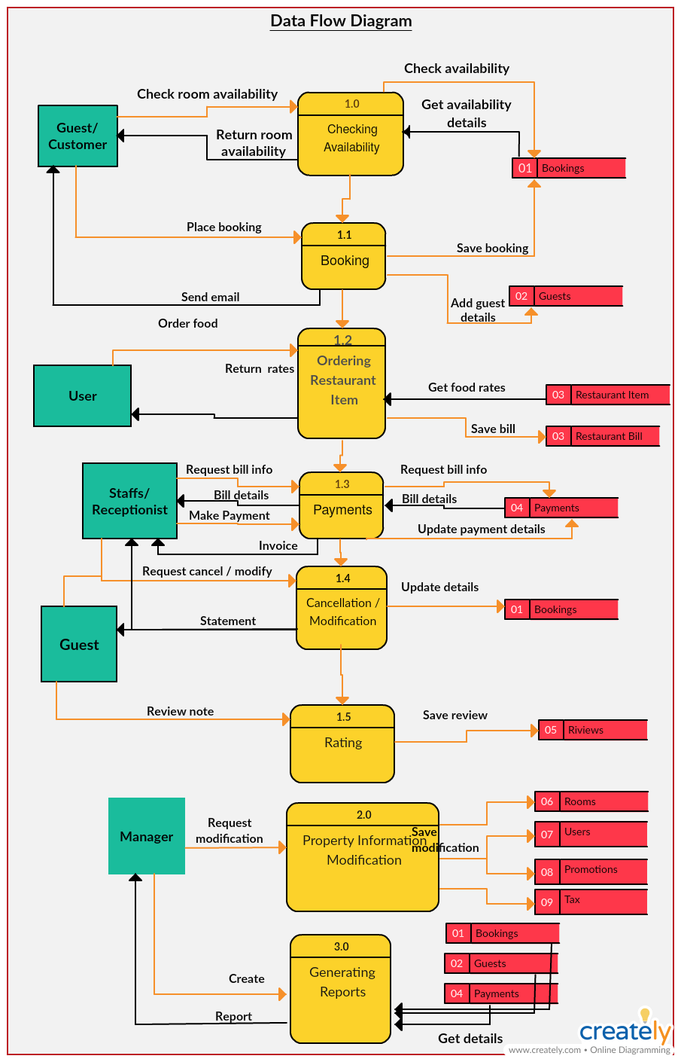.

# ER-Diagrams

The entity Relationship Diagram (ERD) depicts the relationship between the data objects. The ERD is the notation that is used to conduct the date modeling activity the attributes of each data object noted is the ERD can be described resign a data object descriptions.

The set of primary components that are identified by the ERD are

* Data object  Relationships
* Attributes  Various types of indicators.

The primary purpose of the ERD is to represent data objects and their relationships.

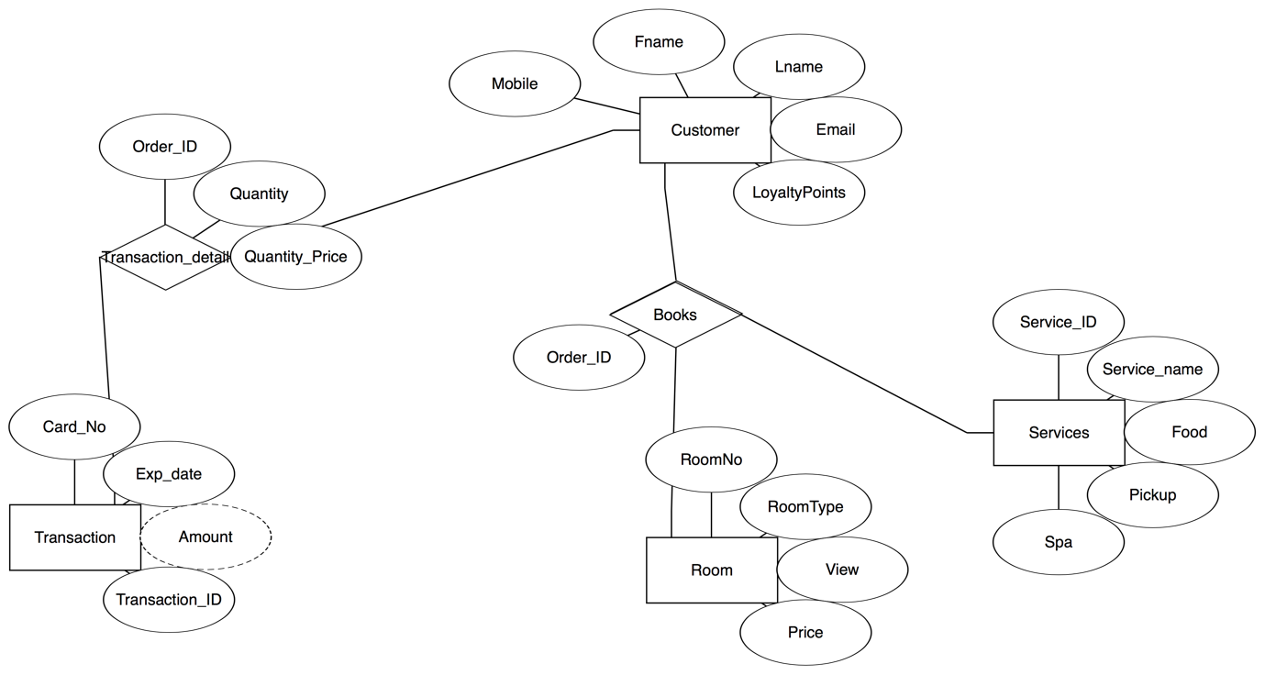

# Unified Modeling Language Diagrams

The unified modeling language allows the software engineer to express an analysis model using the modeling notation that is governed by a set of syntactic semantic and pragmatic rules.

A UML system is represented using five different views that describe the system from distinctly different perspective. Each view is defined by a set of diagram, which is as follows**.**

* User Model View:

1. This view represents the system from the users perspective.
2. The analysis representation describes a usage scenario from the end-users perspective.

* Structural model view:

1. In this model the data and functionality are arrived from inside the system.
2. This model view models the static structures**.**

* Behavioral Model View:

a. It represents the dynamic of behavioral as parts of the system, depicting the interactions of collection between various structural elements described in the user model and structural model view**.**

* Implementation Model View:

1. In this the structural and behavioral as parts of the system are represented as they are to be built.

* Environmental Model View:
  1. In this the structural and behavioral aspect of the environment in which the system is to be implemented are represented.

**Use Case Diagram**

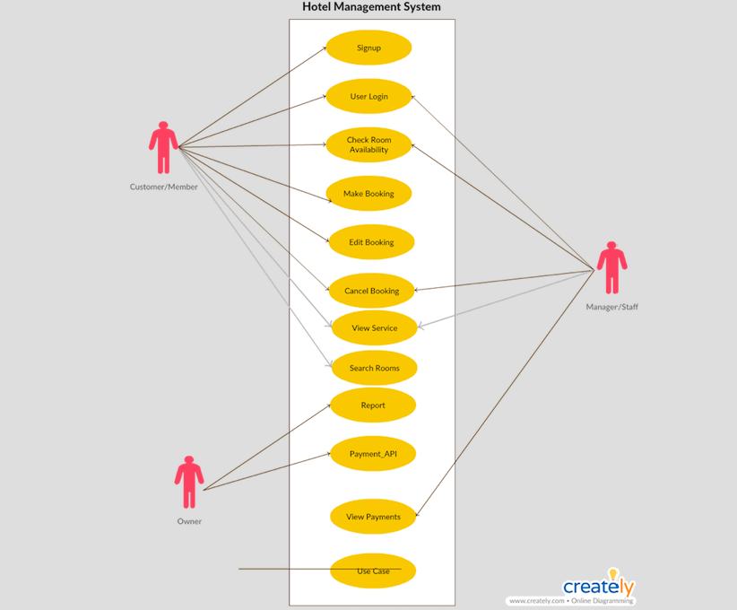

# SEQUENCE DIAGRAMS

**User Login Sequence Diagram:**

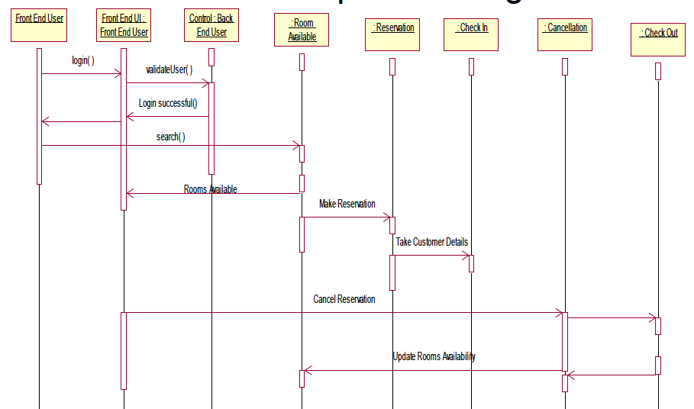

**Sequence Diagram for Complete functionality of Hotel Management**

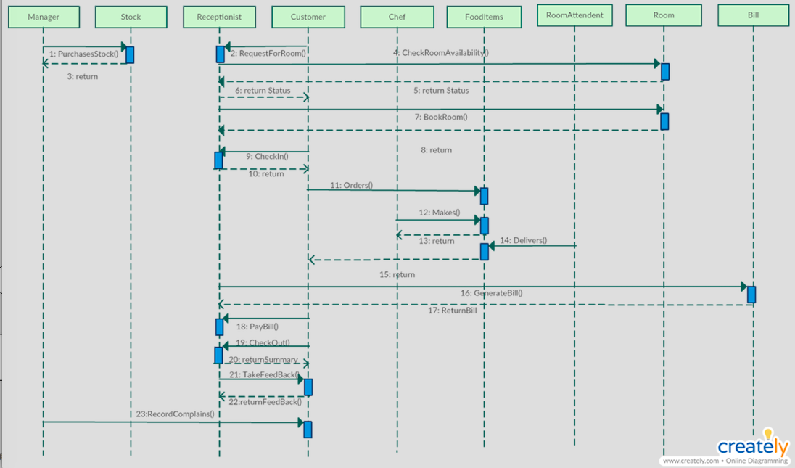

# Testing

Testing is the process of detecting errors. Testing performs a very critical role for quality assurance and for ensuring the reliability of software. The results of testing will be used later on during maintenance.

Testing Objectives:

The main objective of testing is to uncover a host of errors, systematically and with minimum effort and time. Stating formally, we can say

* Testing is a process of executing a program with the intent of finding an error.
* A successful test is one that uncovers an as yet undiscovered error.
* A good test case is one that has a high probability of finding error, if it exists.
* The tests are inadequate to detect possibly present errors.
* The software more or less confirms to the quality and reliable standard.

Levels of Testing:

In order to uncover the errors, present in different phases we will consider different levels of testing. The basic levels of testing are as shown below…

Client Needs



Acceptance Testing

Requirements



System Testing

Design



Integration Testing



Unit Testing

Code

# Conclusions

The HLD has been written and deployed as per the requirements by the user, it is found to be bug free as per the testing standards that are implemented. Any specification untraced errors will be concentrated in the coming versions, which are planned to be developed

in near future.

# References

# <https://creately.com> – Online Diagram Software

* https://www.cms.gov/Research-Statistics-Data-and.../HighLvlTechDesign.docx
* https://www.slideshare.net