**Test Suites**

**for**

**Hotel Management System**

**Version 1.0**

**Prepared by**

**Bhagya Shree**

**Bhavya Ahuja**

**Maninder Kaur Baria**

**Ravneet Singh Oberoi**

**Santhamohan Manivannan**

**Vivekanand Boopathy**

**MSCDA5510 Software Development in Business Environment**

**Purpose**

Programming testing empowers making target appraisals with respect to the level of conformance of the framework to expressed necessities and details. Testing checks that the framework meets the diverse prerequisites including, practical, execution, unwavering quality, security, ease of use et cetera. This check is done to guarantee that we are building the framework right. What's more, trying approves that the framework being created is the thing that the client needs. Approval is performed to guarantee that we are building the correct framework. Aside from helping decide, the data from programming testing assists with hazard administration.

This record clarifies the different exercises executed as a major aspect of testing for inn administration framework.

**Testing Scope**

1. ***In Scope:***

|  |  |  |  |  |
| --- | --- | --- | --- | --- |
| Feature | Action | Constraint | Positive Values | Negative Values |
| User Login | Registration | Registered User | First name  Last name  Email  Contact  Location  Zipcode | First name Empty  Last name Empty  Invalid email address  Left Empty/ Digits are less or more  Location left blank  Wrong Zipcode |
| Room  Searching | Room Selection | Type  Number of Rooms | Double  One | Left empty |
|  | Service Selection | Type | Food  Recreational Service  Add-on Services |  |
| Update Booking | Cancel Booking | Booking Id | 231233232 | Wrong booking Id.  Not Logged in before. |
|  | Edit Booking | Booking Id  Room Updation  Service Updation | 231232321  Double/One  Food/Recreatonal/Add-On | Wrong Booking Id.  Room not Selected  Service not selected |
| Check In/  Check Out | CheckIn CheckOut. | Must select Check Date  Must select Check Out Date | 12/12/2018  01/2/2019 | Empty  Date entered wrongly |
|  | Fill Personal Details | Name  Email  Phone no.  Expected  Check Time  Special Request. | Will Jenny  902348567  2:00 pm – 3:00 pm  Non-veg Meals | Empty fields  Phone number not entered in proper format  Digits are less or more than 10 |

**Test Cases**

1. ***Out of Scope:***

Application not tested for performance testing.

Reverse transaction from bank was not tested.

**Metrics**

**No. of testcases planned, executed, passed and failed**

|  |  |  |  |
| --- | --- | --- | --- |
| Test Cases Planned | Test Cases Executed | Test Cases Pass | Test Cases Failed |
| 34 | 34 | 32 | 2 |

A Test Case is an arrangement of activities executed to confirm a specific element or usefulness of your product application. The objective of Test Case documentation is to indicate and convey the particular conditions which should be approved to empower an appraisal of the framework.

Experiments are spurred by numerous things however will more often than exclude a subset of Use Cases, execution attributes and dangers in the undertaking.

**ACCEPTANCE TESTING**

It is a dimension of programming testing where a framework is tried for adequacy. The motivation behind this test is to assess the framework's consistence with the business necessities and survey whether it is adequate for conveyance.

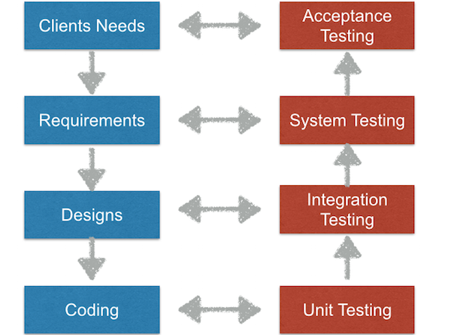

Usually, Black Box Testing method is used in Acceptance Testing. Testing does not normally follow a strict procedure and is not scripted but is rather ad-hoc.

Black box testing typically involves running through every possible input to verify that it results in the right outputs using the software as an end-user would. We have decided to perform Equivalence Partitioning and Boundary Value Analysis testing on our application

**Acceptance Level Testing based on Client Needs:**

|  |  |  |  |
| --- | --- | --- | --- |
| USER | REQUIREMENTS | VALID TEST CASE | INVALID INPUTS |
| *Customer* | As a customer I want to be able to login using social media so that they have easy access. | User can login using facebook or gmail id on to the portal | Connection is not well established between two platforms. |
|  | As a customer I want to have member booking so that I do not have to remember my contact info | Using booking id, I can able to fetch all the details related to the booking. | From member booking id relevant information is not fetched. |
| *Hotel Owner* | As an owner I want to review/feedback page visible by owner so that I can improve customer satisfaction | System correctly retrieves the requested relevant customer feedback data and displays it within the admin portal. | Failure to retrieve requested review data. |
|  | As an owner I want a search option based on dates so that customer can see room availability | Based on dates,  Availability is show accurately. | Booked rooms are shown as available |

**Testing performed**

a) Smoke Testing

This testing was done at whatever point a Build is gotten (sent into Test condition) for Testing to ensure the real functionalities are working fine, Build can be acknowledged, and Testing can begin.

b) System Integration Testing

This is the Testing performed on the Application under test, toverify the whole application functions according to the prerequisites. Basic Business situations were tried to ensure essential functionalities in the application fills in as planned with no mistakes.

c) Regression Testing

Relapse testing was played out each time another form is conveyed for testing which contains imperfection fixes and new improvements, assuming any. Relapse Testing is being done on the whole application and not simply the new functionalities and Defect fixes. This testing guarantees that current functionalities works fine after imperfection settle and new improvements are added to the current application. Experiments for new functionalities are added to the current experiments and executed.

**Lessons Learnt**

1. Smoke testing test cases required to be executed manually each time. Smoke test cases were automated and the scripts were run, which ran fast and saved time.

2. Initially, few testers were not having rights to change defect status. Rights were obtained from Client, by explaining the difficulty.

**Conclusion**

* As the Exit criteria was met and satisfied as mentioned in Section 10, this application is suggested to ‘Go Live’ by the Testing team.
* Appropriate User/Business acceptance testing should be performed before ‘Go Live’.

**References**

* Ghahrai, A. (2018). Why do we Test? What is the Purpose of Software Testing? —

Testing Excellence.

* Subramanian, B. and VERMA, R. (2018). A Simple 12 Steps Guide to Write an Effective

Test Summary Report