**Master of Science in Computing and Data Analytics**

**Team Project Halifax Science Library (HSL)**

Team

Aditi Avinash Dhage - A00446685

Akshaykumar Mashalkar - A00443319

Chirag Panasuriya - A00442907

Kishor P. Deshmukh- A00439253

Somto Johnpaul Muotoe - A00442756

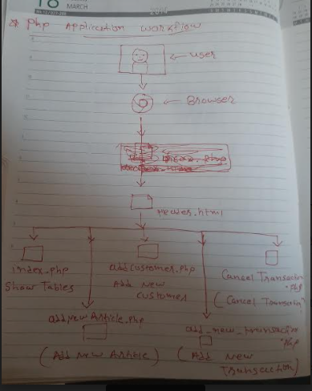

1. Header.html

Below is our home page and has navigation links to all other pages like Show tables, Add a new article, Add a new Customer, Add a new Transaction, Cancel a Transaction.

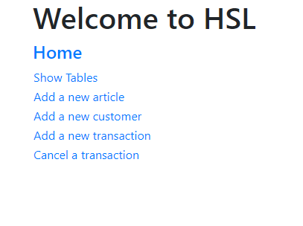

1. Show Tables

Show Tables page will display dropdown with all available tables and user can view the data if the table

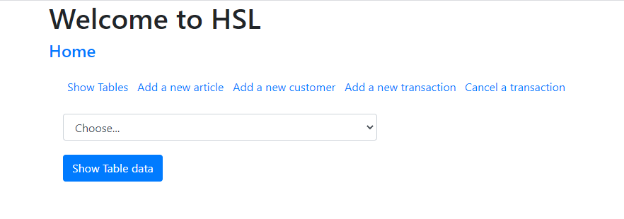

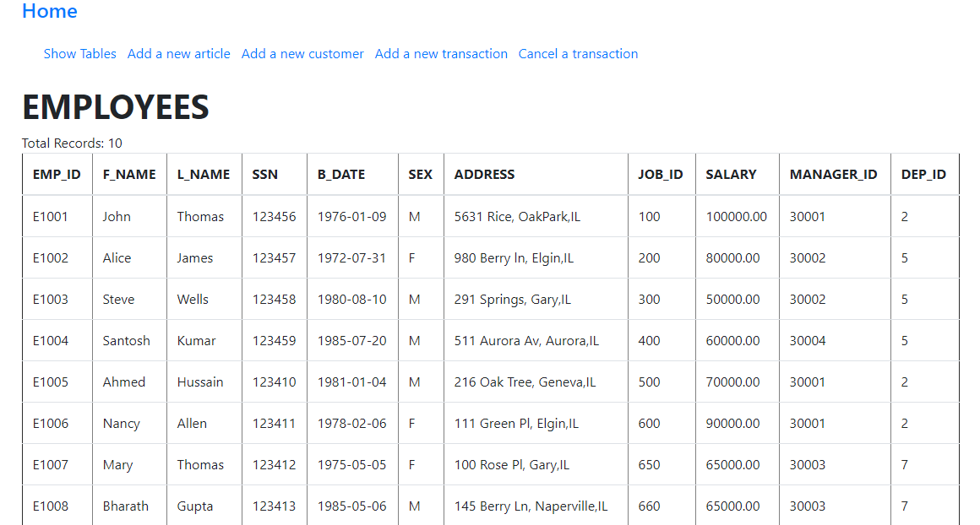

1. addNewArticle.php

Add new Article

Magazine, volume, Publication year, Title and Pages are the inputs from the users.

On submit it successfully adds new article to the database.

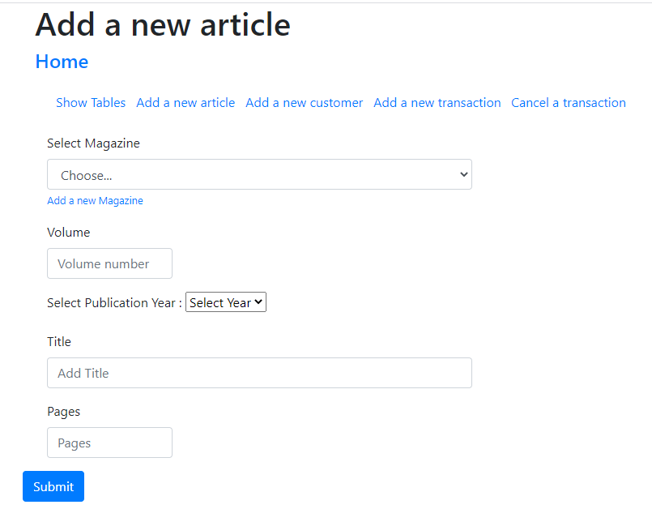

On Click of Add new Magazine, below page will open and user will Enter Magazine name,

On Submit click new Magazine will be added

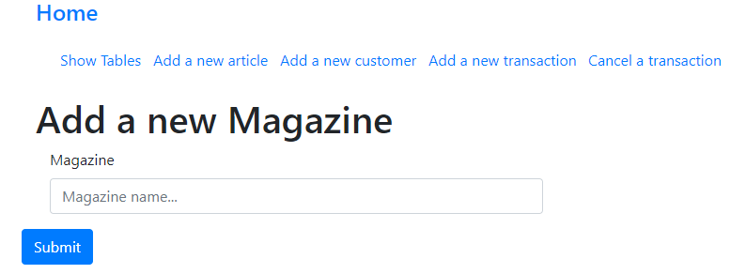

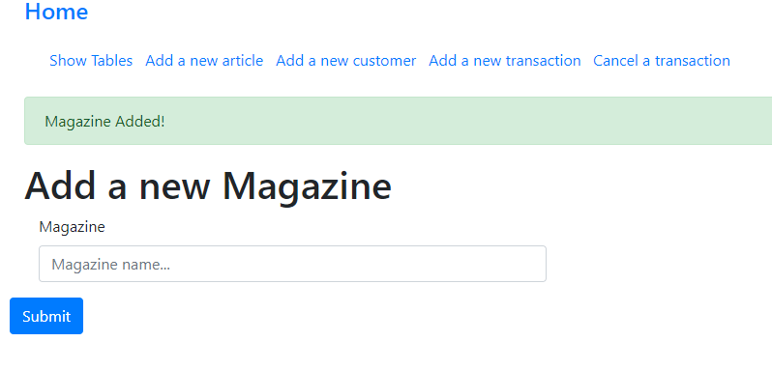

1. add_new_customer.php

Add new Customer

First Name, Last Name, Address and Telephone Number are the inputs from the users.

On submit it successfully adds new Customer to the database.

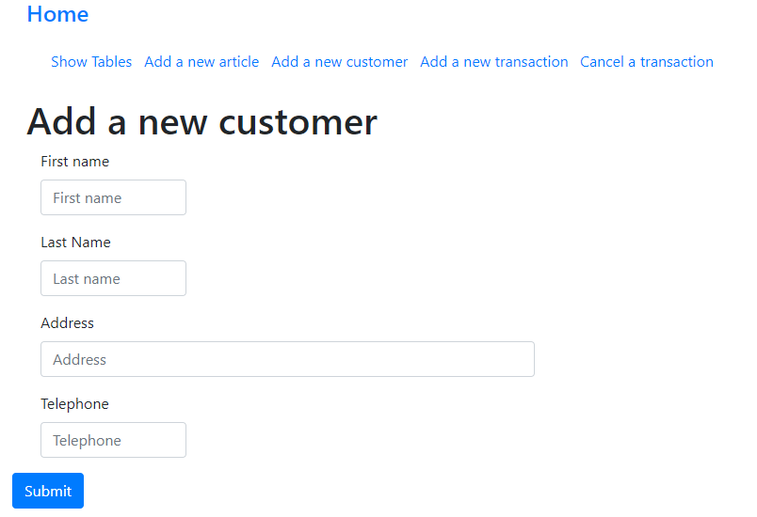

1. add_new_transaction.php

Customer Number and Name, Item id and price are the inputs from the users.

On submit it successfully adds new Transaction and Transaction details to the database.

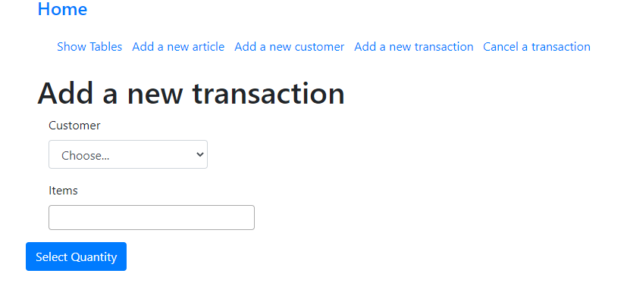

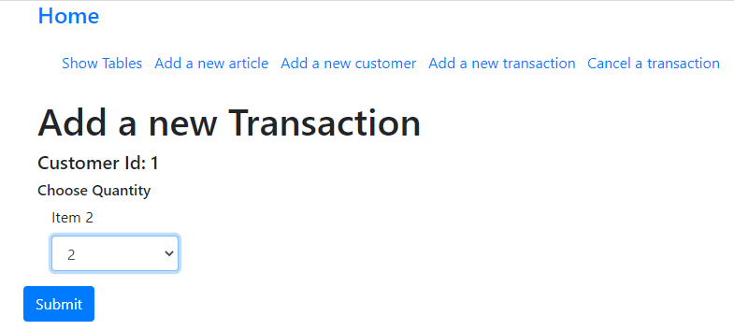 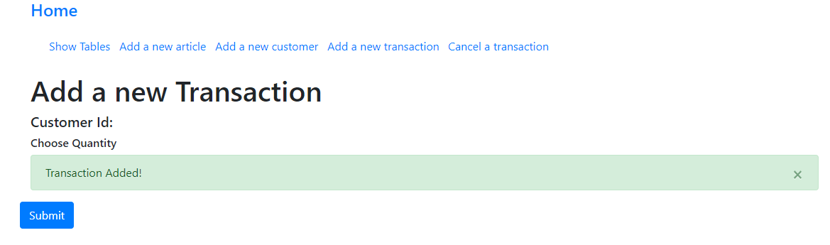

1. cancelTransaction.php

Transaction Number is the input from the users. On click of submit it removes entries for given Transaction Number from CustTransaction and Txn_ITEM tables.

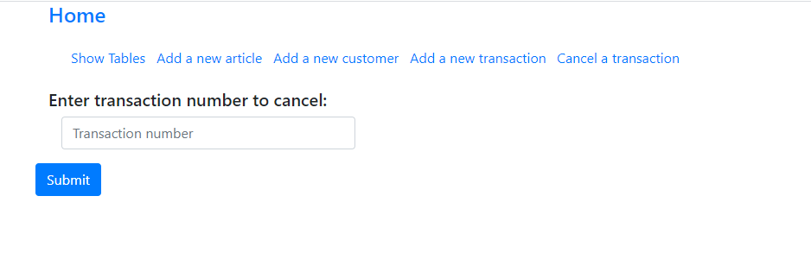If entered transaction number is older than 30 days, transaction cannot be canceled.

