MCDA5580 Assignment 1

Team Member

* Hemalatha Srinivasan A00452621
* Ajay Jain A00455849
* Kin Wa, Chan A00467755

**Table of Content**

Executive Summary 3

Objectives 4

Design/ Methodology/ Approach 4

Customer Cluster Analysis 5

Selected Columns 5

Data Cleaning 6

Data distribution (Before outliner removal) 6

Box Plot for field “NO_OF_VISIT” 6

Data distribution (After outliner removal) 7

Define no. of cluster (elbow plot) 8

Fviz plot to visualize clusters with PCA 10

Cluster Analysis 10

Customer Cluster Summary 11

Product Cluster Analysis 12

Selected Columns 12

Data Cleaning 12

Data distribution (Before outliner removal) 12

Box Plot for field “Baskets” 13

Data distribution (After outliner removal) 14

Define no. of cluster (elbow plot) 14

Fviz plot to visualize clusters with PCA 15

Cluster Analysis 16

Product Cluster Summary 16

Conclusion 16

Appendix 17

Customer Cluster Analysis 17

Product Cluster Analysis 20

# Executive Summary

We took 2000 records from the sample data received from Sobey’s transactions and analyzed using K-Means Algorithm for clustering the customer and products based on the result we received.

**Customer Segments**

Based on the K-Means Algorithm we formed 5 clusters for the total record and divided customers into 5 different categories based on customers behaviours. The results are given below.

Cluster – 1 Elite Customers

Cluster – 2 Loyal Customers

Cluster – 3 Undecided Customers

Cluster – 4 Weekend Bees

Cluster – 5 Need-Based Customers

**Product Segments**

Products were clustered into 5 categories. One cluster required attention which is having low price but not many sales. There are premium categories which have high prices and sales and are performing well for stores. Staples are also performing well in terms of sales. The results are given below.

Cluster – 1 Premium Staples

Cluster – 2 Premium Products

Cluster – 3 Problem Area

Cluster – 4 Semi Premium

Cluster – 5 Staples

The detailed behavior of the clusters we have mentioned below in Cluster Analysis segment.

# Objectives

Transaction data of a Sobey store is collected to improve sales performance. The data is analyzed by K-mean clustering method (product clustering and customer clustering) in order to discover customer behavior and buying preference of product and produce recommendations and strategy to improve sales.

Main objectives

* Find out product and customer groups lead to highest revenue and try to maintain the strength.
* Find out potential product and customer groups that have space to improve the revenue from them.

# Design/ Methodology/ Approach

K mean clustering method is used to discover the potential clusters for product and customer because the feature of clusters is unknown. It is used to identify the group share common characteristics in the complex data set.

Before performing the K mean clustering, data cleaning will be carried out. Data will be visualized by ggpair function in R and with help of box plot, outliners will be found and removed. After that, elbow plot will be used to define the optimal clusters. Finally, the resulted data will be used for K mean analysis.

# Customer Cluster Analysis

## Selected Columns

|  |  |  |
| --- | --- | --- |
| **Feature Name** | **Measurement** | **Description** |
| CUSTOMER_SK | N/A | Unique field for identifying customer |
| NO_OF_PRODUCT | COUNT | Total number of products brought by a customer |
| DISTINCT_PRODUCT | COUNT DISTINCT | Total number of distinct product brought by a customer |
| TOTAL_REVENUE | SUM | Total revenue of distinct generated from a customer |
| NO_OF_VISIT | COUNT | Total number visit of a customer, assume each basket created is a visit for the customer |
| PERCENTAGE_BASKETS_WEEKEND (Additional attribute) | COUNT  PERCENT | Percentage of basket created on weekend (Saturday & Sunday). Use to evaluate customer purchase behavior. |

## Data Cleaning

### Data distribution (Before outliner removal)

There is obvious outliner in “NO_OF_VISIT” dimension, use box plot for further analysis.

### Box Plot for field “NO_OF_VISIT”

Outliner: CUSTOMER_SK = 1



Reason for choosing outliner:

The NO_OF_VISIT of record of CUSTOMER_SK =1 is 369037, which is obviously higher than other records (The NO_OF_VISIT of other records in range of 5 - 290). So, we will remove this record in the analysis.

### Data distribution (After outliner removal)

## Define no. of cluster (elbow plot)

With reference to the slope of the elbow plot the number of clusters should be near 5 to 10. So, try to plot K means with clusters = 5 and 10.

K means with clusters = 5

K means with clusters = 10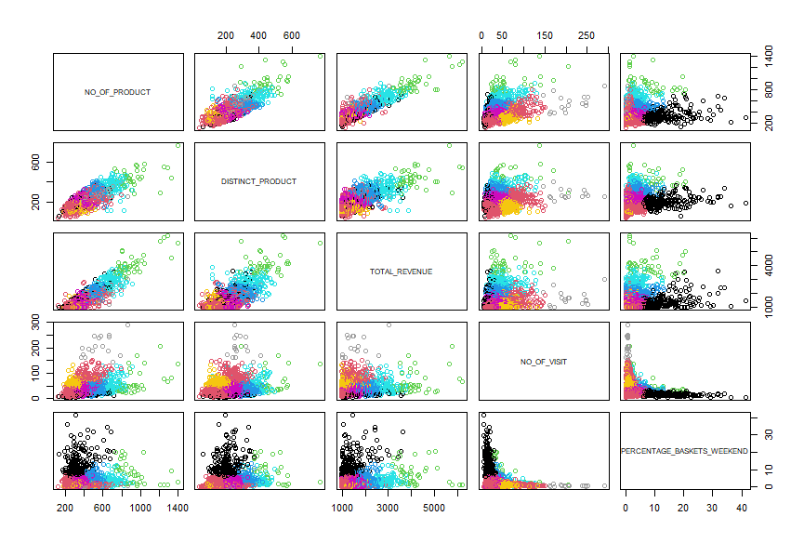

Comparing the cluster plots, when number of clusters = 10, the cluster size is small and many of them have some overlaps. So, we will choose the number of clusters = 5 for the result.

## Fviz plot to visualize clusters with PCA

## Cluster Analysis

With respect to below Elbow graph from range 1 to 50, we won’t be able to see any major improvements after 5th point so we decided 5 as number of clusters to be considered which can avoid deviation of results.

## Customer Cluster Summary

|  |  |  |
| --- | --- | --- |
| Customer Segment | Description | Recommendation |
| **Cluster – 1 Elite Customers** | Constantly visit the store irrespective to day  Purchase large number of items based on their wish.  Try to invest in different types of products.  Generates large revenue to store | We can consider them to purchase membership which can help them to get discounts and bonus in return. We can make them happy to continue their shopping continuously. We can provide regular gifts during festival seasons. |
| **Cluster – 2 Loyal Customers** | They buy regularly.  Involves constant purchase and generate considerable revenue | Increase the visibility of the product they purchase constantly.  Increase the stocks they buy |
| **Cluster – 3 Undecided Customers** | They make high frequent visits.  When compared to visits, they buy less product.  They have constant dilemma to buy things | Provide discounts for the products they buy. Provide discount vouchers as encouragement to buy. |
| **Cluster – 4 Weekend Bees** | They prefer weekends when compared to weekdays.  Their purchase during weekends more. | Add new and fresh stocks during weekends. Introduce weekend offers and send them email. |
| **Cluster – 5 Need-Based Customers** | They purchase based on their daily need.  Daily visitors  Doesn’t consider buying more products | Keep basic necessary products in the front. |

# Product Cluster Analysis

## Selected Columns

|  |  |  |
| --- | --- | --- |
| **Feature Name** | **Measurement** | **Description** |
| ITEM_SK | N/A | Unique field for identifying products |
| TOTAL_REVENUE | COUNT | Total revenue generated by store from each product. |
| BASKETS | COUNT | Total number of transactions for each product. |
| DISTINCT_CUSTOMERS | COUNT DISTINCT | Unique customers who have purchased the product. |
| AVERAGE_PRICE | AVERAGE | Average sell price of the product. |

## Data Cleaning

### Data distribution (Before outliner removal)

There is one clear outlier which can be seen in second column with more than 75000 baskets. There is one more with more than 25000 baskets.

### Box Plot for field “Baskets”

Outliner: ITEM_SK = 11740941 and 11740923 (First two rows from below)

Reason for choosing outliner

First two data points are having 75000 and 25000 as number of baskets. Next point is around 17000 baskets. Hence removing both the points as outlier.

### Data distribution (After outliner removal)

## Define no. of cluster (elbow plot)

With reference to the slope of the elbow plot the number of clusters should be 5 or 6 since error is reducing till those points. Keeping it 5 since difference in errors between 5 and 6 clusters is not significant and 5 clusters will be easier to visualize and analyze.

K means with clusters = 5

## Fviz plot to visualize clusters with PCA

## Cluster Analysis

## Product Cluster Summary

|  |  |  |
| --- | --- | --- |
| Customer Segment | Description | Recommendation |
| **Cluster – 1 Premium Staples** | Many customers are buying it frequently. Revenue generation is good. | Continue to monitor. |
| **Cluster – 2 Premium Products** | Average price is higher.  Less transactions but decent revenue. | Increase the visibility of the product. |
| **Cluster – 3 Problem Area** | Low prices but still not many customers are buying it. | Explore further to see if individual products within this cluster are loss- making. |
| **Cluster – 4 Semi Premium** | Prices are slightly on higher side. Many customers buy it frequently. Revenue generation is good. | Continue to monitor. |
| **Cluster – 5 Staples** | Low price but many customers buy it frequently.  Best revenue generator. | Increase the price a little bit to see the response. May be? |

# Conclusion

The analysis had met the objective stated. 5 customers group and 5 product group are defined. The “Premium Staples”,” Semi Premium”,” Staples” product group and “Elite” customer group are the most beneficial group for revenue generation, continuous monitoring is needed to ensure they are doing well in future as well.

The “Loyal”, “Weekend Bees”, and “Need-Based” are potential customer groups, we discovered performance on them seems to be positive and we had defined recommendations improve the revenue generated from them.

For product cluster “Premium”, it also had potential to improve its sales performance by increase the visibility.

# Appendix

## Customer Cluster Analysis

**SQL**

SELECT

CUSTOMER_SK,

count(ITEM_QTY) as NO_OF_PRODUCT,

count(distinct ITEM_SK) as DISTINCT_PRODUCT,

sum(SELLING_RETAIL_AMT) as TOTAL_REVENUE,

count(distinct TRANSACTION_RK) as NO_OF_VISIT,

COUNT(IF(WEEKDAY(`date`)>=5, 1, NULL))/count(distinct TRANSACTION_RK) as PERCENTAGE_BASKETS_WEEKEND

FROM dataset01.sales219

GROUP BY CUSTOMER_SK

ORDER BY TOTAL_REVENUE DESC

LIMIT 2000;

**R Script**

library(ggplot2)

library(GGally)

library(DMwR)

library(factoextra)

set.seed(84)

cust <- read.csv("sales219_CustomerCluster_2000-2.csv")

summary(cust)

ggpairs(cust[, which(names(cust) != "CUSTOMER_SK")],

upper = list(continuous = ggally_points),

lower = list(continuous = "points"),

title = "Customers before outlier removal")

boxplot(cust$DISTINCT_PRODUCT) # For Box and Whisker plot.

# here cust is dataset and Distinct_prodcust is column

cust.clean <- cust[cust$CUSTOMER_SK != 1, ] # Remove outliers

ggpairs(cust.clean[, which(names(cust) != "CUSTOMER_SK")],

upper = list(continuous = ggally_points),

lower = list(continuous = "points"),

title = "Customers after outlier removal")

# Normalize data using scale and exclude CUSTOMER_SK column.

# -1 will remove first column that is CUSTOMER_SK and keep all other.

cust.scale = scale(cust.clean[-1])

withinSSrange <- function(data,low,high,maxIter)

{

withinss = array(0, dim=c(high-low+1));

for(i in low:high)

{

withinss[i-low+1] <- kmeans(data, i, maxIter)$tot.withinss

}

withinss

}

# Elbow plot to determine the optimal number of clusters between 1 and 50.

plot(withinSSrange(cust.scale,1,50,150))

# K-means using k=5 for products based on results of elbow plot.

pkm = kmeans(cust.scale, 5, 150)

# Denormalize data by reversing scale function

cust.realCenters = unscale(pkm$centers, cust.scale)

# Bind clusers to cleansed Data

clusteredcust = cbind(cust.clean, pkm$cluster)

# Visualizing clusering results.

# Here we want all rows so we are not mentioning anything

# but we want columns only from 2 to 6

# (we don't want to visualize first column - ITEM_SK).

plot(clusteredcust[,2:6], col=pkm$cluster)

# fviz plot to visualize clusters with PCA

fviz_cluster(pkm, clusteredcust[2:6],

palette = 'Set2',

geom = "point",

ellipse.type = "convex",

ggtheme = theme_bw()

)

# Write data to csv

write.csv(clusteredcust, file='CustClusterOutput.csv')

## Product Cluster Analysis

**SQL**

SELECT

ITEM_SK,

sum(SELLING_RETAIL_AMT) as TOTAL_REVENUE,

count(distinct TRANSACTION_RK) as BASKETS,

count(distinct CUSTOMER_SK) as DISTINCT_CUSTOMERS,

avg(SELLING_RETAIL_AMT/NULLIF(ITEM_QTY,0)) as AVERAGE_PRICE

FROM dataset01.sales219

GROUP BY ITEM_SK

ORDER BY TOTAL_REVENUE DESC

LIMIT 2000;

**R Script**

library(ggplot2)

library(GGally)

library(DMwR)

library(factoextra)

set.seed(84)

prod <- read.csv("productcluster.csv")

summary(prod)

ggpairs(prod[, which(names(prod) != "ITEM_SK")],

upper = list(continuous = ggally_points),

lower = list(continuous = "points"),

title = "Products before outlier removal")

boxplot(prod$BASKETS) # For Box and Whisker plot.

# here prod is dataset and BASKETS is column

prod.clean <- prod[(prod$ITEM_SK != 11740941) &

(prod$ITEM_SK != 11740923), ] # Remove outliers

ggpairs(prod.clean[, which(names(prod) != "ITEM_SK")],

upper = list(continuous = ggally_points),

lower = list(continuous = "points"),

title = "Products after outlier removal")

# Normalize data using scale and exclude ITEM_SK column.

# -1 will remove first column that is ITEM_SK and keep all other.

prod.scale = scale(prod.clean[-1])

withinSSrange <- function(data,low,high,maxIter)

{

withinss = array(0, dim=c(high-low+1));

for(i in low:high)

{

withinss[i-low+1] <- kmeans(data, i, maxIter)$tot.withinss

}

withinss

}

# Elbow plot to determine the optimal number of clusters between 1 and 50.

plot(withinSSrange(prod.scale,1,50,150))

# K-means using k=5 for products based on results of elbow plot.

pkm = kmeans(prod.scale, 5, 150)

# Denormalize data by reversing scale function

prod.realCenters = unscale(pkm$centers, prod.scale)

# Bind clusers to cleansed Data

clusteredProd = cbind(prod.clean, pkm$cluster)

# Visualizing clusering results.

# Here we want all rows so we are not mentioning anything

# but we want columns only from 2 to 6

# (we don't want to visualize first column - ITEM_SK).

plot(clusteredProd[,2:5], col=pkm$cluster)

# fviz plot to visualize clusters with PCA

fviz_cluster(pkm, clusteredProd[2:5],

palette = 'Set2',

geom = "point",

ellipse.type = "convex",

ggtheme = theme_bw()

)

# Write data to csv

write.csv(clusteredProd, file='ProdClusterOutput.csv')